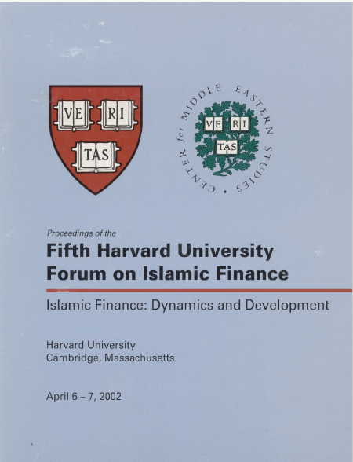

Proceedings of the
Fifth Harvard University Forum on Islamic Finance

Islamic Finance: Dynamics and Development

Harvard University
Cambridge, Massachusetts

April 6 – 7, 2002
<Arabic calligraphy>

In the Name of God, the All-Merciful, the Mercy-Giving
Proceedings of the

Fifth Harvard University Forum on Islamic Finance

April 6 – 7, 2002

Harvard University
Cambridge, Massachusetts

Organized by

Harvard Islamic Finance Information Program
Center for Middle Eastern Studies

in association with

Harvard Islamic Society

Harvard Islamic Finance Information Program
Center for Middle Eastern Studies
Harvard University

1350 Massachusetts Avenue
850 Holyoke Center
Cambridge, MA 02138

Compiled in 2003 by

HARVARD ISLAMIC FINANCE INFORMATION PROGRAM

Copyright © 2003 The President and Fellows of Harvard College. All rights reserved.

Unauthorized reproduction of any part of this volume, by any means, without written
permission from the copyright holders, may be prosecuted to the fullest extent
permissible under relevant U.S. and international copyright laws.

ISBN 0-9702835-4-7

Printed in the United States of America

All papers in this volume express the personal views of the author or authors on the subject and not necessarily those of HIFIP or of the institutions with which they were or are associated.

References to papers in this volume may be cited in the following format:

Vogel, Frank E. “Ijtihad in Islamic Finance” in Proceedings of the Fifth Harvard University Forum on Islamic Finance. Cambridge: Center for Middle Eastern Studies, Harvard University, 2003.

Published by
Center for Middle Eastern Studies
Harvard University

Acknowledgements

The Harvard Islamic Finance Information Program (HIFIP) has successfully completed the demanding task of compiling the Proceedings of the Fifth Harvard University Forum on Islamic Finance. Undertaking this project was not easy; the program has been going through wide-ranging strategic changes. However, dedicated HIFIP staff have taken this burden upon their shoulders and completed the necessary work. The HIFIP team had to repeatedly consult with the authors in the collection and preparation of many of these papers, and in some instances have had to transcribe papers from the recorded speeches. Similarly fact checking and maintaining standards of accuracy were ordeals. Fatima Raja ‘03 took the lead and assumed most of the burden, continuing in her work on these Proceedings even after her graduation from Harvard College. Peri Bearman, Associate Director of the Islamic Legal Studies Program, proofread the manuscript and provided valuable suggestions for improvement. The final editing of the manuscript was once again performed by the veteran compiler of the previous three volumes, Munir Zilanawala ‘01. A number of volunteers devoted considerable effort to editing: Mohsin Ansari (MBA ‘00), J. Marshall Henshaw ‘01, Husam El-Khatib (London School of Economics ‘00), Saif Shah Mohammed ‘02, Wasim Quadir ‘03, Saqib Qureshi (London School of Economics), Michael Medeiros (Class of 1959), Alisa Khan ‘05, Lale Nalincioglu (Harvard Extension School), Omar A. Khan ‘06, Rameez A. Qudsi ‘06, Hasan K. Siddiqi ‘07, and Owais Siddiqui ‘07.
I am particularly indebted to the authors. HIFIP is proud of their contribution to the fund of knowledge in Islamic economics and finance. It is their work which makes this volume an accepted and widely consulted reference tool. I am also grateful to the writers of introductions to the individual sections of the Proceedings: Rodney Wilson (Durham University), Hussein Hassan (Oxford Center for Islamic Studies), Ibrahim Warde (Euromoney), and Abdulkader Thomas (Samad Group). Special thanks go to Samuel Hayes (Conference Chair) for his Foreword, and to Thomas D. Mullins for his Preface.
A special section has been added to these Proceedings containing a report by Fatima Raja ‘03 on Islamic Finance in the contemporary context as well as a review by Munir Zilanawala ‘01 of the Harvard Islamic Finance Information Program from 1995 through 2003.
I would also like to recognize the efforts, enthusiasm, and support of the program throughout its existence on the part of HIFIP’s board members: Samuel Hayes (Professor Emeritus, HBS), Frank Vogel (Adjunct Professor, HLS), Iqbal Khan (CEO, HSBC Amanah Finance), Amr AlFaisal Al Saud (Dar Al Maal Islami), and Thomas Mullins (Executive Director, HIFIP). The success of HIFIP can also be attributed to the efforts of both former and current students, as well as friends who have extended assistance in various ways. A partial list includes: Taha Abdul-Basser ‘96 (Ph.D. Candidate, NELC), Shahzad A. Bhatti (J.D. ‘97), Gohar Bilal, Fatimah Iliasu (S.J.D. candidate, HLS), Husam El-Khatib, Michael Medeiros, Saif I. Shah Mohammed, Aamir Rehman ‘99 (M.A. ‘99, MBA ‘04), Abdur-Rahman Syed ‘99 (now at the University of Chicago), and Munir Zilanawala.
The dedication of these individuals has been well complemented by generous institutional support from Harvard’s Center for Middle Eastern Studies (CMES), especially its Director, Professor Cemal Kafadar, for his support and understanding. Special recognition must go to the Harvard Islamic Society (HIS), which played a key role in helping organize and staff the Forum. Particularly helpful were Professor David Mitten, HIS Faculty Advisor, and Saif I. Shah Mohammed, President of the Society at the time of the Fifth Forum.
Generous financial support has been received from the Forum’s sponsors: Abu Dhabi Islamic Bank, Albaraka Investment & Development Company, Al Batha Group, Citi Islamic Investment Bank, Crescent Capital Management, Dubai Islamic Bank, First Islamic Investment Bank, HSBC Amanah Finance, The International Investor, Kuwait Finance House, National Commercial Bank, Oasis Asset Management, Path Solutions, and SEDCO Services, as well as our associate sponsors, A’ayan Leasing and Investment Company, Bank Al-Jazira, iHilal (Middle East) FZ-LLC, King & Spalding, Wafra Investment Advisory Group, and the Wellington Management Company, whose support allowed HIFIP to bring its vision and plans for the Forum to fruition.
In closing, HIFIP wishes to extend profound thanks for the support, friendship, and faith of our many Program members (a complete list may be found on the inside back page), as well as individuals, particularly Atif Abdulmalik (CEO, First Islamic Investment Bank), Jassar Al Jassar (General Manager, Kuwait Fiance House), Mohammed Al Shroogi (Chairman, Citi Islamic Investment Bank), Nizam Yaquby, and Iqbal A. Khan. I extend my heartfelt gratitude and appreciation to all of the many who have been associated in the production of this volume and have contributed to HIFIP’s success over the years.

S. Nazim Ali, Ph.D.
Director, Harvard Islamic Finance Information Program

Table of Contents

Preface 15
Thomas D. Mullins

Foreword 17
Samuel L. Hayes, III

Part I: Islamic Economics 1

Introduction
Rodney Wilson . . . . . . . . . . . . . . . . . . . . . . . . . . . . . . . . . . . . . . . . . . . . . . . . . . . . . . . 3

Islamic Banking in Turkey (1990-2000): Boon or Bane for the Turkish Financial Sector?
Mahmoud A. El-Gamal and Hulusi Inanoglu . . . . . . . . . . . . . . . . . . . . . . . . . . . . . . . 7

A Capital Adequacy Framework for Islamic Banks: The Need to Reconcile Depositors’ Risk Aversion with Managers’ Risk Taking
Maximilian J.B. Hall, Humayon A. Dar, and Dadang Muljawan . . . . . . . . . . . . . . . 21

Risk, Return, and Volatility of Faith-Based Investing: The Case of the Dow Jones Islamic Index
M. Kabir Hassan . . . . . . . . . . . . . . . . . . . . . . . . . . . . . . . . . . . . . . . . . . . . . . . . . . . . 43

Eliminating Riba: The Holy Alliance between Law and Economics in Pakistan
Tariq Hassan . . . . . . . . . . . . . . . . . . . . . . . . . . . . . . . . . . . . . . . . . . . . . . . . . . . . . . . 69

Quantitative Methods of Stock Selection in the Construction and Testing of Shari^{c}a-Compliant Strategies
John Lightstone . . . . . . . . . . . . . . . . . . . . . . . . . . . . . . . . . . . . . . . . . . . . . . . . . . . . . 75

Part II: The Shari^{c}a 81

Introduction
Hussein Hassan . . . . . . . . . . . . . . . . . . . . . . . . . . . . . . . . . . . . . . . . . . . . . . . . . . . . . 83

The Centrality of Fiqh: An Introduction to Shari^{c}a-Compliant Finance
Taha bin Hasan Abdul-Basser . . . . . . . . . . . . . . . . . . . . . . . . . . . . . . . . . . . . . . . . . . 85

Shari^{c}a-Compliant Financing Structures and the Development of an Islamic Economy
Michael J.T. McMillen . . . . . . . . . . . . . . . . . . . . . . . . . . . . . . . . . . . . . . . . . . . . . . . 89

Shari^{c}a Principles and Their Application: Examples from Islamic Finance
Muddassir H. Siddiqui . . . . . . . . . . . . . . . . . . . . . . . . . . . . . . . . . . . . . . . . . . . . . . . 105

Credit Enhancement in Ijara Transactions
Robert W. Toan and Monir Barakat . . . . . . . . . . . . . . . . . . . . . . . . . . . . . . . . . . . . 109

Ijtihad in Islamic Finance
Frank E. Vogel . . . . . . . . . . . . . . . . . . . . . . . . . . . . . . . . . . . . . . . . . . . . . . . . . . . . . 115

What Can Islamic Banks Do Besides Eliminating Riba?
Nizam Yaquby . . . . . . . . . . . . . . . . . . . . . . . . . . . . . . . . . . . . . . . . . . . . . . . . . . . . . 119

Part III: Islamic Finance 121

Introduction
Ibrahim Warde . . . . . . . . . . . . . . . . . . . . . . . . . . . . . . . . . . . . . . . . . . . . . . . . . . . . . 123

Islamic Financial Products: Addressing the Needs of the Retail Market Using the Internet as a Platform
Ramzi Abu Khadra . . . . . . . . . . . . . . . . . . . . . . . . . . . . . . . . . . . . . . . . . . . . . . . . . . 125

Corporate Customer Perceptions of Islamic Banking Products and Services
Norafifah Ahmad and Sudin Haron . . . . . . . . . . . . . . . . . . . . . . . . . . . . . . . . . . . . . 131

The Emerging Islamic Financial Architecture: The Way Ahead
Ahmad Mohamed Ali . . . . . . . . . . . . . . . . . . . . . . . . . . . . . . . . . . . . . . . . . . . . . . . . 141

Regulatory Environment and Strategic Directions in Islamic Finance
Jassar Al Jassar . . . . . . . . . . . . . . . . . . . . . . . . . . . . . . . . . . . . . . . . . . . . . . . . . . . . 155

The Progress of Islamic Banking and Finance in Bahrain
Ahmed bin Mohammed Al-Khalifa . . . . . . . . . . . . . . . . . . . . . . . . . . . . . . . . . . . . . 159

Strategic Trends in the Islamic Banking and Finance Movement
Monzer Kahf . . . . . . . . . . . . . . . . . . . . . . . . . . . . . . . . . . . . . . . . . . . . . . . . . . . . . . 163

The Comparative Advantages of Islamic Banking and Finance
M. Nejatullah Siddiqi . . . . . . . . . . . . . . . . . . . . . . . . . . . . . . . . . . . . . . . . . . . . . . . . 173

Recent Developments in Islamic Banking in Indonesia
Mulya E. Siregar and Nasirwan Ilyas . . . . . . . . . . . . . . . . . . . . . . . . . . . . . . . . . . . 179

Alternative Trading Systems and the Viability of an Islamic Electronic Communications Network
Thomas Tellner . . . . . . . . . . . . . . . . . . . . . . . . . . . . . . . . . . . . . . . . . . . . . . . . . . . . 187

Part IV: Commercial Products, Business Models, and Other 203

Introduction
Abdulkader Thomas . . . . . . . . . . . . . . . . . . . . . . . . . . . . . . . . . . . . . . . . . . . . . . . . . 205

Creating Financial Solutions for American Muslims: HSBC’s Experience in the United States
Tariq Al-Rifai . . . . . . . . . . . . . . . . . . . . . . . . . . . . . . . . . . . . . . . . . . . . . . . . . . . . . . 209

Managing Shari^{c}a-Compliant Mutual Funds in a Volatile Equity Environment: The Emerging Market Experience and the Global Experience
Adam Ebrahim and Bernard R. Horn, Jr.. . . . . . . . . . . . . . . . . . . . . . . . . . . . . . . . 215

Prospects for the Evolution of Takaful in the 21st Century
Omar C. Fisher and Dawood Taylor . . . . . . . . . . . . . . . . . . . . . . . . . . . . . . . . . . . . 227

Opening Doors for Muslim Families in America
Saber Salam . . . . . . . . . . . . . . . . . . . . . . . . . . . . . . . . . . . . . . . . . . . . . . . . . . . . . . . 245

Strategies in the Islamic Funds Industry: An Exploratory Analysis
Zafar Sareshwala and Mohammed Obaidullah . . . . . . . . . . . . . . . . . . . . . . . . . . . . 251

Islamic Windows: A Solution for Muslim Community Banking in the United States
A. Rushdi Siddiqui . . . . . . . . . . . . . . . . . . . . . . . . . . . . . . . . . . . . . . . . . . . . . . . . . . 261

Part V: Islamic Finance in the Contemporary Context 265

An open discussion of the challenges and opportunities facing the Islamic financial industry since September 11 and the market downturn, crises, and bankruptcies that have followed.

Panelists: Mahmoud A. El-Gamal (Chair); Fred Crawford, James Godec, Iqbal Ahmad Khan, Abdulkader Thomas
Report: Fatima Raja

Part VI: A Brief History of the Harvard Islamic Finance Information Program 271

An overview of the history of the Harvard Islamic Finance Information Program and its achievements.

Report: Munir Zilanawala

Appendices 291

A: Fifth Forum Program of Events . . . . . . . . . . . . . . . . . . . . . . . . . . . . . . . . . . . . . . . . . 293

B: Profiles of Speakers and Chairs . . . . . . . . . . . . . . . . . . . . . . . . . . . . . . . . . . . . . . . . . 297

Index 308

Preface

The Fifth Harvard University Forum on Islamic Finance, originally slated for October 6 and 7, 2001, was postponed to April 2002 because of the events of 11 September 2001. I would again like to extend my condolences to the families of the victims of that tragedy.
One consequence of 9/11 was the need for a better understanding, by the academic community as well as the general public, of Muslim communities and the religion of Islam. Given its mission of fostering informed awareness of the field of Islamic finance and economics, in theory and in practice, among the Muslim community, the Fifth Forum directly addressed this need. The conference was, as usual, attended by financial practitioners, lawyers, shari^{c}a scholars, regulators, researchers, and students. In addition, media outlets displayed a marked interest in the Forum, which resulted in wide coverage, including an article in Fortune magazine.
As at previous conferences, the range of topics covered was large and varied and embraced shari^{c}a perspectives, investments and financial products, new opportunities and directions, and other aspects of economics, finance, and development relevant to Islamic finance. A few sessions stood out. The Forum featured a number of dignitaries, including Ahmed Mohamed Ali (President of the Islamic Development Bank) and Ahmed Al Khalifa (Governor of the Bahrain Monetary Agency, responsible for governmental oversight in one of the hubs of the Islamic financial industry), who addressed issues in the regulation of Islamic finance. A special session on Islamic finance in light of the post-9/11 environment was also held. The Forum reprised its session on Islamic finance for newcomers.
As a follow-up on the Forum, HIFIP organized, at the request of the U.S. Department of the Treasury, a seminar at the Department’s offices in Washington, DC, on April 26, 2002. The seminar, entitled “Islamic Finance 101,” aimed to education U.S. banking regulators, members of the Treasury Department, Congressional aides, and other government staffers about this field. Speakers on the panel included academics and practitioners of Islamic finance. The seminar was moderated by Professor Emeritus Samuel Hayes of the Harvard Business School and chaired by Treasury Undersecretary John Taylor.
The papers presented at the Fifth Forum are collected in these Proceedings and published by the Harvard University Center for Middle Eastern Studies. Like previous Proceedings, they have been edited by HIFIP’s dedicated team of student staff and volunteers, who were also invaluable in organizing the conference itself.
The direction of the Fifth Forum and the publication of these Proceedings, and indeed, the excellent work of HIFIP in creating dialogue and awareness about Islamic finance and collecting and disseminating data on the field, would not have been possible without the untiring efforts of Dr. S. Nazim Ali, Director of HIFIP. The Program has drawn its energy from his passion and perseverance, and I should like once again to thank him for his absolute and infectious devotion. In addition, I would be remiss not to salute the students, mostly from Harvard College and its graduates, and including some from other Harvard schools, who have been the workforce behind this Program.
HIFIP continues to closely monitor the developments in the industry and across the globe. While matters beyond our control have so far prevented us from calling the Sixth Forum, we are hopeful that these Proceedings will continue to benefit research and casual interests alike.

Thomas D. Mullins
Executive Director, Harvard Islamic Finance Information Program

Foreword

Samuel L. Hayes III*

We are gathered at a particularly important juncture in the evolution of Islamic Finance. September 11th is seared on the consciousness of the world. It has turned on its head a number of geopolitical relationships. It has sharpened the perceptions of the disparate principles and goals of different religions and has focused a bright and often times unflattering light on the Islamic faith. The current high level of violence and carnage in Palestine and Israel supplies still another overlay to the current focus on Islam. There are dramatically different perceptions of the reality of that conflict as between the U.S. public and its leadership wearing one set of lenses, and most of the rest of the world wearing an entirely different set of lenses. The Palestinian side of the story has received scant attention from the U.S. media, in part because its supporters have not invested enough in getting that message through, as difficult as that is to do. While the U.S. economy was stumbling before September 11th, there is no doubt that the attack on the World Trade Center so traumatized this country that the economic downturn was further accentuated. The terrorists who identified themselves as Muslims are blamed for that economic malaise. And it is made all the worse because the U.S. is currently the world’s chief engine of economic growth. Japan, which used to be the other engine of economic growth, is mired in its worst economic crisis since World War Two. The European Union is faltering economically, partly in response to the U.S. downturn but more fundamentally because of continuing nationalist pressures and union-fostered welfare systems, which are unsupportable in the competitive global economy of the 21st century. Further, the collapse of Argentina has cast a shadow over the economic outlook for Latin America. The only bright spot in the economic sphere at this point is China, and even here, most foreign companies moving into China have yet to make any real profit.
Not surprisingly, the global money and capital markets are reflecting the political and economic malaise just described. There is even some dark talk of the possible use of an oil boycott by Muslim countries to induce the developed world, and most particularly the U.S., to act on their grievances in the international sphere. Some observers predict that these political and economical difficulties will cast a pall over Islamic finance and dampen its prospects for wider inherence and growth. I think, on the contrary, that it offers a real opportunity. It can serve to focus new attention on Islam in the industrialized world and provide an opportunity to contrast the philosophy underlying the financial and commercial tenets of Islam (which are basically pacific and community-oriented) with the distorted stereotype of Islam identified with the terrorists who attacked the World Trade Center and the “martyrs” who blow themselves up in market places crowded with innocent civilians. Not many non-Muslims know, for instance, that Islam promotes a partnership mentality with the objective of assuring that all parties obtain fair benefits and liabilities from a venture. Very few non-Muslims understand that Islam promotes a sense of community responsibility among its business people and consideration for those who are in financial and personal distress. Very few non-Muslims recognize that Islam frowns on gambling and speculation in commerce as not contributing to the welfare of the community. Very few understand that it discourages enterprises that do harm to the community, such as liquor distribution or armaments manufacture. Very few non-Muslims in this country understand that Islam discourages the use of debt which could cause a company to fail. Very few understand that it encourages investment in real goods and services, as opposed to financial manipulations, such as have recently been demonstrated in the Enron case.
I am convinced that Islam has an important story to share with the uninformed. And I am hopeful that that story will not only help dispel the misinformed stereotypes of what the Islamic faith is all about, but also attract more participants to its financial products. To attract those new participants, it must offer practical solutions to the needs of people living in the 21st century.
PART I

ISLAMIC ECONOMICS

Introduction
Rodney Wilson

Islamic Banking in Turkey (1990-2000): Boon or Bane for the Turkish Financial Sector?
Mahmoud A. El-Gamal and Hulusi Inanoglu

A Capital Adequacy Framework for Islamic Banks: The Need to Reconcile Depositors’ Risk Aversion with Managers’ Risk Taking
Maximilian J.B. Hall, Humayon A. Dar, and Dadang Muljawan

Risk, Return, and Volatility of Faith-Based Investing: The Case of the Dow Jones Islamic Index
M. Kabir Hassan

Eliminating Riba: The Holy Alliance between Law and Economics in Pakistan
Tariq Hassan

Quantitative Methods of Stock Selection in the Construction and Testing of Shari^{c}a-Compliant Strategies
John Lightstone

Introduction

Rodney Wilson*

Unlike in previous years when many of the papers were theoretical, the papers devoted to Islamic economics at the Fifth Forum deal largely with institutional and policy issues. Three are concerned with Islamic banking and two with shari^{c}a-compliant portfolio investment through mutual funds. All are topical, even though the poor performance of international equity markets since 2000 has damaged the mutual fund industry, including Islamic portfolios, and ethical investments more generally.
Two of the Islamic banking papers deal with the experiences of Pakistan and Turkey, but it is perhaps appropriate to start this introduction by reviewing the paper on a capital adequacy framework for Islamic banks, where the authors see the need, as the subtitle indicates, to reconcile depositors’ risk aversion with managers’ risk taking. The early proponents of modern Islamic banking, such as M. Nejatullah Siddiqi (who introduced this section of the Proceedings of the Third Harvard Forum), envisaged the new institutions as being based on profit-and-loss sharing, with the depositors similar in some respects to equity investors. In practice, however, as Dadang Muljawan, Humayon Dar and Maximilian Hall correctly point out, contemporary Islamic banks are organized as companies rather than on a mutual basis; hence their shareholders are distinct from their depositors. The former have ownership rights and responsibilities, but the latter do not. Muljawan, Dar and Hall use modern banking theory, notably principal-agent analysis, to develop a formal framework to ascertain the optimal capital structure for Islamic banks. Their contribution is cleverly formalized, and it has much relevance for empirical applications.
Before addressing the question of capital adequacy, it is perhaps useful to place the work of Muljawan, Dar and Hall in a wider perspective, to see its larger significance. This involves corporate governance issues within Islamic banks, and the responsibilities of the management to shareholders and clients with investment deposits. As has been recognized in discussions at the Bank for International Settlements in relation to Basel II, to which the authors refer, capital adequacy is linked to corporate governance and financial reporting. Arguably, if there is fair governance reflecting the interests of the different stakeholders in an Islamic bank, and sound financial reporting, the probability of the bank’s getting into difficulties is reduced, hence there will be less prudential concern over capital adequacy.
With Islamic banks, as with any bank listed on a stock market, there are potential conflicts of interest between the bank’s management and its shareholders: the classic principal-agent problem. For example, higher pay or bonuses for the bank’s management, unless matched by efficiency gains, may be at the expense of dividends paid to shareholders. This two-way conflict may become a three-way conflict in Islamic banks, as customers with investment deposits on a mudaraba profit-sharing basis may have their payouts reduced if management rewards itself more, their position being similar to that of the shareholders as principals, at least in this respect. At the same time, however, there may also be a trade-off between the interests of shareholders and clients with mudaraba deposits, as higher dividends for the former may be at the expense of the profit shares of the latter.
With interest-based conventional banks, shareholder’s dividends may also be adversely affected by the interest payments to depositors, but these tend to be linked to the monetary policy pursued by the central bank, and thus to macroeconomic developments—with banks being price-takers rather than price-makers as far as interest is concerned. In Islamic banks the management is much more in control, as payments to investment depositors depend on profits, and hence on the success of the management, not on central bank monetary policy. The management of Islamic banks has therefore potentially greater discretion over payouts to investment account holders, as well as over dividends. This has implications for financial reporting, as arguably the constituency to which the management of an Islamic bank is accountable is the investment depositors as well as the shareholders.
A tightening of monetary policy in a conventional economic system will have implications for capital adequacy, as rises in interest rates may force commercial banks to pay more for deposits than they can afford, perhaps causing losses and even collapse. Islamic banks are less likely to fail in such circumstances, as investment depositors may be prepared to accept a temporarily lower return, or even no profit, in the interest of maintaining the longer-term viability of the bank.
Of course, Islamic banking is not a zero-sum game, and if the management is successful in enhancing profitability, then shareholders can be paid higher dividends, investment depositors can enjoy higher payouts, and arguably the management should be entitled to performance bonuses. In such favorable circumstances there is no need to worry about capital adequacy, as profits are presumably a reflection of the management’s skill at acquiring profitable assets, most of which will be performing in the sense of not having been subject to repayment difficulties or an inability to make ijara leasing payments or other similar payments from which the bank derives its income.
It is, as already indicated, when Islamic banks get into difficulties that capital adequacy becomes important, perhaps because of non-performing financing as a result of poor management decision-making over what is funded or of unforeseen macroeconomic recessions that adversely affect the banks’ clients. In such circumstances Islamic banks, like their conventional equivalents, will need adequate resources to meet any run on deposits if customers lose faith in the institution’s ability to meet its commitments. As Muljawan, Dar and Hall point out, AAOIFI addressed this issue in a 1999 statement on capital adequacy for Islamic banks, and Khan and Chapra took the issue further in a paper published in 2000. Both AAOIFI and Khan and Chapra argue that the status of mudaraba investment depositors is different from that of depositors in a conventional bank, for the latter do not share in their bank’s profit and are guaranteed the nominal value of their deposits.
The major contribution of Muljawan, Dar and Hall is to extend these arguments by recognizing that Islamic banks have a portion of their deposits in current accounts where the nominal value is guaranteed, and a proportion in investment accounts where it is not. Capital adequacy is more critical for risk-averse depositors with current accounts than for those willing to take on some risk to earn a higher return. Consequently, the higher the proportion of mudaraba investment deposits, the lower the capital-to-assets ratio needed. There is therefore an incentive for Islamic banks to encourage more murabaha investment deposits even though these imply a higher cost of funds.
The position regarding Islamic banking in Pakistan often seems confusing to outside observers. Tariq Hassan’s paper is therefore very welcome, as it sheds light on recent developments: notably, why, in spite of the commitment by the Supreme Court to implement the shari^{c}a in Pakistan, it has yet to be applied to the banking system. Hassan suggests the Supreme Court has gone beyond its legal mandate in proposing economic and financial restructuring. To explain why the Supreme Court takes such a stance, he considers the situation in the 1960s, when the attempt to apply Islamic law to banking was first made. He suggests these early efforts were a sham, as all that happened was a change in nomenclature, with “interest” being replaced by “service charges” in lending, a “mark-up” in trade and “profit” in investment.
Although simply having service charges for lending as a replacement for interest is clearly in conflict with the shari^{c}a, both murabaha mark-up trade financing and profit-sharing investment deposits account for a significant proportion of the shari^{c}a-compliant financing in most Muslim countries. The problem in Pakistan, according to Hassan, was that these innovations were introduced in an ad hoc fashion, without any change in the regulatory framework. He alleges there was little conceptual discussion or debate on the subject, a situation presumably remedied by the Supreme Court’s ruling on the Khaki case in December 1999, when certain provisions relating to interest contained in various laws were declared to be in conflict with the injunctions of Islam. This provoked widespread debate, but Tariq Hassan does not specify what the laws questioned were, or what the reasoning of the Supreme Court was. The inclusion of these would have been instructive for the reader.
It is clear that little progress has been made with Islamic banking in Pakistan in spite of the commitments of the Finance Minister in his 2001 budget speech that Hassan summarizes. The task force set up to consider legal changes has not reported, nor has the task force to identify ways the government could fund its own debt in accordance with the shari^{c}a. The Transformation Commission submitted its report to the government, but Hassan indicates it reduced by half the number of financing instruments permissible for the banks. Consequently, like earlier reports, it is most likely to be shelved.
It would have been useful if Hassan had provided a critique of the report of the Transformation Committee, including its specific rationale for arguing what is not permissible in Islamic finance. Despite this limitation, the paper is nevertheless valuable in highlighting the shortcomings of a top-down approach rather than a market-based solution to Islamic finance. Tariq Hassan suggests that Pakistan might be better to introduce an Islamic system in parallel with the conventional system, as happened in most Muslim countries. He does not indicate whether this requires special legislation, or simply some regulatory changes by the central bank. Rather, what is suggested is that the government should seek ijma^{c}, a consensus of Islamic scholars nationally as well as internationally.
Such an approach stands little chance of success, however, as any consensus is unlikely. It would be more realistic to consider in detail how the central bank might handle regulatory issues, and the extent to which it should participate actively in the Kuala Lumpur-based Islamic Financial Services Board. For Islamic banking to take off, it is necessary for regulatory authorities to provide a framework to ensure the integrity of the products offered, and perhaps set an example with their own financing. The job of the regulatory authority is to ensure there is the transparency for customers to make informed choices, but after that, the marketing is best left to the Islamic banks themselves.
The paper by Mahmoud El-Gamal and Hulusi Inanoglu on Islamic banking in Turkey analyzes the type of dual banking system that Hassan envisages for Pakistan. At first glance, the extent of Islamic banking development in Turkey is unimpressive, as the share of total deposits in the Special Finance Houses (the term used by Ankara for Islamic banks) is less than three percent. Despite a history now spanning two decades, many questions remain regarding the Special Finance Houses, not least the extent to which they attract funds that would otherwise be hoarded by the pious, or how much the growth of their admittedly limited deposit base has been at the expense of the conventional banks. El-Gamal and Inanolglu’s analysis assumes the latter, as their main task is to compare the efficiency of Special Finance Houses with that of conventional banks.
The methodology for the efficiency analysis seems sound, as it allows for input prices, mainly labor costs and capital outlays, which are ingeniously estimated. It contains quality and risk indices, although it would have been helpful to the reader to provide more information on the measures used. Surprisingly, although the Special Finance Houses are less efficient than the major banks, when an adjustment is made for size, the Islamic institutions are in the top rank. This is explained by the higher quality of assets held by the Special Finance Houses, which have fewer non-performing loans, perhaps reflecting the greater integrity of their clients.
The measures used for the analysis of the dual sectors include capital adequacy ratios, total loans to total assets, and non-performing loans. Other ratios used include: employee expenses to total assets, net income to assets, and liquid assets to total assets, the last being lower for the Special Finance Houses, as they do not hold government bonds. El-Gamal and Inanoglu suggest the lower employee expenses to total expenses ratio for Special Finance Houses reflects their less-developed branch networks, as these are costly to maintain and staff. No information is provided on relative labor costs, however, though since the numbers of employees is known, this could be estimated without a detailed investigation of pay structures and the criteria for remuneration.
The type of analysis pioneered by El-Gamal and Inanoglu to evaluate the relative efficiency of Turkish conventional banks and Special Finance Houses could usefully be undertaken in other Muslim countries with dual banking systems. There is clearly much scope for empirical work, not only in estimating overall efficiency, but also in examining whether the loyalty and trust between staff, and between staff and customers because of their common values and faith, is reflected in financial and other ratios that may feed through to profits and share performance in the case of listed banks.
John Lighthouse and Kabir Hassan are concerned with the returns on shari^{c}a-compliant equity investments in their respective papers, and both use the Dow Jones Islamic Indices. Lighthouse compares the Islamic index for large capitalization stocks with the Russell 1000 index using monthly financial data from January 1987 to December 2001. The Islamic indices were found to be more volatile, largely reflecting, according to Lighthouse, the greater weight of technology stocks in these indices. The exclusion of conventional bank stocks from the Islamic indices may also reduce stability, as the banks were steady earners over the period analyzed and the fluctuations in their fortunes were less dramatic than in the 1970s or early 1980s, when interest rates varied more and aggregate economic performance was less stable. Overall Lighthouse’s results are not unexpected, and are consistent with those from earlier studies.
The paper by M. Kabir Hassan is much more substantial, as he attempts to apply a wide range of empirical tests to analyze the capital market efficiency of the Dow Jones Islamic Index, drawing on the standard financial theory of Fama and others, using variance analysis, and using the Dickey-Fuller test much favored by contemporary econometricians as well as GARCH. This is the first time such work has been done using the Dow Jones Islamic Index, the data set being daily figures over the 1996-2000 period. There appear to be no calendar effects in terms of end-of-year or end-of-financial-year effects, and the GARCH results reveal a significant positive relationship between conditional volatility and the Dow Jones Islamic Index returns, indicating that there is market efficiency.
Hassan provides not only empirical analysis, but also a useful introduction to the market for, and the rules governing, Islamic investment. He estimates that the world’s Muslims have over $100 billion to invest and that the market is growing by 15% per year, although whether this is still the case given the decline in global equity prices is debatable. He outlines the criteria used for the selection of shari^{c}a-compliant stock, and lists (though does not discuss) the responsibilities of shari^{c}a boards for monitoring stocks, management, fees, and documentation, as well as their remit in portfolio purification and zakat estimation. Hassan also draws useful parallels between the composition of Islamic mutual funds and the ethical investment industry more generally. He highlights the bias of ethical investment funds toward smaller companies, this bias increasing risk.
From his paper, it is evident that there are many avenues for further research, including what motivates individuals to undertake ethical investment, of which Islamic investment is a subset. Hassan believes that the relationship between altruism and social reputation should be investigated, as well as the question of internal faith-based motivation versus approval seeking. As Islamic investment becomes more significant, companies will need to actively communicate what their social and environmental commitments are in order to attract funds from investors motivated by their faith. For Muslims to have an impact on global economic management and the culture of multinationals, engagement with companies and changing corporate behavior is a much more promising way forward than policies of rejection and confrontation of capitalism. What is wanted is a change of business values, not a change of economic systems.

Islamic Banking in Turkey (1990-2000)
Boon or Bane for the Turkish Financial Sector?

Mahmoud A. El-Gamal* and Hulusi Inanoglu†

Abstract

This paper aims to analyze the dual banking system in Turkey and investigate the relative efficiency position of Islamic banks for the last decade. Empirical studies on Islamic banking are not only rare and limited, but also lack rigorous methodologies. Our earlier results in El-Gamal and Inanoglu (2002) indicated that while the share of Islamic banks in Turkey is less than three percent, and their 15 years’ experience compared poorly to conventional banks’ 150 years experience, Islamic banks are no less efficient than their conventional counterparts. Indeed, we found Islamic banks to be more efficient when controlling for size of operations. Those results were obtained based on a Turkish banking panel dataset, thus controlling for macroeconomic and other factors affecting the performance of all banks. The current study looks more closely at the relative performance of the four main Turkish Islamic banks during the decade 1990-2000.

I. Introduction

The majority of financial flows in Turkey take place through the banking sector, which accounts for about 75% of the assets of the total financial sector assets in Turkey c.f. the BRSA Report (2001: 1). The average total loans to total assets ratio for the Turkish conventional banking sector is less than 40% (compared to above 60% for the U.S.) for the last decade. An unofficial but commonly quoted statistic estimates $15 billion is kept by households in the form of cash and gold, as hedges against Turkey’s high inflation levels.
The negative real return on bank deposits in Turkey may have contributed to this poor level of financial intermediation. However, it is also possible that generating deposits through the conventional banking system exacerbates this problem in Muslim countries. It has been suggested that the development of “interest-free” or “Islamic” banking may contribute to solving this problem. On the other hand, it is possible that Islamic banks, in addition to mobilizing previously hoarded funds, may draw funds from the conventional sector. Thus, an efficiency comparison of an Islamically-oriented banking system with the conventional system in a society should be examined, in order to determine whether the net effect of Islamic banking is positive or negative.
Islamic banks were allowed by government decree to operate in Turkey, starting in 1983 under the name of “Special Finance Houses” (SFHs). The two stated reasons for allowing their operations were: (i) to facilitate the inflow of funds from Gulf countries, and (ii) to mobilize the hoarded savings of observing Muslims. The early entrants were Al-Baraka Turk and Faisal Finance House, both established in 1984. Kuveyt-Turk Finance House was established in 1988, bringing the number of SFHs to three, till 1991. The year 1991 is considered the starting year for a new era in Islamic banking in Turkey. Anadolu Finance House, the first SFH with 100% domestic capital, was established in that year, followed by Ihlas Finance House in 1995 and by Asya Finance House in 1996, all domestically owned. These three domestic SFHs not only increased the competition but also led the older SFHs to change the legal status of these institutions.
Special Finance Houses were subject to a government decree under the Interest-free Banking Decree No. 83/7506 and were regulated and supervised by the Under-Secretariat of the Treasury and Central Bank of Turkey. In addition to its ambiguity, the decree gave conventional banks unfair competitive advantages over SFHs. In large part due to the introduction of domestic SFHs, existing Special Finance Houses became subject to the new Banking Act No: 4389 and 4491, effective 19 December 1999, which improved their competitive position.
The competitive disadvantage of SFHs became less pronounced with the revision of the banking law on 21 May 2001. Two main changes were the establishment of “Special Finance Houses Association” and the introduction of “Deposit Insurance Fund for SFHs” which guarantees the deposits at the SFHs in a manner similar to deposits at conventional banks. This fund was to be directly managed by the Special Finance Houses Association, whereas the conventional deposit insurance fund is managed by the state. This allowed SFHs to give more security to their depositors, while keeping their operations ostensibly interest-free.
In this regard, the efficiency of Islamic banks relative to their conventional counterparts in Turkey is expected to have improved after the year 2001. In a 2002 study, we studied the efficiencies of the four SFHs (Al-Baraka Turkish Finance House, Anadolu Finance House, Faisal Finance House and Kuveyt-Turk Finance House) that were in operation throughout the previous decade, relative to those of forty-nine conventional banks in operation (managing 93% of the total assets of conventional banking during the decade). Ihlas Finance House, which was founded in 1995, and Asya Finance House, which was founded in 1996, were excluded from the dataset since these banks were not in operation for more than half of the decade. In this paper, we shall review some of the major results in El-Gamal and Inanoglu (2002), and put them within the context of efficiency of Islamic banks.

II. Previous Empirical Studies of Islamic Banks

Empirical studies of Islamic banks have mostly relied on descriptive statistics, and theoretical analyses, rather than rigorous statistical estimation methodologies. For instance, Aggarwal and Yousef (2000) surveyed the financial instruments used by Islamic banks, and found that most of their instruments mimicked conventional banking debt-based financing. That is in contrast to the historical theory of Islamic banking, which portrayed the focus of the latter to be on equity-based financing and profit-sharing arrangements. In this regard, Al-Deehani, Abdelkarim, and Murinde (1999) proposed a model in which, under certain assumptions, an increase in investment accounts financing would enable Islamic banks to increase both their market values and their shareholders’ rates of return at no extra financial risk to the bank. Their empirical analysis of the annual accounts of twelve Islamic banks supported their theoretical predictions of increased Islamic banks’ market values without a change in their cost of capital. More recently, Iqbal (2001) reviewed the performance of various groups of Islamic and conventional banks within various countries, using trend and ratio analyses. His sample consisted of twelve Islamic banks with a “control group” of twelve conventional banks from ten different countries, over the period 1990-98. Similarly, Samad (1999) compared the performance of one Malaysian Islamic bank to seven Malaysian conventional banks over the period 1992-1996 using financial ratios. Bashir (1999) performed a similar risk and profitability examination of two Sudanese banks.
Thus, the extant efficiency analyses of Islamic banking have been limited to the examination of simple financial ratios. In this regard, El-Gamal and Inanoglu (2002) provides the first rigorous efficiency analysis of Islamic banks within a conventional banking industry. That study utilized a fully parametric stochastic frontier analysis in order to utilize the likelihood-based EC-estimator of El-Gamal and Grether (1995) for modeling unknown heterogeneity. The issue of separating heterogeneity effects from efficiency has been a concern in many studies of U.S. and European banking. (See, for example, the recent studies by Brown and Glennon (2000), Elysiani and Rezvanian (2002) for U.S. banking and Altunbas et al. (2001) for German banking.)
El-Gamal and Inanoglu (2002) first examined heterogeneity in the industry and then studied the relative efficiencies in the sector. Surprisingly, no evidence was found to suggest heterogeneity between Islamic banks and their conventional counterparts. However, the authors rejected the hypothesis that all banks had the same cost frontier. In other words, there is compelling evidence that not all banks used the same technology. Using the data-driven Estimation-Classification method, significant differences in banking technology were found between small and large banks, and between foreign (mostly small) and domestic banks. The efficiency results of El-Gamal and Inanoglu (2002) will be summarized in section four, below.

III. Turkish Banking at a Glance

The dataset includes four SFHs and forty-nine conventional banks, of which thirteen are foreign banks or branches of foreign banks, twenty-three are domestically owned, four are state-owned, and nine are failed private banks that were transferred to Savings Deposits Insurance Fund (SDIF) during the period 1997-2000. As of December 2000, the six SFHs (including Ihlas Finance and Asya Finance House) accounted for 2.2% of total assets of the Turkish banking sector. Among the SFHs, Al-Baraka Turkish Finance House is the largest (795 thousand real U.S. dollars) whereas Faisal Finance House is the smallest (181 thousand real U.S. dollars) in asset size in year 2000. Figure 1 shows the asset growth of SFHs for the last decade while Figure 2 shows comparisons of average asset sizes of SFHs with different owner type conventional banks for the year 2000.

Figure 1: Total Asset Growth of SFHs (1990-2000)

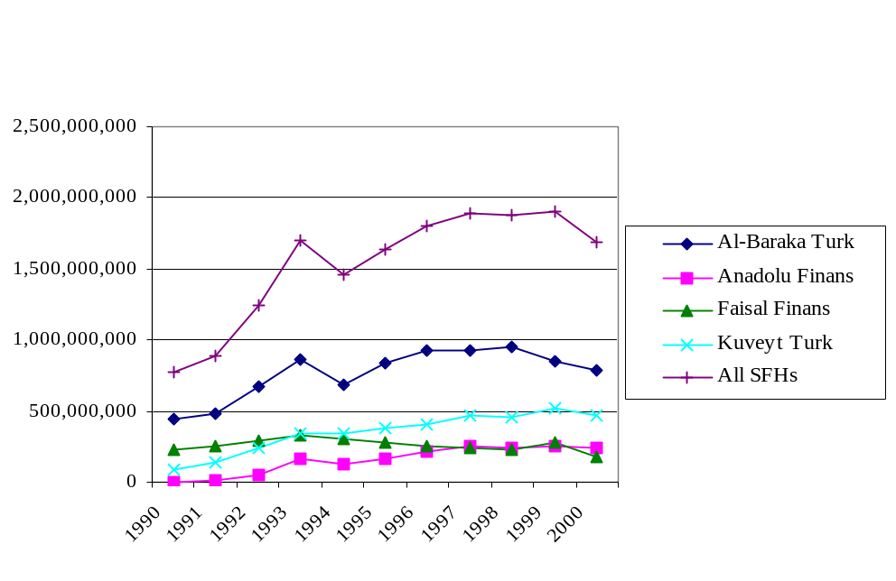
‘All SFHs’ excludes Ihlas Finance House and Asya Finance House

Figure 2: Average Asset Size of Banks in 2000

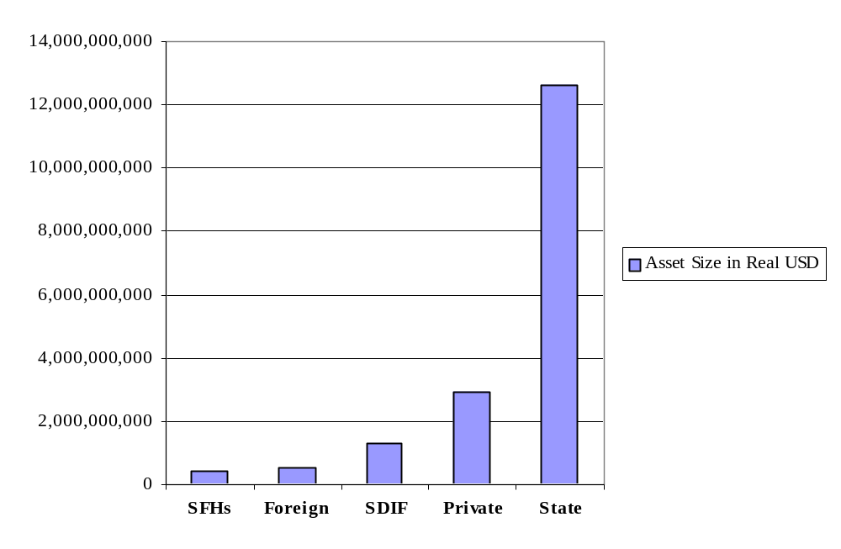

The share of SFHs in total assets, and the average sizes of SFHs more generally, were very small compared to conventional banks. But the small shares and sizes are mostly due to SFHs being new, as well as their small numbers of branches. In this regard, it is worthwhile noting that Turkish banking is heavily branch-based. In addition, SFHs were officially limited to opening ten new branches each year, at most. Even though SFHs’ shares in total assets has been low, their impact on financing real transactions was disproportionate to their assets, since their total loans to total assets ratio reached 76%, compared with 33% for their conventional counterparts, in 2000.
On the other hand, the maturity structure of deposits at SFHs is similar to that at conventional banks, concentrating mainly on short-term funds mobilization. Figure 3 shows the maturity structure of participation accounts. This structure, in turn, gives SFHs a disadvantage in terms of profitability, due to the longer-term nature of their higher-yield assets. In contrast, conventional banks were able to invest in high-yield (due to astronomical inflation rates) short-term government papers or repos, which SFHs were unable to hold as assets.
SFHs’ deposit share was 2.7% in the banking system in year 2000. Taking into account that the target of SFHs is to reach at least 15% (approximately $15 billion) of all deposits in the country, SFHs have not been very successful in attaining this goal. On the other hand, SFH deposits increased significantly after the mid-90s, with the entrance of Ihlas Finance House and Asya Finance House, both of which pursued aggressive branching throughout the country. Fig. 4 shows the deposit growth of SFHs for years 1990-2000, excluding Ihlas Finance House and Asya Finance Houses’ deposit shares.

Figure 3: Maturity of Deposits at SFHs in 2000

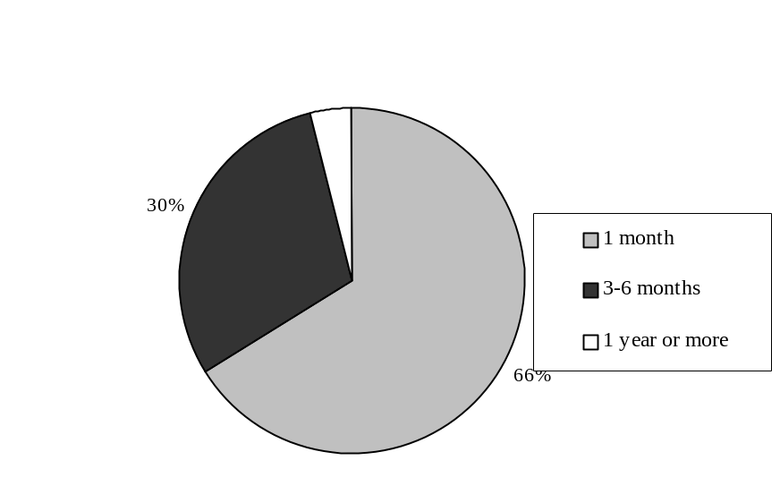

Figure 4: Total Deposit Growth of SFHs (1990-2000)

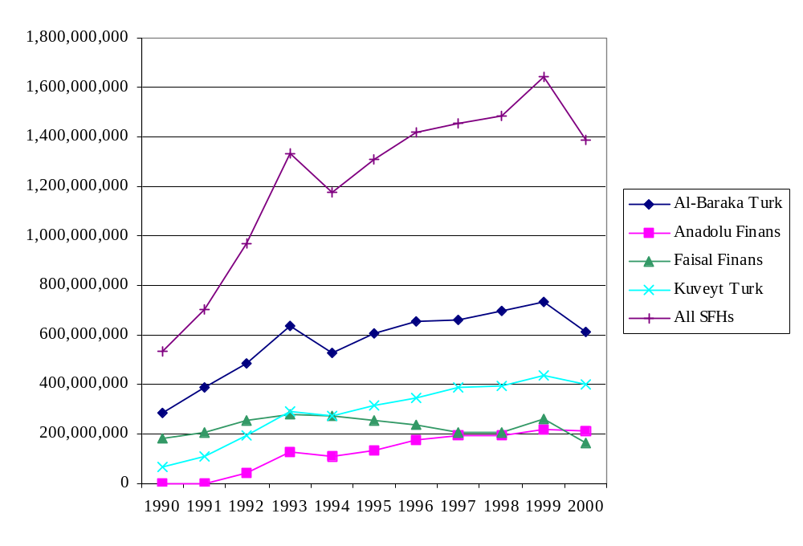

Table 1 provides a summary of some other comparative indicators for the relative sizes of operation of SFHs and their conventional counterparts in Turkey at the end of the past decade.
Table 1: Turkish Banking at a Glance

 | 1990 | 2000
Conventional Banks
Number of Banks | 66 | 79
Number of Branches | 6,560 | 7,837
Number of Employees | 154,089 | 170,401
Shares in Sector
Total Assets | $ 58.1 billion | $ 155.2 billion
Total Deposits | $ 32.6 billion | $ 101.9 billion
Total Loans | $ 27.3 billion | $50.9 billion
Special Finance Houses
Number of SFHs | 3 | 6*
Number of Branches | 21 | 143*
Number of Employees | 640 | 2998*
Shares in Sector
Total Assets | $ 663 million | $ 3.374 billion*
Total Deposits | $ 459 million | $ 2.774 billion*
Total Loans | $ 458 million | $ 2.570 billion*
* Including Ihlas Finance and Asya Finance House which are not studied in this paper
Source: BRSA 2000 and authors’ own calculations for SFHs 1990 values

IV. Study of Efficiency Analysis

El-Gamal and Hulusi (2002) conducted a stochastic frontier analysis (SFA) of Turkish banking for the decade 1990-2000. SFA comprises estimation of a best-practice frontier, and comparison of the individual firms with that frontier. We assumed in that study that each bank attempted to maximize output (loans) for any given level of inputs. In other words, profit maximization of the banks was modeled as cost minimization for any given level of output, and the production technology of banks can be represented by a dual cost function. The estimated cost function represents the minimum expenditure needed to produce a given output with given input prices. Bank inefficiency is then measured by the difference between each bank’s realized costs of production, and the theoretical minimum at the estimated frontier. Although conventional banks are multi-product firms, we were concerned in that study with a single output: loans. We focused on this one output since the SFHs in our sample issued virtually no securities during our sample period. Moreover, SFHs did not distinguish between short- and long-term loans, and thus we considered aggregated loans as the single output of the banks in our sample.
The cost frontier was obtained by estimating a cost function with a composite error term:

… (1)

where: C_{it} is the observed cost of bank i in period t, y_{it} is its output,
P_{it} is a vector of input prices
q_{it} is a quality index
r_{it} is a risk index
B is a vector of parameters
v_{it} is an i.i.d. 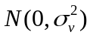 error term
u_{it} is an i.i.d. 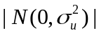 (inefficiency) error term

We measured total cost as the sum of weighted interest expense and employee and fixed assets expenses. We followed the recommendation of Mester (1996) by weighting interest expense with the ratio of loans/total earning assets, to account properly for interest expenses if the only output is loans. The prices of inputs were approximated by dividing the related input expenses by the input levels. In our case, the price of labor P₁ was calculated as total employee expenses divided by total number of employees; the price of borrowed capital P₂ was calculated as weighted interest expense divided by total borrowed funds; and the price of physical capital P₃ was calculated as fixed asset expenses (depreciation and amortization) divided by total fixed assets. Utilizing the El-Gamal and Grether (1995) estimation classification procedure and a translog cost function specification, we obtained an endogenous (data-driven) classification of Turkish banks into two groups. The data-driven classification was mainly along the small and foreign (all but two of which were in Group 2) vs. domestic (Group 1) dimension. Group 1 consisted of forty institutions, four of which are the SFHs in our sample.
Surprisingly, the SFHs claimed the top ranks among the 40 institutions in Group 1, mainly due to their relatively low ratios of non-performing loans. The average inefficiency score (smaller is better) for SFHs was 1.13, which is the smallest in the sector, compared to a high of 1.82 for SDIF banks. Fig. 5 illustrates the average inefficiency scores for different types of banks in the estimated Group 1. Table 2 shows the rankings of the SFHs in Group 1.

Table 2: Ranking of SFHs

 | Asset Size | Inefficiency Score | Rank
Faisal | 181,852,962 | 1.1036 | 1
Al-Baraka | 790,351,206 | 1.1068 | 2
Kuveyt-Turk | 472,856,200 | 1.1442 | 6
Anadolu | 242,328,134 | 1.1454 | 8

Figure 5: Average Inefficiency Scores

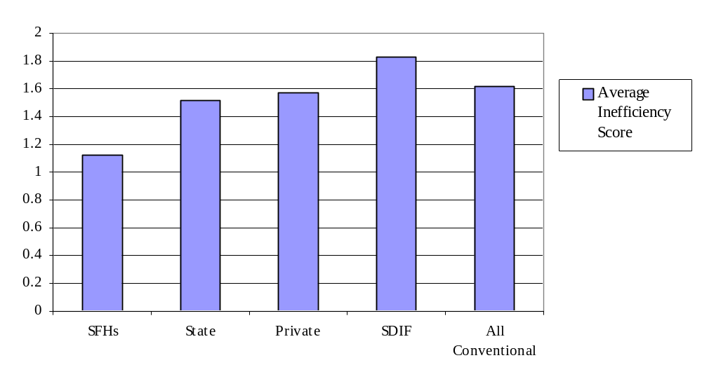

V. Explaining SFH Rankings with Financial Ratios

To explain the high rankings of SFHs within their group of banks, and how all non-foreign banks compared to the latter, which were classified to a different group, we provide some intuitive analysis based on familiar financial ratios.
The soundness of a bank should first be investigated in terms of its capital adequacy ratio. We used the leverage ratio (which does not weight the assets for default risk) as a proxy for capital adequacy to compare SFHs with conventional banks. The leverage ratio is calculated by dividing equity capital by total assets. Figure 6 shows the trends of leverage ratios. SFHs seem to have been less capitalized than both domestic and foreign conventional banks, even though SFHs increased their equity capital once they were made subject to the banking law. The reason for the later increase in equity capital for domestic conventional banks can be explained by failed banks (SDIF) restructuring program and their receipt of significant capital injections after being taken-over by the state.

Figure 6: Equity Capital/Total Assets

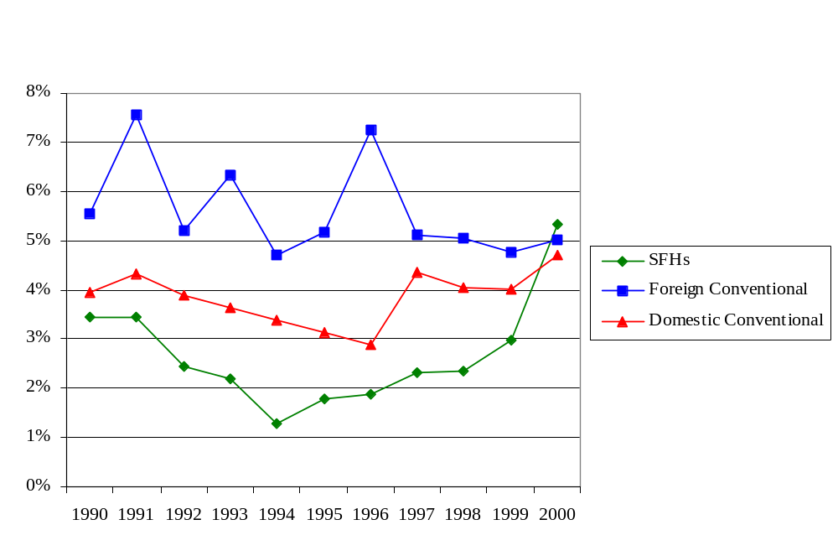

After checking the soundness of a bank, asset quality is the second concern. A standard measure for asset quality is the loans-to-assets ratios, analyzed in Figure 7. This ratio was significantly different across bank-types, ranging from an average high of 70% for SFHs to an average low of 30% for foreign conventional banks, which reached a minimum of 18% in 2000. This reluctance of conventional banks to make loans is explained by the relative profitability of borrowing abroad and investing the funds in high-interest-paying government bonds. This trend will become even more apparent when we analyze liquidity ratios.

Figure 7: Total Loans/Total Assets

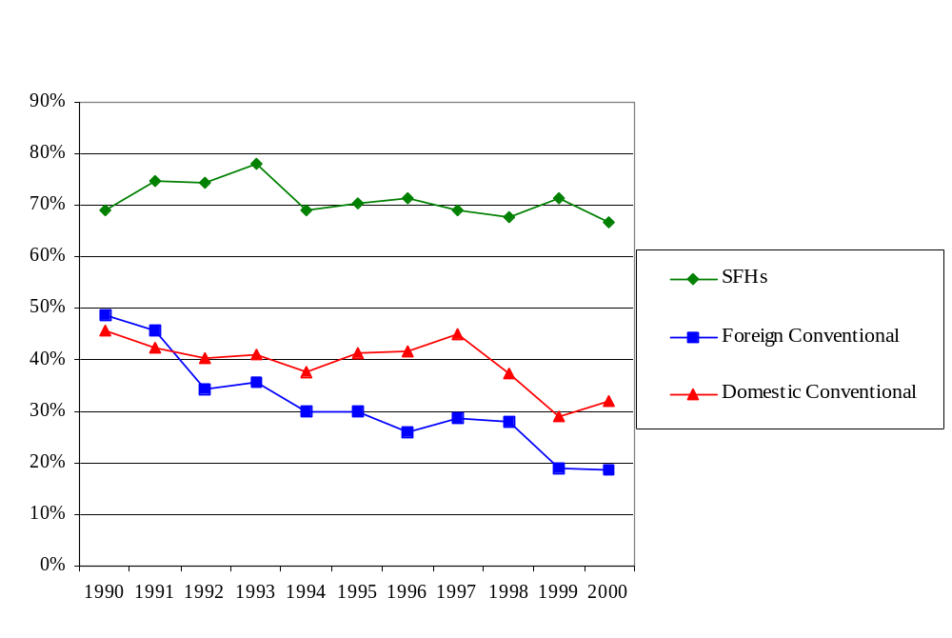

Having investigated the loans-to-assets ratio, we now turn to loan quality by investigating the ratio of non-performing loans to total loans (NPL/TL). We can see in Figure 8 that the average ratio of NPL/TL increased steeply for all banks toward the end of our sample period. This increase is particularly marked for domestic conventional banks. The latter included SDIF banks, for which the ratio of non-performing loans reached a staggering 77% by 1999. On the other hand, this sharp increase may be attributed in part to the adoption of the best accounting practices after those banks were taken over by the state, thus recognizing many previously hidden non-performing loans.
Following the 1994 financial crisis, foreign banks showed the highest non-performing loans ratio in the sector, which drove them in later years to reduce their exposure to borrower-credit risk, as shown in Figure 7. Their success in achieving the lowest non-performing loans ratio in later years may thus be attributed to this reluctance to extend loans after that date. In contrast, SFHs seemed to continue to extend loans, resulting in an upward trend in their non-performing loans ratio following the 1994 crisis. Thus while other banks reduced their extension of credit in fear of default, SFHs were unable to mimic them and invest mainly in government treasury bonds, and hence continued to extend credit despite the tough financial environment.
Figure 8: Non-Performing Loans/Total Loans

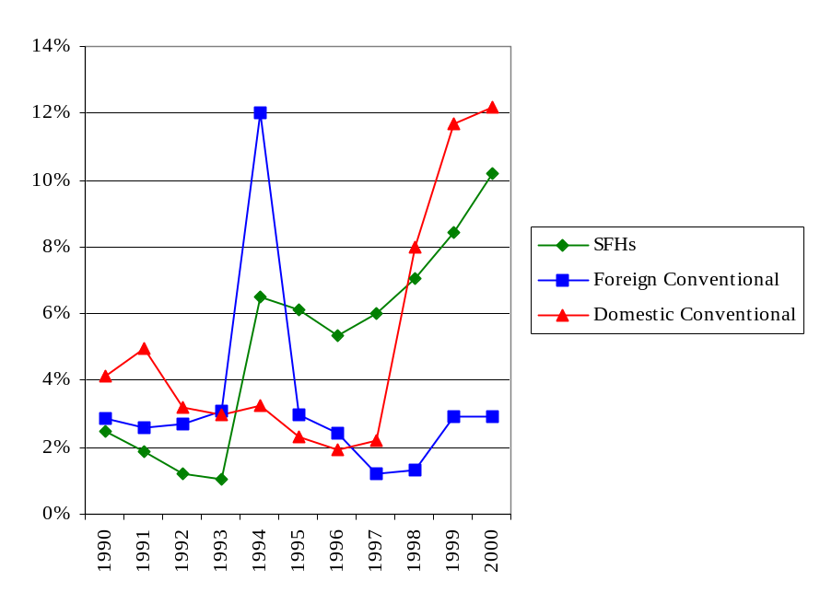

To study management-efficiency, we consider the ratio of employee expenses to total assets. This ratio seems to have declined for conventional banks, and to have slightly increased for SFHs, leading to convergence between the two groups around 2000. The secular decline for conventional banks reflects the overall decline in bank-employment over the studied period. On the other hand, the increase in SFH employment expenses reflects the increase in branching from the mid-1990s. The earliest SFHs (Al-Baraka Turk, Faisal Finance and Kuveyt-Turk Finance House) were originally capitalized by Gulf-country owners who resisted opening many branches. However, as the domestically-owned Ihlas Finance House and Asya Finance House entered the Islamic finance market, and pursued aggressive branching strategies in 1995 and 1996, respectively, the older SFHs responded accordingly.

Figure 9: Employee Expenses/Total Assets

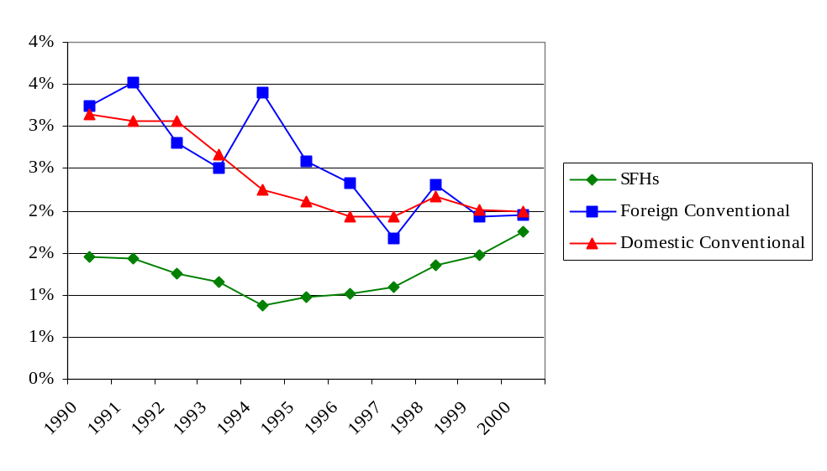
Turkish banks’ bad loans and maturity mismatch losses are illustrated clearly by their earnings performance, as shown in Figure 10. Both the ROE (return on Equity) and the ROA (Return on Assets) profitability ratios are very low. SDIF banks’ consistent losses make the average return for domestic conventional banks negative, while foreign conventional banks and SFHs managed to sustain profitability, with foreign banks being the most profitable in the sector.

Figure 10: Net Income/Total Assets

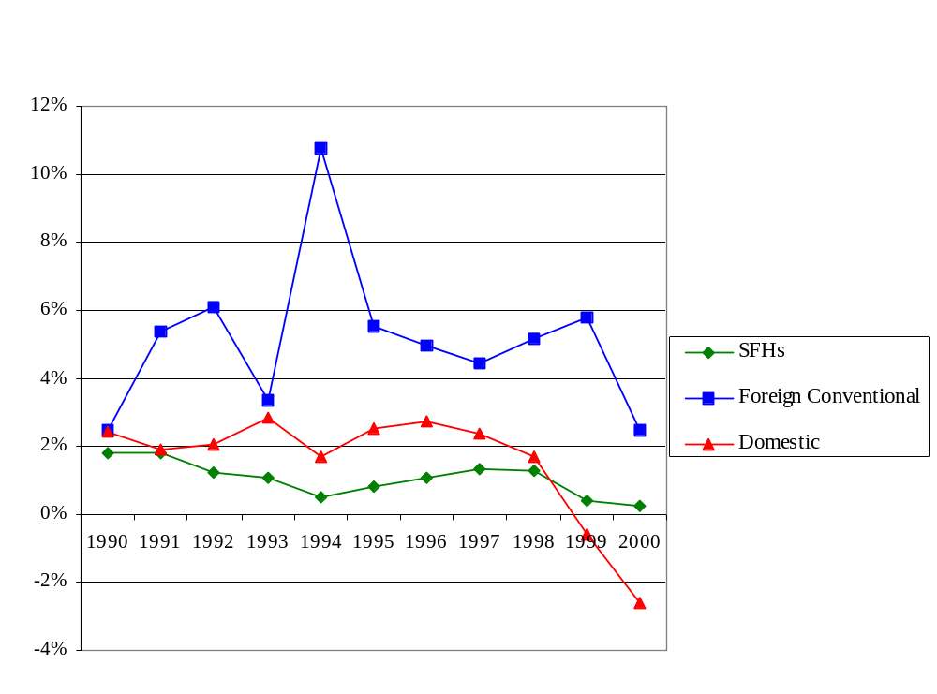

The relatively poor performance of SFHs relative to foreign banks may be explained by their lack of liquidity. Liquid assets are defined as vault-cash, cash at the Central Bank and other banks, securities, and reserve requirement. SFHs had the lowest levels of liquidity mainly due to their inability to invest in government. In contrast, foreign conventional banks maintained the most liquid assets since they refrained from extending loans and mainly utilized funds, transferred from abroad, to buy high yielding government papers. Although domestic conventional banks tried to replicate the foreign banks’ strategies, they were not as successful as their foreign counterparts, due to poorer access to foreign funds. Most of the liquid assets held by the SFHs in our sample consisted of the obligatory 10% cash holdings stipulated in their banking law.

Figure 11: Liquid Assets/Total Assets

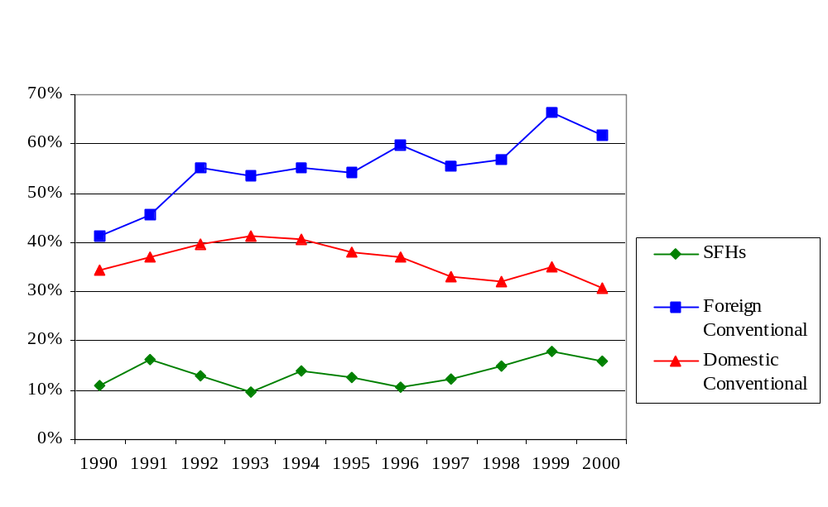

VI. Conclusion

In this paper, we analyzed the dual banking system in Turkey and investigated the relative efficiency position of Islamic banks (labeled as “Special Finance Houses” in Turkey) for the 1990-2000 period. We compared the efficiencies of 49 conventional banks with 4 special finance houses (SFHs), as estimated in the Stochastic Frontier Analysis of El-Gamal and Inanoglu (2002). Our results indicate that while SFHs were a relatively new participant in the Turkish banking sector, comprising only three percent of the sector in the past decade, they seemed relatively efficient using the conventional banking technology. The SFHs’ relative efficiency was best explained by their emphasis on Islamic asset-based financing, which led to lower non-performing loans ratios.
It is worth indicating that SFHs reached such high efficiency levels despite the limitations imposed by their banking law (e.g., branching restriction provisions), as well as self-imposed restrictions (e.g., inability to hold government bonds). This suggests that Islamic banks did not have a negative effect on the financial sector, even if they drew funds away from conventional banks. To the extent that they also helped to mobilize funds that are otherwise hoarded outside the formal financial sector, they may play a valuable role in the economies of countries with large Muslim populations.

References

Agaoglu, EA. “A CAMEL-wise comparative financial and market share analysis of the Islamic banks currently operating in Turkey.” Middle East Technical University Studies in Development 21.4 (1994): 475-500
Aggarwal, RK and T Yousef. “Islamic Banks and Investment Financing.” Journal of Money, Credit and Banking 32.1 (2000): 93-120.
Al-Deehani T, RA Abdelkarim and V Murinde. “The Capital Structure of Islamic Banks under the Contractual Obligation of Profit Sharing.” International Journal of Theoretical and Applied Finance 2.3 (1999): 243-283.
Altunbas, Y, L Evans, and P Molyneux. “Bank ownership and Efficiency.” Journal of Money, Credit and Banking 33.4 (2001): 926-954.
Bashir, Abdelhameed M. “Risk and Profitability Measures in Islamic banks: The Case of Two Sudanese Banks.” Islamic Economic Studies 6.2 (May 1999): 1-24.
Battese, GE and TJ Coelli. “Frontier Production Functions, Technical Efficiency and Panel Data: With Application to Paddy Farmers in India.” Journal of Productivity Analysis 3.1-2 (1992): 149-65.
Brown, J.A. and D. C. Glennon. “Cost Structures of Banks Grouped By Strategic Conduct.” Applied Economics 32 (2000): 1591-1605.
BRSA. Towards a Sound Turkish Banking Sector. Ankara: Banking Regulation and Supervision Agency, 2001.
BRSA. Banking Restructuring Report. Ankara: Banking Regulation and Supervision Agency, 2001.
El-Gamal, M. and D. Grether. “Are People Bayesian? Uncovering Behavioral Strategies.” Journal of the American Statistical Association (Applications and Case Studies) 90.432 (December 1995): 1137-1145.
El-Gamal, M and H Inanoglu, “Efficiencies and Unobserved Heterogeneity in Turkish Banking: 1990-2000.” Houston: Rice University Economics working paper, October 2002.
Elyasiani, E and R Rezvanian. “A Comparative Multi-Product Cost Study of Foreign-Owned and Domestic-Owned U.S. Banks.” Applied Financial Economics 12 (2002): 271-284.
Isik, I and MK Hassan. “Technical, Scale and Allocative Efficiencies of Turkish Banking Industry.” Journal of Banking and Finance 26 (2002): 719-766.
Iqbal, Munawar. “Islamic and Conventional Banking in the Nineties: A Comparative Study.” Islamic Economic Studies 8.2 (April 2001): 1-27.
Mester, Loretta J. “A Study of Bank Efficiency Taking Into Account Risk-Preferences.” Journal of Banking and Finance 20 (1996): 1025-1045.
Samad, Abdus. “Comparative Efficiency of the Islamic Bank Vis-à-vis Conventional Banks in Malaysia,” IIUM Journal of Economics and Management 7.1 (1999): 1-25.

A Capital Adequacy Framework for Islamic Banks
The Need to Reconcile Depositors’ Risk Aversion with Managers’ Risk Taking

Maximilian J.B. Hall*, Humayon A. Dar†, and Dadang Muljawan‡

Abstract

Conceptually, an Islamic bank has an equity-based capital structure, dominated by shareholders’ equity and investment deposits based on profit-and-loss sharing (PLS). There is no need for capital adequacy regulations if the Islamic banks are structured as pure PLS-based organizations. However, due to informational asymmetry and risk aversion by investors, there currently exist fixed claim liabilities on the Islamic banking balance sheets. This necessitates the imposition of capital adequacy requirements, which aim at maintaining systemic stability by achieving two fundamental objectives. First, capital regulations should protect risk-averse (assumed unsophisticated) depositors. This requires a minimum equity capital cushion and an optimal assets-liabilities composition. Second, capital regulations should give the right incentives to shareholders to promote prudent behavior by the banks. This requires analysis of the effect of financial participation by shareholders on Pareto optimality, and analysis of potential behavior by shareholders when facing financial uncertainty. This paper combines modern banking theory and principal-agent analysis to develop a framework for an optimal capital structure for Islamic banks. The proposed capital regulation includes a minimum risk-based equity capital cushion (as required under the Basel Accord), a prudent assets-liabilities (capital) structure (i.e., appropriate proportions of PLS- and non-PLS-based assets and liabilities) and a minimum “financial participation” requirement. We infer from the analysis that such capital adequacy requirements will improve the soundness of current Islamic banking practice, thus paving the way for the wider use of PLS by Islamic banks in the long run.

I. Introduction

Capital adequacy has become one of the most important indicators for assessing the soundness of banking operations. Due to its importance, the western banking system has already established internationally-recognized capital regulations, which are formulated by the Basel Committee on Banking Supervision. In its latest form (Basel Committee, 2001), the Basel Capital Accord covers not only the calculation of capital adequacy ratios but also other supporting issues, like sound supervisory processes and market discipline.
Many steps have in the recent past been taken to devise an appropriate framework for the capital regulation of Islamic banks. The Accounting and Auditing Organization for Islamic Financial Institutions (AAOIFI) released a statement on the purpose and calculation of the capital adequacy ratio for Islamic banks in 1999, although the concept seems to need continual review. Khan and Chapra (2000) have also proposed a fundamental approach to capital adequacy for Islamic banks. Following up on the previous research, this paper combines western banking theory on capital regulation with an analysis of principal-agent relationships to develop new proposals for the capital regulation of Islamic banks.
The paper proceeds as follows. The next section reviews the Basel Committee’s capital regulations and the current approaches adopted toward the capital regulation of Islamic banks. Section 3 proposes a new approach for the capital regulation of Islamic banks. This section includes the analysis of principal-agent relationships and the potential moral hazard faced by the shareholders. Section 4 concludes the paper.

II. Review of Existing Capital Regulations

A. Capital Regulation in Western Banking Systems
Prudential banking regulation is needed to deal with imperfect consumer information and agency problems where they exist. Llewellyn (1999b) mentions three particular elements for robustness while referring to the ability of the financial system to remain stable and efficient under a wide range of market conditions and shocks. First, the financial system should be able to accommodate any change in the system as the market alters (flexibility). Second, the financial system should have a capability to overcome any financial turbulence caused by external shocks, including macroeconomic instability (resilience). Third, the financial system should also have internal stability. Capital regulation is designed to enhance the capability of individual banks to absorb temporary financial shocks. The soundness of capital structure can also induce prudent behavior by the bank since the shareholders can reasonably expect positive future cash-inflow without the bank taking excessive risks (Milne and Whalley 2001).
The current capital regulations for western banks are outlined by the Basel Committee on Banking Supervision in the Basel Capital Accord of 1988, as subsequently amended (see Hall, 2001 for a review of its evolution). Recently, the Committee has released a consultative document concerning its proposal for a New Basel Capital Accord. It covers three mutually reinforcing areas, the so-called “pillars,” comprising: (i) minimum capital requirements; (ii) the supervisory review process; and (iii) market discipline. The first pillar reviews the calculation of minimum capital requirements and technical issues leading to the capital adequacy requirements. The second pillar establishes key principles designed to ensure an efficient supervisory process. The third pillar reviews minimum disclosure requirements necessary to enhance market discipline (for full details, see Basel Committee, 2001, and for an assessment, see Hall, 2001).
As discussed by Dewatripont and Tirole (1994b) and Hall (2001), the Basel Committee adopts the Cooke ratio as a common measure of solvency. The Cooke (Risk Asset Ratio (RAR)) ratio is defined as:

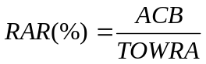
… (1)
where ACB and TOWRA are the adjusted capital base and the total of weighted risk assets.
The regulation requires the RAR to be equal to at least 8% of total assets, after applying risk-weighting coefficients to the assets, on- and off-balance-sheet. The U.S. banking system, meanwhile, also adopts a regulatory regime of “prompt corrective action” when dealing with ailing banks (Fries et al., 1997). The regime implies the allocation of control to shareholders if the bank performs well and to debt-holders if the bank performs otherwise. The Committee, however, continuously reviews the more sophisticated Cooke ratio to take into account other factors that influence the realistic valuation of the bank’s assets.
The proposed New Accord will be applied on a consolidated basis to the internationally-active banks. The purpose of the consolidation is to capture financial risk throughout the whole business group that engages in banking activities. The consolidation process includes majority-owned banking, securities and other financial entities.
The New Accord also provides a range of options for the assessment of capital adequacy. The banks are required to have more advanced (i.e., “internal ratings-based”) risk management capabilities if they wish to use the more advanced credit risk assessment methodologies. The internal risk management process is subject to supervisory review and intervention. A new set of disclosures and recommendations is also standardized to allow other market participants to assess critical information about the risk profiles and capital adequacy of banks.

B. The Existing Capital Regulation for Islamic Banks

1. The Existing Capital Regulation for Islamic Banks
An Islamic bank uses various types of financial contracts. Exhibit 1, section (a) shows three types of deposits on the liabilities side of an Islamic bank: non-investment deposits [SA]; unrestricted profit-sharing investment deposits [PSLA^{U}]; and restricted profit-sharing investment deposits [PSLA^{R}]. Islamic banks guarantee the principal amount of deposits and share any monetary surplus with the SA, while they share the profit or losses with the PSLA^{U}. Islamic banks provide only administrative services to the PSLA^{R} since the depositors are themselves actively involved in investment decision-making. This demonstrates that Islamic banks perform fiduciary and agency roles at the same time.
Islamic banks should maintain their repayment capabilities for the risk-averse depositors, and deliver the highest monetary return possible to the risk-taking investors. However, the proportion of PSLA^{U} to total assets varies depending upon the preferences of the investors; the higher the proportion of PSLA^{U}, the more significant the agency role undertaken (i.e., the PSLA^{U} give full authorization to the bank to take all decisions relating to the investment process). On the contrary, the higher the proportion of SA, the more significant the fiduciary role undertaken (i.e., the bank should strive to maintain the value of the SA first and foremost). The capital regulations for Islamic banks should be capable of enhancing the fiduciary roles performed for risk-averse depositors, and the agency roles performed for risk-taking investors.
Exhibit 1: Relationships within an Islamic Banking System

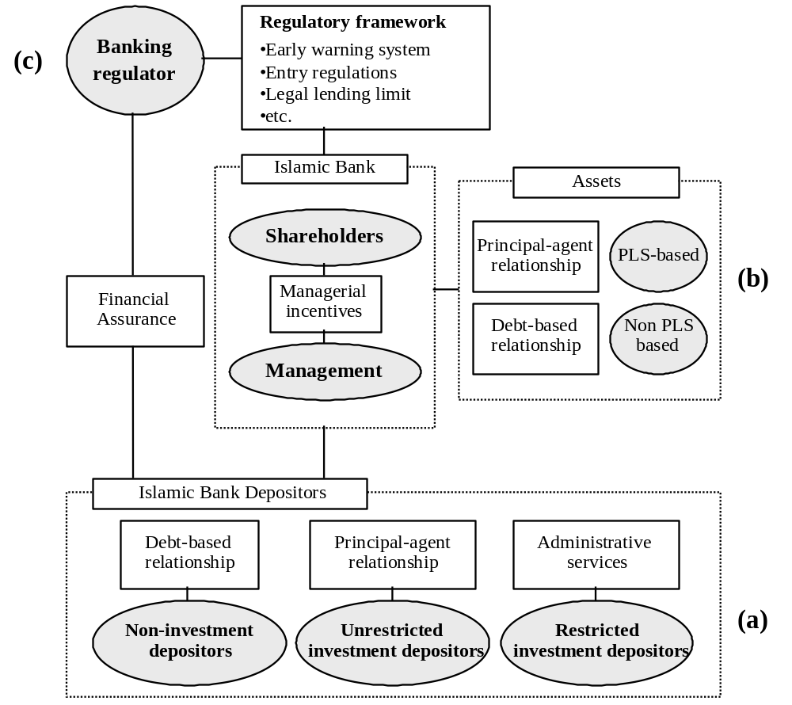

Exhibit 1, section (b) shows various types of investment on the assets side of an Islamic bank. These investments can be classified into PLS- and non-PLS-based investments. Mudaraba and musharaka modes of financing can be classified as PLS-based investments (PLSI), while murabaha, ijara and salam can be classified as non-PLS-based investments (MUI-denoting mark-up-based investments). In practice, there also exist hybrid-types of investment (HYBI) that combine the two basic modes of finance (i.e., some part of the claims is fixed and some part is variable), for example, lending money with a guarantee on the repayment of principal but also sharing the profits. Individual Islamic banks select their preferred compositions of assets. (For more details about the variety of permissible Islamic investments, see Haron and Shanmugam 1997; Errico and Farahbaksh 1998; and Haron 1997.)
Exhibit 1, section (c) shows the pivotal position of the banking regulator, who is trying to ensure the sustainability of the savings/investment process. The regulations implemented should be able to provide the right incentives and protection for all market players to induce them to behave prudently. Besides designing a proper set of financial ratios for capital regulation, the regulators of Islamic banks should also consider adopting the second and third pillars of the Basel Committee’s new capital accord to empower the supervisory process and to improve transparency in the banking system.

2. The AAOIFI’s Approach to Capital Regulation
The existence of Profit Sharing Investment Accounts (PSIA) raises some fundamental issues in calculating the Capital Adequacy Ratio (CAR) for an Islamic bank. The basic issue surrounds the possibility of including PSIA as a component of capital because they have a risk-absorbing capability. In this respect, the AAOIFI’s Discussion Memorandum on the Calculation of the Capital Adequacy Ratio for Islamic Banks (issued in January 1998) is relevant. This document tries to design a capital adequacy framework for Islamic banks within the Basel’s capital adequacy framework. Following this, the AAOIFI issued the Statement on the Purpose and Calculation of the Capital Adequacy Ratio for Islamic Banks in March 1999. According to this statement, Islamic banks’ own capital is exposed to normal commercial risk, fiduciary risk and displaced commercial risk, implying that these types of risk should underlie the design of the capital regulations. It proposes three things. First, that there should be no inclusion of PSLA in the risk-bearing capital. Second, that all assets financed by debt-based liabilities and own-equity should be included in the denominator of the CAR. And, third, 50% of PSLA-financed assets should be included in the denominator of the CAR. The last measure is needed to cover possible losses arising from misconduct or negligence in investment activities. Thus:

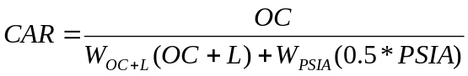
… (2)
where OC is the bank’s own capital; L represents its non-PLS-based deposits; W_{OC+L} represents the average risk weight for assets financed by OC and L; and W_{PSLA} represents the average risk weight for assets financed by PSLA. Like the Basel standards, the AAOIFI standard requires the CAR to be at least 8%.

III. The Proposed Capital Adequacy Regulation for Islamic Banks

1. A Critique of the AAOIFI’s Approach
Although significant efforts have been made to design a more appropriate capital regulation for Islamic banks, there are a number of criticisms to be addressed. First, the existing capital adequacy ratio developed by the AAOIFI is only designed to assure a given level of solvency and ignores the agency roles performed by Islamic banks and the principal/agent relationships involved. Second, there has been an inconsistency in defining the restricted-investment deposits. According to the international accounting standard developed by the AAOIFI (AAOIFI, 1997), PSLA^{R} deposits cannot be recognized as liabilities of Islamic banks and should not be reflected on the banks’ statement of financial position. This is because the depositors are highly involved in investment decisions. Thus, it can be argued that PSLA^{R}-financed assets should be excluded from the risk-weighted assets in the denominator of the CAR. Yet in the CAR, no distinction is drawn between PSLA^{R} and PSLA^{U}. (From now on, we exclude PSLA^{R} from the analysis.) And third, the possibility of a bank facing “an abnormal risk” arising from a managerial dispute (i.e., where the PSLA^{U} depositors consider that a bank has neglected or breached the contract agreed upon) should be seen as legal risk, which ideally requires a case by case approach being taken (i.e., depending on the terms used in the contract). In this case, the banks should be able to identify the difference between deposits taken on a pure PLS basis and those representing a hybrid contract. Deposits with any potential claim (partly) should be classified as hybrid-based deposits. Exhibit 2 shows the differing expectations of different types of depositors, and the corresponding bank roles in investment decision-taking.

Exhibit 2: The Expectations of Different Types of Depositors and the Corresponding Bank Role in Investment Decisions

 | Types of depositors | Depositors’ expectation | Bank’s role
Saving/current depositors | - Risk averse  - Unsophisticated | Repayment guarantee (principal) with a moderately high monetary return | Full authorization to manage the funds
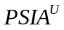 depositors | - Risk taking  - Unsophisticated | A high monetary return and a possibility of facing financial losses | Full authorization to manage the funds
 depositors | - Risk taking  - Sophisticated | A high monetary return and a possibility of facing financial losses from a preferred investment | A limited level of authorization to manage the funds

In practice, Islamic banks may have different proportions of PSLA^{U} in their balance sheets. The variability of the PSLA^{U} proportion is simulated in the following analysis (see Appendix A for the underlying assumptions used and for full details). Exhibit 3, section (a) shows the ratio of OC to PSLA^{U} as a function of the percentage of PSLA^{U} to total assets [TA]. This indicates that Islamic banks which have a higher proportion of PSLA^{U} within their assets will have a lower proportion of OC to PSLA^{U}.

Exhibit 3 (a): Proportion of  to as a Function of the Ratio of to 

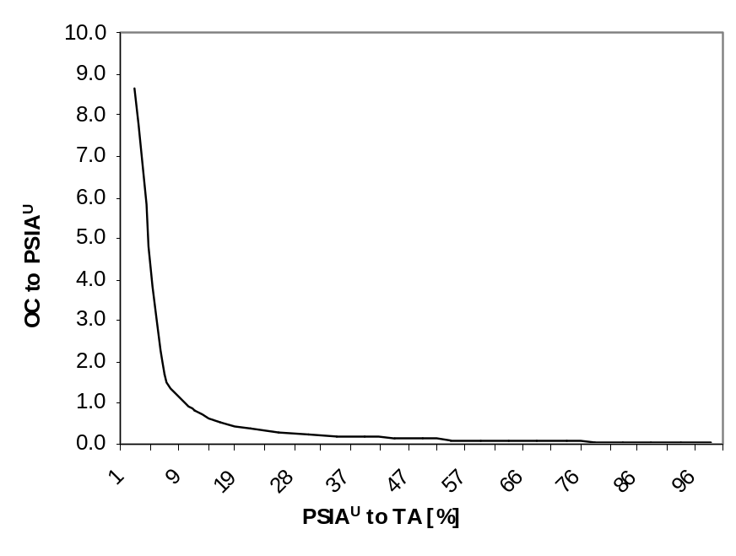

Exhibit 3 (b): Relative Agency Cost as a Function of the Ratio of to

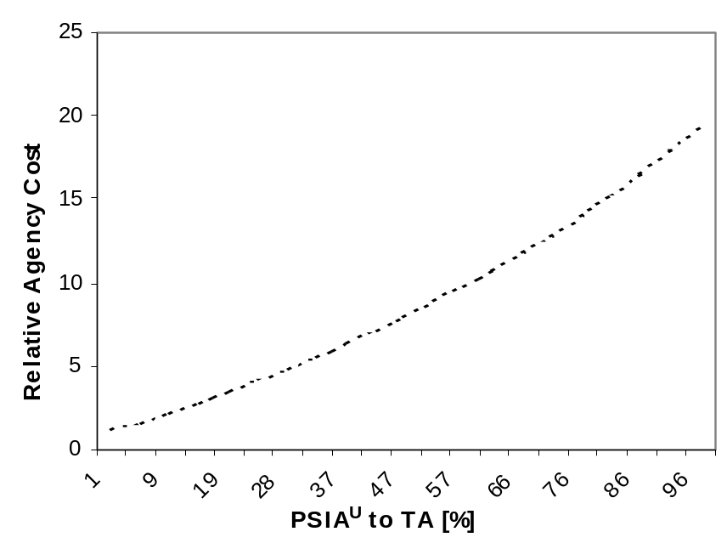
Data source: Exhibit A.1 in Appendix A

Exhibit 3, section (b) shows the relative agency (i.e., monitoring) cost (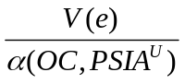) as a function of the percentage of PSLA^{U} to TA. This indicates that a higher level of relative agency cost is associated with a higher proportion of PSLA^{U} to TA as the latter implies lower monetary surplus for shareholders. A high level of relative agency cost thus implies a high probability that shareholders will exert less effort (e) to supervise the bank and instead, allocate their funds to a more profitable investment.
Khan and Chapra (2000) suggest the adoption of separate capital adequacy standards for SA and PSLA^{U}. They argue that such a separation of capital requirements would enhance comparability, transparency, market discipline, depositor protection and systemic stability. Furthermore, they mention the possibility of either keeping the demand deposits in a trading book, or pooling the investment deposits in a securities subsidiary. This suggestion, basically, expresses two important things. First, the need for a reliable accounting system that is able to prevent a potential dilution between fiduciary roles and agency roles. And second, the need to promote a system that will be able to accommodate different types of customer preferences without jeopardizing systemic stability.

2. Possible Improvements: Enhancement of Fiduciary Roles
- Prudent Financial Structure
The assets and liabilities structure is an important feature of a prudent financial structure. Fulfilling the accounting principle that total assets must be equal to total liabilities, the total value of PLS_{t}, HYB_{t}, and MU_{t} (i.e., the values of PLS-based, hybrid, and mark-up-based assets, respectively) is equal to the total of equity-based capital [EC_{t}] and debt-based capital [DBC_{t}] in period t, i.e.,
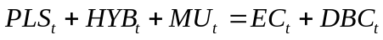
… (3)
Therefore, the total cash flow of PLS [ΔPLS_{t+1}], hybrid [ΔHYB_{t+1}] and markup-based assets [ΔMU_{t+1}] in the period t+1 is equal to the total cash flow of equity-based capital [ΔEC_{t+1}] and debt-based capital [ΔDBC_{t+1}] in period t+1. That is,

… (4)

where:

,
,
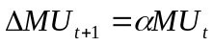, : Average rate of mark-up,
, and

In an adverse condition when total cash flow is negative, risk-averse depositors (fixed claimant and hybrid deposit holders) receive nothing, i.e., 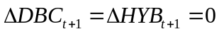. In order to prevent insolvency, the negative cash flow should be less than the equity-based capital, i.e.,

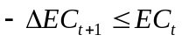
… (5)
Plugging the value of ΔEC_{t+1} from Equation (4) into Equation (5) yields:

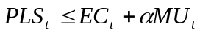
… (6)

In an Islamic bank, collateral is applied to ensure repayment of the debt-based assets and to avoid contractual breaches in PLS contracts, with the consequence that the monetary surplus of the hybrid assets and the total value of the PLS-based assets are not also considered as liabilities. Therefore, in order to implement a prudential banking operation and to ensure the sustainability of the banking operations, the value of PLS_{t} should not exceed the total value of EC_{t} plus the expected monetary surplus of the markup-based assets [αMU_{t}] (as shown by Equation (6) above).

- Minimum Level of Net Worth
A requirement for a minimum level of net worth (financial cushion) to enhance the capacity of a bank to maintain its solvency when facing temporary financial shocks has been adopted widely by Islamic banking regulators in many countries. However, the calculation of the CAR should only include the assets financed by debt-based liabilities and own capital. In other words, the capital adequacy ratio should be calculated as follows:

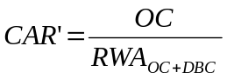
… (7)
where RWA_{OC+DBC} is the value of the risk weighted assets financed by OC and DBC. Subject to this caveat, the regulators should adopt the same methodology used by the Basel Committee.

3. Possible Improvements: Enhancement of Agency Roles
- Minimum Level of Net Worth and Shareholder Value
The requirement for a minimum financial cushion is aimed at protecting the risk-averse depositors. This is also expected to enhance the agency role of Islamic banks, as explained below. In an Islamic bank, the level of OC is not the only factor determining shareholder value. The PSLA^{U} also proportionally affect shareholder value. The higher the proportion of PSLA^{U} in total deposits, the higher the financial buffer for the bank; but, at the same time, the shareholders enjoy a lower level of earnings. Shareholder (deterministic) value is thus directly proportionate to the level of financial participation; 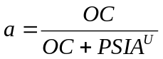. If SA is dominant (a ≈ 1) in the deposit mix, the shareholder value resembles that of a western bank. If the net worth of the bank is negative (i.e., OC plus PSLA^{U} is negative), the bank is operated under the threat of liquidation by the banking regulator. In the liquidation process, the shareholders and equity-based depositors receive nothing. The savings depositors receive their financial claims in full (government deposit insurance arrangement) and the financial guarantor pays the difference between the claimed value and the real asset value of the bank.

Exhibit 4: Absolute Risk Aversion as a Function of the Net Asset Value

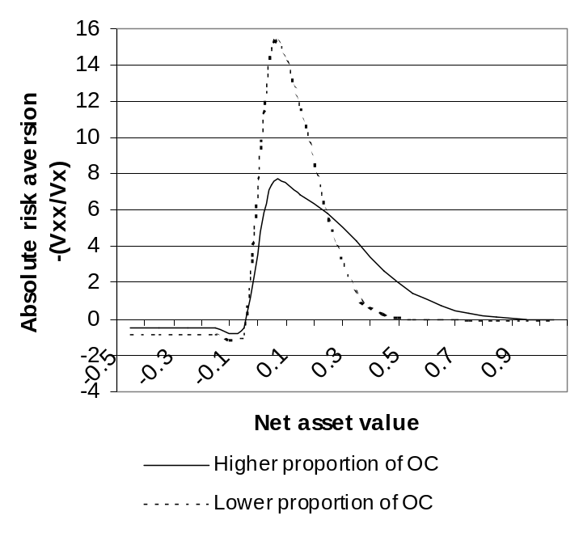
Data source: Simulation in Appendix B

As illustrated in Exhibit 4 (see Exhibit B.1 for data simulation), the shareholders with a higher level of financial participation increase their risk aversion way before the net worth of the bank becomes negative, as compared with the shareholders holding a lower level of financial participation in a bank. This is because the former would suffer more from monetary loss than the latter. It can be concluded that a bank with a higher capitalization will have a wider risk aversion threshold for shareholders, which might be able to act as a safer internal insurance mechanism.
This theoretical analysis addresses the importance of financial participation by shareholders, especially when SA is significant. From the analytical derivation (see Appendix B), it is found that the proportion of PSLA^{U} in total deposits is negatively correlated with the level of risk aversion shown by shareholders. And, the higher the financial participation by the shareholders, the more prudently the shareholders will behave. This phenomenon is quite important since the shareholders play important roles in directing the management of the bank.

- A Requirement For Minimum Financial Participation by Shareholders
PLS, at least in theory if not in practice, is the most distinguishing feature of Islamic finance. However, due to information asymmetry, agency problems are likely to exist. The regulations implemented should be able to improve the quality of the contracts entered into, so that all the contracting parties benefit. One possible option to improve the quality of the contracts is to require a minimum level of financial participation by the shareholders, OC, proportionate to the PSLA^{U} (imposed in addition to the Basel’s capital adequacy framework). The mutual benefits for the contracting parties can be obtained under several assumptions (see Appendix C for the mathematical derivation). First, the level of effort is positively affected by the sharing ratio. Second, the higher level of effort brings a positive monetary benefit. And third, the total increment of monetary surplus is higher than the opportunity cost. This is expected to enhance the agency role of Islamic banks.

- Higher Level of Transparency
Another possible option to enhance the banks’ agency role is to require the banks to provide comprehensive financial reporting to the investment depositors describing the actual financial conditions of the investments. Holmstrom (1979) proves, analytically, that a higher level of shared information will improve the quality of the contracts. This informational requirement, in fact, has been included in the third pillar of the proposed new capital accord of the Basel Committee. The regulators of Islamic banks can also benefit from this approach.

4. Possible Improvements: Implications of the Minimum Capital Ratio Requirements
In the simulation (see Exhibit D.1 in Appendix D), we choose a minimum financial participation 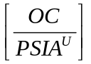of 6% arbitrarily. And, as in the previous simulations, the analysis is conducted by inputting all possible variations of the proportion of PSLA^{U} to SA. Shareholders’ minimum equity stake should be determined by the minimum CAR of 8% (as indicated in Equation (7)) or the minimum financial participation requirement, whichever is the higher. This requirement has significant implications when PSLA^{U} dominate the total liabilities of an Islamic bank.

Exhibit 5 (a): Effects of Imposing a Minimum Financial Participation on Shareholders – On Relative Agency Cost

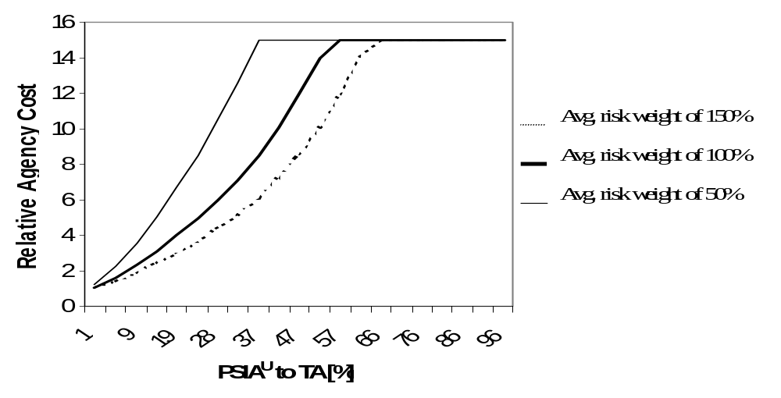

Exhibit 5 (b): Effects of Imposing a Minimum Financial Participation on Shareholders – On the Relationship Between the Proportion of to and to Ratio

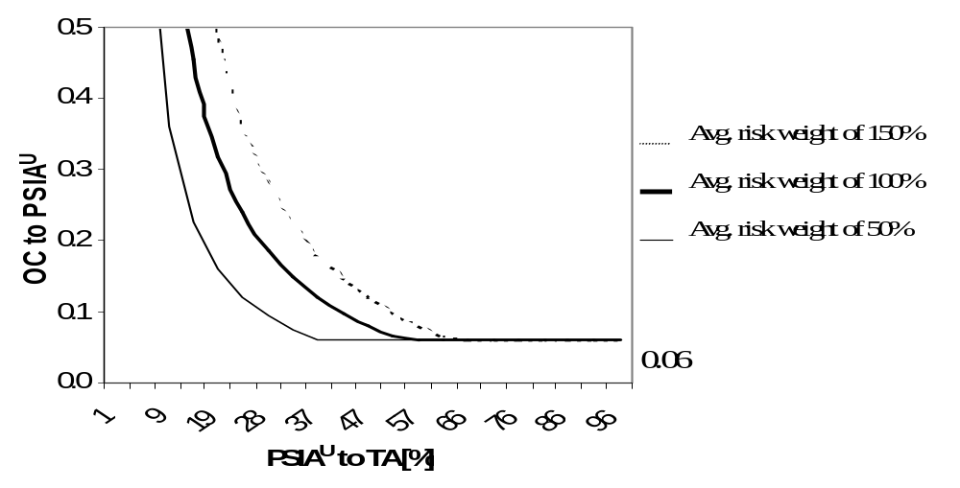

Exhibit 5, section (b) and Exhibit D.1 show that the OC to PSLA^{U} ratio becomes binding when the percentage of PSLA^{U} to TA becomes dominant. This can, alternatively, be expressed in terms of a requirement for a maximum level of relative agency costs (see section (a) of exhibit 5). In other words, the shareholders should always maintain their financial contribution (equity stake) so that their effort to supervise the bank’s management is adequately compensated. The thick, thin and dotted lines represent possible risk-weighted asset values for 100%, 50% and 150% average risk weights, respectively.

Exhibit 5 (c): Effects of Imposing a Minimum Financial Participation on Shareholders – On the Relationship Between the Proportion of to and to Ratio

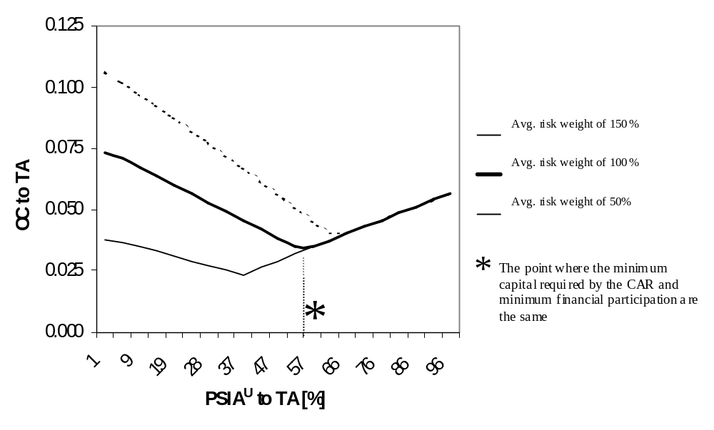

Exhibit 5 (c) shows the impact of applying the new capital framework proposed (see Exhibit D.1 in Appendix D for data simulations). The analysis shows that there are two constraints for a minimum level of capital adequacy for Islamic banks. Capital adequacy should be determined by:

- The capital adequacy ratio (to assure the repayment capability) if the bank’s liabilities are dominated by debt-based contracts (hybrid products)(to the left of the star on Exhibit 5 (c)); and
- The minimum proportion of financial contribution if the bank’s liabilities are dominated by investment deposits (i.e., PSLA^{U}) (to the right of the star on Exhibit 5 (c)).

IV. Conclusion

The Islamic banks conduct fiduciary and agency roles concurrently in the presence of savings deposits [SA] and investment deposits [PSLA^{U}]. The existing capital regulations emphasize only their repayment capabilities without adequately paying attention to the principal-agent relationship which exists between investment depositors and shareholders. The proposed capital regulation for Islamic banks outlined in this article seeks to enhance both repayment capacity and the quality of PLS contracts.
We demonstrate, formally, that the fiduciary role can be enhanced by requiring Islamic banks:

- To have prudent asset-liabilities (capital) structures; and
- To have adequate financial cushions.

The former is necessary because, although Islamic economics recommends the use of PLS contracts, their excessive use on the assets side can jeopardize the sustainability of the banking operations if the Islamic banks are not financially supported by equity-based capital.
We also demonstrate, formally, that the agency roles can be enhanced by requiring:

- The shareholders of Islamic banks to observe a minimum level of financial participation; and
- The banks to disclose crucial financial information to investors.

Theoretically, higher financial participation and a higher quality of information will both improve the quality of the contracts entered into by the banks and their customers.

Appendix A: Mathematical Simulation of Capital Adequacy Using the AAOIFI’s Standard

In simulating Equation (2), we assume that W_{OC+L} and 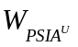are equal to 100% (all the capital sources are used in the assets side). Under the AAOIFI’s approach,

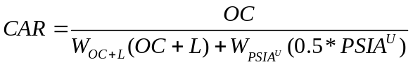

By using a minimum CAR of 8% and simulating for different values of PSLA^{U} and SA, we find OC. In the simulations, we keep the sum of PSLA^{U} and SA (i.e., equal to total deposits) equal to 1.

Exhibit A.1: Simulation process of capital regulation set by the AAOIFI

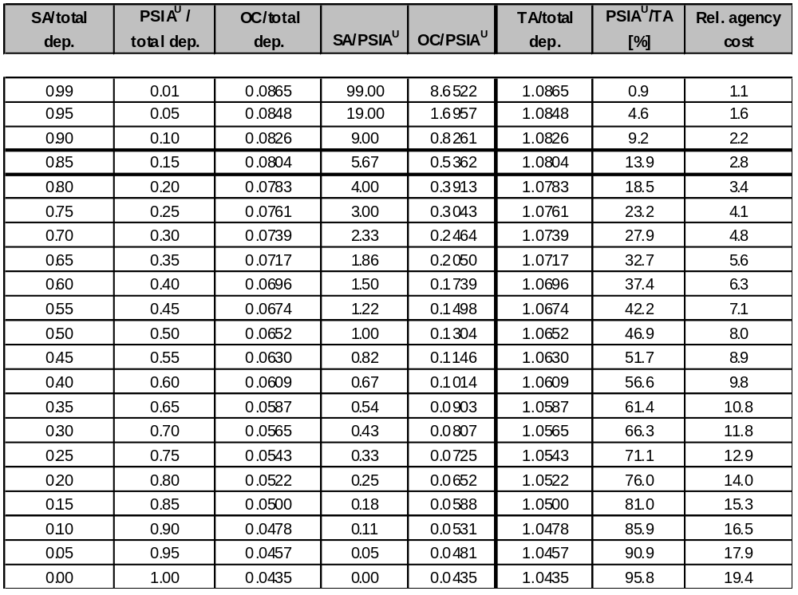

Relative agency cost is defined as the ratio of opportunity cost (expressed as a multiplicative factor) to the proportion of monetary surplus for the shareholders or 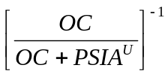. For example, agency cost in a bank, which has PSLA^{U} equal to OC, will have an agency cost which is twice as high as that of a bank which has no PSLA^{U}. The shareholders in the latter bank will receive half of the monetary surplus while they perform the same supervising function to the bank’s management (the multiplicative factor is  or 2).

Appendix B: Stochastic Effect in the Analysis of Shareholder Value

In order to conduct a dynamic analysis of shareholder value within an Islamic bank, let us assume that the net worth of an Islamic bank is determined by a perpetual and certain cash flow generated at a constant expected rate by the assets. The bank faces business uncertainty, which is expressed in variance (σ), and is able to make choices over 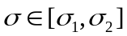. Mathematically, the net worth can be modeled in a geometric Brownian motion with drift, with time (t) being a continuous variable.

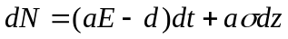
… (B.1)

The bank is assumed to have a constant expected monetary surplus of E per unit of time with a variance of monetary surplus of 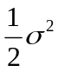; hence, the shareholders may expect monetary surplus of aE per unit of time with a variance of 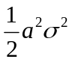. The shareholder value (which also represents the net worth of the bank) satisfies the ordinary differential equation:

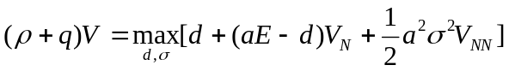 for , and (B.2)
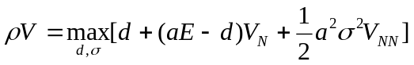 for 

where ρ represents the discount factor in the time horizon and q represents a stochastic “jump process.”
Applying proposition 1 of Milne and Robertson (1996), the optimal dividend policy takes the form that  subject to d (N) = 0 for N < N* and barrier control at N = N*, where 0 < N < ∞.
The argument for proposition 1; assuming that r < ρ implies that a policy of never paying a dividend would result in V = 0.

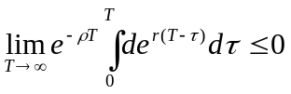
Optimal dividend policy is to retain all earnings in order to increase the survivability of the company, thus 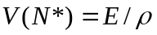.
Some assumptions for pasting conditions at N = 0 and smoothing at N* are given by:

- The sample path for N = 0 (liquidation threshold) is continuous.
- V_{N} = 1 at N*. For, the shareholder value is given by 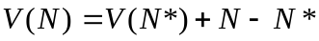.
- Therefore V_{NN} = 0 at N*.

Applying proposition 2 of Milne and Robertson (1996) that for all values of N, 0 < N < N*, the boundary condition (1), (2), (3) and 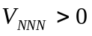, 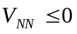, and 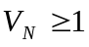, the general solution satisfies the ordinary differential equations with boundary conditions:

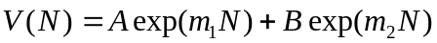
where  and 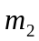 are the roots of 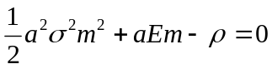. The roots of the ordinary differential equation will be:
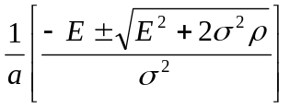.
Let us assume the general solution for  is given by:
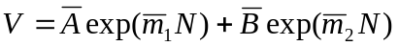
… (i)
The solution for  is given by:
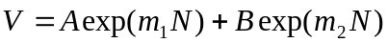
…(ii)
There are six boundary conditions to estimate the unknown parameters 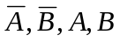 and .
At
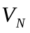 =
… (iii)
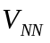 =
… (iv)

At 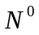:

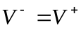: 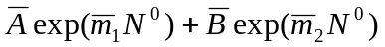 = 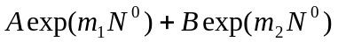
… (v)
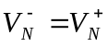: 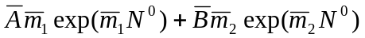=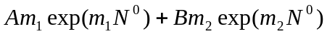
… (iv)

At 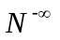:

 = 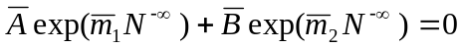
… (vii)

Using the boundary conditions, we obtain the value of the unknown parameters of the general solutions.
Applying = 0 at the boundary condition, we find the pasting condition between two general solution.

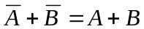
… (viii)

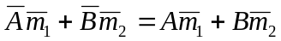
…. (ix)
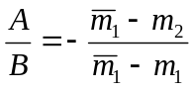
… (x)

Combining two smoothing conditions between and  we find the magnitude of the model,
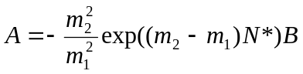
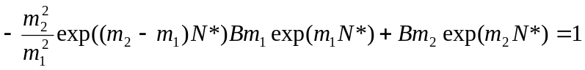
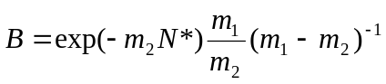
… (xi)

Similarly for another parameter, we find:

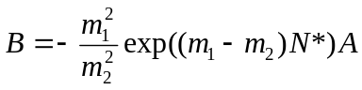
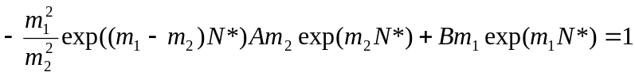
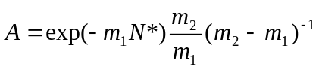
… (xii)

The critical value for zero-dividend threshold is given by:

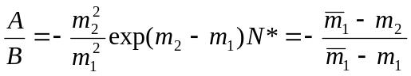
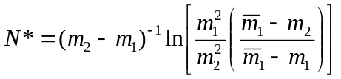
… (xiii)

Exhibit b.1: Simulation Result

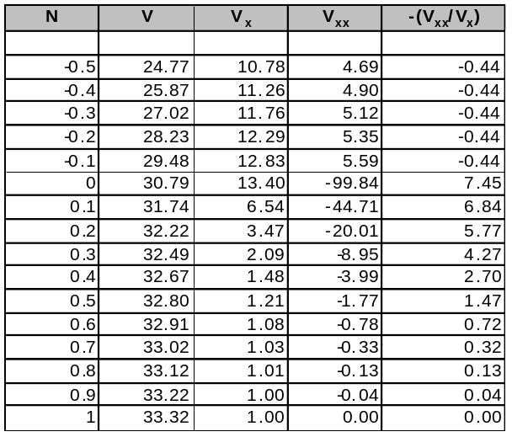

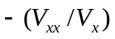 expresses the portfolio decision impact on both expected returns and the variance of returns; thus, determines the mean-variance trade-off (Milne and Robertson, 1996).

Appendix C: Financial Participation in a Sharing Contract

The analysis explores the effect of financial participation by the bank’s shareholders on the quality of contracts. The analysis starts with the following assumptions:

- The shareholders and the investment depositors share the monetary surplus in proportion to their financial shares 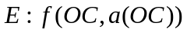.
- The investment depositors and the shareholders have strictly concave utility functions.
- The shareholders suffer from opportunity loss for any effort given to monitor the bank performance 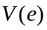, and if they invest the money somewhere else 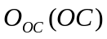.
- The investment depositors suffer from opportunity loss if they invest the money somewhere else 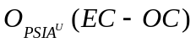. (when  equals total equity-based capital)

Hence, we have the shareholders’ utility function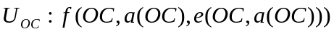 and the 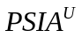 holders’ utility function 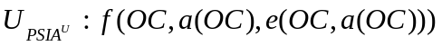. This analysis is inspired by Baldwin (2000). Let us assume that 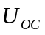 is determined by the shared monetary surplus:
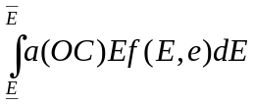
minus agency cost and the opportunity cost of funds , which is expressed in equation (C.1).
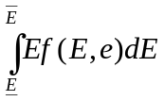
expresses the expected outcome as a function of and the density function of production uncertainty 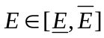.

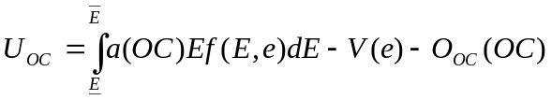
… (C.1)

Similarly, for the , 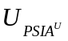 is determined by the shared monetary surplus and the opportunity cost of funds 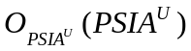, which is expressed in Equation (C.2).
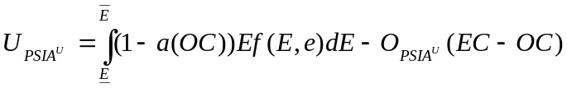
… (C.2)

According to Harris and Raviv (1979), Pareto improvement can be achieved if the agent’s expected utility can be increased without decreasing the expected utility of the other party. Assuming that the investment depositors are invariant to compensating changes in 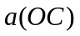 and , the total differentiation gives:

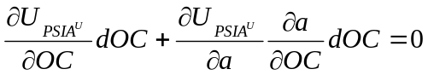
… (C.3)

Differentiating and with respect to we have:
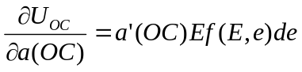, and
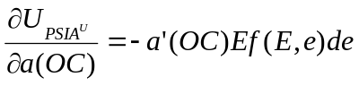

Hence,

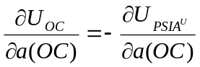
… (C.4)

Differentiating totally the shareholders utility function gives:

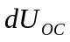= 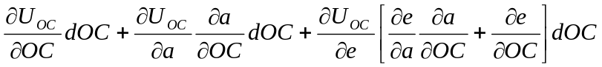
… (C.5)

Combining the agent compensating conditions (C.3) and (C.4) into the shareholders’/depositors’ utility for compensating changes in and gives:

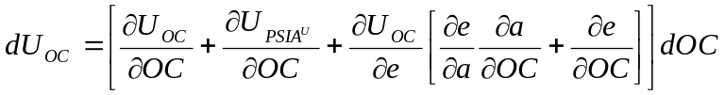
… (C.6)

The quality of the contract will be improved if 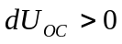 (i.e., if the utility level is at least the same while the improves (the change is higher than 0), the contract is said to be improved). Substituting equations (C.3) and (C.4) into (C.6), we have:

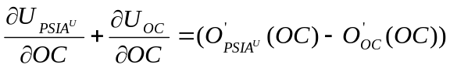
… (C.7)

Therefore,

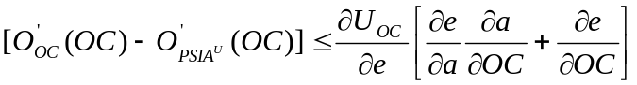
… (C.8)

This means that the necessary conditions for a higher quality of contracts are:

- the utility must be positively correlated with effort,
- effort is positively correlated with profit share,
- profit share is positively correlated with financial participation, and
- marginal opportunity cost should be lower than the monetary surplus.

Appendix D: Simulation of the Proposed Capital Regulation

In the simulation, we use a minimum CAR of 8% (equation 7] and a ratio of 6% to find the overall capital ratio requirement (i.e., the higher of the two). In the simulation, we keep the total value of and  equal to 1.

Exhibit D.1: Simulation of the Proposed Capital Regulation

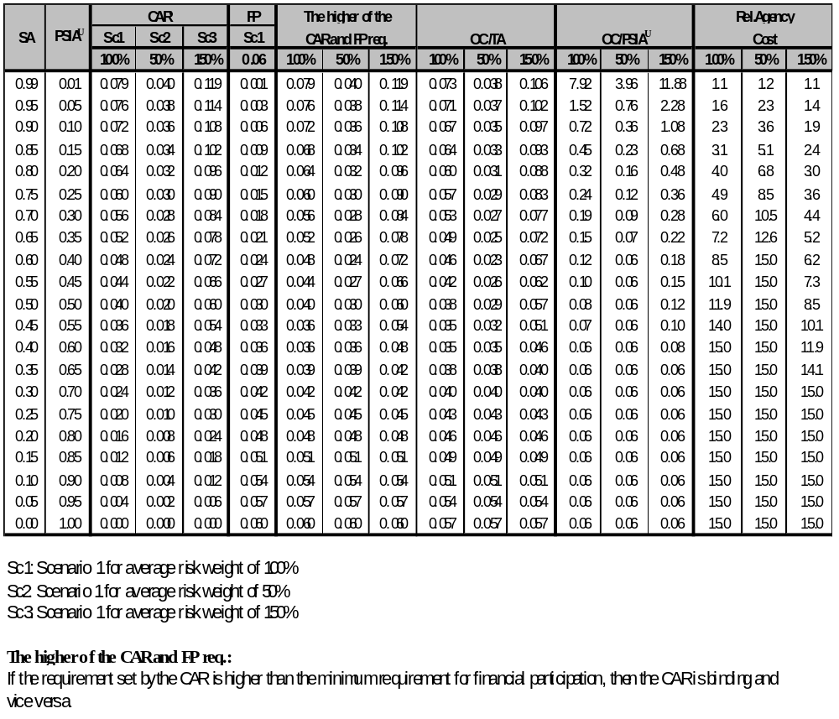

References

Accounting and Auditing Organization for Islamic Financial Institutions. Accounting and Auditing Standards for Islamic Financial Institutions. Manama: 1997.
Accounting and Auditing Organization for Islamic Financial Institutions. Statement on the Purpose and Calculation of the Capital Adequacy Ratio for Islamic Banks. Manama: 1999.
Baldwin, K. The Economics of Information and Piecewise Linear Limited Liability Profit Sharing Contracts. Ph.D. Dissertation, Loughborough University. Unpublished. 2000.
Basel Committee. The New Capital Accord. Consultative Document. Basel: 2001.
Dewatripont, M. and Tirole, J. “A Theory of Debt and Equity: Diversity of Securities and Manager-Shareholder Congruence.” The Quarterly Journal of Economics. Nov 1994(a). pp. 1027-1054.
Dewatripont, M. and Tirole, J. The Prudential Regulation of Banks. Massachusetts Institute of Technology Press. Cambridge, Mass.: 1994(b).
Errico, L. and Farahbaksh, M. Islamic Banking: Issues in Prudential Regulation and Supervision. International Monetary Fund Working Paper WP/98/30. Washington D.C.: 1998.
Fries, S., Mella-Barral, P., and Perraudin, W. “Optimal Bank Reorganisation and the Fair Pricing of Deposit Guarantees.” Journal of Banking and Finance 21. 1997. pp. 441-468.
Hall, M.J.B. “The Basel Committee’s Proposals for a New Capital Adequacy Assessment Framework: A Critique.” Banca Nazionale del Lavoro Quarterly Review 217. Rome: 2001. pp. 111-179.
Hall, M.J.B. “Financial Regulation Report.” Basel Committee. 1997. pp. 2-5.
Haron, S. Islamic Banking: Rules and Regulations. Pelanduk Publications. Selangor: 1997.
Haron, S. and B. Shanmugam. Islamic Banking System: Concept and Applications. Pelanduk Publications. Selangor: 1997.
Harris, M. and Raviv, A. “Optimal Contracts with Imperfect Information.” Journal of Economic Theory 20. 1979. pp. 231-259.
Holmstrom, B. “Moral Hazard and Observability.” Bell Journal of Economics 19. 1979. pp. 74-91.
Khan, T and Chapra, M.U. Regulation and Supervision of Islamic Banks. Islamic Research and Training Institute, Islamic Development Bank. Jeddah: 2000.
Llewellyn, D.T. The Economic Rationale for Financial Regulation. FSA Occasional Paper. London: 1999(a).
Llewellyn, D.T. “Some Lessons for Regulation from Recent Bank Crises.” Paper presented at Second International Conference on the New Architecture of the International Monetary System. Florence: 1999(b).
Macho-Ines, I. and Peres-Castrillo, D. An Introduction to the Economics of Information, Incentives and Contracts. Oxford University Press. Oxford: 1997.
Milne, A. and Robertson, D. “Firm Behavior under the Threat of Liquidation.” Journal of Economic Dynamic and Control 20. 1996. pp. 1427-1449.
Milne, A. and Whalley, A.E. “Bank Capital Regulation and Incentive for Risk Taking.” Mimeo. City University, Business School, London: 2001. Available at <http://www.staff.city.ac.uk./~amilne>
Milne, A. and Whalley, A.E. Bank Capital and Risk Taking. Bank of England. Working Paper 90. 1999.
Obaidullah, M. “Capital Adequacy Norms for Islamic Financial Institutions.” Anthology of Islamic Banking. Ed. Asma Siddiqi, London: 1999. pp. 198-202.

Risk, Return and Volatility of Faith-Based Investing
The Case of the Dow Jones Islamic Index

M. Kabir Hassan *

Abstract

Ethical investing refers to funds that exclude stocks mainly for ethical or religious reasons. Most studies that have examined the performance of unit trusts in the U.S. and the U.K. have found that they do not outperform the market. This underperformance of ethical investing may result from increased monitoring costs, a smaller investment universe and restricted diversification potential. Islamic investors represent a unique ethical investment market. The Islamic investment funds are growing at an estimated annual rate of 15%. This paper empirically examines the issues of market efficiency and the time-varying risk return relationship for the Dow Jones Islamic Index (DJIM) over the 1996-2000 period. This paper employs serial correlation, variance ratio and Dickey Fuller tests to examine the market efficiency of DJIM index. The results show that DJIM returns are normally distributed. The returns show that DJIM index returns are efficient. This paper also examines calendar anomalies of the DJIM and the results show that there is no turn-of-calendar-year, turn-of-financial-year, or month effect of DJIM index returns. Utilizing a GARCH econometric framework, this paper examines the volatility of the DJIM index returns. The results show a significant positive relationship between conditional volatility and DJIM equity index returns. Finally, this paper discusses various policy options to improve the functioning of the Islamic capital market.

I. Introduction

Ethical investing refers to the exclusion of stocks from funds mainly for ethical or religious reasons. Most studies examining the performance of unit trusts in the U.S. and the U.K. have found that they do not outperform the market. This underperformance of ethical investing may result from increased monitoring costs, the smaller size of the investment universe and restricted potential for diversification.
A mutual fund is an open-end investment company that combines the funds of investors who have purchased shares or ownership in the investment company and then invests that money in a diversified portfolio of securities issued by various corporations and/or governments. Shares are generally offered for sale on a continuous basis, with the fund standing ready to buy back shares on demand. There are two types of returns a mutual fund investor can expect from owning shares in a mutual fund. The first return is from distributions, which includes both dividend distributions and capital gains distributions. Dividend distributions come from the interest and dividend income received from securities owned by the fund. Capital gains distributions represent the net gains (capital gains minus capital losses) that a fund realizes on its sale of securities from its portfolio during the year. Capital gains distributions are usually made on an annual basis, often in the month of December. The second type of return from mutual funds comes from share prices appreciation. The investor hopes that, over time, the market price of the fund’s shares and the net asset value (NAV) will increase.
It is estimated that the world’s one billion Muslims have roughly $100 billion to invest, an amount that is growing by 15% each year. Needless to say, this fact has caught the attention of investment firms around the world that are interested in capturing this market. Interest in Islamic investments continues to grow as evidenced by the creation of the Dow Jones Islamic Market Index which was launched in December 1995. It is estimated that only $1 to $2 billion are invested in Islamic products. Thus the market is virtually untapped.
However, investment firms must tread carefully to succeed in the Islamic mutual fund market. Although most of their clients would be delighted to have portfolios of Philip Morris, Citigroup, and Seagram, devout Muslims would be less than pleased. Muslims’ actions are governed by their strict adherence to their religious tenets, even where investments are concerned. Critical to the success of the fund is the product’s structure and performance, shari^{c}a oversight, human resource and cultural issues, and distribution.
In this paper, we apply a serial correlation test, variance ratio tests of Lo and MacKinlay (1988) and ADF unit root tests to investigate the behavior of DJIM indices within the general framework of market efficiency and the random walk hypothesis. We examine the risk and return volatility of DJIM within a GARCH framework. Then, we examine the calendar anomalies of DJIM. Finally, we examine the issue of thin trading and non-linearity of DJIM by conducting a series of tests that consider such issues.
Dow Jones has created a family of equity indices for people who wish to invest according to Islamic investment guidelines. The Dow Jones Islamic Market Indexes track shari^{c}a-compliant stocks from around the world, providing Islamic investors with comprehensive tools based on a truly global investing perspective. The Dow Jones Islamic Market Indexes currently include the DJ Islamic Market Index (DJIM), the DJ Islamic Market U.S. Index (IMUS), the DJ Islamic Market Technology Index (IMTEC), the DJ Islamic Market Extra Liquid Index (IMXL), the DJ Islamic Market Canadian Index (IMCAN), the DJ Islamic Market UK Index (IMUK), the DJ Islamic Market Europe Index (IMEU), and the DJ Islamic Market Asia/Pacific Index (IMAP).
The Dow Jones Islamic Market Indices are constructed from the 2,700 stocks in the Dow Jones Global Indices family, which means they are accessible to investors and are well traded. The DJGI methodology removes issues that are not suitable for global investing. The Dow Jones Islamic Market Indices include the most liquid securities meeting the shari^{c}a investment criteria in the market, and reflect an industry-wise breakdown of the global market. The Indices are capitalization weighted and are calculated and disseminated to major market data vendors in real time. Index calculation is based on Laspeyres’ formula; it does not include reinvested dividends.
Certain businesses are incompatible with the shari^{c}a. Thus, stocks of companies whose primary business is in areas not suitable for Islamic investment purposes are excluded from the Dow Jones Islamic Market Index. Excluded products include alcohol, pork-related products, conventional financial services (banking, insurance, etc.), and entertainment (hotels, casinos/gambling, cinema, pornography, music, etc.). Shari^{c}a scholars also do not advise investments in companies that deal in tobacco, defense or weapons. These incompatible lines of business, represented by 18 of the 122 industry groups within Dow Jones Global Indexes, are removed from the “universe” of stocks considered for the Dow Jones Islamic Market Index. Other companies classified in other industry groups also may be excluded if they are deemed to have a material ownership in or revenues from prohibited business activities.
After removing companies with unacceptable primary business activities, the remaining universe is tested by three financial-ratio “filters.” The purpose is to remove companies with unacceptable financial ratios. The filters exclude companies if Total Debt divided by Total Assets is equal to or greater than 33% (where Total Debt = Short-Term Debt + Current Portion of Long-Term Debt + Long-Term Debt), if Accounts Receivables divided by Total Assets is equal to or greater than 45%. (Where Accounts Receivables = Current Accounts Receivables + Long-Term Receivables), and if the sum of Non-Operating Interest Income plus other impure income divided by Revenues is equal to or greater than 5%.
The Dow Jones Islamic Market Indexes use 31 December 1995 as their baseline. The base value is set at 1000. The Dow Jones Islamic Market Indices are reviewed quarterly, with component changes implemented on the third Friday of March, June, September and December. This frequency insures that the indices reflect the latest trends and developments in the global stock market.

II. Literature Review of Ethical Investments

The Ethical Investment Research Service defines ethical funds as those that exclude one or more company groups from their portfolio for non-financial reasons. Most trust brochures indicate the types of investments they positively seek out: conservation/anti-pollution, community responsibility, charitable giving, safety of product, employment practices, advertising policies and customer relations. Any extraordinary performance that ethicals may exhibit is unlikely to be directly attributable to a common strand of uniformly defined ethicality. As a group they are neither cohesive nor highly specialized and differences in performance relative to the market, to the extent that they exist, may be attributable to commonalties other than ethicality. Small companies have a lower probability of being invested in some potentially objectionable activity. It may therefore be the case that the portfolios of ethical trusts are dominated by smaller companies and hence the characteristics of their returns will be influenced by the well-known “small company effect.”
There is weak evidence of some over-performance, on a risk-adjusted basis, by “ethical” unit trusts. Ethical trusts have U.K. investment portfolios more skewed toward small market capitalization than the market as a whole. They tend to invest in low dividend yield companies. The degree of international diversification varies between ethical trusts and is clear that a suitable international benchmark may be needed to separate out any ethical effect.
Consumers appear to have grown increasingly concerned about ethical misconduct of business. This is reflected in a number of surveys. A Business Week/Harris poll shows that 49% of the respondents view white-collar crime as very common. A Gallup poll shows that only the U.S. government scored lower marks than corporations in terms of trustworthiness. According to Schlegelmilch (1997), only 17% of the public rate the honesty of top business people as “high.”
Corporations have been taking steps to incorporate ethics into their organization. Nearly all Fortune 1000 companies have now formulated corporate codes of ethics. More than half of the largest corporations teach ethics to their employees.
Ethical investment is clearly moving beyond the small niche that it occupied some ten years ago. The San Francisco-based Women’s Equity Fund specializes in women’s issues, the Amana Income Fund invests only according to Islamic principles, and the Boston-based Union Standard Equity channels its money only into “union-friendly companies.”
Exact data on the proportion of investments that is ethically screened are difficult to establish, since there is a lack of consensus on how to define ethical investments. One definition proposed by Tennant (1991: 32) says that ethical investment is widely understood to mean investment according to personal principles that have commonly precluded investment in such areas as South Africa, arms, alcohol, gambling, etc. In a definition proposed by Langbein and Posner (1980: 73), ethical investment involves “[e]xcluding the securities of certain otherwise attractive companies from an investor’s portfolio because the companies are judged to be socially irresponsible and including the securities of certain otherwise unattractive companies because they are judged to be behaving in a socially laudable way.”
Some experts advance the theoretical view that ethical portfolios are unsound investments as they increase risk unnecessarily. Langbein and Posner agree that ethical stocks are riskier, but point out that social investment should not yield significantly worse returns, since even ethical investors do not invest in clearly unprofitable stock. Comparing the actual performance of ethically screened funds against the Standard and Poor Index (S&P 500) or the FT All-Share Index usually yields mixed results, depending on which funds are compared and which time periods are considered (Cooper and Schlegelmilch 1993). Lloyd Kurtz states that his research found no correlation between a portfolio’s ethics and its performance. Further evidence reports that the performance of the average socially screened mutual fund did better than 58% of all mutual funds for the 12 months ending September 1994. In the U.K., ethical investment funds outperformed other funds in their sector over one-, two-, and three-year periods. A comparison between ethical investment performance and unrestricted investments can be made using the Domini Social Index (DSI 400). Although this index shows ethically screened investments faring slightly better than the S&P index, the difference is small and may well be explained by the fact that DSI 400 includes more retail stocks and small companies.
More research needs to be conducted on the motivation behind ethical investments, to investigate, for example, the relationship between altruism and social reputation, or internal motivation versus approval seeking. From a company’s perspective, it becomes necessary to actively communicate social and environmental commitments in order to ensure endorsements of investment professionals. Future research needs to focus on individual investors, rather than investment professionals.
An analysis of the composition of the investment portfolios of “ethical” unit trusts in the U.K. has shown that “ethical” investing is found to be correlated with at least three factors that may have an impact on realized returns: low market capitalization, international diversification, and low dividend yield. Luther and Matatko measure trusts’ portfolio performance not only against the ‘risk free rate’ and the usual market proxy, the FT All-Share Index, but also against a small-company benchmark, the Hoare Govett Smaller Companies Index (HGSC). The ethical trusts (being open-ended) are constrained by liquidity requirements to hold a proportion of their funds in easily marketable large equities, but they are, nevertheless, indisputably small-company funds. Nine U.K. ethical unit trusts form the basis of the study. The empirical results indicate that regardless of the benchmark used, be it a value-weighted market index, a small company index, or both, mean abnormal returns are almost always significantly different from zero. The “systematic” component of ethical trust returns does appear to be better described by a benchmark made up of both a “market” and a small company index, than by either index singly.
Fletcher examines the performance of British and American trusts. He addresses three main issues. The first is whether trusts exhibit superior performance. The second is the relationship between performance and various trust characteristics, for example, size and expenses, while the final issue relates to the predictability of trust performance. The sample consists of 85 British and American unit trusts from January 1985 through December 1996. All trusts that were identified in the 1985 Unit Trust Yearbook and invested more than 70% or more in the U.S. were included in the sample. No survivorship requirements were imposed on the trusts. Fifty of the trusts have continuous return data. Transfers of unit trusts and name changes were treated as a continuation of the original trust.
The performance evaluation of unit trusts uses both the Jensen (1968) measure and the conditional Jensen measure of Ferson and Schadt (1996). In examining the relationship between various trust characteristics and abnormal performance, three factors are considered:

- size of trust,
- initial (load) charge, and
- annual charge.

The returns used are gross of the load charge and other trading costs but net of the annual charge. There should be no relationship between the load charge and performance if the markets are efficient. If annual charges are positively correlated with trading costs, then there should be no relationship between annual charge and performance if markets are efficient. This implies that net abnormal returns will be lower for trusts with higher annual charges because of the higher trading costs.
There are three main conclusions of this paper. First, there is no evidence that British/North American unit trusts on average or individually deliver significant abnormal returns. Second, there is no evidence of the relationship between the charges of the trust and abnormal performance. Finally, there is no evidence of any significant predictability in trust performance.
Mallin, Saadouni and Briston (1995) concentrate on analyzing the performance of the ethical and non-ethical funds using the “traditional” risk-adjusted measures used in the majority of studies previously carried out, i.e., the Jensen, Sharpe and Treynor measures. It has been argued that the possible failure of the Jensen methodology to detect superior performance appears to arise from two main causes, namely, a failure to identify correctly the relationship between superior performance based on superior information and appropriate tests of superior performance, and possibly more importantly, the weakness of the statistical tests used. This is the real reason why so many empirical investigations have been forced to accept the null hypothesis of no evidence of superior performance.
The financial performance of the total population of British ethical investment funds over the period 1986-1993 is analyzed. The null hypotheses to be tested are as follows:

- Ethical investment funds do not outperform (or underperform) the market
- The performance of ethical investment funds is no different from that of non-ethical investment funds.

The performance of the funds is then analyzed using several different one-parameter performance measures to evaluate the portfolios:

- The excess return to variability measure (Sharpe, 1966)
- The excess return to non-diversifiable risk (Treynor, 1965), and
- The differential return with risk measured by betas (Jensen, 1969)

By analyzing the mean excess returns, ethical trusts appear to underperform both non-ethical and the market generally. There is weak evidence that non-ethical trusts outperform the market in this sample. On a risk-adjusted basis both the ethical and non-ethical trusts tend to underperform the market, and increasingly the ethical trusts tend to outperform the non-ethical trusts. Taking the ranking of all three measures, Jensen, Treynor and Sharpe, again it is the ethical trusts that outperform the non-ethical ones.
Luther, Matatko and Corner (1992) argue that from the purely financial point of view, growth in investing in ethical companies may be expected to produce gains in shares with a “positive” ethical rating and losses on others. On the other hand, it may be that ethical investment offers inferior performance due to increased monitoring costs, a smaller investment universe, and restricted potential for portfolio diversification. Some studies have shown a positive relationship between financial performance on the one hand and environmental performance or social disclosure performance on the other. The authors review the investment performance of ethical unit trusts with specific reference to the following questions:

- Have ethical trusts offered superior or inferior investment performance?
- Can an ethical effect be separated out from other well-known phenomena?

Ethical companies tend to be small companies and they investigate the portfolios of ethical funds with respect to the market capitalization of constituent companies.

III. Islamic Mutual Funds

In addition to using a conventional portfolio management process, investment firms must use a shari^{c}a process to manage the fund. The shari^{c}a is a comprehensive code of behavior that governs both private and public activities; accordingly, Islamic mutual funds maintain shari^{c}a advisory boards. The primary purpose of the advisory board is consumer advocacy. The board is used to assure Muslim investors that their money is being invested in accordance with Muslim law. The shari^{c}a board is also responsible for portfolio purification, screening of stocks, monitoring stocks, monitoring management, monitoring fees, monitoring fund documentation, and zakat. Thus, the shari^{c}a advisory board is responsible for both religious and fiduciary matters. (Bauer and Keigher, 2001; DeLorenzo, 2001; Hamid, 1999; Moran, 1999; Valpey, 2001)
The shari^{c}a advisory board should be composed of independent scholars who are intimate with the shari^{c}a. While a knowledge of investments may be helpful to an advisor, it is not necessary to ensure that the mutual fund is shari^{c}a-compliant. A supervisor usually leads the advisors. In some instances in which a fund is composed of stocks in shari^{c}a-based indices, such as the Dow Jones Islamic Market Index, the fund’s shari^{c}a supervision may be undertaken by only one person.
Screening is the practice of including or excluding publicly traded securities from investment portfolios or mutual funds based on the religious and ethical precepts of the shari^{c}a. Generally, Muslim investors seek to own profitable companies that make positive contributions to society. Certain businesses are incompatible with shari^{c}a laws. Therefore, stocks of companies whose primary business is not permissible according to shari^{c}a are excluded. In addition, most of the shari^{c}a screens currently in use by fund managers include the three financial ratio filters already mentioned.
The Islamic law of transactions is governed by riba. Basically, this is the prohibition of interest in any form. Muslims believe that profit should be based on effort. Therefore one who lends money has expended little effort. His money is working for him while he sits idle. It is up to the shari^{c}a advisory board to ensure that the fund portfolio purifies itself of these ill-gotten gains. Often companies that are shari^{c}a-compliant have non-operating income from interest-bearing investments. These impure funds are placed in a separate account and are distributed to suitable charities according to shari^{c}a.
In addition to the purification of riba from the portfolio, the portfolio must also be morally purified. At the heart of Islam is the belief that the community should be benefited from its people’s actions. Therefore a company that is shari^{c}a-compliant that purchases or merges with a company that is not shari^{c}a-compliant must be eliminated from the portfolio. Moral purification also entails making the management of major corporations aware of issues that are important to Muslims. This can be done through attending annual meetings or by casting proxy or absentee ballots.
Because very little remains the same, the board is also faced with monitoring the compliance of the fund’s stocks. In instances where a stock is linked to an index, pertinent information must be provided to the index. Thus, shari^{c}a advisors may evaluate the stock. However, when a stock is not linked to an index, information gathering is added to the list of tasks that the board must complete. Once the information is gathered, computer programs are available to assist shari^{c}a boards in the supervision of their portfolios. This software helps the board identify its problem areas, but it is ultimately up to the board to correct these problems.
Of importance to the shari^{c}a advisory board is the management of the mutual fund itself. Often those managing the mutual fund are not as well versed in the shari^{c}a as the advisory board, as is the case with western investment firms. Most western funds managers feel that they must be fully invested at all times. This policy leads to the creation of riba. The board must be careful that management avoids earning interest on cash that is idle, or that the firm does not change its strategy to include high quality, short-term securities and money-market instruments. Another item that the board must watch for is the purchase of securities on margin. According to Islamic law, gambling is sinful, and in the eyes of Islam purchasing securities on margin is considered a form of gambling and must be avoided.
In its consumer advocacy role, the advisory board must monitor the fees charged by the mutual fund. This entails ensuring that the fee structure is reasonable and that it is clearly stated in the fund’s literature. By looking out for the interests of the consumer in this manner, the shari^{c}a supervisory board is actually adding value to the fund. In the consumer’s interest, the board should also monitor fund documentation. The board should ensure that all filings are made timely and accurately with regulatory agencies like the Securities and Exchange Commission. The board should also review all marketing publications as they will almost all reference the shari^{c}a and the Islamic nature of the fund to ensure that such references are correct and not misleading.
It is also the responsibility of the shari^{c}a board to keep abreast of issues specific to the industry in which they operate. As the shari^{c}a board is composed of academics and professionals, they must comprehend issues in a broader marketplace perspective. The attention brought to bear on the issues by the board will result in the board’s decisions being more informed and ultimately of more value to the investor.
The advisory board should also prepare guidelines for the calculation of zakat on financial investments. Zakat is a financial obligation that Muslims must fulfill yearly by donating one-fortieth of their capital. The guidelines established by the board should be published for investors. However, the ultimate calculation of zakat is dependent upon each investor’s financial condition.
Finally, one of the most important functions of a shari^{c}a supervisory board is to prepare reports on the status of the fund it supervises. Such reports are best issued quarterly and should address issues of shari^{c}a-compliance in the portfolio and on the part of management. The reports should also tell investors of the purification process and the ways in which purified proceeds have been distributed to various charities.

IV. Capital Market Efficiency Tests OF DJIM

The efficient market hypothesis (EMH) assumes that stock prices contain all available information and adjust rapidly to the infusion of any new information. Based upon the random walk hypothesis, early studies presumed that stock prices fluctuated randomly. Fama (1970) first formalized the EMH theory in terms of a fair game and classified them into three groups in terms of information subset. The weak form of the EMH states that stock prices reflect all historical information such as historical prices, trading volumes and any market related information. The semi-strong form of the EMH states that stock prices reflect all publicly available information such as accounting information. Finally, the strong form of the EMH states that stock prices reflect all information, both public and private. Fama (1970) also notes that EMH and asset pricing models such as CAPM are inseparable joint-hypothesis. We use serial correlation, variance ratio tests and unit root tests to examine the market efficiency of DJIM.

A. Serial Correlation Coefficient Test
The serial correlation coefficient measures the relationship between the value of a random variable at time t and its value in the previous period. The weak-form EMH is expressed as

Pt = a+b Pt-1 + ξt
… (1)

where Pt is the stock price in period t, Pt-1 is the stock price in the preceding period, and ξt is the error term. According to the EMH, the sequence of stock prices is assumed to fluctuate randomly with a rising trend, where E(ξt) = 0, E (ξt, ξs) = 0 (t ≠ s), and the Var (ξt) is finite, so that news comes in randomly. Thus the error term ξt is a white noise process without serial correlation. This provides us the basis to conduct a joint test of serial correlation and the EMH, which is dependent on the randomness of stock prices.

B. The Variance Ratio Test
The Lo and MacKinlay (1988) variance ratio test for random walk is based on the premise that the variance of random walk increments in finite sample is linear in the sampling interval. The variance ratio test is sensitive to correlated price changes but robust with respect to many forms of heteroskedasticity and non-normality of the stochastic disturbance term. The variance ratio test is more powerful than the Dickey-Fuller test.
If a time series follows a random walk process, the variance of a kth-difference variable is k time as large as that of the first-difference interval. Hence, for equally spaced intervals, we partition the stock price into nk + 1 segments denoting them by y₀, y_{1 …} y_{nk}. For a time series characterized by random walks, one kth of the variance of P_{t} – P_{t-k} is expected to be the same as the variance of P_{t} –P_{t-1} or

VR(k) = σ_{k}²/σ₁²
… (2)

where σ_{k}² is the unbiased estimator of one kth of the variance of lnP_{t} – lnP_{t-k}, and σ₁² is the unbiased estimator of the variance of lnP_{t} – lnP_{t-1}. These estimators can be conveniently calculated as following:

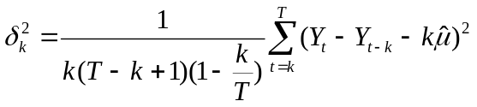
… (3)

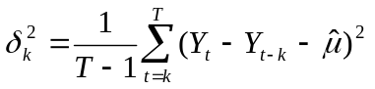
… (4)
in which T is the sample size and 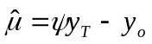. With the assumption of homoskedasticity, the asymptotic variance of the VR statistic is shown to be:

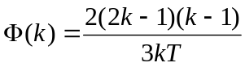
… (5)

The VR statistic (Lo and MacKinlay, 1988) asymptotically approaches normality or:

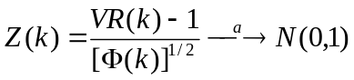
… (6)

where 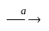denotes that the distributional equivalence is asymptotic.

As is well documented in the literature, variances of most stock returns are conditionally heteroskedastic with respect to time (Hamao et al., 1990; Koutmos et al., 1993, 1994). As a result, there may not exist a linear relation over the observation intervals. To overcome this difficulty, Lo and MacKinlay (1988) derive the heteroskedasticity-consistent variance estimator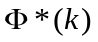:

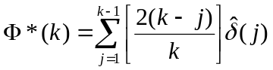
… (7)
in which:
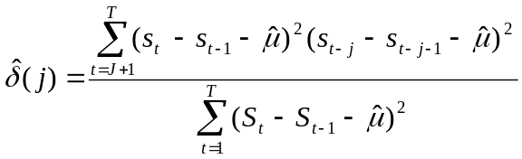
… (8)

Thus, the variance ratio test statistic can be standardized asymptotically to a standard normal variable or:

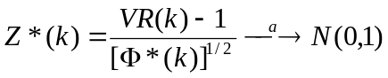
… (9)

C. The Dickey-Fuller Test
Another important alternative approach to examining the random walk hypothesis is the Dickey-Fuller (DF) unit root test. More specifically, the augmented Dickey-Fuller (ADF) test is often used to model the time series data that are not generated by the pure AR(1) process and the data which are fraught with non-white noise error terms. Typically, the ADF test is based on the following formulation:

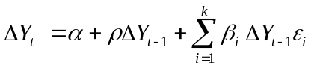
… (10)

where 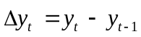 is a drift term with the null hypothesis H_{o}: ρ = 0 and its alternative hypothesis H_{o}: ρ < 0. Note that failing to reject H_{o} implies the time series has the property of random walk.

D. Data and Empirical Results
Daily and monthly data for DJIM from January 1996 through December 2000 were collected to conduct statistical analysis. Monthly data from January 1996 through December 2000 were used to perform statistical tests of five DJIM regional indices. The general test statistics of DJIM aggregate index, and five regional indices are given in Table 1a and 1b. The Jarque-Berra normality tests show that DJIM indices are normally distributed.
Table 2a presents the results of unit root tests of market efficiency of DJIM indices. Unit root tests are necessary (but not sufficient) conditions for market efficiency, and are widely used as tests of market efficiency (Fama, 1970). Based on unit root tests, the DJIM aggregate index and the five regional indices show unit roots in the level of stock prices, that is, the series are non-stationary. However, after taking the first difference on the indices, it appears that stock prices show random walk or are stationary in the first differences. However, the existence of random walk components in stock prices does not necessarily imply that stock returns are unpredictable. Since DJIM indices are integrated of I(1), there exist some predictable components. While ADF unit root tests are both convenient and effective in detecting the existence of random walk components in a time series, they cannot distinguish the serial correlation components from short-term fluctuations. The purpose of the variance ratio (VR) approach is to detect if the short-term fluctuations dominate the stochastic trend components, while the ADF approach is formulated to examine only the existence of stochastic trend components. Lo and MacKinlay (1989) demonstrate via Monte Carlo simulations the superiority of the VR over ADF in terms of statistical power.
Table 2b presents the VR tests of DJIM index and its five regional indices. Under the assumption of homoskedasticity, the VR rejects the null hypothesis of random walk of DJIM daily index. However, under the assumption of heteroskedasticity, VR cannot reject the random walk of DJIM daily index. When monthly data are used, the aggregate DJIM and its five regional indices all show random walk. In the light of a long literature on the efficiency of stock market and inconclusive nature of empirical results, the results for DJIM are encouraging. While the traditional stock indices from both developed and developing countries show various forms of inefficiency, the DJIM shows remarkable market efficiency.

Table 1a: Statistics of DJIM Indices (Monthly Data)

 | DJIM-Europe | DJIM-Pacific | DJIM-Tech | DJIM-UK | DJIM-USA | DJIM-World
Mean | 1737.563 | 1105.986 | 3110.193 | 1645.781 | 1852.850 | 1647.773
Median | 1767.797 | 1063.657 | 2437.072 | 1774.004 | 1860.232 | 1615.138
Maximum | 2515.176 | 1583.747 | 6970.611 | 2285.347 | 2695.639 | 2351.868
Minimum | 1006.236 | 769.9472 | 1015.349 | 981.1274 | 1024.989 | 1021.841
Std. Dev. | 451.5201 | 194.5427 | 1761.608 | 357.3548 | 531.3427 | 408.9486
Skewness | -0.107517 | 0.615254 | 0.713001 | -0.442671 | -0.096058 | 0.061168
Kurtosis | 1.645480 | 2.671383 | 2.315847 | 2.011442 | 1.634956 | 1.727448
Jarque-Berra | 4.780785 | 4.122932 | 6.358101 | 4.476071 | 4.829809 | 4.153988
Probability | 0.091594 | 0.127267 | 0.041625 | 0.106668 | 0.089376 | 0.125306
Observations | 61 | 61 | 61 | 61 | 61 | 61
The Jarque-Berra statistic is given by: T-k/σ [ s² +1/4(K-3)²], where T is the number of observations, k is zero for an ordinary series, s is skewness and K is the kurtosis. Under the null hypothesis of normality, the Jarque-Berra statistic is distributed as χ² with 2 degrees of freedom.

Table 1b: General Statistics of DJIM (Daily Data)

Mean | 0.000355
Median | 2.44E-05
Maximum | 0.523292
Minimum | -0.500928
Std. Dev. | 0.019033
Skewness | 1.372022
Kurtosis | 599.4978
Jarque-Berra | 26033957
Probability | 0.000000
Observations | 1756

Table 2a: Results of Dickey-Fuller Unit Root Tests (Monthly Data)

 | DJIM-Europe | DJIM-Pacific | DJIM-Tech | DJIM-UK | DJIM-USA | DJIM-World
x | -1.427 | -1.273 | -1.345 | -2.056 | -1.533 | -1.475
dx | -4.112* | -2.886* | -3.808* | -4.823* | -4.055* | -3.881*
x = Stock Price; dx = first difference of x; * denotes 1% significance based on McKinnon critical values for rejection of hypothesis of a unit root.

Table 2b: Variance Ratio Estimates for DJIM

A. Variance Ratio Estimates of DJIM Aggregate (Daily Data)
 | 24 | 72 | 96 | 120 | 144
Z(q) | -6.128* | -3.577* | -3.135* | -2.876* | -2.634*
Z*(q) | -1.372 | -1.415 | -1.435 | -1.475 | -1.481
Number of days (q) of base observations interval

B. Variance Ratio Estimates for Individual DJIM Aggregates (Monthly Data)
 | 6 | 12 | 24 | 48 | 60
U.S.
Z(q) | -0.936 | -0.700 | -1.077 | 0.269 | 0.103
Z*(q) | -0.968 | -0.945 | -1.884* | 0.665 | 0.285
Europe
Z(q) | 0.192 | -0.468 | -0.921 | 0.199 | 0.028
Z*(q) | -1.372 | -1.372 | -1.415 | -1.435 | -1.475
U.K.
Z(q) | -0.097 | 0.707 | -0.378 | 2.285 | 0.799
Z*(q) | -0.074 | 0.752 | -0.552 | 4.709 | 1.8436
Pacific
Z(q) | 0.807 | 1.609 | 2.269 | 0.122 | 0.063
Z*(q) | 0.850 | 2.148 | 3.960 | 0.299 | 0.1723
The variance ratio VR(q) is defined as [σc (q)]/[σa (q)], where σc (q) is an Unbiased estimator of 1/q of the variance of the qth difference of stock price and σa (q) is an unbiased estimator of the variance of the first difference of stock price. Z (q) is the homoskedasticity test statistic and Z* (q) is the heteroskedasticity robust test statistic. * Indicates that ratios are statistically different from one at the 5% level of significance.

V. Time Varying Risk and Return Behavior of DJIM

A. GARCH Methodology
The Autoregressive Conditional Heteroskedasticity (ARCH) model introduced by Engle (1982) allows the variance of the error term to vary over time, in contrast to the standard time series regression models which assume a constant variance. Bollerslev (1986) generalized the ARCH process by allowing for a lag structure for the variance. The generalized ARCH models, GARCH models, have been found to be valuable in modeling of the time series behavior of stock returns (Hassan et al., 2000; Baillie and DeGennaro, 1990; Akgiray, 1989; French et al., 1987; Koutmos, 1992; Koutmos et al., 1993). Bollerslev (1986) allows the conditional variance to be a function of period errors squared as well as of its past conditional variances.
The GARCH model has the advantage of incorporating heteroskedasticity into the estimation procedure. All GARCH models have martingale difference, implying that all expectations are unbiased. GARCH models capture the tendency for volatility clustering in financial data. Volatility clustering in stock returns implies that large (small) price changes follow large (small) price changes of either sign. Modeling and forecasting volatility helps one to analyze the risk of holding an asset. Forecast confidence intervals may be time-varying, so that more accurate intervals can be obtained by modeling the variance of the errors. Moreover, more efficient estimators can be obtained if heteroskedasticity in the errors is handled properly. Autoregressive Conditional Heteroskedasticity (ARCH) models are specifically designed to model and forecast conditional variances. The variance of the dependent variable is modeled as a function of past values of the dependent variable and independent or exogenous variables.
In the standard GARCH(1,1) specification:

yt = χtγ + ξt
… (11)

σt² = ω + ∝ξt-12 + β σt-1²
… (12)
The mean equation given in (11) is written as a function of exogenous variables with an error term. Since σt² is the one-period-ahead forecast variance based on past information, it is called the conditional variance. The conditional variance equation specified in (12) is a function of three terms:

- The mean: ω.
- News about volatility from the previous period, measured as the lag of the squared residual from the mean equation: ξt-12 (the ARCH term).
- Last period’s forecast equation: σt-12 (the GARCH term).

The (1,1) in GARCH(1,1) refers to the presence of a first-order GARCH term (the first term in parentheses) and a first-order ARCH term (the second term in parentheses). An ordinary ARCH model is a special case of a GARCH specification in which there are no lagged forecast variances in the conditional variance equation.
This specification is often interpreted in a financial context, where an agent or trader predicts this period’s variance by forming a weighted average of a long-term average (the constant), the forecasted variance from last period (the GARCH term), and information about volatility observed in the previous period (the ARCH term). If the asset return was unexpectedly large in either the upward or downward direction, then the trader will increase the estimate of the variance for the next period. This model is also consistent with the volatility clustering often seen in financial returns data, where large changes in returns are likely to be followed by further large changes. We start with identifying the ARMA(p,q) process for modeling the autocorrelation structure of the stock returns for the DJIM index. GARCH(1,1) is employed to control for the autoregressive conditional heteroskedasticity. Residuals from the GARCH(1,1) model are then used in the ARMA(p,q) models. If after accounting for the GARCH effects, the ARMA coefficients remain significant, the stock returns could then be considered predictable.

B. Empirical Results
The GARCH results are presented in Table 3. Before testing our hypothesis concerning the behavior of volatility, it is important to check the existence of an ARCH and GARCH process in the data series and their lag length. Table 3 shows that the coefficient (α₁) for the ARCH process is highly significant. (α₁) is the coefficient for the first lag of the squared error term (e²_{t-1}). Both coefficients α (the coefficient of the lagged square error) and β (the lagged variance) are significant at 1%. If α + β = 1, this implies that a current shock persists indefinitely in conditioning the future variance. Moreover, if α + β > 1, this implies that the response function of volatility increases with time. This particular result is worthy of further analysis. Volatility increases over time, implying that there is still operational inefficiency with the DJIM that needs to be corrected to make the risk behavior of the DJIM stable over time.

Table 3: Estimates for GARCH (1,1) Model DJIM

(p,q) | (1,1)
α₀ | 0.05208  (2.53**)
α₁ | 0.000045 (18.7551*)
β₁ | 5.9698 (18.14127*)
I(θ)³ | 6818.883
S.E.E⁴ | 0.017487
Jarque-Berra test of normality of residuals | 26033957
Breusch-Goldfry LM test⁵ | Insignificant
Ljung-Box Q test⁵ | Insignificant
Number of observations | 1756
The whole sample period 1996-2000

VI. Market Efficiency and Calendar Anomalies in DJIM

A. Methodology
Capital market inefficiency exhibits itself in many different forms. One of these forms is calendar anomalies or seasonalities. Calendar anomalies refer to abnormally high or low returns on certain times in the year. This phenomenon has been referred to in the literature as the day-of-the-week, weekend, time-of the-month, turn-of-the-month, month-of-the-year, turn-of-the-year, and holiday effects. The day-of-the-week effect refers to abnormally high or low returns on certain days of the week. For example, observing high returns on Fridays and low returns on Mondays has been referred to as the weekend effect. An explanation for the weekend effect is that the change in the stock price on Monday represents the change in the price during the weekend. Calendar anomalies have widely documented in many mature and emerging capital markets around the world.
The null hypothesis that the differences between turn of the month returns and other day of the month returns are zero is tested by estimating the following regressions:

Rt = ∝0 + ∝1 DTy + et
… (13)
Rt = ∝0 + ∝1 DTfy + et
… (14)

DTy is a binary variable for the turn of the year, with values 1 for the last 6 trading days of each year and the first 6 trading days of the year (last 6 trading days in Dec. and first 6 trading days of Jan.) and zero otherwise. DTfy is a binary variable for the turn of the fiscal year. It takes a value of 1 for the last 6 trading days of each fiscal year (ends on the 30th of June) and the first 6 trading days for the beginning of the fiscal year (last 6 trading days of June and first 6 trading days of July). It takes a value of zero otherwise.

B. Empirical Results
The calendar anomalies results are presented in Tables 4a and 4b. With respect to the results of parameters and F test, neither the end-of-calendar-year nor the end-of-fiscal-year effect has been found in the DJIM index using daily data. In addition, no month-of-the-year effect is found in the DJIM index. No one can profit by making trading rules to benefit from DJIM stock trading. This implies DJIM market efficiency.

Table 4a: Turn of the Year and Turn of the Financial Year Effect in DJIM (1996-2000)

Turn of the Year effect
Rt = α₁ + α₂DTy + Ut
α₁ T-stats | α₂ T-stats | No. of Observations | F
0.0003  (0.647) | 0.0012  (0.002) | 1756 | 0.583
Turn of the Fiscal Year effect
Rt = α₁ + α₂Dtfy + Ut
α₁ T-stats | α₂ T-stats | No. of Observations | F
0.0004  (0.650) | 0.002  (0.572) | 1756 | 0.567

DTy is a binary variable for the turn of the year, with values 1 for the last 6 trading days of each year and the first 6 trading days of the year (last 6 trading days in December and first 6 trading days of January) and zero otherwise.
DTfy is a binary variable for the turn of the fiscal year. It takes a value of 1 for the last 6 trading days of each fiscal year (ends on June 30) and the first 6 trading days for the beginning of the fiscal year (last 6 trading days of June and first 6 trading days of July), and zero otherwise.
With respect to the results of parameters and F test, neither the end of the calendar year nor the end of the fiscal year has been displayed in the DJIM index.

Table 4b: The Month of the Year Effect for the DJIM (1996-2000)

Rt = α₁ + α₂Dm + Ut
α₁ T-stats | α₂ T-stats | No of Observations | F
0.0004  (0.555) | 0.00001  (0.011) | 1756 | 0.991

Dm is a binary variable with value 1 for the first 15 trading days of the month and 0 otherwise. The results show that there is no month of the year effect of the DJIM.

VII. Thin Trading, Non-Normality and Market Efficiency Methodology

A. Methodology
Market efficiency is concerned with whether prices follow a random walk or are predictable. The assumptions behind the concept of market efficiency imply a linear generation process. However, non-linearity may take place due to non-linear feeding back mechanism in price movement, market imperfection, and the microstructure of the market. Empirical research has in fact spotted non-linearity in both mature markets and emerging markets. Hassan et al. (2002, 2001, 2000) and Haj et al. (2001, 2002, 2003) studied extensively three international stock markets employing a variety of econometric methods that incorporate thin trading, non-normality and time varying risk premia. Both Bollerslev (1987) and Akgiray (1989) support the same claim. They both conclude that the independence assumption of successive price change is incorrect. The same conclusion is reached from studies on other countries. Koutmos (1992) examines nonlinear dependence in the daily stock returns of the following countries: Belgium, Canada, France, Germany, Great Britain, Italy, Japan, Netherlands, and Switzerland. All the indices exhibit negative skewness and high leptokurtosis. The primary results also indicate that strong nonlinear dependence exists in all of the indices. Asset returns may be generated by deterministic chaos in which case the forecasting error grows exponentially so that the process appears stochastic. Stock returns may also follow a non-linear process. Since non-linearity is found in mature markets, one can expect to find it in emerging markets. In fact, the current nature of these markets may lead to non-linearity. Regulatory changes to enhance trading conditions, disclosure, and listing requirements may be one factor causing non-linearity. Other factors include thin trading, unreliable information, overreaction, high transaction costs, and inside information. In fact Swell, Stansell, Lee, and Pan (1993) examine the daily indices of four emerging Asian markets (Hong Kong, Korea, Singapore, and Taiwan), the Japanese Stock market, and the United States stocks. They reject the independence hypotheses for all emerging markets in question. Therefore, market efficiency based on linear models may wrongly lead to the acceptance or rejection of the null hypothesis. Furthermore, thin trading may introduce serial correlation, which may be thought of as evidence of price dependence and predictability. Therefore, in testing efficiency we have to take non-linearity, thin trading and structural changes in emerging markets into account.
To account for possible non-linearity in the generating process of return, the logistic map equation will be used. This equation takes into account non-linear behavior in stock prices, but does not determine the exact nature of non-linearity.

R_{t} = α₀ + α₁R_{t-1} + α₂ R² _{t-1} +α₃R³ +ξ_{r}
… (15)

where R_{t} is the return at time t. For a market to be efficient α₀ = α₁ = α₂ = α₃ = 0, and ξ_{t} has to be a white noise process.
In addition, emerging markets are characterized by thin trading. Many studies have investigated the effects and consequences of this aspect. These studies include Dimson (1979), Lo and MacKinlay (1990), Stoll and Whaley (1990), and Miller, Muthuswamy and Whaley (1994). The bias of the infrequently traded shares is brought by prices that are recorded at the end of a time period that have a tendency to represent an outcome of a transaction that occurred prior to the period in question. Hence, thin trading induces serial correlation in the time series of returns. To correct for thin trading, Miller, Muthuswamy, and Whaley’s (1994) method will be adapted. According to this method, to remove the effect of thin trading we need a moving average model (MA) that reflects the number of non-trading days and then returns must be adjusted accordingly. However, given the difficulties in identifying the number of non-trading days, Miller has shown that it is equivalent to estimate an AR (1) model from which the non-trading adjustment can be obtained. The AR (1) equation is as follows:

R_{t} = a₀+a₁ R_{t-1} + e_{t}
… (16)

Using the residuals from equation (2) to adjust return, the adjusted return is estimated as follows:

R_{t}^{adj} = e_{t/(1 –} a₂ ₎
… (17)

where Rtadj is the return at time t adjusted for thin trading. Miller, Muthuswamy, and Whaley find that thin trading adjustment reduces the negative correlation among returns. The model above assumes that non-trading adjustment is constant over time. While this assumption may be correct for highly liquid markets, it is not the case for emerging markets. Therefore, equation (3) will be estimated recursively. In testing for efficiency, equation (2) is estimated using corrected returns calculated recursively from equation (4). Moreover, efficiency will be examined using the linear and non-linear model to see if the results of both models are different. To trace the effect of structural changes over time, the previous models will be estimated on a daily basis using daily data.

B. Empirical Results
Table 5a shows the coefficient of the linear model. Daily data on DJIM index are used to conduct statistical tests. The results show that DJIM is efficient, which is consistent with the serial correlation test. To take into account any possible non-linearity in the return generating process that might affect the efficiency of the DJIM, a non-linear term is incorporated into the model. It is clear from Table 5b that the conclusion about market efficiency does not change. The coefficient of the third nonlinear term is significant. Even though the non-linear terms in the equation are statistically significant at 1% significance level, still the market efficiency of the DJIM cannot be rejected.
Thin trading is one of the characteristics of the DJIM. If it is not taken into account when studying market efficiency, one can reach a wrong conclusion. Table 5c gives the result when adjusted for thin trading in the linear model. It is clear that the coefficient of adjusted lag return is not significantly different from zero. Therefore, the DJIM is efficient during the period of study.
Table 5d gives the results when the model is adjusted for thin trading and non-linearity. It is clear that the coefficient of the lagged return is not significantly different from zero, which implies that the market is efficient.
To investigate how the efficiency of the DJIM evolves over time, the yearly results of the basic linear model adjusted for thin trading and non-linearity are given in Tables 5e and 5f, respectively. We estimate equations (2) and (3) on a yearly basis. The results in 5e show that the coefficients of lagged return are not significantly different from zero. Therefore, the market efficiency of DJIM cannot be rejected. Finally, Table 5f gives the coefficient estimates of the linear model, adjusted for thin trading and non-linearity. Based upon these yearly results, the aggregate test statistics show DJIM market efficiency.

Table 5a: Random Walk Model without Non-Linearities for Uncorrected Returns for DJIM Index

R_{t} = α₀ + α₁ R_{t-1}+ ε_{t}
Periods | α₀ (T-statistics) | α₁ (T-statistics) | χ²(2) ¹ | F⁽²⁾ χ²
1996-2000 | 0.0005  (1.179) | -0.3961  (-18.062*) | 307.258 | 165.56*  145.23*
* indicates Significant at 1%.
1/ white test for heteroskedasticity. Ho: is the series is homoskedastic. Ha: is otherwise.
2/ Ramsey RESET Test. Ho: the functional form is correct. Ha: otherwise.
3/ Ljung-Box Q test is significant for the residuals is found to be significant for 52 lags.

Table 5b: Random Walk Model with Non-Linearities for Uncorrected Returns for DJIM Index

R_{t} = α₀ + α₁ R_{t-1}+α₂R²_{t-1}+ α₃R³_{t-1} +ε_{t}
Periods | α₀ (T-statistics) | α₁ (T-statistics) | α₂ (T-statistics) | α₃ (T-statistics)
1996-2000 | -0.0001  (-0.114) | 0.0520  (1.203) | 1.0886  27.818* | -2.1988  (-12.109*)
1/* indicates Significant at 1%.
χ²(9) is Chi-square statistics for White’s test for heteroskedasticity and it is equal to 756.19, Ho is the series is homoskedastic.
F and χ² test is for Ramsey RESET Test for functional form. Ho: the functional form is correct. Ha: otherwise. F statistics is 3.235, and for χ² statistics are 3.234
Ljung-Box Q test is significant for the residuals are found to be significant for 52 lags.

Table 5c: Random Walk Model without Non-Linearities for Corrected Returns for DJIM Index

R_{t} = α₀ + α₁ R^{adj}_{t-1} + ε
Periods | α₀ (T-statistics) | α₁ (T-statistics) | χ²(2) ¹ | F⁽²⁾ χ²
1996-2000 | -0.0001  (-0.004) | -0.0755  (-3.170) | 412.72 | 21.543*  34.768*
1/ white test for heteroskedasticity. Ho: is the series is homoskedastic. Ha: is otherwise.
2/ Ramsey RESET Test. Ho: the functional form is correct. Ha: otherwise.
3/ Ljung-Box Q test is significant for the residuals is found to be significant for 52 lags.

Table 5d: Random Walk Model with Non-Linearities for Corrected Returns for DJIM Index

Radjt = α0 + α1 Radjt-1+α2 R2adjt-1+α2 R3adjt-1 + εt
Periods | α₀ (T-statistics) | α₁ (T-statistics) | α₂ (T-statistics) | α₃ (T-statistics)
1996-2000 | -0.0004  (-1.245) | 0.2917  (7.568*) | 1.2328  (12.923*) | -1.304  (-4.250*)
* indicates significant at 1%.
1/ χ2(9) is Chi-square statistics for White’s test for heteroskedasticity. Its statistics are 1226.79.
2/ F and χ2 test is for Ramsey RESET Test for functional form. Ho: the functional form is correct. Ha: otherwise. F statistics is 0.7586. And the χ2 statistics is 0.7253.
3/ Ljung-Box Q test is significant for the residuals is found to be significant for 52 lags.

Table 5e: Random Walk Test on a Daily Basis without Non-Linearities for Adjusted Return for DJIM

R_{t} = α₀ + α₁ R^{adj}_{t-1}+ ε
Year | α₀ (T-stat) | α₁ (T-stat) | χ²(2) ⁽¹⁾ | F⁽²⁾ χ² | Q-stats⁽³⁾ | #of obs.
1996 | 0.000060  0.04712 | 0.0017  0.01518 | 0.95872 | 5.46215*  11.4561* | 16 | 348
1997 | 0.0000035  0.00249 | -0.0001565  -0.00253 | 121.48* | 1.55623  1.52354 | 16 | 365
1998 | -0.000005  -0.0091 | 0.000145  0.00222 | 153.902* | 9.45263*  17.2563* | 24 | 366
1999 | -0.000008  -0.04 | -0.0293  -0.484 | 56.0* | 9.253645*  22.45358* | 52 | 365
2000 | -0.0000007  -0.0016 | -0.00124  -0.02015 | 147.36* | 4.25368*  10.2535* | 52 | 313
1/ white test for heteroskedasticity. Ho: is the series is homoskedastic. Ha: is otherwise.
2/ Ramsey RESET Test. Ho: the functional form is correct. Ha: otherwise.
3/ Ljung-Box Q test is significant for the residuals of the lag indicated.

Table 5f: Random Walk Test on a Daily Basis with Non-Linearities for Adjusted Return for DJIM

R^{adj}_{t} = α₀ + α₁ R^{adj}_{t-1} + α₂ R^{2adj}_{t-1} + α₃ R^{3adj}_{t-1} + ε_{t}
Year | α₀ (T-stat) | α₁ (T-stat) | α₂ (T-stat) | α₃ (T-stat) | χ²(9) ⁽¹⁾ | F⁽²⁾ χ² | Q-stats⁽³⁾ | #of obs.
1996 | -0.00046  -0.40004 | 0.3443  3.981* | 1.949  1.452 | -92.515  4.02* | 46.849* | 0.267547  0.272711 | 52 | 348
1997 | -0.0023  -1.279 | 0.112  1.17 | 3.506  2.7468* | -10.928  -0.439 | 37.0* | 1.658888  1.685216 | 52 | 365
1998 | 0.0015  1.412 | 0.50675  5.55* | -4.182  -6.175* | -68.556  -6.992* | 195.41* | 0.459844  0.468115 | 36 | 366
1999 | 0.0004  0.789 | 0.3558  3.82* | -11.06  -2.785* | -1010.73  -5.404* | 14.32 | 3.92414**  3.98186** | 52 | 365
2000 | -0.00021  -0.4676 | 0.0547  0.599 | 7.396  1.58 | 81.35  1.32 | 154.91* | 2.496213  2.531276 | 52 | 313
1/ white test for heteroskedasticity. Ho: is the series is homoskedastic. Ha: is otherwise.
2/ Ramsey RESET Test. Ho: the functional form is correct. Ha: otherwise.
3/ Ljung-Box Q test is significant for the residuals of the lag indicated.

VIII. Ethics, Efficiency and Regulation of the Islamic Equity Market

The major goals of stock market regulation are to promote efficiency and to ensure ethics and fairness in markets. However, a conflict exists between efficiency and ethics, and sometimes there must be a trade-off. Islamic norms and ethics are defined by the shari^{c}a for Islamic markets. (Obaidullah, 2000)
Allocative efficiency implies that funds are channeled into desirable projects. Prices signal the flow of funds and reflect intrinsic worth of stocks in both the primary market where initial public offerings are made and in the secondary market where stocks are continuously traded. Pricing efficiency (prices of stocks must equal their respective fundamental values at all times) is a prerequisite for allocative efficiency. Equality between prices and the value of a stock may be achieved only when there is informational efficiency, i.e., there are no lags in the dissemination and assimilation of information. Both informational efficiency and operational efficiency (i.e., transactions should be executed at minimal costs) are prerequisites for pricing efficiency.
Any move or regulation that reduces transaction costs, simplifies the trading system, increases the availability and accuracy of information, or improves information processing by participants is a step toward improving allocative efficiency. In an efficient market, violent price swings are also ruled out. While promotion of efficiency is the primary goal of the stock market regulator, another goal is to ensure ethics and fairness in the markets.

A. Ethics and Efficiency Issues in Conventional and Islamic Investing
Shefrin and Statman (1992) present a much broader framework and identify the following seven classes of market fairness:

- Freedom from coercion: Investors have the right not to be coerced into a transaction.
- Freedom from misrepresentation: All investors have the right to rely on information voluntarily disclosed as truthful.
- Equal information: All investors are entitled to have equal access to a particular set of information.
- Equal processing power: It entitles all investors to a competency floor of information processing ability and protection against cognitive errors.
- Freedom from impulse: It entitles all investors to protect themselves from imperfect self-control.
- Efficient prices: It entitles all investors to trade at prices they perceive as efficient or correct.
- Equal bargaining power: It entitles all investors to equal power in negotiations leading to a transaction.

Shefrin and Statman (1992) also analyze the following six major stock market regulations: Merit or blue sky regulations, mandatory disclosure regulations, suitability regulations, margin regulations, trading-interruption regulations and regulation of insider trading. Regulations would vary across country markets because of difference in the relative importance given to concerns about ethics and efficiency by regulators. This author believes that in many countries that have embarked upon a process of Islamization of stock markets, regulators seem to have adopted the framework of governance that exists in the U.S. as a benchmark, hence, the ethics-efficiency notions underlying the U.S. model, subjecting them to an Islamic evaluation.
The Islamic system does not define ethics in terms of rights or entitlements alone. Rights in the Islamic framework are subsumed under the broader concept of haqq which emphasizes both rights and obligations. The shari^{c}a as formulated through various judicial schools contains commands and prohibitions in five broad categories: obligatory acts, recommended acts, permitted actions, acts that are discouraged and regarded as reprehensible but not strictly forbidden and acts that are categorically forbidden. Both ethics and efficiency notions involve masalih which underlie all shari^{c}a rulings that form the basis of legislation and regulation in an Islamic system. The objectives (maqasid) of rulings or regulations in the Islamic system comprise benefits or maslaha. Regulations in conventional markets, such as the U.S., have continuously evolved over time. Their present shape may be traced to decades of debate, discussions in the light of new events, practices in markets and experiential learning of regulators and policy makers. All regulations and rules in an Islamic system must be derived from the Qur’an, the Sunna, and ijma^{c}. The process of extracting or deriving legal rules from the sources of the law is termed ijtihad, which means an endeavor involving total expenditure of efforts. The methods of ijtihad found in Sunni Muslim jurisprudence are qiyas, istihsan, and istislah. Of the various methods of ijtihad, the one that is most easily comprehensible to the secular regulator is istislah or maslaha mursala that refers to unrestricted public interest or public benefit.

B. Ethics and Regulation of Islamic Stock Markets
- Freedom of Contract: Neither conventional markets nor Islamic markets provide total freedom from coercion. Conventional markets are characterized by merit regulations and trading halts. In the primary market, merit regulations regulate the issuance and sale of securities. This regulation diminishes the right to freedom from coercion and makes sense only in a world where investors are likely to commit cognitive errors and lack perfect self-control. Regulations requiring mandatory disclosures improve informational efficiency of the market. As far as the secondary markets are concerned, trading halt regulations permit an exchange to suspend trading temporarily. Similar regulations also attempt to introduce price limits—upper and lower bounds outside which trading cannot take place, and disallow short-sale when prices are declining. In an Islamic market, there are far greater constraints on freedom. A constraint that has a direct impact on the size of the Islamic stock market relates to the object of the exchange. In an Islamic market, the object of the contract must be lawful. Equity or stock as a contract has been subjected to much scrutiny and has been generally found to be acceptable in an Islamic system. However, while stocks of all kinds of companies may be traded in a conventional market, the universe of permissible stocks is considerably smaller in an Islamic market. Based on shari^{c}a-compatibility, only about 22% of stocks that are part of the Dow Jones Global Index are found to be permissible.
- Prohibition of Riba: Prohibition of riba is central to Islamic financial law and also unique to Islamic stock markets. The Qur’an and the hadith are explicit in condemning riba and leave little room for divergence of views or interpretation. The riba-related norms require that stocks of conventional banks and financial institutions that explicitly deal in interest-based activities are excluded from the universe of permissible stocks. Another major requirement is that stocks must reflect ownership interests in real assets and not in debts or money in order to be tradable at a market price. When a stock represents ownership interests in money or debt, these can only change hands without any increase or riba. Interest-based borrowing that is part of the market microstructure, such as margin trading, is also forbidden.
- Prohibition of Gharar: The Arabic word gharar means risk, uncertainty and hazard. Some degree of gharar is acceptable in the Islamic stock market. Only conditions of excessive gharar need be avoided. There are several types of gharar:
- Settlement Risk (when the seller has no control over the subject matter, i.e., a sale without taking possession),
- Inadequacy and Inaccuracy of Information (gharar or uncertainty caused by lack of adequate value-relevant information),
- Complexity in Contracting (gharar also refers to undue complexity in contracts; shari^{c}a does not permit interdependent contracts, for instance, combining two sales in one is not permitted according to a number of authenticated ahadith) and
- Games of Chance (the Qur’an prohibits contracts based on uncertainty or pure games of chance).
- Al-Suwailem (1999) shows that a gharar transaction is a zero-sum game with uncertain payoffs. Zero-sum games, by definition, are games in which the interests of the two parties are in direct opposition. The set of Islamic rules and regulations, such as the prohibition of gharar, seek to ensure that exchange is undertaken for achieving win-win outcomes, and excluding transactions leading to win-lose or lose-lose outcomes. A legitimate question arises concerning the difference between buying a lottery ticket and buying a share in the stock market. A clear difference is that a lottery is a zero-sum game. The winner of a lottery only wins at the expense of the others. In a stock market, all participants might win when economic conditions are favorable. The implication is that since collective winning is possible in a stock market, it certainly does not involve gharar and is therefore permissible. But Al-Suwailem (1999) provides very useful regulatory rules for the stock market as far as gharar is concerned. From the above discussion, it is evident that the regulator would need to be extremely vigilant, play a dynamic role and ensure that speculation is minimal, even if not entirely eliminated. But the microstructure of conventional markets is often designed to facilitate such speculation. With minimization of speculation as the most important motive of the regulator, the regulator should focus on curbing the anomalies which arise primarily due to the presence of speculation fuelled by availability of riba-based financing of stock transactions, stock lending systems, margin trading and periodic settlement system.
- Free and Fair Price: At a macro level, Islam envisages a free market where prices are determined by forces of demand and supply. There should be no interference in the price formation process even by the regulators. Islam condemns any attempts to influence prices through creating artificial shortage of supply (ihtikar). Similarly, any attempt to bid up the price by creating artificial demand is considered unethical. The presence of ghubn (the difference between the price at which a transaction is executed and the fair price) makes a transaction unethical. Speculation is against the norms of Islamic ethics and an Islamic market would be free from any mechanism that encourages speculation. However, since the distinction between speculation and genuine investment is largely a matter of intention of the individual, the former cannot be directly prohibited. Of course, the observed difference is generally in terms of the difference in time horizon. To curb speculation it is suggested to impose a minimum holding period requirement.

C. Efficiency of Islamic Markets
The absence of professional speculators, liquidity and operational efficiency adversely affects the Islamic markets but it would certainly have a salutary impact on its allocative efficiency. Keynes (1936) shows that prices of stock deviate significantly from their underlying values because of the undue emphasis of liquidity. Even the so-called presence of informed and professional investors is not likely to ensure pricing efficiency or equality between prices and values. Subsequent developments in stock market literature brought back the emphasis on liquidity as the efficient market theory gained wide acceptance. Stock prices are at all times equal to their values in an efficient market. The efficient market theory was the dominant paradigm for about four decades till the eighties. The second half of the 1980s witnessed the birth of a new body of literature which questioned the fundamental assumption underlying the efficient market theory, that the markets are dominated by informed traders. This brings the focus back to the need for ensuring equality between prices and values. In the Islamic framework, this is sought to be achieved through stringent restrictions on all form of speculation. What is condonable in an Islamic market is mild speculation and marginal discrepancy between price and value, not because these are desirable, but because it is difficult to fully eliminate them, since intentions and perceptions play a role.

IX. Conclusion

This paper empirically examines the issues of market efficiency and the time-varying risk return relationship for the Dow Jones Islamic Index (DJIM) over the 1996-2000 period. This paper employs serial correlation, variance ratio and Dickey Fuller tests to examine the market efficiency of DJIM index. The results show that DJIM returns are normally distributed. The returns show that DJIM index returns are efficient. This paper also examines calendar anomalies of the DJIM and the results show that there is no turn-of-calendar-year, turn-of-financial-year, and month effect of DJIM index returns. Utilizing a GARCH econometric framework, this paper examines volatility of the DJIM index returns. The results show a significant positive relationship between conditional volatility and DJIM equity index returns.
There is a great degree of commonality between the notions of Islamic ethics and the secular notions of ethics and efficiency underlying regulations in conventional markets. However, what makes an Islamic market distinct is its emphasis on riba prohibition and curbs on speculation. Regulation is a dynamic process and the shari^{c}a scholar should be part of a process of continuous monitoring and surveillance of the market and of devising regulatory rules based on the realities in a given market. Islamization of the stock market does not hamper market efficiency within the Islamic ethics. A clear focus on Islamic ethics as a goal would ensure stability and allocative efficiency to a large extent by reducing disparity between prices and stock values.
A consensus is emerging that there should be a clean separation between Islamic and conventional banking. Instead of having Islamic finance windows within conventional banks, the industry is moving toward establishing separate subsidiaries or separate banks. Therefore, a case could be made for a clear separation between Islamic and conventional stock markets. The case for banking is obvious since Islamic finance instruments have distinct characteristics in terms of contracting, risk, liquidity and return. These characteristics lead to unique systemic risks and the shari^{c}a concerns that justify the separation between Islamic and conventional banking in terms of operations and regulations. The difference between Islamic and conventional stock markets may not be as stark as those of banks. Nonetheless, the Islamic stock market is different from conventional ones in three broad areas: permissibility of transactions, contracting, and trading. First, given the shari^{c}a prohibition of certain transactions, trading is permitted only in companies that do not engage in these transactions. This prohibition should not be sector-based. For example, the business of hotel companies is in essence permissible; only when they engage in prohibited transactions should they be excluded. Second, the shari^{c}a stipulates certain ways of drafting contracts. This means that even if the company’s business is permissible, investing in it may still be prohibited because of violations in its basic establishment contract (e.g., allowing the issuance of preferred stocks, or not explicitly banning prohibited transactions even if approved by the majority shareholders). Finally, trading in stock must conform to Islamic rules that are based on the prohibition of gharar and ghubn. In essence, Islamic banks differentiate themselves because they want to raise (through deposits taking) and invest funds in shari^{c}a-compliant ways. While those who are not concerned with Islamic finance principles may find Islamic banking products convenient and profitable, the main impetus behind Islamic banking are investors (bank owners), depositors, and borrowers who want to conduct their business in shari^{c}a-compliant ways. Similarly, one could argue that those who want to raise capital (through equity issuing) and invest in shari^{c}a-complaint ways must be enabled to do so in an Islamic stock market.
In order for an Islamic Mutual Fund to succeed, it must be successfully promoted. Retail bank employees are not knowledgeable enough of investments to sell mutual funds. Their jobs are focused on selling banking products. A qualified investment advisor may be capable of selling mutual funds, but they must also be versed in Islamic practices to promote Islamic funds. Investment firms must avoid customer confusion at all costs. Once again the knowledge of the shari^{c}a board is quite useful in this situation by providing recommendations on how to promote the Islamic mutual fund.
Another key to growth in the Islamic mutual fund industry is patience. The concept of equity investing is new to Muslims, who are typically accustomed to real estate or leasing investments. Therefore, time must also be spent educating the investor. The process may be time-consuming at first, but will lead to increased consumer participation.
The final step necessary for a successful Islamic mutual fund is distribution. A fund may either be marketed through a distributor such as Al-Rajhi, a national organization operating in the field of finance, or a financial investment firm (such as Fidelity) may create its own fund. Either way the company should have a solid reputation for successful investments and customer service.
At this time, the reputation of the shari^{c}a advisory board must also be considered. In order for the fund to get widespread Muslim approval, the shari^{c}a members must be well-respected members of the community. In many ways the success of the fund is based on the board’s reputation. The fund must be easily accessed through multiple distribution channels. These channels include automated telephone systems, communication with a broker, or the Internet. A key ingredient in today’s financial markets is the ability to access investment accounts via the Internet.
There exist opportunities for fund managers in marketing Islamic investments worldwide. The demand for Islamic mutual funds comes from one-fifth of the world population. These investors as well as ethical investors want to own profitable companies that make contributions to society and help economic growth. Mutual fund companies can target these investors by customizing their operations, products and services. Of the estimated $100 billion that the Muslim community has to invest, only 2% to 3% is invested in equities. There is no question then that there is a sizeable, yet untapped market for Islamic mutual funds. If financial institutions want to capitalize on this market, they must be knowledgeable of shari^{c}a precepts and structure their products accordingly. Of most importance to Islamic investors is that their religious tenets are followed and respected. They desire to invest in profitable companies that make a positive contribution to society. As evidenced by the profitability of existing Islamic mutual funds, these religious precepts can lay the foundation for a successful investment portfolio.

References

Aggrawal, A. and Contract. Tandon. “Anomalies or Illusions: Evidence from Stock Markets in Eighteen Countries.” Journal of International Money and Finance 13 (1994): 83-106.
Aggrawal, R. and P. Rivoli. “Seasonal and Day-of-the-Week Effects in Four Emerging Stock Markets.” Financial Review 24 (1989) 541-550.
Akgiray, Vedat. “Conditional Heteroskedasticity in Time Series Stock Returns: Evidence and Forecasts.” Journal of Business 62 (1989): 55-80.
Al-Rifai, Tariq. “The Realities and Challenges Facing Islamic Equity Funds: Islamic Bankers Are Missing the Point.” Paper in Proceedings of Second Harvard University Forum on Islamic Finance: Local Challenges, Global Opportunities. Harvard University, Cambridge, Mass. October 9-10, 1998.
Al-Suwailem, Sami. “Venture Capital: A Potential Model of Musharaka,” Al-Rajhi Banking and Investment Corporation Research Center, Riyadh, Saudi Arabia, 1999.
Antoniou, Antonios, and Nuray Ergul. “Market Efficiency, Thin Trading and Non-Linear Behavior: Evidence from an Emerging Market.” European Financial Management 3.2 (1997): 175-190.
Ariel, RA. “A Monthly Effect in Stock Returns” Journal of Financial Economics 17 (1987): 161-174.
Baillie, RT and RP DeGennaro. “Stock Returns and Volatility,” Journal of Financial and Quantitative Analysis 25 (1990): 203-214.
Barnes, P. “Thin Trading and Stock Market Efficiency: The Case of the Kuala Lumpur Stock Exchange.” Journal of Business Finance and Accounting 3 (1986): 609-617.
Barry, Christopher, John W. Peary III, and Mauricio Rodriguez. “Emerging Stock Markets: Risk, Return, and Performance.” The Research Foundation of Institute of Chartered Financial Analysts. 1997. 1-2.
Bauer, C John and Richard P Keigher. “Islamic Equity Funds: Challenges and Opportunities for Fund Managers.” Paper in Proceedings of Fourth Harvard University Forum on Islamic Finance. Harvard University, Cambridge, Mass. September 30-October 1, 2001.
Bekaert, Geert and Campbell R Harvey. “Capital Market, Stock Markets and World Development.” Working Paper. Stanford University and Duke University. 1997b.
Bekaert, Geert and Campbell R Harvey. “Capital Markets: An Engine for Economic Growth.” Working Paper. Stanford University and Duke University. May 1997a.
Bekaert, Geert, and CR Harvey. “Emerging Equity Market Volatility.” Journal of Financial Economics 43 (1997a): 29-77.
Bekaert, Geert. “Market and Investment Barriers in Emerging Markets.” World Bank Economic Review. 9 (1997b): 75-107.
Bollerslev, T. “A Conditionally Heteroskedastic Time Series Model for Speculative Prices and Rates of Return,” Review of Economics and Statistics 69 (1987): 542-547.
Bollerslev, T. “Generalized Autoregressive Conditional Heteroskedasticity.” Journal of Econometrics 31 (1986): 307-327.
Butler, KC, and SJ Malaikah. “Efficiency and Inefficiency in Thinly Traded Stock Markets: Kuwait and Saudi Arabia.” Journal of Banking and Finance 16 (1992): 197-210.
Campbell, John Y, Andrew W Lo, and A Craig MacKinlay. The Econometrics of Financial Markets. Princeton University Press. Princeton: 1997.
Chapra, Umer. “Regulation and Supervision of Islamic Banks: Current Status and Prospective Developments.” Paper at International Conference on Regulation and Supervision of Islamic Banks. Khartoum: April 24-26, 2001.
Chou, Ray. “Volatility Persistence and Stock Valuation: Some Empirical Evidence Using GARCH.” Journal of Applied Econometrics 3 (1988): 279-294.
Condoyanni, L, JO O’Hanlon and CWR Ward. “Day-of-the-Week Effect on Stock Returns: International Evidence.” Journal of Business Finance and Accounting 14 (1987): 159-174.
Cooper, Marc and Bodo B Schlegelmilch. “Key Issues in Ethical Investment,” Business Ethics: A European Review 2.4 (1994): 213-27.
Cullis, John G., Alan Lewis and Adrian Winnett. “Paying to be Good? UK Ethical Investments.” Kyklos 45 (1992): 3-24.
Dailami, Mansoor, and Michael Atkin. “Stock Markets in Developing Countries: Key Issues and a Research Agenda.” Policy Research Working Paper No. 515. World Bank, Country Economic Department. Washington, DC: 1990.
DeLorenzo, Yusuf Talal. “Shari^{c}a Supervision of Islamic Mutual Funds.” Paper in Proceedings of Fourth Harvard University Forum on Islamic Finance. Harvard University, Cambridge, Mass. September 30-October 1, 2001.
Dickinson, JP and K Muragu. “Market Efficiency in Developing Countries: A Case Study of the Nairobi Stock Exchange.” Journal of Business Finance and Accounting 21 (1994): 133-150.
Dimson, E. “Risk Measurement When Shares Are Subject to Infrequent Trading.” Journal of Financial Economics 7 (1979): 197-226.
El-Ansary, Waleed. “Ethics, Economics, and Law in Classical Islamic Thought.” SISS Occasional Paper. 1999.
Elyasiani, Elyas, Priyal Perera, and Tribhuvan Puri. “Market Efficiency and Calendar Anomalies in Emerging Capital Markets: Evidence from the Colombo Stock Exchange.” Journal of International Financial Markets, Institution and Money 6.4 (1996): 59-77.
Engle, Robert, and Tim Bollerslev. “Modeling the Persistence of Conditional Variances.” Econometric Review 5 (1986): 1-50.
Engle, Robert. “Autoregressive Conditional Heteroskedasticity with Estimates of the Variance of United Kingdom Inflation,” Econometrica 50 (1982): 987-1007.
Fama, E. “Efficient Capital Market: A Review of Theory and Empirical Work.” Journal of Finance 25 (1970): 383-417.
Fama, E. “The Behavior of Stock Prices.” Journal of Business 38 (1972): 34-105.
Fletcher, Jonathan. “The Evaluation of the Performance of UK American Unit Trusts.” International Review of Economics and Finance. 8 (1999): 455-466.
French, KR, GW Schwert and RF Stambaugh. “Expected Stock Returns and Volatility,” Journal of Financial Economics 19 (1987): 3-29.
Gibbons, M, and P Hess. “Day of the Week Effects and Asset Returns.” Journal of Business 54 (1981): 579-596.
Glostein, Lawrence, Ravi Jagannathan and David Runkle. “On the Relation between the Expected Value and the Volatility of the Nominal Excess Return on Stocks.” Journal of Finance (1993): 1779-1801.
Grieb, Terrance, and Mario G Reyes. “Random Walk Tests for Latin American Equity Indexes and Individual Firms.” Journal of Financial Research 22.4 (1999): 371-383.
Gultekin, MN and NB Gultekin. “Stock Market Seasonality: International Evidence.” Journal of Financial Economics 12 (1983): 469-481.
Haj, Mahmoud, M Kabir Hassan and Mazhar M Islam. “Market Efficiency and Calendar Anomalies in the Jordan Stock Exchange,” Paper Presented at the 2001 Meetings of the Academy of Financial Services on October 17, 2001 in Toronto, Canada.
Haj, Mahmoud and M Kabir Hassan. “Testing for Beta in Emerging Markets: The Case of Amman Market.” Paper Presented at the 2003 Annual Meetings of Southwestern Society of Economists (SSE) Meetings in Houston, TX on March 4-8, 2003.
Haj, Mahmoud, M Kabir Hassan and Abdel-Hameed Bashir. “Thin Trading and Efficiency of Emerging Capital Market: The Case of Jordan.” Paper Presented at the 2001 AIB-Southwest Conference in New Orleans, Louisiana, on February 27- March 3, 2001.
Haj, Mahmoud, M Kabir Hassan and Ahmed Telfah. “Stock Market Return, Volatility and Macroeconomic Variables in Jordan Economy.” Paper Presented at the 2001 Southwest Finance Association Meetings in New Orleans, Louisiana, on February 27-March 3, 2001.
Haj, Mahmoud, and M Kabir Hassan, “Market Efficiency of Jordan Stock Market and Individual Firms: Variance Ratio Method.” Paper presented at the 2002 Southwestern Society of Economists (Federation of Business Disciplines; FBD) Annual Conference in Saint Louis, Missouri, March 5-9, 2002.
Hamao, Y, R Masulis, and V Ng. “Correlations in Price Changes and Volatility across International Stock Markets,” Review of Financial Studies 3 (1990): 281-308.
Hamid, Shaikh Abdul. “Investing in Equities: Some Issues from the Islamic Perspective.” Paper in the Proceedings of Third Harvard University Forum on Islamic Finance: Local Challenges, Global Opportunities. Harvard University, Cambridge, Mass. October 1, 1999.
Harvey, R Campbell. “The Risk Exposure of Emerging Equity Markets.” The World Bank Economic Review 9.1 (1995): 19-59.
Harvey, R Campbell. “Predictable Risk and Returns in Emerging Markets.” The Review of Financial Studies 8.3 (1995): 816.
Hassan, M. Kabir and Charles Rayhorn. “Thin Trading and Efficiency in the New Zealand Stock Market.” Paper Presented at the Academy of Financial Services Annual Meetings held in San Antonio, Texas on October 14, 2002.
Hassan, M Kabir and Imtiaz Mazumder. “The Stability of Islamic Financial System.” Paper in Proceedings of Fourth Harvard University Forum on Islamic Finance. Harvard University, Cambridge, Mass. September 30-October 1, 2001.
Hassan, M Kabir Hassan, M Anisul Islam and Syed Abul Basher. “Market Efficiency, Time-Varying Volatility and Equity Returns in Bangladesh Stock Market,” University of New Orleans, 2000 Working Paper.
Iqbal, Zamir. “Islamic Financial Systems.” Finance and Development. June 1997.
Jacobs, BJ, and KN Levy. “Calendar Anomalies: Abnormal Returns at Calendar Turning Points.” Financial Analyst Journal 44.6 (1988): 28-39.
Jaffe, J and R Westerfield “The Weekend Effect in Common Stock Returns: The International Evidence.” Journal of Finance 40 (1985a): 433-454.
Jaffe, J, and R Westerfield. “Patterns in Japanese Common Stock Returns: Day of the Week and Turn of the Year Effects.” Journal of Financial and Quantitative Analysis 20 (1985b): 261-272.
Jensen, MC. “Risk, the Pricing of Capital Assets, and the Evaluation of Investment Portfolios.” Journal of Business, April 1969.
Jensen, MC. “The Performance of Mutual Funds in the period 1945-1964.” Journal of Finance 23.2 (1968): 389-416.
Keim, D, and Stambaugh. “A Further Investigation of the Weekend in Stock Returns.” Journal of Finance 39 (1984): 819-834.
Keynes, JM. The General Theory of Employment, Interest and Money. Harcourt Brace and World. New York: 1936.
Kim, Dongcheol and Stanley Kon. “Alternative Models for the Conditional Heteroskedasticity of Stock Returns.” Journal of Business 67 (1994): 563-598.
Koutmos, G, C Negakis and P Theodossiou. “Stochastic Behavior of the Athens Stock Exchange.” Applied Financial Economics 3 (1993): 119-26.
Koutmos, G, U Lee and P Theodossiou. “Time-Varying Betas and Volatility Persistence in International Stock Markets.” Journal of Economic and Business 46 (1994): 101-112.
Koutmos, G “Asymmetric Volatility and Risk Trade-off in Foreign Stock Markets.” Journal of Multinational Financial Management 2 (1992): 27-42.
Lakonishok, J, and S Smidt. “Are Seasonal Anomalies Real? A Ninety Year Perspective.” Review of Financial Studies 1 (1988): 403-425.
Langbein, J and R Posner. “Social Investing and the Law of Trusts.” Michigan Law Review 97.72 (November 1980): 72-111.
Levine, Ross. “Stock Markets: A Spur to Economic Growth.” Financial Development 33 (1996): 7-11.
Lo, A, and AC MacKinlay. “An Econometric Analysis of Nonsynchronous Trading.” Journal of Econometrics 45 (1990a): 181-212.
Lo, A, and AC MacKinlay. “Stock Market Prices Do Not Follow Random Walks: Evidence from a Simple Specification Test.” Review of Financial Studies 1 (1988): 41-66.
Lo, A, and AC MacKinlay. “The Size and Power of Variance Ratio Test in Finite Samples: A Monte Carlo Investigation.” Journal of Econometrics 40 (1989): 203-38.
Luther, RG and J Matatko. “The Performance of Ethical Unit Trusts: Choosing an Appropriate Benchmark.” British Accounting Review 26: 77-89.
Luther, RG, John Matatko and Desmond C Corner. “The Investment Performance of UK ‘Ethical’ Unit Trusts.” Accounting, Auditing and Accountability Journal 5.4 (1992) 57-70.
Machan, Tibor. “Reason in Economics versus Ethics.” International Journal of Social Economics. 1996.
Mallin, CA, B Saadouni and RJ Briston. “The Financial Performance of Ethical Investment Funds.” Journal of Business Finance and Accounting 22.4 (June 1995).
Mecagni, Mauro and Sourial, Maged Showky. “The Egyptian Stock Market: Efficiency Test and Volatility Effects.” Working Paper of the International Monetary Fund, WP/99/48. 1999.
Miller, M, HJ Muthuswamy and RE Whaley. “Mean Reversion of Standard and Poor 500 Index Basis Changes: Arbitrage-Induced or Statistical Illusion?” Journal of Finance 49 (1994): 479-513.
Moran, David E. “The Role of Dow Jones Islamic Market Index in Islamic Finance.” Paper in Proceedings of the Third Harvard University Forum on Islamic Finance: Local Challenges, Global Opportunities, Harvard University, Cambridge, Mass. October 1, 1999.
Najand, Mohammad, and Hamid Rahman. “Stock Market Volatility and Macroeconomic Variables: International Evidence.” Journal of Multinational Financial Management 1.3 (1991): 51-65.
Naqvi, Syed Haider. Ethics and Economics: An Islamic Synthesis. The Islamic Foundation. Leicester, England: 1981.
Nasr, Seyyed Hossein. Religion and the Order of Nature. Oxford University Press. Oxford: 1996.
Obaidullah, Mohammed. “Regulation of Stock Market in an Islamic Economy.” Paper at Fourth International Conference on Islamic Economics and Banking, at Loughborough University, U.K. August 13-15, 2000.
Panas, E. “The Behavior of Athens Stock Prices.” Applied Economics 22 (1990): 715-727.
Schlegelmilch, Bodo B. “The Relative Importance of Ethical and Environmental Screening: Implications for the Marketing of Ethical Investment Funds.” International Journal of Bank Marketing 15.2 (1997): 48-53.
Sen, Amartya. On Ethics and Economics. Basil Blackwell. Oxford: 1989.
Shabsigh, Ghiath. “Issues in Transparency in Islamic Banking.” Paper at International Conference on Regulation and Supervision of Islamic Banks. Khartoum. April 24-26, 2001.
Sharpe, William F. “Mutual Fund Performance.” Journal of Business 39.1 (1966): 119-138.
Shefrin, H and M Statman. Ethics, Fairness, Efficiency, and Financial Markets. The Research Foundation of Institute of Chartered Financial Analysts, Virginia: 1992.
Soydemir, Gokce; Susmita Dasgupta, and Jack Glen. “Return Behavior in Emerging Stock Markets.” The World Bank Economic Review 9.1 (1995): 131-151.
Stoll, H and RE Whaley. “Stock Market Structure and Volatility.” The Review of Financial Studies 3 (1990): 37-46.
Swell, Susan, S Stansell; I Lee and MS Lee. “Nonlinearities in Emerging Foreign Capital Markets.” Journal of Business, Finance, and Accounting 20 (1993): 237-248.
Tag El-Din, Seif I. “The Stock Exchange from an Islamic Perspective.” Journal of King Abdul Aziz University: Islamic Economics 8 (1996): 31-50.
Thaler, Richard. The Winner’s Curse. The Free Press. New York: 1992.
Treynor, JL. “How to Rate Management of Investment Funds,” Harvard Business Review 43.1 (1965): 63-75.
Urrutia, JL. “Tests of Random Walk and Market Efficiency for Latin American Emerging Equity Markets.” Journal of Financial Research 18 (1995): 299-309.
Valpey, F Scott. “Structuring Islamic Equity Funds: Shari^{c}a Portfolio Management and Performance.” Paper in Proceedings of the Fourth Harvard University Forum on Islamic Finance. Harvard University, Cambridge, Mass. September 30-October 1, 2001.
Zaher, Tarek, and M Kabir Hassan. “A Comparative Literature Survey of Islamic Finance and Banking.” Financial Markets, Institutions and Instruments 10.4 (2001): 155-199.

Eliminating Riba
The Holy Alliance between Law and Economics in Pakistan

Tariq Hassan

Abstract

The Pakistani Constitution requires the state, as part of its principles of policy, to eliminate riba as early as possible. A law on the enforcement of shari^{c}a has been promulgated with a view to providing the institutional framework for undertaking, inter alia, the Islamization of the economy. Successive governments in Pakistan have taken a number of different steps toward Islamization and the elimination of riba from the banking system. Dissatisfied with the results so far, the Supreme Court of Pakistan has directed that necessary legislative and executive measures be taken to transform the current interest-free banking system into a genuine Islamic financial system. The government remains committed to eliminating riba and to promoting Islamic banking in the country. It is in the process of taking various measures in line with the guidelines and directives of the Supreme Court. It intends to promote Islamic banking in the country while keeping in view its linkages with the global economy and existing commitments to local and foreign investors.

I. Introduction

Pakistan is an interesting case-study for the review of the slow developments that lead to the institution of an Islamic financial system. The Supreme Court of Pakistan is trying to forge a holy alliance between law and economics by seeking to eliminate riba. In holding that any excess or increase over principal is riba, the Court has decided that riba means not usury alone, but includes interest as well. Thus, the Supreme Court ruling has the effect of outlawing all interest-based financial transactions both within and outside the banking sector. Recognizing the broader impact of its judgment on the whole economy, the Supreme Court has dealt not only with legal issues but has proposed economic restructuring as well. As such, it has gone beyond its judicial mandate and instructed that necessary legislative and executive measures be taken to transform and expand the current interest-free banking system into a genuine Islamic financial system.
This holistic transformation of Pakistan’s financial system into a purely Islamic system must take place within a specified time frame. The Pakistan Government has been trying to abide by the directives of the Supreme Court, but a complete transformation of the entire financial system does not appear to be possible. It is doubtful whether the Supreme Court directive can be met, at least in the short term. This lack of achievement has little to do with the will of the Pakistani Government, but is reflective of the complexity and near-impossibility of the task entrusted to it by the Supreme Court. Pakistan has been a pioneer in the Islamization process and was one of the first countries to introduce interest-free banking at the national level.
The purpose of this paper is twofold. First, it aims to critically review both the process and substance of the ongoing transformation of the financial system in Pakistan with a view to understanding the difficulties in implementing the Supreme Court directives. Second, it seeks to suggest a viable solution to the problem. Time and space do not permit a thorough identification and analysis of all of the issues involved but I hope these preliminary talks will spawn productive dialogue down the line.

II. Historical Perspective

The 1973 Constitution of Pakistan requires the State, as part of its principles of policy, to eliminate riba as quickly as possible. Further, it requires that all existing laws be brought in conformity with the injunctions of Islam as laid down in the Qur’an and Sunna, and instructs that no law can be enacted that contradicts the injunctions of Islam. A law on the enforcement of shari^{c}a has been promulgated with a view to providing the institutional framework for undertaking the Islamization of the economy. Under this law the State is required to “take steps to ensure that the economic system of Pakistan is constructed on the basis of Islamic economic objectives, principles, and priorities.” Successive governments in Pakistan have taken a number of timid steps toward Islamization generally, and toward the elimination of riba from the banking system specifically.
Pakistan started the process of Islamization in the 1980s, and this effort led to the introduction of an interest-free banking system in the country. At the time there was very little conceptual discussion or debate on the subject; nor was there any change in the goals and objectives of banking, such as the elimination of exploitation. Instead, there was more emphasis on form than on substance. An interest-free banking system was introduced merely by replacing traditional forms of bank financing by twelve specified modes of Islamic financing. There was no corresponding change in either the legal or regulatory framework of banking. There was no consequent institutional restructuring of either bank regulations or operations. Thus, it was pretty much business as usual. The change was superficial, merely a change in nomenclature. Interest was replaced by a “service charge,” “mark-up” or “profit” in lending, trade, and investment. The results have not, therefore, been very different: indeed, the cost of funding has gone up without any corresponding benefit.

III. Judicial Intervention

The Supreme Court of Pakistan has recognized and condemned the superficiality of the change in the banking system in Pakistan, and has thus taken an active role in promoting a purer form of Islamic finance. In its landmark judgment on riba in the Khaki case in December 1999, it accomplished two things. First, it specifically declared certain provisions relating to “interest” contained in various laws to be repugnant to the injunctions of Islam, and directed that all said provisions be deleted in those particular laws. Second, it defined riba in broad terms that include any element of interest, and declared that all prevailing forms of interest are clearly prohibited by the Qur’an and Sunna. The Supreme Court considered the earlier actions taken by the Government to be inadequate and declared some of the most commonly used interest-free banking practices as a sham. It has, for example, judged the popular “mark-up” system to be a negation of the principles of Islamic finance. The Supreme Court has thus ordered the transformation of Pakistan’s banking and financial system into a purer and more wholly Islamic one.
It is not surprising that the Supreme Court has termed the current interest-free banking practices in Pakistan a sham and has directed the transformation to a genuine Islamic banking system. But in doing so the court has clearly gone beyond its judicial mandate to decide only the cases before it, by also directing the transformation of the entire national financial system. Although it was initially intended to serve merely as a guideline, the transformation directive has a binding effect because of the broad definition of riba. It is likely to have a profound impact not only on the banking and financial sectors but on the economy as a whole. Mindful of the economic impact of its judgment, the Supreme Court has suggested the restructuring of the economy.
The extension of the Supreme Court’s jurisdiction raises issues of judicial competence and the separation of powers between the legislative, executive, and judicial branches. It also raises myriad other banking, financial, economic, political, religious, legal, administrative, regulatory, institutional, and contractual issues as well. For example, an unplanned implementation of the Supreme Court judgment may, inter alia, not only jeopardize savings and deposits but also adversely affect loan recoveries. Furthermore, it is likely to cause uncertainty regarding existing domestic and international financial contracts.
The Supreme Court definition of riba is not universally accepted. For example, in Egypt the Shaykh al-Azhar considers ordinary interest (as opposed to usury) as Islamically permissible. He emphasizes that it is the exploitative nature of transactions that constitutes riba. But even if riba is deemed to include interest, the question remains as to whether to exclude inflation from the definition of riba. The Supreme Court considered the issue of inflation and indexation but has left the determination of this point for later. It has, however, closed the door for accommodation by giving a watertight definition of riba.

IV. Government Policy

The Government is, as a matter of policy, committed to eliminate riba and promote Islamic banking in the country, and has taken various measures in line with the guidelines and directions of the Supreme Court. The Finance Minister of Pakistan made the following commitment to the nation during his budget speech in 2001:

- A legal framework is being designed to encourage practice of Islamic banking by banks and financial institutions as subsidiary operations of their main operations;
- Consultations and exchanges are undertaken with other Islamic countries and renowned institutions of Islamic learning, such as al-Azhar University of Egypt, to learn more about their experiences and practices;
- Amendments to the HBFC Act are being made in line with the directive of the Supreme Court. With these changes, HBFC would be a fully shari^{c}a-compliant institution, which will play an effective role both in the promotion of Islamic financing methods and in the development of the important housing sector;
- Shari^{c}a-compliant modes of financing like musharaka and murabaha will be encouraged so that familiarity with and use of such products are enhanced and their adoption on a wider scale made possible;
- The Transformation Commission established by the State Bank of Pakistan will continue to function and its recommendations, when finalized, will be considered by the government for appropriate action.

Most of these actions have already been taken. It is the Government’s intention to promote Islamic banking in the country, while keeping in view its linkages with the global economy and existing commitments to local and foreign investors. The Pakistan Ministry of Finance, while being fully committed to the transformation process, is obligated to:

- Promote and protect the stability of the economic system;
- Ensure that there is no chaos in the financial system;
- Promote confidence in the economic and financial system with a view to generating savings;
- Protect depositors, particularly small depositors (poor, pensioners, widows, etc.);
- Ensure that there is no improper benefit or unjust enrichment by loan defaulters;
- Ensure the safety and soundness of the banking industry and the capital markets;
- Ensure that the inherent risks in trade and investment modes of financing advocated by the new system are regulated prudentially;
- Ensure that Pakistan is not isolated in this era of globalization and remains an important part of the international financial system.

The Government is, furthermore, faced with a number of issues regarding (i) the implementation of the orders of the Supreme Court within the time frame specified by it, and (ii) the practicality of transforming the entire economic system. At present, Pakistan has neither the professional and institutional capacity nor a well-functioning legal and judicial system, which are both prerequisites for the introduction and sustainability of an Islamic economic system.
The Government has made reasonable efforts to comply with the guidelines and directives of the Supreme Court. It has taken the required actions, including the establishment of the Transformation Commission in the State Bank of Pakistan, the Task Force on Laws in the Ministry of Law, and the Task Force on Government Borrowing in the Ministry of Finance. So far, only the Transformation Commission has submitted its report and recommendations to the Government. Nevertheless, just like half a dozen other reports commissioned by the earlier governments, the Report of the Transformation Commission does not deal with the critical issue of safeguarding the liability-side of the balance sheet of banks and concentrates instead on the purification of financing modes. The purification process has resulted in the reduction by half of the number of financing instruments available to banks. In this era of financial innovation, this recommendation alone appears to be retrogressive. In short, the Transformation Commission does not provide any meaningful or comprehensive plan for either a holistic or purist transformation of the economic or financial system in Pakistan.

V. Conclusion

This critical evaluation of the substance and process of Islamization in Pakistan is not intended to negate the concept of Islamization. It is only intended to highlight the difficulties in total transformation. Mere transplantation of Islamic modes of financing is not likely to achieve the goal of Islamization. Pakistan, which has so far only gone through the introductory phase of the Islamization process, is now entering the second phase of development. The instant, holistic transformation of the banking and financial system is not possible. Nothing short of a revolution, as in the case of Iran and Sudan, can provide the instant transformation of the whole system, but even that may be devoid of the desired purity. Complete transformation of the financial system is simply not feasible. The purity of the system is only likely to be achieved through an evolutionary process; and only constructing a new system through consensus can do this. The development of a parallel system, as demonstrated in Malaysia, may be the only viable way to go.
The Pakistan Constitution only requires the provision of an enabling environment for Muslims to order their lives in accordance with the tenets of Islam. It requires the elimination of riba but does not define the term. Given the fact that it contains provisions regarding interest, it can be safely assumed that it does not consider simple interest as riba. The Constitution obligates the State to eliminate riba. This is a collective responsibility of the legislative and executive branches of government rather than the judiciary.
Instant and total transformation is neither possible nor desirable and may not even be necessary. The Supreme Court has been requested to review its judgment and may modify its decision in view of the practical difficulties being faced by the Government and the banking sector to implement its decision. Mindful of the importance of the subject, the Government should seek ijma^{c} (scholarly consensus) on the subject not only nationally, but internationally as well. Before eliminating riba in its wider manifestations, it would be expedient to introduce an Islamic banking system that parallels the existing system. The alternate system may be allowed to evolve gradually through a viable long-term national plan for the banking and financial sectors in Pakistan.
In the ultimate analysis, the proposed holy alliance between law and economics will only succeed by close cooperation among religious scholars (^{c}ulama’), shari^{c}a scholars, lawyers, bankers, financiers, and economists. Such cooperation will require an interdisciplinary approach by all these groups rather than independent input from each. The development of such a capacity remains a challenge both for Pakistan and the rest of the Islamic world.

Appendix I: Recent Events in Islamic Finance

A. Review Petition
The Government did not file a review petition and, in fact, started the process of transformation in compliance with the directives of the Court. However, a review petition was filed against the riba judgment by one of the aggrieved banks, namely, United Bank Limited (UBL). In its review petition, UBL contended that the judgment was against the applicable law and recorded facts and also not fully in accordance with the injunctions of Islam. UBL further contended that the Supreme Court exceeded its jurisdiction while giving the judgment. It therefore sought a review of the judgment and asked for suspension of the operation of the riba judgment.
The UBL review petition was later supported by the Government at the Supreme Court hearing to review the petition. The Government indicated that after trying hard to comply with the Court’s directive, it was ultimately unable to transform the entire system as required by the Court. It used reports of the Transformation Commission and the Task Forces to indicate the difficulties faced by the Government in implementing the judgment in toto.

B. Supreme Court Review
The Supreme Court rendered its judgment on the UBL review petition on 24 June 2002—just six days before the extended deadline imposed by it. In this judgment, the Court has done two things: (i) it has negated its earlier judgment of 23 December 1999 on riba; and (ii) it has remitted the cases to the Federal Shariat Court for determination afresh. The Supreme Court concluded:

… we are of the considered view that the issues involved in these cases must be reviewed by thorough and elaborate research and a comparative study of the financial systems which are prevalent in the contemporary Muslim countries of the world. Since the Federal Shariat Court did not give a definite finding on all the issues involved, the determination whereof was essential to the resolution of the controversy involved in these cases, it would be proper that the matter be remanded to the Federal Shariat Court, which under the Constitution is enjoined to give a definite finding on all the issues falling within its jurisdiction.

Resultantly, … the Review Petition … filed by the United Bank Ltd is allowed, the judgment dated 23 December, 1999 passed by the Shariat Appellate Bench of this Court … and the judgment dated 14th November, 1991 of the Federal Shariat Court … are set aside and the cases are remitted to the Federal Shariat Court for determination afresh in the light of the contentions of the parties noted above and the observations made which are germane to the controversy. Besides the points raised before this Court, the parties would be at liberty to raise any other issues relevant to these cases and the Federal Shariat Court may also, on its own motion, take into consideration any other aspect which may arise or may be found relevant for determination of the issues involved herein.

C. Conclusion
This new Supreme Court judgment, while averting an impending crisis on account of the total transformation of the financial system, has reintroduced an element of uncertainty in the financial market. The Court has, by remanding the cases, put the country in the same place in which it had started. The Supreme Court has not fixed any time frame for the disposal of the cases by the Federal Shariat Court. The parties will have to go through the whole process of litigation all over again in the Federal Shariat Court, and perhaps in appeal to the Supreme Court, before the issue of the elimination of riba is ultimately resolved.
Despite the reversal of the Supreme Court judgment, the Government has, as a matter of policy, announced its willingness to promote Islamic banking in the country. The Finance Minister of Pakistan in his recent budget speech reaffirmed the Government’s commitment and explained its strategy in this regard: “A high level delegation was sent to Egypt, Saudi Arabia and Malaysia to learn from their experience of Islamic banking. Based on the practices adopted by these countries, the government believes that a parallel evolutionary approach would be a proper course to follow. Let me reiterate the intention of the government to promote Islamic banking in the country while keeping in view its linkages with the global economy and existing commitments to local and foreign investors.”
The Government, in consultation with the State Bank, is in the process of developing a distinct legislative and regulatory framework for Islamic banking. A licensing framework for the establishment of new Islamic banks in the country was announced by the State Bank of Pakistan and the first license for an Islamic bank was granted to Al-Meezan Investment Bank, which has already begun operations. Furthermore, existing banks are at various stages of starting their own subsidiaries or branches to undertake operations on the basis of principles of Islamic finance.
Although the Government is committed to developing a parallel Islamic banking system in the country, there is no self-imposed deadline for this goal. Further, there is now no compulsion from the Supreme Court for the total transformation of the financial system in Pakistan. Despite the lingering uncertainty about the final outcome, it is expected that Pakistani courts will now perhaps be inclined to accept the evolutionary approach adopted by the Government rather than imposing any revolutionary change.

Quantitative Methods of Stock Selection in the Construction and Testing of Shari^{c}a-Compliant Strategies

John Lightstone*

Abstract

The use of quantitative methods of stock selection has many advantages in the construction and testing of shari^{c}a-compliant portfolios. Quantitative methods permit the objective exclusion of stocks that do not meet shari^{c}a guidelines, allowing an easier communication between the shari^{c}a board and the portfolio manager. Additionally, quantitative methods allow managers to back test models over an extended period of time while complying with the constraints of shari^{c}a in an objective and consistent way. In the absence of the back testing of an active strategy, the relatively short history of most shari^{c}a funds limits a potential investor in his evaluation of the strategy. The effect of excluding stocks that are not permitted by shari^{c}a law is evaluated in back tests for both passive and active strategies over a 15-year period. It is shown that not only does an Islamic index tend to be more volatile and more heavily weighted in technology stocks than the unconstrained universe from which it is derived, but that this overweighting in technology has also had a major impact on performance during recent years. An active strategy applied to a selection universe from which stocks not meeting shari^{c}a law guidelines have been excluded is also discussed. The strategy has strongly outperformed the associated Islamic index in back tests over the past 15 years and has matched the risk-adjusted performance of the same strategy applied to the selection universe without exclusion of stocks not meeting shari^{c}a guidelines. The imposition of shari^{c}a constraints is likely to have less effect on the performance of an active strategy if there are limits on sector concentration and if the initial selection universe is sufficiently large to ensure that a large number of stocks will remain after the shari^{c}a constraints have been applied.

I. Introduction

The use of quantitative methods of stock selection has many advantages in the construction and testing of shari^{c}a-compliant portfolios. It permits the objective exclusion of stocks that do not meet shari^{c}a guidelines, thereby allowing an easier communication between the shari^{c}a board and the portfolio manager. Additionally, it allows managers to back test models over an extended period of time while complying with the constraints of the shari^{c}a in an objective and consistent way. In the absence of the back testing of a quantitative strategy, a potential investor is limited in his evaluation of a strategy to the relatively short history of most shari^{c}a funds.
There is obvious interest in understanding how the performance of an equity strategy is likely to be influenced by the exclusion of stocks that do not meet shari^{c}a guidelines. The question can be answered in two ways, which take into account whether the Islamic investor wishes to pursue a passive investment strategy or an active one. A passive investor will invest in an index or basket of stocks that are held without changing the portfolio, while an active investor will change the portfolio as he reevaluates each stock in the selection universe.
The importance of considering the effects of shari^{c}a constraints over a complete market cycle in any analysis will also be shown. For example, during much of the 1990s, U.S. markets were characterized by strength in technology stocks, which tend to be halal investments, so that the effect of the constraints during this period was to concentrate the portfolio in better performing sectors of the market. It is not surprising therefore that Atta found that the Dow Jones Islamic Market Index outperformed the Dow Jones Global Index over the period 1996-1999. The opposite effect might occur during other parts of a market cycle when technology stocks underperform the market. Unfortunately, Islamic funds have not been in existence for a sufficiently long period of time to allow this comparison to be made over a complete market cycle based on the performance of an actual Islamic fund.
This paper attempts to address these issues by using quantitative methods to replicate the performance of shari^{c}a-compliant strategies over a market cycle. An Islamic index is typically constructed by excluding from a parent index stocks that do not meet shari^{c}a guidelines. For example, the Dow Jones Islamic Market Index is formed from the Dow Jones Global Index. Shari^{c}a constraints are first translated into quantitative screens. These screens are then applied to stocks that were members of the Russell 1000 Index at the beginning of each month from January 1987-December 2001, using financial information which would have been available on the screening date to calculate the screening parameters. In this way, the universe of stocks in the Russell 1000 Index which would have met shari^{c}a constraints over a complete market cycle can be objectively reproduced and the performance of this shari^{c}a-compliant universe can be compared with the performance of the Russell 1000 Index. This comparison shows the effect of the shari^{c}a constraints on the performance of a passive index-type strategy. The performance of a shari^{c}a-compliant universe formed from the Russell 2000 Index can be similarly compared with the performance of the Russell 2000 Index.
Additional considerations arise when the effects of the shari^{c}a constraints on an Islamic investor pursuing an active portfolio strategy are considered. The shari^{c}a constraints may eliminate the stocks that would otherwise have been selected in an active strategy. The active strategy may also offset sector shifts that otherwise would have occurred in the formation of the halal universe. Using quantitative rules to select stocks from the Russell indexes and then using the same rules to select stocks from the halal universe formed from the indexes can replicate these effects. In this way, the effects of shari^{c}a constraints on an active portfolio strategy can be examined.

II. Methodology

Monthly financial data and analysts’ earnings estimates were obtained from commercial database providers for stocks in the Russell 3000 Index from January 1, 1987 to December 31, 2001. By using the membership of the Russell indexes as they existed in the past, issues of survivorship bias were avoided. The Russell 3000 Index measures the performance of the three thousand largest U.S. stocks and represents approximately 98% of the investable U.S. equity market. The largest one thousand of these stocks make up the Russell 1000 Index and the remaining stocks make up the Russell 2000 Index. For purposes of this analysis, an Islamic index of large capitalization stocks (IILCS) and an Islamic Index of Small Capitalization Stocks (IISCS) were constructed on a monthly basis by excluding any stocks in the Russell 1000 and Russell 2000 Indexes that did not meet the shari^{c}a constraints for that month, as described in Appendix 1. The broad Russell indexes were used as a starting point to ensure that a large number of stocks would remain after the application of the shari^{c}a constraints. Sections III and IV compare the IILCS with the Russell 1000 Index and the IISCS with the Russell 2000 Index, respectively.
An active stock selection strategy from January 1, 1987 to December 31, 2001 was also back tested on the universe of stocks in the Russell 3000 Index. The results were compared with the performance of the same strategy applied to a universe of shari^{c}a-compliant stocks in the Russell 3000 Index. This comparison is only strictly applicable to the specific strategy used in the analysis but the comparison is likely to capture some of the trade-offs that are introduced when shari^{c}a constraints are overlaid on a stock selection strategy.

III. Comparison of Islamic Index of Large Capitalization Stocks with Russell 1000 Index

From 1987-2001, the IILCS contained about 22% of the stocks in the Russell 1000 Index and there was a reduction in the median market capitalization in 14 of the 15 years when shari^{c}a constraints were introduced. The comparisons were made at the end of each year. Over the entire period, the IILCS outperformed the Russell 1000 Index by 3.1% per year, which seems to be consistent with Atta’s findings for the period 1996-1999. The situation is in fact more complicated. What drives relative performance becomes more apparent when various parts of the market cycle are examined. The IILCS underperformed by 18.6% and 7.4% in the year 2000 and 2001, respectively. These were both years when technology stocks underperformed the market. This suggests that the recent outperformance of the IILCS is due to the fact that it has a higher weighting of technology stocks than the Russell 1000 Index. This overweighting has exaggerated the technology-related swings in the Russell 1000 Index. This effect was confirmed through direct comparison of the percentage of technology stocks in the two indexes. On December 31, 1998, technology stocks comprised 23% of the Russell 1000 Index but 55% of the IILCS, while on December 31, 1999, technology stocks comprised 34% of the Russell 1000 Index but 72% of the IILCS. On December 31, 2000, technology stocks comprised 25% of the Russell 1000 Index but 57% of the IILCS. And on December 31, 2001, technology stocks comprised 20% of the Russell 1000 Index but 50% of the IILCS. As long as technology stocks were leading the general market, the IILCS would be expected to outperform the market. More recently, as technology stocks have declined, the IILCS has declined even faster. The heavier weighting of technology stocks is consistent with a higher median trailing P/E ratio. The IILCS also has a higher standard deviation and a slightly lower Sharpe Ratio, so that the higher absolute return is achieved at the cost of increased risk.

 | Return | Standard Deviation | Sharpe Ratio
Islamic index of large cap stocks | 17.8% | 26.0% | 0.47
Russell 1000 Index | 14.7% | 16.2% | 0.56

IV. Comparison of Islamic Index of Small Capitalization Stocks with Russell 2000 Index

Similar effects are observed upon comparison of the Islamic index of small capitalization stocks (IISCS) with the Russell 2000 Index, though the overweighting of the technology sector in the IISCS is less pronounced. The IISCS outperformed the Russell 2000 Index over the 15-year period by 4.1% per year but still underperformed by 25.9% in 2000 and 4.6% in 2001, when technology shares declined. The IISCS had a higher standard deviation than the Russell 2000 Index but also a slightly higher Sharpe Ratio. On December 31, 1998, technology stocks comprised 22% of the Russell 2000 Index and 42% of the IISCS. On December 31, 1999, technology stocks comprised 33% of the Russell 2000 Index and 49% of the IISCS. On December 31, 2000, technology stocks comprised 18% of the Russell 2000 Index and 34% of the IISCS, and on December 31, 2001, technology stocks comprised 22% of the Russell 2000 Index and 42% of the IISCS. The heavier weighting of technology stocks is consistent with the higher median trailing P/E ratio for the IISCS.

 | Return | Standard Deviation | Sharpe Ratio
Islamic index of large cap stocks | 16.1% | 24.6% | 0.43
Russell 2000 Index | 12.0% | 17.0% | 0.38

V. Effects of Shari^{c}a Constraints on an Active Strategy

It is difficult to compare the performance of an active strategy with and without shari^{c}a constraints unless quantitative methods of stock selection are employed. An active strategy was back tested on stocks selected from the IILCS and the IISCS for the calendar years 1987-2001. The strategy enforces size and style diversification by selecting ten growth and ten value stocks from both the IILCS and the IISCS. Value stocks are selected not only based on factors such as price-to-book but the stocks are also screened for likely increases in future earnings. All stocks are equally dollar-weighted on the selection date. There is also a limit imposed on sector concentrations to offset any overweighting in technology when shari^{c}a constraints are introduced. Portfolios are formed at the beginning of each year and held for one year without rebalancing. The same strategy was used to select ten growth and ten value stocks from both the Russell 1000 Index and the Russell 2000 Index. Average annual returns, standard deviations and Sharpe Ratios over the 15-year period are as follows:

 | Return | Standard Deviation | Sharpe Ratio
12-month holding period strategy, with stocks selected from equal-weighted IILCS and IISCS | 21.6% | 17.8% | 0.90
Equal-weighted IILCS and IISCS | 17.0% | 24.1% | 0.47
12-month holding period strategy, with stocks selected from equal-weighted Russell 1000 and Russell 2000 Indexes | 25.4% | 21.5% | 0.93
Equal-weighted Russell 1000 and Russell 2000 Indexes | 13.3% | 15.4% | 0.51

Transaction costs are small with a one-year holding period and have not been included. In performing these back tests, errors that could arise from survivorship bias and look-ahead bias were carefully avoided. For example, a research database made up of stocks that would have been available for selection on the selection date was used. The long holding period also reduced the importance of trading issues.
The active strategy applied to stocks in the IILCS and the IISCS outperforms the passive strategy of investing in an equal-weighted portfolio of the IILCS and the IISCS on an absolute return basis and also has a lower standard deviation. It underperforms on an absolute return basis the same active strategy applied to stocks in the Russell indexes but also has a lower standard deviation. However, on a risk-adjusted return basis measured by the Sharpe Ratio, the active strategy applied to stocks in the IILCS and IISCS not only greatly outperforms the passive strategy of investing in an equal-weighted portfolio of the IILCS and the IISCS but also matches the performance of the same strategy applied to stocks in the Russell indexes.

VI. Conclusion

There is obvious interest in understanding how the performance of an equity portfolio is likely to be influenced by the exclusion of stocks that do not meet shari^{c}a guidelines. Unfortunately, Islamic funds have not been in existence for a sufficiently long period of time to allow this comparison to be made over a complete market cycle based on the actual performance of an Islamic fund. This paper seeks to overcome the problem by using quantitative methods to replicate the performance of both passive and active shari^{c}a-compliant strategies over a market cycle. It shows that an Islamic index will tend to be more heavily weighted in technology than the parent index and this overweighting explains the outperformance of an Islamic Index noted by Atta from 1996 to 1999. Active strategies that limit sector concentrations may compensate for the sector distortions that might otherwise occur when shari^{c}a guidelines are applied. An active strategy applied to a selection universe from which stocks not meeting shari^{c}a have been excluded is discussed. The strategy has outperformed the associated Islamic index in back tests over the past 15 years and has matched the risk-adjusted performance of the same strategy applied to the universe without the application of shari^{c}a constraints. The imposition of shari^{c}a constraints is likely to have little effect on the performance of an active strategy if there are limits on sector concentration and if the initial selection universe is sufficiently large to ensure that a large number of stocks will remain after shari^{c}a constraints have been applied.

Appendix 1: Excluded Stocks

Stocks were excluded from the Russell Indexes if they were involved in the following businesses:

- Alcoholic beverages
- Financial services
- Tobacco
- Aerospace and defense
- Movie and TV production and distribution
- Meat products
- Gambling

Also excluded were stocks with unacceptable levels of debt or interest income, defined as follows:

- Interest income greater than 15% of total revenue
- Debt greater than 30% of equity
- Accounts receivable greater than 50% of book value

Appendix 2: Calendar 12-Month Returns

 | Russell 1000  Return (%) | IILCS Return  (%) | Russell 2000 Return (%) | IISCS Return  (%)
1987 | 2.94 | 7.94 | -8.77 | -0.52
1988 | 17.23 | 6.26 | 24.89 | 23.55
1989 | 30.42 | 29.17 | 16.24 | 26.95
1990 | -4.16 | 2.49 | -19.51 | -9.65
1991 | 33.03 | 47.82 | 46.05 | 54.07
1992 | 9.04 | -1.00 | 18.41 | 11.82
1993 | 10.15 | 5.45 | 18.91 | 16.73
1994 | 0.38 | 6.44 | -1.82 | 3.47
1995 | 37.77 | 39.34 | 28.44 | 35.80
1996 | 22.45 | 23.91 | 16.49 | 13.64
1997 | 32.85 | 27.14 | 22.36 | 14.05
1998 | 27.02 | 54.49 | -2.55 | 12.81
1999 | 20.91 | 62.50 | 21.26 | 70.15
2000 | -7.80 | -26.77 | -3.03 | -25.41
Average | 16.59 | 20.37 | 12.67 | 17.67
Sharpe Ratio | 0.74 | 0.60 | 0.41 | 0.50

PART II

THE SHARI^{c}A

Introduction
Hussein Hassan

The Centrality of Fiqh: An Introduction to Shari^{c}a-Compliant Finance
Taha bin Hasan Abdul-Basser

Shari^{c}a-Compliant Financing Structures and the Development of an Islamic Economy
Michael J.T. McMillen

Shari^{c}a Principles and Their Application: Examples from Islamic Finance
Muddassir H. Siddiqui

Credit Enhancement in Ijara Transactions
Robert W. Toan and Monir Barakat

Ijtihad in Islamic Finance
Frank E. Vogel

What Can Islamic Banks Do Besides Eliminating Riba?
Nizam Yaquby

Introduction

Hussein Hassan*

The papers presented here are illustrative of the increasing depth and breadth of the learning and research in fiqh that the practice of Islamic finance has given rise to. Nizam Yaquby in “What Can Islamic Banks Do Besides Eliminating Riba?” shows that the original objective of establishing banks that did not deal primarily with interest has now grown to encompass many other equally important goals. Among these is the central role that banks can play in establishing a just economic system, and in infusing business dealings with a sense of virtue. Some of these virtues are honesty and fair trade and the avoidance of unfair and anti-social practices, such as hoarding and short-weighting. Islamic banking has also come to play an important role in the rejuvenation or awakening of interest in the learning of fiqh and economics. All of this has meant that many Muslims who previously mistrusted and avoided riba-practicing institutions are now banking their money. This in turn has led to growth in savings and investments, which in turn increases the flow of funds to productive activities. Yaquby does not explicitly say so, but it is clear that this is a cycle that benefits society generally, for when productive activities increase there is an increase in earnings and employment, and therefore a reduction in poverty and dependency. There is also an increase in the amount people pay as zakat, and so on.
The point about the rejuvenation of interest in fiqh is taken up and developed by Taha bin Hasan Abdul-Basser. Abdul-Basser recognizes that Islamic finance is a multi-disciplinary field, but points out that fiqh necessarily plays a pivotal role. This is due to the simple fact that almost all contemporary financial transactions are analyzed on the basis of the nominate contracts traditionally recognized by the shari^{c}a, or by combinations of those recognized contracts. Thus shari^{c}a scholars and scholarship, he continues, are central because it is the scholars who determine the validity or otherwise of the products and services offered in Islamic finance. The centrality of fiqh in Islamic banking and finance has also posed new questions of fiqh and awakened a few old ones. One of these questions is especially glaring: Who is a faqih? My own experience is that there are few fuqaha’. Thus, although Islamic finance is probably the best example that we have today of fiqh in action, there is a massive shortage of principal actors.
The qualifications of a faqih and the job description receive some treatment in the paper by Muddassir H. Siddiqui. Siddiqui argues that a competent jurist must possess overall intelligence as well as piety. I am not sure that piety is a requirement. He then ignores most of the current scholarship on ijtihad by repeating the old claim that there was a long period of stagnation in ijtihad and a consequent gap arose as a result.
Frank Vogel takes the notion of Islamic finance as fiqh in action and develops it further in his paper “Ijtihad in Islamic Finance.” He demonstrates that classical fiqh is responsive to modern needs, and he gives a glimpse of the dynamics of the responsiveness. He shows that scholars are both creative and principled in their approach to problem-solving. At the same time, they are independent in the sense that they are not subject to politics or state compulsion. There are, of course, areas in which fiqh has yet to provide appropriate solutions. Vogel suggests that one way of providing solutions without jettisoning important principles and safeguards would be to create institutions which will remove the risk of abuse that fiqh and the fuqaha’ are keen to minimize. Vogel points out that this happened in relation to takaful and could/should happen in relation to hedging.
Robert Toan and Monir Barakat take an alternative approach to fiqh in “Credit Enhancement in Ijara Transactions.” Rather than attempt to provide ways in which the shari^{c}a could or should be adopted in order to provide solutions to problems, they show how conventional risk mitigation and credit enhancement techniques may be used in a shari^{c}a-compliant way. Thus, for example, there is no reason the credit-worthiness of a lessee cannot be assessed using credit ratings, or no reason conventional data from any industrial sector or other appraisal information cannot be used to calculate the residual value of any leased asset. The authors mention a number of other risks and the way these can be minimized in a shari^{c}a-compliant way. I am not sure that all the methods they mention are, in fact, shari^{c}a-compliant. One that is problematic is the use of the ^{c}arbun contract. I am also not in agreement with the authors that in the shari^{c}a the lessor, as owner of the asset, must bear the risk of damage or destruction. It is, after all, possible for the lessee to indemnify the lessor for damage to the asset where such damage is due to misuse or negligence on the part of the lessee. However, the general approach of the authors of using two approaches toward providing solutions for the Islamic finance sector by looking first at how conventional techniques can be used in a shari^{c}a-compliant way and then looking at how the shari^{c}a can be adopted to provide appropriate solutions is one that I endorse.
Finally, Michael McMillen shows with a practical example how both these approaches can work in harmony in “Shari^{c}a-Compliant Financing Structures and the Development of an Islamic Economy.” He demonstrates how the istisna^{c}-ijara combination can be used together with conventional shari^{c}a-compliant techniques to finance investment in real estate. I have recently been involved in drawing up a proposal whose backbone was istisna^{c}-ijara, and I think this concept has many possibilities and a lot of flexibility and is thus likely to be increasingly popular.
The papers presented at the Fifth Forum are indicative of the increasing interest in scholarship and research on matters that had long been given far less importance than was their due. The study of fiqh and economics, it is to be hoped, will prosper in an atmosphere of learned debate and practical application.

The Centrality of Fiqh
An Introduction to Shari^{c}a-Compliant Finance

Taha bin Hasan Abdul-Basser*

Abstract

Although the study of shari^{c}a-compliant finance is essentially multidisciplinary, fiqh plays a uniquely significant role in its development and is therefore deserving of special attention from those who are interested in the field. It is useful to introduce the study of shari^{c}a-compliant finance from the vantage point of fiqh. The rationale for shari^{c}a-compliant finance depends upon fiqh. The transactions that have been designed by the sector’s financial engineers and that are routinely executed by shari^{c}a-compliant financial institutions are modeled on the traditional nominate transactions presented in the standard fiqh texts. The organizational structure of shari^{c}a-compliant financial institutions illustrates the centrality of fiqh to the field. This centrality is demonstrated by the fact that some of the most significant challenges that face the shari^{c}a-compliant finance sector are fiqh issues.

I. Introduction

In presenting the following concise introduction to the field of shari^{c}a-compliant finance, commonly referred to, less precisely, as “Islamic banking” or “Islamic banking and finance,” I concentrate on the unique significance of traditional Islamic jurisprudence (fiqh) to the entire field. By “shari^{c}a-compliant finance” I mean the alternative finance sector that has developed over the last 50 years and is characterized by a concern for compliance with Islamic sacred law (shari^{c}a). I show that, by examining several areas of active study in the field from the vantage point of fiqh, we may gain insights into these areas. This assertion may appear to be self-evident and even trivial. After all, the participation of traditional Islamic jurists (fuqaha’, sing. faqih) is an obvious feature of shari^{c}a-compliant finance that distinguishes it from conventional, non-shari^{c}a-compliant finance. Asserting that fiqh is uniquely significant to the field, however, is a not a trivial observation. Shari^{c}a-compliant finance is an intrinsically multidisciplinary, collaborative effort of various types of scholars and practitioners—including economists, lawyers, management professionals, financial engineers, financial analysts, auditors, regulators, accountants, and traditional Islamic jurists. All of these fields do not contribute equally to the larger field of shari^{c}a-compliant finance. By asserting that fiqh plays a uniquely significant role in the field, I am proposing that among the various disciplines that contribute to the field, fiqh does so to a degree and in a manner sufficiently different from the others that it may be described as central to the field.
Introducing shari^{c}a-compliant finance from the vantage point of fiqh is intellectually intriguing in part because there are several other filters through which the field could be introduced. An economist, for example, when introducing the field, might compare the foundational theories of neo-classical economics with the theories advocated by the Muslim economists who laid down the principles of the field called Islamic economics, one of the fields that contribute to shari^{c}a-compliant finance. A student of finance, on the other hand, might concentrate on the types of financial institutions that constitute the sector, survey the structure of the financial products that they offer their clients, and compare the types of transactions that shari^{c}a-compliant institutions execute with those executed by their conventional counterparts. In introducing the field from the vantage point of fiqh, I will not assay a review of the intellectual history of shari^{c}a-compliant finance. Rather I will summarize how fiqh has contributed to the field and how it continues to do so.

II. Fiqh: The Islamic Ethical-Legal Tradition

Fiqh (lit. “understanding”) is a traditional Islamic discipline that is concerned with the rulings (aḥkam, sing. hukm) that are assigned to actions by Allah (God) in the sacred law (shari^{c}a). The values of these ahkam include validity (sihha) and invalidity (fasad); degrees of permissibility ranging from obligation (wujub) to disapproval (karahiyya) and prohibition (tahrim). A faqih, a fiqh practitioner, discerns the hukm assigned to an action through knowledge of the indicants (adilla, sing. dalil) that point to the hukm. The term “fiqh,” when used by itself, usually refers to furu^{c} al-fiqh (lit. “the branches of fiqh”), the discipline that is concerned with the results of applying the rules that govern the use of indicants, i.e., the ahkam themselves. The discipline that is concerned with the study of the indicants—what they are, how they indicate what they indicate, and so forth—is called usul al-fiqh (lit. “the bases of fiqh”).
Fiqh has evolved, as a tradition, throughout the history of the Muslim community. The Companions (sahaba) of the Prophet Muhammad were encouraged by him to record his statements and to deduce the ahkam of actions that had not been addressed explicitly in the Qur’an and the Prophet’s exemplum (Sunna). The fiqh positions of the fuqaha’ of the first few generations of the Muslim community—the fiqh positions of the sahaba, their students, and their students’ students—were critically transmitted. Eventually, schools (madhahib, sing. madhhab) of fiqh came into being. Increasingly sophisticated fiqh texts were produced in which terms of art and concepts were developed and refined.
One of the standards that came into being was the set of topics (abwab, sing. bab) with which the fiqh texts dealt and the order in which these topics were presented. According to this standard, the set of topics began with acts of worship (^{c}ibadat), such as ritual purity and prayer, then dealt with transactions (mu‘amalat), such as sales, leases, and marriages. One of the concepts that is indispensable to the fiqh of these transactions, fiqh al-mu‘amalat, is the concept of the contract (^{c}aqd). The integrals (arkan) of a contract include: 1) the two contractual parties; 2) a spoken form (sigha) that consists of a spoken, written, or otherwise communicated offer and a spoken, written, or otherwise communicated acceptance; and 3) the object of the contract. The spoken form (sigha) indicates the willingness (rida) of the contractual parties to enter into the contract, which is a condition (shart) for the validity of the contract according to most fuqaha’.
In the fiqh texts, the fuqaha’ transmit and record various types of prohibited transactions. For example, transactions that are characterized by chance (maysir), inappropriate consumption of wealth (akl al-mal bi l-batil), deception (ghabn), indeterminateness (gharar), and gross ambiguity (jahala) are prohibited.
Exchange transactions (mu^{c}awadat) that are characterized by riba are also prohibited. The fiqh texts define riba and give examples of it. Although there is a diversity of opinion among the fuqaha’ about some of the details of its definition, the essential nature of riba is well understood in fiqh: riba is a shari‘a-specified surplus in an exchange transaction. Some fuqaha’ divide riba into riba al-fadl and riba al-nasi’a. Riba al-fadl is a type of riba in which the exchange items 1) are of certain categories (ribawi items) and 2) are exchanged in unequal quantities. The ribawi items are gold, silver, dates, salt, wheat and barley. Things that resemble these items in certain ways that differ across madhahib are also treated like them. For example, in some madhahib the quality that the jurists extrapolated from the six named items is the quality of being money (thamaniyya). Accordingly, anything other than gold or silver that has the quality of being money must also be exchanged in equal amounts. Riba al-nasi’a is a type of riba in which the prohibited increase is in consideration of a delay. The fuqaha’ recognized an increase on a debt (dayn) in consideration of a delay as riba and therefore prohibited.
The fiqh texts typically present a standard set of mu^{c}amalat. As we will see, these nominate transactions figure prominently in shari^{c}a-compliant finance.
The bay^{c} transaction is typically presented first in the standard set of mu^{c}amalat in the fiqh texts. The fuqaha’ define bay^{c} slightly differently across the madhahib, but it is defined by some as the exchange of wealth, the price, for wealth, the sales item. A valid bay^{c} contract results in the transfer of ownership (milk) of the sales item (mabi^{c}) from the seller (ba’i^{c}) to the buyer (mushtari). The buyer or seller may introduce stipulations (shurut, sing. shart) and exercise various types of options (khiyarat, sing. khiyar). There are other contracts—such as salam (a type of sale in payment is immediate but the sales items is delivered later), istisna^{c} (a type of sale similar to salam in which the sales items does not exist when the contract is closed) and sarf (currency exchange)—that are treated as types of bay^{c} by some fuqaha’ and as distinct contracts by others.
The qard transaction is a loan. Among the aḥkam that the fuqaha’ transmit is that the stipulation that a borrower repay more than the loan amount is void (batil) since this surplus would be riba as mentioned above.
The ijara transaction is defined as the sale of the use (manfa^{c}a, lit. “benefit”) of an object. It applies to both the hiring of human beings, as when as employer employs a laborer, and the leasing of objects, as when a lessee rents a vehicle. Various details, including the conditions for the validity of the transaction, are presented in detail in the fiqh texts.
The shirka transaction is a partnership. The fuqaha’ present several types of this transaction in the fiqh manuals. According to one form of this transaction, partners (shuraka’, sing. sharik) agree to contribute money to a common pool and divide the profits that result from transacting with the pool’s funds among themselves according to agreed upon ratios. Mudaraba, called qirad by some fuqaha’, is treated in some of the fiqh texts as a type of shirka. In a mudaraba, the two contracting parties are the investor (rabb al-mal, lit. “owner of the wealth”) and the entrepreneur (mudarib). The investor provides the funds and the entrepreneur buys and sells with the funds. Any profits are distributed between the two as agreed upon.
When attempting to ascertain the ahkam of conventional financial transactions, contemporary fuqaha’ use the standard nominate transactions and other concept from fiqh al-mu^{c}amalat as analytical tools. They typically conceive of contemporary financial transactions as complex combinations of the traditional nominate transactions and evaluate them for validity or permissibility accordingly. For example, when ascertaining the hukm of transacting in stock markets, contemporary fuqaha’ conceive of modern corporations as a type of shirka and treat the shares of these companies as certificates of partnership in the corporation. In keeping with the condition of validity for a bay^{c} transaction that states that anything whose use is impermissible may not be sold, they observe that it is haram to transact in the shares of a company that sell items that are impermissible to use. This h̣ukm applies to transacting in the shares of companies that manufacture intoxicants, for example.
Contemporary fuqaha’ have identified several widely used classes of conventional financial transactions that feature riba, gharar, gross jahala and other characteristics that indicate the impermissibility of the transactions in question. The majority of contemporary fuqaha’, for example, hold that interest-bearing loans—such as personal loans, home financing loans, educational loans, international loans, conventional bonds—are characterized by riba and are therefore impermissible. Similarly, the majority of contemporary fuqaha’ hold that conventional insurance transactions feature gharar, jahala and riba and are therefore impermissible.
In response to the positions of contemporary fuqaha’ on several conventional financial transactions, the shari^{c}a-compliant finance sector has developed a set of transactions that are named after and based on the traditional nominate transactions. They are designed to serve the same purposes as the conventional transactions that they replace. Contemporary fuqaha’ aided in the innovation of these contracts—either by collaborating with financial engineers during the design process or by responding to the inquiries of financial engineer who came to them for approval of the contracts after they had been designed. Shari^{c}a-compliant financial institutions—in the areas of project finance, trade finance, consumer banking, home finance and insurance—have developed substitutes for interest-based debt financing and conventional insurance contacts. In the case of interest-based debt financing, the sector has developed three major classes of shari‘a-compliant financing: bay^{c}-based financing (e.g., al-murabaḥa li l-amir bi l-shara’), shirka-based financing (e.g., al-musharaka al-mutanaqiṣa) and ijara-based financing (e.g., al-ijara wa-al-iqtina’ or al-ijara al-muntihi bi l-tamlik).
In a typical example of the first method, al-murabaḥa li l-amir bi l-shara’ (lit. “the cost-plus sale to the one who orders the [initial] purchase [of the sales item]”, an individual who wants to finance her purchase of an item (such as a factory, an airplane, a house or a car) identifies the item that she wants to purchase, brings it to the attention of the financing entity (e.g., a shari^{c}a-compliant finance company) and promises that she will buy the item from the financing entity if the financing entity purchases the item. The financing entity buys the item and sells it to the buyer at an agreed upon, cost-plus price in installments.
In a typical example of the second method, al-musharaka al-mutanaqiṣa (lit. “the reducing partnership”), an individual who wants to finance her purchase of an item (such as a factory, an airplane, a house or a car) identifies the item that she wants to purchase and brings it to the attention of the financing entity (e.g., a shari^{c}a-compliant finance company). The financing entity agrees to purchases the item along with the buyer as her partner. The financing entity and the buyer are now joint owners of the item. Then the buyer purchases the larger share of the item from the financing entity over time and thereby eventually owns the entire item.
In a typical example of the third method, al-ijara wa-al-iqtina’ (lit. “ijara and acquisition [of the leased item by the lessee]”) or al-ijara al-muntihi bi l-tamlik (lit. “ijara terminating in transfer of ownership [to the lessee]”), an individual who wants to finance her purchase of an item (such as a factory, an airplane, a house or a car) identifies the item that she wants to purchase and brings it to the attention of the financing entity (e.g., a shari^{c}a-compliant finance company). The financing entity agrees to purchases the item, and after doing so leases the item to the lessee. At the end of the lease the financing entity sells the item to the lessee.

III. Uniqueness and Centrality

As we saw, the fuqaha’ created the ethical-legal basis for the creation of the shari^{c}a-compliant finance sector by establishing the impermissibility of several widely-used classes of conventional financial transactions and by aiding in the innovation of the alternative transactions that make the shari^{c}a-compliant finance feasible. Since only fiqh could have played this role, the uniqueness of the position of fiqh among the various disciplines that contributed to the genesis of the sector is established. The centrality of fiqh to the sector, however, extends to the present and is likely to continue into the future because the ongoing activity of shari^{c}a-compliant financial institutions remains dependent on the fuqaha’.
The organizational structure of shari^{c}a-compliant financial institutions reflects the centrality of fiqh to the field of shari^{c}a-compliant finance. Shari^{c}a-compliant financial institutions tend to be structured in a manner similar to the structure of their conventional counterparts. As entities that are recognized by the legal systems of the locales in which they operate, these institutions often have shareholders, directors, senior management (e.g., chief executives, presidents and vice president) and other corporate officers. Shari^{c}a-compliant financial institutions, however, tend to have organizational features that conventional institutions do not: namely, organizational features responsible for shari^{c}a supervision. One such feature is the shari^{c}a supervisory board (hay’at al-riqaba al-shar^{c}iyya). Each of these boards is meant to consist of members who can ascertain the ahkam of the various activities of the financial institution with which it is associated. Ideally, this board is composed of fuqaha’ who are capable of ascertaining these ahkam themselves. A minority of the board members may also be researchers in fiqh who are not technically fuqaha’. Periodically, often annually, each shari^{c}a supervisory board is expected to review the operations of the financial institution with which it is associated and issue a statement about the institution’s state of shari^{c}a compliance. The shari^{c}a supervisory board is expected to respond to questions that the management of the financial institution brings to its attention, to proactively issue statements of guidance to management when it decides that these are appropriate and to be accessible to the general public so that issues of concern related to the behavior of the institution can be brought to its attention. The role of the shari^{c}a supervisory board is so important that it is an emerging matter of agreement in the shari^{c}a-compliant finance sector that an institution should not be called a shari^{c}a-compliant financial institution without a shari^{c}a supervisory board.
The centrality of fiqh to shari^{c}a-compliant finance is further borne out by the observation that several of the most pressing challenges facing the sector are challenges to the discipline of fiqh itself and vice-versa. One of the challenges facing the sector, for example, is the relative scarcity of fuqaha’. It is a challenge for the sector to identify fuqaha’ who can serve as internal shari^{c}a advisors, external shari^{c}a auditors or members of shari^{c}a supervisory boards. The fuqaha’ who are best suited to serve in these capacities are those who are familiar with the basics of modern finance in addition to being well trained in the tradition. There is a dearth of individuals who have these skills. This issue is related to the more general problem of the scarcity of fuqaha’, which is a challenge facing fiqh itself as a discipline. Although it may not be well known among non-specialists, the number of fuqaha’ who are well trained in the standard texts, experienced and capable of offering authoritative opinions that are continuous with the tradition, is relatively small. The solution to the larger problem and its manifestation in the shari^{c}a-compliant finance sector lies in giving particular attention to the training and cultivation of junior students of fiqh so that they can become fuqaha’ needed by the larger community in general and the sector in particular.

IV. Conclusion

Fiqh and its practitioners, the fuqaha’, played a unique role in the founding of shari^{c}a-compliant finance. They taught and inspired the economists and activists who laid down the theoretical foundations of the field and agitated among the general Muslim populace for greater awareness of the impermissibility of integral features of conventional finance. As the number and sophistication of shari^{c}a-compliant financial institutions grows, fuqaha’ continue to play a central role in the sector because of their indispensable ability to authoritatively opine on the ahkam of the transactions executed by the sector’s institutions. Since fiqh is related to some of the most pressing challenges and solutions facing the sector, it is expected that fiqh will remain central to the field in the future.

Shari^{c}a-Compliant Financing Structures and the Development of an Islamic Economy

Michael J.T. McMillen *

Abstract

This article notes that the disruption in the equity markets has resulted in a renewed interest in investments in real estate assets, with many Middle Eastern investors seeking shari^{c}a-compliant investment in United States properties. In that connection, the article addresses an istisna^{c}-ijara structure that has been used in construction and mini-perm financing of United States residential real estate projects and is currently being used in construction, mini-perm and long-term financing of commercial and industrial projects in the United States, Europe and the Middle East. Fatawa have been obtained for the on-going use of the structure in individual transactions and for groups of transactions that will constitute investments by Islamic investment funds. The article first surveys some of the assumptions underlying, and constraints to, the development of the istisna^{c}-ijara structure, including (a) shari^{c}a-compliance, (b) foreign investment criteria, (c) the extensive regulatory environment in the United States and the variations in law among the 51 legal jurisdictions that comprise the United States and its states (and the virtually unlimited number of other governmental entities having regulatory and statutory control over United States real estate projects), and (d) the nature of standardization in the construction and banking industries in the United States. Shari^{c}a precepts applicable to istisna^{c} contracts and ijara contracts are reviewed and summarized. The article then surveys the development of the istisna^{c}-ijara structure in two transactions that have implemented the structure, the Maconda Park Project (a de novo Islamic financing) and the Truman Park Project (a take-out of a conventional interest-based financing using the shari^{c}a-compliant structure). The survey includes consideration of factors that influenced the choice of structure at each step and the effect of those factors on each of the major documents comprising the structure (the site lease, the construction (istisna^{c}) agreement, the lease (ijara), the agreement to lease, the put option, the call option, the managing contractor agreement, and the tax matters agreement, each of which is discussed with specificity). Finally, the article considers some of the further applications of the istisna^{c}-ijara structure, with observations on how acceptance of shari^{c}a-compliant financing, such as those discussed in the article, in the United States is advancing the development of a true Islamic economy that interacts with the Western interest-based economy without sacrifice to Islamic principles or faith, and observations on how the shari^{c}a-compliant structure may actually be more economically efficient and competitive than existing conventional loan structures.

I. Introduction

Variations in the economic and investment cycles have been pronounced over the last two years. Strong equity markets and the dotcom enthusiasm reigned for a prolonged period, showing a marked and abrupt downturn only two years ago. Product development follows economic cycles. This resulted in the development of many equity-based investment products during the long period of escalation in the equity markets. This was as true in the search for shari^{c}a-compliant investment products as for non-Islamic products, perhaps more so, as the period coincided with an accelerated demand for financing and investment in compliance with shari^{c}a. The strong performance of equity investments provided both the need for products, and the profitability to make investment in their development economically palatable: a self-perpetuating cycle. Islamic financiers and shari^{c}a advisors responded admirably, exploring and developing a wide range of shari^{c}a-compliant equity funds and financing techniques. Creativity abounded within the bounds of shari^{c}a precepts.
The booming equity markets and the dot.com mania have both passed, at least temporarily. Investor interests have shifted to other instruments, including a broad range of real estate investments. Financiers have, and will, turn their creative efforts to the development of products to meet these investor desires. There are many reasons to believe that Islamic financiers and shari^{c}a advisors will respond as any market participant would, and that they will continue the creative exploration and development process into and through this new business cycle. The result will be a broader range of investment products and investment opportunities for Islamic investors. Among those reasons are (a) the growth of Islamic finance as an industry, (b) the increased awareness of Islamic finance and its potential by non-Islamic financial institutions, (c) the current strong cash position of many Middle Eastern institutions and investors, (d) the long-standing favoritism shown by Middle Eastern investors to real estate investments, and (e) the continuing growth of new construction in the United States real estate markets and the strong need for developers of real estate projects for both equity and debt or debt-equivalent financing.
This article considers one aspect of this current developmental process. It examines the development of a shari^{c}a-compliant construction financing structure that has been developed for Islamic investment in the United States real estate markets. Specifically, the article focuses on such construction financing in the residential real estate markets over the last two years. The primary areas of focus are (i) how the determination was made to develop such a structure; (ii) how the structure was actually developed and implemented, including the documentary and economic risk considerations of the structure; and (iii) the prospects for use of the structure in various markets. The structure that is discussed in this article is an “istisna^{c}-ijara” (construction contract-lease) structure. The structure (including variations for different market environments) has received various shari^{c}a board approvals, as has the detailed documentation for the transactions implementing the structure. The structure has been implemented in two transactions that are discussed in this article, and has been implemented in other transactions that are currently in various stages of completion. Use of the structure is considerable and growing at the present time, not only with respect to residential real estate projects, but also for commercial and industrial real estate projects. The structure is being used for “one-off” investments and for a broad range of transactions that will be pooled for real estate fund investments.

II. Context of the Transactions

The istisna^{c}-ijara construction and mini-perm financing structure that is discussed in this article was developed to enable shari^{c}a-compliant investments in real estate projects throughout the United States by Islamic investors who are not U.S. citizens for purposes of the Internal Revenue Code of 1986 (as amended) of the United States of America (the “Internal Revenue Code”). That simple statement implies a broad range of constraints and incorporates a broad range of assumptions, a few of which are noted in this article.
First, the investments must be compliant with shari^{c}a precepts. Many are now aware of the basic elements of shari^{c}a compliance, such as the avoidance of riba. Other aspects of shari^{c}a compliance as they pertain to istisna^{c} and ijara contracts are discussed in this article.
Second, the Islamic investors are not U.S. persons for purposes of the Internal Revenue Code; they are foreign persons. This fact necessitates substantial tax structuring to minimize the imposition of United States federal income and withholding tax on the yields made available to the Islamic investor. Imposition of such taxes would render the investment totally unattractive. Similarly, foreign persons are subject to the limitations of various laws of the United States that limit ownership of real property by such persons.
Third, the structure was developed for investments in real estate projects throughout the United States. One set of laws applicable to the transaction and the participants in the transaction is the federal law of the United States of America. Businesses in the United States are among the most heavily regulated in the world, or at least subject to the most extensive pattern of legal requirements of any businesses in the world. Among the many laws applicable at the federal level are (a) tax laws, (b) bank regulatory laws, including in respect of bank ownership of real property, (c) environmental laws, including liability based on property ownership, and (d) bankruptcy laws. Each of these categories of laws, and many others, influences the structuring and implementation of the istisna^{c}-ijara structure. And the United States is comprised of 50 separate states, each having an extensive legal structure applicable to property, transactions and participants in transactions. Further, each city, county, township, borough and similar political subdivision of a state has extensive regulatory authority over real property and the participants in transactions involving real property. None of those legal systems is identical, and many are widely divergent in their requirements and peculiarities. Real property is almost exclusively the province of state and local law and particular state and local law requirements pertain to ownership, zoning, use, licensing, enforcement of remedies in respect of real estate, environmental and a lengthy and bewildering list of other topics. Transactions are subject to a similar range of legal constraints. Similarly, transactional participants must satisfy a broad range of legal requirements, including in respect of the nature of the entity, licensing, qualification to do business and taxation. Conventional real estate financing in the United States fails to easily comply with these widespread variations in applicable law, and an Islamic structure is surely less likely to comply than a conventional structure, if only because of the difficulty of making compliance determinations for a new structure.
Fourth, the construction industry in the United States is relatively standardized in a large number of aspects. This standardization is designed to achieve a precise and pre-defined allocation of each and every risk in the transaction, and, in a highly competitive industry, to achieve that allocation and completion of the project at the lowest possible cost. For example, developers of United States real estate projects, particularly residential housing projects, operate with relatively thin margins. Because they also bear the risks of transactional costs, developers seek to standardize their transactions to the greatest possible extent. This includes standardization of financial structures and documentation. They attempt to develop financing relationships that minimize transactional costs in every regard, including through multiple transactions involving the same structures and parties. Payment of transactions costs for a unique structure or one that is more complicated or difficult to implement might well render the transaction uneconomic. And, in the current market, any Islamic structure is fairly said to be both unique and more difficult to implement.
Bankers and other financial institutions also achieve economies through standardization. To give just two examples, they have relatively standardized credit requirements and means of implementing those credit requirements, including standardized documentation. When first viewing a structural chart and the documentation for an Islamic structure such as an istisna^{c}-ijara transaction, it is difficult to ascribe credibility to the Islamic financier and his lawyers when they assert that there is really very little difference between a conventional construction loan financing and an istisna^{c}-ijara construction financing.
General construction contractors almost uniformly use an absolutely standardized form of construction contract on each and every transaction. One commonly used model is the form that has been prepared by the American Institute of Architects. Variations from the form, particularly the standard form and the general conditions, are not entertained or accepted. Asking such a general contractor to modify its customary form flirts heavily with rejection, and if the general contractor should acquiesce, will entail significant transactional cost in educational and examination time. The risk allocations required by an istisna^{c} arrangement fit the mold for rejection and extreme implementation cost in every particular.
And then there is the notion of convincing a title insurance company that the Islamic structure is in substance something that is familiar to them and insurable by them. One can only say that, at first blush, such a claim seems without any basis in reality and sympathy should lie entirely with the title insurance company.
In developing the structure and documentation for, and implementing, the shari^{c}a-compliant transaction each of the foregoing, and many other factors, had a profound influence. This article will attempt to provide an indication of how some of these factors were addressed in the istisna^{c}-ijara structure and the transactions discussed herein.

III. Genesis of the Structure

A limited number of United States banks provide the predominant share of construction financing for residential housing projects in the United States. They develop strong relationships with developers that meet their credit criteria and often have the first opportunity to look at, and provide financing for, those developers. One such United States bank is KeyBank, National Association (“KeyBank”). An affiliate of KeyBank, Key Global Capital, Inc. (“Key Global Capital”) has relationships with a range of Middle Eastern investors. And those Middle Eastern investors have a preference for using structures that are compliant with Islamic shari^{c}a precepts. One such investor is Gulf Investment House (“GIH”) of Kuwait. These relationships, and market trends in late 1999 and early 2000, gave rise to the desire to develop a shari^{c}a-compliant investment structure for the financing of the construction of United States residential properties. Key Global Capital turned to the law firm of King & Spalding to assist in the development of that structure. The result was the istisna^{c}-ijara structure that is the subject of this article. The first two transactions to implement the resultant structure were a residential housing project in Austin, Texas (the “Maconda Park Project”) and a residential housing project in Largo, Maryland (the “Truman Park Project”).
The Maconda Park Project reached financial closing in June of 2000. It involved a de novo construction financing. The Truman Park Project closing occurred in April of 2001 and involved the take-out of a conventional interest-bearing construction loan and conversion of the financing to a shari^{c}a-compliant structure.” The variations in the Truman Park transaction were that (a) the structure was used to take out an existing conventional construction loan, (b) an “orphan” special purpose vehicle was introduced to enter into the two construction contracts in the transaction (the Construction (Istisna^{c}) Agreement and the Construction Contract, each as hereinafter discussed), and (c) various aspects of the structure were modified in an effort to reduce transactional costs and expedite the documentation process.
The structure used in the Maconda Park and Truman Park transactions was designed for project financing of all types, and was then modified for the real estate transaction. The structure has been designed to accommodate construction, mezzanine, and long-term project financing, including take-outs of conventional loan financing (as in Truman Park). Modified versions of this structure have been, and are being, implemented in various European and Middle Eastern jurisdictions.

IV. Some Basic Principles of Istisna^{c} and Ijara

The Maconda Park and Truman Park transactions may be characterized as an “istisna^{c}-ijara” structure. An istisna^{c} is a type of sale of assets to be constructed or, more correctly, manufactured according to designated specifications and for a specific determined price. An ijara is a type of simple hire, or lease, of an object or services.
It is helpful to review a few of the shari^{c}a principles applicable to istisna^{c} (construction or manufacturing) agreements. An istisna^{c} is a sale of assets to be constructed involving a transaction in which a bank finances the construction of permissible assets. The assets must be precisely determined by description and specifications. Although the liability to pay for the construction, and deliver the constructed assets, will be that of the bank providing the financing, the bank does not have to itself construct the assets. The financing bank (sani^{c}) may contract with a third party (mustasni^{c}) to construct the assets so long as this arrangement entails no contractual obligations between the bank client that ultimately desires to purchase the constructed assets and the construction contractor. Payment by the bank client to the bank may be made up front or pursuant to periodic installment payments. The istisna^{c} amount payable by the bank client to the bank, and by the bank to the construction contractor, must be fixed and known to both parties. The bank client is permitted to inspect and supervise the construction activities to insure compliance with the specifications and for other purposes. The bank client may accept delivery of the constructed assets on behalf of the bank.
It is also worthwhile to summarize certain relevant shari^{c}a principles relating to ijara (lease or hire) arrangements. The ijara is a lease of an object or services involving the transfer of the usufruct or manfa^{c}a (the use of an object or the services of a person) for a rent consideration. The nature of the manfa^{c}a must be precisely defined and the rental consideration must be for a fixed value, whether payable in a lump sum or installments, and the term of the ijara must be precisely determined. The lease arrangements may be such that the lessee acquires ownership upon the termination of the lease. Both the rent and the term must be clearly ascertained and designated in the ijara. The rent will commence immediately upon execution of the ijara if the manfa^{c}a has sufficient economic value, substance and benefit at that time, meaning that it can be, and is, put to the use for which it is intended with benefit to the lessee. If it does not then have such economic value, substance and benefit, the rent will commence when such value, substance and benefit do exist. If the rent is reviewed during the term of the ijara, each such review and any agreement (if reached) changing the rent results in the creation of a new lease for shari^{c}a purposes. The rent must be specified as a fixed sum for each ijara and the related rental term. However, the rent may escalate or diminish during the rental term so longs as the amounts of such escalation and/or decrease are specified and known to both parties. The lessor of assets is permitted to claim compensation from the lessee for misuse of the leased assets, but may not make claims in respect of ordinary wear and tear of the assets. The lessor is responsible for structural maintenance of the assets and this obligation may not be passed to the lessee pursuant to the ijara. The lessor is entitled to rent as long as the lessee has the enjoyment of the leased assets as specified in the ijara. If the lessee does not have such enjoyment, as upon destruction or condemnation of the manfa^{c}a, the lessee may rescind the ijara and any contrary provision will be invalid.

V. Methodology of Development of the Istisna^{c}-ijara Structure

A “conventional” construction financing in the United States involves three primary parties: a project company, consisting of a real estate developer and its equity investors (the “Project Company”); a bank or other financial institution (the “Bank”); and a general construction contractor (the “General Contractor”) that will build the improvements. The Project Company obtains an interest bearing loan from the Bank which is evidenced by a standardized loan agreement (and a note). The proceeds of that loan are disbursed against the satisfaction of various conditions precedent, including completion of construction milestones, and are used to pay the General Contractor for construction of the improvements pursuant to a standardized construction contract. Figure 1 provides a diagrammatic summary of these relationships.

Figure 1: Conventional Loan Financing

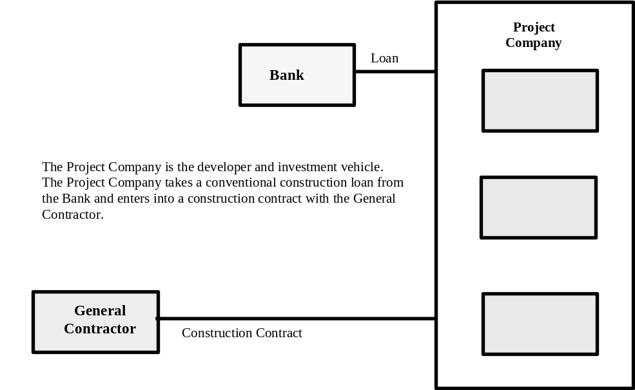

Analysis of a conventional lending transaction reveals immediately that the Bank has no relationship with the General Contractor (other than pursuant to conventional consents to assignment and exercise of rights). The Bank’s relationship is exclusively with the Project Company, its borrower. The General Contractor’s relationship is exclusively with the Project Company (again, except for such consents). The Project Company is generally a special purpose vehicle, such as a limited partnership or a limited liability company, formed exclusively to effect the construction and subsequent sale of the project. The project is usually sold soon after it has reached stabilization (i.e., a given level of occupancy), whereupon the developer and the investors are paid and the developer moves on to a new project.
As noted above, the entire construction process in the United States is quite standardized. Most importantly, the risk allocations among the various parties to the transaction are standardized and well defined. Variations from these risk allocations are rare, and where such variations do exist they are made at substantial cost, usually to the developer and the Project Company.
One of the greatest challenges in the development of the shari^{c}a-compliant construction finance program was to effect that program in such a manner as to place each of the parties in the same risk-allocated position such party would have occupied in a conventional loan financing. Another critical requirement was to develop the structure so that it could be implemented at essentially the same cost as a conventional loan financing. Failure to achieve these results would render the transaction prohibitively expensive to one or more parties, usually the Bank or the Project Company, and would render the financing structure non-competitive in the United States market. The diminution in return resulting from increased transaction costs or significant pricing adjustment as a result of reallocation of risk (as compared with a conventional loan financing) would decrease yields and deter necessary equity investment.
Various Islamic financing techniques were considered in the early stages. Some of the considerations related to the inherent merits and shortcomings of the relevant contractual device and its use in a structure in the United States. Other considerations related to the flexibility of a given Islamic contract or structure in the United States legal environment. For example, istisna^{c}-parallel istisna^{c} structures (and variants) were considered and ultimately rejected. Use of an istisna^{c} (or related agreement) was appropriate given the nature of the undertaking to be financed (i.e., construction), but was fraught with difficulties in the United States legal environment. Some of the types of legal difficulties relate to United States bank regulatory provisions that prohibit a bank from owning real property, except for very limited purposes, and the provisions of environmental laws in the United States that provide for liability for an “owner” or an “operator” of real property (and the limited nature of the safe harbor from those liability allocation provisions). Use of an ijara (lease) as the primary document for repayment of the financing was thought desirable from the early stages of the developmental effort because of (a) the flexibility of leases in both the Islamic and the United States legal systems, (b) the widespread use of leases in both Islamic jurisdictions and the United States, (c) the relative standardization of leases in both jurisdictions, and (d) investor familiarity with leases in both jurisdictions.
Consideration was given to a variety of structures that would implement different Islamic contracts, and to the use of a variety of entities that would give effect to the risk allocations required under shari^{c}a precepts in connection with each of the Islamic contracts. The result of those deliberations was that a structure incorporating both an istisna^{c} (construction contract) and an ijara (lease) would provide the greatest flexibility and would result in a risk allocation that best approximated a conventional loan financing.

VI. Development of the Structure and Documentation

This section of this article describes the evolution of the istisna^{c}-ijara structure. An overall diagrammatic summary of the structure is set forth in Figure 2.

Figure 2: Istisna^{c}-Ijara Overall Transaction

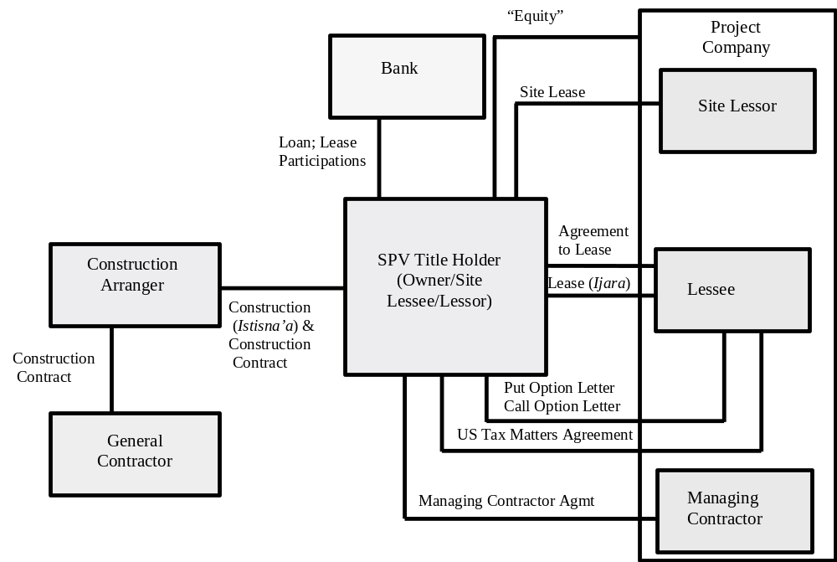

A. General Regulatory Considerations
The first major regulatory issues that arose in development of the structure related to prohibitions on Bank ownership of real property and to environmental liability exposures attendant upon ownership of real property. There are two primary means of addressing this issue: either the Bank has or obtains regulatory approval to own a given project for financing purposes and effects a structure that provides isolation of environmental liability and other adequate environmental liability protections or a structural mechanism is effected to remove the Bank from direct ownership. In the transactions that have been effected, both means have been implemented. In some transactions, the Bank has obtained the requisite approval. In other transactions, a structure has been implemented whereby the Bank does not directly own the improvements; rather, a special purpose vehicle is inserted to own the improvements and lease them to the Project Company.

B. Site Lease
Market and economic constraints were also initial considerations. These types of construction financing are relatively short-term, usually one and one-half to two and one-half years in the residential housing market. Because they are construction financing, there is no income to the project during the construction period and there is no repayment of the financing during the construction period (with capitalization of interest during construction in most transactions). At the end of the construction period the project is sold and the investors cash out, with the developer moving on to other projects. Recordation and transfer taxes upon any transfer of the real property, if incurred more than frequently than upon acquisition of the undeveloped land and upon a sale of the improvements and the land to a third party, would make the transaction uneconomical. As a result, for example, it is economically advantageous to have land ownership stay with the Project Company (rather than being transferred to the Bank affiliate which is the title owner of the improvements on the land).
This led to the creation of a site lease (the “Site Lease”) whereby the land is leased by the Project Company, as the site lessor, to the Bank affiliate that owns the improvements being constructed (the “Owner”), as the site lessee, to allow the Owner to construct those improvements on the land. The Islamic structure that may or may not continue upon a default by the Project Company or a sale of the project to a third party. Thus, the site lease was constructed as a unique document with each provision being bifurcated to provide for the situations where (i) the Islamic structure is in effect, and (ii) the Islamic structure is not in effect. The Site Lease is unusual in other aspects as compared to a customary United States ground lease for a project financing or real estate financing. The differences from a conventional ground lease relate to applicable Islamic shari^{c}a precepts and to risk allocations that must be made to accommodate use of the istisna^{c}-ijara structure in the United States with parties that are accustomed to a specified pattern of risk allocations. As examples of such differences, in the istisna^{c}-ijara structure, the site lessor, as owner of the site, retained responsibility for environmental liabilities, the state and condition of the site, unforeseen circumstances pertaining to the site, compliance with legal requirements by the lessee under the Lease (ijara) (as hereinafter defined), and payment of taxes and other amounts, among other things. In addition, the site lessor has the obligation to prevent unlawful use of the site, unlawful conditions on the site, and other uses of that site that may give rise to damages or liabilities pertaining to use or occupation of that site, including compliance with environmental laws. The Project Company, as the site lessor, also provided indemnities to the Owner and other indemnities in respect of such matters. This allocation of risks and responsibilities, while variant from United States practices, is more harmonious with shari^{c}a precepts.

C. Construction (Istisna^{c}) Agreement and Construction Contract
The development of the primary financing documentation began with a consideration of a conventional loan agreement and a customary construction contract. Specific attention was devoted to (i) how such an agreement allocates risks, and varies the risk allocations over time (for example, during the draw-down period and during the repayment period), and (ii) the mechanics of effecting those risk allocations. Various provisions of a conventional loan agreement relate to the “lending” portion of the financing transaction. These include, in whole or in part, the commitment to lend, the disbursement mechanics, the conditions precedent, the representations and warranties, and the covenants. Other provisions of a conventional loan agreement relate to the “repayment” portion of the financing transaction. These include, in whole or in part, rate calculations, amortization provisions, representations and warranties, covenants, events of default, remedies, indemnities, mandatory prepayments, and voluntary prepayments. The analysis of the customary construction contract revealed a range of provisions that would be incompatible with an Islamic construction contract (an istisna^{c}) and these were identified.
It was determined that, for analytical and drafting purposes, the conventional loan agreement should be torn down the middle, with the “lending” half going into the istisna^{c} and the “repayment” half going into the ijara. Drafting commenced with the istisna^{c} (the “Construction (Istisna^{c}) Agreement”). There were two main tasks to give effect to preservation of conventional risk allocation and compliance with shari^{c}a precepts. The first was to incorporate the “lending” half of the conventional loan agreement into the Construction (Istisna^{c}) Agreement, and the second was to purge the transaction of elements of the customary construction contract that are offensive to shari^{c}a precepts. The various “lending” elements in a conventional loan agreement were considered one-by-one and modified for incorporation in the Construction (Istisna^{c}) Agreement. Thus, the lending commitment became a commitment to pay for construction milestone payments in the requisite amount of the total construction cost for the improvements (the “Total Construction Cost”). The conditions precedent to advances on the loan became conditions to payment of milestone payments in respect of construction, although this requires various modifications to reflect shari^{c}a precepts. Incorporation of appropriate loan agreement representations and warranties and covenants, each in modified form, was a much easier task, and these were combined with the customary representations, warranties and covenants of a customary construction contract. Finally, the Construction (Istisna^{c}) Agreement became a two-part document comprised of (a) standard Islamic istisna^{c} provisions plus the incorporated and modified loan agreement provisions, and (b) the customary construction contract used by the General Contractor for that transaction (the “Construction Contract”). One section of the Construction (Istisna^{c}) Agreement was then developed expressly to sanitize the offensive provisions of the Construction Contract for Islamic purposes.
Realizing that the Bank and the General Contractor would each be different for each transaction led to further structural decisions. Each Bank has its own standard requirements pertaining to documentary provisions. It has standard lending mechanics that relate to the operational organization and procedures of that Bank. It has its own standard representations, warranties and covenants that relate to its own credit requirements and its own business practices and methods. Similarly, each General Contractor has its own standardized construction contract. This led to development of the Construction (Istisna^{c}) Agreement in modular form, which allows for substitution of modules depending upon the identity and requirements of specific Banks and General Contractors. It also allows each General Contractor to use its customary form of Construction Contract without modification, and without the necessity of involving the General Contractor in the Islamic structure. The project developer will then negotiate the Construction Contract directly with the General Contractor, as it would in a non-Islamic transaction. The project developer will not execute the Construction Contract, however. Instead, the Construction Contract will be executed by a special purpose vehicle that is established to act as the construction arranger for the transaction (the ‘Construction Arranger”). The Construction Arranger will then cause the General Contractor to build the project for a fixed amount, the Total Construction Cost. The Construction (Istisna^{c}) Agreement, in turn, will be executed by the Construction Arranger and the Owner.
Payments under the Construction (Istisna^{c}) Agreement are made in the same manner, on the same schedule and subject to the same conditions that advances would be made in connection with a conventional construction financing arrangement. Those conditions precedent that would be conditions precedent to the initial advance and all subsequent advances in a conventional construction financing are conditions precedent to the making of payments under each Construction (Istisna^{c}) Agreement. Conditions precedent for subsequent advances are addressed through the construction payment request mechanism, which, in turn, incorporates a milestone completion payment mechanism. Thus, for example, the General Contractor, the Construction Arranger and the Managing Contractor (as hereinafter defined) will prepare payment requests and milestone completion certificates that will resemble advance requests in a conventional construction financing. The obligation of the Owner to make such payments will be conditioned upon compliance with performance of matters relevant to the payment request.
In the event that a payment request cannot be given due failure of the Project Company to satisfy one or more of the relevant conditions precedent, the General Contractor and the Construction Arranger will continue to be entitled to pursue their respective rights to payment, but only against the relevant Project Company. However, as discussed later in this article, it will have to do so under the Managing Contractor Agreement and certain other documents. The amount of damages that a General Contractor and the Construction Arranger will be entitled to collect will be limited to amounts obtainable from the Project Company and other amounts payable through performance bonds, warranties, completion bonds, insurance proceeds and similar arrangements. Neither the General Contractors nor the Construction Arranger is entitled to pursue remedies against an Owner for failure to perform a funding condition.

D. Lease (Ijara) and Agreement to Lease
Drafting of the ijara (the “Lease (Ijara)”), with incorporation of the “repayment” half of a conventional loan agreement, was simultaneously undertaken. A standard triple-net financing lease was chosen as the base model because of its familiarity to the investment community and its comprehensive treatment of most lease financing issues. It was relatively easy to incorporate the repayment half of the conventional loan agreement into the Lease (Ijara), although significant issues arose with respect to capitalization of profit amounts during the construction period, which proved to be one of the most difficult issues in the transactions. And the Lease (Ijara) had to be modified to address shari^{c}a precepts pertaining to, among other things, retention of structural maintenance by the bank entity that owned the improvements and the doctrines pertaining to adequacy of sufficient value and benefit to the lessee to permit leasing of the improvements.
The Lease (Ijara) is the primary financing document on the repayment side of the transaction. The Project Company, as the lessee (the “Lessee”), repays the financing amounts made available by the Owner through the payment of periodic basic rent (the “Basic Rent”). Commencing upon an agreed date, the Lessee will be required to begin paying Basic Rent in installments over the agreed rental period (the “Rental Term”).
The Lease (Ijara) was executed at the same time as the other financing documents. However, the Lease (Ijara) cannot become fully effective at such time due to a shari^{c}a principle that prohibits the payment of rent for an asset until that asset has sufficient economic value, sufficiency and benefit for shari^{c}a purposes, i.e., until the asset can be, and is, put to the intended use and the Lessee derives the intended benefits from the leased property. Different shari^{c}a boards take different positions as to when an asset has sufficient economic value, sufficiency and benefit. This determination is dependent upon the specific facts of the project being considered. For example, each of the Maconda Park Project and the Truman Park Project is comprised of numerous buildings, including common buildings, and with each apartment building containing many units. Construction commences with the common building and then the first apartment building and moves in sequential fashion through each of the buildings. As a result, the first building will be completed and occupied prior to completion of construction on the last building. Rental activities with respect to the buildings will thus commence substantially before the entire project is constructed.
Under one of the strict interpretations of relevant Islamic principles, shari^{c}a boards may allow an ijara to become effective only on a building-by-building basis as construction nears completion. Such an interpretation might require the use of a dozen lease (ijara) agreements (assuming a eleven buildings and common property), and twelve construction (istisna^{c}) agreements, to provide financiers with required certainties of repayment and perfected security interests over all funds advanced in respect of construction. This, in turn, might require twelve filings under local law of memoranda of leases, mortgages and other security agreements. Filing and recordation fees, and title insurance costs, alone might make such an approach prohibitively expensive. Such a transaction would be complicated and difficult to implement. Other shari^{c}a boards acknowledge the practical difficulties of multiple filings of mortgages and have taken a pragmatic view of the financing process in Europe, the Middle East, Southeast Asia, and the United States. Those shari^{c}a boards have allowed a single lease (ijara) to become effective as to all provisions other than the Basic Rent (and related) provisions at the inception of the transaction. The boards have allowed the Basic Rent (and related) provisions to become effective at the time that marketing and rental activities commence with respect to any part of the project or some other similar date that relates to commencement of binding activities in respect of rent generation. The date of effectiveness of the Basic Rent provisions (“Full Effectuation Date”) for the projects is then determined in accordance with relevant shari^{c}a principles as specified by the shari^{c}a board. This concept was embodied in a separate agreement to lease (the “Agreement to Lease”) which activates the Basic Rent provisions when the relevant shari^{c}a criteria in respect of value, sufficiency and benefit have been met.
The GIH shari^{c}a board that considered the structure of, and documentation for, the Maconda Park Project and the Truman Park Project was intimately involved in defining and implementing the mechanism for determining the Full Effectuation Date. The GIH shari^{c}a board took a rigorous position with respect to the determination of sufficient economic value, sufficiency and benefit (as have subsequent shari^{c}a supervisory boards that have approved this istisna^{c}-ijara structure). However, based upon the factual configuration of each project and its development, the GIH shari^{c}a board also allowed each of the transactions to be structured using a single Lease (Ijara), a single Construction (Istisna^{c}) Agreement, and a single set of Security Documents (subsequent shari^{c}a boards have also allowed the single document structure). If the Full Effectuation Date has not occurred by a stated date, then the Owner may cause the Project Company to purchase the project in accordance with the Put Option (as hereinafter discussed).
Pursuant to the Lease (Ijara), the Owner, as the lessor (the “Lessor”), leases the improvements, and subleases the site, to the Project Company, as the Lessee. The improvements and the site will be leased and subleased, respectively, as-is, where-is, as the same is constructed or otherwise provided to the Owner. Property becomes subject to the Lease (Ijara) on a continuous on-going basis as construction is completed and, as hereinafter discussed, the project is inspected and accepted by the Managing Contractor. Except as prohibited by applicable shari^{c}a precepts, the Lease (Ijara) is a triple net lease, with all costs associated with the use and operation of the relevant Project being payable by the related Lessee, and with broad indemnity provisions similar to those found in triple-net financing leases, although such indemnity provisions must themselves be modified to comply with shari^{c}a precepts. The Lessee has and will have the right to operate and use the project and the obligation to maintain the project (except, for example, that structural maintenance will remain the responsibility of the Owner as the Lessor).
The Basic Rent payable under the Lease (Ijara) has been structured to include a profit to the Lessor. The profit amount is determined on the basis of a weighted group of LIBOR reference rates for different time periods and advance allocations (the “Lessor Profit”). The Basic Rent is due and payable on the leased assets (i.e., the relevant improvements) commencing upon the Full Effectuation Date or a later scheduled repayment commencement date thereafter. The Basic Rent payable at any given time is a pro rata portion of the Total Construction Cost paid to the Construction Arranger at such time, plus the Lessor Profit on such amount. Thus, the Basic Rent will be re-determined on a time schedule (for example, a monthly basis) in lock step with the payments by the Owner to the Construction Arranger. This arrangement keeps the Basic Rent Payments in harmony with the on-going partial payments in respect of the Total Construction Cost and the increase in the portion of the project that has been completed, inspected, and accepted. The mechanism for achieving this recalculation of Basic Rent, which involves change orders accepting completed work, has been structured so as to comply with relevant Islamic shari^{c}a precepts and does not involve an uncertain rent amount under such precepts. Change orders for each transaction will become effective only when agreed upon by the Construction Arranger, the General Contractor, the Managing Contractor, the Owner, and the Lessee. Part of such approval process will include an addition of such items to the leased asset base under the Lease (Ijara) in the relevant period (i.e., for future periods).
The standard supplemental rent provision is used to provide for payment of costs of use and operation of the project above and beyond the Basic Rent (the “Supplemental Rent”). Supplemental Rent includes taxes, impositions, third-party payments, and indemnity payments. Pursuant to the sublease arrangement for the site under the Lease (Ijara), the Lessee is responsible to pay the rent under the Site Lease directly to the site lessor. Basic Rent, Supplemental Rent, and such site rent are collectively referred to as “Rent.”
In the event that the Lease (Ijara) is terminated during the Rental Term, and in a case where no long-term financing takes out the construction financing pursuant to the Lease (Ijara), all Rent due to such date of termination or otherwise permissible under relevant shari^{c}a precepts will be immediately due and payable. In addition, the Owner will be entitled under the Put Option Agreement to cause the Project Company to purchase the project at such time.
Various shari^{c}a precepts pertaining to leases resulted in the Lease (Ijara) being structured differently from customary United States leases. For example, under shari^{c}a precepts, a lessor must retain responsibility for structural maintenance of the leased property. The obligation for structural maintenance cannot be passed to the lessee under an ijara. Similarly, some shari^{c}a boards require the lessor to retain the obligation to provide property casualty insurance. The Lease (Ijara) for each of the Projects was structured in compliance with these, and other similar, shari^{c}a precepts.
The events of default in the Lease (Ijara) are those that are customary for a lease of such type, and include most of the events of default usually found in a conventional construction financing. Certain other events constitute events that permit the purchase and sale of the project under the Put Option (as hereinafter discussed). As with a conventional construction financing, an event of default will allow the Lessor a broad choice of remedies, including the ability to terminate the Lease (Ijara) and related arrangements, to sell the project, and to collect the purchase price in respect of such sale. The remedies provisions have been structured to reflect those available to a lender in a conventional loan financing. The overall structure also allows the Owner to exercise its right under certain of the financing documents to suspend or cease making payments to the Construction Arranger (and thus the General Contractor) upon the occurrence of events of default under those documents, assign rights under the Lease (Ijara) (and/or related documents) to the related General Contractor in certain circumstances, and be relieved of further liability to the General Contractor, the Construction Arranger and the Lessee.

E. Put Option and Call Option
It proved difficult to incorporate some elements of the conventional loan agreement in the Lease (Ijara) due to the application of shari^{c}a precepts. This was particularly true of the mandatory prepayment and voluntary prepayment provisions. It was determined that these provisions would not be incorporated in the Lease (Ijara). Instead, certain of these would be incorporated in a put option agreement (and the Lease (Ijara) (the “Put Option”) and a call option agreement (the “Call Option”) that complied with shari^{c}a precepts applicable to sales of property. The Put Option allows the Owner to compel the Project Company to purchase the project in certain circumstances. The Call Option allows the Project Company to purchase the project from the Owner at any time in order that the Project Company may effect a sale of the project to a third party, and use the proceeds of that sale to repay the financing. Circumstances in which a sale will be permitted under the Put Option include defaults under the Lease (Ijara) or the other financing documents, including the failure of the Project Company to make payments or to accept any property that is required to be subject to the Lease (Ijara) or the other project documents, termination of the Lease (Ijara), the Site Lease, the Managing Contractor Agreement, and certain other agreements prior to the last day of the stated Rental Term, certain agreed termination events, illegality, and certain termination events relating to excess payments in respect of the Project. There are significant shari^{c}a issues with respect to any Put Option as put options are generally considered to be executory agreements that are cancelable by either party to the options. With the assistance of the GIH shari^{c}a board, the Put Option (and the Call Option) for the Maconda Park and the Truman Park transactions were structured to comply with shari^{c}a precepts applicable to valid sale and purchase agreements. Subsequent reviews by other shari^{c}a boards have resulted in variations on this aspect of the structure for different types of transactions.
A range of shari^{c}a precepts are applicable to irreparable damage or destruction of assets and to the application of insurance, condemnation, or similar payments that are received in respect of destroyed assets. These precepts require termination provisions to be structured quite differently than conventional construction and project financings. However, within the ambit permitted by applicable shari^{c}a precepts, the transaction must be structured to insure full repayment of all financing amounts and put the financiers in the same position they would occupy in a conventional financing. In the istisna^{c}-ijara structure, including the financings for the Maconda Park Project and Truman Park Project, upon destruction or total condemnation of the relevant project, the Lease (Ijara) will terminate immediately as required by shari^{c}a precepts, the Rent then due and payable (but not future rents) will be paid to the Lessor, the Project Company will be required to purchase the project and pay the purchase price therefore, and the proceeds of such insurance, condemnation, and other payments will be applied to the payment of the purchase price for the project (and related transfer costs) and any excess thereafter remaining will be paid over to the Project Company. Difficult issues arise in connection with the determination of the relevant purchase price as shari^{c}a principles generally restrict payments to the fair market value of the project after the event of destruction or condemnation.
Upon any purchase by the Project Company of the project, the Construction (Istisna^{c}) Agreement (and related rights and agreements) will be assigned to the Project Company and the Project Company will assume all of the obligations of the Owner thereunder. Similarly, all insurance policies and warranties will be assigned and assumed such that the Project Company is afforded complete ownership rights.

F. Managing Contractor Agreement
Other elements of the conventional loan agreement, and a variety of risks that are allocated to the Bank (through the Owner) in one form or another (and which would not be so allocated in a conventional financing), were addressed in a separate agreement, the managing contractor agreement (the “Managing Contractor Agreement”) between the Owner and the Project Company acting as the managing contractor (the “Managing Contractor”). As previously noted, Islamic shari^{c}a precepts require an Owner to retain obligations in respect of structural maintenance of the improvements. Other shari^{c}a precepts pertain to inspection of property being constructed, responsibility for latent defects, acceptance of leased (or purchased) assets, and operation and maintenance of leased assets. In order to achieve, as closely as possible, the risk allocations found in a conventional financing, it was necessary to structure the transaction in reliance upon a body of shari^{c}a principles that allows an owner of property to contract with other entities to perform activities on behalf of the Owner. Generally, these principles pertain to concepts of agency and contracting for services under the shari^{c}a. Those principles also incorporate certain of the doctrines of Western jurisprudence applicable to the retention of independent contractors to perform activities on behalf of a property owner.
It is permissible under applicable shari^{c}a precepts for the Owner to retain the Managing Contractor to perform certain of the activities retained by the Owner under the Lease (Ijara) and accept responsibility for them in connection with the performance of its duties. The istisna^{c}-ijara structure (and the Maconda Park and Truman Park transactions) have been structured to allow the Owner to hire and appoint the related Project Company as the Managing Contractor for the primary purposes of (a) supervising and managing the design, engineering, and construction of the project by the General Contractor and the Construction Arranger, (b) inspecting the project, (c) accepting delivery of the project, (d) enforcing the rights of the Owner as against the related General Contractor and the Construction Arranger, and (e) operating and maintaining the project, all pursuant to the Managing Contractor Agreement.
This Managing Contractor Agreement has been structured such that the Managing Contractor bears the risks (i) of construction of the relevant Improvements in compliance with specifications and other terms and conditions of the Construction (Istisna^{c}) Agreement (including the Construction Contract) to the extent permissible applying shari^{c}a precepts pertaining to the options of inspection and defect, and to precepts applicable to supervision and acceptance, and (ii) for maintaining the structure of the project and certain related matters throughout the Rental Term. The arrangement facilitates immediate and continuous inspection and acceptance by the Project Company of the work and assets comprising the project and insures on-going maintenance of the project, including in respect of its structural integrity. In accordance with shari^{c}a precepts, the Owner, as the title-holder of the improvements, retains some of the exposure on these items. The liability exposure of the Owner for such defects and conditions will be limited by express substantive provisions and by provisions that limit the payment obligation of the Owner to amounts actually collected under applicable warranties, performance bonds, completion bonds, guarantees, insurance policies and similar documents and instruments. Similarly, claims of the Project Company under the Lease (Ijara), and other documents, against the Owner, including as the Lessor and the owner of the project, are limited to amounts collectible from the Managing Contractor, the General Contractor, the Construction Arranger, and relevant insurance policies, performance bonds, completion bonds, warranties, guarantees and similar documents and instruments.
The Managing Contractor also has responsibility for enforcing the insurance agreements, condemnation award proceedings, performance bonds, completion bonds, warranties, and similar documents and instruments in respect of the project, although these obligations and related rights are restricted in various situations (such as default scenarios) and are subject to defined parameters. This arrangement removes the Owner from involvement in the enforcement process to the greatest possible extent. The Managing Contractor Agreement extends to enforcement, on behalf of the Owner, of any claim under the Construction (Istisna^{c}) Agreement that the Owner may have against the General Contractor or the Construction Arranger. As a corollary, in any circumstance where the claim of the Project Company relates to any matter covered by insurance, bonds, warranties, or similar arrangements, the Project Company’s damage recovery will be limited to amounts recovered thereunder or otherwise from the relevant General Contractor and the Construction Arranger.

G. Tax Matters Agreement
The Tax Matters Agreement has been designed to afford legal recognition to the fact that the istisna^{c}-ijara structure is a financing arrangement under applicable United States law. Various characterizations are also made under relevant state law (for example, New York law for the financing, and the relevant state law for mortgage and other real property purposes). These characterizations may be somewhat different than those appearing in the Construction (Istisna^{c}) Agreement or the Lease (Ijara). For example, the Tax Matters Agreement clarifies that the entire transaction is, for purposes of United States tax law and applicable state law, a loan financing, and that all amounts (other than costs and expenses) payable to an Owner in excess of the Total Construction Cost are to treated as interest for United States tax and bank regulatory purposes. This is important in order to allocate tax benefits (such as depreciation, interest deductions, and various project expenses) to the Project Company (and thus to the investors, including the Islamic Investors). It additionally allows payments to Islamic Investors that are not United States persons to be made without tax withholding in accordance with the relevant portfolio interest provisions of Internal Revenue Code. Environmental matters are also addressed in this agreement, with the Project Company having all risks in respect thereof as regards any exposure of the Owner.

H. Miscellaneous Documents
Various consents and other documents have been structured to specifically address structural matters, including shari^{c}a principles. For example, payment obligations of the Owner under the Construction (Istisna^{c}) Agreement cannot be conditioned on the status, actions, or omissions of the Lessee under the Lease (Ijara). Thus, a default by, or bankruptcy of, the Lessee will not relieve the Owner of its obligation to make payment to the Construction Arranger under the Construction (Istisna^{c}) Agreement, except in certain circumstances. Documents have been structured to address this difference from a conventional construction financing in a manner that puts the various parties, as nearly as possible, in the same position they would occupy in such a conventional financing. This is effected in part by documents that provide for agreed methods of enforcement of claims and agreed limitations on damage amounts and sources of damage awards or compensation in delineated circumstances. For example, in certain situations awards and damages are limited to amounts collected in respect of insurance policies, warranties, performance bonds, completion bonds, guarantees, other similar documents and instruments, and other security and amounts available from the estate of the bankrupt entity. In other situations, mandatory and voluntary assignments of rights and assumptions of liabilities, temporary and permanent, are operative to reallocate risk and responsibility to effect the allocations that would exist in a conventional financing.

I. Summary of Primary Documents
In summary, the primary documents for the construction and mini-perm financing of each of the Maconda Park Project and the Truman Park Project are, in each case:

- “Site Lease”: The lease of each of the site (and assignment of related easements) and the remainder of each of the relevant premises from the Project Company, as the site lessor, to the Owner, as the site lessee, to allow the Owner to occupy the site and cause construction and leasing of the improvements thereon;
- “Construction (Istisna^{c}) Agreement”: The shari^{c}a-compliant construction contract between the Owner and FF Development, L.P., as the general contractor (in the Maconda Park Project) and between the Owner and the Construction Arranger (in the Truman Park Project), in each case for the construction of the improvements for the relevant project, having attached thereto the Construction Contract (with FF Development, L.P., in the Maconda Park Project; and with Bovis Lend Lease, Inc., in the Truman Park Project), including the specifications and details of the cost of construction;
- “Construction Contract”: A standard construction contract between the General Contractor and the related Owner (in the Maconda Park Project) and between the Construction Arranger and the General Contractor (in the Truman Park Project) with respect to construction of the improvements for the relevant project, including all specifications for such improvements;
- “Lease (Ijara)”: A lease of the improvements constituting part of the project, and a sublease of the site and the remainder of the premises for the project, from the Owner thereof to the each of the relevant Project Company;
- “Put Option Agreement”: An agreement allowing each Owner to cause the related Project Company to purchase the project at various times and under various circumstances at the election of such Owner;
- “Call Option Agreement”: An agreement allowing the Project Company to purchase the project from the Owner at various times and under various circumstances at the election of the Project Company;
- “Managing Contractor Agreement”: An agreement between the Owner and the Project Company pursuant to which the Project Company performs various construction and operation activities as the representative of the Owner; and
- “Tax Matters Agreement”: An agreement to clarify the characterization of the transaction for United States tax and other laws.

J. Taking it to the Bank, the Board and the Market
Having arrived at a general structure that was thought workable and compliant with shari^{c}a precepts, there remained a critical issue of convincing the relevant parties that the structure worked to cover all risks covered in a conventional loan financing and allocate those risks as they would be allocated in a conventional loan financing. The first tasks in this regard were to make that demonstration to the KeyBank credit committee and the GIH shari^{c}a board. With regard to KeyBank, we determined to make the demonstration by taking each provision of the conventional loan agreement (and the other documents used in a conventional loan financing) and itemizing it on a spreadsheet. We then noted on the spreadsheet where and how that risk was addressed in the istisna^{c}-ijara documentation. As one might imagine, this was a long and arduous process. But it successfully proved the point that there is near identical coverage and equivalency in risk coverage and allocation in the conventional loan financing and the Islamic financing. KeyBank, N.A. and, in particular, Key Global Capital, Inc., made a substantial and creative effort in developing the istisna^{c}-ijara program (and other Islamic financial products) and deserve the highest of accolades for their efforts. Without them, this type of Islamic financing would be purely theoretical at this time in the United States of America.
After receiving the approval of the Islamic structure from the KeyBank credit committee, we were prepared to undertake the first transactions, which is also where the structure and the documentation were considered in detail by the GIH shari^{c}a board. Islamic religious law as applied to commercial activities is comprised, for purposes of this article, of two parts: shari^{c}a (literally, “the Way”), or perfect, immutable, divine law, as revealed in the Qur’an and the Sunna; and fiqh (literally, “understanding”), or the sum of human comprehension of that divine law. While there is dispute among Islamic scholars as to the precise manner in which Islamic law is to be determined, those who determine Islamic law are religious scholars (^{c}ulama’) skilled in interpreting the revealed sources of the shari^{c}a and in financial and economic disciplines. The primary methodology used in this determinative and interpretive effort is ijtihad (literally, “effort”), or legal reasoning. Ijtihad observes a particular methodology, called the “roots of the law” (usul al-fiqh). According to one formulation, the roots (usul) upon which Islamic jurisprudence is based are (a) the Qur’an, the holy book of Islam, (b) the Sunna of the Prophet Muhammad, which comprises the binding authority of his dicta and decisions, (c) the ijma^{c} or “consensus” of the community of scholars, and (d) qiyas, or analogical deductions and reasoning.
The GIH shari^{c}a board was the first to approve the istisna^{c}-ijara structure discussed in this article. The structure was presented to them in connection with the financings of the Maconda Park Project and the Truman Park Project, and the structure was modified and refined with their assistance. Subsequently, the shari^{c}a boards of ABC Islamic Bank, Abu Dhabi Islamic Bank and Saudi Economic & Development Company have also considered and approved this structure, with slight variations, and with insightful modifications and refinements. Given that shari^{c}a board determinations are fiqh (human comprehension of shari^{c}a, the divine law), there can be variations in interpretation and implementation from one shari^{c}a board to another, with a multiplicity of views on a specific issue. These variations occur even though shari^{c}a scholars in this period strive to achieve a consensus on difficult and novel issues, such as those involved in the development of new financial instruments and products. Islamic investors, be they financial institutions or individual investors, rely heavily on the involvement of shari^{c}a boards in the structuring and documentation of a transaction or financial product, and may request that the shari^{c}a board’s fatwa of approval be provided before an investment is made. In developing and implementing the istisna^{c}-ijara structure discussed in this article, we have attempted to retain the flexibility to adapt the structure to the requirements of different shari^{c}a boards and the precepts of the different schools of Islamic jurisprudence.
All of us who are actively involved in Islamic finance are grateful for the wisdom, insight and interest that these shari^{c}a boards have provided and for the assistance the members of these shari^{c}a boards have provided in making new investment opportunities available to Islamic investors and new sources of financing available to United States developers. We have moved one more step in the direction of establishing an Islamic economy that works in harmony with a Western interest-based economy without sacrificing compliance with Islamic principles.
We are also grateful to the developers and the arrangers who have shown a willingness to pioneer the use of these shari^{c}a-compliant structures in the United States of America. As this article indicates, the documentation and structure of the istisna^{c}-ijara transaction is substantially different from that of a conventional loan financing. In an industry where standardization is a refined and near-immutable concept, these entrepreneurs have shown a willingness to blaze a new path and facilitate the introduction of Islamic financing techniques in the United States market. Particular praise must go to the people who comprise Fairfield Residential Properties, Inc. and The Dolben Company, Inc. and their respective affiliates and attorneys. Without their willingness to expend considerable time and effort, structures such as that discussed in this article would remain entirely theoretical goals. Because of them, we have achieved a first-instance implementation of the istisna^{c}-ijara structure in the Maconda Park Project and demonstrated that this shari^{c}a-compliant structure can be refined and used to take out a conventional loan financing, as in the Truman Park Project.

VII. Conclusion

The istisna^{c}-ijara structure discussed in this paper is one of the early efforts to develop Islamic financial products that are competitive in the United States markets with conventional Western financial products. The Maconda Park Project and the Truman Park Project demonstrate that a shari^{c}a-compliant structure can be acceptable to United States banks, real estate developers and construction contractors. And this Islamic product can compete with conventional financing techniques in the United States market. Further, the acceptance and use of this type of structure significantly expands the investment opportunities for Islamic investors. It allows those investors to participate in United States transactions without a compromise in their faith and beliefs. As such, it is an early step in the development of a true Islamic economy. The transactions described in this article, and others, are efforts to lay the critical base and explore the use of a variety of Islamic techniques within a framework that must acknowledge the critical security, credit, economic, cultural, religious and legal concerns of both Western and Islamic participants. These techniques and structures will be further refined to achieve greater simplicity, increased economics of implementation, and a smooth interface between a Western interest-based system and an Islamic interest-averse system. New structures are being developed as more and more Western financial institutions move into Islamic banking, which is an accelerating trend.
The istisna^{c}-ijara structure is being widely used at this time. It is being applied in the financing of residential, commercial and industrial real estate projects throughout the world. The availability of a practical Islamic structure of this type has also given rise to the development of a range of related Islamic financial products. Consider, for example, Islamic investment funds. The author is currently working on a number of real estate funds, both closed-end and open-end funds, that will use this structure (and a similar acquisition structure). Two of those funds will pool investments in residential properties in the United States, with all of such investments being made pursuant to the istisna^{c}-ijara structure. Two other similar funds will invest in properties and projects in Europe, Southeast Asia, Australia, New Zealand, Canada and the United States. Those funds will use the istisna^{c}-ijara structure for new construction and a similar acquisition structure for recently-completed and seasoned commercial and industrial properties. The transactions involving commercial and industrial properties will incorporate shari^{c}a screens similar to those applied to equity investments in order to screen tenants of the properties. All of these funds will contain diversification elements heretofore not seen particularly as to geography, tenant base, and other characteristics. The funds will be sold to Islamic investors, primarily in the Middle East and Europe.
The istisna^{c}-ijara structure is also being applied to equipment and vessel financing, including shari^{c}a-compliant ijara charter parties for liquefied natural gas tankers. This will enable Islamic construction financing for those vessels and the development of related financial instruments to allow Islamic investment in those financing, a particularly pertinent development in light of the fact that most growth in this market over the next decade will relate to gas sales between the predominantly Muslim countries of the Middle East and the predominantly Muslim countries of Southeast Asia.
To date, most of the investment by Islamic investors in United States transactions has been of “equity.” In the Maconda Park Project and the Truman Park Project, GIH made equity investments in the Project Company. But there are significant opportunities to expand the range of Islamic financial products deriving from the existing istisna^{c}-ijara structure. For example, the “debt equivalent” or “financing” portion of the transactions can also be sold, individually or in a pool. These are essentially participations in the Lease (Ijara) and the Basic Rent that is paid thereunder. These can be, and are being, structured in a shari^{c}a-compliant manner for sale to a different group of institutional Islamic investors. Other opportunities exist, as well. As pools are built of these leases, shari^{c}a-compliant instruments can, and are being, structured for sale at the retail level in the Middle East. These instruments can be structured as very short-term shari^{c}a-compliant instruments and sold to Middle Eastern Islamic retail investors that are presently receiving little or no return on their investments. The yield to such investors can be substantially lower than to other investors, with great benefit to those investors (in terms of a much greater yield than they presently obtain), and a great benefit to United States developers (because the cost of funds is substantially lower than can be obtained from other more traditional sources). If these investments are properly structured, Middle Eastern Islamic investors should have a competitive edge in the United States markets for some time to come.
The future for shari^{c}a-compliant project financing is bright. The structures discussed in this article, and many others, involve joint participation by both Western and Islamic investors and transactional participants. This is true at all levels of the project cycle, and as to both equity and the “debt equivalent” financing. This is leading to greater familiarity of Western financiers with the Islamic market and its significant opportunities and Islamic investors and their sensitivities. And that, in turn, is resulting in enhanced interest and involvement of Western financial institutions in the development of not only Islamic project financing techniques, but a wide range of other Islamic financial products. From the vantage of both financiers and legal practitioners, there is a marked movement toward the development of an Islamic alternative to each Western financial product and the development of a true Islamic economy that interacts seamlessly with the Western interest-based economy, without compromise of principle or faith.

Shari^{c}a Principles and Their Application
Examples from Islamic Finance

Muddassir H. Siddiqui *

Abstract

The Qur’an and the Sunna are not books of law or shari^{c}a. They are sources of theological, ethical, spiritual and legal guidance. In these sources we find some laws but mostly we discover the objectives of the shari^{c}a and its guidance for developing further Islamic rules and laws. We must distinguish between the principles and the rules (ahkam) of the shari^{c}a. The principles of the shari^{c}a, as mentioned in or derived from the text of the Qur’an, are permanent and applicable at all times and in all circumstances. Ahkam may be permanent, or open to modification as the time and place require. Changes in ahkam, however, must be based on and justifiable under the principles of the shari^{c}a. Muslim jurists need to develop Islamic criteria for determining the permissibility and impermissibility of specific financial insruments, with an understanding of the underlying shari^{c}a reasoning and wisdom (hikma) behind various prohibitions mentioned in the Qur’an and the Sunna. For instance, jurist must look into the purposes and rationale for the prohibition of usury (riba) and then develop a precise definition of usurious transactions. Modern financial transactions must be examined on the basis of the basic principles of the shari^{c}a, and not merely on the basis of their conformity to the form at the expense of the substance. Islamic products should not merely camouflage the interest element contained in traditional products; they should rather conform to both the letter and the spirit of shari^{c}a concerns, while at the same time representing transactions that are commercially viable when compared to conventional products.

I. The Sources of Islamic Law

The Qur’an and the Sunna of the Prophet are the two basic sources of the shari^{c}a or Islamic law. The Qur’an is the divine scripture revealed to the Prophet. The Sunna consists of the Prophet’s sayings (aqwal), actions (a^{c}mal), and confirmations (taqrir, that is, what he approved and/or did not object to among the actions of others in his presence). There is a mistaken impression that qiyas (analogy), ijma^{c} (consensus of opinion) and ijtihad (the endeavor to develop the rules of the shari^{c}a from the latter’s sources) are also sources of Islamic law. In fact, these are only tools to develop the rules of the shari^{c}a.
The Qur’an and the Sunna are the two sources of guidance (hidaya), but are not a constitution or codes of law, as these terms are commonly understood among modern scholars of jurisprudence. The two sources serve as guides to Muslims, and set very broad parameters within which Muslims may develop constitutions and legislation, promulgate rules and regulations, and enact and apply rules of enforcement, to meet society’s changing needs.
The legal injunctions in the Qur’an and the Sunna are found in various forms. Some are specific, such as the prohibition of pork. Most are more general, such as the injunction to keep one’s covenants and to not indulge in usury. The general injunctions are seldom accompanied by precise elements for the underlying prohibition or permission. In fact, a very small portion consists of purely legal verses, such as the verses describing the punishment for murder or the distribution of inheritance.
However, it would be wrong to conclude, as some have done, that the Qur’an and Sunna are inadequate for the complex legal needs of humanity at various times. A closer analysis of the sources of the shari^{c}a shows that what appears to be purely ritualistic, doctrinal or historical on the surface can actually play an important role in enacting regulations for a Muslim community. For instance, the Qur’an says:

O mankind, We created you from a single male and female and made you into nations and tribes that you may know one another. Indeed, the noblest among you in God’s sight is one who is most righteous among you.

This verse is not accompanied by a legal injunction, or specifically prohibited actions, but nevertheless provides principles for a society to develop its own detailed code of ethics and laws, under which no discrimination on the basis of race or ethnicity can be tolerated.
The concepts of life after death and accountability in the Hereafter, which are repeatedly mentioned in the Qur’an, may appear in the first instance as irrelevant to regulating life on earth and therefore are not legal norms. The Prophet Muhammad is reported to have said:

O people you come to me with your claims, and perhaps some of you are more persuasive in their argument in front of me than the others. I [the Prophet] only judge on the basis of what I hear. Thus if I give someone something, which in reality, does not belong to him, he may take it, but remember he will only be taking a piece of hellfire.

Imagine the positive effect of this saying on a society struggling to control floods of frivolous lawsuits and exaggerated demands for compensations by plaintiffs who do not hesitate to falsify claims of injury, or to blame others for their own negligence.
Thus, the fact that these two sources do not set forth a set of laws for all circumstances of human behavior is not a deficiency. In fact, it is arguably a blessing that the shari^{c}a, instead of establishing a rigid code of law, by its very design allows a society to develop its own rules, and to modify the rules to meet changing circumstances, so long as such rules, and the procedures under which they are promulgated, remain within the limitations (hudud) set forth by the shari^{c}a.
Rules (ahkam) are identified or developed and human actions are scrutinized in the light of the guidance derived from the understanding (fiqh) of the Qur’an and Sunna in their entirety. A matter should not be judged by reading and quoting a single verse and mechanically applying it to a contingency. A jurist (faqih) should comprehend and understand the objectives (maqasid), the principles (usul), the priorities (awlawiyyat), the reasoning (hikam), and the elements (^{c}ilal) of all permissions and prohibitions in the Qur’an and Sunna. The jurist should also have knowledge of the conditions and the circumstances in which the rules are to be applied. Understanding (fiqh) of the totality of the two sources and the circumstances is a must for a scholar to be able to give practical, consistent, rational and comprehensive answers to meet the changing needs of society. A competent jurist must possess intelligence (hikma and firasa) and piety (taqwa) in order to comprehend the sources in totality, and apply them to meet the challenges of the time.
During the early stages of the development of the Islamic fiqh, Muslim scholars exercised a dynamic approach to interpretation, and developed detailed rules (ahkam) appropriate to their times and circumstances. Unfortunately, this form of ijtihad ceased to be practiced by Muslim societies many centuries ago. Most Muslim societies have ceased to administer the shari^{c}a in daily life through an organized and dynamic legal system. As a result, most shari^{c}a rules today are the product of theoretical deliberations and debates among Muslim scholars and jurists, and not of legal precedents created by judges operating within a dynamic Islamic legal system, dealing with real cases, and arriving at practical resolutions.
Because of the long stagnation in ijtihad, for various historical, political and social reasons, the Muslims scholars of today are struggling to bridge the gap—a large gap—between the rules (ahkam) as found in the old books of Islamic jurisprudence, and the demands of modern Muslim societies in developing a comprehensive Islamic code, which is relevant and responsive to contemporary needs. There are many reasons why the process of bridging the gap is fragmented and proceeding at a slower pace than is desirable. The primary reasons are as follows:

- The enormity of the task and the lack of resources. Also, the lack of political and ideological freedom in most Muslim countries does not permit adequate mobilization of existing resources.
- Muslim societies lack truly independent Islamic legislative bodies or even fiqh committees whose credibility is not questioned by the majority of the population.
- Many Muslims fear departing from long-established ways, and prefer strict allegiance (taqlid), to a particular school of law (madhhab) or sect, and hold the statements and opinions of early jurists to be eternal and unchangeable expressions of the shari^{c}a.
- The fear of being thought advocates of “radical” solutions.
- The fear of being labeled “westernized” if one accepts a form of business transaction or law developed by non-Muslims. As a student of both shari^{c}a and American law, I can confidently state that the vast majority of U.S. secular laws do not conflict with the shari^{c}a. In fact, in many cases, such laws provide a more effective way of implementing and enforcing the objectives (maqasid) of the shari^{c}a. There is no reason why a Muslim should not benefit from the efforts and the experiences of others in improving his own life, since the ultimate source of all cures for human physical, spiritual or social ailments is Allah, regardless of who discovered it first.
- Few Muslim scholars today are equally familiar with the rules of Islamic jurisprudence and maqasid of the shari^{c}a, and the objectives of modern laws, accounting, business, economics and other fields.

II. Islamic Finance and Islamic Law

With some exceptions, Muslim scholars are moving slowly toward examining some of the fundamental issues related to Islamic finance. For example, there is no doubt that both the Qur’an and the authentic Sunna prohibit riba, and condemn it in the strongest terms. However, the exact definition of riba, the elements and components of a usurious (ribawi) transaction and the objectives behind the prohibition are yet to be analyzed by Muslim scholars in a rational and objective manner. The second caliph, ^{c}Umar, regretted that the Prophet was unable to identify all the forms of riba, due to his death soon after the revelation of its prohibition. It is reported in Ibn Majah, that ^{c}Umar said: “the last verse related was the verse of riba, and then the Messenger of God was taken. He had not explained it to us. So leave riba and doubt [riba].” The Prophet is reported to have said: “Riba is of seventy-three types. The least of them is like a man having sexual intercourse with his mother.”
It seems Muslims scholars are still searching for filters, screens and tests for determining a transaction as usurious, or purifying a usurious transaction by using those filters. Generally speaking, most Muslim scholars today consider any unequal exchange (sale or loan) between two identical items usurious. Factors such as inflation, time value of money, exploitation of the needy (zulm), the rate of the additional amount (reasonable, single or multiple), and a host of other criteria which may provide a more workable definition are considered irrelevant by most.
Market interest, according to the prevalent opinion of the vast majority of scholars, is considered to be the same as riba and the terms are often used interchangeably. There is felt to be no difference between a pure interest-based transaction, such as one involving borrowing $1,000 dollars for one year at a 5% interest rate, and a transaction in which interest is charged as an integral part of a financing transaction for the purchase or lease of a house or goods.
The inability of scholars to reach a consensus on the definition of the forms of riba has resulted in some Muslims rejecting otherwise perfectly valid conventional forms of business transactions and offering as “Islamic alternatives” transactions which differ only in form, but not in economic substance from their conventional counterparts.

III. Practical Issues in Islamic Finance

Having discussed the historical and theoretical aspects of the shari^{c}a, I now turn to some of the more specific concerns and challenges facing Muslim scholars and lawyers in drafting contracts for Islamic products in America. I will only highlight some of the issues to point out the nature of the practical challenges in developing a viable and marketable Islamic product within the precepts of the shari^{c}a and in compliance with U.S. laws.

A. Shari^{c}a Issues
As mentioned earlier, the vast majority of Muslims and shari^{c}a committees view paying interest on borrowed money as riba. The shari^{c}a committees have thus approved certain Islamic forms of transaction which are structured as sale, lease and partnership, (murabaha, ijara and musharaka) contracts and combined them with varying lengths of long-term installment payments options, as an Islamic alternative to lending on interest-based contracts. This creates various problems when a lease (ijara) or partnership (musharaka) transaction is used for what is essentially a financing transaction on an installment basis. More specifically, they create challenges in areas such as who (the tenant/consumer or the landlord/financier) bears the risk of loss and reward resulting from the appreciation of the property, who should be held responsible for the maintenance of the property, and how to determine the rent (e.g., using prevalent interest rates, rent indexes, etc.). On their own, these challenges are not as difficult to overcome. In the United States, however, a consumer compares his Islamic product with the risks, rewards, and responsibilities or (lack thereof) with the other conventional alternatives available to him, expecting the Islamic product to at least match such alternatives, if not better them.

B. Islamic Vendor Concerns
Most vendors offering shari^{c}a-compliant home financing Islamic products in the U.S. today are either conventional banks or mortgage companies operating under relevant U.S. federal and state laws. Even institutions owned and operated by Muslims, providing home financing services, have to operate under the same laws. There are no separate laws for Muslims to set up an Islamic bank or home financing operation in America. U.S. laws are basically written to implement the purposes and objectives of a Western secular system. The purpose and scope of services of an ideal Islamic bank, for example, would be to engage in mudaraba, pooling financial resources of individual Muslims depositors/investors, investing them in profit-making business ventures and sharing with them any profit or loss. Banks in the West are not allowed to do this. Their primary objective is to take deposits, lend money and provide other financial services. Thus, Islamic vendors organized under U.S. banking laws have to make sure that they do not violate their charter and applicable local laws while providing services to Muslim consumers in accordance with the shari^{c}a.

C. Sources of Funds
Islamic vendors in the U.S. today acquire the funds necessary to assist Muslim consumers either from investors and depositors, or by assigning their contracts in the secondary market to entities such as Fannie Mae or Freddie Mac. Organizations such as the latter two have their own charters and laws, which they are mandated to follow. If an Islamic provider intends to pass his contracts to any one of these organizations, it can only use documents, such as notes, mortgages or deeds of trust provided or approved by these organizations. All this places challenges and constraints on the Islamic vendor, who must comply with the shari^{c}a.

D. Consumer Concerns
Costs: A Muslim consumer rightly expects that the closing costs, markup or rent for buying a home Islamically should not be more than the closing costs and the rate of interest for comparable conventional mortgage products.
Taxes: A Muslim consumer is subject to the same tax liabilities and privileges as any other U.S. resident. One of the major benefits afforded by U.S. laws to buyers of homes using borrowed money on interest is the reduction in annual tax liability. A U.S. Muslim taxpayer rightly expects to also be able to minimize his tax liability. This requires drafting the contract in such a way that, while the Muslim consumers’ monthly payments under the Islamic contract include a portion defined as markup or rent, such portion of the payment should also fit the standards and criteria set by the Internal Revenue Service to qualify it as deductible interest payment. Failing to do so renders Islamic products prohibitively expensive and thus unmarketable.
Title Transfer and Other Fees: Some aspects of rigid compliance with shari^{c}a rules can result in the payment of title transfer fees twice. This concern is known as the “double stamp duty dilemma” in the U.K.. In the U.K., an attempt is being made to change the laws to resolve this concern. Drafters of Islamic contracts in the U.S. need to find some other practical means to avoid double taxation within the existing applicable laws of various states in the U.S.

The shari^{c}a requirements, the legal constraints, the expectations of a Muslim consumer and Islamic vendor, together with the absence of an integrated and cohesive Islamic legal system, pose a great challenge for drafters of Islamic contracts not only in the U.S. but also in most Muslim countries. However, one cannot wait for ideal conditions to exist to practice one’s religion. The process must continue and the search for fundamental issues and substantive solutions accelerate. It is heartening that shari^{c}a scholars and world-class bankers, economists and lawyers, who seldom communicated in the past, are now brainstorming in Karachi, Kuala Lumpur, Bahrain, Geneva, London, Washington and Cambridge, searching for solutions which are not only shari^{c}a-compliant but are responsive to the expectations of Muslim consumers as well as funds suppliers.

IV. Conclusion

We should not be discouraged if the initial response leaves many concerns unanswered. These efforts will eventually give way to more in-depth analysis of the substance of modern financial transactions, and subject them to the objectives (maqasid) of the shari^{c}a. Solutions based on rationality and substantive justice, as guided by the principles of the Qur’an and Sunna, will ultimately prevail. Perhaps there is wisdom in not pushing new ideas at a speed which neither the scholars not the present Muslim community can absorb. Having a thriving Islamic banking and financial system, even if not perfect, is certainly better than having none.
The current developments in the field of Islamic finance and jurisprudence should therefore be viewed as an evolving and transitory process. In time, new ideas and realistic solutions shall gain ground and shape the life of Muslims positively. Islam is a religion of nature and human conscience, and the forces of nature and rationality will play a major role in sorting right from wrong, and technical from substantive. Human conscience guided by revelation and honest collective ijtihad will produce the right answers. As the Prophet Muhammad said, “My people shall not collectively agree on falsehood.”

Credit Enhancement in Ijara Transactions

Robert W. Toan* and Monir Barakat †

Abstract

The last several years have seen a flurry of leasing company failures. As a result, new emphasis is being placed on credit enhancement procedures that seek to protect leasing investors against such failures. However, the rules of Islamic finance may restrict the use of certain types of credit support that are commonly used in conventional finance. This paper examines several types of credit support in conventional finance and corresponding or similar arrangements in Islamic finance. The analysis examines the use of related-party or third-party guarantees; the use of insurance, including residual-value insurance and takaful; over-collateralization and related strategies; and liquidity support.

I. Introduction

The Equipment Leasing and Finance Foundation recently acknowledged that a “perfect storm” has swept the U.S. equipment leasing industry. Nearly two dozen leasing companies, including large public companies such as Comdisco, UniCapital, and Finova, have become bankrupt in the last several years. Thirty-two companies have left the leasing market during this period.
In light of this environment, investors in leasing transactions have increasingly sought to mitigate risks through the use of credit enhancement devices. Conventional investors in leasing, such as U.S. banks and other financial institutions, have employed a range of enhancement methods including guarantees, insurance, and derivative contracts that may include options, swaps, and other mathematical models.
Investors in Islamic leasing transactions (ijara) are no less risk averse than other investors. However, Islamic investors may be somewhat more restricted in the use of credit enhancement or risk mitigation techniques.
A fundamental precept of Islamic finance is that a person who invests in an asset should bear the risks inherent in the asset in order to earn profits from its ownership. Risk mitigation, depending on the scope and structure of the provisions that are employed, may be inconsistent with bearing the risks of investment. When a party seeks to escape risks, the ensuing profits may be tainted by riba. Islamically, there is always a linking of risk and reward, so the question arises as to whether techniques that curtail risks are Islamically acceptable.
In this article, we analyze the diverse risks inherent in ijara, survey the restrictions that Islamic finance places on risk mitigation and credit enhancement techniques, and discuss types of risk management devices that may be acceptable to the Islamic investor in ijara.

II. Risk Assessment in Ijara Transactions

In 1963 Mehr and Hedges in their book Risk Management in the Business Enterprise proposed the following three basic rules for risk management:

- Do not risk more than you can afford to lose
- Consider the odds
- Do not risk a lot for a little

Risk or uncertainty, referred to as gharar in Islam, is inherent in any financial transaction. Risk has been defined as an adverse deviation from a designed outcome that is expected or desired. It is a condition of the real world. The hadith literature notes that risk arises because of lack of knowledge (jahala) or uncertainty about an outcome.
Fundamental to risk control is risk assessment. Islamic investors need not blindly accept whatever risks any investment may involve; rather, the Islamic investor, no less than the conventional investor, can assess the risks of a transaction relative to its potential rewards. Risk assessment is considered the front line of risk control.
The following is an overview of some significant elements of risk inherent in any ijara transaction. In fact, these risk elements are inherent in any leasing transaction, conventional or Islamic, and the methods of risk assessment that can assist the investor in controlling risk are also similar.

A. Credit Risk
The bulk of the income from most leasing transactions is derived from the initial equipment lease. The financial capability of the initial lessee to satisfy its lease obligations is the most important criterion in determining the success of the transaction.
Companies are usually rated when they issue public debt so that investors can assess the risk. Rated companies are generally large in size. If the lessees have credit ratings issued by recognized rating agencies such as Moody’s or Standard and Poor’s, the credit rating will provide a good initial indication of the credit quality of the lessee. The credit ratings are not infallible, but reflect a fairly careful assessment of fixed credit criteria. Companies rated triple B and above are considered “investment-grade” and are generally accepted as having good credit. A leasing program may be structured to include investment-grade lessees in whole or in part in order to reduce the risk of default. But a number of large companies are not engaged in the public sale of debt and thus may not be rated by rating agencies. These companies can be assessed independently based on their balance sheet and credit history and can be included in a lease portfolio as “credit equivalent” to investment grade.
For companies without standard credit ratings, it may not be possible for the investor to assess the credit-worthiness of these companies based on the balance sheet alone when there are many lessees and the lease size is relatively small. However, the credit of a lease portfolio consisting of unrated lessees may be assessed by reviewing the overall track record of the lease originator. Lease originators maintain extensive data on lessees’ historical default and delinquency rates. If the lease originator deals with the same lessees on regular basis, or uses a standard form of credit review with a large number of lessees, a new portfolio can (at least in theory) be expected to perform approximately like similar lease portfolios. For this reason, rating agencies will frequently rate debt which is collateralized by lease pools even if the lessees are not rated companies.
Additional forms of credit support may also be available. Sometimes the lease originator or some other party may advance a portion of the equipment cost—say 5% or 10%—on a first loss basis, whereby any losses incurred by the portfolio are first charged against the capital of the lease originator. Of course, investors must recognize that there is a direct relationship between risk and yield, and that all forms of credit support have a cost.
From a credit point of view, leasing in some ways provides a better form of security than conventional secured debt. In the event of a lessee bankruptcy, the lessee must promptly determine whether to affirm the lease and continue paying rent or return the equipment. In the case of secured debt, the bankrupt party can sometimes delay making payments or turning over the collateral for months or even years.

B. Residual Value Risk
Residual value is the income which may be earned from the equipment after the expiration of the initial lease term. Residual value may be earned in one of two ways. First, residual value may be earned by a renewal or extension of the lease by the original lessee, or a sale of the equipment at the end of the term to the original lessee. Second, if the equipment is returned at the end of the initial lease, residual value may be earned by selling or leasing the equipment in the secondary market place.
In the case of finance leases, where the lessee generally has a $1 purchase option or another below market value purchase option, the residual value will essentially belong to the lessee and the investor need not be concerned with residual value. In the case of fair market value (FMV) leases in which the lessee has no option to purchase or only has an option at FMV, residual value will be a significant element in achieving a satisfactory yield on the equipment.
Leasing industry statistics indicate that in half or more of all FMV leases, the initial lease is renewed or extended, or the equipment is purchased by the initial lessee. In addition, lease originators maintain extensive data on the renewal and extension rates of their existing lessees. These statistics are a very important indication of residual value realization and can help determine pricing when the lessor structures a bid for a leasing transaction.
If equipment does come off lease, the lease originator will be responsible for releasing or selling the equipment in the secondary market place. Most lease originators have a remarketing department which is responsible for remarketing the equipment and also maintain data on their remarketing realization. If the equipment in a new portfolio is substantially the same as the equipment for which historical data is available, the historical data may give a good indication of future realization, subject, of course, to significant market changes. Additionally, certain technology consulting companies, such as the Gartner Group, provide appraisals of the projected future value of technology equipment.
A careful review of industry data, lease originator data, and appraisal information can help the investor make a reasonable estimate of future residual value.

C. Risk of Damage or Loss
In a typical U.S. equipment lease, the risk of loss or damage to the equipment is shifted from the lessor to the lessee, and the lessee is required to maintain insurance to cover this risk. Similarly, in most U.S. equipment leases the obligation to maintain the equipment is shifted to the lessee.
However, in structuring an ijara program the onus is on the lessor to bear responsibility for loss or damage. Shari^{c}a requires that the lessor, as owner of the equipment, must bear the risk of damage or destruction to the equipment. The ijara contract cannot require that the lessee shall bear these risks. To do so would violate the fundamental principle that the owner of a business or asset must bear the risks of the business or asset in order to enjoy the income therefrom. Avoiding such risks in the contract of ijara may involve riba.
As a practical matter, most commercial equipment leases involve equipment in locations quite remote from the lessor where the lessee has almost sole control and access. For example, how can a Texas-based lessor be expected to control the risk of loss or destruction of a piece of computer equipment (which the lessor has never seen) located in the office of the lessee in Salt Lake City?
An initial assessment may be made based upon the equipment type and the nature and history of the lessee. Certain types of equipment may be more easily damaged or more difficult to remove in the event of lessee default. Some lessees may be more prone than others to poor equipment maintenance or hand use. While the typical investor will not have access to such information, the leasing companies originating the transaction often keep such data. Moreover, as we will see in the next section, contractual servicing arrangements may be available to mitigate these risks.

III. Application of Credit Enhancement Techniques

Having identified the basic risk elements in ijara, we now move on to explore shari^{c}a restrictions and credit enhancement techniques that may fit within a shari^{c}a framework.
As we have already noted, shari^{c}a generally requires that in order to earn income from asset ownership, the investor must assume the risks of ownership. This general principle has led to certain restrictions on the use of capital protection devices in ijara transactions. Nonetheless, some techniques that are utilized to enhance the security of leasing transactions have been met with approval from various shari^{c}a boards.

A. Performance or Commercial Risk Guarantees
Islamic law permits a second party to guarantee the obligations of another party (daman or kafala) with three important limitations. First and most important, the guarantee must be gratuitous, although the guarantor may recover out of pocket expenses not including the cost of capital. Second, the guarantor should be able to cancel the guarantee at any time before the obligation actually becomes due. Third, the guarantee must concern the payment of an obligation rather than contingent losses (the guarantee is not insurance).
Notwithstanding these limitations, third-party guarantees in the form of Islamic letters of credit or standby letters of credit are common in murabaha transactions. In the context of ijara, a third-party guarantee is often structured as a put option obtained from the bank in exchange for payment of rent. If the lessee at some future time should cease making payments, either because it concludes that the equipment being leased is not as valuable as the remaining installment payments or, more likely, because the purchaser has become insolvent, the lessee could “sell” the equipment to the bank in return for the bank taking over the remaining installment payments. The bank, of course, would have the right to recover its losses from the lessee, but in the event of insolvency such a right might not be meaningful. The bank in effect guarantees the payments to the lessor.
For its role in the transaction, the bank charges a fee which is typically added to the rental price of the equipment and is not paid separately by the lessee. To be acceptable for shari^{c}a purposes, the fee should not be a percentage of the value of the contract but should be a stated fixed fee payment related to the actual services of the bank.

B. Protection Against Damage or Loss
Insurance against contingent loss (for example, a guarantee against loss of an asset as a result of casualty) is generally considered unacceptable in Islamic finance because it violates principles against gambling or maysir as prohibited in the Qur’an. Typical casualty insurance should be unacceptable for these reasons. This is particularly significant in the context of ijara transactions, since ijara requires that the risk of damage or destruction of the asset must be born by the lessor. In conventional finance, the risk of such losses is placed upon the lessee, and the lessee is in turn required to cover these risks with insurance.
However, other methods of transferring this risk exist. Shari^{c}a does not preclude the lessor from entering into a contract with a third-party to engage in servicing activities with respect to the equipment. The servicing agreement may provide, for example, that the servicer must monitor and supervise the use of the equipment in such a way as to prevent damage or loss. Damage or loss that might be prevented by adequate precautions can effectively be transferred to the servicing party by appropriate contract provisions.
Shifting the risk of loss pursuant to a servicing agreement would not appear to violate the rule which requires lessors to retain the risk of loss under the lease. The servicer is not the same as the lessee, although in some cases it may be related to the lessee. Moreover, the risk of loss has effectively been shifted pursuant to separate contracts which are Islamically valid.
A contract provision whereby the servicer simply acts as insurer, guaranteeing against any catastrophe, might be considered insurance of the prohibited kind. However, the areas of risk can be tightly restricted by service provisions. It may also be possible to shift the ultimate risk of “no fault casualty” (such as a hurricane) by means of a put option embedded in the servicing agreement and compensated by the servicing fee paid to the servicer. Such a provision may not violate the rules concerning guarantees.

C. Residual Value Insurance or Guarantee
The principal techniques used for reducing residual value risk typically involve either guarantees of residual value issued by the originator of the leasing transactions (or perhaps some affiliate of the originator) or through obtaining residual value insurance from insurance companies specializing in such transactions. The insurance policy in most instances will have a deductible. Each of these risk mitigation devices may be problematic from a shari^{c}a point of view.
A guarantee will typically not be issued without consideration unless the guarantor is affiliated with the ultimate lessee. Thus while affiliate guarantees may be acceptable, the lessee will often not have any parent which is willing to make such a guaranty. Third-party guarantees are usually in the form of a guarantee of principal investment or a certain return, both of which are presumptively unacceptable in Islamic finance. Residual value insurance might be available on a takaful basis in the future, but now there are only a small number of companies that issue residual value insurance, and none operate Islamically.

D. Derivative Contracts
The shari^{c}a rules prohibiting risk (gharar) and the Islamic principles linking reward with risk establish significant barriers to the creation of Islamically acceptable derivatives. Options, futures, forward contracts, and swaps all appear to be fundamentally unacceptable.
With certain modifications, however, some forms of option contracts may be acceptable to Islamic finance. One type of contract acceptable to some shari^{c}a scholars is the ^{c}arbun, or the earnest money contract. Under such a contract, a buyer advances a down payment and agrees to pay an additional purchase price when the goods are delivered at some future date. The purchaser may, however, decide not to accept the goods in the future, in which case the seller keeps the down payment. While not universally accepted, the ^{c}arbun contract appears to be widely used in the Islamic finance industry. For example, ^{c}arbun contracts have been used to create principal protected equity funds in which the ^{c}arbun contract is effectively a forward option against an Islamic equity index.
In most respects the ^{c}arbun appears similar to a conventional option, although the ^{c}arbun can alternatively be viewed as a binding contract with a liquidated damages provision in the event the buyer fails to complete the transaction. The key restrictions that are imposed in the ^{c}arbun contract are that the seller must possess the goods to be sold throughout the ^{c}arbun period and that he cannot deal in them during this time. For example, in the case of an ^{c}arbun on stocks, the seller must possess specific stocks to be sold over the period of the ^{c}arbun. The purchaser apparently bears the risk of loss. Such contracts provide the opportunity for the application of significant risk mitigation techniques. In ijara transactions, the techniques used with derivatives can be applied to large leasing portfolios which consist of different types of equipment, risk, and lessees. We have not seen an attempt in this direction so far.

E. Over-Collateralization as a Credit Tool
A traditional method for investors to protect themselves against the risk of credit default on a portfolio of leases is over-collateralization. In general, the concept is that the portfolio of leases transferred to the investor will have a total value in excess of the amount paid by the investor. The lease income then runs to the investor until it realizes a specified rate of return, after which the excess yield on the portfolio reverts to the seller. This is the classic structure used in the securitization of lease portfolios and usually involves “tranches” of investor instruments with different priorities in the cash flows.
The “tranching” of cash flows—the ranking of priorities of one investor over another—is generally inconsistent with the principles of Islamic finance. Preferred stock, like debt, is generally considered impermissible. The fundamental concept of over-collateralization may imply a set of priority returns that are not generally permissible under shari^{c}a.
Nonetheless, certain forms of over-collateralization would appear to be consistent with the rules of Islamic finance. For example, a form of over-collateralization can be achieved through the use of a sale-leaseback transaction containing a purchase option. The seller transfers assets with a value of $100 in exchange for a payment of $80. Directly thereafter the assets are leased back to the seller for fixed lease payments together with an option on the part of lessee to acquire the equipment at the end of the lease term for a fixed price. The purchaser of the assets receives the benefit of over-collateralization in that he has acquired the cash flow from more than $80 worth of assets at the inception of the transaction. The purchaser has a bargain purchase which enhances his confidence that the lessee will in fact keep up its lease payments. If all lease payments are properly made, the lessee eventually reacquires the equipment through the exercise of its purchase option at the end of the lease term. The parties will have all achieved their appropriate returns. If, for any reason, the lessee should default, or not exercise the purchase option, the purchaser/lessor payments should be made by selling or leasing the excess assets purchased.

IV. The Use of Special Purpose Vehicles for Risk Mitigation

The difficulties surrounding credit enhancement in ijara transactions may in some cases be avoided through the use of a special purpose vehicle (SPV) owned by an independent third party. Typically, the independent third party would be the originator of the leasing transaction or another party involved in the leasing business. The lease originator can establish a special purpose vehicle, that is, a subsidiary organized solely for the purpose of a particular leasing transaction or set of transactions. In such an arrangement, an investment company, operating on an Islamically acceptable basis, would purchase appropriate equipment that complies with the precepts of shari^{c}a. The investment company would then lease this equipment to the SPV. The terms of the lease between the investment company and the SPV would be fully compliant with the rules of Islamic finance. The SPV can in turn enter into subleases of the equipment and engage in credit enhancement transactions such as credit guarantees or residual value insurance contracts. This transaction is diagrammed in Figure 1.

Figure 1: Special Purpose Vehicles
Equipment Leasing Company
(Originator)
Special Purpose
Vehicles
Insurance
Company
Equipment
User
Islamic Investment
Company
Ijara
subleases
Loss insurance
Guarantees +
Servicing
Equipment

Because the SPV engages in no transaction whereby it incurs liability to any party other than the investment company (other than transactions related to its lease with the investment company) any credit guarantees or insurance entered into by the SPV will indirectly benefit the investment company. Of course, if the SPV were liable for the debts of the lease originator or other outside obligations, the benefit of these risk mitigation devices might not be passed on to the investment company.
If properly structured and operated, the use of an SPV to mitigate risk would appear to be appropriate under the principles of Islamic finance. However, it should be noted that certain trade-offs must be made. First, the investment company should not control the operation of the SPV. Thus, the investment company, even though it is the owner of the assets, must give up a significant measure of control over the assets. This lack of control over the SPV may be a significant drawback.
A second important drawback is that the benefit of any risk mitigation devices will not run directly, by assignment or otherwise, to the investment company. If the investment company were to have the right to enforce the guarantees or insurance contracts, it would be engaging in an impermissible transaction. Thus, the investment company must rely upon the SPV (and perhaps, the parent of the SPV) to enforce the risk mitigation contracts.
These drawbacks, while real, may be acceptable. The SPV should be “bankruptcy remote” from its parent company. In other words, it should not be responsible for the obligations of its parent. Unless the SPV is operated in an improper manner, it should therefore have no significant obligations other than those with respect to the investment company. The investment company, which has the right to enforce its lease contracts on the SPV, will indirectly benefit from the risk mitigation.

V. Conclusion

Certain fundamental concepts of Islamic finance, including the linkage of asset risk to return and the prohibition against contingent contracts considered to involve gharar, limit the use of conventional credit enhancement devices in ijara. However, a number of mitigation techniques are still feasible. A variety of contractual devices, as discussed above, may give Islamic investors protection similar to that of conventional investors. Moreover, the use of a third-party SPV to intermediate between the Islamic investor and the various leasing risks may avoid the restrictions inherent in ijara. The third-party SPV should not itself be subject to restrictions in the use of credit enhancement techniques so that the Islamic investor may be benefited indirectly. However, to avail itself of a third-party SPV, the Islamic investor must give up a significant degree of control over the use and disposition of the assets.

Ijtihad in Islamic Finance

Frank E. Vogel*

Abstract

Islamic finance is a case-study of the modern development of fiqh. Examining Islamic finance yields valuable insights into how Islamic legal thought progresses in practice as it approaches novel situations. Even though notable for their conservatism, scholars have made tremendous doctrinal advances to adapt to new circumstances. Finally, novel approaches to innovation, in particular the design of new institutions, have emerged that are underutilized by Islamic scholars.

I. Introduction

I view Islamic finance here not in its own right but as an example or case-study of the modern development of Islamic law or fiqh. When Professor Samuel Hayes and I set out to do a study of Islamic finance back in 1994 or so, it may be that what motivated Sam, the business professor, was the strong impression, gained from his trips to the Gulf and Malaysia, of the surging importance of the new industry of Islamic finance. But what motivated me, as a student of Islamic law, was the importance of Islamic finance as an area where the classical Islamic law is being brought into application in modern times. Islamic finance insists, on the one hand, on the application of the classical law, but also, on the other hand, seeks to become a thoroughly modern industry meeting all the modern needs of its participants. Therefore, it seemed an obvious place to look for case-studies on how the old law is applied to meet modern needs.
I also remember thinking that Islamic finance has two other advantages as an area for research on modern Islamic law. First, in some other areas of modern life, such as politics, human rights, criminal law, or women’s status, social and political sensitivities greatly complicate the fiqh scholars’ tasks. But in finance, in contrast, the issues are relatively politically and socially insensitive ones—how one chooses to obtain or place funds. Second, in most areas of Islamic law controversy today, one is debating laws that in theory will be compulsorily applied by, or otherwise involve, a state, but Islamic finance is an area where deciding to adhere to Islamic law is largely a matter of free choice and voluntary association.
Therefore, it seemed to me, Islamic finance would be a wonderful field in which to observe fiqh’s advancement in modern times—its degree of progress, the methods it has used, the institutions it has evolved, and the degree to which it has earned the approval or satisfaction of ordinary Muslims.
From the study Sam and I did, I did come away with many new ideas about Islamic fiqh development. First, I gained an opportunity, invaluable for an outsider to Islam and Islamic law, to observe closely how change happens in Islamic fiqh when it faces novel issues. Second, by closely studying the subject I identified a number of legal issues on which scholars of Islamic finance had achieved intellectually bold and satisfying solutions. Third, I detected some possible methods of advancing the law that, it seems to me as an outsider, are not as yet fully exploited. My impressions can be put under three headings: one, the methods of the scholars; two, some points where the scholars have achieved striking doctrinal advances; and three, some approaches to change that it seems to me have not yet been fully employed. By such remarks I hope to encourage others to spend time discussing Islamic finance not only for its own sake but also as an important instance of contemporary Islamic legal innovation and development.

II. Methods for the Scholars

Examining legal debates in Islamic finance fields leads to many valuable impressions about how Islamic legal thought progresses in practice. Notable among these is the discovery—seemingly new to modern Western scholars of Islamic law—of the centrality in contemporary Islamic legal reasoning of the famous basic legal principles called qawa^{c}id. It is rather striking—in view of Islamic law’s reputation as “casuistic” or consisting of solutions for a collection of discrete and unrelated cases—to find out how internally consistent Islamic fiqh is, at least in contract and commercial law. The legal corpus in this field seems linked together by a number of generalizations or general principles, some of these articulated as actual verbal maxims and others largely unarticulated. These general principles are discovered by scholars by induction from the entire collection of fiqh outcomes; they are in a way generalizations or commonalities across a great many fiqh rulings. In fact, the most important qawa^{c}id in contract law are the prohibitions in the Qur’an and Sunna of riba and gharar. Indeed, it seems that a great part of the Islamic contract law, and most of its principles, derive in complex ways from these very two principles. The bans on riba and gharar, together with other principles that derive from them, create a vigorous internal structure for Islamic contract law, and give it internal coherence and regularity.
Most Islamic finance scholars in particular have great admiration for the classical law and for its success in unfolding the meaning of the Qur’an and Sunna. Therefore, they also have great admiration for the old qawa^{c}id or principles, and these will greatly guide and shape their views when they set out to consider any development in the classical law. Thus, a scholar—even one who practices a relatively free ijtihad—will want to test any new idea against the qawa^{c}id. If it comes into conflict with them, he may legitimately worry whether his idea will tear a gap in the texture of the old law, and thus allow many unintended consequences to enter in. For such a scholar, the qawa^{c}id are in a way guidelines to help him avoid breaching fundamental norms of the Qur’an and Sunna, among them, most importantly, the prohibitions of riba and gharar. When a proposed change offends no qawa^{c}id, then change may be relatively easy; but when it confronts one or more of them (and many proposed changes will, given how pervasive these qawa^{c}id are), then approving a change becomes far more risky. This explains some of the commonly noted conservatism of modern Islamic legal scholars in the field of Islamic finance and elsewhere.

III. Doctrinal Advances

Scholars of Islamic finance have achieved some striking, intellectually satisfying advances in legal thought. Here there are a great many candidates for mention, since Islamic finance has made many ingenious adaptations of classical law to modern situations. But, still, certain innovations are from a legal perspective weightier or bolder than others. (I confine myself here to innovations that seem to have been widely accepted, as opposed to individual opinions.) One single major set of legal innovations that can be marked for admiration consists of those that opened the way for the valuation and transfer of ongoing partnership interests. These innovations are striking since, as Sami Homoud once told me, the classical law nowhere even mentions the possibility of sale of an interest in a partnership as an on-going concern. The old law required that, if a partnership interest is to be sold, the entire partnership must be first terminated and liquidated—to permit the exact valuation of the interest. From the viewpoint of the classical law, all this is the natural result of concerns about riba and gharar.
Yet modern Islamic finance has made the transfer of interests in ongoing partnerships an everyday occurrence. One example is when an investor in a mudaraba, such as a depositor in an Islamic bank or an investor in an Islamic fund, liquidates or transfers his interest during the lifetime of the investment and receives a pro-rata share of profits. Another much more complex example is the modern scholars’ acceptance of the concept of common stock, and particularly of the concept of buying and selling such stock. Accepting such modern practices—much needed in modern financial life—required a series of sophisticated legal innovations. If the scholars had been too narrow-minded or too wed to the obvious analogies to the old law, they would have balked somewhere along the way. But they instead wisely rose to higher levels of reasoning from which it could be seen that, while these were innovations and did involve apparent breach of long-standing fiqh rules, still, considered in the context of modern life with institutions such as artificial personality, reliable accounting practices, securities and financial institution regulation, and duties of disclosure, they actually did not offend the most fundamental qawa^{c}id and could be accepted as novel and valid legal institutions.

IV. Further Approaches to Change

Seemingly, there are approaches to innovation that the scholars of Islamic finance have not yet fully availed of. Here the basic problem is the one just mentioned, that, in an industry that is almost by definition based on respect and devotion for the old classical fiqh, the pervasiveness of qawa^{c}id mentioned above will typically act to greatly constrain innovation at the doctrinal level. Radical change therefore may require invoking legal arguments that supervene mere doctrine, or in other words, invoke more important objectives of the law than just doctrinal consistency. In particular, modes of argument are needed that can take systematically into account the setting in which laws are applied—the conditions of society, technology, legal institutions, communications, etc. (all wildly changed from the conditions when the fiqh was first devised)—and use these to argue for particular doctrinal changes.
A somewhat narrow example of this general approach, still somewhat neglected in Islamic finance circles, is the approach of innovating not only by devising new rules but also by simultaneously creating new institutions that will help the rules achieve their shari^{c}a objectives. Many proposed changes or deviations from the old rules arouse fears in scholars of abuses; but those fears may often be allayed if the doctrinal change is conditioned on a specific institutional setting that tends to obviate those abuses. Or a specific institutional setting may allow a wholly different contractual approach to a problem, one that surmounts the doctrinal objections that otherwise apply. To give an actual example, this is how the problem of Islamic insurance was solved. When the individual contract of insurance was found to offend laws on riba and gharar, some innovative scholars set out not only to modify the contract but also to create a new institution in which it operated—the takaful company. Viewed from the perspective of a new institution, with its different moral objectives and motivations, the insurance contract was seen in an altogether different light and was legalized, overcoming various doctrinal objections. It seems to me that this approach could be followed much more commonly, exploiting the greatly increased capabilities in the modern world to create made-to-order institutions for all purposes, public and private. For example, many industries face the need for certain risk hedges, but Islamic law raises strong objections to the derivative contracts typically used to achieve hedges. But what if we shift our attention from individual contracts to the creation of institutions that would provide the needed hedges only under certain conditions and protections or only to persons with proven need and records of appropriate behavior?
The full implementation of Islamic financial exchanges in the future will probably rely more heavily on the creation of institutions to achieve Islamic objectives than on mere doctrinal innovation. This approach will likely grow as the Islamic finance industry reaches its maturity. Indications in this direction include the creation of institutions for accounting standards (AAOIFI), ratings, and fatwa uniformity.

V. Conclusion

These few observations demonstrate the importance of Islamic finance both as a vital and successful arena for contemporary Islamic legal development and as a useful case-study for learning more about the prospects and methods for advance in other areas of contemporary Islamic legal thought. Our findings under each of the three headings have significance for other areas of Islamic legal development. One might attempt to restate these abstractly: under the first heading, the importance of appreciating not just the specific rules of the old law but also its internal terminology, logic and structure; under the second heading, the importance, when weighing innovations, of considering not just consistency with old rules but also how those rules will operate in the changed institutional and legal setting of modern times; and lastly, under the third heading, the importance once again that fiqh evolution occur with full awareness of the current social and legal institutional setting, but adding also the awareness that that setting is in fact malleable, and that new institutions should evolve along with fiqh in order better to meet Muslim religious aspirations.

What Can Islamic Banks Do Besides Eliminating Riba?

Nizam Yaquby*

Abstract

Is the broader objective of Islamic finance only to eliminate riba? What are the social implications and larger economic benefits of an Islamic financial system? The paper will address the above questions and will evaluate the success of the industry in light of the answers to these questions. What are banks doing to eliminate poverty? Has Islamic finance become the roost of the few, or has it been able to address the needs and aspirations of the general populace? In other words, have the claims of the universality of Islamic finance been justified?

I. Introduction

The purification of sources of income is a very important subject in Islam, one which Muslims take very seriously. According to the Qur’an and the Sunna, those whose income is not pure must face the consequences in both this world and the Hereafter. Accordingly, in the pre-colonial era all dealings in Islamic communities were conducted on shari^{c}a-compliant bases. After the colonial powers took control in Muslim countries, however, the legal, financial and the banking systems were drastically altered. In the postcolonial era, pioneering Muslim economists and shari^{c}a scholars began the discussion on how to return to Islamic values. The later development of Islamic banking came about as a result of this theoretical movement.
The prohibition of interest, generally understood to refer to any increment over and above the principle, is common to all the Abrahamic religions, and is found in other religions as well. A recent doctoral dissertation presented to the University of Aberdeen contains one of the finest discussions of the conceptions of interest in Islam, Judaism and Christianity.
The modest inception of Islamic banking came about with the establishment of the Dubai Islamic Bank in 1975. The businessmen involved wished to have a different banking system from the conventional one: they wanted to bank without interest. This movement was initiated by the public, not the government. Indeed, the nascent institutions faced severe challenges: from the conventional banking system, the environment itself, the other banks, and the regulators. Many official organs did not like this movement, and in some parts of the world, even today, regulators are wary, for various reasons. There was also no widespread public awareness of these movements; this has changed, as the success stories in Islamic banking indicate.
There are many reasons why global financial institutions are interested in this movement. They considered it a good opportunity for investment, and perhaps as a challenge for the conventional interest-based capitalistic system. The basic difference between the Islamic and the conventional system is simple. The conventional bank advances a loan, and the client pays with money plus money, i.e., interest. In the Islamic model, however, the banks are not allowed to lend money, but may sell goods and services, through which they may earn.
The main objective of the pioneering Islamic banks was to eliminate riba, which was usually taken to mean interest on loans advanced. We must be aware, however, that the theoretical considerations prohibiting riba were not exclusive to this practice, but are part of the effort to construct an entire system, and to have economic and social justice within this system. This why it is essential that the objectives and philosophies of Islamic banks be in line with the teachings of the Qur’an and Sunna. They must be guided by the comprehensive principles of the Islamic law as derived from these basic sources, not just the compulsion to eliminate riba, in order to be considered purely Islamic. Thus, all teachings imposed on Muslims, in buying selling these things are also applicable to Islamic banks.

II. Honesty and Speculation in Islam

The most important Islamic teachings related to business encourage honesty and fair trade. Thus trade manipulations, malpractices, hoarding, black marketing, cheating, profiteering, short weighting; all are among the greatest of sins. It is very tempting for businessmen to make a quick profit by cheating, or by hiding the defects in their merchandize, and thus those who are really honest are held in very high esteem. Spending for good causes, for the welfare and the benefit of people is encouraged, and wastefulness and overindulgence are prohibited, israf. Justice in all dealings and transactions is a basic tenet: thus one cannot say that the end justifies the means, or that an enemy or non-believer may be cheated. The prohibition of gambling and other risk-related purely speculative activities based on luck are also prohibited in the Islamic market today.

III. Increasing Awareness of Banking and Islamic Finance in Muslim Societies

What are the most important achievements attracting depositors in societies with less developed public interest in banking? Prior to the advent of the Islamic banks, most Muslims were under-banked. The main reason is that most Muslim communities did not want to deal with banks, because of the prohibition of interest. Islamic banking’s great achievement was to attract Muslim depositors, who learned to be satisfied with the security that derives from depositing wealth in a bank. This encouraged saving and investment activities, since it is a human tendency to spend money one has access to, and to save money which is held in a secure, less accessible place. Islamic banks thus encouraged individual Muslims, families and even children to save and invest. This also leads to the channeling of depositor funds toward productive and commercially beneficial activities. Moreover, Islamic finance relieved Muslims from trading in prohibited sectors or activities; a welcome relief, since previously there was no guarantee that banks and insurance companies would abstain from unacceptable transactions. Islamic institutions have also organized and streamlined zakat and charity, with set standards for auditing Islamic financing institutions on how to calculate zakat for stock, equity and account holders.
Disseminating the knowledge of Islamic law prior to the advent of Islamic financial institutions was minimal, because it hadn’t been used for generations. Scholars tended to lack confidence, and there were very few qualified in this subject. Now, with the increasingly mainstream practice of Islamic finance, the number has risen. Moreover, Islamic finance also encouraged the takaful movement, which has gained wide acceptance in the international financing community, including by the World Bank and the IMF.

IV. Conclusion

To restrict the definition of Islamic finance to the prohibition of riba is to undervalue it. There are two key parts to the term to which one must pay attention. One is “finance”: the field is not only a spiritual endeavor, but is a viable and growing industry in the practical world of business, on par with conventional finance. In this regard, the increasing importance given to organized finance in Muslim societies, among the rich and poor, is of use to both the users and the providers of Islamic financial services. Muslims become aware of the advantages of saving and investing, and are relieved from the necessity of indulging in forbidden practices.
The second half of the term is “Islamic.” Practitioners in this field are bound to obey all the injunctions of Islam: from finding alternatives to interest, to the fair and equitable distribution of zakat. Moreover, faith-based financial institutions, more than any other, must remain above even the imputation of dishonesty or wrongdoing. Islamic finance is a rapidly growing sector, and it is the duty of its practitioners to always look beyond the restricted goal of eliminating riba, to bring shari^{c}a-based finance to the forefront of equitable social development for all Muslims.
PART III

ISLAMIC FINANCE

Introduction
Ibrahim Warde

Islamic Financial Products: Addressing the Needs of the Retail Market Using the Internet as a Platform
Ramzi Abu Khadra

Corporate Customer Perceptions of Islamic Banking Products and Services
Norafifah Ahmad and Sudin Haron

The Emerging Islamic Financial Architecture: The Way Ahead
Ahmad Mohamed Ali

Regulatory Environment and Strategic Directions in Islamic Finance
Jassar Al Jassar

The Progress of Islamic Banking and Finance in Bahrain
Ahmed bin Mohammed Al-Khalifa

Strategic Trends in the Islamic Banking and Finance Movement
Monzer Kahf

The Comparative Advantages of Islamic Banking and Finance
M. Nejatullah Siddiqi

Recent Developments in Islamic Banking in Indonesia
Mulya E. Siregar and Nasirwan Ilyas

Alternative Trading Systems and the Viability of an Islamic Electronic Communications Network
Thomas Tellner

Introduction

Ibrahim Warde*

Islamic finance is at a crossroads. Since 11 September 2001, a number of Islamic institutions have been under a cloud of suspicion, yet demand for Islamic products is growing faster than ever before. The ten papers in this section were written prior to the September 11 attacks, although some were slightly revised to take into account the impact of those attacks (the Fifth Harvard University Forum on Islamic Finance, initially scheduled for September 2001, was eventually held in April 2002).
The papers nonetheless remain relevant today. Written by academics, practitioners, and government and international organizations officials, they present an interesting mix of perspectives—descriptive as well as prescriptive, empirical as well as theoretical—on a broad range of issues.
Three papers discuss the “big picture” of Islamic finance. Monzer Kahf’s “Strategic Trends in the Islamic Finance Movement” is an original and important contribution to the field. It traces the path adopted so far by Islamic institutions and suggests future trends, based on the working relationship between bankers and a class of ^{c}ulama’. The considerable erudition of the author helps understand how this alliance resulted in the creation of specific products based on a dominant paradigm. Kahf argues that Islamic finance has the potential to bring about a democratization of finance, as the relation between banks and their sources of funds gets closer. That proximity, in addition to the introduction of more appropriate products, has the potential of bringing about more ethical practices. He predicts that the evolution of Islamic finance will result in a redistribution of economic and political power throughout the Islamic world, in the form of political moderation and greater mass involvement.
M. Nejatullah Siddiqi’s “The Emerging Advantages of Islamic Finance and Banking” presents another sanguine perspective on the field. Whereas conventional finance is increasingly disconnected from the underlying economy, Islamic finance, being asset-backed, sets limits on speculation and credit inflation. The author explains the rapid growth of the Islamic sector in terms of the deficiencies of the conventional system, the religious revival, and the quest for ethical products. Islamic finance may also be better suited for the global economic environment, insofar as it offers the potential of integrating poor countries in the international system.
As president of the Islamic Development Bank (IDB), Ahmad Mohamed Ali is in a unique position to assess the prospects for an improved Islamic financial architecture. In his paper “The Emerging Islamic Financial Architecture: The Way Ahead,” he discusses issues of transparency, accountability, governance, and compatibility with emerging global norms. Insofar as Islamic finance is asset-backed, it has a stabilizing impact—provided appropriate regulation and supervision. In that respect, the IDB (in collaboration with international organizations such as the International Monetary Fund) has played a central role by contributing to the creation of the Accounting and Auditing Organization for Islamic Financial Institutions (AAOIFI), the Islamic Financial Services Organization (IFSO), the Islamic Credit Rating Agency, and other bodies and initiatives designed to foster a well-regulated and stable market.
Three of the papers focus on particular countries. “The Experience of Indonesia in Developing Shari^{c}a Banking” by Mulya E. Siregar and Nasirwan Ilyas provides a rare glimpse into Indonesian Islamic finance. In 1998, as Indonesia emerged from a major banking crisis, it decided to convert to a dual banking system, which would accommodate both conventional and Islamic institutions. In 1999, a law made it possible for the country’s central bank to conduct monetary operations based on shari^{c}a principles, in addition to its mandate to develop Islamic banking throughout the country. The paper documents the achievements, obstacles and prospects of these efforts. As the world’s most populous Islamic country, Indonesia offers significant potential for growth of the Islamic sector, and the experiment deserves to be closely watched.
The Malaysian case is much better known. Islamic products are available at two full-fledged Islamic banks, and at virtually all commercial and merchant banks. But despite the efforts of the government in promoting Islamic finance, the size of the Islamic sector remains small (total deposits in the Malaysian Islamic system in 2000 were only RM 31 billion, whereas total deposits at conventional banks were RM 381 billion). The chief merit of the paper by Norafifah Ahmad and Sudin Haron, titled “Corporate Customer Perceptions of Islamic Banking Products and Services,” lies in a rare empirical attempt to understand the motivations of customers of Islamic banks. The question is at the heart of the marketing strategy of any Islamic institutions: why does a customer choose a conventional instead of an Islamic bank? The survey may usefully be replicated in other countries.
Ahmed bin Mohammed Al-Khalifa, Governor of the Bahrain Monetary Agency, in his paper titled “The Progress of Islamic Banking and Finance in Bahrain” focuses more specifically on issues of regulation, operation and education. The dilemma of Islamic institutions is that they need a specific regulatory regime, yet also one that is compatible with prevailing regulatory norms and one “constructed to a standard that compares favorably with international best practices in the regulation of conventional financial institutions.” The paper deals for example with such innovative instruments as the sukuk, designed to provide liquidity and set much-needed common standards for the Islamic industry.
One paper is based on the specific experience of an Islamic institution. Jassar Al-Jassar, General Manager of the Kuwait Finance House, argues in “Regulatory Environment and Strategic Directions in the Islamic Financial Sector” that the “dual compliance” culture—shari^{c}a-compliance mechanisms and conventional prudential supervision—offer useful safeguards, especially when it comes to ethical and moral values and money laundering issues.
Ramzi Abu Khadra, in his paper titled “Islamic Financial Products: Addressing the Needs of the Retail Market Using the Internet as a Platform,” discusses the potential of the Internet as a way of reaching those customers living outside the Islamic world, where the absence of Islamic products has “opened the door for the Internet as a global platform to aggregate, to introduce transparency into, and to streamline some aspects of the retail market.” According to the author, “Muslims globally can now access competitive financial products that abide by the shari^{c}a yet do not compromise excellence in wealth management.” Finally, Thomas Tellner, in “Alternative Trading Systems and the Viability of an Islamic ECN” discusses the regulatory environment within which ECNs (Electronic Communications Network) and ATSs (alternative trading systems) operate, and the feasibility of an Islamic ECN.
The papers in this section offer an interesting variety of points of view that are representative of the range of persons involved in the study and practice of Islamic finance. It should be interesting to see how their views and analyses shall be affected by the longer-term implications of the War on Terror and the economic downturn in the United States.

Islamic Financial Products
Addressing the Needs of the Retail Market Using the Internet as a Platform

Ramzi Abu Khadra*

Abstract

The retail market for Islamic financial products and services is growing at double-digit rates, as evidenced by the annual reports of Islamic and conventional banks that have entered the retail Islamic space. With more product choice and a proliferation of new distribution channels, retail customers are finally finding what they have been looking for. Nevertheless, the market for retail products and services remains extremely fragmented and inefficient. Customers in the Islamic world entering the retail Islamic space are currently offered the products provided by their primary banking institution. Outside the Islamic world, this choice is not available. This inequity has opened the door for the Internet as a global platform to aggregate, to introduce transparency into, and to streamline some aspects of the retail market. Thus, Muslims globally can now access competitive financial products that abide by the shari^{c}a yet do not compromise excellence in wealth management.

I. Introduction

With awareness of the Islamic finance industry expanding, and a widespread desire for growth in the industry, it is important to consider the issues and trends that it faces. Through an examination of the situation from the perspective of an Islamic finance practitioner, namely, iHilal, many of the issues and trends will become clear.
At present, the Islamic finance industry exhibits a set of clear characteristics. The industry is fairly large, with about two hundred or more institutions, and has been growing at 10-15% or 15-20% for the past five years, but is highly fragmented. The industry is largely illiquid with minimal secondary markets, with only a few exceptions. There is minimal collaboration between Islamic institutions on the retail side but considerable cooperation on the institutional side. No universal standards on shari^{c}a or accounting currently exist. Some $200 billion is distributed among 200 institutions, averaging some $1 billion per institution. This figure includes some giants, such as Kuwait Finance House, with $7 billion. The industry has a lot of cross-border trading, so that products come from one country and end up being sold in another country. The client base is composed of individuals from all over the world, but seventy percent of the funds entrusted to Islamic financial institutions comes from the Middle East. At the moment, the industry suffers from low product visibility and an underserved retail sector.

II. Current Needs

Due to security and accounting concerns post-September 11, some sort of regulatory environment is essential for businesses that plan to work internationally. Islamic financial institutions must work within regulatory constraints in order to be able to increase product selection to consumers in different geographic locations. They must also enable existing product providers to reach other markets through globally recognized cross-border “know your customer” and anti-money laundering procedures.
The industry needs to enable existing Islamic financial institutions wishing to expand their market coverage and streamline business procedures to have access to electronically-aided distribution, as iHilal has been able to do. This is due to its self-characterization as a specialized company with global reach. In order to create liquidity in the market, it is essential to have a centralized place with all products, and people buying and selling. Today all the markets which had this layout in previous decades, such as stock markets, are moving toward electronic distribution or electronic trading, and ventures such as iHilal apply these technologies and methods to the Islamic finance industry, and specifically, to business-to-business transactions in the industry. This application of electronically-aided distribution should streamline business procedures and expand market coverage.

III. The Internet

Consumer investing via the Internet started in the late 1990s, mainly because of the bull market and the spread of Internet usage. Many people took advantage of the strong stock market and their Internet access to invest. For the most part they made money, until the beginning of the bear market and the end of the technology boom. Today we see that, with the exception of day traders, gamblers, and savvy investment professionals, people have ceased to invest online. It is very hard to make money selecting stocks unless one is a dedicated professional; even the latter do not always do it very well.
The Internet continued to be used in a somewhat different capacity after the technology bust: as an add-on tool by financial advisors to keep their investors informed about their portfolios and positions. There are several limitations when it comes to the Internet and consumers. Those limitations include brand, confidence, physical reach, trust, credibility, financial advice, asset allocation coordination, education and customer service. Even withstanding all of these limitations, however, the Internet is the greatest networking tool to emerge since the telephone. Large efforts are being made to moving distribution toward independent advisors using the Internet as a platform. The Internet is ideal because it shows advisors, banks and institutions a selection of products coming from all over the world. It makes it possible for the players to consider all of the possibilities and choose the “best of the breed” products.
When it comes to institutional investing via the Internet, the best way to allow the customer to have choice is actually not for him or her to move directly to the Internet, but to come to a financial institution. That financial institution, be it a bank, financial advisor, or a money manager, should be asked about the best places to invest. Accordingly, that financial institution needs to have choice and selection when it comes to investment opportunities. The Internet and its derivative electronic distribution network fill those needs perfectly. Due to this capability there are moves being made toward providing electronic access and distribution through a dedicated sales force. Financial institutions are moving toward giving financial advice and sophisticated asset allocation services with the assistance of the open architecture platform inherent in the Internet. With this move, they are able to offer “best of the breed” products to their clients much more easily. Today’s customers prefer to buy without the hassle of signing papers and sending them off, as had traditionally been the case with the off-shore space.
Many institutional players, especially in the Middle East, are currently maintaining their own proprietary product range and are reluctant to offer third party products. This is a problem in that it hinders the exposure customers to the “best of the breed” products.
There are many barriers for financial institutions wishing to enter the Islamic financial space. These barriers include cumbersome business processes, lack of quality product sourcing and acquisition, a lack of marketing and sales know-how, and a failure to adopt electronic signatures. If these barriers were lifted, it would be far easier for new financial institutions to join the marketplace and engage in transactions.

IV. The International Scene

There are many differences and complications when dealing with different inter- and intra-national operations. The rules and typical procedures that one operates under in the United States are not always applicable in off-shore markets. Likewise, the rules and procedures that one operates under in off-shore markets are not always applicable in the United States, such as the Know Your Customer anti-money-laundering procedures, which differ from one country to the next. Thus practices that are sufficient in one country may not be sufficient in another.
The large homogenous economy of the United States is atypical when compared with the smaller economies in Europe or the Middle East. Those economies are often very fragmented in terms of jurisdictions and regulations. When dealing with international operations, it is important to realize that multiple regulatory constraints will have to be handled. A player in the Islamic financial space dealing with two hundred institutions all over the world, must know the regulations that apply in different parts of the world. Aside from knowing the regulations themselves, it is also important to work with regulated distributors in each country. This may complicate things for the player, but is absolutely essential in such a fragmented and diverse world. At present, several nations, especially in the Middle East, do not allow independent distribution channels—this barrier must be broken down for there to be full access to “best of breed” products. Lack of open access to “best of breed” products in many countries benefits “suitcase financial advisors and money managers,” but only hurts consumers. Along both intra- and inter-national lines, the Internet can assist Islamic financial institutions greatly in their very important goal of opening up access to “best of breed” products for their clients.

V. Conclusion

iHilal is an independent, specialized company in the Islamic financial space. It works in between buyers and sellers, assists players in the Islamic finance industry in structuring themselves and their operations, and aggregates the industry into the supply and demand sides. Operating in the manner that it does, it is able to assist individuals, private banks and financial institutions. In applying cutting-edge technologies and methods to the Islamic financial space, iHilal is helping to bring the “best of the breed” products to consumers and is helping stabilize the growth of the industry as a whole. With practitioners, such as iHilal, working closely with academics and shari^{c}a scholars, the growth and success of the industry as a whole can be assured.

Figure 1: The Supply Chain

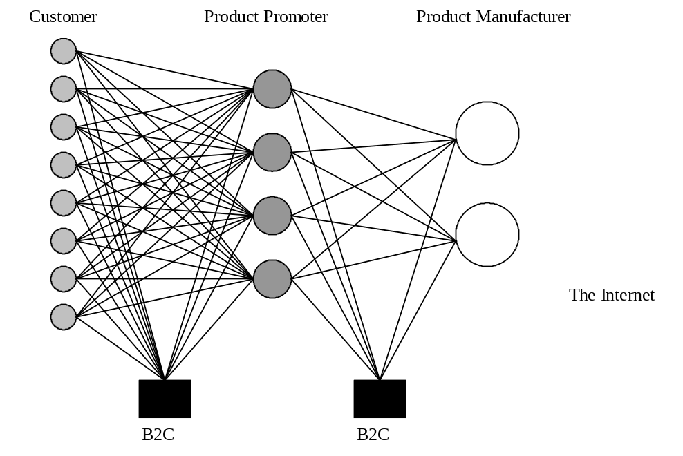

Figure 2: Product and Services Open Platform

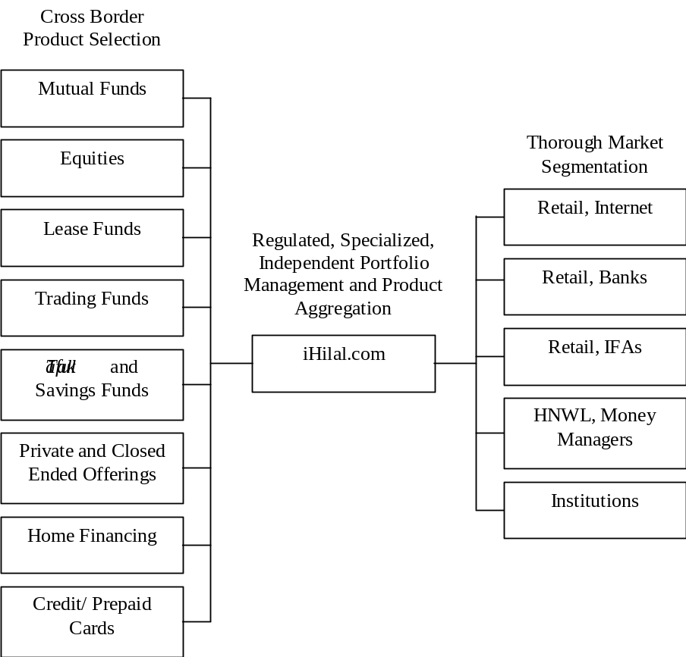

Figure 3: iHilal Business Model

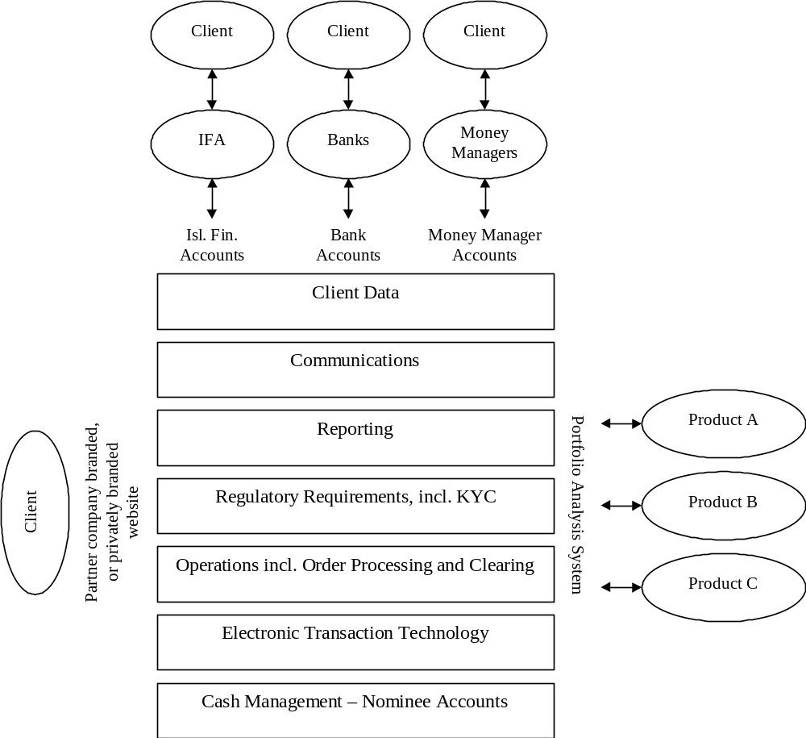

Corporate Customer Perceptions of Islamic Banking
Products and Services*

Norafifah Ahmad and Sudin Haron

Abstract

The Islamic banking system has been established in Malaysia since 1983. To date, Islamic banking products are available at two full-fledged Islamic banks, and at all commercial and merchant banks. However, these products are still not fully accepted by customers. At the end of 2000, for instance, the total deposits at conventional banks amounted to RM 381 billion and only RM 31 billion in Islamic institutions. Since corporate customers are key players in the economy, it is imperative that the reasons for them to choose or not to choose Islamic system be studied. This seminal study explores the perceptions of persons responsible in financial affairs of public listed companies in Malaysia. Among the issues covered in this study are usage of conventional and Islamic banking facilities, respondents’ understanding of the Islamic banking system, and their personal opinion on various aspects of Islamic banking products.

I. Introduction

Malaysia is among those Muslim countries that are committed to developing not only an Islamic banking system, but a complete Islamic financial system. Islamic banking started in Malaysia in 1983, when the first Islamic bank, Bank Islam Malaysia Berhad (BIMB), commenced operations. It was the objective of the Malaysian government to develop Islamic banking parallel to the conventional system. Instead of establishing many new Islamic banks, the government introduced the concept of Islamic windows, which allows existing conventional banks to introduce Islamic banking products to customers. This concept was initiated in March 1993, when the central bank, Bank Negara Malaysia (BNM), introduced its Interest-Free Banking Scheme. Twenty-one Islamic financial products were developed, with only three major banks participating initially. By July of the same year, this scheme was extended to all financial institutions in Malaysia. By the end of 2000, the Islamic banking system was represented by two Islamic banks, seventeen domestic commercial banks, five merchant banks and seven discount houses. There were also four foreign-owned banks providing Islamic banking products and services.
The step toward developing a complete Islamic financial system began with the fostering of both Islamic capital and money markets. The former started when the Malaysian government issued Islamic bonds in 1983. To further enhance the development in the capital market, Islamic private debt securities were introduced. At the end of 2000, a total of RM 22,935 private debt securities were issued, out of which RM 6,278 were Islamic bonds (Hassan 2001). The establishment of BIMB Securities in 1994, as Malaysia’s first Islamic stockbroker, was the first step toward promoting an Islamic equity market. Apart from providing Islamic broker houses and Islamically managed funds, a separate Islamic Index was established. This index comprises 179 permissible stocks on the Kuala Lumpur Stock Exchange (New Horizon, 1996). Muslim investors have been able to invest directly in halal (permitted) counters. Conventional securities firms also set up their own Islamic stockbroking windows to advise investors on halal stocks. As of July 1996, 364 stocks of the total 633 listed on the Kuala Lumpur Stock Exchange (KLSE) were considered halal. On 17 April 1999 the KLSE Shari^{c}a Index was launched to facilitate public investment in instruments in line with the shari^{c}a law.
The BNM further boosted the growth of a Malaysian Islamic financial system by pioneering an Islamic interbank money market in January 1994. This market was the first Islamic money market in the world. In the year 2000, the volume of funds traded in this market was RM 301.9 billion (BNM Annual Report, 2000).
Malaysia also plays a major role in developing an international Islamic financial system. The first step taken was realigning Labuan from an offshore financial center to an international Islamic financial center. The first international Islamic financial market was to be established in Labuan at the end of 2001.
As a result of the financial turmoil in 1997 and the liberalization of the world banking system, Malaysia has developed a ten-year plan known as “Financial Sector Stability.” The aim of this plan is to create a more efficient and competitive, innovative, technology-driven, and strategically more focused financial system. The plan includes the Islamic financial system as a component that can be further developed to become the key player in the Malaysian and international banking sector.
Even with the support of the government in introducing various measures to develop Islamic finance, its success is heavily influenced by the market players. The market share of Islamic banking assets, deposits and financing reflects public acceptance of this system. For example, the total assets in the Islamic banking system were 6.9% of the total in 2000, while Islamic banking deposits and financing constituted 7.4% and 5.3%, respectively. Malaysia is a country in which Muslims represent half of its population and which is governed by a coalition government led by a Muslim-based party. That despite this, the total funds deposited in the Islamic system remain insignificant compared to the total deposits in commercial banks, is a notable indicator of public unwillingness to use the system.
Haron et al. (1994), who pioneered the research on bank patronage in Malaysia, find that almost 100% of Muslims and 75% of non-Muslims were aware of the existence of Islamic banks. Most of them wished to develop a relationship with these banks, but only if they had a complete understanding of the system. The study used retail customers as its samples, and the findings showed that bankers considered retail customers less important than corporate customers. The latter were considered crucial in generating profits for the banks, and thus it is important that a study on their perceptions of Islamic banks be carried out.
This study examines the existing usage of Islamic banking facilities, the level of understanding of Islamic banking features among corporate financial controllers, their roles in switching and using banking products, and their personal opinions toward Islamic banking products. While the government can use these findings in formulating additional strategies and policies, where appropriate, the Islamic bankers will be able to understand the needs of corporate customers, by providing services to fulfill these needs.
This paper is divided into five sections. Section two highlights findings of previous research that deal with corporate customers’ perceptions on banking products and services, section three discusses the methodology of our research, section four presents the findings, and the concluding remarks and suggestions for future research are provided in section five.

II. Literature Review

With the exception of a few studies that used individual and small business customers as samples, no attempt has been made in the area of corporate customers’ understanding of Islamic banking in mainstream publications. Similarly, there are only a few published works that relate to corporate customers’ perceptions on the quality of conventional banking services.
Turnbull (1983) was among the first researchers to study the perceptions of corporate customers toward their banks. He examined the relationship between forty-four corporate customers in the United Kingdom and their bankers, and found that size played an important role in maintaining split banking practices. Another important finding was that large corporations tend to prefer foreign banks to local banks.
Rosenblatt et al. (1988) sampled 423 Canadian corporate treasury personnel in their study to determine the responsible person(s) in selecting bank(s) for the organization, the factors attributed to the selection of the bank(s), and perceptions of these personnel on the bank’s service quality. They found that almost half of the corporate treasurers were solely responsible for the selection of the bank(s). The two factors that influenced their decision-making were better branch networks and the quality of services. Half of the respondents also preferred the bank to assign special officers familiar with customers’ business operations. The corporate treasurers were also more concerned about quality products and services than innovative products. They were not keen on the concept of the “one-stop banking center.”
Turnbull and Gibbs (1989) conducted a study using “large” and “very large” companies in South Africa. The objectives of their study were to find factors that were considered important among corporate customers in selecting their banks, and whether companies have single or split banking relationships. The findings generally showed that the corporate customers felt the quality of service to be the most important factor in establishing a relationship. Other influential factors were quality of staff, the bank manager’s attitude, and price of service. Although very large companies considered quality of service the most important factor, both price and quality of staff were equally important. Split banking relationships were common among corporate customers. Almost all of the treasurers agreed that the physical appearance of banks had no impact on their selection process.
Chan and Ma’s (1990) study in Hong Kong was aimed at understanding corporate customers behavior on split-banking, bank-switching, factors that attribute to patronage, level of awareness, and usage of banking product and services. They found that corporate customers preferred to use big and reputable banks, and split banking. Corporate customers would only switch their banks if the new bank could show that the quality of its products and services was superior.
Tyler and Stanley (1999) used orthodoxy-grounded theory in their study, with the objective of identifying key elements of perceived service quality by large corporations. They found that elements considered important were reliability, assurance, empathy, responsiveness and pro-activity.
The studies of Erol and El Bdour (1989) and Erol et al. (1990) are considered the earliest patronage studies on Islamic banking. Using both conventional and Islamic bank customers, they found that customers who patronized Islamic banks perceived that the three most important criteria in bank selection were the provision of fast and efficient service, the bank’s reputation, and confidentiality.
Haron et al. (1994) sought to establish the selection criteria used by Muslim customers in Malaysia when selecting their banks. The three most important criteria perceived by Muslims in Malaysia were fast and efficient service, speed of transaction, and friendly bank personnel. Another important contribution from this study was the potentiality of individual customers in patronizing an Islamic bank when they had knowledge of this new system. 80% of Muslim and 53% of non-Muslim respondents indicated that they would consider establishing a relationship with an Islamic bank if they had substantial understanding of its operations.
While applying Haron et al.’s study, Gerrard and Cunningham (1997) found that as with their Malaysian counterparts, Singaporean Muslims were more aware of the existence of Islamic banking than non-Muslims. Similarly, this study found no evidence of Muslims and non-Muslims differing in their bank’s selection criteria. Gerrard and Cunningham’s study did not include any question that could measure the intention of their respondents to patronize Islamic banking.
Metawa and Almossawi (1998) focused on customers of Bahrain Islamic Bank and Faisal Islamic Bank of Bahrain. They found that customers of these two Islamic banks considered Islamic principles the most important factor when selecting Islamic banks. The second most important factor was the reward extended by the banks, followed by influence of family and friends, and convenient locations. This study also indicated that socio-demographic factors such as age, income and education were important criteria in bank selection. The finding that religion, in the form of Islamic principles, was the most important reason for customers’ patronizing Islamic banks countered the findings of Haron et al. (1994), and Gerrard and Cunningham (1997).

III. Methodology

The respondents participating in this exploratory study were the persons responsible for the financial affairs of companies listed in the Kuala Lumpur Stock Exchange. Research assistants made initial telephone calls to selected companies for the purpose of identifying these persons. Once the person was identified, a call was made to explain the intention of this research and the types of assistance required from him/her. A total of 100 respondents were identified and willing to participate in this study. These respondents were financial directors, financial managers, general managers of finance, and accountants.
Out of the 100 questionnaires sent to all agreed participants, 45 were returned. No further attempt was made to increase the samples. The questionnaire contained five sections; the first section was designed to gather information about the respondent’s personal background. The profiles of the respondents are shown in Table 1, below. About 80% of the respondents were non-Muslims. This study therefore reported mostly the opinions of non-Muslims toward Islamic banking. About 55% of the respondents were less than forty years old, with most having professional qualifications such as CPA, CA and ACCA. About 60% of the respondents had been working for their companies for less than five years.

Table 1: Profile of Respondents

 | N | %
- Religion  Muslim  Non-Muslim  Missing Value | 9  35  1 | 20.0  77.7  2.3
 | 45 | 100.0
- Age  <30 years  30-39 years  40-49 years  50 and above  Missing Value | 4  21  14  5  1 | 8.8  46.7  31.1  11.1  2.3
 | 45 | 100.0
- Qualifications  University/College  Professional  Both University/Professional | 12  20  13 | 26.7  44.4  28.9
 | 45 | 100.0
- Years in the present position  < 1years  1-5 years  6-10 years  more than 10 years | 7  14  11  13 | 15.6  31.1  24.4  28.9
 | 45 | 100.0
- Years with the present organization  < 1 years  1-5 years  6-10 years  more than 10 years | 7  21  7  10 | 15.5  46.7  15.6  22.2
 | 45 | 100.0

In the second section of the questionnaire, the respondents were asked to indicate the usage of common conventional and Islamic banking facilities and derivatives by their companies. The banking facilities and derivatives included overdraft, term and fixed loans, letters of credit, trusts receipts, bankers acceptances, export credit refinancing facilities, bank guarantees, notes issuance facilities, bonds, current accounts, fixed deposits and other facilities. With regard to Islamic banking, the respondents were asked when their company started using these facilities.
The third section of the questionnaire was designed to measure the respondents’ overall knowledge of the Islamic banking system. The questions asked in this section included those that measured the respondents’ level of understanding of the concepts and principles of Islamic banking. The questionnaire in the fourth section was designed to determine the role of respondents in the decision-making process of the bank selection. The final section of the questionnaire sought respondents’ perceptions on some general matters of which answers could be used by Islamic banking product and service providers in their effort to win these customers.
Since this study is exploratory in nature, no rigorous statistical technique was used in analyzing the data.

IV. Findings

A. Usage of Banking Facilities:
The banking facilities used by respondents are shown in Table 2. All the respondents used current accounts for their daily transactions, while 75% had conventional fixed deposit facilities. Overdraft, followed by bank guarantee, was the most popular facility for financing and trade facilities, while bond and note issuance facilities were unpopular among the respondents.

Table 2: Usage of Conventional/Islamic Banking Facilities/Derivatives

Types of Facilities | Conventional |  | Islamic
 | N | % | N | %
Overdraft | 42 | 93.3 | 3 | 6.7
Term/Fixed loan | 33 | 73.3 | 5 | 11.1
Letters of Credit | 21 | 46.7 | 3 | 6.7
Trusts receipts | 15 | 33.3 | 2 | 4.4
Bankers acceptance | 25 | 55.6 | 5 | 11.1
ECR | 3 | 6.7 | 1 | 2.2
Bank guarantee | 38 | 84.4 | 3 | 6.7
Note Issuance Facility | 5 | 11.1 | 1 | 2.2
Bond | 8 | 17.8 | 1 | 2.2
Current Account | 45 | 100.0 | 11 | 24.2
Fixed deposit | 34 | 75.6 | 4 | 8.9
Others | 6 | 13.3 | 2 | 4.4

Based on the findings in Table 2, it seems that Islamic banking products were not popular among Malaysian corporate customers. Only eleven respondents maintained banking relationships under the Islamic banking system. Despite Islamic banking having been established more than 15 years ago, most of the respondents started patronizing Islamic banks less than five years ago.

B. Knowledge of Islamic Banking
As indicated in Table 3, the respondents indicated that they had knowledge of the Islamic banking system, but more than 65% indicated that their knowledge was limited. Although the majority of the respondents were non-Muslims, they knew that Muslims were forbidden to engage in conventional banking, due to the Islamic prohibition on interest. This table also indicates that there was a misconception among the respondents about the objective and philosophy of the establishment of Islamic banks. About 65% of the respondents believed that Islamic banks must adopt profit-maximization principles in order to survive in the competitive business environment: a perception contradictory to the objective of Islamic banks, i.e., a combination of moral and profit motives. The lack of knowledge among the respondents of the Islamic banking system was further confirmed when they were questioned about the principles used in Islamic banking. While 38.1% of the respondents were unsure of the nature of the profit-sharing principle, about 50% believed that this was the only principle used by Islamic banks to replace interest. They were unfamiliar with other principles such as mudaraba, bay^{c} mu’ajjal, ijara, istisna^{c}, bay^{c} salam. This unfamiliarity is to be expected since 80% of the respondents were non-Muslims.

Table 3: Salient Features of the Islamic Banking System

 | N | %
- Islamic banking was introduced because Muslims are prohibited from associating themselves with interest as practiced by conventional banking system.  Absolutely untrue  Untrue  Not sure  True  Absolutely true | 2  5  4  -  10 | 4.8  11.9  9.5  -  23.8
 | 21 | 50.0
- Both Islamic and conventional banks must adopt a profit-maximization principle in order to survive in this competitive business environment.  Absolutely untrue  Untrue  Not sure  True  Absolutely true | 2  10  3  19  9 | 4.7  23.3  7.0  44.2  20.9
 | 43 | 100.1
- The profit-sharing principle is the only principle that can replace the element of interest in the operations of an Islamic banking system.  Absolutely untrue  Untrue  Not sure  True  Absolutely true | -  5  16  15  6 | -  11.9  38.1  35.7  14.3
 | 42 | 100.0
- How do you rate your level of overall knowledge of Islamic banking?  Very knowledgeable  Knowledgeable  Understand partially  Limited knowledge  No knowledge at all | -  4  11  29  - | -  9.1  25.0  65.9  -
 | 44 | 100.0

C. Roles of Respondents
The findings in Table 4 indicate that only one respondent had no authority at all, while 16% had no influential power. The rest of the respondents were those who made influential recommendations, took part in decision-making processes, or were authorized to make decisions. In most cases the respondents were those who had the power to determine relationships with banks.

Table 4: Administrative Matters: Respondents' Role in Bank Activities

 | N | %
- Opening an account with a new bank.  Recommendation with influential power  Recommendation with no influential power  Authorized to make decision  Take part in decision-making  No authority at all | 19  7  5  13  1 | 42.2  15.6  11.1  28.9  2.2
 | 45 | 100.0
- Applying new financing facilities.  Recommendation with influential power  Recommendation with no influential power  Authorized to make decision  Take part in decision-making  No authority at all | 14  11  2  16  2 | 31.1  24.4  4.4  35.6  4.4
 | 45 | 99.9
- Applying additional financing facilities.  Recommendation with influential power  Recommendation with no influential power  Authorized to make decision  Take part in decision-making  No authority at all | 14  13  2  14  2 | 31.1  28.9  4.4  31.1  4.4
 | 45 | 99.9
- Terminating a relationship with the existing bank.  Recommendation with influential power  Recommendation with no influential power  Authorized to make decision  Take part in decision-making  No authority at all | 17  10  3  13  2 | 37.8  22.2  6.7  28.9  4.4
 | 45 | 100.0

Similar trends were apparent in the case of applying new financing or additional facilities, and ceasing relationships with bank. In both cases about 70% of the respondents had either made influential recommendations, taken part in decision-making, or were authorized to make decisions.

D. Potentiality of Islamic Banking
As indicated in Table 5, few respondents believed that religion was the only reason for customers to select Islamic banks. More than 55% felt that both religion and economics were factors. About 50% believed that Islamic banking products and services had the potential to be accepted by customers. About 75% of the respondents felt that Islamic banks in Malaysia have not done enough marketing to promote their products and services to corporate customers.

Table 5: Personal Opinions

 | N | %
- The main reason why people select Islamic banking products.  Strictly religion  Economics (profit & cost elements)  Both religion and economics  Other reasons  No idea | 5  8  25  -  7 | 11.1  17.8  55.6  -  15.6
 | 45 | 100.1
- The potential of Islamic banking products in the Malaysian corporate sector.  A very good potential  A good potential  Some potential  No potential  No potential at all  No idea | 3  19  5  11  1  5 | 6.8  43.2  11.4  25.0  2.3  11.4
 | 44 | 100.1
- Is it true the Islamic banking products available in Malaysia are similar to the products of conventional banks except that the banks use different names in highlighting those products?  Absolutely true  True  Partly true  Untrue  Absolutely untrue | 2  12  22  6  2 | 4.5  27.3  50.0  13.6  4.5
 | 44 | 99.9
- Do you think that Islamic banks have done enough in marketing their products to corporate sector?  More than enough  Enough  Just enough  Not enough  Not enough at all | -  1  4  32  6 | -  2.3  9.3  74.4  14.0
 | 43 | 100.0

Table 6 shows the factors perceived as important in selecting banks. The most important one was cost and benefit to the company, followed by service delivery (fast and efficient), size and reputation of the bank, convenience (location and ample parking), and friendliness of bank personnel. This finding was inconsistent with previous research whereby the size of banks was considered the most important criterion.

Table 6: Selection Criteria of Bank (%)

Factors | Very  Important | Important | Moderately  Important | Of Little  Important | Least  Important
Cost/Benefit | 73.3 | 11.1 | 11.1 | - | 4.4
Service | 13.6 | 29.5 | 31.8 | 13.6 | 11.4
Size and Reputation | 13.6 | 52.3 | 18.2 | 13.6 | 2.3
Convenience (location & parking) | 2.3 | 9.1 | 22.7 | 29.5 | 36.4
Friendliness of Bank Personnel | 2.3 | 9.1 | 13.6 | 36.4 | 38.6
Total | 105.1 | 111.1 | 97.4 | 93.1 | 93.1

V. Conclusion

This study, though exploratory in nature, provides useful information to both policymakers in the government and also those who manage Islamic banks in Malaysia.
Firstly, it is a strong possibility that a dream has come true for the late Tan Sri Jaafar Mohammed, the former Governor of Bank Negara Malaysia. He wished to see an Islamic banking system operating parallel to the conventional system. Almost half of the individuals surveyed who had financial decision-making authority in the Malaysian corporate sector believed that the Islamic banking system had a good potential as an alternative to the conventional system.
Secondly, this study shows that providers of Islamic banking products and services have not done enough to educate customers and market their products. For example, more than 65% of the respondents indicated that they had limited knowledge of Islamic banking. Similarly, despite the fact that the Bank Islam Malaysia Bhd has gained footing since 1984, and that the Interest-Free Banking Scheme was launched in 1993, most respondents started relationships with this system only four years ago. This lack of a marketing effort among the providers could be a contributory factor toward the smaller market share of Islamic deposits and loans against the total loans and deposits of the Malaysian banking system.
Finally, this study also shows that the most important factor perceived by corporate customers in selecting their banks is the cost of the services and products. This means that Islamic bank products will not be attractive to this market unless and until its costs are lower than those of the products of the conventional banks.

References

Bank Negara Malaysia. Monthly Bulletin. Kuala Lumpur: Various issues.
Bank Negara Malaysia. The Central Bank and the Financial System in Malaysia. Kuala Lumpur: 1999.
Chan, AKK and Ma, SM. "Corporate Banking Behaviour: A Survey in Hong Kong." International Journal of Bank Marketing 8.2 (1990): 25-31.
Erol, C and El-Bdour, R. "Attitudes, Behaviour and Patronage Factors of Bank Customers towards Islamic Banks." International Journal of Bank Marketing 7.6 (1989): 31-39.
Erol, C, Kaynak, E and El-Bdour, R. "Conventional and Islamic Bank: Patronage Behaviour of Jordanian Customers." International Journal of Bank Marketing 8.5 (1990): 25-35.
Gerrard, P and Cunningham, JB. “Islamic Banking: A Study in Singapore.” International Journal of Bank Marketing 15.6 (1997): 204-216.
Haron, S, Ahmad, N and Planisek, S. “Bank Patronage Factors of Muslim and Non-Muslim Customers.” International Journal of Bank Marketing. 12.1 (1994): 32-40.
Hassan, MZ. “Challenges Towards Deepening of the Islamic Bond Market and Islamic Multi-Investment Funds.” Paper presented at Kuala Lumpur International Summit of Islamic Banking & Finance, 19-21 February. Kuala Lumpur: 2001.
Khan, M Fahim. “Islamic Banking as Practised Now in the World.” In Money and Banking in Islam. Ziauddin Ahmed et al. (eds.). Islamabad: Institute of Policy Studies, 1983. 259-276.
Metawa, SA and Almossawi, M. “Banking Behaviour of Islamic Bank Customers: Perspectives and Implications.” International Journal of Bank Marketing 16.7 (1998): 299-313.
“News Monitor: Malaysia to Establish Islamic Index.” New Horizon 52 (1996): 19.
Rosenblatt, J, Laroche, M, Hochstein, A, Mctavish, R and Sheahan, M. “Commercial Banking in Canada: A Study of the Selection Criteria and Service Expectations of Treasury Officers.” International Journal of Bank Marketing 6.4 (1988) 20-30.
Turnbull, PW. “Corporate Attitudes Towards Bank Services.” International Journal of Bank Marketing 1.1 (1983): 53-68.
Turnbull, PW and Gibbs, MJ. “The Selections of Banks and Banking Services among Corporate Customers in South Africa.’ International Journal of Bank Marketing 7.5 (1989): 36-39.
Tyler, K and Stanley, E. “UK Bank-Corporate Relationships: Large Corporates’ Expectations of Service.” International Journal of Bank Marketing 17.4 (1999): 158-172.

The Emerging Islamic Financial Architecture
The Way Ahead

Ahmad Mohamed Ali*

Abstract

Increased transparency and accountability of financial institutions are strengthening the international financial system, as do proper regulation and supervision. Since Islamic finance is entirely asset-backed, it is expected to contribute to financial stability. Countries in which Islamic banks operate are regulated and supervised in the same manner as conventional banks. The infrastructure required to fortify the Islamic financial industry continues to evolve. In cooperation with other institutions, the Islamic Development Bank (IDB) has undertaken a number of initiatives to add to this stability. Initiatives include establishing specialized institutions, such as the Accounting and Auditing Organization for Islamic Financial Institutions, the Islamic Financial Services Organization, an international Islamic financial market, and an Islamic rating agency. These institutions, as well as the inherent features of Islamic finance, strengthen the international financial architecture and promote greater financial stability.

I. Introduction

The Islamic financial industry has evolved during the last three decades. Comprising Islamic commercial and investment banks, insurance companies, mutual funds and Islamic windows of conventional banks, the industry has been established due to the demand to do business and to manage money in compliance with the shari^{c}a. According to various estimates, there are presently more than two hundred Islamic financial institutions operating in various parts of the world. The value of their combined assets is estimated to be about $150-180 billion.
During these last thirty years, the Islamic financial system has gained considerable respect in international financial circles. It is recognized as a viable and efficient alternative model for financial intermediation. A large number of multinational banks are offering Islamic financial products around the globe. Unfortunately, in the aftermath of the tragic events of 11 September 2001, misconceptions emerged regarding Islamic banks’ alleged involvement in money laundering and in terrorist-financing activities. These misconceptions arose either from a lack of understanding or from vested interests.
Like conventional banks, genuine Islamic financial institutions are simply profit-seeking businesses. They are not associated with any political objectives nor are they knowingly involved in any illegal activity. In international financial centers, such as Bahrain, Islamic financial institutions are subject to essentially the same regulations as conventional banks. Central banks and other financial regulatory authorities monitor compliance. Regulations are set in accordance with international best practice, and assign prime importance to the “know thy customer rule.” In Bahrain, laws were recently updated to fully comply with the recommendations of the Financial Action Task Force on Money Laundering (FATF). The Bahrain Monetary Agency has also complied with recent FATF recommendations regarding combating terrorist financing. Though Islamic financial institutions have the same legal and regulatory obligations as conventional banks, their overall legal and compliance environment is more stringent; insofar as Islamic financial institutions are subject to additional self-regulation needed to comply with the shari^{c}a.
Of course, despite institutions’ best efforts to apply “know your customer” standards, terrorists and other criminals, without the management’s knowledge, can misuse any conventional or Islamic financial institution. However, we should always bear in mind that Islamic finance has noble objectives and principles, and therefore its ethically oriented owners and managers should not be subjected to the results of undue ignorance or prejudicial defamation.
Recent misconceptions about Islamic financial institutions do, however, oblige those in the industry to better articulate the highly ethical and well-regulated business of Islamic finance. While outlining some of the challenges currently facing the industry, this paper attempts to highlight some actions and responses taken by a number of institutions to improve the image of the business.
The second section briefly discusses the importance of financial stability while underlining the causes of recent crises. The third section provides an update on the emerging Islamic financial architecture. It focuses on various measures the Islamic Development Bank (IDB) has initiated with the active support of other institutions. The fourth section highlights the way forward for Islamic finance, putting forth some considerations on its contribution to the international financial architecture. Finally, the paper concludes with some key recommendations.

II. Concerns with Financial Stability

Financial stability is a prerequisite for sustained economic growth and social development. Historic financial crises demonstrate that economic progress achieved over several years can be significantly reversed in a short period. Over the last two decades the international financial system has been victim to numerous crises, resulting in large losses that impacted the economic output of many countries and affected the stability and growth of the world economy adversely (see Table 1).

Table 1: Estimated Length of Crisis, Gross Output Loss and Recovery Time

Country | Recovery Time | Recovery years | Gross output loss (% of GDP)
Argentina | 1980-82 | 4 | 16.6
Argentina | 1995-96 | 3 | 11.9
Bulgaria | 1996-97 | 3 | 20.4
Chile | 1981-88 | 9 | 45.5
Colombia | 1982-85 | 5 | 65.1
Egypt | 1991-94 | 5 | 6.5
Finland | 1991-96 | 7 | 23.1
Ghana | 1982 | 2 | 6.6
Hungary | 1991-92 | 3 | 13.8
Indonesia | 1992 | 9 | 42.3
Indonesia | 1997 | 4 | 33.0
Japan | 1992-present | 9 | 27.7
Malaysia | 1985-87 | 4 | 13.7
Malaysia | 1997-present | 4 | 22.8
Mexico | 1994 | 2 | 9.6
New Zealand | 1987-92 | 7 | 18.5
Norway | 1987-93 | 8 | 19.6
Philippines | 1983-86 | 5 | 25.7
Philippines | 1998-present | 3 | 7.5
South Korea | 1997-98 | 3 | 16.5
Sweden | 1991-92 | 3 | 6.5
Thailand | 1983 | 2 | 8.7
Thailand | 1997-present | 4 | 31.5
Turkey | 1994 | 2 | 9.1
United States | 1981-82 | 3 | 5.4
Uruguay | 1981-85 | 6 | 41.7
Venezuela | 1994-96 | 4 | 14.1

In response to these crises, the international financial community reiterated the need to strengthen its financial institutions through appropriate management measures. These measures include effective regulation and supervision, corporate governance, risk management, enhanced disclosure, and transparency.
For a number of reasons, Islamic finance itself plays an important role in the stability of the global financial system. First, investment deposits of Islamic banks are based on risk sharing and asset-based financing. Second, the practice of Islamic finance takes a number of forms. Some Muslim countries implement Islamic principles on an economy-wide scale. Others allow the establishment of Islamic institutions alongside conventional institutions. Still others allow conventional institutions to write Islamic banking contracts. As a result, Islamic banking and finance function as vital parts of the financial systems of several states.
Nevertheless, the Islamic financial system is in its evolutionary phase. Despite being fully regulated and supervised, lack of familiarity with the industry in some circles has generated some unwarranted misconceptions. The Islamic financial industry can be strengthened by suitably adapting international standards to its unique risk characteristics. Yet to remain compliant with the shari^{c}a, some risks of Islamic financial contracts will remain unique. Provided the basic supportive infrastructure is established, the inherent features of the Islamic financial industry can themselves contribute to strengthening the global financial architecture.

A. Causes of Financial Instability
Some common causes of financial crises are:

- Lack of proper regulation and supervision. Due to the lack of proper regulation and supervision, financial institutions in several developing countries are not properly capitalized, loan loss provisions are not carefully maintained, large amounts of imprudent lending exists, transparency and disclosure standards remain low, risk management and internal control systems are weak, and public sector influence is extensive. As a result, financial institutions are frequently unable to absorb even small shocks from internal or external sources.
- Noncompliance with standards. For a sound financial system, compliance with international standards by governments as well as public and private sector institutions is extremely important. Noncompliance to best practice standards in financial reporting, accounting, auditing, transparency and disclosures can cause financial systems to be vulnerable to instabilities.
- Currency crises. As a result of unrealistic exchange rate regimes and/or excessive speculation, the exchange rate of a currency may depreciate below normal levels. Consequently, the value of financial assets/liabilities held in a foreign currency will appreciate leaving the value of those held in a local currency to depreciate. In developing countries in which scarcity of foreign exchange is common, a currency mismatch can lead to banking and payments crises and can have domino effects.
- Maturity mismatch. Maturity mismatch between short-term liabilities and short-term assets of the public and private sectors also cause financial crises. If short-term foreign exchange liabilities are high compared with the availability of liquid foreign exchange assets, foreign contractual obligations cannot be met in time, thus triggering larger financial failures.
- Moral hazard. A considerable part of financial instability is attributable to deposit insurance schemes that allow inefficient financial bodies to continue to practice. As a result of such policies, some institutions become motivated to practice imprudent policies, which then weaken the overall state of the financial system.

The interest mechanism is central to most of these causes. Fast movement of short-term interest-based funds is an important basis of financial instability. High leverage and expansion of credit without any link to the real sector of the economy also contributes to this instability. Interest-based credit sponsors undesirable speculative activities in stock, commodity and foreign exchange markets. Interest-based funds dilute the capital of banks and weaken their potential to overcome a crisis when it arises. So if the interest mechanism can be avoided, the effects may be contained. This point is discussed further in the next section.

B. Strengthening the International Financial Architecture
Recurring financial failures have made international financial institutions, standards-setters, national regulators and policy-makers, the industry and the academic world all conscious of the need to avert and to manage them effectively. As a result, they have initiated ongoing consultations, debates and reforms, broadly known as the international financial architecture. Close cooperation and coordination between these bodies is of prime importance. Institutions, standards, guidelines, systems and procedures all need to be strengthened. Systems and procedures gaps need to be identified both for crisis prevention and for crisis resolution. These challenges can all be classified into three key areas, namely: enhancing transparency and accountability, strengthening domestic financial systems and managing international financial crises.
Transparency in releasing accurate and timely information by both the public and private sector institutions is essential. The collapse of Enron and a leading auditing firm in the process emphasize the critical role of transparency in financial accounting and auditing within this financial architecture. Indeed, by strengthening institutions’ regulations and supervision, by implementing international standards, by enhancing market discipline and by minimizing public sector influence similar outcomes can be avoided.
However, risk-sharing mechanisms underlying financial systems are more significant. The key to managing international financial failures lies with better risk management. It involves financial intermediation by efficient risk-sharing schemes and making the private sector at least partially responsible for crisis management. The first recommendation of the Working Group on International Financial Crises was to “encourage the governments of emerging markets to explore the possibility of developing and using contractual arrangements that contain a degree of risk-sharing between debtors and creditors and that provides additional liquidity during periods of market volatility.”

III. Islamic Financial Architecture: An Update

Interest-based lending is prohibited in Islam as well as in the original scripts of Christianity, Judaism and Hinduism. The Islamic financial industry evolved as a result of the response of Muslim scholars to the prohibition of interest in the shari^{c}a.

A. Salient Features of Islamic Finance
The salient features of Islamic banking and finance can be summarized as follows.

- Interest-based lending as well as financing of gambling forms of transactions, and unethical goods and services are all prohibited in Islam.
- Deposits can either be based on qard (interest-free but principal protected loans) or profit-and-loss sharing (PLS).
- Equity participation, temporary equities, credit sale, leasing and other suitably designed modes replace interest-based finance.
- Financial engineering of new products and instruments must comply with shari^{c}a requirements.
- Debt cannot be traded, rescheduled or discounted for interest. However, debt can be swapped for goods and services.
- Private property and free markets are basic to the economic system.

B. Features of Islamic Finance That May Enhance Stability
Efficiency of a financial system cannot be sustained without stability. A number of features of the Islamic financial industry, on both the liability and asset side, contribute to the stability of financial markets.
Islamic financial institutions primarily raise money on the PLS basis. A bank’s positive performance on its assets side can be shared by PLS depositors on its liability side. As a result, depositors help share the bank’s losses allowing it to overcome financial difficulties. Due to this responsibility, depositors are expected to remain vigilant about the performance of banks. Academic and policy circles view such vigilance as a way of contributing to financial stability.
Debt creation in Islamic finance is not possible without the backing of goods and services. So, debt instruments are not readily tradable unless re-enforced with specific goods and services. Therefore, little room exists for a sudden mass movement of funds as compared to the flexibility available in interest-based short-term funds. Hence the effects of destabilizing speculation would be significantly curtailed. Monetary flows through Islamic financial modes would all be tied directly to commodities and services. In other words, the dichotomy between financial and real activities is removed. Here, finance is automatically earmarked for specific uses on goods and services leaving little room for excessive credit expansion.
Interest-based lending has no doubt created debt pyramids from which many indebted countries discover no way to honor contractual obligations. It is not uncommon to find that borrowers’ servicing payments are many times the original principal borrowed. Despite continuous efforts to seek relief, debtor developing countries and institutions face unending debt problems.
Islamic asset-based finance has certain characteristics due to which debt crises are less likely to arise. In particular, the total value of debt, which includes the spot value of commodities purchased on credit as well as an implicit mark-up, is set from the very beginning. The total value of debt can be paid in installments, without increasing its total value, as there is no compounded interest to pay on the outstanding balance. When debtors face unavoidable circumstances that would make them insolvent, they are often granted grace periods to assist them to bring their finances back into order. No penalty interest can be levied in this case. In other words, debt rescheduling is granted at no extra cost to borrowers. Islamic asset-based finance is created through the finance of acquiring goods and services on credit, and the loan is thus used from the very beginning for its prescribed and asset-based purpose. Default resulting from improper use of borrowed funds is therefore most unlikely. Asset-based finance directly contributes to the ability of the economy to meet its internal and external financial obligations.

C. Major Institutions Comprising the Islamic Financial Architecture
A timeline of the evolution of Islamic financial architecture is given in Table 2 below. The Islamic financial industry has come a long way during its short history. Its future, however, will depend on how it copes with the rapidly changing financial world. One major factor will be how well its institutions can manage the risks generated in providing such Islamic financial services. Islamic financial institutions need to equip themselves with up-to-date management skills and operational systems to deal with the changing environment. The establishment of a number of supporting institutions is also needed to bring the infrastructure of the Islamic financial industry, if not at par, at least closer to the infrastructure of the traditional industry—quantitatively and qualitatively.
The Islamic Development Bank (IDB) has been playing a leading role in establishing several supporting institutions which includes the Accounting and Auditing Organization for Islamic Financial Institutions (AAOIFI), the International Islamic Rating Agency (IIRA), the Islamic Financial Services Board (IFSB), the International Islamic Financial Market (IIFM), the Liquidity Management Center (LMC) and the General Council of Islamic Banks and Financial Institutions (GCIBFI).

Table 2: Evolution of the Islamic Financial Architecture: A Time Line

6th century CE | - Prohibition of commercial lending in the Qur’an.
1890s | - Commercial banking is initiated in the Muslim world. | - Critique of bank interest as riba starts, particularly in Egypt.
Early 1900s | - The critique spreads to other Arab regions, and particularly to South Asia. | - Majority of scholars subscribe to the view that interest in all its forms constitutes riba.
1930s | - A critique of interest from an Islamic perspective provided by a professional economist. | - Islamic scholars argue that bank interest falls under the purview of prohibited riba.
1950s | - Islamic scholars and Muslim economists start to offer theoretical models of organizing banking and financing as a substitute to interest-based banking. | - Models of interest-free banking based on two-tier mudaraba are proposed.
1960s | - Practice of Islamic principles of finance starts.  - Operational mechanisms for Islamic financial institutions begin to be proposed. | - Rise and fall of Mitghamr Egypt Saving Associations during 1961-64.  - Establishment of Tabung Hajji Malaysia in 1966.
1970s | - Establishment of Islamic banks and non-banking financial institutions.  - Organization of academic activities.  - Establishing academic institutions.  - Development of the financial murabaha mechanism.  - First International Conference on Islamic Economics, Mecca 1976. | - Publications of a number of books on Islamic banking based on profit-and-loss sharing, murabaha, and leasing.  - Dubai Islamic Bank 1971.  - Islamic Development Bank 1975.  - Center for Research in Islamic Economics Jeddah.
1980s | - Public sector policy interests.  - More private banks.  - Islamic banking product diversification.  - Interests in the Western academic and financial circles increase.  - Some conventional banks start Islamic windows.  - More research, teaching and training programs initiated. | - Pakistan, Iran, Sudan, Malaysia and other countries try transforming overall systems or patronize the Islamic system.  - IMF publishes working papers, articles on Islamic banking.  - PhDs, research, publications on Islamic banking increase in West.  - OIC Fiqh Academy and other fiqh boards established.
1990s | - Rise of Islamic Index and Mutual Funds.  - Spread of Islamic windows.  - Progress in Islamic asset-based instruments.  - Recognition of systemic importance of Islamic banks and financial institutions. | - Establishment of Islamic mutual funds globally.  - Establishment of the Dow Jones and Financial Times Islamic Indices.  - Regulation and supervision get momentum.  - AAOIFI standards issued  - Work on building supporting institutions start.
2000 and beyond | - Continuous growth and maturity but rising challenges.  - Advancement of the Islamic financial architecture.  - Need for economic size, mergers. | - Concern with risk management, and corporate governance.  - Establishment of:  - Asset-based security markets.  - Islamic Financial Services Supervisory Office.

- The Accounting and Auditing Organization for Islamic Financial Institutions. Shareholders, depositors, investors and regulators all utilize information provided in financial statements. Where statements are prepared on the basis of uniform standards, objective comparison between different financial institutions can be made, enabling market discipline to work more effectively. In this regard, the Accounting and Auditing Organization for the Islamic Financial Institutions (AAOIFI) succeeded in adopting international standards to suit Islamic financial institutions. AAOIFI standards were first introduced in 1993. Since then an increasing number of Islamic financial institutions have embraced these standards.

- Shari^{c}a Supervision. Shari^{c}a supervision is one of the most important pillars of the Islamic financial architecture. Almost all main market participants including central banks have constituted their own shari^{c}a supervisory boards. As the raison d’être of Islamic banking and finance is compliance with the shari^{c}a, Islamic financial institutions carry vital fiduciary responsibilities. Non-compliance can prompt excessive deposit withdrawals and cause even a financially sound institution to fail. Hence, client confidence in financial institutions is extremely important to financial stability. A dynamic financial services industry has to constantly upgrade its product designs and structures to meet shari^{c}a compliance. AAOIFI is also working on standardizing some of its basic rules for shari^{c}a supervision.

- The International Islamic Rating Agency (IIRA). Market discipline is important for an efficient and stable financial system. In this regard, external rating systems and accounting standards play vital roles in improving the availability of information to depositors, bankers and regulators. Existing conventional rating systems are primarily concerned with the financial strength of counter-parties and not that of compliance with shari^{c}a requirements. Since non-compliance of even a financially sound Islamic bank with the shari^{c}a can be a cause of serious systemic instability, the need for an Islamic rating agency has always been felt. Keeping this in view, the establishment of the IIRA has been under active consideration by the IDB as well as other Islamic financial institutions for some time. The Agency is presently undergoing registration procedures in Bahrain.
Once operational, the IIRA will also scrutinize shari^{c}a aspects of financial institutions and their products. As a basis for its operations, the agency will use AAOIFI accounting standards, which will therefore contribute toward the goal of ushering in a sound and strong Islamic financial system. The agency’s activities and global appeal will be of major importance to the Islamic financial industry. As a specialized rating agency, the IIRA should complement existing agencies, adding value to the market. In no way will it compete with conventional agencies, as its objectives are different. Its scope of work will distinguish it from other conventional rating agencies in at least four aspects:
- It will provide independent assessment of the likelihood of default by determining fiduciary risk of the issuer.
- It will assess compliance with the principles of shari^{c}a.
- Applicable accounting standards will be those of Accounting and Auditing Organization for Islamic Financial Institutions (AAIOFI).
- It will scrutinize shari^{c}a transparency for new financial instruments and their issuers.
By assessing the fiduciary relationship and the credit risk inherent in any instrument or issuer, the IIRA will help create a higher degree of confidence and acceptability of products among the players in the industry. Therefore, IIRA operations will be broader than those of conventional rating agencies.
The target market of the IIRA will include international financial institutions incorporated or operating in IDB member countries. It will also focus on securities issues targeted for the Islamic market/investors, issuer/corporate credit ratings and foreign currency funds raised by sovereign/companies/financial institutions from IDB member countries.

- The Islamic Financial Services Board (IFSB). Proper regulation and supervision of banks and financial institutions are also important for financial efficiency and stability. Due to shari^{c}a requirements, some risks faced by the Islamic financial industry are unique. Bank supervisors utilizing conventional standards cannot assess such risks. Hence, the need for special guidelines for the regulation and supervision of Islamic banks has long been felt. Some regulatory authorities have already introduced guidelines for Islamic banking supervision in their respective jurisdictions. Through an active involvement of the International Monetary Fund (IMF), the IDB, the Bahrain Monetary Agency (BMA), Bank Negara Malaysia (BNM) and other central banks, an initiative has been taken to establish the IFSB. This institution is expected to be operational in Malaysia by 2002.

- International Islamic Financial Market (IIFM). At present, the Islamic financial services industry faces greater liquidity risk due to the absence of a secondary market for Islamic financial instruments. The non-existence of an interbank Islamic money market makes liquidity management a challenging task. The Islamic banks are thus under a constraint to maintain liquidity that is higher than what conventional banks do. This adversely affects the Islamic banks’ competitiveness. The establishment of an IIFM is thus one solution to this problem, making it an important building block in the Islamic financial services infrastructure.
To this end a Working Group was constituted, comprising of the Labuan Offshore Financial Services Authority (LOFSA), the Bahrain Monetary Agency (BMA), the Bank of Sudan, the Bank of Indonesia, and the IDB. Its objective is the establishment of a more structured global financial market based on shari^{c}a principles and to enhance the cooperative framework among Islamic countries and financial institutions.
The agreement to establishing the IIFM Board was signed in Paris on 13 November 2001. The IDB has the role of chairing the Board. Though currently dealing with the organization’s set-up, the IIFM Board is specifically tasked with determining broad directions and setting major policies and determining standards, fostering promotion and development of Islamic financial instruments, necessary prerequisites for the success of the market.
Ultimately, the market will be functional and operational only if a critical mass of players is achieved. To this end, strong support from central banks and governments is required. The market aims to set high standards of integrity, by allowing only authorized institutions to act as arrangers, managers and/or underwriters, effectively protecting investors and participants.
In order to effectively deal with shari^{c}a issues, IIFM will have its own Shari^{c}a Supervisory Board (SSB) comprising of internationally recognized experts in the shari^{c}a from various parts of the world. The SSB is of paramount importance to the success of the IIFM for the global financial market. The SSB will effectively bridge gaps and differences in opinions among the different schools of thought. The SSB will approve financial instruments and harmonize the application of shari^{c}a among the shari^{c}a boards.

- Liquidity Management Center (LMC). As mentioned above, one of the most acute problems facing the Islamic banking industry is the lack of short-term liquidity instruments and the lack of such a market. It is estimated that the total liquid funds available to the Islamic financial institutions for short-term investments are between $20-30 billion. Thereby the need of a money market for efficient managing of short-term liquidity is evident. The LMC as an operating arm of the IIFM Board is under establishment. Founding shareholders are invited to subscribe to its share capital.
There are two important constraints on the Islamic financial markets that result in the need for the LMC. These are the lack of quality assets and the lack of secondary markets. The envisioned LMC will among other things help to overcome a number of problems. Such problems include the lack of shari^{c}a credibility and acceptance of existing liquidity programs, insufficient generation of funds, lack of treasury instruments with different tenors, lack of product and geographic diversification and the absence of secondary markets. It is also expected that returns on instruments offered in the LMC should have better risk-return profiles than returns available from ad-hoc alternatives, usually commodity murabaha, which are below LIBOR.
The liquidity management center will operate via securitizing tangible long-term assets acquired from a variety of sources. The sukuks (certificates) will be issued against the pool of assets. Due to the tangible nature of the asset pool, these certificates will offer enhanced shari^{c}a credibility. In addition, the LMC will create opportunities for buyers to finance long-term projects that can be liquidated at their discretion.
The LMC will also create a secondary, over-the-counter market for its products by establishing a consortium of liquidity providers. Therefore, asset and liquidity risks, from the sukuk holders’ point of view, will be diversified across multiple assets and institutions. The LMC will bridge the needs of asset rich conventional institutions with that of Islamic financial organizations holding surplus liquidity through a Special Purpose Vehicle (SPV). The SPV will structure, securitize and ensure shari^{c}a compliance of conventional institutions’ assets and thereby channel the liquidity flows via SPVs. Therefore, LMC is envisioned as a mechanism of pivotal importance under the new global Islamic finance architecture. It will add value toward standardization and unification of Islamic financial markets. In return, this will promote growth in the industry, making it more attractive and significant to both conventional and Islamic investors.

- The General Council of Islamic Banks and Financial Institutions (GCIBFI). The understanding of Islamic banking and finance has grown rapidly during the past three decades. Nevertheless, being relatively new, it is important for the industry to develop strategic alliances and partnerships with others to remove misconceptions and to pool together resources to confront challenges. The GCIBFI, with its headquarters in Bahrain, was been established with such a background and objective in mind.

IV. The Way Ahead

As discussed above, the central premise of Islamic finance is risk sharing, asset-based nature of finance and the control of gambling-like and unethical transactions. The Islamic financial industry has been using these contracts with success during the last two decades. Since then, their use continuously grows worldwide. Such expansion is beneficial to strengthening financial institutions and promoting financial stability. Since the development of the Islamic financial architecture is a significant task, several challenges and opportunities can be forecast. The most pertinent are mentioned here briefly.

A. Consolidation of the Emerging Islamic Financial Architecture
Considerable expansion of the Islamic financial industry has taken place during the last three decades, both in terms of number of institutions, as well as institutions supporting the industry as an infrastructure. It can be predicted that the next stage may be the consolidation of both types of institutions.
Consolidation in the financial institutions may take the form of size consolidation and functional consolidation. With respect to the former, Islamic financial institutions are generally small in size. It is in the interest of the industry for institutions to workout cooperative mergers of viable economic sizes in order to operate on competitive grounds. The establishment of Al-Shamil Bank has already set the trend of mergers.
In the latter, there is a need for functional consolidation within the various segments of the Islamic financial industry. Namely, there is a need for cooperative mergers among banks, insurance companies and other functional entities. This trend enlarges the platform of universal banking, which is considered to be much closer to the philosophy of Islamic banking. This trend may actually be necessitated by size consolidation as well. It is important to note that such mergers will require effective supervision and clearer capital adequacy requirements for the various functional entities of a consolidated group.
The need to consolidate supporting institutions is even more important as most of these institutions are still in their inception phase. Once fully operational, they can be strengthened by consolidating their activities. For instance, all institutions should comply with the AAOIFI standards and adopt international special risk standards set by the IFSB. The Islamic Rating Agency, for example, has to rely on the standards of IFSB and AAOIFI for its own work. All these institutions have to comply with the shari^{c}a. The usefulness of the Islamic financial architecture depends on the complete consolidation of operations of these institutions.

B. Application of International Standards to Islamic Banks
There are a number of channels through which the stabilizing effects of Islamic banking and finance can be transmitted to the global markets. Those countries that have adopted the Islamic system are in the process of consolidating their respective experiences. Their successes in doing so can contribute to stability of their respective economies and can have favorable implications for financial stability in their respective regions. Countries that have allowed the establishment of Islamic financial institutions side by side with their conventional banks have in fact liberalized their financial markets. If Islamic financial institutions prove to be more stable due to their inherent characteristics, this will have positive implications in their respective countries further adding to financial stability. This will also encourage the transformation of conventional banks in line with Islamic principles as well as establish new Islamic banks. Similarly, conventional banks, which offer Islamic banking products, may benefit from the stabilizing features of Islamic principles, and hence contribute to financial stability of the markets at large.

- Application of international standards. The positive effects of Islamic banking and finance depend on the strength of Islamic financial institutions in actual practice. Such strength rests on them being properly regulated and supervised by internationally acceptable standards. No disagreement exists on the need for Islamic financial institutions to meet such required international standards on risk management systems. However, it is important to note that a number of the risks faced by Islamic banks differ from those of conventional banks. Some international standards meant for conventional banks need to be adapted to make them relevant and effective to Islamic banks. Hence, effective supervision of Islamic banks requires proper study of their unique risks as well as formulating suitable guidelines. In this regard IFSB will play a vital role.

- Preconditions for effective Islamic banking supervision. As far as the Basel Committee’s Core Principles for effective banking supervision, disclosure and transparency requirements are concerned, these are equally relevant to Islamic banks. Due to the risk sharing nature of Islamic banks, these banks need an even more effective system of supervision and transparency. In addition to the preconditions for effective banking supervision set in the Core Principles document, there are a number of other preconditions specific for effective Islamic banking supervision. One set of these preconditions has to be fulfilled by bank regulators and supervisors. These include providing a level playing field for competition, licensing facilities, lender of last resort facilities acceptable to the mandate of Islamic banks, proper legal framework, proper shari^{c}a supervision, etc. The other set of preconditions has to be met by the Islamic banks themselves. These include: effective corporate governance, development of interbank market and instruments, resolution of a number of unresolved fiqh-related issues, and development of proper internal control and risk management systems. The consolidation of the initiatives discussed above is expected to play an important role in strengthening the infrastructure of the Islamic financial industry.

- Capital adequacy standards. The Basel capital adequacy standards are applied to Islamic banks in addition to the risk absorbing features of their investment accounts. Islamic banks are in fact better capitalized. However, due to the diverse nature of the Islamic modes of finance and their unique risks, there is a difficulty in applying the risk weighting methodology of the 1988 Basel Accord. This difficulty equally applies to those conventional modes of finance, which are more complex and which couldn’t be appropriately put into the five buckets required by the standards. Indeed, one of the fundamental considerations of the proposed new Basel accord is to overcome this limitation as in the 1988 Accord by offering the internal ratings based (IRB) approach for credit risk-weighting of assets. The IRB approach allows mapping the risk profile of each asset individually. Since the Islamic modes of finance are diverse, the IRB approach suits these modes more than the old approach. Moreover, the IRB approach aligns the actual risk exposure of banks with their capital requirements. This is consistent with the nature of Islamic banks. Furthermore, the IRB approach is expected to encourage and motivate banks to develop a risk management culture and thereby reduce the risks in the banking industry and enhance stability and efficiency. For these and a number of other reasons, Islamic banks are expected to benefit from the IRB approach in the long run. Again, IFSB’s important role in this approach is evident.

- Off-site and on-site supervision. Most Islamic banks are located in IDB member countries. A growing number of these countries are in the process of adopting and effectively implementing international standards, namely, the Core Principles, minimum risk-weighted capital requirements, and the international accounting standards. Some countries are undertaking financial sector reform programs. Strengthening the capital of banks is an important part of these programs. Since most Islamic banks are very small, some countries have announced a program of mandatory merger of Islamic banks to strengthen their capital base. An increasing number of countries, where Islamic banks are located, are putting in place both off-site and on-site supervisory systems. The well-known on-site supervisory risk assessment system, CAMELS, is also being used in some countries. Islamic banks are generally being supervised within the framework of the prevailing international commercial banking supervisory systems. In this manner, capital adequacy requirements, international accounting standards, best practices of transparency and disclosures and other standards are equally applied to Islamic banks as to conventional banks.

C. Strengthening National Regulatory and Supervisory Capacities
Strengthening national financial institutions is of primary importance for sustained economic growth and social welfare. Islamic financial institutions can also be strengthened like their conventional counterparts by adopting best practices in corporate governance, in internal control systems, in risk management, and in disclosure and transparency standards. The application of international acceptable standards to Islamic financial institutions can be ensured only with proper regulation and supervision. It hence can be visualized that adoption and supervision of international standards for Islamic banks are going to be among the most important challenges for the Islamic financial industry in the near future.

D. Liaison with International Standard Setters
Achieving financial stability is a common concern for all constituents of the international financial architecture. Islamic finance is one part of this overall financial system. There is therefore a need for greater interaction between the above-mentioned emerging Islamic institutions and their relevant international counterparts such as the Basel Committee, the International Accounting Standards Committee, the International Organization of Securities Commissioners, the International Association of Insurance Supervisors and relevant national institutions. Such interaction will be in the interest of the entire international financial architecture, helping to achieve sustained financial stability.

V. Conclusion

The Islamic banking and financial system is based on three main ingredients:

- Replacement of the interest mechanism with a system of real asset-based finance.
- Putting controls on gambling like transactions and on financing of unethical goods and services.
- Having a greater reliance on risk-sharing types of contractual relations wherever possible.

The practices of Islamic financial institutions show that reforms are feasible to implement and will not cause any undesirable disruption to the financial markets and institutions. The past three decades’ theoretical, practical and policy-oriented works in the area demonstrate that significant progress has been made. Yet, considerable challenges and opportunities can still be visualized ahead. If the policies of Islamic finance are combined with the implementation of international standards of best practices, a more efficient, stable and equitable financial system could be established. The IDB in cooperation with interested national, regional and international organizations will continue to enhance the role of the Islamic financial industry in achieving financial stability.

References

Accounting and Auditing Organization for the Islamic Financial Institutions (AAOIFI). Accounting, Auditing and Governance Standards for Islamic Financial Institutions. Bahrain: 1999.
Aggarwal, R. and Yousef, T. “Islamic Banks and Investment Financing” in Journal of Money, Credit and Banking 32.1 (2000).
Ahmad, Khurshid (ed.). Studies in Islamic Economics. The Islamic Foundation. Leicester: 1976.
Ahmad, Ziauddin. Islamic Banking: State of the Art. Islamic Development Bank Prize Lecture. Islamic Research and Training Institute. Jeddah: 1995.
Ahmad, Ziauddin, Khan, M. Fahim and Iqbal, Munawar (eds.). Money and Banking in Islam. Institute of Policy Studies. Islamabad: 1983.
Ahmed, Habib. Exchange Rate Stability: Theory and Practice from An Islamic Perspective. Islamic Research and Training Institute Research Paper No. 57. Jeddah: 2000.
Al Qari, M Ali. “Towards An Islamic Stock Market.” Islamic Economic Studies 1.1 (1993).
Ali, Ahmad Mohamed. Role of Islamic Banks in Development. Islamic Research and Training Institute. Jeddah: 1996.
Al-Jarhi, Mabid Ali. “The Relative Efficiency of Interest-Free Monetary Economies: The Fiat Money Case.” In Ahmad, Khurshid, (ed.) Studies in Islamic Economics. The Islamic Foundation Leicester: 1981.
Al-Jarhi, Mabid Ali. “A Monetary and Financial Structure for an Interest-Free Islamic Economy: Institutions, Mechanism and Policy.” In Ahmed, Ziauddin et al. (eds.). Money and Banking in Islam. Institute of Policy Studies & King Abdul Aziz University. Islamabad & Jeddah: 1983.
Al-Jarhi, Mabid Ali and Iqbal, Munawar. Islamic Banking: FAQs. Islamic Research and Training Institute Occasional Paper 4. Jeddah: 2001.
Al-Jarhi, Mabid Ali. “Enhancing Corporate Governance in Islamic Financial Institutions.” Presented at IRTI-AAOIFI Conference on Transparency, Governance and Risk Management in Islamic Financial Institutions. Beirut: March 2001.
Al-Jarhi, Mabid Ali. “Financing for Development: Efficient and Equitable Options.” Presented at UN Conference on Financing for Development. Monterrey, Mexico: March 18-20, 2002.
Allais, Maurice. The Monetary Conditions of An Economy Of Markets. Islamic Research and Training Institute. Jeddah: 1993.
Al-Omar, Fouad and Abdel Haqq, Mohammed. Islamic Banking, Theory, Practice and Challenges. Oxford University. London: 1996.
Ariff, Mohammad and Mannan, MA. Developing A System of Islamic Financial Instruments. Islamic Research and Training Institute. Jeddah: 1990.
Bank Negara Malaysia. “Supervision and Examination of Islamic Banking Operations in Malaysia.” Presented at Seminar on Islamic Financial Industry. Alexandria, Egypt: November 2000.
Bendjilali, Boualem and Khan, Tariqullah. Economics of Diminishing Musharaka. Islamic Research and Training Institute. Jeddah: 1995.
Chapra, M Umer. Towards A Just Monetary System. The Islamic Foundation. Leicester: 1985.
Chapra, M Umer. “Alternative Visions of International Monetary Reform.” In Iqbal and Llewellyn (eds.) Islamic Banking and Finance: New Perspectives in Profit Sharing and Risk. Edward Elgar Publishers. 2002. pp 219-239.
Chapra, M Umer and Khan, Tariqullah. Regulation and Supervision of Islamic Banks. Islamic Research and Training Institute. Jeddah: 2000.
Council of Islamic Ideology, Pakistan. The Elimination of Interest from the Economy of Pakistan. 1981.
Errico, Luca and Farahbaksh, Mitra. “Issues in Prudential Regulations and Supervision of Islamic Banks.” International Monetary Fund. WP/98/30. Washington DC: 1998.
Garcia, VF et al. “Remedy for Banking Crises: What Chicago and Islam Have in Common.” Presented at Islamic Research and Training Institute Seminar on the Islamic Financial Industry in the 21st Century. University of Alexandria, Egypt: September 2000.
Ibrahim, Tag El-Din S. “Risk Aversion, Moral Hazard and Financial Islamization Policy.” Review of Islamic Economics 1.1 (1991).
Institute of Islamic Banking and Insurance. Encyclopedia of Islamic Banking and Insurance. Institute of Islamic Banking and Insurance. London: 1995.
International Association of Islamic Banks. Directory of Islamic Banks and Financial Institutions. International Association of Islamic Banks. Jeddah: 1997.
Iqbal, Munawar. “Islamic and Conventional Banking in the Nineties: A Comparative Study.” Presented at Fourth International Conference on Islamic Economics and Banking. Loughborough University, United Kingdom: August 13-15, 2000.
Iqbal, Munawar and Llewellyn, David T. (eds.). Islamic Banking and Finance: New Perspectives in Profit Sharing and Risk. Edward Elgar Publishers. 2002.
Iqbal, Munawar, Ahmad, Ausaf, and Tariqullah Khan. Challenges Facing Islamic Banking. Occasional Paper 1. Islamic Research and Training Institute. Jeddah: 1998.
Iqbal, Zubair and Mirakhor, Abbas. Islamic Banking. IMF Occasional Paper 49. International Monetary Fund. Washington DC.
Iqbal, Zubair. “Macroeconomic Issues and Policies in the Middle East & North Africa.” International Monetary Fund. Washington DC: 2001. pp. 117-123.
Kahf, Monzer and Khan, Tariqullah. Principles of Islamic Financing. Islamic Research and Training Institute. Jeddah: 1992.
Khan, M. Fahim. Comparative Economics of Some Islamic Financing Techniques. Research Paper 12. Islamic Research and Training Institute. Jeddah: 1991.
Khan, Mohsin S. “Islamic Interest-Free Banking.” IMF Staff Papers. International Monetary Fund. Washington DC: 1986.
Khan, Tariqullah and Habib Ahmad. Risk Management: An Analysis of Issues in the Islamic Financial Industry. Islamic Research and Training Institute Occasional Paper 5. Jeddah: 2001.
Khan, Tariqullah. “Demand for and Supply of PLS and Mark-up Funds of Islamic Banks: Some Alternative Explanations.” Islamic Economic Studies 3.1. Islamic Research and Training Institute. Jeddah: 1995.
Khan, Waqar Masood. Towards an Interest-free Islamic Economic System: A Theoretical Analysis of Prohibiting Debt Financing. Ph.D. Dissertation, submitted to the University of Boston. The Islamic Foundation. Leicester: 1983.
Mills, Paul S and Presley, John R. Islamic Finance: Theory and Practice. Macmillan. London: 1999.
Mirakhor, Abbas and Khan, Mohsin S. “Islamic Banking” in Peter Newman, Mulley Milgate and John Eatwell. (eds.). The New Palgrave Dictionary, Revised. 1994.
Mirakhor, Abbas and Khan, Mohsin S. (eds.). Theoretical Studies In Islamic Banking and Finance. The Institute For Research And Islamic Studies. Texas: 1987.
Presley, John R. Directory of Islamic Financial Institutions. Croom Helm. London: 1988.
Presley, John R and Sessions, John G. “Islamic Economics: The Emergence of a New Paradigm.” Journal of Economic Theory. 1994.
Siddiqi, MN. Issues in Islamic Banking. The Islamic Foundation. Leicester: 1967 & 1983.
Siddiqi, MN. Banking Without Interest. Revised Edition, Urdu. Islamic Publications and The Islamic Foundation. Lahore and Leicester: 1967 & 1983.
Sundararajan, V, Marston, David and Shabsigh, Ghiath. “Monetary Operations and Government Debt Management under Islamic Banking.” International Monetary Fund WP/98/144. Washington, D.C.: 1998.
Udovitch, Abraham. Partnership and Profit in Medieval Islam. Princeton University Press. Princeton: 1970.
Usmani, Muhammad Taqi. An Introduction to Islamic Finance. Idaratul Ma’arif. Karachi: 1998.
Vogel, Frank E. and Hayes, Samuel L. Islamic Law and Finance: Religion, Risk and Return. Kluwer Law International. The Hague: 1998.
Wilson, Rodney (ed.). Islamic Financial Markets. Routledge. London: 1990.
Zarqa, MA. “Stability In An Interest-free Islamic Economy: A Note.” Pakistan Journal of Applied Economics 22. (1983): 181-188.
Zarqa, M Anas. “An Islamic Perspective on the Economics of Discounting in Project Evaluation” in Ahmad, Ziauddin, et al., (eds.) Fiscal Policy and Resource Allocation in Islam. 1983. 159-215.
Zubair, Mohammad Ahmed. “Global Financial Architecture: Policy Options for Resolving Issues Relating to Regulatory Framework of Islamic Financial Institutions.” Islamic Development Bank Working Paper. Jeddah: 1999.

Regulatory Environment and Strategic Directions in Islamic Finance

Jassar Al Jassar *

Abstract

The regulatory and compliance environment in Islamic financial institutions benefits from the independent supervision of shari^{c}a boards and from shari^{c}a-compliance mechanisms that supplement the normal regulatory and compliance mechanisms found in other financial institutions. This provides a solid basis for products and services on both sides of the balance sheet. Islamic financial institutions function under strict shari^{c}a principles that uphold moral and ethical values and guard against money laundering and other types of malpractice. The strategic directions of Islamic financial institutions today include full cognizance of regulatory and compliance requirements, technological development (including e-banking and e-commerce), and development of more sophisticated products in the realm of, among other things, project finance, securitization, and Islamic sovereign/treasury securities. The example of Kuwait Finance House (KFH) illustrates how the increasing sophistication of the industry and its participants on one hand, and government involvement in the strategic direction of the industry on the other, bodes well for continuing Islamic banks’ track record of regulatory compliance.

I. Introduction

Islamic financial institutions need to project the edge they have over their conventional counterparts—a dual-compliance mechanism, which has been in place since the very beginning. However, more universally accepted regulations and standardized accountancy procedures are also needed. The time has come for Islamic financial institutions to intensify research and development efforts in product innovations and sophistication.
This paper covers two different but related topics: the regulatory environment, and the strategic direction in Islamic finance.

II. Regulatory Environment

It is especially important to begin by taking careful account of the regulatory environment in which Islamic finance operates. This is particularly relevant today, since in the immediate aftermath of the September 11 terrorist attacks, a public perception has arisen that Islamic financial institutions are vulnerable to financial malpractice such as money laundering and terrorist funding. On the contrary, Islamic financial institutions can truthfully claim to have an excellent track record in monitoring their financial practices. This is largely due to the inherent design, and the culture of compliance within Islamic financial institutions.

A. Inherent Design and Dual Compliance Culture
The Islamic financial institutions, like their conventional counterparts, are regulated by their respective Government Authorities. In addition to this, the regulatory and compliance environment in Islamic financial institutions benefits from an additional independent supervision from shari^{c}a supervisory boards and shari^{c}a compliance mechanisms. The shari^{c}a principles, which uphold moral and ethical values, bolster the guardianship from any malpractice such as terrorist funding, money laundering and other evils. Due to shari^{c}a considerations, Islamic investment funds are not employed in certain industries, including such obvious items as breweries or banks, but also arms manufacturing and dealing. This is a common investment guideline subscribed to by all the mainstream shari^{c}a scholars and Islamic financial institutions all over the world. Such industries, accordingly, are automatically excluded from the universe of acceptable Islamic investments.
The anti-money laundering fundamental, “Know Your Customers” (KYC), has been in force in the Islamic banking industry since its inception. Not only from the liability side, but also from the assets side of the balance sheet, the Islamic finance is screened through the dual processes of credit and shari^{c}a compliance, which direct Islamic financial institutions to know the customers and their operations better.
On the assets side, not only do all the credit criteria have to be satisfied, but the lines of business of the customer need to be acceptable, and the structures and implementation are normally closely linked to the flow of business or tied to particular assets. On the liability side, the shari^{c}a guidance pertaining to lines of business applies as well, in addition to any regulatory KYC requirements. Further, shari^{c}a rules regarding structuring of liability products especially as regards the sharing of risk and returns, apply.
This provides a solid basis from which stem products and services, on both assets and liability side of the balance sheet, which promise to be of wholesome benefit to the society at large, and where chances of malpractice are systematically minimized.

B. Kuwait Finance House and the Regulatory Environment
The stringency of the regulatory environment in which Islamic finance operates, by necessity of its special restrictions, are exemplified by the Kuwait Finance House.

- Kuwait Finance House complies with the instructions of both the Ministry of Commerce as well as the Central Bank of Kuwait.
- The Board of Directors comprises 10 members, of whom six are nominated by the government, including the chairman, as well as a nominee of Central Bank of Kuwait.
- The Shari^{c}a Supervisory Board of the Kuwait Finance House has met on a weekly basis since its inception in 1978. In addition, the Finance House has Shari^{c}a Compliance Officers for day-to-day supervision and guidance.
- Kuwait Finance House is required to comply with the Accounting Bureau of Kuwait, a government regulated body.
- It is also required to be audited by two independent and reputable external international auditing firms.
- It adheres to the Accounting and Auditing Organization for Financial Institutions, which follows International Accounting Standards.
- It has established an Anti-Money Laundering Compliance program, with the assistance of Citibank, a major international bank.

C. Regulatory Environment for Islamic Financial Institutions: Improvement Potential
The risk profile of Islamic financial institutions differs from their conventional counterparts mainly with respect to profit/loss sharing deposits and assets-backed financing. In this respect, further development of a regulatory framework for Islamic financial institutions by refining and adjusting the required capital adequacy, reserve and liquidity ratios could greatly help the smooth and sustainable growth of the industry.
Due to the unique accounting features of Islamic finance products, the development and application of an appropriate and well-accepted accounting and auditing framework would enhance the transparency and disclosure of Islamic financial Institutions.

III. Strategic Direction

The strategic direction in Islamic finance today can be clearly seen to be fully cognizant of the regulatory and compliance requirements. To operate successfully in a highly competitive environment, efforts are being directed toward technological development including telephone banking, e-banking, and e-commerce and strengthening the industry’s institutional and operational capabilities by developing more sophisticated products like project finance, securitization and Islamic sovereign/treasury securities. The increasing sophistication of the industry and its participants on one hand and the start of government involvement in the strategic direction of the industry on the other hand, are good indicators for continuing the excellent track record of compliance.
As competition increases, the industry is forced toward project and corporate finance for higher spreads and these markets are marked by increased tenor—mostly medium- and long-term financing. Institutional investors and Islamic banks can provide more long-term funding if those investments or transactions can be securitized or if their liquidity profile could be made more flexible.
Islamic sukuks (asset-backed bonds) have recently been introduced in the industry. Besides, a global Islamic financial infrastructure, comprising an Islamic Financial Services Board (IFSB); an International Islamic Money Market (IIMM); a Liquidity Management Center (LMC) and an Islamic Credit Rating Agency (ICRA), is expected to be in operation soon, perhaps by the end of this year, at the initiative of Islamic Development Bank and with the assistance of the International Monetary Fund (IMF). If the infrastructure’s operation becomes a success, this can help largely in meeting the concerns and requirements of effective and efficient liquidity management of the Islamic financial institutions.
The use of technology now enables the banks to offer and distribute the products in different ways and through a number of delivery channels such as the use of ATMs, Point Of Sale units, Telephone banking, e-com and Internet banking services. Although e-commerce is still a largely unregulated market place, conscious attention and the dual screening processes of Islamic financial institutions are likely to better position them in avoiding any malpractice or oversights.

A. Kuwait Finance House: Emphasis on Technology
- Kuwait Finance House provides traditional banking services through its Internet services, as well as real estate, consumer finance, commercial trading products and services.
- It provides the latest telephone banking technology services such as SMS, WAP, and tele-banking IVR.

B. Kuwait Finance House: Project Finance
- Kuwait Finance House arranged and co-arranged the Islamic tranche for two large projects in the Gulf region, namely, Equate Petrochemical (Kuwait) and Shuweihat Power and Desalination (UAE). Both received a Euromoney Best Deal of the Year award last year.
- It is also a founder of the Liquidity Management Center in Bahrain, alongside Bahrain Monetary Agency, Islamic Development Bank and other Islamic banks, with the aim of introducing short-term liquid instruments (asset backed securities).

IV. Conclusion

The increased competition and the rapid growth in the Islamic industry forces Islamic financial institutions to adopt and comply with both international standards and shari^{c}a requirements. Islamic financial institutions are also required to apply the latest technology in all aspects, and to be more innovative in developing project finance and asset securitization in the long, medium, and short terms. By following the regulatory guidelines and applying these strategic directions, it is certain that Islamic banking will continue its excellent track record.

The Progress of Islamic Banking and Finance in Bahrain

Ahmed bin Mohammed Al-Khalifa *

Abstract

The progress of Islamic banking and finance in Bahrain is discussed under three broad but interrelated headings: regulation, operation, and education. Islamic institutions have long recognized the need to establish a regulatory regime that is industry-specific but constructed to a standard that compares favorably with international best practices in the regulation of conventional financial institutions. The Islamic financial industry well understands the urgent need to design financial instruments acceptable to the shari^{c}a in order to enable institutions to better handle liquidity and investment priorities and to provide markets wherein those instruments may be traded. The Islamic financial community needs to show the world that it is an able competitor to conventional finance and has promise for success and expansion. In this regard, Islamic finance may have to accept its primary responsibility for human resource development and public education, and to invest accordingly.

I. Introduction

In reviewing the progress of Islamic banking and finance in Bahrain, it is important to consider three broad but interrelated aspects: regulation, operations, and education. All three of these aspects are good indicators of the growth and maturity of Bahrain’s Islamic finance sector.

II. Regulation

The Bahrain Monetary Agency, the central bank of the Kingdom of Bahrain, has the statutory regulatory responsibility for the banking industry, and thus regulates Islamic institutions that conduct banking and financial activities in the Kingdom. While rigorous regulation is always the prime objective of the authorities, it is also an important concern of all the institutions licensed by the agency, including the Islamic institutions themselves. This mutual interest underpins the excellence of Bahrain’s regulatory reputation on the world stage. The voluntary acceptance of both the conceptual and the practical implementation of a stringent regulatory regime is a clear indication of the maturity of these institutions. Islamic institutions have long acknowledged that the need to construct a regulatory regime that is industry-specific, transparent, and maintained to a standard that is comparable to the best of international practices. Indeed, since the establishment of the first Islamic bank in 1975, intensive efforts were made to develop such a framework.
These efforts culminated over a decade ago in the creation of the Accounting and Auditing Organization for Islamic Financial Institutions. The organization was registered in Bahrain in 1991, and to date has issued eighteen financial accounting statements: four auditing standards, four government standards, nine shari^{c}a standards, and a code of ethics. At the practical level, the organization is a member of the standard advisory council of an international accounting standards board, and maintains close links with the IMF, the Basel Committee, and the United Kingdom Financial Authority. The standards set by the Accounting and Auditing Organization for Islamic Financial Institutions are at least comparable to, and in some cases more stringent than, those applied to the conventional sector. The Kingdom of Bahrain, which is home to two-thirds of the Islamic institutions operating in the Gulf, now requires licensed institutions to adopt IFE standards. The Saudi authorities require all banks offering Islamic products to be guided by IFE standards, and Malaysia has been committed to this conversion as well. In addition, Qatar has issued standards based upon IFE standards. These developments are clear evidence of the acceptance of standards by the international regulatory community. In this context, the agency in consultation with the industry has developed a framework known as the Prudential Information and Regulation for Islamic Banks (PIRI) which takes the standards developed by the Accounting and Auditing Organization for Islamic Financial Institutions into consideration.
The Basel Committee guidelines and PIRI framework covers five important aspects:

- Capital adequacy, for both credit and market risk
- Asset quality including monetary large exposures and related party exposures
- Regulatory treatment of investment accounts both restricted and unrestricted and both on and off balance sheet
- Prudential requirements concerning liquidity management on balance sheets
- Separated funds related to restricted investment accounts analysis of earnings quality.

It is therefore self-evident that Islamic financial institutions based in Bahrain, at least, are now subject to a regulatory standard that is comparable to that expected by international regulatory authorities of the conventional sector.

III. Operation

The agency has long been aware that the framework of liquidity management is less efficient for Islamic institutions than for conventional operations. The ability of conventional banks to use short-term instruments to absorb liquidity surpluses or relieve shortages is a long-established mechanism that enables the efficient working of capital markets. It has given these institutions the benefit of a central bank and lender of last-resort operations: a delicate, yet flexible, mechanism that can be engaged for the mutual benefits of all parties. These instruments are not used by Islamic institutions, being structured on the basis of deferred financial compensation for consumption.
There has, therefore, been a need to design instruments capable of performing similar liquidity functions for Islamic financial institutions. Clearly, the prime property of such instruments is universal acceptability within the Islamic banking community; any new instrument must straddle the gap between secular finance and religious belief. The Bahrain Monetary Agency has, over the last two years, developed and successfully issued two types of instruments within these parameters: sala-sukuk, short-term securities, and ijara leasing certificates, with three to five years of maturity. Both issues have been listed on the Bahrain Stock Exchange.

A. ≠ukuk
The short-term sala-sukuk instrument closely resembles a forward contract. It is essentially a transaction where two parties commit to a sale, the purchase of an underlying asset. The price is determined and fully paid at the time the contract is agreed. The seller agrees to provide the asset in the agreed quantity, and of the agreed quality to the purchaser, at an agreed future date. Since this transaction requires a full prepayment, it is clearly beneficial to the seller. As such, the contract price is pitched lower than the prevailing spot price of the underlying commodity. The difference between the lower sale price and the spot price is the compensation by the seller for the privilege of receiving an advance payment.

B. Establishment of Markets
Linked to the development of Islamic instruments has been an urgent need to establish markets where such instruments can be traded on a day-to-day basis, to satisfy both the liquidity and investment preferences of individual institutions. An agreement signed by the Agency, the Islamic Development Bank, and a number of other central banks, has created a framework for the establishment of an international Islamic financial market. Similarly, various Islamic financing institutions have committed resources to provide a liquidity management center to help institutions manage their liquidity flows.

IV. Education

There are two aspects to the question of education: first, the enhancement of skills and encouragement of professional competence among those engaged in the industry, and second, the education of the general public.

A. Educating the Industry
It is widely understood within Bahrain and the greater Gulf region that someone must accept primary responsibility for the training and development needs of Islamic financial institutions. A meaningful investment in human resources is the foundation upon which any company or industry flourishes. The Islamic financial community must realize this if truly seeks to be a significant and competitive financial services alternative in a global economy, and invest accordingly.
The Bahrain Institute of Banking and Finance was established in 1981 in order to provide contemporary training and education in management, leadership skills, banking, insurance, accounting, finance, and information technology. In the years since its establishment, the Institute has become the premium provider of training and learning services to all sectors of the economy for the Gulf region, and is the undisputed regional center for banking and financial training. The Institute has now developed a dedicated Islamic training department which serves as a resource for both Islamic and conventional banks. It continues to enhance its professional reputation through strategic alliances with professional international bodies and academic institutions, in order to integrate strategic partnership resources into its training solutions, and make sure that benchmark practices around the globe are central to its approach to performance improvement.

B. Educating the World
One must acknowledge that the image of Islamic finance has suffered a blow, particularly after the tragic events of 11 September 2001. It is now widely seen as having a presence only on the very periphery of the international financial world, and its theoretical and practical concepts are little understood outside the Muslim world. It is believed to be an easy target for money-laundering, criminal, and terrorist operations. These negative views are untrue and unfair. This prejudice must be countered, and there is thus a pressing need for the industry to explain and promote Islamic finance to the rest of the world. Such responsibility, which needs to be assumed by practitioners and regulators alike, must demonstrate that, like its conventional counterpart, Islamic finance is engaged in genuine economic activity motivated by similar concepts of wealth creation; that its business is conducted in an open and transparent manner, while working within the tenets of Islamic laws; and that it is regulated to standards comparable to international best practice adopted by the conventional financial sector.

V. Conclusion

Bahrain is required by its role as a center of the Islamic finance industry to take active interest in the process of furthering its development. The Bahrain Monetary Agency, and other institutions in the Kingdom, have thus been leaders in the innovations described above: in regulation, operational development, and in the oft-neglected sphere of education. Such steps are essential in order for the industry to flourish in a changing global environment.

Strategic Trends in the Islamic Banking and Finance Movement

Monzer Kahf*

Abstract

Islamic finance has proliferated beyond Islamic banks to a number of conventional banks. Both the growth of Islamic banks and the spread of Islamic finance are closely associated with newly developed working relationships between bankers and a class of ^{c}ulama’ (Islamic religious scholars). The new economic-cum-political alliance between the scholars and bankers affects the invention of new modes of finance and will affect the future of Islamic finance on theoretical and practical levels. A byproduct of the new alliance is the redistribution of economic and political power in Muslim countries toward moderation and more mass involvement. The Islamic finance movement restores the banking profession to its original role in financing commodity production and exchange, with an emphasis on eliminating all kinds of non-commodity finance. Additionally, as a result of reformulating the relation between banks and their sources of funds, it brings depositors closer to the bankers’ use of funds. Moreover, the new alliance is able to emphatically introduce moral or ethical standards in investment. On the other hand, it brings national bankers in Muslim countries closer to the public and bridges the gap between governments and significant segments of the Islamic movement. Islamic finance is heading more toward mainstream banking, and there is currently little or negative effort by Islamic banks to follow the international trend of integration and consolidation.

I. Introduction

Islamic banks came into existence in the second half of the twentieth century as an offshoot of the newly rediscovered Islamic economics. Writings on Islamic economics date back to the late 1940s, both in English from the South Asian subcontinent, and in Arabic from the Middle East. To understand the strategic trends of Islamic banking and finance, it is important to look at its roots in recent history. Writings on Islamic economics describe it as a market system that abides by the Islamic legal code, the shari^{c}a. In the 1950s and early 1960s writings on interest-free banking implied the prohibition of interest, and culminated in the establishment of two Islamic banks in Egypt and Malaysia. In 1974 an Islamic commercial bank was established in Dubai, and in 1976 the Islamic Development Bank (IDB) started operations, as an inter-governmental Islamic bank that presently includes 53 member countries. With a few exceptions, Islamic banks exist today in almost all Muslim countries from Indonesia to Guinea-Conakry. There are also a number of smaller financial institutions in North America that offer financing based on the Islamic modes of financing.
Two interrelated phenomena have accompanied the development of Islamic banking and finance in the last four decades: the invention of new banking techniques and the alliance between ^{c}ulama’ and bankers. These phenomena are inherently related, since Islamic banking techniques were both a cause and an effect of the alliance. They also shape the future trends of this movement. This paper aims to shed light on the two phenomena, their causes, and effects on future developments in Islamic banking and finance.
In particular this paper will discuss:

- The formation of strategic alliance between ^{c}ulama’ and bankers, its implicit objectives and effects on future trends in Islamic banking;
- Banking techniques produced by the alliance and introduced by Islamic banks;
- Extrapolating present strategic elements into future developments of Islamic banks and the movement of Islamic banking and finance.

II. The ^{C}ulama’-Bankers Strategic Alliance

The first Pakistani writing on Islamic banking came from a banking economist (Uzair) while the first Arabic writing came from a shari^{c}a scholar (al-Sadr). It is interesting to note that the first two projects in Islamic banking, in Egypt and Malaysia, kept their distance from shari^{c}a scholars. It was therefore expected that the first two commercial Islamic banks, Dubai Islamic Bank (IB) and the IDB, would not pay much attention to establishing their own shari^{c}a boards.
Between 1950 and 1970 there were several important works on the possibility of creating interest-free banks, creating awareness among Muslims, especially in South Asia and the Middle East, of the need for Islamic finance. When full-scale Islamic banks, like Dubai Islamic Bank and the IDB, were established they did not have any models of operation to follow. Undoubtedly because of differences in scope and their management perspective, the IDB took the direction of professional public-sector banking/administration, while the Dubai Islamic Bank took a business-trading direction, without any formal or systemic contact with shari^{c}a scholars.

A. An Alliance is Born
The formal contact between bankers and shari^{c}a scholars came during the almost concurrent preparations for the establishment of Islamic banks in Egypt and Jordan, during the second half of the 1970s. Both banks required special exemptions from banking laws, and relied on the Islamic Affairs Divisions of the government for support. This new political alliance was solidified when the shari^{c}a members of preparatory committees became shari^{c}a councils/boards of the newly founded banks. Both Faisal Islamic Bank of Egypt (1976) and the Jordan Islamic Bank (1978) have their own formal shari^{c}a advisers. This tradition continued with the establishment of the Sudanese Faisal Islamic Bank (1978), the Kuwaiti House of Finance (1979), and with other Islamic banks throughout the Arab countries, Turkey, Bangladesh, Indonesia and more recently, the private sector Islamic banks in Pakistan.
During the 1980s, countries such as Pakistan, Iran and later Sudan underwent a government-spurred transformation of the whole banking sector. In most Arab countries, West Africa, Malaysia, Indonesia, Turkey and Bangladesh, however, the move toward Islamic banking came as a result of the private initiatives of a few visionary individuals, such as Mohammad al-Faisal and Saleh Kamel of Saudi Arabia, Ahmed al-Yasin of Kuwait, Sa^{c}id Lutah of the UAE, Sami Hamoud of Jordan and Abd al-Halim Isma^{c}il of Malaysia. These private initiatives were influenced by intellectuals of the caliber of Ahmed al-Najjar and Issa Abdu Ibrahim, both from Egypt. Their true allies, however, were the shari^{c}a scholars rather than the Islamic intellectuals.
When Prince Muhammad al-Faisal embarked upon the idea of Islamic banking he was able to give it a momentum that has carried his name since 1976, with the Faisal Islamic Bank represented from Pakistan in South Asia to Guinea in West Africa. He remained in close association with Ahmed al-Najjar until 1986, when the collapse of Faisal Islamic Bank of Cyprus separated them forever. The Prince knew that his relation with al-Najjar would not buy him prospective clients, nor the government blessings that he needed for his bank in Egypt. At the same time he could not associate himself with the Muslim Brotherhood, and such an association would, moreover not bring him closer to the business sector in Egypt or other Arab countries. The former Grand Mufti of Egypt made a perfect ally who could deliver acceptance and legitimacy without negative effects on relations with the government and the prospects of the issuance of a special law that the Prince needed President Sadat to implement, in order to permit the establishment and operation of the first (Faisal) Islamic Bank in the world.
At about the same time, discussions were underway for the establishment of the Islamic Bank of Jordan, with venture capital, the Ministry of Islamic Affairs and Awqaf, Sami Hamoud who needed Islamic legitimacy, and financiers spearheaded by Saleh Kamel. Shari^{c}a legitimacy was sought in the ranks of the Ministry of Awqaf and the General Office of Fatwa, and a former Grand Mufti of Jordan was recruited. A new strategic alliance started to emerge between ^{c}ulama’ and businessmen-turned-bankers. This alliance has continued to prosper and grow till today.
From the newly-turned bankers’ point of view, the shari^{c}a scholars, unlike other Muslim intellectuals, have far closer contacts with the average Muslims who form the clientele of Islamic banks than the economics and finance professionals, academics or the activists of Islamic movements. Hence, the shari^{c}a scholars were seen to have the capability to pave the ground for the acceptance of these newly established Islamic banks and to give them the required credibility and legitimacy. In exchange a declared commitment by the bankers to abide by the shari^{c}a not only in the prohibition of interest, but also the detailed fiqh of financial transactions related to murabaha, ijara, money exchange, debt contracts and other such rules and principles. These details are usually decreed by shari^{c}a scholars, while Islamic economists and finance professionals usually have little knowledge of fiqh.
Islamic banking and finance expansion and its market penetration have thus always been associated with the involvement of professional shari^{c}a scholars, the ^{c}ulama’. When international Islamic investment funds, managed by western bankers and brokers, emerged in the mid-90s, they had to get shari^{c}a scholars to gain the legitimacy needed to win depositors. Since 1970s the seminars, meetings, conferences, and symposia organized globally have further strengthened this alliance between Islamic bankers and shari^{c}a scholars and developed mutually rewarding working relationships.
The role of shari^{c}a scholars, essential as it is at the establishment stage and for public relations, has always been restricted to an advisory capacity. Shari^{c}a boards did not participate in decision-making. The management of these institutions have, at times, passed decisions without consulting their shari^{c}a advisers, and have subjected the latter’s opinions to tactics of delay and further review without risking the loss of public confidence. In such circumstances the boards of directors realize that the alliance with ^{c}ulama’ better serves their business objectives. As such, all Islamic banks remain full-service financial intermediary institutions that abide by Islamic law as a code of transactions.

III. Banking Techniques Introduced by the Alliance

Interest-free Islamic financing is derived from two shari^{c}a axioms related to the fiqh of transactions: achieving a balance between the obligations of the two parties in exchange contracts, and a close tie to reality. Generally speaking, bank financing is redefined in terms of real commodities. For Islamic banks, financing is the provision of capital goods, inventory, and consumer durables and, to a limited extent, services against payments at a future maturity. Islamic banks are relatively less involved in activities such as project equity financing for sharing returns that are actually realized. In Islamic financing based upon sale or lease, the banker carries a risk of owning a good for a short or long time. In both cases, market forces determine the profit for the banker either directly, as a rate of markup, or as rentals. In equity financing, the revenue is based upon a ratio of profit distribution between the financier and the beneficiary’s business venture. Financing on the basis of profit/loss sharing is based upon direct investment, in which the bank’s attention is focused on the profitability of its investment.

A. Resource Mobilization
Since the 1950s the Islamic banking approach toward funds mobilization has been a topic of discussion. One view is that the Islamic bank receives funds on the basis of mudaraba, if returns are to be expected. Another view is that funds are received as loans, if the principal is to be guaranteed. This matter was settled more than a decade before the establishment of the first commercial Islamic bank, when the concept of mudaraba, or investment deposits, was preferred: this sacrifices an important characteristic of time deposits, namely, the guarantee of principal and fixed return. This was not an easy task for Islamic banking personnel who have been trained in conventional banks.

B. Partners, Not Depositors
Restructuring conventional time deposits in the form of investment deposits with an ex-post, de facto rate of return is an innovation in the banking industry. Since the early practices of money changers that set the pace for the European invention of banks, the relationship between depositors and bankers have been structured as loans, guaranteed and sometimes secured. A significant part of economic analysis is based on this concept of loans and lending. Interest, as a price determined at the time of the loan contract is taken for granted, and treated as a cost of money in the banking profession. Islamic banking differs from this view and changed the nature of the contractual relations between bankers and fund owners. The new relationship is based on partnership—a type of cooperation, in which cash is entrusted to bankers for investment, and the returns are shared when and if they materialize; the principals are not even guaranteed. Returns paid to fund owners are de facto and ex-post. No assumptions or presumptions are made about the rate of return on deposits. Even the share of the bank as a mudarib is ex-post.
At the time a deposit is made, the ratio of distribution of profit is determined. Islamic banks act as mudarib, i.e., authorized agents, to make investment decisions for depositors. The ratio of profit distribution is normally subject to market forces.
All types of savings deposits at Islamic banks follow this sharing principle. In 2000, a small Islamic bank collapsed, along with the funds of its shareholders and investment depositors alike, in a substantial deviation from traditional practices. Under normal governmental fraud control the sharing principle creates a performance incentive in bankers, because their ability to mobilize resources becomes dependent on their actual performance in fund utilization. In commercial banks the sharing principle makes resource mobilization a long-term function which is related to the accounting cycle. In contrast, short-term deposit mobilization is driven by interest rates. Islamic banking incentives also reduce the risk of overnight deposits withdrawal with changes in interest rates.
The principle of risk-sharing also changes the attitude of management toward doubtful debts and other potential liabilities, and losses that burden a bank’s balance sheet. As shares of profit are distributed to depositors at the end of each accounting cycle, any attempt to hide or brush aside potential liabilities would have cumulative negative effects from shareholders to depositors.
Another change that affects the banking system is the monetary policy of central banks. Commercial Islamic banks can count on passing on the negative effects of such policies to their depositors, or at least, distributing it between the bank and depositors, rather than carrying the burdens alone.
Finally, it should be noted that Islamic finance has not yet received critical analysis sufficient to refine its application. For instance, there are no satisfactory studies in the area of administrative and managerial checks and balances, and the responsibilities of the bank management and depositors. There are suggestions for depositors’ representation in boards of directors, and the creation of a depositors’ general assembly parallel to the shareholders’ general assembly, or the creation of a depositors’ committee to advise the management. There are also suggestions for creating certain forms of deposits insurance by a collective action of the Islamic banks.
With regard to current accounts, the alliance with the ^{c}ulama’ strengthens the bankers’ position, which is similar to those of conventional banks. Current accounts balances are considered loans on the bank in spite of the fact that a certain percentage is actually invested. The return on this investment is reaped by the shareholders of the Islamic banks. This is legitimized on the ground that current accounts’ balances are guaranteed, and therefore have no right to any share in the profit. Keeping in mind that shareholders’ equity usually makes a small proportion of the bank’s funds, this practice disproportionately boosts their return. This approval from the shari^{c}a boards can easily be refuted on the grounds that the percentage of shareholders’ equities to the Islamic banks’ assets is so small as to render useless any guarantee of such liabilities in case of a default. Additionally, current accounts’ holders’ preferences indicate that they value withdrawal facilities more than return on their balances. If the Islamic banks ease restrictions on withdrawal from investment deposits, current accounts holders would be inclined to move their balances to mudaraba-based deposits.
The use of mudaraba as a foundation of the relationship between the Islamic banks and their sources of funds created a theoretical confusion within Islamic economic and banking analysis. On the basis of the pioneering Egyptian experiment of the 1960s, and in an attempt to keep away from debt-producing finance, Islamic banking is understood to depend on profit-sharing for funds utilization and mobilization. This approach to Islamic banking would give little attention to current accounts as a main source of monetary resources. Two versions are considered in early writings. A two-tier mudaraba version sees an Islamic bank as a simple financial intermediary, whose only role is to channel venture capital from fund providers to businesses, and does not have room for demand deposits. The second version accommodates demand deposits on a 100% reserve basis. It sees the Islamic bank as a two-compartment organization, whereby deposits in current accounts are managed in one compartment under a 100% reserve condition, with the second compartment working side by side to manage the mudaraba deposits that are to be directed to businesses. From this point of view commercial Islamic banks have actually failed, as they do not to maintain a majority of mudaraba-based financing in their assets.

C. Funds Utilization
Thus, in reality, Islamic banks have drifted away from the basic features of the pre-conceived paradigm. The main financing mode they use is murabaha and not mudaraba. The alliance with ^{c}ulama’ was in a sense the savior of Islamic banks from the perception that dominates the western-educated Islamic intelligentsia. ^{c}Ulama’ were able to provide the Islamic banks with a legitimacy umbrella. This can be considered an achievement of the alliance between the ^{c}ulama’, as shari^{c}a board members, and the bankers. The early writing did not provide sufficient clues for funds placement. Since 1976, it was the strong argument of Sami Homoud that carried the Islamic banks’ shari^{c}a boards to new modes of financing, while the early writings as well as the experiences of Egypt and Malaysia have concentrated on direct investment under the terms of musharaka and mudaraba.

D. Commodity Financing
Financing production and exchange of commodity is the most remarkable contribution of the banking system. The role of bankers in the economic growth of the United States, Europe and Japan is apparent. Even in developing countries, like Egypt, the initiatives of its early bankers during the second quarter of the twentieth century in financing commodity production and exchange are outstanding. Somehow bankers lost that original focus. Rescheduling debt, discounting and wholesale finance have become the essential features of the banking sector. Islamic modes bring financing back in line with commodity production and exchange. They bridge the gap between the financial and the real market. As Islamic banks restrict their financing to the three modes or principles of sale, lease and equity, it is available only to help in the creation or exchange of real goods and services, i.e., it has a one-to-one relationship with the real goods market.
Additionally, Islamic financing differs from the conventional rule of thumb for micro-finance that “shareholders equity should be used to finance fixed assets and bank credit should finance current expenses, payroll and inventory.” Except in very rare cases the Islamic banks do not finance payroll and current expenses, because the Islamic modes require a commodity base and delivery before resale. Customers of Islamic banks can rely on bankers to finance capital goods and inventories, intermediate and final goods but cannot hope to finance labor compensation. Islamic banks finance economic activities such as the establishment of new productive projects, purchases of producer/consumer goods, and the lease of productive machinery, equipment, housing and consumer durables.
The restriction of Islamic banking and finance to commodity production and exchange is deeply rooted in the shari^{c}a. Shari^{c}a specifically excludes two main categories of conventional financing from its profit-seeking finance. One is general purpose financing which aims at simply supplementing government and/or corporate budgets, whether for seasonal or non-seasonal purposes. This financing is normally dependent only on the debtor’s ability to repay the loan, i.e., the trustworthiness of the beneficiary. The Qur’an uses the term riba specifically for a loan with an increment. Second, there is rescheduling finance in all its forms, as long as a common feature of an increment in the amount of debt is associated with a change of maturity or final owners. These two categories are, under the shari^{c}a, a task of philanthropic finance only.
The establishment of a strict tie between financing and commodity production and circulation not only upset the conventional wisdom of corporate finance but also imposed a tap on the size of financing in an economy, as it makes financing tailor-made to the size of production and exchange. This works in eliminating “parasitic” financing aimed at servicing pre-existing debts. Needless to say, the financing layers that burden the real markets in interest-based economies have to be reduced if not totally abolished if Islamic modes of financing become the backbone of mainstream banking.

E. Beyond the Elimination of Interest
While the attention of the Islamic economic and finance participants was centered on the elimination of interest, the alliance between bankers and ^{c}ulama’ was able to shape the Islamic banks not only as interest-free financial intermediaries, but also as intermediaries of ethical standards. The alliance defined an Islamic bank as one that abides by all the shari^{c}a rulings. The Islamic banks introduced a new dimension in the practice of the banking profession, requiring the inclusion of moral criteria in the process of investment screening and selection. Good bankers are conceived as moneymakers who have a commitment only to the ethics of their profession, i.e., trustworthiness and fair play. Islamic bankers, on the other hand, must adhere to Islamic values in investment. As shari^{c}a has other prohibitions than riba, abiding by shari^{c}a-defined moral standards in investment becomes tantamount to being Islamic. Islamic banks do not finance any commodities or services that are condemned by shari^{c}a. Thus the financing of tobacco, gambling, drugs, alcohol, weapons, and environmentally harmful products are excluded.

F. Are Islamic Banks Bankers or Traders?
The alliance of ^{c}ulama’ and bankers failed to emphasize specialization in Islamic banking. As a result two operational approaches have characterized commercial Islamic banking since the birth of the first commercial banks in the mid-1970s: as mere financial intermediaries, in which the bank does not take any business initiatives, in buying goods for financed sale/lease and in providing venture capital, only at the requests and initiative of its customers. This approach is exemplified in the behavior of the Islamic Bank of Jordan, the Faisal Group and other banks. According to this approach, a financing transaction must always begin from the user of funds.
This approach is usually desired and promoted by central banks as it equates the Islamic banks with their conventional counterparts. It is defended on the grounds of efficiency, specialization and justice. Banks are permitted to solicit deposits from the public. This gives them financial power that other businesses cannot avail. Allowing banks to compete with other businesses gives them an edge that can be used unfairly to dominate the market, and lead to monopolistic practices.
Alternatively, the Kuwait Finance House promotes a business approach. In addition to financial intermediation this approach allows Islamic banks to open showrooms, maintain warehouses and buy goods that the banks offer to customers on a markup (murabaha) basis. This approach is equally supported by most ^{c}ulama’, who call on Islamic banks to compete in the goods market. Inadvertently the special laws and decrees that established Islamic banks in Kuwait, Egypt, Sudan, Jordan and other countries seem to permit them to practice trade, i.e., to buy and sell goods without restricting them only to an intermediary financing role. This approach has caused annoyance to both central banks and the Muslim economic and finance members. This unease became apparent especially when the Kuwait central bank started exercising a formal control and supervision of the Kuwait Finance House and resulted in stalling the proposed act of Islamic banking in the Kuwaiti parliament because of the strong opposition from the supporters of the Kuwait Finance House.

IV. Strategic Trends of the New Alliance

The alliance between the ^{c}ulama’ and Islamic bankers will remain with us for the time to come. The reason is clear: both parties derive benefits from their togetherness. The strategic alliance creates a new power structure in the sociopolitical arena in the Muslim countries that affects both the short-term struggle for economic and political influence and the long-term Islamic finance and banking movement.

A. The Benefits of the Strategic Alliance
Several factors contribute to bringing the ^{c}ulama’ and some rich Muslims into alliance. The Muslim bourgeoisie and bankers enjoy several benefits. First, it provides a good means of reaching out to Muslim populations, to convince them to deal with the new banks. This is especially important if we keep in mind the history of suspicion and apprehension toward the banking sector from foreign, national and even central banking authorities; as well as to the often secularist media where the new Islamic banks advertise, and more generally, toward their own governments which license such banks. Secondly, the new alliance helps create a clientele among those who did not use the banking system at all, because it relies on interest. The alliance also helps in competing with conventional banks and in attracting their customers. A study conducted in the mid-90s by the Department of Islamic Financing Services of the National Commercial Bank of Saudi Arabia indicates that more that a third of the clients of a conventional branch would be willing to shift to Islamic financial services, if convinced the latter is “truly Islamic.” The alliance helps in public relations: something new bankers need, to assert their stand and arguments against governments, the media, and the central banks and their conventional competition. It also creates a kind of buffer that is used to support the main shareholders and professional managers of Islamic banks, who are usually drawn from conventional banks, in their dialogue with depositors, dormant shareholders and users of finance. Further, shari^{c}a boards are also used by bankers to bail them out vis-à-vis the depositors and shareholders as can be seen from the shari^{c}a board report of 1998 of Bank al Taqwa.
The ^{c}ulama’ benefit, as this alliance brings them back to the forefront of the political scene at a time when most were marginalized by the rising political Islamic movement. It gives the ^{c}ulama’ a new image and allows them to implement the fiqh they have taught all their lives. This alliance also gives them a new source of income and a new lifestyle, which includes air travel, sometimes in private jets, staying in five-star hotels, media attention, advisory positions to people of high social and economic rank, and commissioned fiqh research. In some Islamic banks shari^{c}a scholars have reached positions as high as vice-president, and a shari^{c}a scholar even served as deputy governor of the central bank.

B. Trends in Islamic Finance and Banking
This new power alliance resulted in creating new strategic trends that affect not only the Islamic banking industry and the ^{c}ulama’, but Muslim society as a whole. Additionally the expansion of Islamic banks and their modes of financing played an important icebreaking role that points to important future trends in finance and banking. It proves that it can be done and encourages a pro-active attitude. It is no surprise that Islamic banks were able to maintain a growth rate of more than ten percent over three decades.
The alliance of ^{c}ulama’ and bankers enhances the engineering of new financing modes. Initially there was only one financing mode, mudaraba. The introduction of murabaha enabled Islamic banks to finance imports and domestic trade. Murabaha actually gave momentum for the establishment of commercial Islamic banks. Ijara was also invented by the ^{c}ulama’/bankers alliance. Salam and parallel salam were added to be used in financing agriculture and light industries. Even the conservative Islamic Development Bank, that restricted its financing to musharaka and murabaha for many years, added ijara to the purchase order, and later developed its own financial contract of a three parties’ istisna^{c}-and-parallel-istisna^{c} to become the main contract for financing development projects.
The development of new financing contracts never ends, and the coalition between ^{c}ulama’ and bankers continues to introduce new modes of financing, including: swap sale of a bundle of investments consisting of debts and real assets as a form of secondary market financing contract, combination of deferred-payment sale with cash sale to provide liquidity financing and to substitute interest-based debts. The cooperation extends to the public debt market, and is attempting to develop short-term and long-term public financing instruments in Sudan and Iran, with the help of the IMF. Most of the new modes of Islamic finance have gained acceptance world-wide.
The expansion of Islamic banks led many profit-seekers to enter this new market. The ^{c}ulama’ have provided public acceptance, and Islamic banking is known to the public in most Muslim countries. Islamic banks have grown by expanding their equities, deposits, assets and investment and adding new banks along the way. Between 1990 to 1997 the assets of twelve major Islamic banks grew at a rate of 8.2%, their deposits grew at 7.9% and their equities at 9.0%, in contrast with 5.6%, 4.9% and 5.6%, respectively, for twelve conventional banks of similar size from the same countries. Moreover the total investment of these twelve Islamic banks grew at 9.6%, compared with a 3.3% growth rate for conventional banks during the same period. Moreover, several new Islamic banks were created and/or converted from the conventional banking practices, especially in Indonesia, Bangladesh, Saudi Arabia, Bahrain and Qatar. Hence it is safe to assume 10% as a conservative rate of growth of the Islamic banking industry, which has been sustained since its inception in the mid 1970s.
Islamic banks have a stake in promoting financial research, and thus the alliance has enhanced shari^{c}a research. According to the late Mustafa al-Zarka, fiqh research preceded other areas of Islamic studies in its revival from the beginning of the 20th century. A reasonable claim can be made that the last thirty years have seen more fiqh research in the financial and economic areas than in any other field. Although there are no statistical data to substantiate this trend at the level of scholarly publications, a look at the activities of the OIC Fiqh Academy in its first thirteen years (1985-1997) is enlightening. Fifty-one of its ninety-seven resolutions relate to financial and economic issues: this proportion is representative of fiqh research in the last quarter of the twentieth century, especially when the specialized seminars and workshops conducted by the finance industry are taken into account.
The alliance helps modernize fiqh opinions and rulings, and addresses contemporary transactions from a shari^{c}a point of view. The ^{c}ulama’ have always contended that to be Islamic, a bank must submit all its contracts, transactions, and manuals to shari^{c}a boards for scrutiny and clearance, which requires that fuqaha’ sit with bankers, financiers and economists to learn the details of every single transaction and become acquainted with new terminology, procedures, and methods. Expansion in fiqh has come a long way from the letters of credit, guarantee and acceptance to foreign exchange hedging, syndicated financing, investment swaps and timesharing. An ever-expanding list of issues is daily explored by shari^{c}a boards and subjected to scrutiny in seminars, workshops and conferences.
The alliance contributes to increasing social and economic coherence in Muslim societies, through schemes that end with the finance beneficiaries becoming owners of their productive assets. Such financing programs address small craftsmen, taxi drivers, house financing schemes and micro-financing programs. The ^{c}ulama’ normally encourage and support such programs. In Sudan, for instance, the Islamic Bank of Sudan-West initiated a successful program for small farmers and craftsmen financing. This was followed by a similar program to finance micro-industries by the Sudanese Faisal Islamic Bank. In Jordan, the Islamic Jordan Bank takes pride in a successful scheme to help taxi drivers become owners on a declining musharaka mode of finance. The Arafah Islamic Bank and the Islamic Bank of Bangladesh have their own micro-financing programs that, though far smaller than Grameen Bank, have a much lower effective financing charge than the 22% plus per annum interest charged by the latter.
In my studies of Islamic banking and finance I did not come across any statistical analysis of finance beneficiaries classified on the basis of the amount provided and the business size of recipients; such a study would be very useful. But from repeated visits to many Islamic banks, reading their reports, discussions with officers and from the general information about the size and distribution of the credit markets and the share of Islamic banks in various country markets, it seems clear that most financing is channeled to medium and small entrepreneurs. Observation and discussions with professionals have shown me that in five of the six Islamic banks established in Sudan before the “Salvation Coup” of 1989, financing has been instrumental in creating a new and rising class of non-traditional businessmen.
This new alliance also brought Islamic banking and finance closer to the rich upper strata in Muslim societies: bankers, owners of big businesses, the middle-class, lawyers, economists, bureaucrats, and small entrepreneurs who use a lot of the banks’ financing and even the poor who benefit from the fringe activities of many Islamic banks, especially the distribution of zakat. The social and political impact of this rapprochement is yet to be fully studied. However, it has become normal for many poor and middle-class people to defend and befriend Islamic bankers and their activities, even in very poor countries like Yemen.
The alliance creates an atmosphere of fresh political rapprochement between the Islamic movement and governments, especially in Arab countries. Keeping in mind that the governments in most Muslim countries are non-democratic, Islamic banks have been sensitive in selecting ^{c}ulama’ acceptable to both the state and the people. They were particular to avoid extremists on either side: neither the so-called government-cheering ^{c}ulama’, nor those known as spokesmen of or deeply allied with Islamic movements. Since the establishment of the first Islamic bank in Dubai, Islamic bankers relied on a working relationship with the governments. All other Islamic banks followed suit, in either entering into a partnership with their governments, or keeping friendly contact with the authorities while avoiding any relations that may annoy the ruling class, on the employment as well as the business level. Depending on the type of government, the policy of selecting members of the Boards of Directors and important officers varies from strictly professional technocrats, to hiring persons of known lack of commitment to Islamic teaching. At the same time Islamic bankers did not shy from utilizing the services of “moderate” Islamic activists, as long as the latter do not disturb the banks’ relationships with governments. Hence, many moderate activists have found peaceful havens in the Islamic banks, especially in countries like Egypt, Jordan, Bangladesh, and Indonesia.
The rise of Islamic banking actually helps creates non-hostile relationships between the moderate Islamic movement, mainly professional technocrats and progressive ^{c}ulama’ on one hand, and their governments on the other. This comes at a time when elements within the Arab Islamic movements are calling for a revision of the movement’s position on relations with governments and on strategies of political change. This is especially important, since many of the reconciliatory reformists, who abandoned Sayyid Qutb’s decades-old move to “Take Islam all together or leave it,” for a gradual implementation of the shari^{c}a without a radical political change, are absorbed in Islamic banks. With the exception of Sudan, Turkey, Pakistan, and Iran, Islamic banks help change the map of sociopolitical power, and are creating a nascent power center that consists of the ^{c}ulama’ involved in Islamic financial research and application. There is a new and rising class of rich bankers, entrepreneurs, executives, non-antagonistic (to the Islamists) members of the secularist intelligentsia who are associated as professionals and bureaucrats.

C. The Future of Islamic Banking and Finance
Islamic banking is a movement of development and renovation in the banking profession and practice. By its very existence, the Islamic banks exemplify a potential and empirical success of the idea of a banking system that is morally sound, responsive to depositors, and yet in touch with market realities. The movement is simply a new step in the advancement of banking theory and practice; it comes with a new vision and approach; it has tested new ideas and practices and has proved their applicability. In other words, Islamic banking ideals fit nicely within the theoretical framework of growth and development of mainstream banking rather than as an “alien” paradigm.
The real challenges to Islamic banking arise from the liberalization, deregulation, and globalization of financial services consequent with the expansion of the World Trade Organization. This will open the economies of the Muslim countries to large, robust and efficient financial institutions. On purely theoretical grounds, functional liberalization serves the interest of Islamic banks, since deregulation allows more flexibility to accommodate new relationships in fund mobilization and utilization. While functional liberation accommodates the new “Islamic” modes of financing, it gives conventional banks the opportunity to compete for “Islamic” business, as deposits as well as placement opportunities.
While the banking industry is witnessing a strong trend of integration, Islamic banks continue to be small and fragmented, and rest on a presumed captive clientele. In spite of a rate of growth of equity that reached 10% over the past decade, the average capital of an Islamic bank is still less than $50 million and the average total assets are less than $900 million. In the last five years, two more Islamic banks were created in Bahrain, Bangladesh and United Arab Emirates, respectively. There was one conversion from conventional to Islamic banking in Saudi Arabia, and a merger of two small Islamic banks and an Islamic investment company in Bahrain. At the same time the HSBC, a conventional bank, is expanding its Islamic finance operations, and several American banks are considering going into the “Islamic market” within and out of the U.S. We must also remember that Islamic banks have an edge over conventional banks that offer Islamic financing as they can share their losses with their depositors at times of hardship. Because of their small size, however, Islamic banks cannot enjoy the advantages of economies of scale. They also lack or have limited access to efficient technology, and suffer from other technical, organizational and managerial problems, such as a lack of standardization of shari^{c}a opinions; low know-how on the part of management and staff; inadequate or dysfunctional supervisory standards, both internally and externally by the central banks; uncreative marketing; and inadequate sensitivity to customer satisfaction.
It is critical that Islamic banks merge, integrate and increase their capital and efficiency performance. Merger is not merely desirable; it is a must. Small banks are at a disadvantage in a world of large banks, where they no longer have a monopoly on clients. If Islamic banks want to reach international markets they must have adequate size, capital, and reasonable reach for deposits and assets-creating power. Potential resources are already viewing alternative channels in Islamic investment funds, and many Islamic banking operations, windows and branches, run outside the Islamic banks, both internationally, and in the centers of Islamic finance.
Since the opinions on many financial transactions are not yet codified, the advice shari^{c}a boards offer often varies greatly, particularly when it comes to new banking products. There is a strong need for standardization at all levels, starting with the very raison d’être of Islamic banks, i.e., the shari^{c}a codification of banking transactions. This can be achieved by forming a common platform of shari^{c}a-accepted regulations instead of having independent shari^{c}a boards with varying opinions. There is also a need to standardize reports, balance-sheets and other financial statements, as well as manuals and definitions of transactions, and accounting methods. For the latter, the Board of Accounting and Auditing of Islamic Financial Institutions, established in Bahrain in the late 1980s, needs to work harder and faster, and to increase its acceptability to cover all Islamic banks. Standardizing transactions will improve public understanding of these institutions, and also help spread Islamic banking practices both geographically and functionally.
Another technical problem that the institutions suffer from arises from inadequate training resulting from the rapid establishment of Islamic banks. Islamic banks draw their employees from conventional banks without sufficient retraining. This causes problems in understanding shari^{c}a rulings, and their accidental contravention, and in advising customers on the types of financing and deposit contracts available. The personnel problem also exacerbates the problem of the lack of creativity. Although Islamic banks have grown at over 10% annually over the past three decades, this growth has not been accompanied by innovations in banking services and public outreach.
Islamic banks are generally unable to exercise creative efforts to mobilize resources and direct them toward new investments. Customer satisfaction does not usually have high priority, as the banks do not have competition, and rely on their own “committed” clientele. The effect of monopolistic practices may be traced in the substantial difference between the rate of return on investment deposits and the rate of return on shareholders’ equity, although the difference between investment deposits and share capital is minimal in regard to responsibility toward losses.
Most Islamic banks add deposits at the beginning of the following month and funds withdrawal effective beginning of the current month. One bank does not accept investment deposits less than $265,000, forcing small depositors to use the zero-income current account system, and reaping a return of more than $6 billion in demand deposits, for the benefit of shareholders with a paid-up capital of only $400 million. The improvement of banking services with regard to investment deposit holders, current account holders and users of bank financing is a pre-requisite to increasing the ability of the existing Islamic banks to face rising competition, especially from the new branches and windows of large conventional banks.
The lack of adequate personnel training also reflects on the Islamic banks’ relations with central banks. Except for countries that Islamicized the whole banking sector, the relationships between Islamic banks and central banks have been unsatisfactory. This is partly due to the inability of the staff, themselves unfamiliar with modes of operation, to explain the special characteristics of their transactions to central bankers. Yet the main reason for unpleasant relations with central banks lies in the fact that the specially devised laws for establishing Islamic banks did not adequately address the peculiarities of supervision needed for “special banks.” When governments enacted these laws the very nature of Islamic banking and finance was not clear. At the same time, central banks could not adapt their regular tools of control and supervision to fit the specificities of Islamic banks and their transactions. Communication was thus difficult on both sides. No standard supervision criteria have been developed by any central bank, even in countries with several Islamic banks under the authority of their central banks, such as Egypt and Qatar. Central banks still apply the same tools they use with traditional banks.

V. Conclusion

The survival and advancement of Islamic modes of finance and deposits do not depend on the growth and development of Islamic banks. Islamic modes of finance have already found their way to the mainstream, although they are still offered mainly to Muslims. On the other hand, the sharing mode has not been able to penetrate the mainstream deposits market, except on a partial basis in a few conventional banks with Islamic windows, in countries like Egypt and Malaysia. Theoretically, it seems that partnership deposits make a good case in a conventional banking environment. It is apparent, however, that the use of Islamic financing and deposits modes is a viable alternative to conventional banking. To borrow al-Ghazali’s terminology, we shall need a takhliya, removal or abolishing, in addition to the tahliya, addition or inclusion, to be able to reduce or eliminate the layers of monetary assets that burden the real commodity market as a result of the interest-enabled rescheduling, discounting and debts wholesale. Moreover, a country-wise transformation of the banking system is needed to accomplish the claimed macro-financial effects of Islamic banking.
What is at stake under deregulation and globalization is the future of Islamic banks and not Islamic finance. Improvements and actions are needed by Islamic banks themselves at the state and regulatory levels, quite as much as within the banks themselves.

References

Al Amin, Hassan Abdulla. Al Wadai’ al-Masrafiyya fi al-Shari^{c}a al-Islamiyya. Jeddah: Dar al Shuruq, 1980.
Al Murtan, Sa’id. “Transformation to Islamic Banking: The Experience of the National Commercial Bank.” Casablanca: Seminar on Islamic Banking, April 1999.
Al Omar, Fouad A. “The Future of Islamic Banks Under Globalization of Economies.” Unpublished Paper.
Al Sadr, Muhammad Baqer. The Interest-Free Bank. (Arabic). Beirut: 1960.
Anwar, Mohammad. Modeling Interest-Free Economy. Hernden, Va.: International Institute of Islamic Thought, 1997.
Babikr, Osman. Financing Micro Industries: The Experience of the Sudanese Faisal Islamic Bank. Jeddah: IRTI, 1997
Bahrain Faisal Islamic Bank. Annual Reports 1995-1997.
Bank al Taqwa. Annual Reports 1998-2000.
Homoud, Sami. Modeling Banking Transaction in Accordance with the Islamic Shari^{c}a. (Arabic) Amman: self-published. 1976.
Iqbal, Munawar, “Islamic and Conventional Banking in the Nineties: A Comparative Study.” Islamic Economic Studies 8.2 (2001): 1-27.
Islamic Fiqh Academy of the OIC. Resolutions and Recommendations of the Islamic Fiqh Academy for the Years 1985-1997. (Arabic). Jeddah: Islamic Fiqh Academy, 1998.
Kahf, Monzer. “Al Ijara al-Muntahiya bi al-Tamlik.” (Arabic: Lease Leading to Ownership). Riyadh: Paper for Twelfth Annual Meeting of the OIC Fiqh Academy, September 22-28, 2000.
Kahf, Monzer. “Profit Distribution in Islamic Banks.” (Arabic) Islamic Economics Studies 3.2 (1996): 113-140
Khan, M. Ali. “Globalization of Financial Markets and Islamic Financial Institutions.” Lecture at Islamic Development Bank. June 8, 1998.
Khan, Mohsen and Mirakhor, Abbas. “Monetary Management in an Islamic Economy.” Journal of Islamic Banking and Finance 10 (1993).
Kuran, Timur. “Islamization and Economics: Policy Implication for a Free Society.” International Review of Comparative Public Policy. 71-102.
Luca Errico and Mitra Farahbaksh. “Islamic Banking: Issues in Prudential Regulation and Supervision.” Washington DC: IMF Working Paper No. WP/98/30. International Monetary Fund. 1998.
Martan, Sa’id. “Islamic Branches and Windows of Conventional Banks: Experience of National Commercial Bank.” Casablanca: Paper for International Seminar on Contemporary Application of Islamic Economics. April 20-23, 1998.
Mirakhor, Abbas. “Progress and Challenges of Islamic Banking.” Review of Islamic Banking. 4.2 (1997) 1-11.
Quraishi, Anwar. Islam and the Theory of Interest. Lahore: Ashraf Publications, 1946.
The International Association of Islamic Banks. Annual Directories of Islamic Banks 1994-1996. Jeddah.
Uzair, Muhammad. An Outline of an Interest less Banking. Karachi: Raihan Publications, 1955.

The Comparative Advantages of Islamic Banking and Finance

M. Nejatullah Siddiqi*

Abstract

Three reasons help explain the continued progress in Islamic banking and finance: deficiencies in the current system that make people search for alternatives, the association of the Islamic financial movement with the recent resurgence in Islamic societies, and the strong moral orientation of Islamic finance. Largely curbing the exchange of current money for future money, Islamic finance promises to reduce speculation and the boundless expansion of credit. It forges closer links between the real and financial sectors of the economy. The current practice of Islamic finance can be improved with some restructuring of Islamic financial markets, financial intermediation based on profit-sharing, and specialization of letting firms in murabaha and other trade-based modes of finance. Islamic finance is more suited to a globalizing world than is the conventional finance system, which has failed to elicit the trust of poor countries.

I. Introduction

The practice of Islamic banking and finance began in earnest more than a quarter of a century ago. The Dubai Islamic Bank, a private company, and the Islamic Development Bank, a symbol of the Muslim peoples’ endorsement of the idea launched by the Organization of the Islamic Conference (OIC), were both established in 1975. The idea of Islamic banking is maturing, as numbers are growing and the market share is increasing. It is therefore of profound importance to understand the reasons that Islamic banking has been sustained in an environment overwhelmingly dominated by conventional finance.
Not all Muslims are fully satisfied by the character and performance of existing Islamic financial institutions. Barring the small minority who sees no need for them, most express dissatisfaction either on the ground that they are not Islamic enough or that they are inefficient in comparison to their conventional counterparts. Most do agree, however, that these deficiencies can be remedied over time and there is nothing to justify aborting the experiment. There must be valid reasons for this resilience.
There has been a widespread fear that the dominant interests in the fields of money, banking, and finance will soon gang up to kill the initiative. They would do so, it has been alleged, so that the lucrative markets peopled by Muslims do not slip out of their hands. Nothing of that sort has happened yet, nor does it appear to be on the cards. On the contrary, a great deal of interest in continuation of the Islamic financial movement has appeared among conventional money managers.
Lastly, most of the western professional economists who have found time to pay serious attention to the phenomenon of Islamic banking and finance have been very positive about it. In an intellectual environment in which ideas originating from the Muslim world are often regarded with suspicion, the approval of such intellectuals is particularly meaningful.
An adequate explanation of these observations requires analysis of empirical data and field surveys, many of which have not been conducted until now. Such research can help indicate the future agenda for the nascent scientific discipline of Islamic economics.

II. Background

There are three contemporary phenomena that are of relevance. The first is the widespread dissatisfaction with the performance and consequences of the post-World War II global monetary and financial sectors, particularly since the 1970s. The second is that the Islamic financial movement has appeared on the scene as an offshoot of a much broader Islamic resurgence. And the third factor that could partly explain the above-mentioned resilience and hope invoked by the Islamic approach to money, banking and finance is the strong moral overtones that have accompanied Islamic finance since its inception.
A widely shared perception holds that there is greater inequality in the distribution of income and wealth today within as well as between nations than has ever existed. Indeed, inequality has been growing with little on the horizon to indicate a reversal in this trend. It is rightfully regarded as a potential threat to peace and a phenomenon unbecoming of human fraternity.
The responsibility for this fact lies at least in part in the monetary and financial system that has evolved over the past half century. While a detailed analysis of that system is not possible in the context of this paper, some reference to its main factors is in order.
At the top of the list is the opportunity the current system provides for money to be exchanged for more money, increasing the income gap. Next in importance is the immense scope for gambling-like speculation that huge volumes of debt-based securities provide in a system that permits sales on margin, short selling and other exotic money games. Last but certainly not least is the philosophy that regards profit maximization as the only legitimate concern of investment managers to the neglect of all other ingredients of human wealth. These perennial features of capitalism, in conjunction with the newfound energy that has accompanied globalization and deregulation, yield consequences that hardly come as a surprise.
As it stands, the performance of the current system is generally regarded to be sub-optimal. The monetary and fiscal policies recommended to improve the system’s efficiency are often complicated and unconvincing. Furthermore, some of them may be politically impossible to implement. In this situation, any simple and straightforward approach such as that of Islamic economics is bound to attract attention.
The manifold increase in GNPs and the general uplift in standards of living in most, if not all, parts of the world has been tempered by the colossal rise in anxiety levels caused by the increased instability of the system, accompanied by volatile exchange rates, collapsing currency values, and frequent job losses. These undesirable consequences and mixed performance underscore the need for alternative systems.
Islamic resurgence in the twentieth and twenty-first centuries has gone far from unnoticed. Whether one fears a potential clash of civilizations or hopes that interfaith dialogue will help usher in a happy age of coexistence in the global village, Islam has remained a major player in the world scene. The Islamic financial movement in particular happens to be one of the unique features of twentieth- and twenty-first century Islam. The fact that its rise has coincided with the Muslim countries’ departure from colonial rule speaks volumes about its place in the Muslim psyche. It is as much an expression of their distinct identity as any other symbol of independence. There is a distinction, however, that no other symbol shares: it is meant for all. As Islam is incorporated in contemporary Muslim societies by accommodating what is new but useful and shedding what has accompanied it for long but is not essential, the significance of an Islamic approach to such a mundane affair as finance dawns on all concerned. After all, it was a moral approach to mundane affairs that was the essence of the Prophet’s mission. Anyone who takes Islam seriously can hardly ignore the moral approach to money, banking and finance represented by this new phenomenon. That makes every Muslim a stakeholder in this venture. The same feature makes outsiders give a greater weight to the enterprise than would be otherwise called for by its current size or volume.
A return to ethics and morality is on the cards. Disillusionment with an amoral approach to economics and exasperation at the excesses of secular-materialistic-hegemonic policies of politicians has created a new environment. The “end of history” triumphalist phase is over. People, including the intellectuals, are willing to listen. Is a moral approach to economic activity possible? Is it possible to define distributive justice in terms that take into account not only the immediate and the actual, which is often affected by things transient and insignificant, but also in terms of things essential and durable which relate to the core of the human situation? Is it desirable to manage money, banking and finance in total indifference to such problems as poverty, unemployment and increasing levels of anxiety? The fact that the Islamic financial movement claims to be based on divine guidance and prophetic insights rather than a fine stroke of human ingenuity makes it disarmingly simple. Alone in an age marked by its skepticism and uncertainty, the Islamic financial movement commits itself to a sacred text. To do so in matters economic leaves many gasping for breath. But the fact that the text is supra-human, and not the handiwork of victors in a war or champions of a particular class, introduces an attraction no other school of thought can muster. For whatever the difficulties faced in drawing guidance from a text revealed in the seventh century for life in the twenty-first century, it could not possibly be seen as promoting the interest of one group of people at the expense of the interest of others. The universal nature of the teachings of Islam relevant to finance, be they prohibition of riba (interest) and maysir (gambling) or the obligatory share of the poor in the wealth of the rich (zakat), can hardly be doubted.
But did the movement really demonstrate in practice its ability to fulfill the promise of a moral handling of money, banking and finance that it bears by virtue of its being rooted in religion? That, of course, is a different question, one that needs some research before it can be answered. The most salient point to be made at this stage is that the very promise raises hope no other approach has been able to raise.

III. Islamic Finance in Practice

Raising hope in a desperate situation can take one along part, but not all of the way. What could sustain Islamic banking and finance till now can hardly be expected to guarantee its continued progress in the future. It is one thing to capture a large chunk of the market in one’s home base (i.e., the Persian Gulf region), but it is quite a different task to attract customers in the global market place.
Pursuing a comparative advantage seems to be one possible solution. Comparative advantages of Islamic finance include the following:

- Islamic finance forges a closer link between real economic activity that creates value and financial activity that facilitates it.
- Islamic finance does not allow creating new risks by which to profit.
- Islamic finance is global and cosmopolitan. Having committed itself to a text accessible to all and Prophetic precedents available easily, Islamic finance is open to any innovations that are in congruence with its fundamentals. It is not a closed system and it possesses no regional, ethnic, or class affiliations.

It may be argued that some of these advantages need state sponsorship to be pursued effectively. While that may be the case, before the issue of state sponsorship is addressed, it must be noted that the real source of strength for Islamic finance has always been private initiative. Once a framework for proper exercise of property rights and management of economic enterprise was in place, individuals were left free to organize business the way they liked. When one felt the need for clarification of a given text, or found oneself in a situation in which no available text offered guidance, the Prophet was approached for a ruling. After the death of the Prophet, people turned to those who had been close to him. And as time passed, scholars collected these rulings and developed a whole body of jurisprudence on their basis. Rules relating to finance are also a part of the corpus so developed. But the remarkable thing is that there is nothing “official” about this corpus. It was and remains to date the work of certain individuals endorsed by other individuals, however large their numbers. Those actually involved in financial dealings followed the ruling of their choice as dictated by their conscience and their circumstances. As long as they operated within the framework defined by the texts they enjoyed a great amount of flexibility in their operations. The state did not legislate Islamic commercial law; hence the state could not enforce any particular rulings. The state came into picture when a dispute between trading parties brought them to a court of law, and the court took into consideration the particular rulings shared by the parties which were, therefore, supposed to be the basis of their interaction.

IV. The Islamic State and Financial Markets

This does not mean to suggest that the early Islamic state left the financial markets alone, unsupervised and unregulated. On the contrary, like the market as a whole, whose supervision and regulation dates back to the Prophet’s time, financial markets also were monitored and regulated to ensure that they operated within the framework of the divine guidance mentioned above. The rich literature on hisba (market regulation) bears witness to that. Just as the Islamic state never took over the markets in general, it never took over the financial markets. Though the society’s money, the payment mechanism, soon came to be managed by the state in the same manner that it ensured proper weights and measures, financial practices relating to investment, intermediation, exchange of currencies, transfer of funds, securitization, and others, were all developed in the open market by those engaged in the art.
These facts demonstrate the vast scope that Islamic finance, by its very nature, provides for individual initiatives, innovations and experimentation. It is not viewed as a given list of prohibitions and permissions handed down to all concerned. It rather is a great quest for justice, balance and felicity in economic and financial life in which God provides broad, eternal and universal guidance. His Prophet then proceeded to further apply that guidance to the concrete situation of seventh-century Arabia. It is always a challenge for the faithful to act in accordance with divine guidance. Those who came after the first generation of Muslims enriched Islamic heritage by deriving more elaborate rules from the divine texts and the Prophetic traditions applicable to a variety of lands and peoples. Of course, they lacked the Prophetic immunity from error. Today in circumstances entirely different, but armed with centuries of history, a similar challenge arises. The challenge lies not in conforming to a given set of rules but in realizing the objectives of the shari^{c}a, for which the current generation of Muslims have to do for themselves what the earlier generation had done in their particular time and place.
It is in the nature of the arts that the artist alone knows the details of the job. The art of business enterprise or financial management is no exception. The scholar, however, can help. But he should not aspire to take over the art doing itself. That may kill the art or stifle it. He should rather be at hand to advise and look for any possible guidance the past may have to offer.
Happily, the story of modern Islamic finance in the private sector is not very different. The best of all worlds will be for the practitioners of Islamic banking and finance to internalize the Islamic values and proceed to do their job. They should turn to shari^{c}a scholars for advice when needed. But it is too much to ask them for blueprints for doing things with which they are not the least familiar. It is not, however, only the scholar’s job, but also the job of the business and financial community among Muslims to forge ahead with the distinct Islamic vision of finance in practice and bear witness to it through their activity in the open market.

V. Need for Restructuring Islamic Financial Markets

An example utilizing murabaha (cost plus) financing and mudaraba (financing by sharing the outcome) might further clarify this. Murabaha is considered to be superior to debt financing in a number of respects. Its inclusion in the toolbox of Islamic financial instruments makes that box particularly capable of handling all financial situations for it serves to keep the financial market in sync with the market for real goods and services, thus making it less vulnerable to gambling-like speculation. Demonstrating these and other possible virtues require murabaha to be practiced in earnest as a means of financing the acquisition of means of production and needed goods by people who are expected to be able to pay for them after some time. It would be a caricature of Islamic finance if, instead, murabaha was used as a trick to do what conventional finance is doing, i.e., lending on the basis of interest. It is only the practitioner who can ensure that murabaha does not degenerate to that level.
Since financial intermediation does not involve selling goods and services directly, it would be more appropriate to get financial intermediaries involved in murabaha business indirectly, as will be explained later. The same applies to other forms of business like salam (payment now for delivery of agricultural goods in future), istisna^{c} (prepaid orders for manufactures ), leasing, and others. A financial institution is not fully equipped to handle these businesses directly. It is often reluctant to fully expose its capital to the risks involved in direct businesses. As a result it tries to make the transactions as risk-free as possible. It does not care if this means, on the average and in the long run, settling down for a lower rate of return.
Now imagine a whole range of businesses doing murabaha, salam, istisna^{c} and leasing. These businesses would know the risks they would be taking. They would also be able to diversify their activities as a means of reducing risk. Perhaps they are already specializing in handling different market segments in terms of the commodities involved. These businesses would need financing. This financing could come from Islamic financial institutions. This would create a buffer between the changing circumstances of real businesses and those handling only finance. It will thus relieve the Islamic financial institutions from the need to reduce risk by making their contracts look like payment of less money now in exchange for more money to be received in the future. The fact that their stake will not be in individual deals based on one of the contracts mentioned above but in a large basket of deals will make a crucial difference. In its own interest, the business being financed will have reduced the risk of loss by diversification and other methods. The financial institution will have the added opportunity of diversification by offering its funds to a variety of businesses.
Mudaraba, or profit sharing, seems to be the soundest basis of the Islamic financial institutions’ financing of murabaha companies and leasing companies. Islamic banks accepting people’s savings in their investment accounts on the basis of mudaraba would be giving that money out on the basis of mudaraba. This conforms to the earliest form of financial intermediation discussed in Islamic jurisprudence, al-mudarib yudarib (one person’s taking another’s money on the basis of mudaraba and giving that money to yet another person on the basis of mudaraba). The risks involved will be financial risks which financial intermediaries have learned, and continue learning, how to handle. Business risks will become the concerns of business houses closer to those who buy and sell; even produce and import/export; build and lease; as well as those who hire and sublet. There will be no need to twist and turn a trade deal to make it serve the purposes of a financial intermediary.
One might need to encourage the establishment of a whole range of companies: murabaha companies, salam/istisna^{c} companies, and leasing companies, so that finance is channeled from Islamic banks to those actually engaged in the production of wealth. Whether it is the construction sector, agriculture, manufacturing industries, the transport and communication sectors, foreign trade, domestic commerce, or the government’s infrastructure building activities, ways can be found to meet their financial needs through these companies without recourse to interest-based lending and borrowing.
This vision, which involves separating purely financial transactions from business transactions, has two advantages over what is currently observed in the Islamic financial markets. First, it would comprise a mixture of sharing-based modes with trade-based modes of financing, unlike the current situation that is dominated by trade-based modes. This would result in the creation of fixed payment obligations or debts. Secondly, it would enable Islamic financial institutions to do needed long-term financing, a field from which they are presently shying away. With the exception of istisna^{c}, which can be a basis of long-term financing, all other trade-based modes of financing, e.g., murabaha, leasing and salam, are suitable only for short-term financing. Given this change they could rightfully demonstrate how their activities avoid contributing to the instability of the system, something often accused of interest-based institutions. By doing this, the system will enjoy the unique feature of sharing-based intermediation: synchronization between revenues and payment obligations, and still retain the flexibility which the presence of very low risk modes of financing impart to a system. A strong presence of sharing-based modes of financing will give credibility to the claim that the Islamic financial system is juster than the conventional system.
The comparative advantage of Islamic banking and finance lies in three main areas: it keeps the financial sector in sync with the real sector, it is less vulnerable to gambling like speculation, and it is cosmopolitan and universal. The first two features contribute toward greater stability, among other things. The third makes Islamic banking and finance far more suited to the global village than is the current system, which has been suspected of being partial to the developed countries of the West. The claim to impartiality and cosmopolitanism will be credible insofar as the system is perceived to be rooted in divine guidance. A restructuring of the Islamic financial markets along the lines suggested above will go a long way in enabling that market to demonstrate these distinctive features and thereby attract more adherents.
Much of this restructuring can be accomplished in the private corporate sector. Although some of it is already under way in the form of new subsidiaries and syndicates, it can take the Islamic financial movement a long way if the state in Muslim countries shows awareness of the Islamic approach to economic life in general and to money, banking and finance in particular. The moral approach to worldly wealth, to what Alfred Marshall called the ordinary business of life, is not unique to Islam. All religions share it. Even in the so-called materialist western society, the common man cannot possibly be amoral or immoral. The problem lies with a view of economics as a scientific discipline that refuses to admit ethics and morality. The major failure of capitalism noted above—namely, that it promotes inequality between nations and within nations—cannot be remedied merely by the introduction of Islamic finance. Rather, it requires behavioral changes on the part of all economic agents—the individual consumer and producer, as well as the state.
The suitability of the Islamic finance for the global village and its superiority over conventional finance does not lie in the opportunities it might offer for the wealthy to make more money through investment. Rather it lies in its promise to ensure that good returns to investments shall be accompanied by promotion of the good of the society as a whole. A combination of efficiency with morally superior end results requires that institutional changes be accompanied by moral regeneration.

VI. Conclusion

The role of the state in pursuing the comparative advantages of Islamic finance does not lie only in removing legal hurdles in the way of Islamic financial practices and enacting laws enabling the adoption of such practices. It does not end with the establishment of proper regulatory mechanisms and reform of the central bank. Rather, the Islamic state should aspire to project the moral approach to economics and finance both in world forums as well as in its domestic policies. This is not a call for implementation of a given set of do’s and don’ts. Such a set defined in today’s terms does not exist and no individual or state has the wherewithal of defining such a set in isolation from the rest of humanity. The formulation of a just and equitable set of economic and financial arrangements for the global village of the twenty-first century should be a joint human enterprise in which Muslims—individuals as well as states—should vigorously participate. Although the twin projects of Islamic economics and Islamic finance have set an important precedent, it is necessary that more resources are directed to these projects so that they can attract more people.
Although some faculty members of Western universities have given a positive response to the projects, their success in Western academia has been very limited. Scholarships, research grants, and endowed chairs for Islamic economics and Islamic finance in leading universities are needed to change this, and Islamic financial institutions must take a lead in this respect.
In line with the three bases of the comparative advantage of Islamic finance—namely, through its relation to real-financial linkage, its reduction of speculation, and its focus on the interests of mankind in general, researchers should give priority to the relevant contemporary practices and formulate alternative methods to confer such advantages. Also, practitioners should eschew methods fostering money games with no links to goods and services, speculation based on risks engineered by the speculator, and those serving one section of people at the cost of others. It is in the nature of financial systems that no community can have one in isolation with the rest of the world. It is necessary therefore to bring others on board—through action, persuasion, and thought—in order to establish and maintain a just and equitable financial system for the Muslim peoples of the world.

Recent Developments in Islamic Banking in Indonesia

Mulya E. Siregar* and Nasirwan Ilyas †

Abstract

In 1998 Indonesia decided to convert from a conventional to a dual banking system, to accommodate both types of financial institutions. The dual banking system is based on the 1998 Legal Act 10, which allows commercial banks to operate on shari^{c}a principles. Furthermore, the 1999 Act 23 makes it possible for Bank Indonesia, as the central bank, to conduct monetary operations based on shari^{c}a. Based on these acts, Bank Indonesia has a mandate to develop shari^{c}a banking in the country. However, many obstacles remain. By identifying the important issues strategies can be developed to facilitate shari^{c}a-based banking. This paper explores the strategies for Bank Indonesia to further develop shari^{c}a banking.

I. Introduction

In 1997, the banking crisis in Indonesia created a challenging environment from which the country has still not fully recovered. The issues include high interest rates, which attract deposits, but banks are still reluctant to channel credit because of a high rate of Non-Performing Loans (NPLs) and slow sector restructuring. In such conditions, however, Islamic banks have maintained their performance. Their NPL level is lower, and they are improving faster than conventional banks. Moreover, conventional banks’ Loan to Deposit Ratio (LDR) has declined to below 50%, while Islamic banks’ Financing to Deposit Ratio (FDR) stays at around 100%.
The Islamic banking system possesses several benefits not found in conventional banking. For example, Islamic banks offer products with interest-free mechanisms. This is especially beneficial in the current macroeconomic conditions. With a high interest rate, banking and other sectors are faced with managing high cost of funds, and hence a negative margin. The introduction of a non-interest-based system can, to some extent, alleviate this problem. Additionally, Islamic banking eliminates unproductive speculation, and introduces a system of partnership with a high level of moral principles. While some argue that the growth of Islamic banking will pose a threat to the viability of conventional banking, on the contrary, this development will improve the quality of the overall system on at least two counts. First, an orderly development of both the conventional and Islamic systems will promote healthy competition, which, in turn, will promote market discipline, improve customer service and create value for customers. Second, a parallel systematic, regulated Islamic banking system as an alternative to conventional banking will achieve a better spread of financial risk across the economy. This will, in turn, reduce the systemic effects of widespread financial failures.
In 1992, the development of modern Islamic banking in Indonesia was formally initiated in line with Banking Act 7. This Act has provisions to create opportunities to develop interest-free banking. Business transactions in accordance with Islamic principles have long been practiced among Indonesian Muslims, who constitute over 85% of the population. The profit-and-loss sharing (PLS) system between landowners and tenants has been used for a long time in the agricultural sector. Formal Islamic banking in Indonesia, however, is still in its early stages. In the last three years Indonesia has shown a rapid development of financial institutions offering services in accordance with shari^{c}a principles. Non-Bank Financial Institutions (NBFIs), including Islamic insurance (takaful) and Islamic funds management, have also been offering financial services. In 2000, the Jakarta Stock Exchange introduced Jakarta Islamic Index providing opportunity for halal investment in the stock market. This index can be a benchmark for investment for halal mutual funds. Also, there are more than 400 bayt al-mal wa al-tamwil (BMT) entities that operate all over the country to serve at the grassroots.
In Indonesia, the development of Islamic banking is based on two considerations. Firstly, there is a large niche market in Indonesia, which refuses to be serviced and catered by conventional banks, because of Islamic principles. The introduction of an Islamic banking system will assist the banking system as a whole to effectively mobilize funds in this market. Secondly, the Islamic banking is an alternative system, which could be implemented as one of the banking-restructuring programs initiated by the Indonesian government.

II. Historical Milestones and Current Conditions

In 1990 the Indonesian ^{c}Ulama’ Council (MUI) held its first symposium on “Issues in Interest and Banking.” While the participants were divided on the acceptability of interest, they did realize that some Muslim communities in Indonesia would simply not use conventional banking services. As a result they formed a taskforce, and recommended that the government create the conditions for establishing Islamic banks.
In 1992, in a plan to amend the Banking Act 14 (1967), the government and parliament enacted the Banking Act 7, providing opportunities to develop Islamic banks. Based on this Act, Indonesia recognized the existence of a dual banking system, where conventional and Islamic banking could grow in parallel to serve the economy. During the same year the first Islamic bank, PT Bank Muamalat Indonesia, was established in Jakarta. Some rural Islamic banks were also established in Java. During the early years, Bank Muamalat, as the only Islamic bank, faced some obstacles, particularly due to no market instrument and no alternative for liquidity management. Additionally, the central bank did not provide special central bank facilities (e.g., for open market operations, discount windows or central bank credit facilities) complying with Islamic principles.
In 1998, to overcome these problems and to encourage network expansion, the government amended the Banking Act with a new Act 10, providing a wider opportunity and a stronger legal foundation for Islamic banking. A notable change in this act is the opportunity for conventional banks to open Islamic banking units. Furthermore, in 1999 through the amendment of Central Bank Act by Act 23, the central bank allowed monetary control with instruments based on Islamic principles. Since then the industry has steadily progressed and expanded. As of 2001, there were two main Islamic banks, three conventional banks with Islamic banking units (three others in the licensing process) and 81 rural Islamic banks. Table 1 below shows the statistics of Islamic bank in the countries, and Table 2 shows the share of Islamic banks.
Islamic banking assets increased from 0.03% in 1992 to 0.06% in 1998 and 0.25% in 2001. Between 1990-2001 the growth of asset was 54%. Despite the rapid growth, Islamic banks in Indonesia still need to improve competitiveness especially in term of economic benefits such as return on equity, service quality, efficiency and shari^{c}a compliance assurance. Surveys conducted show that customers consider Islamic banks’ service quality and product information inferior to those of conventional banks’. Also, given their current size and legal lending limits, Islamic banks faced difficulties in serving corporations, except through syndication financing. Other problems include the lack of proactive approach by Islamic bankers to promote their product and services to corporate customers. Still, due to the relatively early stages and lack of supportive infrastructure, Islamic banks in Indonesia are focusing more on debt financing (i.e., murabaha), which formed 69.3% of all Islamic banks financing portfolios at end-2001, with Profit-and-loss sharing (PLS) forming only 22.2% (musharaka: 2.6% and mudaraba: 19.6%).

Table 1: Islamic Banking in Indonesia (December 2001)

Bank | Number of Islamic Bank Offices
A. Full Islamic Banks
1. Bank Muamalat Indonesia | 1 head office  12 branches  4 sub branches  38 cash offices
2. Bank Syariah Mandiri* | 1 head office  23 branches  6 sub branches
B. Conventional Banks with Islamic Banking Full-Branches
1. Bank IFI | 1 SBU**  1 SFB***
2. Bank BNI | 1 SBU**  10 SFBs***
3. Bank Jabar (BPD Jawa Barat) | 1 SBU**  1 SFB***
C. Islamic Rural Banks (BPRS)
Number of banks | 81 BPRS
* Fully converted from conventional bank into Islamic bank per November 1999
** Shari^{c}a Business Unit
*** Shari^{c}a Full-Fledged Branches

Table 2: Share of Islamic Banks (Dec 2001)

Rupee Trillion | Islamic Banks |  | All Banks
 | Nominal | Share
Deposits | 1.81 | 0.23% | 797.40
Total Asset | 2.72 | 0.25% | 1 099.70
Financing/Credit | 2.05 | 0.57% | 358.60
FDR/LDR | 113.50% |  | 44.97%
NPLs | 7.41% |  | 12.10%

The problems faced in developing Islamic banking in Indonesia are both operational and macroeconomic in nature. Primarily, the major problems have been associated with the low level of development of Islamic banks, namely:

- The concept of modern Islamic banking is relatively new and the majority of people still lack a clear concept of the Islamic banking system and its products. As such, the benefits offered by the Islamic banking system have not been fully recognized.
- Inadequate Islamic banking infrastructure. For example, the lack of special regulations for Islamic banking activities.
- Lack of human resource expertise in Islamic banking. The development of expertise among the Islamic bankers have been on an ad-hoc basis relying more on practical experience rather then any formal training. A more structured approach to human resource development in Islamic banking and Islamic economics is required.

III. Development Framework: Achieving Objectives

Islamic banking is promoted by the central bank to create a competitive, efficient and prudent industry that can support the economy through equity-based financing. To achieve this objective, the central bank of Indonesia identified the following tasks:

- Create a favorable environment for Islamic banking, with a commitment to shari^{c}a, and contributing to real sector covering.
- Research the conditions, opportunities and requirements for Islamic banking.
- Establish regulations to enable efficient operations.
- Supervise and audit Islamic banking operations.
- Market Islamic banking to the public, as well as conduct training for the development of human resources, with a high standard of professionalism, integrity, prudence, teamwork and innovation.
- Actively be involved in establishing a strong international Islamic finance community and necessary international institutions and infrastructure.

To develop Islamic banking, the central bank of Indonesia adopted some approaches in shaping policy. These are:

- Market-driven approach in network and product development.
- Fair treatment between conventional and Islamic banks.
- Step-by-step, gradual and sustainable development of regulation and infrastructure.
- Paying attention to shari^{c}a-compliance, applying Islamic universal values in regulation design and development initiatives.

These clear guidelines help Bank Indonesia, as a regulator, maintain objectivity in designing regulations and infrastructure for Islamic banking, and to resist moves to make it a political vehicle.
Since 1998, the foundation for growth has been reinforced in forming regulations for network development. The central bank, through its licensing procedures, allows alternatives for investors and/or banks to operate Islamic banking business, which includes:

- Establishing new (full) Islamic banks (domestic or foreign owned, commercial or rural Islamic banks).
- Converting conventional banks fully into Islamic banks (commercial or rural banks).
- Establishing Islamic banking units within conventional banks (dual system) as alternatives to founding Islamic banking branches.
- Opening new branches that operate as Islamic banking branches.
- Converting conventional branches to Islamic banking branches (with all its sub-branches).
- Converting and upgrading the status of conventional sub-branches to that of Islamic banking branches.

Additionally, the central bank has promulgated basic regulations to overcome liquidity management problems. In the event of over-liquidity, the banks can use Bank Indonesia Wadi^{c}a Certificate (SWBI) and when facing short-term liquidity problems they may use an Islamic-based Interbank Money Market (PUAS) with instrument Modaraba Interbank Investment (MII or IMA) Certificate. The salient features of four basic regulations for Islamic banks issued by Bank Indonesia are listed in the Appendix.
The central bank has established:

- The Islamic Banking Bureau in May 2001 (directly under the supervision of the Board of Governors) which regulates, supervises and licenses Islamic banks. The bureau is an extension of the Research and Development of Islamic Banking Team established in 1999.
- In 1999, the Expert Panel Committee was formed. The committee consists of ^{c}ulama’, scholars and former Islamic bankers, who advise Bank Indonesia in all aspects.
- The National Shari^{c}a Board (NSB) is the only body that may issue fatawa concerning new products and services, and recommends the membership of the Shari^{c}a Supervisory Boards (SSB) within each bank.
- The Muamalat Arbitrageur Agency, which acts as a dispute settlement agency operating according to Islamic law.
- Indonesian Accountant Institute has also played a significant role in setting up standards for Islamic banks. These are mainly accounting and auditing standards adopted from AAOIFI’s guidance which have been modified and adjusted to harmonize with national accounting and auditing standard and local differences.

IV. Prospects and Tasks Ahead

The prospects for Islamic banking can be explored from both the demand and the supply side. Surveys have shown that many prefer it over conventional banking, since many owners of smaller businesses believe interest is akin to riba. These surveys were based upon empirical research conducted in 2000-01, which explored the demand for Islamic banking in the country. The study covered six provinces in Java and Sumatra (about 5,500 respondents), and was conducted by Bank Indonesia, with the assistance of several universities. It showed that, on average, 40% of respondents believed that interest is contrary to Islamic principles and preferred to use Islamic banking if available close by, while 68% agreed with the profit-sharing system and considered it beneficial. In West Java, 42% preferred and felt comfortable with Islamic banking, because it complies with Islamic law.
People are increasingly developing a better understanding of Islamic banking. This awareness is due to the socialization program conducted by Bank Indonesia and other institutions. They advocate Islamic banking as a moral obligation, and also explore Islamic economics and banking as a science. The target is the ^{c}ulama’, practitioners, academics, students and the Muslim community in general. Through this socialization program, it is possible that in the near future non-Muslims will also use Islamic banking.
As we know from surveys, there is a demand for Islamic banking product and services. However, because of rigid networking regulations, the shari^{c}a business units of conventional banks find it difficult to expand their networks. In 2002, therefore, Bank Indonesia issued regulations on network expansion allowing:

- Islamic banking sub-branches within conventional branches.
- Islamic banking services units within a conventional branch, to transition toward a full Islamic branch.

Hopefully, the new regulations will encourage growth, so that people in other regions will be served. Measures to regulate and support these initiatives are needed to develop the dual banking project in Indonesia. It is necessary to ensure that such institutions have sound management, adopt healthy practices and do not indulge in speculation. Such institutions should be regularly inspected and audited by the central bank. Bank Indonesia, as the authority, has a responsibility to consistently formulate, improve and regulate the legal framework, to provide a conducive environment for the development of efficient and competitive Islamic banking. Cooperation and involvement by other government bodies are also necessary, for tasks such as reforming the tax system, nurturing non-bank financial institutions, and creating specialized legal institutions.
The development of Islamic banks in Indonesia has showed significant progress, but their role in the economy is still small. It is envisioned that the industry could achieve a significant contribution and play a greater role in national economy. To support these efforts, the central bank has devised a long-term plan for the next decade, based upon three phases of implementation (Figure 1). This plan will be very important in accelerating the growth of Islamic banking, enlarging its share in the national banking system, and driving the industry toward greater equity-based financing. It considers the international progress of Islamic financial infrastructures, such as the establishment of the International Islamic Financial Market (IIFM) and Islamic Financial Services Board. The first phase involves laying the foundation for growth so that Islamic banks can provide an alternative for the Indonesian people. The second phase is strengthening the industry so that it can play a bigger role in the economy. Finally, the third phase is becoming a world industry by improving performance, increasing competitiveness, and shifting trade-related financing toward PLS schemes.

Figure 1: Process of Implementation to Achieve Objectives

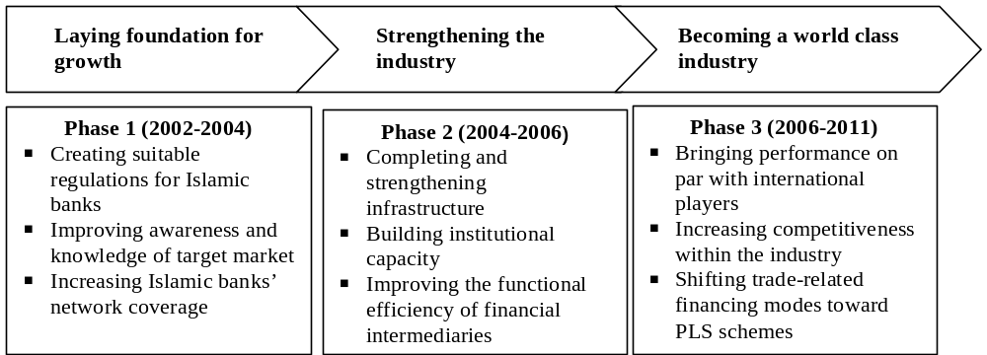

V. Conclusion

Act 10 (1998) has become the legal foundation for Islamic banks, as it provides assurance to investors, bankers, and the general public. The Act 23 (1999) strengthens the legal foundations further. As a consequence, while Islamic banking still has only a small share, its growth is significant. With the national banking system changed to a dual system, different regulations are needed for Islamic and conventional banks. This does not mean that Islamic banking is protected or privileged, but its development, as a different system, is assisted. Islamic banking development policy should not be based on the infant industry argument, but upon factors such as market, fair treatment, gradual approach and shari^{c}a-compliance. In the long term this should allow Islamic banking to be competitive, efficient, prudent and significantly supporting the real sector through equity-based financing.
The success of Islamic banking development policy in Indonesia depends on more than regulations and infrastructure, social and training programs and participation in the international Islamic finance community. It is also dependent upon Islamic bankers, customers, investors and other regulatory bodies viewing Islamic banking as a financial system: a science and not just a religious obligation.
Finally, as Islamic banking continues to grow, the involvement of regulatory and other institutions will increase. We may learn from the experience of one country, and adopt suitably modified policies to continue to independently yet jointly progress in Islamic finance.

Appendix: Salient Features of Bank Indonesia Regulations on the Operations of Commercial Islamic Banks

Table 3: Reserve Requirements for Full Islamic Bank and Islamic Banking Unit of Conventional Bank

Directive Pointers | Full Islamic Bank | Conventional Bank with Islamic Banking Unit
Bank Account at the Central Bank:
Non-Foreign Exchange Bank | - One rupiah account. | - Two rupiah accounts, one for conventional and another for Islamic based business.
Foreign Exchange Bank | - One rupiah account and one foreign exchange account. | - Four accounts, i.e.:  - Two rupiah accounts for conventional and Islamic based business, and  - Two foreign exchange accounts for conventional and Islamic based business.
RR Calculation | - Proportion of bank’s account in Bank Indonesia compared to public deposits in bank. | - Two RR calculations; one for conventional and another for Islamic business, i.e., proportion of bank balance in Bank Indonesia compared to balance of public deposits in bank.
Penalty of RR insufficiency | - RR Insufficiency x 125% x PUAS Return Indication Rate recorded in PIPU (BI) on the day of violation x 1 day: 360. | - Bank’s head office: conventional bank provisions concerning the penalty of RR insufficiency.  - Islamic Banking Unit: provisions as apply to full Islamic bank (penalty calculated separately).
Penalty for Negative Balance Account | - Negative Balance Account x 150% x PUAS Return Indication Rate recorded in PIPU (BI) on the violation date x 1 day: 360. | - Bank’s head office: conventional bank provisions concerning the penalty of RR insufficiency.  - Islamic Banking Unit: provisions as apply to full Islamic bank (penalty calculated separately).

Table 4: Conduct of Local Clearance Process and Final Interbank Settlement for Islamic Banks

Directive Pointers | Full Islamic Bank | Conventional Bank with Islamic Banking Unit
Determining Negative Balance Account for suspending on interbank clearance system membership | - The end of day balance of rupiah account of each bank in Bank Indonesia. | - The calculation of balance account applying by summing-up the end of day balance of rupiah account of conventional business and Islamic Banking Units of each bank in Bank Indonesia
Suspension from interbank clearance system membership | - Applies to all bank business. | - If the sum of account balance of the conventional business (+/-) and Islamic Banking Units (-/+) is positive, then both bank businesses will not be suspended from clearance system membership.  - If the sum of account balance of the conventional business (+/-) and Islamic Banking Units (-/+) is negative, then both bank businesses will be suspended from clearance system membership.  - Bank offices with a negative account balance are penalized.

Table 5: Islamic-based Interbank Money Market (PUAS)

Directive Pointers | Full Islamic Bank & Conventional Bank with Islamic Banking Unit
Market | - Islamic-based Interbank Money Market (PUAS).
Principle | - Investment activities based on mudaraba.
Instruments | - Interbank Mudaraba Investment Agreement (IMA) Certificate.
Information intermediary | - Money Market Information Center (PIPU) of Bank Indonesia.
Participants:
- Endorser: | - Head offices of full Islamic bank, and the Islamic Banking Units of conventional banks.
- Buyer/investor: | - Any commercial bank.
Payment of principal and return) | - Profit sharing return is paid at the end of every month, and the principle is paid back at the maturity.
Reselling of IMA certificate | - Can be re-sold once in the secondary market
Reimbursement of investment fund | - Endorser bank is obliged to pay back the principal on the due date of IMA Certificate. If the endorser used a profit-sharing method, instead of revenue-sharing, and experienced loss, then:  - Investor/buyer bank will not get profit/return.  - As long as the loss is not a result of endorser negligence/fraud then the investor/buyer will share the loss with maximum of IMA nominal amount.
Disagreement/dispute | - Parties may use Muamalat Arbitrageur Board (Islamic Dispute Settlement Agency)

Table 6: Bank Indonesia Wadi^{c}a Certificate (SWBI)

Directive Pointers | SWBI
Purpose | - Monetary instrument in accordance with Islamic principles.  - Instrument of short-term fund placement by a commercial bank according to the wadi^{c}a principle.
Maturity | - 1 week, 2 weeks  - 1 month  - stated on number of days  Bank may get the deposit back before maturity, but will not receive bonus, and will incur administrative costs.
Amount and denomination of entrusted fund | No less than Rp 500,000,000.  In multiples of Rp 50,000,000.
Time of transaction | Every working day from 8:00 p.m. to 2:00 p.m. Jakarta Time.
Procedure for application | Bank shall apply for placement of fund using RMDS/fax/telephone to Bank Indonesia with clear notification of nominal value, term and maturity.
Procedure for transaction settlement | Settlement of transaction for placement of funds shall be executed on the same working days.  Bank Indonesia shall execute the transaction by debiting the demand deposit account of the bank at Bank Indonesia in the amount of the placement.  In the case of insufficient balance in a demand deposit account, the transaction for placement of funds shall be cancelled.  In respect of cancellation, the bank shall liable to administrative sanctions in the form of a letter of warning. If cancellation due to insufficient balance occurs more then twice within a period of six months, the bank shall be penalized 0.1% of the shortfall.
Settlement procedure upon maturity | Upon maturity Bank Indonesia shall credit the demand deposit account of the bank in the amount of the placement of funds
Bonus | If Bank Indonesia provides a bonus to a bank, the amount of bonus calculated with reference to the indicated rate of return for the PUAS, comprising the weighted average indicated rate of return on IMA certificate formed in the PUAS at the date of placement of funds.  In the event the above data is not available for the day of placement of funds, the amount of bonus calculated with reference to the most recent indicator of rate of return formed on the PUAS or average rate of return on mudaraba investment time deposits prior to distribution during the preceding month for all banks conducting business based on Islamic principles.

References

Al Rajhi, Abdullah Sulaiman. “Islamic Banks: Technology and Global Challenges and Opportunities.” Proceedings of the Third Harvard University Forum on Islamic Finance. Cambridge, Mass.: 1999.
Arifin, Zainul. “Strategi Pengembangan Perbankan Bagi Hasil di Indonesia.” Sespibi. Bank Indonesia. 1998.
Chapra, M Umer. Towards a Just Monetary System. The Islamic Foundation. Leicester, U.K.: 1986.
Chapra, M Umer. “Monetary Management in an Islamic Economy.” Islamic Economic Studies 4.1 (1996).
Choudhury, Masudul Alam. Money in Islam: A Study in Islamic Political Economy. TJ International Ltd, Padstow, Cornwall. London: 1997.
Choudhury, Masudul Alam. “Growth of Islamic Banking.” Saudi Commerce & Economic Review 86 (2001).
Choudry, Nurun N dan Abas Mirakhor. “Indirect Instruments of Monetary Control in an Islamic Financial System.” Islamic Economic Studies 4.2 (1997).
Dar, Humayon and John R Presley. Bahan Seminar Sehari Toward A Greater Contribution of the Shari^{c}a Bank for Indonesian Economy. Bank Indonesia. 1999.
Karuvelil, Koshy Zacharia. “Islamic Finance: Sustaining Success.” Proceedings of the Third Harvard University Forum on Islamic Finance. Cambridge, Mass: 1999.
Khan, Iqbal Ahmad. “Developing the Country Framework for Islamic Finance.” Proceedings of the Third Harvard University Forum on Islamic Finance. Cambridge, Mass: 1999.
Mannan, M. A. Seminar Islamic Economics: Theory and Practice. Bank Indonesia. Jakarta: 2000.
Mills, Paul S. and John R. Presley. The Prohibition of Interest in Western Literature. Workshop on Islamic Economics. Islamic Foundation. 1997.
OECD. Economic Outlook Dec. 1991 & June 1995.
Muslehuddin, Mohammad. Sistem Perbankan Dalam Islam. Terjemahan oleh Aswin Simamora (1990). Rineka Cipta. Jakarta: 1974.
Siddiqi, M. Nejatullah. Banking without Interest. Islamic Publications Ltd. Lahore: 1981.

Alternative Trading Systems and the Viability of an Islamic Electronic Communications Network

Thomas D. Tellner*

Abstract

This paper studies current dynamics in the U.S. financial markets that affect the viability of an Islamic ECN (Electronic Communications Network). Foremost are recent regulatory developments that have given rise to an environment favorable to the establishment of such an ECN. However, this study also admits that the profitable continuance of the Islamic ECN is based much less on regulatory than on economic and business considerations. The regulatory history of ATSs (alternative trading systems) is discussed, focusing on the introduction of Reg. ATS and the new display rules. Following that, a brief analysis of the operating experience of ATSs/ECNs ensues, including some of the issues raised between their structure and the structure of traditional exchanges. Finally, the paper proposes an approach to building and maintaining a successful Islamic ECN.

I. Introduction

This paper studies the current dynamics in U.S. financial markets that affect the viability of an Islamic Electronic Communications Network, or ECN. First and foremost are the recent regulatory developments that have given rise to an environment favorable to the establishment of just such an ECN. However, this study also admits that the profitable continuance of the Islamic ECN is based much less on regulatory considerations and much more on economic and business considerations. As this paper attempts to point out, the “build it and they will come” mentality followed by so many Internet ventures is grievously flawed. The paper is organized as follows: First, the regulatory history of ATSs will be discussed, up to the most recent changes of interest. Then a review of the 1996 Order Handling Rules will occur. Following that, a brief study of the operating experience of ATSs/ECNs will ensue, including some of the issues raised by the differences between their structure and the structure of traditional exchanges. It is at this point that the reader must bear in mind that the term ATS is broader than that of ECN—ECNs being a sub-class of ATSs. Lastly, building on the knowledge accumulated in the first two sections, the paper will propose an approach to building and maintaining a successful Islamic ECN. The Islamic financial industry has a golden opportunity in what both the new regulatory environment and its resultant flexibility offer it.

II. Regulatory History of Alternative Trading Systems (ATSs)

A. Background
Since, from a regulatory perspective, an Islamic ECN would be a type of ATS, it is important that a brief survey of the regulatory history of ATSs be first undertaken. ATSs mirror the changes that have swept through the United States’ securities markets in the past three decades. In 1976, the United States Congress, prompted by the rapidly increasing pace of technological development and the simultaneous growth of the stock market, amended the Securities Exchange of 1934. The purpose of these amendments was two-fold. In the first instance, Congress mandated that a National Market System (NMS) be developed, leveraging the advantages of the developing technology and forestalling further disruptions in an orderly evolution of a stable market. The second purpose of the amendments was to ensure fair and equal access to markets and market information. In the early 1970s, automated systems were arising that began to fulfill roles beyond those of simply automating what would be called traditional brokerage house operations. “Pseudo-markets” began to arise, Instinet being the most notable example, where bids and offers were transmitted and orders executed based on these bids and offers. These systems were proprietary and often available to only the brokerage houses or institutions that developed them, their clients, and other subscribers. This lead to some undesirable developments, according to the Securities and Exchange Commission (SEC):

Over time, as these subscribers posted prices in ECNs that were better than the prices they were posting in NASDAQ, the public quote became less reliable and the market became fragmented. This led to artificially wide spreads in the public markets. As a result, many investors, particularly retail investors, were receiving executions at prices inferior to those displayed by market makers and other subscribers on ECNs. This essentially created a two-tiered market—the traditional public market, and the new ECN market with better prices and limited access.

Fragmentation in the securities market occurred because these private trading systems were not integrated in the traditional market as a whole. A National Market System (NMS) was proposed as the first step in remedying this increasing fragmentation. In theory, the NMS would be a centralized location for the publication of quotes against which trades could be executed at what is called the national best bid and offer (NBBO). Hence, if several different trading venues were posting different prices at which retail investors could buy or sell a security, those prices were compiled and the lowest price at which one could buy and the highest price at which one could sell would become the two sides of a quote. Prices at which trades were actually executed would be recorded as well, allowing for comparison between the NBBO and execution price to ensure the quality of executions in practice. However, this was at first only theory, since the SEC was charged in overseeing the establishment and maintenance of such a system. The SEC was then left to tackle the practical problems of establishing the system.
Congress, in amending the 1934 Act, left the SEC a great deal of room in which to maneuver in achieving the goals expressed in the 1976 legislation. For the two decades following 1976, the SEC and the self-regulatory organizations (SROs) worked together to realize the efficient operation of the NMS.

Our national market system, as it has evolved since 1975, has sought the benefits of both market centralization—deep, liquid markets—and competition. To achieve these benefits, the national market system has maintained equally regulated, individual markets, which are linked together to make their best prices publicly known and accessible. Alternative trading systems have remained largely outside the national market system.

ATSs remained so despite the extensive regulatory treatment given the NMS. In 1996, the Order Handling Rules were promulgated by the SEC, in which market makers and specialists employing ATSs were required to disseminate their quotes in accordance with the new rules. However, the ATSs themselves were not necessarily required to do so. Furthermore, if they did operate in accordance to the new rules, it was on a voluntary basis. The 1996 Order Handling Rules were indicative of increasing regulatory gap into which the quickly evolving ATSs were falling, despite the fact that their impact upon the markets was growing as well. In short, while regulations did treat the activities of ATSs, no regulations treated their regulatory status, so to speak, opting instead to promulgate rules within a regulatory framework that had been in place for over six decades.
In 1996, the same year as the Order Handling Rules became effective, Congress took another vital step forward in allowing the evolution of the nation’s securities markets. As in 1976, Congress recognized the need for flexibility in the regulation of the markets required by the pace of technological development. Congress once again turned to the Exchange Act of 1934, amending it in order to allow the SEC far-reaching exemptive powers. As the SEC explains:

In 1996, Congress provided the Commission with greater flexibility to regulate new trading systems by giving the Commission broad authority to exempt any person from any of the provisions of the Securities Exchange Act of 1934 (“Exchange Act”) and impose appropriate conditions on their operation. This new exemptive authority, combined with the ability to facilitate a national market system, provides the Commission with the tools it needs to adopt a regulatory framework that addresses its concerns about alternative trading systems without jeopardizing the commercial viability of these markets.

The SEC always had the power to “except” a person, keeping in mind that the SEC defines “person” broadly, including legal entities other than individual people, without changing the responsibilities of that person according to the regulations. Hence, as we shall see, when an entity fits the definition of “exchange,” the SEC has two alternatives in dealing with that entity. Previously, the SEC could only categorize or define and then “except” certain entities from that definition. Thus, a framework developed that at times proved itself too rigid. An entity was either an “exchange” or it was not and “exchange.” If not an “exchange,” then it was either a “broker-dealer” or it was not. Problems developed when ATSs arose that seemed to be some of both. After the 1996 amendments, the SEC was able to fine-tune its regulation of market institutions with the use of “exemptions.” Now, regardless of the definition that an institution fit, the SEC could exempt that institution from certain sets of rules. If an institution fit the definition of an “exchange,” the SEC could exempt that institution from a specific portion or all of the rules governing “exchanges,” given that other requirements were met. This was less circuitous than finding a way in which the institution could avoid the rules by taking the possibly absurd position that it was not what it was defined as by the SEC despite all logical evidence otherwise.

B. Regulation of Exchanges and Alternative Trading Systems
From 1996 to December of 1998, the SEC formulated a new set of rules that would deal with the changes occurring in the securities markets with as little impact as possible and imbue these rules with a certain amount of flexibility to handle future innovations in the types of institutions that might arise. This release was Exchange Act Release 40760, “Regulation of Exchanges and Alternative Trading Systems.” The new regulatory framework was built on three, distinct pillars:

- A new definition of “exchange”
- Exemptions for the new definition of “exchange”
- Regulation ATS

The new definition of “exchange” made the term broader, thereby netting more of the existing trading systems operating at that time and in the future. An “exchange” was henceforth defined in CFR 17 240.3b-16 (Rule 3b-16) as “any organization, association, or group of persons” that meets a two-prong test. Both of these two tests must be met in order to be considered an “exchange.” Rule 3b-16 defines these tests as being met if “any organization, association, or group of persons:

- Brings together the orders for securities of multiple buyers and sellers; and
- Uses established, non-discretionary methods (whether by providing a trading facility or by setting rules) under which such orders interact with each other, and the buyers and sellers entering such orders agree to the terms of the trade.”

Thus, ATSs fall within the rubric of an “exchange” since they certainly bring together the orders of multiple buyers and sellers as well as using a set trading solution, or algorithm, which handles these orders as they are received. Delving into the details of this definition and its implications is beyond the scope of this article. Suffice it to say for the moment, that this definition alone would require ATSs to register as exchanges. Such registration, however, would then place a much larger number of regulatory requirements upon the ATSs, greatly increasing the costs and burdens of operating such a system.
In order to avoid these prohibitive requirements and to encourage innovation in the establishment and operation of these trading systems, the SEC formulated the second pillar using its new exemptive authority. CFR 17 240.3a1-1 (Rule 3a1-1) exempts ATSs from the definition of an “exchange” given that certain conditions are met. For our purposes at present we are concerned with only the portion of this rule that states that an ATS is exempt if it “(2) Is in compliance with Regulation ATS, CFR 242.300 through 242.303.” Hence, while ATSs were still considered exchanges by virtue of the definition of Rule 3b-16, they were exempt from having to register as exchanges given that they were complying with CFR 17 242.300 through 242.303, also known as “Reg. ATS.” In short, ATSs now had a choice: either register as an exchange and comply with the more prohibitive regulations applicable to exchanges or register under Reg. ATS and comply with the regulations applicable to broker-dealers. The second alternative was widely seen as much less costly and burdensome.
The third pillar, Reg. ATS, is the set of regulations covered by CFR 17 242.300 (Rule 242.300) through 242.303 (Rule 242.303), first mentioned above in the exemption provided by Rule 3a1-1. These rules do not cover the regulation of broker-dealers entirely, but are an addition to a larger set of regulations applicable to registered broker-dealers. For the discussion at hand, emphasis will be put on an even smaller portion of those regulations. Specifically, this discussion will focus on the definition of an ATS under CFR 17 242.300 (Rule 242.300). Under Rule 242.300, an ATS is defined as “any organization, association, person, group of persons, or system [that]:

- That constitutes, maintains, or provides a market place or facilities for bringing together purchasers and sellers of securities or for otherwise performing with respect to securities the functions commonly performed by a stock exchange within the meaning of [Rule] 240.3b-16 of this chapter; and
- That does not:
- Set rules governing the conduct of subscribers other than the conduct of such subscribers’ trading on such organization, association, person, group of persons, or system; or
- Disciplines subscribers other than by exclusion from trading.

C. Issues of Concern for the Islamic ECN
It is the definition of an ATS under Rule 242.300 that raises the most serious questions as to the viability of establishing an Islamic pseudo-exchange in the guise of an Islamic ECN. The questions that will have to be asked and the interpretations that will have to be made revolve around what is exactly meant by “governing the conduct of subscribers.” Furthermore, once these activities have been identified, what is the difference between them and similar activities reserved for exchanges? Specifically, as a broker-dealer, the firm that establishes an ECN is subject to the rules of the self-regulatory authority (SRO) of which it is a member. All broker-dealers are required to a member of an SRO, such as the New York Stock Exchange or NASD, which have their own listing requirements. Accordingly, any member broker-dealers follow these listing requirements by trading only those securities that meet the set criteria. Would then an Islamic ECN be overstepping its authority by limiting trading to Islamically-acceptable stocks, and thereby qualify as an exchange?
There are several indications that this would not be the case, though this conclusion is reached only after brief interpretation rather than official declaration or legal opinion. First, there is the principal that any such Islamic ECN would be setting forth qualifications more restrictive than the applicable SRO as opposed to qualifications less restrictive. In other words, the Islamic ECN would be trading securities “more qualified” rather than “less qualified” to be traded on its system. The Islamic ECN would not necessarily be increasing risk to the investor in doing so. Nevertheless, it would be impossible to tell without the actual establishment of such an Islamic ECN whether or not the SRO would consider such restrictions a usurpation of its powers. In addition, this issue does not revolve around the SEC’s interpretation of an “exchange” since the SEC has defined the two key elements of an “exchange” as being the bringing together of multiple buyers and sellers as well as the use of a non-discretionary system by which there order are handled. Rather, the issue lies with the SRO’s interpretation of this activity. Different SROs might view this in different ways.
In addition, in the SEC’s “Regulation of Exchanges and Alternative Trading System” release, there are several references to such activity on the part of ATSs. The SEC mentions:

The Commission would consider a trading system to be “governing the conduct of subscribers” outside the trading system if it imposed on subscribers, as conditions of participating in trading, any requirements for which the trading system had to examine subscribers for compliance. In addition, if a trading system imposed as conditions of participation, directly or indirectly, restrictions on subscribers’ activities outside of the trading system, the Commission believes that such a trading system should be a registered exchange or operated by a national securities association.

So, the prospective Islamic ECN must realize that the SEC considers it as an exchange. However, the exemptive authority of the SEC paves the way for these ATSs to register as broker-dealers under Reg. ATS. This much is evident. As far as the SEC is concerned, the question becomes one of whether or not limiting trading on the system to Islamically acceptable stocks is “governing the conduct of subscribers” to such a point that it is an activity qualifying it necessarily as an exchange beyond the limits allowed to institutions eligible for registration under Reg. ATS. Also, is a trading system’s refusal to execute an order on a stock that is not in its database considered a way that it would “examine subscribers for compliance”? A case might be made that this is not so. The Islamic ECN is setting forth guidelines as to the securities traded, and hence, only indirectly as to the subscriber’s conduct. Is not the Islamic ECN limiting the securities traded rather than the subscribers’ conduct?
If the answer to this question were in the affirmative and this were the correct interpretation, the question then becomes one of whether such guidelines being imposed upon the securities traded is considered “listing.” Listing standards are the privilege of registered exchanges, not broker-dealers.

An alternative trading system wishing to register as a national securities exchange may choose to set listing standards for its system. If an applicant chooses to set listing standards, it must have written listing and maintenance standards, as well as and adequate regulatory staff to apply those standards. The applicant must also have rules restricting the listing of securities issued in a limited partnership rollup transaction.

There are several points contained in this selection. First, it says that an exchange, “may choose to set listing standards.” Is this to imply that listing standards are not a necessary element of an exchange or SRO, since it employs the use of the term “may”? Otherwise, other points are problematic. The Islamic ECN is sure to have established criteria as to what qualifies a security as an Islamically acceptable stock as well as a staff to apply those standards, regardless of the degree of automation used to periodically evaluate individual companies for compliance to shari^{c}a standards. However, this structure must be in place in the case that, “an applicant chooses to set listing standards.” Does having these standards automatically define the Islamic ECN as an exchange or SRO? Once again, the additional question is whether trading a more restrictive universe of stocks from the larger set approved for listing by the applicable SRO is permissible. This is, in fact, what an Islamic ECN would be doing.
When the SEC formulated this new regulatory framework, it obviously did not have the unique characteristics of an Islamic ECN in mind. As a result, these specific issues must be addressed from an official regulatory position before an attempt to establish an Islamic ECN progresses too far. The fact that these issues are not addressed specifically—and it is only natural that they would not be—does not imply that they are complex or beyond simple resolution. It simply means that participants in the Islamic financial industry must raise these questions before the appropriate regulatory bodies in order to have them settled definitively. This is the task that awaits the prospective Islamic ECN.

III. The Order Handling Rules

A. Background
While Reg. ATS makes it easier to establish an Islamic ECN, the rules to which focus will now turn assist in the viability of such an ECN once established. In the foregoing section, brief mention was made of the 1996 Order Handling Rules. This set of rules was comprised of several other SEC Rules that were either promulgated anew or amended in 1996 in order to further the goals Congress had set forth in the 1976 amendments to the Act of 1934 pertaining to the establishment of the National Market System (NMS). The goals of the 1976 amendments to the 1934 Act have already been discussed, but it is worthwhile to repeat them here since they are of great importance to the discussion to follow. Specifically, Congress determined that it was in the interest of the investing public to construct the NMS such that it provided:

- economically efficient executions;
- fair competition among broker and dealers, among exchange markets, and between exchange markets and markets other than exchange markets;
- public availability of quotation and transaction information;
- an opportunity to obtain best execution; and
- an opportunity to obtain execution without dealer intervention to the extent consistent with economically efficient executions and the opportunity to obtain best execution.

The NMS would achieve these goals by making all quotes and trades on securities publicly available by consolidating the reporting of quotes and executions and disseminating that information to all participants. This transparency would then theoretically allow the individual investors to be more aware of the quality of their executions and make informed decisions based on the more accurate picture painted by the information being presented.
The fifth point above sets forth what was for that time a relatively novel concept. In short, it states that all of the points that precede it—that is one through four—should be available to all participants alike. This meant that the efficiency and quality of trading established via the NMS should be directly accessible to the individual investor and not just the institutions. Congress was not satisfied with the individual investors benefiting from their brokers getting them better executions which would have to be verified by the investors using the more accurate information provided by the apparatus that comprised the NMS. The NMS was to eventually provide the individual investors the opportunity to act without the assistance of a broker or a dealer. This concept of disintermediation was one at which ECNs would later prove they could excel.
However, before such an environment could exist, the SEC had to set forth guidelines for the handling of orders and quotes by broker-dealers—an activity it was found that was fraught with irregularities usually not in the best interest of the public. Before the technological explosion of the 1980’s and 1990’s, investors had to rely on the information provided them by their respective broker-dealers. As has already been mentioned, a fragmented market system was developing, and the information provided to investors was more or less accurate depending upon which “source” the broker-dealer used. While the NMS alleviated this problem somewhat by exposing all market information to the public and disseminating the best bids and offers (NBBO) as well as accurate execution information, the recent rise of ECNs and other ATSs has created the problems once again. In addition, there has always been a regulatory distinction between “orders” and “quotes.” Orders represent for the most part agency transactions executed on behalf of a retail account. As a result, they contain one side of the market—either a buy or a sell. Quotes on the other hand represent proprietary trades for the accounts of broker-dealers. Dealers post quotes to the public to indicate prices at which they are willing to buy and sell, making it necessary to post two sides to each quote. When a dealer can also enter an order to buy or sell only on an ECN for their accounts, they effectively take the role of “investor” instead of dealer since they are technically not executing transactions based upon their obligatory two-sided quotes. That is, they execute transactions by posting prices using only one side of the market. Until the 1996 Order Handling Rules, the dealers’ orders fell under a different set of guidelines than their quotes. The SEC found:

…brokers today may quote one price publicly to retail customers, while showing a better price privately to other investors and dealers on an ECN. In addition, the quotes displayed to public investors may not accurately reflect the best price for a security because limit orders, which specify the price at which customers will buy or sell a security, are not uniformly required to be included in the quote.

The distinction between orders and quotes, as well as the differences in that manner in which they are handled, holds greater significance than mere best execution considerations. When an investor places a “market” order, that investor simply requests the transaction be completed at the best price possible. In this way, the investor is a “price taker.” When an investor places a “limit” order, that investor is setting a ceiling or a floor at which they wish the transaction to be completed. At the same time, they are in effect setting a price at which they are willing to buy or sell much like a dealer. In this way, the investor is a “price setter.” However, price setting was considered the privilege of specialists and dealers, not investors—though this was more of a perception rather than a legal fact.
Unfortunately, as evidenced by the practices described by the SEC above, even limit orders were being executed at small array of available prices if more than one price at all. Limit orders were also not being exposed to the markets as a whole, since they were orders rather than quotes, thereby blocking the chance for other participants to execute the order at improved prices. In short, investors placing limit orders were for all intents and purposes being treated as “price takers” and not “price setters.” Events began to transpire to change this. First, ECNs were established which by virtue of their order-matching structure allowed individual investors to place limit orders into the system which were reflected in the public order book. This display of limit orders allowed the individual to participate directly in the price discovery process since their limit orders were being treated as “price setters.” In addition, the ECNs excelled at disintermediation since the subscribers did not rely on the information and order handling of a broker-dealer. The remaining drawback was that ECNs were not integrated into the NMS.
In 1996, the SEC promulgated the Order Handling Rules that would begin the move toward integrating ECNs into the NMS. This new set of regulations first blurred the distinction between “orders” and “quotes” for the purposes set forth therein. In doing so, the SEC was then able to set forth uniform minimum standards for the handling of orders and quotes that leveled the proverbial playing field between the institutions and investors. Market makers and specialists would now be more likely to compete with customer limit orders than merely attempt to execute them or hold them for later execution. The Order Handling Rules had to treat this from two different perspectives, making the Order Handling Rules comprised of two different rules. One was the creation of a new rule that would be called the “Display Rule’ covering the display of limit orders to the public and other markets. The other method the SEC used was to amend the already established “Quote Rule.’ The details of each shall be discussed separately below as well as their importance to the viability of an Islamic ECN.

B. The Quote Rule
As already noted, the SEC amended the existing Rule 240.11Ac1-1, popularly known as the Quote Rule and hereafter referred to as such, in order to establish these new guidelines for order handling. This rule, before being amended,

…require[d] the collection and public dissemination of the best bid, best offer, and size for each market quoting any security covered by the Quote Rule, as well as the consolidation of those markets’ quotations and public dissemination of the national “consolidated” best bid and offer (“NBBO”). These quotations must be firm, and a market maker or specialist generally is obligated to execute an order at a price at least as favorable as its published bid or offer up to the size of its published bid or offer.

The SEC found that some specialists and market makers were in the habit of quoting bids and offers to the public while entering different prices on ECNs. This was creating a two-tiered market, since the ECN orders placed by market makers and specialists were not being treated as quotes and disseminated to the overall market. The SEC stated that this practice ran counter to the spirit of the 1976 amendments to the 1934 Act, as well as the Quote Rule, and sought a way to integrate these quotes into the NMS.
The solution the SEC created was the “ECN amendment” to the Quote Rule, which begins by stating that any bid or offer entered into an ECN shall be intended for inclusion into the Consolidated Quotation System (CQS) that is part of the NMS universe. In addition, it is expected that if the bid or offer improves the quote that that market maker or specialist reports directly to the CQS, then that market maker or specialist will change its quote to reflect the bid or offer entered into the ECN. Functionally, the market maker or specialist would enter a price into an ECN. If this price bettered that market maker’s or specialists published price, then that market maker or specialist would then have to update their published price as well. Taken as is, this requirement would actually dissuade market makers and specialists from continuing to enter bids and offers into ECNs. The primary enticement to market makers and specialists was the anonymity that the ECNs offered to those participants who placed bids and offers into the respective ECNs. However, if a market maker or specialist entered a specific bid or offer into an ECN and then changed their public quote for the same size and amount, it would become obvious to observers who had just entered the order into the ECN.
To alleviate this concern, the SEC also formulated the “ECN display alternative.” The SEC declared that if a market maker or specialist entered a bid or offer into an ECN, and that ECN was able to disseminate that bid or offer to the entire market, that market maker or specialist would be in compliance with the ECN amendment to the Quote Rule. Therefore, if an ECN could disseminate the limit order as well as the dealer who sent it and allow equivalent access to that order for other brokers or dealers regardless of the fact that those brokers or dealers were subscribers to the system, the ECN could then benefit from order flow from dealers seeking to comply with the Quote Rule as amended.

C. Display Rule
Given the importance of disintermediation and its contributions toward fair and equal access to markets, as well the sudden opening of the markets to individuals due to technological advances, it is unlikely that the SEC could have achieved the stated goals of both the amended Quote Rule and the new Display Rule pertaining to the handling of orders without blurring this distinction. However, it is not the novelty of the approach that the SEC chose to take that is of main concern. Rather the importance to ECNs is found in the manner by which participants can satisfy these new obligations.
The SEC describes the obligations imposed by Rule 11Ac1-4, hereafter referred to as the Display Rule, as follows:

Specifically, the rule allows an OTC market maker or specialist, immediately upon receipt of a limit order, to: (1) change its quote and size to reflect the limit order; (2) execute the limit order; (3) deliver the limit order in an exchange- or association-sponsored system that complies with the requirements of the rule; or (4) send the limit order to another market maker or specialist who complies with the requirements of the rule. The rule would require the specialist or OTC market maker to display a customer limit order when the order was “held” by the specialist or OTC market maker. If the specialist or OTC market maker immediately sends the order to a system or to another specialist or OTC market maker that complies with the rule, the specialist or OTC market maker that routed the order would have satisfied its obligation to display the order. These alternatives are intended to allow market makers, specialists, and market centers an opportunity to continue to provide their valuable services while offering customers the best available execution opportunities.

As part of the third alternative above—the delivery of the limit order to a sponsored system that complies with the rule—the SEC included ECNs. Hence, ECNs were now allowed as alternative channels by which a specialist or OTC market maker could satisfy its obligations to the new rule.
In other words, the new rule required that dealers (either specialists or market makers) to post customer limit orders as part of the public quote—usually within 30 seconds of receiving the order. This would put the dealers’ bids and offers in direct competition with those established by the limit orders entered by customers. Dealers could also simply execute the limit order within the obligations of best execution. Lastly, the dealer could deliver the order to other participants to handle, given that in doing so, the order would be either executed by the recipient or that recipient would update their quote to reflect the limit order. By referencing the “ECN display alternative” in the amended Quote Rule within the text of the Display Rule, the SEC had once more allowed a market maker or specialist to satisfy the rule with the assistance of an ECN. Again, if an ECN could disseminate the limit order as well as the dealer who sent it and allow equivalent access to that order for other brokers or dealers regardless of the fact that those brokers or dealers were subscribers to the system, the ECN could then benefit from order flow from dealers seeking to comply with the new Display Rule.

D. ECN Requirements
ECNs, like all market participants, are thought to benefit from the implementation of this rule through increased executions. With the increased competition from limit orders being included in quotes, there is a better chance that these limit orders will be executed due to the greater transparency they receive. As limit orders increase the competition, spreads should theoretically grow smaller, possibly attracting more market orders for execution as well. The revenue that could be derived from this extra activity is a function of rather straightforward mathematics. Yet, as spreads grow smaller, so too will dealer profits from these spreads. If the quote and order traffic increase significantly, then significant upgrades to the systems employed by these dealers must be made. In an environment of diminishing revenues from market maker activities, it might not be a worthwhile investment to upgrade these systems. Several commentators in the SEC Order Handling Rules release predicted this very situation. The SEC noted in response, “The Display Rule also allows a specialist or market maker several ways to comply with the rule by routing the order elsewhere without displaying the limit order in its own quote by transmitting a customer limit order to…a qualifying ECN.” In this light, ECNs were placed in a position to market themselves as low-cost alternatives to systems upgrades. Dealers could “outsource” compliance with the Display Rule per the alternative to “lay-off” some of the limit orders to qualifying ECNs.
Before the ECNs could profit from this potential order flow influx, they had to meet certain requirements, some to which this discussion has already eluded. The SEC classifies these as two separate requirements:

First, the ECN into which the market maker or specialist enters its order must ensure that the best prices market makers and specialists have entered therein are communicated to the public quotation system. Second, the ECN must provide brokers and dealers access to orders entered by market makers and specialists into the ECN, so brokers and dealers that do not subscribe to the ECN can trade with those orders.

The ECN also has several options before them here as well. To attract the order flow from market makers and specialists, the ECN can identify the price entered as originating from the ECN itself rather than any certain market maker or specialist. By choosing to market itself as an alternative form of compliance with these rules, the ECN must also provide access to brokers and dealers that are not subscribers to the system. Here, once more, is an opportunity to attract more order flow.
Also, the issue of “access” allowed non-subscriber brokers and dealers is an important issue. An easy way to conceptualize the term “access” as the SEC uses it in this instance is that other brokers and dealers must be able to trade against the order as easily as if the order had not been entered into the ECN and remained with the market maker in the first place. So, the ECN must have additional technologies to assist in trade execution, even if this technology is as simple as phone lines and traders to staff them. This becomes as extra consideration for the ECN, which might be accustomed to fully automated executions on the part of its subscribers. Exchange-traded securities are also available for execution of automated systems as well. If the brokers or dealers could normally trade against other orders on the NASDAQ’s Small Order Execution System (SOES), SelectNet, or against Inter-Market Trading Plan/Computer Assisted Execution System (ITS/CAES) securities—also known as Rule 19c-3 securities, then the ECN must establish linkages to the systems and exchanges allowing for similar access. Access and participation in these various systems involves incurring fees for that access and participation. On the other hand, if ECNs in turn charge non-subscriber brokers or dealers for access to the orders, it is not considered an impediment, so the ECN could establish a schedule of charges to offset the cost of this extra burden.

IV. Survey Of Current Market Structures

At this point, given that this paper has now treated the external environmental factors influencing the viability of an Islamic ECN, it is appropriate to turn the focus to more internal factors that must be considered. Primarily, this paper now will focus on certain structural considerations the potential Islamic ECN must take into account in order to become and remain viable. First, this paper will quickly review the key characteristics of the different market structures being employed by exchanges and ATSs currently. Following this, the discussion will move to raising possible alternatives the Islamic ECN can choose from as it decides upon the most advantageous structure it will assume, given the advantages and disadvantages discovered in the discussion of the particular market structures.

A. Electronic Communications Networks (ECNs)
ECNs are primarily “order-matching” systems. Order flow, to use the term loosely, is managed by computer-based algorithms that bring together similar buy and sell orders. For orders not immediately matched, there is the “order book” which is displayed to the public for each individual stock. Hence, an order to buy ABC Inc. at $10 would match with any similar sell order at that price or lower and vice versa. However, should our imaginary buyer’s order be below the current market—say the lowest sell order was at $11, with higher bids at say $10.75—then the buyer’s order would be reflected in a publicly displayed limit order “book.” Orders are usually prioritized on a price-time basis. Theoretically, the combination of order matching without the presence of intermediaries and the publicly displayed order book results in trading at lower cost due mainly to the absence of a spread and an increased level of transparency due to the publicly displayed limit order book.
Lower costs and increased transparency are the two major advantages of ECNs. However, there are additional advantages as well. For example, the high degree—almost complete—of automation results in faster executions and confirmations. This is important to players more concerned with execution at the expense of any particular, exact price. In addition, ECNs allow for simpler expansion into newer markets, especially the international scene. ECNs continue the advantages of traditional markets as well. These include anonymous trading as well as customized trading preferences, such as special instructions on orders. Lastly, ECNs are automated entities that allow for the expansion of trading sessions into after-hours trading and even into the realm of twenty-four hour trading sessions.
ECNs do have certain disadvantages as well, from both practical and structural points of view. Structurally, ECNs provide limited opportunity for price improvement. While the order-matching algorithm may match the lowest prices to buys and highest prices to sells, it normally does so only for that platform and not other venues where better prices may exist. In this sense, ECNs are semi-closed systems suffering from the disabilities of market fragmentation. Fragmentation, due to the undeveloped linkages between systems and venues is in itself another disadvantage of ECNs. While the linkages are being improved, some in response to regulatory requirements, the information being reported can reflect activity substantially different enough from the larger market to skew reporting. Other players relying on this choppy information may draw incorrect conclusions and trading volatility may ensue.
Practically, ECNs have experienced a lack of interest from players other than individual traders. Larger institutional traders have stayed away, preferring the more traditional venues such as the NYSE with all its inherent drawbacks to ECNs. The most obvious reasons are that ECNs lack liquidity to absorb the large orders handled by institutions and the lack of trading volume on any particular system. Again, this is a result of “fragmentation” occurring in the markets especially with the rise of ECNs. Without the ability to absorb an entire institutional order or find the liquidity elsewhere, ECNs will find it difficult to attract institutional interest. The irony of this situation is that the very liquidity the institutions seek would come from other institutions.
As previously mentioned, the SEC characterizes ECNs as a form of ATSs and hence the ECNs choose the regulatory framework under which they will operate—either as exchanges regulated by the SEC or as a broker-dealer regulated by a designated SRO. Currently none of the ECNs have become exchanges, though a select few have begun the registration process as such. As a result, ECNs are still for the most part regulated by the NASD as broker-dealers. In addition, there are no codified rules governing the conduct of ECNs and their members since this would not occur until the ECNs actually attain approval as exchanges. There are no codified rules detailing the roles of the various players as there exist for exchanges such as the NYSE and NASDAQ. Hence, any discussion of the governing rules for ECNs has already been covered by the previous discussion concerning the regulatory environment revolving around the SEC’s Reg. ATS. The situation will prove somewhat different for the other market structures.

B. The Open Outcry Market or Agency-Auction Market (NYSE)
The open outcry market is probably the first image one would bring to mind when mention is made of the stock market. The NYSE is the most famous market using this structure. The NYSE had evolved over the past 200 years from collections of men dealing in various securities in informal crowds, to crowds divided into dealers and auctioneers and then progressively to the arrangement used today. Currently, the NYSE designates certain persons (usually members of partnerships or larger firms) to act as specialists for certain securities. These specialists keep watch on the market activity and “manage” the order flow and liquidity, assisting in the process of finding buyers for sellers and sellers for buyers. Specialists also oversee the activities of the floor brokers who meet around the specialist’s post. This meeting of brokers is still referred to as “the crowd.” The brokers in the crowd execute orders for their clients and firms by conducting trading activities between one another. If a contra-side trade is not to be found in the crowd, the specialist can step in to take the other side of the trade to or from his own inventory. In doing so, the specialist is ensuring the continuance of an orderly market by adding to the liquidity available in the crowd. The inventory accumulated by the specialist, as well as the public limit orders routed through various systems to that specialist’s post, is then used to create an “order book” like displayed by the ECNs. In this way, the specialist also fulfills another duty: to maintain a continuous two-sided quote.
It is useful to note that how the order is actually executed makes a difference to total transaction cost. If a floor broker finds a contra-trade in the crowd with another broker, then the process is actually quite like the order-matching systems of ECNs. Two matching orders are executed between two brokers at the same price, with no spread involved. However, if the specialist must add liquidity to the market and either buy or sell in order to do so using his own inventory—and capital—then he does so in hopes of capturing the spread by later reversing his position by again buying or selling. The agency-auction market therefore does have some distant similarities with the order-matching systems used by ECNs. However, the agency-auction market is believed by some to be superior to order-matching because in the case of thin liquidity on a security, the ECNs have no mechanism like specialists to step in and smooth the disparities that have arisen.
In addition to the system described above, the NYSE and other regional exchanges have increasingly automated their order management systems to take some of the flow load off of the floor. The most well known of these systems is the NYSE’s SuperDOT. SuperDOT “provides automated order routing and reporting services to facilitate the timely and efficient transmission, execution, and reporting of market and market limit orders on the Exchange.” SuperDOT handles market orders up to 39,999 shares and limit orders up to 99,999 shares. This system also has some of the cost advantages of order-matching systems in that, “The specialist shall not charge floor brokerage for the execution of a market or marketable limit order which he receives by the system.” Furthermore, if a specialist must intervene to facilitate the execution of a SuperDOT order, if the order is executed with his assistance in less than five minutes, no commission is charged. The similarities end there, however. SuperDOT is not an order-matching system. All orders received via the system must be displayed to the crowd in order to allow for price improvement. In doing so, orders presented via SuperDOT are often executed at better prices than the NBBO.
The advantages of the agency-auction system have indirectly been mentioned in the immediately preceding discussion on the characteristics of this particular market structure. The agency-auction system, to operate as described above in an efficient manner, has additional characteristics that have drawn criticism recently. For example, while the intervention of a specialist in instances of market disruptions is seen as an advantage over ECN order-matching systems, this advantage comes at a price. The specialist intervenes from his own inventory of stock, which he has accumulated by committing his own capital. In exchange for taking on this risk, the specialist is allowed to see the order book on each security. He can see the amounts of buys and sells and therefore had intimate knowledge of buying and selling pressures on a stock—a privilege a regular trader would pay dearly for as well. This is the exact opposite to the transparency involved in the publicly displayed order books on ECNs. The specialist’s powerful position in relation to the rest of the market has continually raised concerns.
The specialist stands to gain considerably as well given market appreciation. Specialists can often make subjective decisions about how and when they execute trades, sometimes trading out their own accounts at a profit. Given their intimate knowledge of the depth of a market for a given security, this raises some conflict of interest concerns. In addition, the recent move to decimalization has allowed specialists to “penny jump” public and institutional orders. Specialists can simply step ahead of existing orders if they feel that a different price is more indicative of the market for a stock. Whereas when stocks traded in larger, more noticeable increments of fractions, decimal trading has made it far harder to tell when “jumping” has occurred let alone if it were warranted. Such activity is in fact within the rules of the existing exchanges, though most other participants see it as an abuse.

C. The Dealer Model (NASDAQ)
The third and final market structure to be reviewed is the dealer model, represented best by the NASDAQ market in the United States. NASDAQ is a system of approved market makers who post competing bids and offers on securities—the highest bid and lowest offer becoming part of the NBBO. Once involving negotiated dealings, NASDAQ is now more order-driven due to developments such as the Order Handling Rules and new technologies. Hence, the use of the term “competing” is somewhat more accurate. These market makers, like specialists on the floors of the exchanges, keep inventories of each security in which they make a market. The system, like ECNs, is almost completely automated. However, unlike ECNs and the agency-auction system used by the NYSE, the dealer model continually subjects trades to a spread since trades are executed to and from each dealer’s inventory—though some crossing may occur on orders a dealer receives that can be matched. Again, this is not an automatic order-matching system. When a dealer receives an order to buy or sell, he consults the possible contra-orders posted on the NASDAQ system by other dealers. The consulting dealer will find a matching or better price and then send a message to the contra-dealer in order to execute the transaction. This is done until the consulting dealer’s request to trade is accepted and the transaction is executed.
The market makers, like the specialists on the exchanges, are allowed to hold inventories of the stocks they make markets in. As a result, they are hoping to profit from dealing in these securities. While the specialist alone can see the order book of limit orders, all market makers can see the parallel “book” comprised of bids and offers entered by competing market makers. This creates a higher degree of transparency than available in the agency-auction system, but still a lesser degree than that present with ECNs. Systems are now also available to the public, at a subscription price, which allows individuals access to this “book” created by the activity of NASDAQ market makers. Whereas most investors can only see the NBBO—comprising two prices—these newer subscription systems shows the prices present in the book. This is called “Level II” quote systems.
While the specialists on the exchanges are explicitly charged with maintaining an orderly market, the dealers approved for making a market on the NASDAQ fulfill the same function via a more indirect requirement. Specialists are charged with, “The maintenance of a fair and orderly market [which] implies the maintenance of price continuity with reasonable depth, and the minimizing of the effects of temporary disparity between supply and demand.” Beyond this, NYSE members are left to interpret this rule and take actions they feel appropriate in any given instance. NASDAQ, on the other hand, makes the requirements more explicit. “For each security in which a member is registered as a market maker, the member shall be willing to buy and sell such security for its own account on a continuous basis and shall enter and maintain two-sided quotes in the NASDAQ Stock Market.” Following this, depending on the NASDAQ system or classification in which trading occurs, there are explicit standards delineated to define “continuous basis” as used in this instance.

V. Issues Confronting the Operational Viability of ECNs

For present purposes, NASDAQ is sufficiently structured in such a way to make it functionally similar to an ECN. This may explain some of the success at drawing order flow to ECNs has come in the form of NASDAQ securities. The current competition with which ECNs must deal comes from the traditional exchanges, such as the NYSE. The exchanges represent an additional source of liquidity that could push the trading volume of ECNs to a more viable level. Given this, the remainder of this paper will focus on a comparison and contrast between ECNs and the agency-auction market system and the steps the potential Islamic ECN can take to mitigate some of the competitive issues involved, relying on the brief survey of market structures above.
As revealed in a preceding section, ECNs have actually been in existence for nearly 30 years. Instinet is an ECN. However, from a popular standpoint, the last two to three years has been recognized as the “age” or “rise” of ECNs. In this, like the regional exchanges before them, the ECNs arose as competitors to the established exchanges. This competition focused on drawing order flow away from one another. Liquidity is the lifeblood of an exchange or pseudo-exchange, and order flow provides that liquidity. The two are almost synonymous. While existing, floor-based exchanges were heralded as dinosaurs, they soon proved adept at meeting the challenge presented by regional exchanges and ECNs.
Market observers watched the rise of commercial ECNs with concern. Like the developments almost 30 years earlier, the result was predicted to be further market fragmentation and less efficient markets as liquidity was spread thinner among the players vying for order flow. The previous sections also briefly discussed how the SEC and Congress have responded to this threat. In the end, however, the threat seems to have been false. Commercial ECNs being offered to the investing public failed to garner the order flow necessary to remain viable. Currently, this situation has changed little, with order flow to ECNs being anemic at best. Newly established ECNs spent a great deal on the technology required to fulfill their functions, but the revenues that should be produced from order flow are not flowing back to cover the investments already sunk into them and the current investment necessary to keep them running and produce a profit. The order flow has not appeared, especially from the vital institutional sector. While the factors that could explain this situation are numerous, this paper will focus on only one main concern: the differences in market structure between the venues that affect the viability of ECNs.
The competition between the exchanges and ECNs has become one focusing on the differences in their inherent structures, i.e., the differences between a specialist-based (agency-auction) system and an electronic order matching system. Both sides have touted the advantages of trading using their venues, and indeed, it seems that investors—both individual and institutional—have made their choices based on the advantages and disadvantages revealed through the course of this on-going discussion. Both systems achieve the same goal: bringing together buyers and sellers of securities. In most cases, however, that is where the similarities stop. At the risk of over-simplifying matters, exchanges used specialists to maintain an orderly market in assigned securities, balancing the buys and sells entered into their books and presented before them on the floor of the exchange itself. The specialists assist in “price discovery” on each of their securities. ECNs, on the other hand, rely on computer algorithms to match similar orders on opposite sides of the market for securities and to provide price discovery.
ECNs arrived upon the scene as venues that provided a market structure that resolved the issues that many market participants had with the specialist system. ECNs relied upon non-subjective algorithms for price discovery, while matching orders directly by basically using the computer as a tireless specialist that brings together buyers and sellers. Two to three years ago, these systems were widely believed to be the technological development that would make human specialists obsolete. However, specialists retain their importance role in the capital markets to this very day, while it is the ECNs that have begun to falter, or at the very least be said to be stumbling. The reason for the poor showings on the part of the ECNs is purely economic; the order flow they expected failed to materialize. The question remains, then, as to why, if such systems were expected to be such an improvement over the established specialist system, they have not attracted the requisite order flow?
One obvious explanation is that the ECNs did not attract enough institutional interest and the attendant order flow from them. But, this explanation still begs the question of, why not? The situation in which markets often find themselves, especially ECNs at this point in time, is a classic Catch-22. Institutions will be attracted by liquidity (order flow), but a particular market cannot provide that liquidity without the participation and order flow of the institutions. Hence, the old specialist-based system must still hold enough draws, despite the alleged disadvantages inherent to it, to keep the ECNs from capturing the institutional business it had hoped to garner. Somewhere within each market’s structure was a key difference that allowed the exchanges to hold the loyalty of the large institutions participating in the capital markets at the expense of the ECNs.
Probably the greatest difference between the two venues is the role a specialist play as a “market maker.” As already mentioned, he accomplishes this through the often large inventory he holds of his assigned securities. When imbalances occur in either buys or sells on a stock, he can bring the desired balance back to the market on that particular security by buying or selling from his own inventory. Theoretically, he should be doing this regardless of profit and loss considerations this creates in respect to his holdings. The market for each security has a “stand by” pool of liquidity represented by the specialist’s inventory of the stock. While the specialist is rewarded for this role in trading by an intimate knowledge of the buying and selling pressure represented in his order books like no other participant trading in the market, such ignorance on the part of the institutions does not seem to warrant forsaking the liquidity the market receives in return in favor of the transparency offered by ECNs. Institutions, it seems, feel that by switching their order flow to the ECNs, they would have a more complete knowledge of buying and selling pressures on a security represented by the easily accessible “books” posted on the electronic systems, but nevertheless have by far less-than-adequate liquidity.
It should be added at this point that NASDAQ, technically an ECN when SelectNet employed a market-wide “broadcast” feature, seems to be an exception to this rule. While the practice of price discovery is carried out by an electronic system that sorts the bids and offers of NASDAQ participants, the market makers are sanctioned with the responsibility of standing ready to provide liquidity to the markets of the securities trading on the system. As a result, a completely valid comparison cannot be made between NASDAQ and commercial ECNs. There are, however, valuable lessons to be learned from the structure of NASDAQ, which future ECNs may want to replicate without casting themselves in the role of an exchange under the new regulatory structure discussed in the preceding sections.

VI. Practical Suggestions for the Islamic ATS

Up until this point, the discussion has steadily moved from theoretical to practical. Now, it is necessary to take another step in this direction. As has already been said, ECNs established themselves as competitors to established exchanges. In order to compete, ECNs differentiated themselves by focusing on the advantages trading on their venue held for investors. In theory, the advantages that the ECNs pointed out were accurate. However, the fact that they could not attract liquidity—in itself a necessary characteristic—became the most decisive factor in their success. It is expected that, given all other ingredients in a recipe for success, the missing key ingredient will continue to be liquidity. Hence, the Islamic ATS should carefully evaluate the sources of such liquidity and then carefully evaluate the potential means of attracting that liquidity to its venue.
The first step any potential Islamic ATS takes should be to decide that it will not set itself up as if in some sort of inherent competition with the established exchanges. The major and regional exchanges have proven very flexible and creative in responding to the threat once believed to have been posed by ECNs. The NYSE has been most active in this regard. Given some of the “re-structuring” the exchanges have in store, the competition for order flow will only get worse—and the ECNs will find themselves competing with stronger, more modern looking exchanges. The NYSE has begun to adopt a multi-platform structure designed to meet the needs and concerns of the different types of investors. For smaller orders and smaller, individual investors concerned with speed and accuracy, the NYSE is moving to automating its order management systems. At the same time, in deference to the concerns of institutional players who usually are more concerned with price improvement rather than certainty of execution, the NYSE is creating a separate order management system relying heavily on the “human” factor contributed by the specialists who can use more subjective means for evaluating how the large institutional orders should be handled. Most notably, the NYSE has announced plans to go online with what will be called, “Virtual NYSe” [sic]. This system is “the real-time, three-dimensional, virtual-reality representation of the trading floor that, when placed on the Internet, will enable online investors to be in a virtual trading crowd and to look at the limit orders in the specialist’s book.”
Meanwhile, NASDAQ has also begun to transform itself in light of the more order-driven nature of the markets as well. NASDAQ is made up of a series of “markets,” the two most notable of which are SelectNet and SOES. SelectNet can be generalized as the embodiment of NASDAQ. In this system, market makers have the ability to deliver orders to other market makers as well negotiate trades based on their posted quotes. SelectNet accepts both proprietary and agency orders with no restrictions on size. Limit orders and quotes were not placed in a central limit order file used to develop and order book. SOES on the other hand does not accept proprietary orders, but rather allows small public orders to be traded against market makers quotes. In this sense, it is an automatic execution system, with each incoming orders being rotated between market makers for each stock. Market makers for a stock are required to be part of this rotation. Since the system executes these orders against their quotes automatically, market makers are relatively passive participants in the system since they cannot enter proprietary orders and are limited to updating their quotes on the system. In order to allow market makers to take advantage of the alternatives offered in the Order Handling Rules, NASDAQ made certain changes to both systems to allow for enhanced ECN access.
Since the approval of the Order Handling Rules, NASDAQ has attempted to develop newer order delivery and display systems that assist in both compliance with the Order Handling Rules and the increased participation of ECNs in trading. Before 1998, NASDAQ submitted two plans of proposed systems—N*Prove and NAqcess—both of which failed to gain approval by the SEC. Then, in 1998, NASDAQ submitted its third proposal for the NASDAQ Order Delivery and Execution System, nicknamed NODES. In short, NODES would integrate the functionalities of the older SelectNet and SOES systems and develop a central limit order book that can be seen by the public. This is a break with the traditional appearance of orders and quotes and functionality on SelectNet and SOES. It also heralds a shift in market structure for NASDAQ that brings it one more step functionally closer to ECNs than it already has become due to the Order Handling Rules. However, the NODES proposal was later withdrawn and replaced by a proposed system dubbed “Supermontage.” This system has recently received approval from the SEC. Once operating, the system will integrate order delivery, execution, and reporting functions once currently handled by SOES and SelectNet among others.
The recent moves by the NYSE and NASDAQ highlight and important methodological difference between the exchanges and the ECNs. In short, while the ECNs discounted the importance of the established exchanges and their structure—to the point of declaring them dead while they yet had life—the exchanges on the other hand, did not discount the importance of the technology represented by ECNs in the future look of the markets. The ECNs would do well, then, to re-evaluate their opinions on the role that the exchanges have yet to play. By choosing to not compete with the exchanges, the Islamic ECN can approach its business with a totally different paradigm. This paradigm values the roles the exchanges currently play and will probably continue to play into the foreseeable future.
Given the acceptance of such a paradigm, the next consideration becomes one of finding a new source of liquidity. Actually, this would still be a methodological error on the part of the Islamic ECN. The Islamic ECN—and any ECN for that matter—should simply look to the old sources of liquidity: the established exchanges. This would mean then that not only would the ECN not compete with the exchanges, their specialists, and market makers, but it would also partner with them to share the liquidity already in existence. The exact form of any such partnership would be highly dependent upon the exchange itself and certainly upon the degree of its automation.
For some of the smaller regional exchanges, for example, the ECN might represent an opportunity to “outsource” its automated trading, and thus allow it to avoid the expensive process of building or upgrading the infrastructure necessary to keep it competitive. At the same time, even an exchange with a well developed infrastructure might look favorably on some sort of partnership with an ECN—especially an ECN that serves a niche market in the manner that the Islamic ECN would—for obvious marketing reasons. Several market participants have seen the value of this niche strategy. For example, Deutsche Borse is exploring the establishment of an ECN dealing in derivatives while others are looking at an ECN for mutual funds for institutional traders. Exchanges, specialists, and market makers might also see the advantages of leveraging the structure and automation of ECNs to meet the requirements of the 1996 Order Handling Rules, specifically the amended Quote Rule and new Display Rule.
In addition, competitive disparities exist between market makers and ECNs despite the increasing similarities brought about by the shifts in market structures after the approval of the Order Handling Rules. Market makers must now post limit orders. If another participant accesses that quote and executes against it, then the system being used is functionally the same as an ECN. However, the disparities arise in the rights and duties of market makers versus those of ECNs.

First and foremost, ECNs are allowed to charge for access to quotes, while market makers are not…Second, NASDAQ does not deliver SOES executions to ECNs. When an ECN (or group of ECNs) is alone at the inside market, SOES orders against that market are held in queue until a market maker is available at that price to receive an execution. Third, ECNs are not required to display orders placed by non-market maker NASD members and non-NASD member entities (such as institutional investors). Market makers are required to display all orders, subject to the limited exceptions to the Order Handling rules described above.

In practice, the most successful ECNs have been agency order systems rather than proprietary order systems. Nonetheless, if these disparities grow further in favor of the ECNs or the requirements placed upon market makers are perceived as causing undue competitive disadvantage, it may eventually become economically feasible for market makers to establish ECNs—though it is highly unlikely to occur. Until then, the current ECNs have an opportunity to alleviate these disparities through creative arrangements that leverage the increasing access they have to the NASDAQ systems and the market makers using those systems.
In reverse, by partnering with an exchange, the potential ECN would have access to the advantages of the exchange market structure. This would serve as a draw to institutional players seeking the subjective touch represented by specialists who could step in to manage market imbalances as well as lend the liquidity of their respective inventories to trading. Both venues have advantages and disadvantages. By merging to two systems in some form of partnership, the ECN and exchange can benefit from each other’s strong points. This is in fact the route chosen by the NYSE in its decision to build a multi-platform market structure. The NYSE is simply differentiating the needs of different investor classes and tailoring systems to meet those needs. Any future partnership between an exchange and an ECN would simply build upon mutually beneficial aspects of their dissimilar market structure. At the same time, ECNs can benefit by continuing the strategy of partnering with brokerages in which the ECNs obtain commission business and the brokerages rely less on commissions and more on the benefits of increased asset bases attracted by the value-added services the partnership provides to their clients.
Lastly, another strategy for the Islamic ECN to consider is one in which it provides subscribers to multiple venues and systems. In essence, the Islamic ECN would be an ECN of ECNs (and exchanges). The Islamic ECN would consolidate all of the trading activity occurring on the various systems and markets. One market observer has coined the term “trademediary” for this strategy. This market observer also cites the example of CyberCorp, which uses “…expert Systems and Artificial Intelligence techniques to aggregate ECNs and automated trading systems on a single interface.” In short, the Islamic ECN must be willing to view itself as an entity that is unconstrained in its structural form rather than simply an alternative or variation of the traditional exchange structure.

VII. Other Business Model Considerations for the Islamic ecn

In addition to the pure order flow business model, the Islamic ECN has other revenue sources it can explore. Recommendations would be:

- Islamic brokerage services for executing trades
- Clearing and settlements services for participating brokerage houses.
- Product development and licensing
- Investment banking

The first two suggestions are self-explanatory and are in fact employed by many of the established exchanges. The last point in regard to Product Development is especially unique to the Islamic ECN. The Islamic financial industry in the United States is in its bare infancy and may yet be declared stillborn unless cooperation between the different financial product and service providers improves. The Islamic ECN can develop and serve as an outlet for potential products it can create and/or securitize from the portfolios of the rising Islamic banking and mortgage sector, to mention only one example. The Islamic ECN can also avail itself of licensing other products such as indexes and the newly created Folios. In addition, as for Investment Banking, the Islamic ECN would eventually be a natural venue for the introduction of Islamically financed business ventures via any one of a number of methods, including, of course, the initial public offering of a firms stock. In short, the Islamic ECN need not be limited in the scope of its business model, given that there are so few viable institutions currently meeting the various financial needs of the Muslim community.

VIII. Conclusion

Given the infancy of Islamic financial institutions and the markets they intend to serve in the United States, expenditures in terms of both money and effort must be minimized as much as possible. While the advantages of registering as a broker-dealer as opposed to an exchange are evident to existing non-Islamic broker-dealers and ATSs, these advantages are vital to the establishment and operation of an Islamic ECN, which in any case would arise from a foundation that in itself was new and unproven in almost all aspects. Existing ECNs and other ATSs are systems belonging to institutions with long operating records and a wealth of experience to support them. The Islamic financial market has nothing in comparison. Before this new regulatory framework was put into place, establishing an Islamic broker-dealer and establishing an Islamic exchange were two separate goals, the latter being almost unattainable. Now, with this new framework, both goals can be considered almost one. Any existing or future Islamic brokerage firm can simply extend its operations to that of an Islamic ECN at much less cost, expenditure, and resultant business risk than ever before. The first key to this is the exemptions now provided by the SEC in the guise of Reg. ATS, governing the operation of ATSs that choose to register as broker-dealers. The second key is the opportunity for order flow derived from compliance with the Order Handling Rules of 1996.
It is only through constant innovation in products and institutions that the Islamic financial industry will be able to draw the active assets of Muslim investors away from their current place with non-Islamic financial institutions. Without this innovation, the Islamic financial industry cannot expect these assets to move from existing institutions to the newer ones based on Islamic principles. In essence, a strong strain of differentiation is required—differentiation between Islamic and non-Islamic financial institutions. This differentiation cannot be represented simply by the presence of Islamic principles, but new and creative ways of investing according to those principles. Simply touting a firm as “Islamic” will not secure that companies place within the industry, nor will the simple offering of an Islamic screen immediately draw Muslim investors and their assets.
Innovation is needed that not only supports the necessary activities of the Islamic financial institutions being established in the United States, but also that supports the identity of the Islamic financial industry as whole. Such would be the purpose of an Islamic ECN and a universe of Islamic products and services. Recent developments have favored the evolution of ECNs in general. While there are still many unanswered questions pertaining to both ATSs as discussed in this article, the Islamic financial industry would do well to make a closer inspection of the opportunities offered it by the new regulatory framework governing ECNs and other developments in the capital markets.
PART IV

COMMERCIAL PRODUCTS, BUSINESS MODELS, AND OTHER

Introduction
Abdulkader Thomas

Creating Financial Solutions for American Muslims: HSBC’s Experience in the United States
Tariq Al-Rifai

Managing Shari^{c}a-Compliant Mutual Funds in a Volatile Equity Environment: The Emerging Market Experience and the Global Experience
Adam Ebrahim and Bernard R. Horn, Jr.

Prospects for the Evolution of Takaful in the 21st Century
Omar C. Fisher and Dawood Taylor

Opening Doors for Muslim Families in America
Saber Salam

Strategies in the Islamic Funds Industry: An Exploratory Analysis
Zafar Sareshwala and Mohammed Obaidullah

Islamic Windows: A Solution for Muslim Community Banking in the United States
A. Rushdi Siddiqui

Introduction

Abdulkader Thomas*

Participants in the Fifth Harvard University Forum on Islamic finance documented the increasing efficiency with which Islamic financial instruments and organizations are integrating into the global financial system. A fundamental premise of this process is that the business of Islamic finance is a structured and auditable business. Two important sessions at the Forum demonstrated the breadth of this integration, and the success of industry players in proving the premise to be true.
The first of these sessions explicated how achievements in the traditional Islamic finance markets in the Gulf have instigated new developments in meeting the demands of Muslim consumers in non-Muslim countries. In the United States, this has meant the backing of the government-sponsored mortgage investors Freddie Mac and Fannie Mae (collectively “GSEs”), and an expanding universe of home acquisition models. As these experiments fail or mature into proven business models, a road map for successful initiatives, or at worst, a chart of the most deadly shoals, is drawn up.
A further outgrowth of this globalizing integration is a wave of new developments in asset management and wealth protection. The landscape of Islamic financial activity is no longer an Islamic capital sub-market bifurcated between the Middle East and Malaysia, with London as a service center. Instead, the U.K. hinterlands, South Africa, India and the U.S. are among the many new markets being opened and contributing to the sophistication of the sector.
One cannot doubt the important role played by certain central banks, notably the Bahrain Monetary Agency and Bank Negara Malaysia, and independent self-regulatory bodies such as the Bahrain-based Accounting and Auditing Organization for Islamic Financial Institutions (AAOIFI). These three bodies, in particular, have worked closely with their peers in Western countries to build a better understanding of the industry, and respect for its unique regulatory and accounting framework. In tandem with the International Accounting Standards Board and the Basel Committee, they have integrated Islamic financial practices into the global accounting system, and global banking standards into the governance of Islamic banks. The recent formation of the Islamic Financial Services Board in Kuala Lumpur, which, due to its focus on the international Islamic banking sector, may be best understood as a peer of the Bank for International Settlements, is the latest vital addition to the field.
Each of these standard-setting bodies facilitates the work-in-progress documented by the participants of the Fifth Forum. When one has a grasp of the core issues facing Muslim consumers and driving the need for financial innovation, it becomes clear that Muslims are represented by a bright, energetic young generation that includes many who seek to live fully within the guidance of the shari^{c}a. Just as importantly, the global business of Islamic finance has become deeper, offering new approaches, new providers, and new opportunities for non-Muslims as well as Muslims. There is a convergence between the two trends.
Among the areas explored by the Forum participants were the American Muslim community, concepts of Islamic finance, and transactions or business offerings that mark the convergence between Islamic practice and Western demand. The convergence is evidence of how the Islamic financial sector is part of the globalizing trend and not symptomatic of a rejectionist behavior. In essence, Islamic finance offers another set of well-understood tools within the frameworks of modern banking and finance, which allow a broader universe of consumers and businesses to be served in a systematic and transparent manner.
The papers in this section address the creative ways in which Muslim minorities address their concerns about the nature of money, and fit alternative concepts into established norms. To date, the greatest progress has been made in the mortgage field. Four of our papers look into this issue in detail and a fifth takes the next logical step. The remaining two papers address in detail the opportunities in capital markets for Muslim savers and investors.
When it comes to the question of mortgages, one may be excused for wondering how riba and gharar can be eliminated from what is ostensibly a financial contract. Tariq Al-Rifai discusses how his institution, HSBC, has replaced the standard mortgage loan concept of money for time (i.e., earning money for the mere passage of time) and money for money (i.e., money itself as the object of sale), with a viable alternative.
The alternative supported by HSBC is an installment sale/property/murabaha contract. While strict domestic mortgaging rules are addressed, but in lieu of an alternative document supported by standard documents, HSBC has inserted itself into the sales process, and supported the transaction with appropriately modified standard documents.

US Mortgage Alternative Production
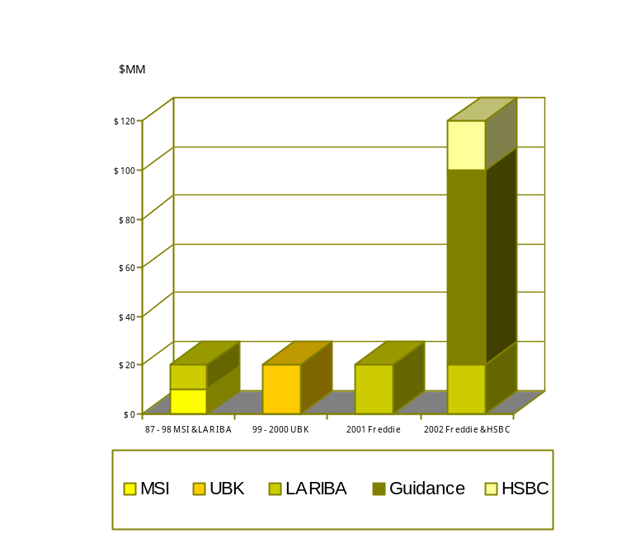

As with the SAMAD Group and the United Bank of Kuwait before and Guidance Financial Group after it, HSBC has discovered that Islamic concerns over gharar are paralleled in the numerous Truth in Lending and Real Estate Settlement Procedures acts, forms and disclosures, which are meant by the Congress to bring transparency to residential real estate dealings, including sales and mortgage loans.
Some may argue that the shari^{c}a overemphasizes the form of a contract. The form, however, is crucial in that it dictates the rights and obligations which flow afterward. A U.S. regulatory view that overlooks the form of contract and relies upon substance may or may not create legal or linguistic arbitrage between Islamic and U.S. legal systems. In reality, the different approaches have allowed a unique opportunity wherein Muslims are now able to increasingly find ways to meet their home acquisition needs, and comply with both sets of rules.
As it takes advantage of this freedom, HSBC adopts the following approach to price and formal shari^{c}a oversight: it bases the markup in its sales price on the market mortgage rate. For some consumers the former method may result in paying a higher price, while for others the similarity in costs when a conventional rate is used as a benchmark creates confusion. HSBC has relied upon a work of eminent and internationally recognized shari^{c}a scholars to assist in the review and development of their mortgage alternatives.
A significant development in the industry took place in 1991, when LARIBA followed the United Bank of Kuwait’s regulatory approvals for contracts which may be applied in lieu of conventional mortgage loans, with the first sale of Islamic mortgage-like assets to a GSE, Freddie Mac. Subsequently, U.S. Islamic mortgage alternative businesses have doubled and show strong continuous growth.
Saber Salam was the Freddie Mac officer who nurtured this development. In a presentation which documents Freddie Mac’s commitment to opening doors to homeownership, Salam, who is now an industry consultant, reviewed how the Freddie Mac culture and mission blended with the pressing need of an excluded community to access these resources. LARIBA was the first to access Freddie Mac, and has been followed by Guidance. LARIBA followed up its success by making an agreement with Fannie Mae, which is now seeking to enter the market with its own version of a murabaha.
All of these developments beg the important question of whether or not there is an American market for Islamic financial services. This is ably addressed by Tariq Al-Rifai, who presents the outcome of HSBC’s market research in this community. Al-Rifai’s research and post-research consumer experiences bring forth three important facts. First, the Muslim population in America is relatively better educated and compensated than the general public. As one might expect with such consumers, they are demanding and wish to be treated well; they require a good customer service experience as much, if not more than shari^{c}a compliance. And, finally, they are engaged. Once consumers became aware of HSBC’s New York programs, many came forth to help the bank identify further consumer needs.
Not surprisingly, HSBC has learned that Islamic authenticity is an important issue to many consumers. Just as the mortgage-alternative providers and Freddie Mac are queried about their source of funds, so HSBC has been asked the same. Even with outstanding shari^{c}a scholars opining on specific products, Muslim consumers are unclear on what it means for a non-Islamic investor to bring forward monies which originally were not raised in a manner compatible with Islamic norms. Scholars have generally addressed this point with specific approvals: that entities such as Freddie Mac and HSBC may apply their funds to Islamic relationships on the condition that the contracts are shari^{c}a-compliant.
HSBC and others are working hard to establish consumer deposits and other means that assure that the collected funds are riba-free before they are applied to Islamic projects. This leads to the business model query: why is there no domestic Islamic bank?
A. Rushdi Siddiqui addresses the point that Muslim consumers need more than mortgages if we truly wish to form an Islamic market. Siddiqui of Dow Jones Indexes provides an overview of how to take these ideas forward into the form of a classic American institution, the community bank. On the one hand, work at HSBC, Rebafree, LLC and SAMAD has made progress with new instruments to fill banking instrument needs. Yet the great question is whether a chartering authority will apply its delegated authority to complete a charting process: three programs have been in process since 2000, and two have withdrawn due to the onerous and slow regulatory dialogues. Once that bridge is crossed, Siddiqui points out three primary business challenges: sufficient capital and access to securitization, market coverage, and availability of trained staff. If a true, successful community bank can be established in conformance with U.S. banking regulations and Islamic principles, the funds collected may require more than just car and home finance outlets.
The remaining papers comprising this section build on Siddiqui’s work at the Dow Jones Islamic Markets Indexes (DJIM). Since 1998, these have provided a basket of benefits to the field of Islamic finance, which includes credibility, standardization of securities analysis, and an independent benchmark. Following the Dow Jones commitment to Islamic finance, a number of investment managers have offered DJIM-oriented products. These range from community-based investment advisors like Allied Management in Chicago and Azzad Funds in Washington, D.C. to mainstream investment managers like Brown Brothers Harriman in New York and on to leading Islamic houses like Al Baraka in Jeddah.
With standardized shari^{c}a-based analytical principles, and a means of purifying investments published by Dow Jones Islamic Markets, the road to satisfying investing consumers becomes much clearer. First, in 1999, came London-based Islamiq.com and in 2000 came Dubai-based iHilal.com. Both firms tested the concept of internet-based brokerage services: the former failed, and the latter refocused on institutional sales. In their paper, Zafar Sareshwala and Mohammed Obaidullah discuss by exclusion how the internet-only method is not likely to succeed. Two of their main findings include a concern that merely mimicking the best market practices and performances in the conventional securities market is not a selling point. They go on to develop a demand, very much in line with the Dow Jones Islamic Markets achievement, for greater transparency in the shari^{c}a process and heightened consumer education. Even if there are overlaps in instruments and methods, an important point from Sareshwala and Obaidullah is that our Islamic approach is, in fact, distinct, and the distinction requires attention to detail from product design through marketing and customer care.
In the Muslim minority markets, one of the most exciting developments has been the success of Oasis Asset Management. The firm has edged into the elite of South African money managers and has outperformed its domestic peers by most measures, most of the time. The Oasis case study, presented by its CEO Adam Ebrahim and director Bernard Horn, demonstrates how an Islamic fund in a weak economy undergoing a political transformation can outperform, even achieve attractive positive results, when its peers are losing. Oasis also presented evidence that showed how the application of Islamic screens may improve the Sharpe Ratio of a fund, lower volatility, and increase yield.
In sum, this section explores the increasing awareness that the shari^{c}a offers a definable, structured way for anyone to do business. Moreover, it is increasingly accepted that Islam presents business methods that are not inconsistent with western practices. This acceptance is bolstered by the fact that Islamic contracts have been working for both foreign investors and nationally chartered banks in the U.S. environment, and by the early success of the Dow Jones Islamic Indexes and Freddie Mac Islamic mortgage alternative initiatives.
This new business context places a significant burden on the developers and distributors of Islamic financial products and services. Each of the authors in this segment has made a significant personal, corporate contribution to expanding consumer acceptance of shari^{c}a-defined financial products and services. Yet, they must join hands with others to achieve better, broader consumer education; assure the market of the shari^{c}a authenticity of their activities; and cross that last hurdle to make the unique Islamic view of financial services beneficial to all consumers.

Creating Financial Solutions for American Muslims
HSBC’s Experience in the United States

Tariq Al-Rifai*

Abstract

HSBC is a global financial institution with a strong history of serving multi-ethnic communities. In the U.S., HSBC actively serves the Chinese, Hispanic, and South Asian communities. Thus, serving the Muslim community is an ideal fit for its community banking strategy. Extensive primary and secondary research was conducted to determine the true potential of serving the Muslim market in New York State. The findings strongly suggested the existence of much unmet demand among Muslims for Islamic financial services. The challenge from then on was to develop a range of products and services to satisfy this demand. HSBC was faced with the challenge of developing products that would at once meet shari^{c}a guidelines and satisfy the state’s regulatory authorities. The outcome of HSBC’s experience lays the foundation for developing future products and services for Muslims in the West.

I. Introduction

HSBC Amanah has done significant research on the United States market for Islamic financial products. HSBC Amanah itself is a reputable financial institution with offices all over the world. The Islamic banking activities of HSBC Amanah are headquartered out of Dubai. Islamic finance by HSBC is also present in one form or another in the U.K., Switzerland and now the United States. Two things that need to be analyzed when considering HSBC Amanah’s involvement in the United States Islamic finance market are the rationale behind it and the means by which they went about determining product offerings.
Table 1: Muslims in the United States

 | American Muslim | American
Median household income | $51,830 | $43,000
Incomes above $75,000 | 32% | 23%
Percent holding college degrees | 39% | 20%
Muslim Population

USA | 7 million
New York | 800,000

The American Muslim demographic is one that is currently underserved in the area of acceptable finance. HSBC Amanah has the resources and commitment to serve that demographic to the fullest. Table 1 shows that the Muslim population of the United States is 7 million and the Muslim population of New York is 800,000. The median household income of American Muslims is higher than that of the average American household, while percentage of household incomes above $75,000 is higher as well, being 32% for American Muslims and 23% for Americans at large. The proportion of college graduates is 39% among American Muslims, which is higher than the U.S. average.

II. Market Research

In determining which services to offer, HSBC Amanah consulted with an independent market research firm to come up with research data. A survey was produced that was taken directly to the Muslim community in order to assess their desires and needs. The survey was comprised of multiple components, including interests, current involvement, preferences, familiarity, etc. The limitation of the survey is that it has only been done in New York State, and the margin of error was roughly 4%. Looking at the services Muslims are engaged in right now (see figure 1), we see general banking services comprising 77%, mortgage 64%, and since there is a margin of error of 4%, the Islamic services taking up a negligible proportion. Insurance and investments and the market penetration of investment of all kinds are roughly 50%.

Figure 1: Banking Services

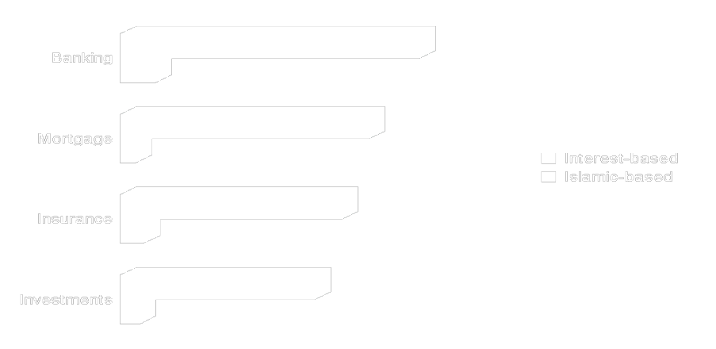

In regard to the most important aspects of a financial institution as far as Muslims were concerned, customer service, rates/fees, full range of products, convenience/access and industry reputation got the highest ratings, while roughly 50% said shari^{c}a-compliance (see figure 2). Organization size preferences were an interesting finding as well. To a surprisingly large proportion of individuals surveyed, organization size was insignificant. The size of the institution did not matter, the services themselves were all that mattered.

Figure 2: Factors in Choosing Financial Service Companies

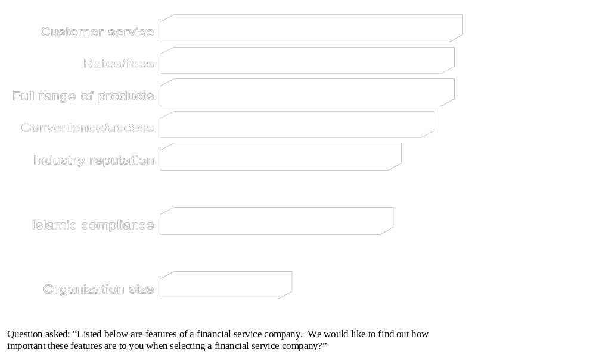

When asked how knowledgeable about the shari^{c}a and principles related to financial matters they were, over half of the Muslims surveyed said they were quite familiar. Only a small percentage had low familiarity (see figure 3).

Figure 3: Familiarity with Shari^{c}a



Almost two-thirds of the respondents said they have changed their use of financial services as they feared they were doing something that might not have been compliant with the shari^{c}a. Roughly 35% haven’t modified their use of services and haven’t done anything different in financial matters. Such respondents tend to live a normal conventional transaction-based life (see figure 4).

Figure 4: Changed Financial Practice to Comply with the Shari^{c}a



The next question related to respondents’ needs with regard to shari^{c}a-compliance (see figure 5). 70% said they were extremely interested in having Islamic products and 24% were very interested. Only about 6% said they were not interested at all.

Figure 5: Interest in Shari^{c}a-Compliance



The service customers were most interested in was a regular checking account that was also shari^{c}a-compliant. This was followed by home finance, investment account, ATM/debit cards, and credit cards (see figure 6).

Figure 6: Desired Shari^{c}a-Compliant Services



Two-thirds of the Muslims surveyed said that they would prefer a shari^{c}a-based home finance program (see figure 7). About a fifth preferred a conventional finance program. A significant percentage, 15%, of the respondents said that they would, if given the choice, select the least expensive option. From this we can infer that a considerable number of Muslims, in this area at least, are price-sensitive.

Figure 7

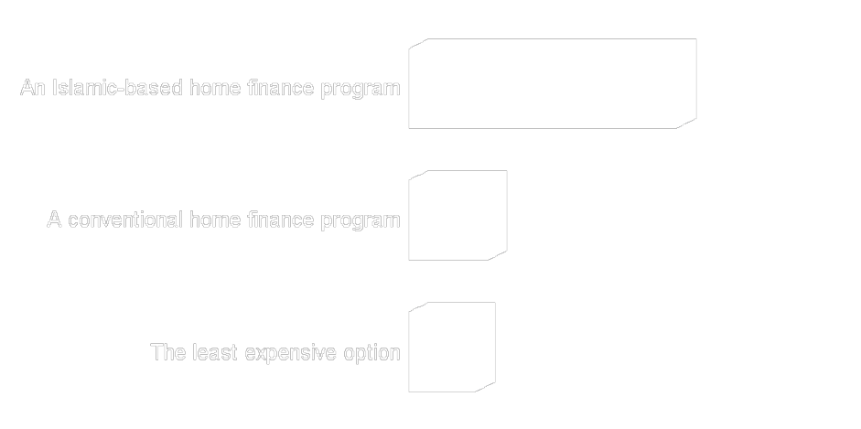

In terms of specific home finance mechanisms, 2/3 of those surveyed preferred murabaha transactions over ijara leases (figure 8).

Figure 8



III. Lessons Learned

Having done the research, HSBC Amanah needed to decide first which products to offer and then which products to add as interest increased. In the first stage, HSBC Amanah offered a murabaha home finance program, for New York State, an interest-free checking with a debit card, and an interest-free charge card. These three products were launched based on the survey results showing what the customers wanted and HSBC Amanah plans on introducing more products as time goes on.
An ambitious project, such as the launching of a line of shari^{c}a-compliant financial products in the United States, will undoubtedly encounter a number of challenges and hurdles. When dealing with home finance products in the U.S., one has to deal with an extensive regulatory environment. In regards to HSBC’s legal team, it was important for them to understand the risks involved since obviously HSBC was going to be involved in the purchase and sales transactions of homes. Also, risk for HSBC came from customer protection laws—they definitely had an effect on the product that they were trying to structure and form. Familiarity with property title issues (title transfer limitations and rules, etc.) was especially important as well. The entire legal team had to also be educated in the shari^{c}a. At the outset, the shari^{c}a was completely foreign to the HSBC legal team; familiarizing them with it was a daunting but fruitful task. Questions answered included: What is the shari^{c}a? What are the things that we need to do differently? What are the obstacles that we are going to face up front? How are we going to deal with these challenges? The shari^{c}a committee itself needed to be educated on the limitations of the U.S. law and legal system. The U.S. legal system is very extensive and it was essential that the limitation and requirements of certain regulations were understood and discussed up front. HSBC also had limitations in their IT system, much of which had to be modified in order to handle the various aspects of Islamic financial products. Another challenge HSBC faced was finding qualified salespeople and customer service representatives—training of whom was conducted internally.

IV. Challenges and Criticisms

Challenges external to HSBC had to be faced as well, regulatory first of all, and it was needed to find where the shari^{c}a and consumer lending laws met. Given the multiple legal frameworks that Islamic financial institutions in America operate under, considering conflicts between shari^{c}a laws and consumer lending laws was important. Educating the regulators about the shari^{c}a and why we are doing this was also essential. The main message sent to them was that a significant group of Americans existed who, because of their religious beliefs, were barred from participating in certain financial practices and that HSBC wanted to be able to serve the customers that had unmet needs. Seeing how the regulators were concerned with the issue of helping people meet their needs, they were very responsive and were willing to help HSBC Amanah.
A number of common criticisms came from within the community itself. One of those criticisms that kept recurring was the question of the source of the funds in HSBC’s Islamic finance program. When people became familiar with what HSBC was doing, community members called in offering suggestions for a multitude of different products. It seemed as if HSBC’s coming to market brought the needs of the community to the surface. The community became somewhat proactive in that they came to us and tried to address the issues that were concerning them. At the same time, HSBC Amanah wanted to address their perceptions of the bank and make sure that they were comfortable with and understand all of their policies. Seeing as how both sides wanted to address certain issues and perceptions, community involvement was extremely important. As such, HSBC has encouraged community members to get involved, participate, discuss issues with us and in return, has kept the community members up to date with the progress of the project and the status of HSBC’s Islamic finance division in the United States. Another important thing was that communication channels were opened with some of the leaders in the Muslim centers around New York State to make sure that they were kept abreast of our progress—in return, those leaders provided feedback and ideas on what was needed.

V. Conclusion

People might have expected HSBC to close its Islamic finance division after the events of 9/11. That was not the case, in fact, HSBC remaining in the market spurred even greater interest in the concepts and ideas of Islamic finance. Indeed, HSBC Amanah’s research and progress shows us that the potential for the Islamic banking services in America has been confirmed, even in the wake of catastrophic events.

Managing Shari^{c}a-Compliant Mutual Funds in a Volatile Equity Environment

The Emerging Market Experience and the Global Experience

Adam Ebrahim* and Bernard R. Horn, Jr.†

Abstract

After the fall of apartheid in 1994, the economy of South Africa experienced a metamorphosis, principally marked by a liberalization of the economy and a relaxation of trade barriers. This has led to a period of higher stock market volatility, but the economic outlook for South Africa is still quite positive. The Oasis Crescent Fund was launched in 1998 by Oasis Asset Management in South Africa. The shari^{c}a-compliant product has demonstrated excellent performance, marked by a consistently high alpha statistic and a low beta risk profile. The key to its successful stock picking has been to select Islamically acceptable companies priced below their true value. This can only be achieved by meticulous bottom-up research. Oasis uses a number of criteria to select companies, and it emphasizes downside protection to limit losses in bear markets.

I. Introduction

As emerging markets open and companies globalize, greater uncertainty prevails. This, in turn, increases volatility and implies higher risks. Globalization is therefore a very complex and fluid process, affecting indiscriminately all the productive sectors of a country and altering the national environment in several ways. However, greater integration into the global marketplace is positive for all countries because it increases the competitiveness of domestic products and ensures a better allocation of resources, thus generating positive pressure on economic growth, employment, and investments.
South Africa is one such emerging market. Global competition, falling commodity prices, and political transformation have prescribed action for South Africa in the form of a strict economic and social regimen that has forced its companies to adapt at a dizzying pace since the fall of apartheid in 1994. Keeping the emerging market paradigm in view, we analyze the South-African economy with particular reference to the shari^{c}a-compliant Oasis Crescent Fund.
Due to these changes in the South African economy and the demands placed on its companies, risk and volatility have increased in the equity market. The fund manager thus needs to be a successful stock picker in order to keep ahead of the market and competitors. The new era of openness in South Africa coincides with increasing volatility of performance of asset managers. The variance of returns of asset managers highlights the need for successful stock picking.
In light of the success of the domestic Oasis Crescent Fund, we offer an analysis of the recently-launched Oasis Global Crescent Fund. The experience of Oasis with these funds indicates that active fund managers who focus on fundamental industry and corporate research should outperform at lower volatility due to their ability to generate a sustained positive alpha.

II. The Emerging Market Experience: South Africa

The South African investment industry has experienced a metamorphosis since its first democratic election in 1994. Years of isolation prior to this had created a protected environment removed from the pressures of global competition. The resultant high inflation of 13% per annum on average created the illusion that companies were price makers. The average return on the Johannesburg Stock Exchange (JSE) All Share Index from 1973 to 1994 was 21.6% per annum. Exposure to the stock market was the most important ingredient of a fund manager’s performance.
South Africa’s return to democracy resulted in the relaxation of trade barriers. As the economy opened and competition increased, profitability declined as more companies became price takers. This, coupled with lower inflation, reduced profitability and increased volatility of returns. This volatility may persist in the medium term.
Negative sentiment toward emerging markets during the 1998 Asian Crisis led to an increased flight of foreign investment capital and placed further pressure on the investment market. A lack of fixed investment and increased unemployment pushed South Africa into a period of low growth. Furthermore, the traditional manager definitions of value and growth—based on a cyclical relationship that does not include the quantification of risk—created an unstable fund management industry.
On the other hand, there is some encouraging corporate restructuring taking place in this new open economy. There has been an ongoing restructuring of South Africa’s major conglomerates. Its virtually closed economy during the apartheid years resulted in excessive domestic diversification and a complex structure of crossholdings. As exchange controls were gradually relaxed, many South African companies expanded internationally and divested themselves of non-core domestic businesses. Announcement of several high-profile mergers and acquisitions suggests that this trend is quickly gaining momentum. Investors should benefit from this in the long term due to improved management, greater synergies, increased liquidity, and better ratings of the underlying businesses.

A. Overview of the Economy
The South African population is 41.4 million, its GDP is $129 billion (0.4% of the world GDP), and its GDP per capita is $2967. In the year 2000, GDP grew by 3.0%, and over the last 5 years it grew by 2.1%.
The economy has gone through a phase of fundamental reconstruction as it evolves into an open economy. Tariffs have declined significantly, opening the economy to competition. Foreign trade now accounts for 50% of GDP, a 40% increase since 1994. The balance of the current account has improved in the year 2000 to about 0.3% of GDP. This number has decreased phenomenally from a peak of 2.7% and is expected to remain below 1.5% at the peak of the business cycle. The phase of reconstruction is approximately 70% complete.
Foreign reserves grew by $654 million to a total of $10.79 billion at the end of 2000, a low level by international standards. Foreign debt is also low: it stands at 30% of GDP. Foreign direct investment into South Africa is $282 million. However, this figure is lower than would be expected due to the restrictive foreign exchange control policy and a weak rand which has also resulted in the poor performance of investments from companies such as Petronas and Telecom Malaysia.
The South African rand has depreciated by 13% per annum since 1995. As was the case with other currencies such as the Australian dollar, the rand did not perform well against other major currencies during the year 2000. It depreciated by 15% to the euro and 23% to the U.S. dollar. A major cause of the depreciation of the currency is the net open forward position. This position peaked within the last five years at over $25 billion and has since reduced to $9.5 billion.
The South African Reserve Bank (SARB) is committed to settling the oversold position from the revenues that are generated by the privatization of the public companies. On settling the position the SARB intends to abolish the present exchange rate control mechanisms to substantially stabilize the currency. This will promote an environment for lower inflation and significantly increase foreign direct investment.
The budget deficit for the 2000-2001 fiscal year was 2.4%. This figure has fallen from a peak of 5.2% and is expected to decline to 2.1% by 2004. The ratio government debt to GDP has fallen from 57% to 44.3% as of the end of February 2001. Within three years the current budget sees the debt ratio falling to 39.1%. Such a forecast is highly probable since revenues from privatization campaigns will decrease debt substantially. Interest rates have also declined remarkably over the last five years. Long-term bond rates have declined from 16% to approximately 12%, and short-term rates have declined from 15% to approximately 10% over this period.
Due to the opening of the economy and financial markets, monetary policy has been tightened. Amid rapidly increasing productivity, headline inflation has decreased from 15% ten years ago to 10% four years ago and finally to 7% at the end of the year 2000. This decrease has been maintained despite the large increase in the price of oil and a weaker currency. The target for inflation has been set at between 3% and 6% by end of 2002. Lower inflation has had a negative effect on company profits, which translates into lower stock profits and lower stock market returns for retailers and financial institutions, respectively.
The private sector has become more competitive as real output per worker in the non-agricultural sector continues to rise. In the 1980s real output per worker was only 0.2%, and during the 1990s it increased to 3.5%. In the year 2000 real output per worker increased by 6.2%.
The current state of the economy indicates several future developments. Not only is productivity booming, but lower real wages will result in decreased inflation, the creation of competitive companies, and additional real wealth for individuals in the economy. Furthermore, both consumer and private sector debt have followed a declining trend to current their current low values, and debt servicing costs have decreased from 15% to 8% of disposable income; therefore disposable income will continue to rise. In the year 2000, gross savings as a percentage of GDP increased by 15%, and given the positive outlook on debt, the scope for further growth is significant. With a stable interest rate environment, normalized inflation, globally competitive companies, an efficient fiscal policy, effective privatization campaigns, controlled government and private debt, the economic outlook for the country is extremely positive.

B. Negative Factors Affecting the South African Economy
Unemployment in the formal public and private sectors has remained high and is increasing at approximately 3% per annum. Although the employment in the informal sector has increased, this has had minimal repercussions for social or fiscal policy, such as taxes and savings. Given the spread of AIDS in Africa, life expectancy has fallen significantly, which may result in a decrease in skilled labor and the number of consumers in South Africa. The recent escalation of crime also contributes to a negative sentiment throughout the country and affects the rate at which skilled individuals leave its shores.

Figure 1: Composition of GDP by Type of Economic Activity

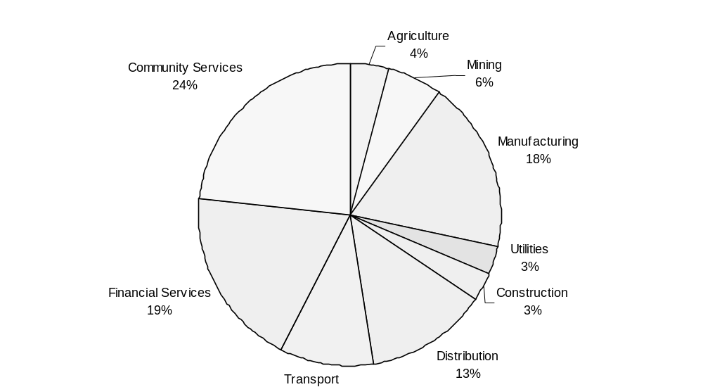

C. Positive Factors for the South African Economy
South Africa is rich in natural resources and is responsible for the majority of the world’s platinum, chrome, gold, and diamond production. The country is also a net exporter of coal which has generated significant revenues while the price of oil remains high. Furthermore, the cost of energy is relatively low in South Africa; it is estimated that its cost of energy is 20% of the cost in the U.S. and Japan. And since South Africa is able to produce its energy from its own coal resources, it is relatively insulated from exogenous energy shocks. The government’s privatization efforts also ensure that the cost of infrastructure to business will decrease. Furthermore as a result of successful fiscal policy, South Africa is experiencing tax relief and increased growth in all areas of its economy.

III. The South African Financial Service Sector

Bank assets total R 821 billion or $110 billion. Six banks dominate the industry with a combined market share of 89% The long-term savings market totals R 1267 billion or $169 billion. Long-term insurers dominate the financial services sector with assets of R 660 billion, with 10% per annum growth (13% market and 3% outflows). Retirement funds total R 488 billion (R 264 billion in private retirement accounts and R 224 billion in public sector retirement funds), with a private sector growth rate of 15% (13% market and 2% volume).
The unit trust sector is the fastest growing at 25% per annum with assets totaling R 120 billion. The unit trust industry is gaining market share at the expense of the long-term insurers. The top 6 unit trust management companies have a market share of 66%.

Table 1: South Africa’s savings markets (non-banking)

 | R (billions) | $ (billions) | Growth Rate
Long-term Insurers | 660 | 88 | 10%
Retirement Funds: Private | 264 | 35 | 15%
Retirement Funds: State | 224 | 30 | 15%
UNIT TRUST | 119 | 16 | 25%
 | 1267 | 169

Figure 2: South Africa’s savings markets (non-banking)

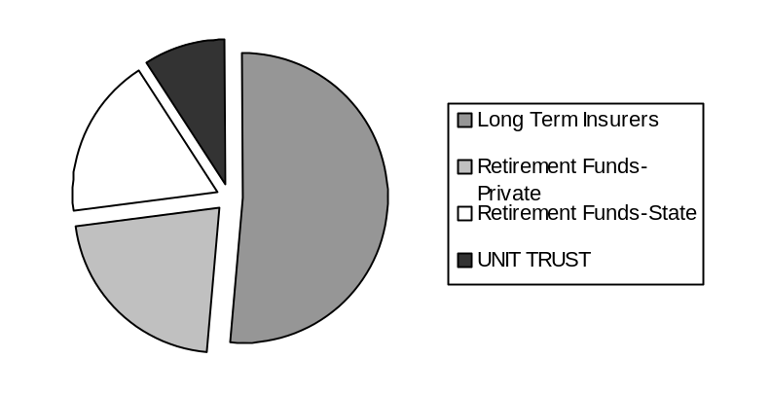
The fund management industry is concentrated among large insurers and banks, which often have cross-shareholdings. International players like Prudential, Franklin Templeton, and Alliance Capital are rapidly expanding their South African businesses. Institutional investors invest 10% of their assets (R 100 billion) offshore.
The financial service industry is undergoing significant change, characterized by increased competition, lower fees, and tougher regulations. The size of the Johannesburg Stock Exchange (JSE) is R 1520 billion. The number of listed shares has decreased from 750 to 525 over the last 10 years, mainly due mergers, acquisitions, and delisting. Liquidity in the JSE has risen from 5% to 35% over the same period. Foreigners own a substantial fraction of the JSE, constituting about 50% of daily trading.

Table 2: Sectoral Split in the Johannesburg Stock Exchange

 | % | Earnings Growth | PE
Resources | 40% | 96 | 11
Financial | 25% | 30 | 10
Industrial | 35% | 1 | 14

South African natural resource companies—such as those dealing with platinum, gold, chrome, diamonds, and coal—are world competitive, supported by high quality reserves, cheap energy, good infrastructure, and a favorable currency. The industrial sector has been the affected by lower tariffs, increased competition, and lower inflation. However, the outlook is improving significantly.
In order to survive, companies must focus on their core competencies since increased competition may erode their domestic base, thus decreasing profitability. Since 1994, the top South African companies have been successful in globalizing their businesses. But smaller companies have struggled with increased competition.

Table 3: Top Ten Listed Shares on the Johannesburg Stock Exchange

Company | Val (Rb) | PE | Listing | Comment
AngloAmerican | 195 | 12 | London | 2nd Largest Mining Co.
DeBeers | 128 | 11 | - | Largest Diamond co.
Richemont | 90 | 17 | Zurich | BAT and Vendome
Billiton | 85 | 15 | London | 4th Largest Mining Co.
Angloplats | 70 | 11 | - | Largest Platinum Co.
Old Mutual | 62 | 9 | London | Global Insurance
Didata | 48 | 30 | London | Global IT
Sasol | 45 | 7 | - | Oil and Chemicals
SAB | 42 | 14 | London | African + European bev.
Stanbic | 42 | 10 | - | Banking

The South African stock market is attractively priced, with a price-earnings ratio of 11.4 and historical earnings growth of 38%. While earnings growth will eventually slow, it will remain robust at 20 to 25% per annum over the next two years. Earnings will be supported by a significant rebound in domestic consumer spending, corporate capital expenditure, and state spending on infrastructure. The macroeconomic environment is favorable, characterized by low levels of inflation, interest rates, and taxes. It is also boosted by a R 200 billion privatization program over the next 3 years. The JSE should be one of the best and most stable markets over this period.

IV. The Crescent Fund: Domestic

The Johannesburg Stock Exchange has experienced increasing volatility over the last decade. There have been 10 moves of 20% since 1994. The period of liberalization of the South African economy has coincided with an increasing volatility of performance of asset managers. The variance of returns of asset managers, the best and worst of which were of 37% per annum and 5% per annum, respectively, highlights the need for successful stock picking. In June 1997, Oasis was born as an active fund management.
The approach of Oasis Asset Management to stock picking has allowed the firm to reap upside potentials and limit downside risks. The success of its approach manifests itself in a high and consistent alpha statistic. Oasis uses a number of criteria to select stocks. Some of its major selection characteristics are that the companies:

- Are internationally competitive or niche operators.
- Own well maintained world-class assets and are strong cash generators.
- Have management with a proven track record of investing in projects that generate above-average returns on equity.

A. Oasis Crescent Fund

Oasis Asset Management: A Chronology

June 1997 | Moved into offices in Cape Town
October 1997 | First institutional clients
August 1998 | Launched Oasis Crescent Fund
December 1999 | Own Unit Trust Man Co license
February 2000 | R 1000m assets under management
October 2000 | Launched Oasis Property Equity Fund
November 2000 | Launched Guernsey Global Funds
March 2001 | Launched Oasis Balanced Fund
April 2001 | R 3000m assets under management

The Oasis Crescent Fund was launched in August 1998. It is a shari^{c}a-compliant product and the first unit trust launched by Oasis. It is a major success and has established a very substantial brand in the South African market.
The Muslim market in South Africa is estimated at R 152 billion. A number of institutions have focused on this market in the past but due to poor service and performance, even bankruptcy, there has been little growth and increased skepticism among investors. A major dilemma that most Muslims in South Africa face is that their employer-provided retirement plans invest more than 75% of their contributions in non-permissible instruments. When moving to a monthly pension at retirement, more than 90% of income is of a non-permissible nature. It is in this environment that Oasis saw the opportunity to establish a shari^{c}a-compliant fund in South Africa.
The universe of stocks for the Crescent fund has a value of about R 1051 billion and consists of 364 companies, about 70% of the JSE. The main sectors that are excluded are financial, beverages, hotels & leisure, furniture and retail, and some other company specific exclusions.

Table 5: Size of the Oasis Crescent Fund

 | Rand (billions) | Number of shares
JSE | 1,520 | 525
Crescent Universe | 1,051 | 364

The Oasis Crescent Fund also excludes companies from its universe based if they meet the following criteria:

- Involvement in liquor, gambling, and financial services
- A net debt to equity ratio greater than 33%
- A ratio of non-permissible income to sales greater than 5%

Based on these criteria, companies selected by Oasis have a low risk of bankruptcy and tend to outperform.
Stock selection varies between fund managers depending on their respective risk profiles and investment styles. At Oasis Asset Management, a high alpha and low beta risk profile has always been one of the key successes to excellent performance. Using the alpha statistic implies that fluctuations linked to company-specific events have been considered.
The approach of Oasis to stock picking has proved to be more rewarding than attempting to time market movements. Oasis believes that superior returns can only be gained by the intelligent application of proven investment principles supported by meticulous bottom-up research. In addition to the shari^{c}a-compliant selection criteria, Oasis focuses on companies operating in low-risk industries with high operating margins. On top of the criteria mentioned earlier, the fundamental criterion for selection is that a company must be priced below its intrinsic value.
In addition to valuing companies on the basis of their financial records (risk, earning growth, quality of earnings, dividends, and cash flows), one must understand management’s philosophies, strategies, and other factors that will affect a company’s future. Bottom-up fund mangers look mainly at individual companies and are more willing to invest in firms with good fundamentals and management, although their industries may not be in vogue at the moment. The shares of such companies are likely to fare well over longer periods of time despite volatility.
Oasis emphasizes downside protection. In order to ensure this objective, companies require certain attributes, namely:

- Low price-earnings ratio
- High dividend yield
- High cash flow
- Low debt

For example, if a company is in a strong cash flow position, it will limit the downside in bearish period.
For the year ending March 31, 2001, the Johannesburg Stock Exchange All Share Index increased by 1.21%, while the Oasis Crescent Equity Fund increased by 23.02%, outperforming the market index by 21.81%. For the six months prior to March 2001, the JSE All Share return was a negative 2.67%, while the Oasis Crescent Equity Fund returned 10.46%, outperforming the index by 13.13%. The Oasis Crescent Fund has outperformed both the JSE All Share Index and the average unit trust by 31% and 39.5%, respectively, which indicates the sustained superior returns driven by superior stock picking.
While the performance of the Oasis Crescent Equity Fund has been phenomenally high, its risk has been exceptionally low. Its beta (which measures risk relative to the market), for example, is the lowest of all domestic equity unit trust funds and is less than half of the average of these funds.
Following the annual distribution on March 31, 2001 the Oasis Crescent Equity Fund declared a total of 2.536 cents per unit. Of this total distribution only 11.75% is taxable and the remaining 88.25% represents non-taxable dividends.

Table 6: NPI Returns

Year | TRR (%) | Inc (%) | NPI (%) | NPI/TRR (%) | PI (%)
1999 | 32 | 2.9 | 1.5 | 4.7 | 95.3
2000 | 55 | 2.7 | 0.7 | 1.3 | 98.7
2001 | 23 | 1.0 | 0.1 | 0.4 | 99.6
Cumulative | 153 | 6.7 | 2.5 | 1.5 | 98.5

The portion of non-permissible income which has been earned by the fund amounts to 1.5% of its total return since inception. In keeping with shari^{c}a-compliance guidelines this amount has been taken from the fund and has been placed into the trust account of the advisory board, which will pay the monies to worthy charities.

Table 7: Track record and performance (Aug 98 - Apr 01)

 | 1998 | 1999 | 2000 | 2001 (ytd) | Annualized
Oasis Crescent | 15.5 | 79.9 | 12.5 | 15.1 | 43.3
ALSI | -20.9 | 61.4 | -0.1 | 8.8 | 12.3
Gen. Equity | -21.2 | 44.7 | -6.1 | 3.9 | 3.8
August 1998 to April 2001

Table 8: Oasis Equity Mandate: May 2001

Share Themes | Oasis | ALSI
Rand Sensitive | 43 | 50
Foreign Assets | 12 | 17
Exporters | 24 | 16
Export Conglomerates | 7 | 17
Domestic | 57 | 50
Financials | 18 | 24
Domestic Conglomerates | 5 | 2
GDFI | 2 | 2
Consumer Staples | 23 | 8
Total | 100 | 100
PE | 11.3 | 12.8
Earnings Growth | 44 | 39

This performance was realized through two key factors: a) downside protection through a focus on stock picking and a positive alpha and b) splitting the portfolio into themes to ensure sufficient diversification.
This split is different from the JSE sector split because the Oasis Crescent Fund groups companies based on the impact of economic drivers and currency sensitivity. The portfolio is monitored on a daily basis to ensure that there is sufficient diversification against the impact of all the macroeconomic variables including economic growth, inflation, currency, and interest rates.
The weighted average price-earnings (PE) ratio of the Oasis Crescent Fund is 11.2, almost at a 15% discount compared to the ALSI PE. At the same time, the weighted average 12 month historical earnings growth is substantially higher than the market. This trend has been consistent over the last three and a half years and is proof that its stock picking is successful in protecting downside risk through stronger earnings growth and choosing companies whose value the market does not fully appreciate.

Table 9: Low Volatility Asset Management Crescent Equity Mandate

 | Beta | Annual Mkt Return | Beta *Mkt | Annual Alpha | TRR
Oasis Crescent Equity Fund | 0.31 | 12.3 | 3.8 | 39.5 | 43.3
Average General Equity Unit Trust | 0.86 | 12.3 | 10.6 | -6.8 | 3.8
Source: Micropal since inception August 1998 to April 2001

The fruits of active management are clearly visible when one separates the total 43.3% return of the Oasis Crescent Fund between the alpha contribution of 39.5% and the beta contribution of 3.8%. This indicates that 90% of its performance is driven by active money management. The average competitor has a negative alpha, indicating the poor stock selection and market volatility in the South African fund management industry (which includes major international fund managers). The beta of the Oasis Crescent Fund will probably remain relatively low because of continuing market volatility.

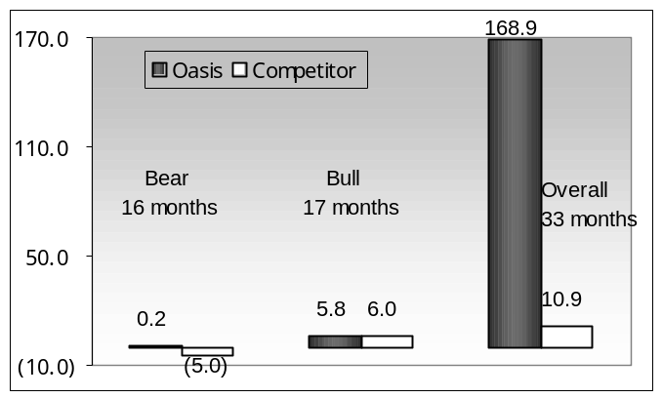
Figure 3: Unit Trust – Crescent Equity Fund
Source: Micropal, from August 1998 to April 1999
If the performance of the Oasis Crescent Fund is categorized into bull and bear months, one confirms that its outstanding performance is driven by superior stock picking and downside protection. In bull months, the monthly return was 5.8%, compared to 6.0% for competitors, and Oasis captured 96% of the upside despite having a lower beta. The cumulative return of the Oasis Crescent Fund is 168.9% compared to the average of 10.9% for all general equity unit trusts. In bear months, the monthly return on the Oasis Crescent Fund was 0.2%, while for competitors it was -5.0%. The ability of the Oasis Crescent Fund to avoid the downside during bearish markets is the major driver behind its excellent returns and is the key to delivering a sustainable positive alpha and superior long-term returns.

Figure 4: Sharpe Ratio: Crescent Equity Fund
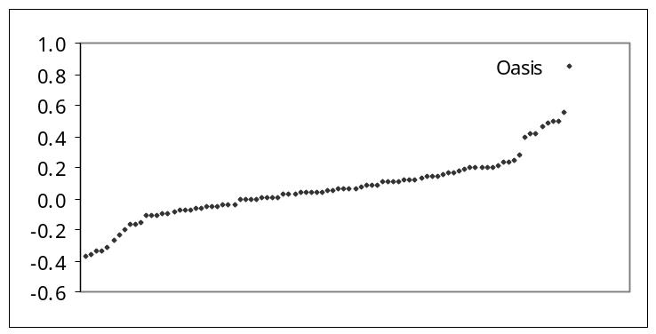
Source: Micropal, from August 1998 to April 1999
The Oasis Crescent Fund delivers twice the return for the same level of risk. The success of Oasis demonstrates that investing in a shari^{c}a-compliant way can be rewarding and that its active management skills have contributed significantly to the excellent performance of the Oasis Crescent Fund, as indicated by a high positive alpha and a low beta.

V. The Crescent Fund: Global

The growth in the number of shari^{c}a-compliant mutual funds can be attributed to an increase in demand for these investments, spurred by rising wealth and heightened confidence in and awareness of the various Islamic investment products available. In light of this growth, Oasis has recently registered a new global fund so as to serve a South African as well as a global client base and to build an internationally recognized track record. After two years of diligence and after consulting with large global fund managers, regulators, investors, and advisors, Oasis decided to remain independent and to continue with this fund its strategy of active money management.

Figure 5: The Organization of Oasis
Regulator: Guernsey Financial Services Commission
Sponsor: Oasis Guernsey Limited
Asset Managers: Oasis Asset Management
Administrator: Royal Bank of Canada
Distribution: Intermediaries
Auditor: PriceWaterhouseCoopers
Attorney: Ozannes
Crescent Global Equity Fund ($7 million)
Global Equity Fund ($20 million)
OASIS

The Crescent Global Fund focuses on developed markets, seeking out companies with a strong franchise, good management, quality assets, and strong earnings. The valuation focuses on a low price to cash flow ratio and a high return on average equity (ROAE).
The global economic slowdown we are currently experiencing affects company earnings and share prices.
Shares that are most vulnerable are those:

- With high PE multiples (tech, telecom, media)
- That have excess capacity and have lost pricing ability (motor, tech, telecom)
- Highly geared (telecom)
- Rely on share options to reward management (banks, telecom)
- Have poor quality assets (banks)

Industries, countries, and companies that are likely to do better are those:

- With low PE multiples and strong cash flows (resources)
- That are well regulated
- Are in a highly consolidated industry and have limited capacity (resources)
- That are strong franchises

Table 10: Oasis Crescent Global: Regional Split

 | (%)
United States | 18
Canada | 2
Britain | 5
Finland | 2
Germany | 1
Ireland | 1
Italy | 1
France | 1
Spain | 1
South Korea | 3
Hong Kong | 1
 | 36
Cash | 64
Total | 100

Table 11: Oasis Crescent Global:
Sectoral Split

Sector | %
Basic Materials | 4
Communications | 2
Consumer (Cyclical) | 10
Consumer (Non-Cyclical) | 2
Energy | 1
Financial | 0
Industrial | 8
Technology | 6
Utilities | 3
Total In Portfolio | 36
Cash | 64
Total | 100

Table 12: The Crescent Fund’s Performance, 1 December 2000 to 31 May 2001

 | Performance
Crescent Global Fund | +3.4%
Dow Jones Islamic Index | -11%
MSCI World Index | -8%

The Crescent Global Equity Fund has started off with an excellent 6 months, outperforming the Dow Jones Islamic Index by more 14% and the MSCI World Index by 11%. However, it is important to note that the data are for a short period. The continued underperformance of the Dow Jones Islamic Index is a concern that highlights the importance of structuring an index and the adding value through active management.

VI. Conclusion

Both the Crescent Global Equity Fund and the Oasis Crescent Fund demonstrate on global and local levels that morally responsible investing with proper management can be highly profitable.

Prospects for the Evolution of Takaful in the 21st Century

Omar C. Fisher* and Dawood Taylor†

Abstract

Financing or investing beyond the short term involves risk as both return on and of capital are uncertain. This paper explores the viability of takaful as a means to tackle such risks and engage in longer-term financial transactions in an Islamically acceptable manner. Numerous takaful schemes and re-takaful (reinsurance) facilities have appeared in many countries as Islamic alternatives to conventional (re)insurance. The takaful models may be categorized into three groups: non-profit, mudaraba, and wakala. It is stressed that an overriding purpose of takaful is cooperative risk-sharing for community wellbeing and not profit maximization. However, a degree of commercialization is unavoidable, and takaful operators are entitled to a fair profit on their risk capital and undertaking the business exposures. The paper also compares conventional insurance and takaful. It provides the profile and statistics of global insurance industry along with the size and scope of takaful markets worldwide. Projections of future demand in 2011 for takaful (life and non-life) are presented, with particular focus on the Middle East. Finally, the paper also discusses array of challenges that confront takaful operators such as internal and external factors, Muslim client profile, and shari^{c}a issues.

I. Introduction

According to the World Bank Development Report 2000, the global population is now approaching six billion, of which about 20% consists of Muslims. Pressures from air travel, globalization, trade, and the news media are compounded by instantaneous satellite telecommunications via the Internet to forge an emerging collective consciousness that all peoples are part of one global village. Yet, the same contemporary pressures reveal ethnic diversity as never before, and this revelation serves to empower affinity groups worldwide.
For Muslims, the rapidly growing field of financial services or Islamic banking seeks to address needs of an underserved affinity group. Individuals and businesses in over forty countries with a Muslim majority, and over fifteen countries with Muslim minority communities, share common values. IslamiQ.com reported that at June 2001, the global Islamic banking sector managed $200 billion in ways that conform to Islamic principles, and was growing at an annual rate of 15%. While no definitive data exist, it is believed that this represents 10% to 15% of Muslim-owned fungible assets worldwide. Islamic banking and financial products are attractive to Muslims precisely because of their combination of financial efficacy, religious correctness and spiritual rewards. Every Muslim is held accountable for how s/he manages wealth, invests or borrows funds and cleanses profits by giving a portion of any gains annually to charity (zakat).

II. How Muslims Save for the Future

Muslims today share similar challenges with non-Muslims as they progress through life phases (see figure 1): how to finance education, marriage, demands of a family and how to save for retirement or an emergency fund to defray expenses that may arise from prolonged illness or tragic misfortune.

Figure 1: Takaful Opportunity Map (Individual)

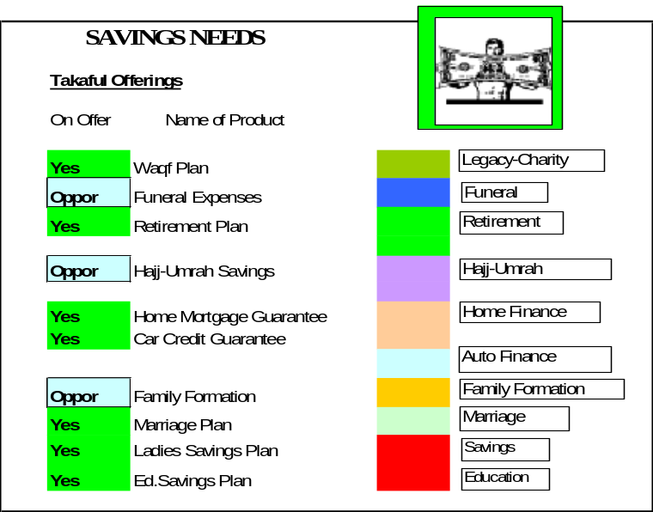

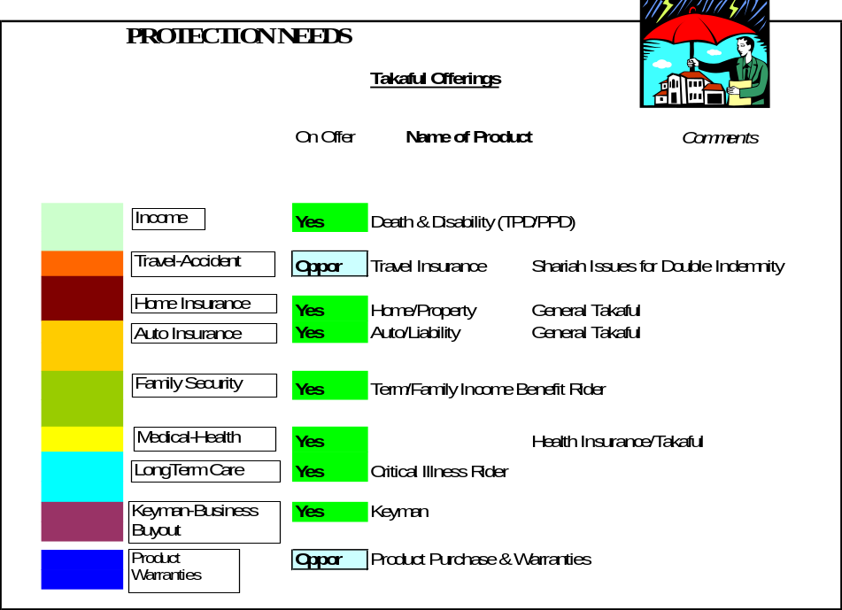

Such everyday important needs are normally addressed by conventional life insurance and associated long-term savings instruments that contain elements that are not permissible for practicing Muslims. Islamic scholars declared conventional life insurance unlawful many decades ago, and reconfirmed this verdict several times:

- Verdict of the Supreme Court of Egypt on Dec. 27, 1926
- Unanimous resolution and fatwa by ^{c}ulama’ in the Muslim League Conference in Cairo in 1965
- Fatwa issued by National Religious Council of Malaysia in 1972
- Unanimous decision by Muslim Scholars in a seminar held in Morocco on May 6, 1972
- Fatwa issued in Judicial Conference held in Mecca in Sha^{c}ban 1398 AH

Among the elements that make life insurance as presently practiced prohibited are:

- Severance of a balanced risk-sharing relationship between policyholders and shareholders
- Presence of prohibited elements:
- riba (excess or interest on loans)
- maysir (wagering, speculation)
- gharar (uncertainty, deception and unclear terms)
- Investment of premiums by insurers into non-Shari^{c}a-compliant securities.

For centuries Muslims were under the misconception that insurance programs (especially life insurance) are prohibited because they violate Islamic principles. This has contributed to restricting capital formation and the spectrum of available long-term investment and savings vehicles. Even the advent of Islamic banking in 1972 has not succeeded in redressing these views. In fact, some 80% of Islamic banking assets are managed in short-term instruments such as murabaha and virtually risk-free time deposits. The prevailing aversion to investing funds long term is partly due to a lack of familiarity with acceptable risk hedging mechanisms, including takaful schemes.
Financing or investing beyond the short term involves risk where both the return on capital as well as the return of capital are uncertain. Clearly, insurance is a dominant method by which conventional investors choose to hedge or transfer risk. What options are open to a practicing Muslim to properly address such risks and engage in longer-term financial transactions? To address this question, we must first revisit the origins of cooperative risk-sharing in Islam.

III. Origins of Takaful

A close examination of the primary sources of guidance for Muslims (the Qur’an and the Sunna), reveal that members of the first Islamic community fourteen centuries ago practiced successful schemes of cooperative risk sharing, even before the advent of takaful. Early precursors were developed in response to the risks associated with long-distance trade by caravan or sea, and included hilf (confederation), aqila (pooling of resources), and daman al-tarik (surety), which gradually evolved into a system of community self-help and financial assistance, which the Prophet validated as takaful. During the early development of community in Medina (1-20 AH) there were three instances in which the Prophet Muhammad employed an insurance mechanism to solve daily issues. In the first constitution (Medina, 622 CE) there were codified references to social insurance relying upon practices such as diya and aqila (wergild or blood-money to rescue an accused in accidental killings), fidya (ransom of prisoners of war) and cooperative schemes to aid the needy, ill and poor.
Based on such practices found in primary Islamic sources, religious scholars have issued numerous judicial opinions and fatwas confirming that takaful as cooperative risk sharing is acceptable for Muslims:

- Fatwa issued by the Higher Council of Saudi Arabia in 1397 AH (1976 CE) in favor of Islamic model.
- Fatwa issued by the Fiqh Council of Muslim World League in 1398 AH in favor of Islamic insurance.
- Fatwa issued by the Fiqh Council of the Organization of the Islamic Conference in 1405 AH in favor of insurance under the Islamic model.
- The Grand Counsel of Islamic Scholars in Mecca, Majma^{c} Al-Fiqh, approved the takaful system in 1985 as the correct alternative to conventional insurance in full compliance with shari^{c}a.
- Takaful Act of 1984 authorized by the ^{c}ulama’ and Government of Malaysia.

IV. Defining Elements of a Takaful System

There are four elements that must exist to establish a proper framework for a takaful system:

- Niyya, or utmost sincerity of intention to follow the guidance and adhering to the rule and purposes of takaful—cooperative risk-sharing and mutual assistance.
- Integrating shari^{c}a conditions like risk-sharing under ta^{c}awuni principles, coincidence of ownership, participation in management by policyholders, avoiding riba and prohibiting investments, and including mudaraba principles or wakala for management practices.
- Incorporating moral values and ethics and conducting the business openly in good faith, with honesty, full disclosure, truthfulness and fairness in all dealings.
- No unlawful element that contravenes shari^{c}a, and strict adherence to Islamic rules for commercial contracts, namely:
- Parties have legal capacity and are mentally fit
- Insurable interest
- Principle of indemnity prevails
- Payment of premium is consideration (offer and acceptance)
- Mutual consent which includes voluntary purification
- Specific time period of policy and underlying agreement

The differences between conventional insurance as currently practiced and Islamic cooperative risk-sharing can be summarized in three points:

- Takaful is an ethical system with absolute rather than normative values revealed by God that are not subject to periodic reinterpretations
- The main elements of takaful are:
- piety [individual purification];
- brotherhood [via ta^{c}awun or mutual assistance];
- charity [tabarru’ or donation];
- mutual guarantee
- self-sustaining operations as opposed to profit maximization.
- Cooperative risk-sharing and profit-sharing prevails throughout in the primary insurance level as well as in any re-takaful arrangements, as opposed to using a brokerage fee-based relationship common in reinsurance.

The key motivation for Muslims to utilize the takaful system is to perform acts of piety using tabarru’ and ta^{c}awun to promote community wellbeing, while achieving individual purification.

V. Proliferation of Takaful Programs

With the verdict by Islamic scholars and discomfort with existing insurance schemes, Muslims, from 1973, began rediscovering takaful models to pioneer its implementation. Groundbreaking efforts to introduce takaful schemes emerged rapidly all over the world:

- Sudan (1971), General Insurance Co.
- Sudan (1973), National Reinsurance Company of Sudan
- Sudan (1979), The Islamic Insurance Company
- Saudi Arabia (1979), The Islamic Arab Insurance Company
- UAE (1980), The Islamic Arab Insurance Company
- Switzerland (1981), Dar Al Mal Al Islami
- Bahrain (1983), Bahrain Islamic Insurance Company (re-capitalized and renamed Takaful International in 1999)
- Bahamas (1983), Saudi Islamic Takaful and Retakaful Company
- Luxembourg (1983), Islamic Takaful Company
- Sudan (1984), Al Barakah Insurance Company
- Saudi Arabia (1983), Takaful Islamic Insurance Co./Bahrain
- Bahrain (1985), Islamic Insurance and Reinsurance Company
- Malaysia (1984), Syarikat Takaful Malaysia
- Saudi Arabia (1986), National Company for Cooperative Insurance
- Turkey, Uluslarais Sigorta ve Reasurar
- Saudi Arabia (1992), Al Rajhi Islamic Company for Cooperative Insurance
- Brunei (1993), Takaful IBB Berhad
- Brunei (1993), Takaful TAIB Berhad
- Iran, Alborz Insurance Company
- Iran, Beimeh Iran Insurance Company
- Indonesia (1994), PT Syarikat Takaful Indonesia
- Indonesia (1994), Asuransi Takaful Umum
- Singapore (1995), Syarikat Takaful Singapore
- Malaysia (1993), Malaysia National Insurance Takaful Company
- Qatar (1995), Islamic Insurance Company of Qatar
- UAE/Dubai (1997), Dubai Takaful Insurance Co.
- U.S. (1997), First Takaful USA‡

Additional recent initiatives include Soar Al-Amane, Senegal (1998), Amana Takaful Ltd., Sri Lanka (1999), the Bangladesh Islamic Insurance Co. (1999), plus three new takaful licenses approved in Kuwait (2000), a takaful ta^{c}awuni (family/life) program sponsored by Bank Al Jazira in Saudi Arabia to be launched in summer 2001 and at least one license under review in Egypt.

VI. Re-Takaful and Reinsurance

With progress, primary takaful operators aggregated risks on commercial property (general takaful), and on individuals (life/family takaful), and a need arose for reinsurance, or the sharing of risks with other insurers. However, Islamic insurance companies are required to reinsure their risks on a takaful basis (i.e., risk-sharing and profit/loss-sharing rather than brokerage arrangement). According to the Islamic Banking and Insurance Encyclopedia (IIBII, London 1998) due to the meager reinsurance capacity of re-takaful operators, shari^{c}a advisors granted latitude to cede primary takaful premiums to conventional reinsurers. This allowance is temporary, and lays down the challenge to takaful and re-takaful operators alike to work toward for a swift resolution of these anomalies.
The evolution of primary takaful operators has naturally spawned creation of re-takaful entities:

- Sudan (1979): National Reinsurance
- Sudan (1983): Sheikan Takaful Company
- Bahamas (1983): Saudi Islamic Takaful and Retakaful Company
- Bahrain (1985): Islamic Insurance and Reinsurance Company
- Malaysia (1996): ASEAN Takaful Group which evolved into ASEAN Retakaful International (ARIL) in 1997, Labuan
- Tunisia (1985): Beit Ladat Ettamine Sauodi Takafol, Ltd. (BEST Re)
- Malaysia (1993): Takaful Nasional, part of the Malaysian National Insurance (MNI) Group.

Collectively, these re-takaful operators write between $35 million to $75 million of premiums annually. Paid-up capital ranges between $80 million to $100 million, and staff about 750 employees. An overview of the reinsurance industry is useful in gaining familiarity with Islamic counterparts. Global reinsurance premiums in 1998 grew 10% to $76 billion. Five OECD nations dominate this sector with 77% of worldwide reinsurance: Germany, 30%; U.S., 23%; Switzerland, 11%; U.K., 7%; Japan, 6%. Overall business was profitable in 1998, with pre-tax profits of $3.9 billion (from $7.0 billion in 1997). The industry loss ratio was 73.6% versus 71% (1997 was the lowest in 10 years).
According to the Journal of Commerce (September 19, 1999), “At the beginning of the decade (1990) a reinsurer was considered strong if it had capital and/or surplus of $50 million. Today, capital of 10 times that is considered barely adequate with several companies having many billions.” Examples include Gen RE, $5.5 billion; Employers RE, $4.0 billion; American RE, $2.6 billion; Swiss RE, $1.8 billion. These are massive stock corporations with substantial capital assets and a global reach.
In the fifteen countries with large Muslim populations, there are $24.5 billion in life and non-life insurance premiums written annually, of which 50% are in ASEAN countries. Over the next ten years, assuming certain insurance penetration rates (i.e., per capita usage increases; refer to the section following in this paper) and the local market share of takaful coverage increases to approximately 15%, the gross premiums written could climb to $3.75 billion. If 33% of this were to be ceded to re-takaful operators, then $1.2 billion of re-takaful revenues could result as reinsurance business, which would require a capital base of between $600 million and $1 billion. This compares with the existing (estimated) global capital base for re-takaful companies of less than $100 million (1999).

VII. Insurance and Takaful Compared

It is beyond the scope of this paper to present the features of each model and the shari^{c}a arguments for or against. However, the key structural issues must be examined and understood to fully appreciate differences between conventional insurance and takaful:

- Sources of and return to capital.
- Organizing principle: relationship among participants and between participants and takaful operator
- Treatment of expenses and liability for claims
- Zakat and charitable features: how to cleanse profits
- Funds management: pooled or combined
- Investment of premiums
- Dissolution: who ends up with any surplus capital
- Regulations, taxation and accounting

Table 1 below highlights the salient differences between takaful companies and conventional insurance (excluding mutual companies that have much in common with takaful companies).

Table 1: Comparing Conventional Insurers and Takaful Operators

Conventional Insurers | Takaful Operators
- Sources of laws & regulations are man-made and set by state | - Sources of laws are based upon Qur’an and Hadith
- Profit motive: maximizing returns to shareholders | - Community well-being, optimizing operations for affordable risk protection
- Profits and/or bonus units to be returned to policyholders as determined post ante by managers and board of insurer | - Takaful contract specifies in advance how and when profits/surplus and/or bonus units will be distributed
- Initial capital supplied by shareholders | - Initial capital supplied by rabb al-mal (agent) or paid in via premiums from participants
- Separation of policyholder and insurer with differing interests | - Coincidence of interests between policyholder and operator as appointed by participants
- Transfer of losses among insurance pools and from policyholders to shareholders | - Losses retained within classes of business written and sole obligation of participants
- Right of insurable interest is vested in the nominee absolutely in life insurance | - Right of insurable interest is determined by Islamic principles of fara’id (inheritance)
- Insured may elect cost or replacement cost valuation and claim accordingly whether or not they chose to rebuild property | - Insured may not “profit” from insurance and entitled to compensation only for repair or rebuild or replacement
- Agents and brokers are typically independent from insurer and paid a fee from the premium charged to policyholders that is not disclosed | - Agents are employees of the takaful and any sales commission should be disclosed
- Benefits paid from general insurance account owned by insurer | - Benefits paid from contributions (al tabarru) made by participants as mutual indemnification
- Investment of premiums conducted by insurer with no involvement by policyholders | - Under principle of mudaraba, takaful contract specifies how premiums will be invested and how results are shared. Under wakala, there is a similar practice plus participant can direct his investments into a range of unitized funds
- Insurer invests premiums consistent with profit-motive with no moral guidelines; hence coexistence of riba and maysir | - Takaful invests premiums in accordance with Islamic values and shari^{c}a guidelines
- Dissolution: reserves and excess/surplus belong to the shareholders | - Dissolution: reserves and excess/surplus must be returned to participants, although consensus opinion prefers donation to charity
- Taxes: subject to local, state and federal taxes | - Taxes: subject to local, state and federal taxes (if any) plus obligated to arrange annual tithe (zakat) donations to charity

VIII. How a Conventional Insurer Makes Money

There are five ways a conventional risk-sharing/insurance operation makes money and profits:

- Bearing risk: accepting risk exposures on behalf of or alongside policyholder and keeping the result from premium revenues less underwriting losses (claims) less operating expenses (i.e., surplus).
- Managing a spread: surplus/profit comes from the difference between the cost of funds and the uses of funds.
- Processing information: processing transactions, administering financial products and programs for a fee.
- Aggregating money: funds under management are long-term without accepting investment risk. If the magnitude of funds magnifies so do the management fees and/or the performance fees as a share of positive returns.
- Distribution: selling financial services at a mark-up or brokerage fee.

IX. How a Takaful Operator Makes Money

Given the above principles, what are the allowable ways that takaful operators can make money as compared with conventional insurers? In contrast to the conventional insurers, takaful operators do not directly bear risk, which is borne uniquely by the participants (policyholders). Takaful operators charge a fee for their management services on behalf of the participants and will make profits by managing their expenses within the fee structure, and by aggregating money under management subject to a funds management fee.

X. Three Takaful Models

As a matter of faith, Muslims believe that there is unity in diversity. One expression of this is that no single “best” model exists for takaful. Shari^{c}a scholars worldwide concur on fundamental components that characterize a takaful scheme, yet in their legal opinions (fatwas) operational differences are tolerated that do not contradict essential religious tenets. As such, takaful models may be separated into three categories:

- Non-Profit Model. Includes social-governmental owned enterprises and programs operated on a non-profit basis (such as Al Sheikan Takaful Company, Sudan), which utilize a contribution that is 100% tabarru from participants who willingly give to the less fortunate members of their community.
- The Mudaraba Model. Whereby cooperative risk-sharing occurs among participants, the takaful operator also shares in any operating surplus as a reward for its careful underwriting on behalf of participants. Examples of this model include Takaful Malaysia (STM-Malaysia), Takaful Nasional (Malaysia) and Takaful International (Bahrain).
- The Wakala Model. Whereby cooperative risk-sharing occurs among Participants, the takaful operator earns a fee for services [as a wakil or agent] and does not participate or a share in any underwriting results as these belong 100% to participants as surplus. Under the wakala model, the operator may also charge a funds management fee.

It must be reemphasized that the overriding purpose of takaful is cooperative risk-sharing for community wellbeing, not profit maximization. Of course, there is an understanding that for spreading takaful programs widely there must be a degree of “commercialization” using sales and marketing techniques. The necessity for operators is to develop and promulgate takaful programs to give Muslims alternatives to conventional insurance. It demands that these operators are rewarded for their efforts and business risk exposures, but profits per se are not the end goal.

XI. Ongoing Debate Between the MuØaraba and Wakala Takaful Models

Until recently, dominant companies pursuing application of takaful in various classes of risks have successfully employed the mudaraba model. As explained by Takaful Malaysia the “mudarib (takaful operator) accepts payment of (a) the takaful installments or takaful contributions (premium) termed as ra’s al-mal from investors or providers of capital and (b) investment funds from takaful participants acting as sahib al-mal. The contract specifies how the profit (surplus) from the takaful operations managed by the takaful operator will be shared, in accordance with the principle of mudaraba, between the participants as the providers of capital and the takaful operator as the entrepreneur. The sharing of such profit (surplus) may be in a ratio of 5:5, 6:4, 7:3, etc. as mutually agreed between the contracting parties.” Generally, these risk-sharing arrangements allow takaful operator to share in the underwriting results from operations as well as the favorable performance returns on invested premiums. Proponents of the mudaraba model mention that this provides an incentive for the operator to perform careful underwriting, so as to manage claims judiciously and to limit selling expenses so as to increase its return on management/shareholder capital and efforts.
However, some Islamic scholars have noted that the conditions for the mudaraba in commercial transactions render it inappropriate for application to mutual risk-sharing or cooperative insurance. Objections to application of mudaraba model to insurance focus on three areas:

- Profit is defined as returns after recovery of invested capital. In insurance, however, no profit occurs: the surplus results by not fully exhausting original premiums (capital), rather than by generating excess capital.
- In mudaraba, the initial capital provider (rabb al-mal) is liable for all losses from the commercial transaction or business but only up to their respective share capital contribution. This contrasts to insurance, where by mutual assessment capital providers (participants) are obligated to unlimited losses from claims. Such losses in a takaful model are usually covered by a qard hasan (free loan) from participants of the takaful pool.
- The mudarib (agent/operator) in a family takaful is not free to invest funds as in a typical commercial mudaraba arrangement. Regulatory authorities determine the degree of freedom that the takaful operator has in investing the contributions. In Malaysia there is a pooled investment fund strategy. In Saudi Arabia, regulations allow for separation of risk protection and investment funds where participants can choose in the latter case how to invest premiums into a range of unitized funds.
- Premium contributions cannot be simultaneously both a premium contribution and a tabarru’ (donation) as the participant may claim returns on these funds. A rebate such as a no claims bonus and a portion of the pool may benefit him in case of need. A donation must be a gift (hiba) freely given, with no intent for self-gain.
- The takaful pool should bear all expenses related to risk protection and reinsurance while the operator should be responsible for all expenses pertaining to managing operations and investment of premium funds in its capacity as mudarib. In some mudaraba models, marketing expenses and selling commissions are not strictly company/operator expenses (i.e., not salaried employees) and are yet charged to the participant’s takaful pool.

By contrast the wakala model:

- Consists of contribution (ishtirak) by participants (mushtarikun) that includes payment of fees and charges and a portion for donation (tabarru’) to a community takaful fund. All risks are borne by the takaful fund and the annual operating results (surplus/loss) belong solely to the participants. The takaful operator (wakil) does not share in either the risk or the surplus.
- All installment contributions flow into an Individual Investment Reserve Account (IIRA) where a specified portion is “dripped” out monthly as a donation (tabarru’) into the takaful pool for mutual benefit of all other participants.
- Participants agree to pay specified direct expenses (such a re-takaful costs, medical expenses, legal fees, etc.) and to pay the takaful operator a set fee (wakala fees) to manage the operations on their behalf. If the takaful operator is to generate a profit from its efforts, he must manage the operations (including salaries, overhead, selling commissions, sales and marketing expenses, etc.) entirely within the disclosed wakala fees.
- Since there is no other benefit to the takaful operator other than the declared wakala fees, the wakala model demands that all other charges/costs to the program are provided to the participants at the lowest possible costs that can be negotiated by the operator on their behalf.
- The wakala model can be viewed as more transparent as fees are clearly related to operator’s operational costs. This differs from the mudaraba model where the division of profits is clearly disclosed, but operator’s expenses to the participant’s pool or various loadings may not quite so obvious.

It must be noted that in 2000 AAOIFI (Bahrain) issued accounting regulations as guidance for takaful operators in which the mudaraba practices were preferred for investment aspects of takaful while wakala practices were preferred for risk-sharing aspects. However, the wakala model is yet to be implemented and proven commercially viable. In 2001, Bank Al Jazira, a premier private Islamic bank in Saudi Arabia, introduced the first takaful ta^{c}awuni program in the Middle East based upon the wakala model. Nevertheless, whatever takaful model is adopted, it is clearly filling a void where the scope and magnitude of business opportunity is enormous for both general (non-life) and family (life) takaful.

XII. The Global Insurance Industry: A Profile

Worldwide insurance industry premiums written in 1999 were $2,324 billion, an increase of 7.3% over the prior year. Of this total, $0.9 billion (40%) was generated as non-life premiums (an increase of 1.2%), while $1.0 billion (60%) was written as life premiums (an increase of 7%). Industrialized and OECD countries account for 91% of these premiums, as compared with their 15% population and 75% of global GDP. On average 7.5% of GDP is expended worldwide on insurance. With a population of 260 million, the Middle East and Central Asia represent 4.4% of the world’s population and wrote over $3.5 billion in life business (0.3% of global) and $7.9 billion of non-life business (0.9% of global). In comparison, North America, with its slightly higher population, wrote $425 billion (or 30% of global) life premiums and $447 billion (or 49% of global) non-life premiums, whereas Japan (126 million population) wrote $392 billion (or 28% of global) life and $102 billion (or 11% of global) non-life premiums.

Figure 2a: Global Non-Life Premiums (2000)

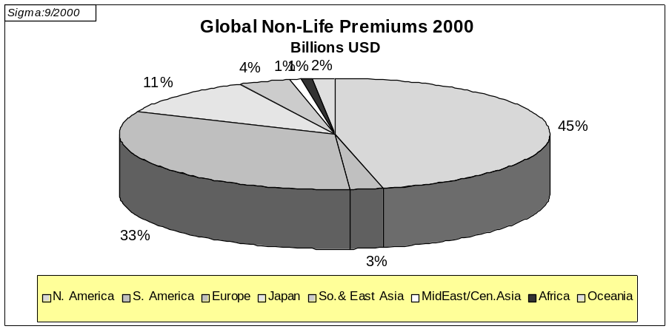

Figure 2b: Global Life Premiums (2000)

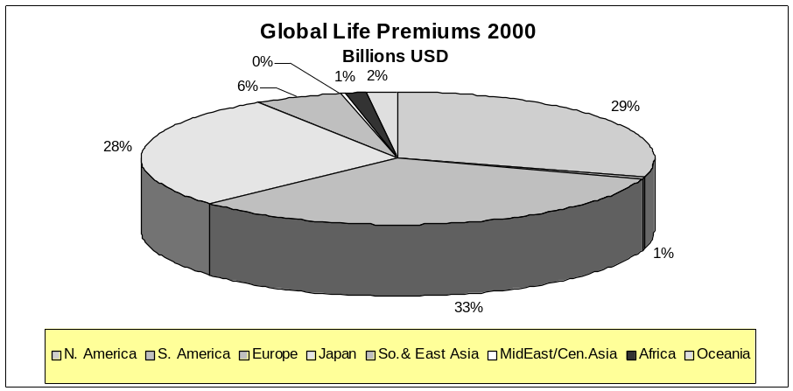

XIII. Acceptance Rates of Insurance

Insurance acceptance, called penetration rates, are measured as an average percentage of per capita expenditures. In 1999, industrialized nations had penetration rates of 8.8% of Net Domestic Product, or $2,285. Switzerland was the highest overall at $4,643 per capita, with 5% penetration rate ($1,729) in life per capita premiums. Japan’s 10% penetration rate ($3,103) for life per capita is the highest in the world.
Specific levels of premiums written per capita (penetration rates) are shown below for selected countries in Middle East, North Africa and Asia that have significant Muslim communities.

Figure 3: Per Capita Insurance: Non-Life and Life, 1999 ($)

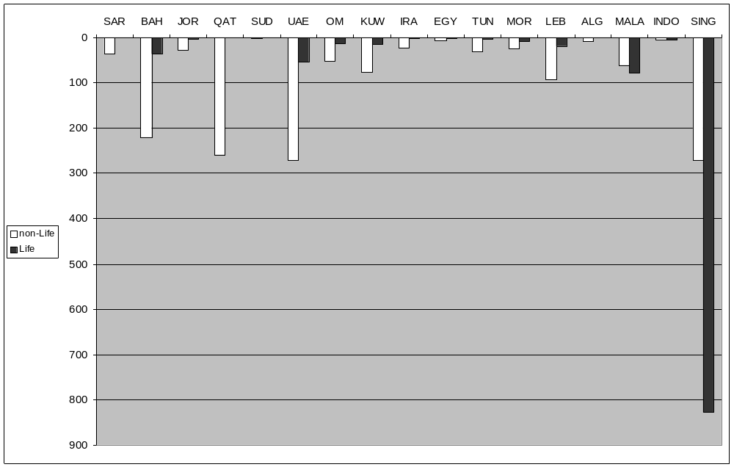
Figure 4: Volume of Insurance (Non-Life and Life) in Arab Countries, 1999

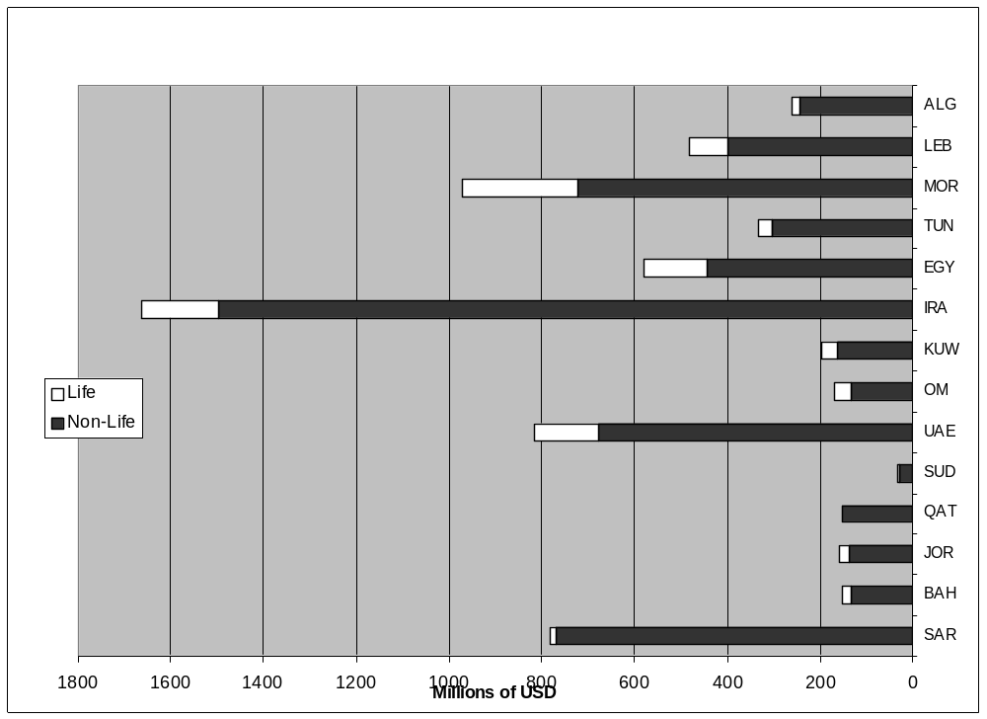

It is clear that the traditional cultural perspective on risk and risk protection throughout the Central Asia, Pacific and Middle East regions has curtailed the development of an insurance industry and limited the penetration, especially for life insurance, as a percentage of per capita income. The highest rates of penetration exists in mature markets of Asia-Pacific, 1.72% ($62 per year) for non-life and 2.16% ($78 per yr) for life in Malaysia and 1.03% ($271) for non-life and 3.15% ($828) for life in Singapore, respectively. By contrast, the lowest penetration rates are in Saudi Arabia with 0.55% ($37) for non-life and 0.01% ($0.60) for life and in Kuwait with 0.50% ($77) for non-life and 0.11% ($16) for life, respectively.

XIV. The Emergence of the Takaful Industry

There are currently some thirty registered companies in the takaful industry worldwide writing cover directly, another ten Islamic windows through which takaful is brokered and seven companies performing re-takaful. A broad estimate of the size of the takaful market worldwide is as follows:

Table 2: World Takaful Premiums, 2000 (est.)

Region | Total Takaful Premiums (mill.) | % of Total
Malaysia | 143 | 27
Other Asia-Pacific | 50 | 9
Europe, U.S. | 6 | 1
Arab Countries | 340 | 63
TOTAL | 539 | 100

Figure 5: World Takaful Premiums, 2000 (est.)

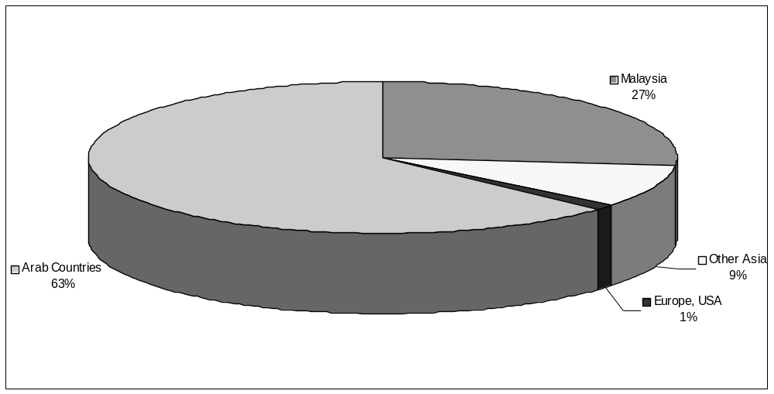

Table 3: Middle-East/North Africa Takaful Premiums, 2000 (est.)

 | Takaful Non-Life | Non-Life | Takaful Life | Life | Total Takaful ($mil) | Total Mkt | % Takaful
Bahrain | 5.0 | 129.0 | - | - | 5.0 | 134.0 | 3.7
Jordan | 6.6 | 131.0 | 0.3 | 4.0 | 6.9 | 141.0 | 4.9
Qatar | 6.0 | 147.0 | - | - | 6.0 | 153.0 | 3.9
S. Arabia | 60.0 | 707.7 | 1.3 | 12.0 | 61.3 | 781.0 | 7.8
UAE | 12.0 | 649.0 | 1.1 | 152.0 | 13.1 | 815.0 | 1.6
Sudan | 27.0 | 1.6 | 0.4 | 4.0 | 27.4 | 33.0 | 83.0
Oman | 5.0 | 132.0 | 1.0 | 30.0 | 6.0 | 168.0 | 3.6
Kuwait | - | 162.0 | - | 34.0 | - | 196.0 | 0.0
Egypt | - | 414.0 | - | 165.0 | - | 579.0 | 0.0
Iran | n/a | 1,537.0 | 15.0 | 160.0 | 15.0 | 1,712.0 | 0.9
Tunisia | 5.0 | 300.0 | - | 26.0 | 5.0 | 331.0 | 1.5
Morocco | - | 703.0 | - | 269.0 | - | 972.0 | 0.0
Lebanon | - | 398.0 | - | 79.0 | - | 477.0 | 0.0
Algeria | - | 244.0 | - | 14.0 | - | 258.0 | 0
Total | 127 | 5,655 | 19 | 949 | 146 | 6,750
Note: Takaful business would increase to 32% if all NCCI premiums were included as takaful business.

Of the African and Middle Eastern countries profiled in table 3 above, none has enacted takaful-specific legislation and seven do not have domestic takaful companies.

XV. Projected Demand for Takaful

Table 4 uses economic and social data to describe a profile of the Muslim world. The data on per capita income, Muslim population and savings rates per capita can be used to estimate the future demand for takaful cover (Life and Non-Life). Assuming that (a) the penetration rates for insurance increase substantially to an average 1.25% to 2.5% per capita (yet still would be approximately one-half of those rates in developed economies) and (b) 10% to 15% of the per capita savings were allocated to cooperative risk-sharing schemes (takaful), the projected demand worldwide for takaful cover both non-life and life in year 2011 could be $10.1 billion. Of this amount, nearly $2 billion in annual premiums would be written in GCC countries, $3.1 billion written in the Asia-Pacific region and an additional $2.6 billion in Europe, Turkey, China, India and the U.S.

Table 4: Economic Profile of the Muslim World

Country | Muslim Pop. (mil.) | Total Pop. (mil. 1999) | GDP ($ bil. 2001) | GNI/Per Cap ($ 2001) | Literacy (%, 1999) | SavingsX PerCap Inc | Savings Rate (% GDP, 1993) | Insurance Premiums (%, 1999)
SAR | 18.5 | 21.5 | 139 | 6,900 | 64 | (1,394) | -20.2 | -2.7
BAH | 0.6 | 0.6 | 4.9 | 7,640 | 84 | (206) | -2.7 | -124.1
JOR | 4.8 | 5 | 8.1 | 1,630 | 87 | 220 | 13.5 | 14.3
QAT | 0.7 | 0.7 | 9 | 12,800 | 81 | n/a | n/a
SUD | 21 | 31 | 9.4 | 303 | 46 | - | 0.0
UAE | 2.5 | 2.6 | 44.6 | 17,870 | 80 | n/a | n/a
OM | 2.45 | 2.5 | 16 | 6,400 | 80 | n/a | n/a
KUW | 1.7 | 2.1 | 30 | 14,300 | 80 | n/a | n/a
IRA | 64.3 | 65 | 117 | 1,810 | 73 | (60) | -3.3 | -42.9
EGY | 60.9 | 63.4 | 89 | 1,403 | 51 | 191 | 13.6 | 5.0
TUN | 9.3 | 9.4 | 20 | 2,120 | 67 | 271 | 12.8 | 12.8
MOR | 28.3 | 29.7 | 35 | 1,190 | 44 | 181 | 15.2 | 18.0
LEB | 3.2 | 4.3 | 15.8 | 3,700 | 86 | n/a | n/a
ALG | 30.8 | 31.8 | 46.5 | 1,550 | 62 | 104 | 6.7 | 8.2
PAL | 6 | 6 | 10 | 1,780 | n/a | n/a | n/a
MALA | 12.4 | 22.7 | 76.9 | 3,390 | 84 | 631 | 18.6 | 22.2
INDO | 186 | 207 | 140 | 676 | 84 | 93 | 13.8 | 11.8
SING | 1.8 | 3.5 | 85 | 24,150 | 91 | 9,153 | 37.9 | 12.0
Subtotal: | 455.25 | 508.8 | 896.2
IRQ | 21.7 | 22.4 | 52.3 | 2,400 | 58 | n/a | n/a
LIB | 6 | 6.2 | 40 | 6,450 | 76 | n/a | n/a
SYR | 15.8 | 17.2 | 26 | 1,511 | 71 | n/a | n/a
U.S. | 8 | 278 | 8879 | 31,910 | 97 | 3,063 | 9.6 | 93.1
U.K. | 1.5 | 59.4 | 1403 | 23,600 | 99 | 1,558 | 6.6 | 207.6
FR | 3.5 | 59 | 1453 | 24,170 | 99 | 3,263 | 13.5 | 64.1
GER | 3 | 82 | 2103 | 25,620 | 99 | 3,126 | 12.2 | 54.1
JAP | 0.6 | 126 | 4054 | 32,030 | 99 | 8,392 | 26.2 | 46.6
TURK | 60 | 64.1 | 50 | 780 | 83 | 120 | 15.4 | 29.6
CHINA | 50 | 1266 | 1030 | 813 | 82 | 175 | 21.5 | 7.6
INDIA | 90 | 998 | 439 | 440 | 53 | 32 | 7.2 | 27.1
PAK | 138 | 144 | 68 | 470 | 38 | 22 | 4.7 | 12.7
S.AFR | 1.6 | 44 | 139 | 3,170 | 82 | 165 | 5.2 | 342.8
KAZAK | 8 | 16.6 | 20.7 | 1,250 | 98 | n/a | n/a
UZBEK | 21 | 24.4 | 23 | 942 | 99 | n/a | n/a
BRUNE | 0.2 | 0.33 | 7.7 | 24,620 | 89 | n/a | n/a
YEMEN | 16.1 | 16.9 | 6.6 | 390 | 40 | n/a | n/a
World |  | 6,000 | 30,898
Source: World Bank Atlas/Development Reports, 2001

Figure 6: Projected Gross Premium Written 2011

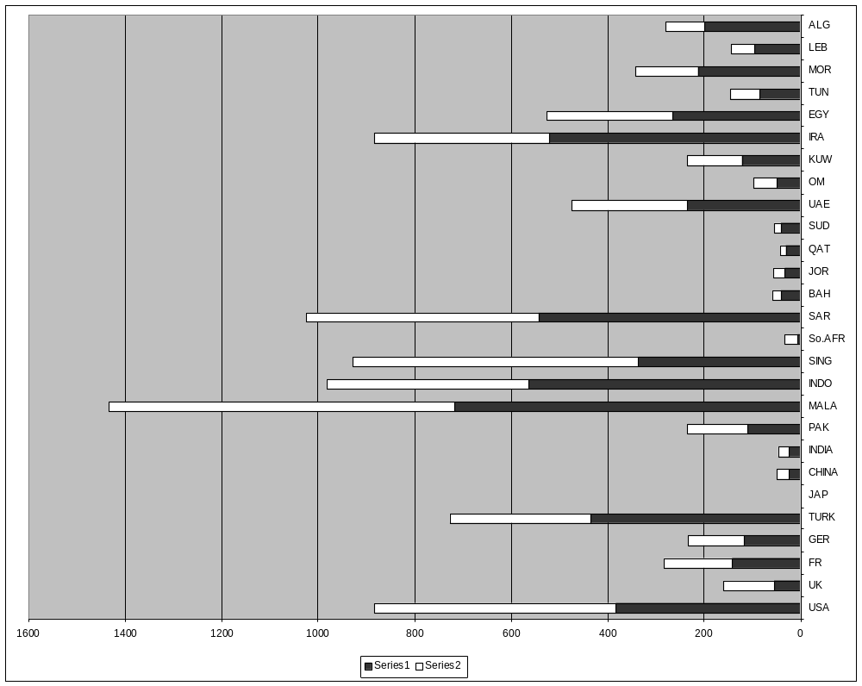

Approximately, 52% of the projected total annual takaful premiums would be non-life with an increase in life/family takaful up to $4.9 billion. These figures indicate the magnitude of the business opportunity in takaful yet to be realized. The forecast also assumes that takaful operators augment capital commitments to their primary takaful operations so that significantly higher volumes of non-life and life premiums written can be achieved.

XVI. Challenges and Obstacles to Future Growth

The array of challenges that confront the primary takaful cover writers can be grouped into four categories:

- Internal factors: skilled staff, management style, level of capitalization
- External factors: regulatory framework, competitive environment, treatment of takaful versus conventional insurers, role of government, maturation level of insurance industry (conditioning/mandates), etc.
- Muslim client profile: attitude toward risk and response, savings rates and discipline, access to capital markets and investment options (mutual funds, bonds, etc.), Islamic awareness and habits, majority versus minority position in country, and
- Shari^{c}a issues: coexistence of various shari^{c}a rulings on takaful practices, controversy between mudaraba and wakala models and a gradual consensus building around a set of takaful norms.

We will highlight now the challenges that comprise each category.

A. Internal Factors
There are traditional and cultural reasons why Muslims have not generally chosen insurance as a career. It remains for training organizations such as MII, BIRT, and BIBF (Bahrain) to reshape attitudes about insurance and encourage young people to seek out promising careers in takaful, including professional areas of actuarial sciences, treasury management, investments fund management and underwriting.
At present, there appears to be a shortage of skilled personnel who are also dedicated Muslims to enable takaful operators to strike an important balance between insurance industry expertise and Islamic values. For example, there are less than six trained Muslim actuaries worldwide working with takaful companies. There are only a handful of accountants knowledgeable about insurance statutory accounting as well as takaful accounting. Globally there are only about a score of Muslim underwriters and fund managers expert in Islamic finance. Muslim and non-Muslim trained personnel as takaful operators and insurance personnel knowledgeable about takaful operations must be expanded. Although there is no definitive data available on the takaful industry worldwide, the authors estimate that the primary takaful operators employ nearly 2,000 personnel worldwide whereas the seven re-takaful companies employ upwards of 100-150 staff in total. This compares with 250,000 conventional insurance personnel in the U.S., along with over 150,000 conventional insurance agents and brokers, and some 86,000 insurance staff, agents and brokers in Malaysia.
The development and innovation of new products is not keeping pace with the overall insurance industry. Takaful management must strive to be proactive in designing cooperative savings and risk protection products for a broad range of client needs. For example (refer to Figure 1, above), to date a takaful savings product for hajj and/or ^{c}umra, takaful product purchase warranties and specialized property and liability coverage for religious buildings and organizations have yet to be developed.
Another important area of development is the operational and accounting standards for takaful. The two pioneering companies in Malaysia, Takaful Malaysia and Takaful Nasional, joined forces in 2000 to develop a code of ethics for the industry. With the encouragement of Bank Negara they launched an initiative in 2001 with the Life Insurance Association of Malaysia to promote best practices and greater professionalism in the industry. Other takaful operators are urged to also implement locally the best practices gleaned from the industry worldwide.
As we have seen, the level of capitalization for takaful operators and re-takaful companies is relatively modest and should be augmented to enable them to accept higher volumes of premiums or retain greater level of risk exposure. Inadequate capitalization or capital reserves result in excessive ceding of primary risks by takaful companies to conventional insurers. The under capitalization of re-takaful companies only serves to compound this trend whereby takaful operators today typically retain a mere 15%-40% of the primary takaful risk.

B. External Factors
There are narrow options currently available for takaful operators to invest premiums on a shari^{c}a-compliant basis. Only Malaysia has a special law that recognizes and regulates takaful operators separately from conventional insurers. Other takaful operators must conform to the investment restrictions that violate Islamic values, namely, placing investments in interest-based securities such as bonds, T-bills, treasury notes, etc. Prudent risk management would dictate that a takaful operator diversifies its portfolio in secure, liquid and long-term instruments, which are rare in Islamic finance offerings. Islamic bankers have yet to develop a shari^{c}a-compliant money-market fund that is sanctioned by a central bank, although these are under development presently in Bahrain and Malaysia. There is an urgent need to create leased backed securities, REITS and other securitizable assets which are publicly traded to broaden the investment options for takaful operators and assist them to overcome the competitive disadvantage where conventional insurers gain interest returns on “idle” and short-term funds.
In Muslim-majority countries, government and insurance regulatory bodies could elect to follow the worthy example of Malaysia and authorize a special legislation for takaful companies. Such an act would recognize the primacy of the shari^{c}a and balance its guidance with secular laws generally geared to assure solvency of insurers and to protect consumers. A special Takaful Act could also address the requirement of takaful operators to invest funds in accordance with Shari^{c}a principles. In addition, the act would address the critical issue of how to rate the takaful operators (e.g., AM Best or S&P) which will require them to adopt a transparent operations and standardize their accounting, claim-paying and reserves practices. At this time, it is difficult to see how takaful operators can be rated internationally with a modest capital structure and the absence of internationally rated Islamic securities.
Finally, the Muslim client profile and attitude toward risk along with the shari^{c}a issues can only be redressed by education and consensus-building. While it is undeniable that most Muslims follow the advice of contemporary Islamic scholars, many practicing Muslims still keep their own counsel. A recent survey by Islamic Business and Finance Network (IBF Net) concluded that 55% of respondents, if facing “conflicting fatwas” would study the different opinions and develop their own opinion. Islam is ultimately a religion of conscience. Therefore, prevailing customs and popular understandings about risk and risk-taking can only be modified by sustained dialogue between individuals and takaful operators. They must clearly state their case to prospective consumers substantiated with historical and religious evidence. Takaful offers a strong viable alternative to conventional insurance. Takaful programs offered with competitive protection features along with spiritual benefits are being truly welcomed by Muslims as witnessed by the 60% annual growth in applications even in a mature market like Malaysia.
The specific merits of takaful models are emerging to be passionately debated in takaful forums and in private shari^{c}a advisory consultations. We are confident that, eventually, a scholarly consensus will emerge that can guide the further evolution of the global takaful industry.

XVII. Conclusion

There are eight main obstacles to the rapid evolution and expansion of a global takaful industry:

- How to react to the sweeping changes impacting the conventional (re)insurance sector such as global consolidation, demutualization and the Internet revolution.
- How to respond to advancing disintermediation whereby customers are redefining distribution channels and their information needs.
- How to attract capital for the local takaful sector.
- How to accelerate product innovation, not imitation.
- How to widen the scope of shari^{c}a dialogue, both to include risk securitizations and other innovations as well as to help focus Islamic scholarly research and reflection on such issues.
- Emergence of a scholarly consensus for models of takaful operations that is sensitive to regional differences and local governmental regulations yet adheres strictly to the fundamental cooperative principles of takaful.
- Establishment of a global re-takaful facility in order to increase underwriting capacity and expertise available to indigenous takaful operators.

One should remember that insurance is a major mechanism for wealth and capital creation in emerging markets worldwide—both as an important source of funding and to address risk mitigation in human activities from family formation to launching new enterprises. Hence, to expand takaful and re-takaful business is to nurture indigenous capital and wealth formation.
In conclusion, Islamic finance and Islamic takaful are ethical financing and cooperative risk protection methods that are superior alternatives precisely because they reinvigorate human capital, emphasize personal dignity, community self-help, and economic self-development, generating manifold benefits for all participants. Islam is an integrated way of life. Thus interest-free financing and takaful are mutually reinforcing systems that promote economic efficiency, communal risk-sharing and individual rewards through self-purification. While the takaful system revolves around active participation by members of the community, it is imperative that public awareness be enhanced. As Muslims and non-Muslims alike come to understand the real benefits of takaful and cooperative risk sharing, the evolution of the takaful industry will accelerate making the projections described herein possibly overly conservative.

References

Aziz, Zulkify. “Takaful: What Differentiates it from Conventional Insurance?” Islamic Banking & Finance Forum. Dubai: 1996.
Bank Negara Takaful Industry Report 2000. Kuala Lumpur. 7-17.
Bhatty, Ajmal. “Takaful Industry: Global Profile and Trends, 2001.” New Horizon. Institute of Islamic Banking & Insurance. London: April 2001.
Billah, MM. “Life Insurance: An Islamic View.” Arab Quarterly 8.4 (1993).
Billah, MM. Principles and Practices of Takaful and Insurance Compared. International Islamic University. Malaysia: 2001.
Fisher, Omar. “Awakening of a Community: Rediscovery of Takaful Worldwide.” Speech at Institute of Business Administration. Karachi: April 1999.
Fisher, Omar. “Growth of Islamic Finance and Scope for Retakaful.” International Takaful Conference. Kuala Lumpur: June 2000.
Institute of Islamic Banking and Insurance. Directory of Takaful Companies. London: 2000.
Islamic Banker 63 (April 2001): 4.
Siddiqi, MN. Insurance in an Islamic Economy. The Islamic Foundation. London: 1985.
Takaful Nasional. Annual Report 2000. Kuala Lumpur.
Taylor, Dawood. “Developing Takaful Ta^{c}awuni in Saudi Arabia.” International Takaful Conference. Kuala Lumpur: June 2000.
World Bank Atlas and Development Indicators. 2001.
World Bank Economic Review 13.2 (1999).
Yaquby, Nizam. “Possibilities of Global Uniformity amongst Takaful Operators in Light of the Shari^{c}a Norms.” International Summit on Takaful. Kuala Lumpur: June 2001.
Yaquby, Nizam. “Role of Shari^{c}a Board in Islamic Insurance.” International Conference on Takaful. Kuala Lumpur: June 1999.
Yusof, M Fadzil. “Brief Outline on the Concept and Operational System of Takaful Business.” BIRT. Kuala Lumpur: 1997.
Zulkifly, Ahmad Mazlan. “The Origin of Takaful and Evolution.” Rediscovery of Takaful and Retakaful Forum. New York: April 2000.

Opening Doors for Muslim Families in America

Saber Salam*

Abstract

Although home ownership is central to the American way of life, as it facilitates wealth accumulation and builds strong and vibrant communities, opportunities for American Muslim families have been very limited. Most observant Muslims purchase homes through family savings, financing from individual investors, cooperatives organized by communities, or the handful of financial institutions providing financing through portfolio lending. The lack of steady capital flows combined with the expense of alternative financing modes make it prohibitively expensive for riba-avoiding Muslim families in America to realize the dream of homeownership. Although the home-financing system in the United States is among the most progressive in the world, structuring contracts that are both compliant with Islamic standards and compatible with U.S. home financing regulations is a difficult task. In addition, the secondary markets central to providing a steady flow of low-cost financing are not being fully employed. In March 2001, Freddie Mac entered the market to facilitate the flow of low-cost financing available through secondary markets. Key areas of focus for Freddie Mac include product development, providing a steady flow of capital by purchasing home financing contracts from Muslim homebuyers, and approving new Freddie Mac Sellers/Servicers that specialize in providing financing to Muslim consumers in the U.S.

I. Introduction

While the dream of homeownership remains one of the core values of American society, there is a growing segment of our society that will require innovative thinking to realize this dream. For devoted Muslims, financing a home presents a unique challenge as they strive to avoid interest-based mortgages.
Homeownership is one of the primary methods by which American families accumulate wealth. Over 68% of American families own their own homes. The pride of owning a home and the opportunity to build wealth through appreciation and federal tax incentives explains why housing drove an estimated 40% of annual economic growth in 2001. As figure 1 illustrates, America’s homeowners have seen over $2 trillion dollars in-house price appreciation since 1998.

Figure 1

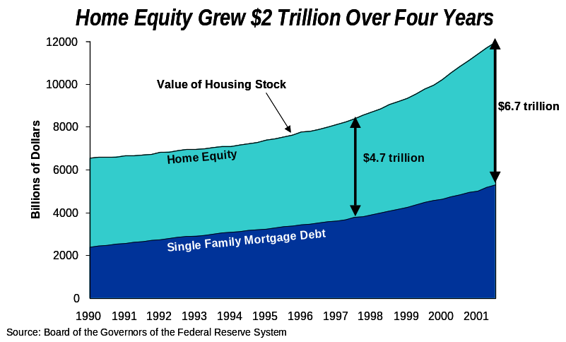

II. Home Financing Outlook

Not surprisingly, the mortgage finance industry has seen record originations over the past 24 months; 2001 set a record with $2.1 trillion in originations, of which 57% were refinances. In addition to lowering the cost of housing related expenses, these refinances enabled consumers to tap into their home equity to finance home improvement, automobiles, and college education and to consolidate consumer debt. Single-family mortgage rates are now at a 30-year low (figure 2).

Figure 2

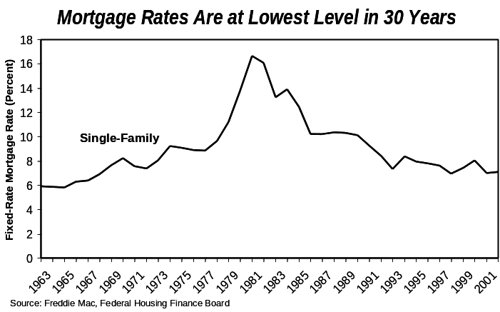

The outlook for mortgage origination continues to be very strong in the coming decade. The Federal Reserve Board and Freddie Mac expect the mortgage finance market to double from about $5.5 trillion to $11 trillion by 2010. The factors driving this growth include: 1) growth in the number of households, 2) house price appreciation, 3) growth in the overall homeownership rate in the United States, and 4) better leveraging of housing debt by consumers. Taken together, the Residential Mortgage Debt Market is likely to grow by an annual rate of 8% in the coming decade as seen in figure 3.

Figure 3

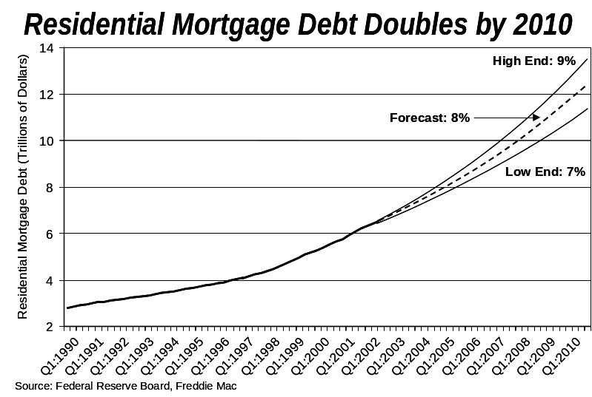

A significant portion of the growth in homeownership is expected to come from minority communities. Although the national homeownership rate is 68%, homeownership rates among minority and immigrant families lag by about 20% compared to non-minorities in the United States. The homeownership rate is even lower among Hispanics and African-Americans, as seen in figure 4.

Figure 4

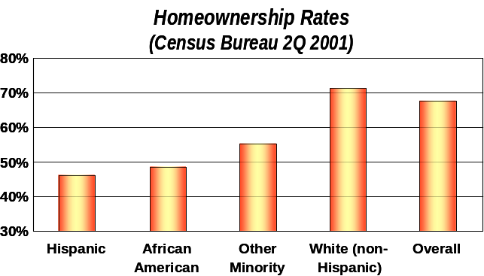

A. Home Financing Structure
The United States home financing process is among the most progressive in the world. As shown in figure 5, secondary markets finance more than 50% of homes in the United States, more than any other country. Banks and mortgage lenders play the traditional role of sourcing borrowers, processing, underwriting, closing, and servicing loans in collaboration with the capital markets. The capital markets in turn auction mortgage-backed securities to individual and institutional investors to attract capital for the home financing industry in the United States. Three Government Sponsored Entities (GSE’s), Freddie Mac, Fannie Mae and Ginnie Mae, facilitate the securitization of mortgages. This process, known as MBS mortgage-backed securitization (MBS), has created significant liquidity for the home financing industry. In addition, the process enables banks to recover their capital from home financing while maintaining their relationships with consumers. From a consumer’s prospective, the availability of abundant low cost financing has enabled them to finance their homes using 30-year repayment terms.

Figure 5

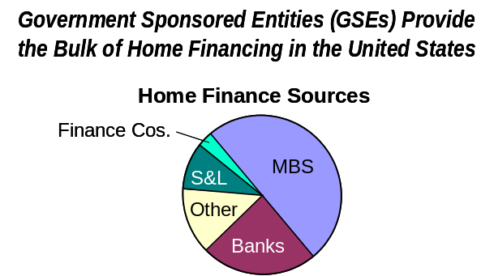

B. Industry Structure and Outlook
The mortgage industry has continued to be one of the very few bright spots in the economy over the past 18 months. In addition to lower rates which have enabled consumers to refinance their mortgage debt and reduce their monthly housing expenses, American families have also been able to leverage the appreciation of their homes to consolidate higher cost debt and other expenses. Furthermore, house price appreciation and lower financing costs have created a strong demand for new homes and sales of existing homes.
The mortgage industry has responded to this increased demand by adding both origination and servicing capacity. On the origination side, which is typically more labor-intensive, a record number of loans are originated, underwritten, processed and closed by mortgage brokers, mortgage bankers, credit unions, community lenders, and national banks. The cost of entry in the origination business is relatively low thereby allowing many originators to enter the business with fairly modest investments. On the servicing side of the business, we see continued consolidation. Servicing, which requires substantial investments in systems, people, and infrastructure, has created an opportunity for large, national, primarily bank-owned mortgage companies to thrive because of their scale operations and risk management expertise.
During 2001, the mortgage origination market totaled a record $2.1 trillion. Of this, approximately 57% of the mortgages originated were refinances. The current mortgage finance rates in 2002 are at a 32-year low thereby creating an opportunity for a bigger mortgage origination market than in 2001. Both Housing and Urban Development and Freddie Mac continue to project a strong home financing market in the coming years as illustrated in figure 6.

Figure 6
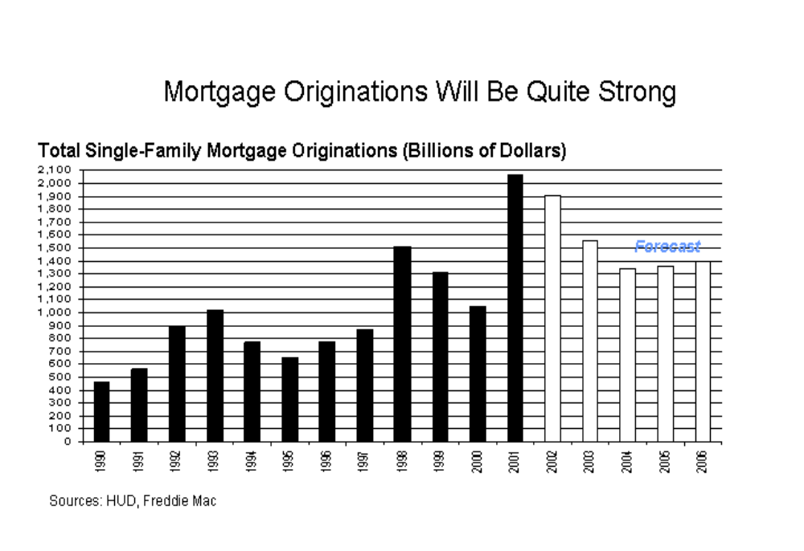

C. The Role of Freddie Mac
Congress chartered Freddie Mac in 1970 to facilitate the steady flow of mortgage financing capital to the mortgage market. Freddie Mac enables banks and mortgage companies to originate mortgage assets for sale in the secondary market. In 1989 Freddie Mac became a publicly owned company whose stock is listed in the New York Stock Exchange (FRE).
Freddie Mac does not lend money directly to consumers but rather guarantees the performance of Mortgage-Backed Securities (MBS) against credit risk. Freddie Mac is also an investor in mortgages and MBS’s. It finances its investment in mortgage instruments by raising capital both domestically and internationally. Freddie Mac’s major business areas include the financing of home loans through its Single Family Unit, financing of multifamily complexes through its Multifamily Unit, and investment in mortgage assets through its Funding & Investment Unit. The Single Family unit at Freddie Mac offers two main models for mortgage securitization as illustrated in figure 7. The first one involves lender’s closing the mortgages in their own name and then selling their assets to Freddie Mac through Freddie Mac’s Cash Window. Freddie Mac then determines whether to keep all or a portion of these mortgages in its investment portfolio and to sell portions of these mortgages in the secondary market by issuing MBS. Approximately 15% of sales to Freddie Mac come through cash transactions. Alternatively, a bank or mortgage company that is an approved Seller/Servicer of Freddie Mac can sell MBS directly to the secondary market on behalf of Freddie Mac, based on terms approved by Freddie Mac. Approximately 85% of Freddie Mac’s business is done using this approach.

Figure 7

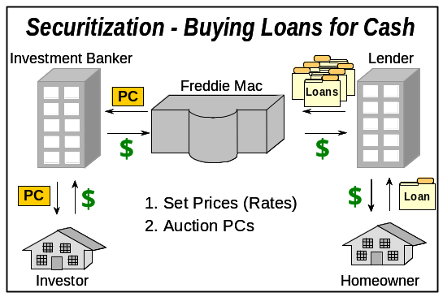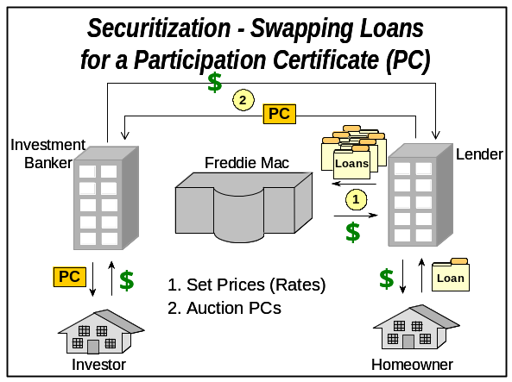

III. Islamic Mortgage Initiative

So what does this mean for observant Muslims who are forbidden to pay or receive interest by religious law? Until recently, America’s housing finance system really did not work for them. As a result, the demand for home financing alternatives for Muslim families far exceeds the capital available to the Muslim community. Many of the home-financing options for devout Muslims are available through limited access to capital from portfolio lenders and/or community-related investor groups. This lack of access to capital is limiting the potential for Muslim families to own homes and accumulate wealth through house price appreciation.
Recognizing the need to expand homeownership opportunities in this underserved market, Freddie Mac began seeking out organizations that were in a position to help meet the home financing needs of Muslim families. Freddie Mac’s role in the process is to collaborate with companies that are financing homes in the Muslim community and to develop products that are eligible for sale in the secondary market. Once this is done, these organizations have the ability to make home-financing available to Muslim families and then sell the financing contracts to Freddie Mac and recoup their capital. The result is a constant flow of capital for financing more homes for Muslim families.
Freddie Mac is pursuing a two-pronged approach. First, it is helping to identify products that can be sold in the secondary market. Second, it is approving new Seller/Servicers that have the experience with Muslim homebuyers to better connect the financing needs of Muslim families with the financing structures needed to do business with Freddie Mac.
This process started in March of 2001 when Freddie Mac financed a $1 million pool of Muslim home financing contracts for a single company. As of March 2002, Freddie Mac has approved two additional mortgage finance companies, three more financing structures, and more than $45 million worth of home financing contracts for Muslim families in the United States. We are forecasting over $100 million in financing contracts for Muslim families in the calendar year 2002.
Some of the opportunities that we see in the Muslim market include: 1) standardization of home financing contracts that simultaneously conform to Muslim religious requirements and United States home financing laws and regulations, 2) helping more mortgage professionals and firms to reach out to the Muslim community with financing products that can facilitate the growth of homeownership, and 3) investing in marketing, infrastructure, and operational capabilities needed to tap the potential of this underserved market.

IV. Conclusion

Homeownership is an important aspect of building communities and wealth in the United States. There is a gap between the home financing needs of the Muslim community and the available capital. This creates an opportunity for the community to standardize product structures, for mortgage professionals to help create home financing solutions, and for investors to develop an infrastructure to help reach this market. In addition, these efforts will allow observant Muslims to utilize more broadly the home financing system in the United States which leverages the secondary market, thus making homeownership a reality for many more Muslim families.

Strategies in the Islamic Funds Industry
An Exploratory Analysis

Zafar Sareshwala† and Mohammed Obaidullah*

Abstract

The industry of Islamic funds has demonstrated a number of diverse strategies in recent years. Players in the industry have implemented combination strategies such as joint ventures, strategic alliances in the form of licensing and franchising, outsourcing, and co-branding in order to achieve competitiveness. Popular product-market strategies include innovative bases of segmentation along income, geographic, demographic, or gender lines. Product design strategies include differentiation achieved by selected exposure to different markets, the development of indices, and varying degrees of financial complexity. In order to measure the performance of Islamic funds, a metric in the standard risk-return space is not appropriate due to the different objectives of Islamic investments compared to conventional investments.

I. Introduction

The Islamic funds industry has been developing steadily. In the recent past, a large number of Islamic funds have appeared, competing for the savings of 1.2 billion Muslims around the world. While there were just about half a dozen Islamic funds a decade ago, the number increased to about a dozen in the mid-nineties. The growth has been exponential since then. The number of players in this industry has now crossed the three-digit mark. Assets of these funds have grown at a rate of over fifty percent during the last five years. As the industry transitions from a pioneering phase to an expansionary phase, one can observe a range of strategies implemented by Islamic funds. The industry has also seen a wide variation in performance. In this paper we attempt to develop a framework enumerating various strategies implemented in this industry, specifically focusing on combination strategies that have been widely used. We also discuss various product-market strategies including bases for market segmentation and product design issues. Lastly, we argue that a performance measure in the conventional risk-return space is not appropriate for Islamic funds, given their unique set of objectives compared to conventional investments.

II. Some Hypotheses from Related Studies

At the risk of stating the obvious, one may identify the growth of Islamic awareness and consciousness as the single most important environmental factor that has influenced the origin and development of Islamic financial services (At-Tawjiri, 1988; Habib et al., 1987; At-Tawjiri, 1991). The same also holds true for the industry of Islamic funds. However, there may be several additional factors that have contributed to its expansion. Preliminary findings from a recent online survey of Muslim investors conducted by IBF Net reveal that Islamic equity funds, which account for a major portion of the Islamic funds industry, are becoming better understood by the community of Muslim investors. Furthermore, Islamic funds may be perceived as more “Islamic” than other investment vehicles such as wadi^{c}a and mudaraba deposits with Islamic financial institutions. Islamic windows at conventional banks score much worse in terms of perceived conformity to Islamic norms, as their products are perceived to be tainted by conventional interest-based investments and profits. On the other hand, Islamic funds have a high degree of perceived conformity to Islamic norms, perhaps because of the transparency that accompanies a fund in its investment policy and because of the use of a screen. Funds are required to state that investment is subject to market risk and may lose value under adverse market conditions. Moreover, the screen used by funds is perceived to be a constraint and a mechanism to ensure shari^{c}a compatibility. No such transparent mechanism exists with Islamic deposits. Often the profit rates paid on deposits are perceived as disguised riba, no different from interest rates. Islamic funds are also characterized by greater agreement among shari^{c}a scholars concerning their acceptability, unlike the controversies surrounding many Islamic banking practices.
The above findings, though preliminary, provide supporting evidence to several hypotheses. The first is that transparency pays. Secondly, Islamic bankers would do well to avoid activities and products that are based on dubious and marginal viewpoints about their shari^{c}a acceptability. In the short run, an institution may manage to obtain approval for some of its products from a handful of scholars, but such a strategy may prove disastrous in the long run.
The findings above also corroborate recent assertions that the key driving force behind the industry is its “otherness” (Cunningham, 2000). Further research is needed into this very crucial hypothesis. However, if the hypothesis were true, then it would have profound strategic implications for Islamic fund managers. Firstly, it implies that Islamic fund managers need to react proactively to the growing Islamic consciousness in Muslim societies, instead of trying to bridge the gap between Islamic finance and conventional finance. Secondly, it suggests that the role of shari^{c}a scholars is of the utmost significance; hence fund managers should seek scholars with greater acceptance and better reputation among Muslim investors. Thirdly, it advocates greater transparency regarding the duties and responsibilities of shari^{c}a auditors.
It would be useful here to briefly touch upon findings from a few empirical studies conducted on consumer behavior in the Islamic financial services industry in general. Ugur Yavas (1988) undertook a survey of Saudi Arabian customers and noted the role of “deeply ingrained values and religious beliefs” in shaping consumer behavior. He attempted to determine the importance of selected patronage factors and found that a financial institution’s experience, reputation, quality of service, and helpfulness of personnel are prime considerations for consumers. Advertising and rate of return (implicit interest rates) were among the least important factors. In another significant study, Erol et al. (1990) conducted a survey of Jordanian customers and found that explicit interest rates and fixed-price related banking services do not play important roles in customers’ selection of an Islamic bank when the bank directly addresses their concerns about riba and underscores the importance of religion. An analogous study conducted for Malaysian customers by Haron et al. (1994) has similar findings: the most important patronage factors for customers of Islamic financial institutions in Malaysia are image, reputation, confidentiality, friendliness of personnel, and speed of service. Furthermore, explicit interest rates and fixed-price related financial services do not seem to be important to the Malaysian consumer in his choice of financial institution. Although these studies relate generally to Islamic banking and financial services, they help explain and highlight factors that Islamic fund managers need to consider when formulating and implementing corporate strategy.
We now turn to a qualitative analysis of strategies that have been pursued in the Islamic funds industry in the recent past.

III. Strategic Analysis of the Industry

Before we undertake an examination of actual strategies at the company level or fund level, it may be helpful to briefly discuss the overall industry of Islamic funds.

A. Potential Opportunities
As stated earlier, the total assets in the Islamic funds industry are estimated at approximately $1.5 billion. This figure looks grossly insignificant if one considers the following statistics: the funds industry in the United States consists of about one trillion dollars worth of assets. Of this, ethical funds alone account for over 20 billion dollars. In the United Kingdom, ethical funds account for over 1.5 billion dollars, of which about half is managed by just one player, the Friends Provident Stewardship Fund. What should be noted here is that Islamic funds for Muslims are different from ethical funds in the sense that they are backed by shari^{c}a requirements, unlike the voluntarism that accompanies conventional ethical investment. Given the growing religious consciousness of Muslims, one would expect a large exodus of Muslim investors from conventional to Islamic funds. Given this scenario, it appears that competitive pressures are not very intense, and new entrants can grow along with older funds as long as they can maintain their distinct Islamic identity. The growing affluence of middle-class Muslims and the predominance of the internet which facilitates cross-border investments are two other contributory factors that add to the potential growth of this industry. What has been the nature of actual strategies in this industry so far?

B. Investment Objective(s)
Most of the Islamic funds state that their objective is to provide medium- to long-term capital appreciation through investment in Shari^{c}a-compliant equities. However, there are a few exceptions. For instance, the Tabung Ittikal Fund by Arab-Malaysian Unit Trusts Berhad states its objective is to produce income and, to a lesser extent, capital growth. The fund always maintains at least 10% liquidity. Amanah Saham Bank Islam by BIMB Unit Trust Management Berhad seeks “to achieve an optimal rate of return through investments in equities and money-market instruments in the medium to long term in compliance with Shari^{c}a.” RHB Mudaraba also seeks “to invest in a portfolio of equities and debt securities which comply with Shari^{c}a in order to provide a balanced mix of income and capital growth.”
Perhaps the only non-Malaysian fund that is income-oriented is by Saturna Corporation, a U.S.-based company which aims to produce current income and preserve capital by investing in U.S. equities. The reason for this difference in objective originates in the multitude of divergent scholarly opinions about the permissibility of bay^{c} al-^{c}ayna and bay^{c}al-dayn. Permissibility accorded to these mechanisms by scholars in Malaysia has led to a high-growth private debt securities market that is deemed Islamic and hence eligible for investment by the Malaysian funds.
The only Islamic fund to focus on risk management is the Alkhawarizmi Fund by The International Investor (TII). This fund seeks “to achieve long-term capital growth from securities and other financial instruments while managing risk through hedging and efficient portfolio management techniques, using for example, short-selling. The fund aims to maintain a market-neutral strategy.”
One notably different objective is that of the Amanah Saham Wanita (ASNITA) which seeks “to invest in a portfolio of equities and debt securities which comply with Shari^{c}a in order to preserve and enhance capital. The fund has the ultimate objective of facilitating the development of Malaysian women as informed savers and investors as well as achieving their financial independence.”
A few funds like the Pure Specialist Fund by Futuregrowth Unit Trust Management in South Africa and the Tata Equity Fund in India initially had the objective of providing an investment medium acceptable to various religious groups including Muslims. However, while the former has increased its focus on Muslim investors over the years, the latter has diluted its objective and has neglected this group.

C. Criteria for Screening
Criteria for screening stocks to be included in the universe can be positive or negative. Positive criteria have been used by the managers of some ethical funds such as the Stewardship Fund in the U.K.. A company may be given greater weight in portfolio construction for factors such as a good record for quality products, safety, staff management, customer relations, involvement in environmental improvement, pollution control, sustainable woodland management, and energy conservation. Negative criteria exclude certain companies from the universe such as producers of alcohol and pork-related products, providers of conventional financial services (banking, insurance, etc.), and providers of certain entertainment services (casinos, cinema, pornography, music, etc.). Tobacco manufacturers and defense and weapons companies, although not strictly forbidden for investment under Islamic Law, are excluded as well.
Islamic funds have also been using a financial screen to exclude companies that rely on excessive interest-based debt and derive a significant portion of their income from interest. For instance, the Dow Jones Islamic Index Fund, which mimics the Dow Jones Islamic Market Index, uses the following filters to remove companies with unacceptable financial ratios. The three filters are as follows:

- Exclude companies if Total Debt divided by Trailing 12-Month Average Market Capitalization is greater than or equal to 33%. (Note: Total Debt = Short-Term Debt + Current Portion of Long-Term Debt + Long-Term Debt).
- Exclude companies if the sum of Cash and Interest Bearing Securities divided by Trailing 12-Month Average Market Capitalization is greater than or equal to 33%.
- Exclude companies if Accounts Receivables divided by Total Assets is greater than or equal to 45%. (Note: Accounts Receivables = Current Receivables + Long-Term Receivables).

Islamic funds in Malaysia pursue a somewhat more liberal screening strategy. For instance, the criteria set by the Shari^{c}a Advisory Council (SAC) of the Malaysian Securities Commission excluded stocks from the approved list based on the following criteria:

- Operations based on riba, like commercial banks, merchant banks, and financial institutions.
- Operations involving gambling.
- Activities involving the manufacture or sale of haram products such as liquor, non-halal meats, and pork.
- Operations containing an element of gharar (uncertainty), such as conventional insurance businesses.

As for companies whose activities consist of both permissible and non-permissible elements, the SAC applied several additional criteria, i.e.:

- The core activity of the company must not be against the shari^{c}a, as outlined in the four criteria above. Furthermore, the haram element must be very small compared to the core activities.
- Public perception or the image of the company must be good.
- The core activity of the company must have importance and maslaha to the Muslim umma and to the country, and the haram element must be very small and involve matters such as ^{c}umum al-balwa, ^{c}urf, or the rights of the non-Muslim community which are accepted by Islam.

Some funds explicitly use a further purification methodology, after implementing the screens and filters. For instance, the RHB Mudaraba Fund was the first fund in Malaysia to introduce the purification process which separates and removes profits or income derived from a company’s incidental activities that do not comply with shari^{c}a principles. Proceeds from the purification process are paid to specific charitable organizations endorsed by the RHB Shari^{c}a Panel.

D. Strategic Alliances and Partnerships
The Islamic funds industry has witnessed the widespread use of strategic alliances and partnerships to further the long-term objectives of the parties involved. These alliances have taken different forms such as joint ventures, co-branding, franchising, and outsourcing.

1. Joint Ventures
When two or more capable firms lack a necessary component for success in a particular competitive environment, the solution is a joint venture, which is comprised of commercial companies (children) created and operated for the benefit of the co-owners (parents). A good example of such a cooperative arrangement is between American Express Bank and Faisal Finance in order to offer Islamic Multi-Investment Funds. While the former is an international banking institution with over 80 offices in 36 countries, the latter is part of one of the largest financial groups in the world, the Dar Al-Maal Al-Islami (DMI) group. Another example of a joint venture is the arrangement between DBS Asset Management Ltd, a wholly owned subsidiary of DBS Bank (one of the leading managers of unit trust funds in Singapore), and Mendaki Holdings Pte Ltd, a wholly owned subsidiary of Yayasa Mendaki, a charitable organization whose mission is to develop the Malay Muslim community in Singapore. The objective of this joint venture is to set up the Mendaki Global Fund and the Mendaki Growth Fund. Yet another good example of a joint venture is between Al Tawfeek Company for Investment Funds Ltd and Nomura of Japan in order to launch the Al-Nukhba Asia Equity Fund, which targets the South East Asian companies in which both parties have invested an equal amount of 10% of the subscribed capital.

2. Strategic Alliances
Strategic alliances are different from joint ventures because the companies involved do not take an equity position in each other. In a few instances, strategic alliances are synonymous with licensing and franchising arrangements.
A major proponent of franchises is the Kuwait-based The International Investor, a company that has used this strategy to expand operations into Bahrain, Qatar, and the United Arab Emirates. TII regards franchising as a way of combining Islamic expertise and brand name with its partners’ knowledge of their own domestic markets. The objective goes beyond merely delivering products; it entails channeling Islamic expertise, technology, and a brand name with a proven track record to the franchisees. When successfully implemented, the result is an effective low-cost and low-risk entry into a growing niche market. The franchising arrangement is targeted at conventional players for whom establishing in-house capabilities in order to reach the Islamic market effectively is both expensive and risky: in order to gain full access to the Islamic market, conventional players would need to employ specialized personnel trained in the intricacies of Islamic finance. Conventional players may also have to overcome certain market perceptions such as not possessing sufficient Islamic expertise to achieve shari^{c}a compliance.
TII entered into its first franchise relationship with Gulf Bank, a significant player in the Kuwaiti market, with the Al Deema range of products. Al Deema provides investors with a choice of portfolios containing Islamic products developed by TII with the objectives of income, growth, or income-cum-growth. While the Gulf Bank is entrusted with distribution and administrative functions such as sales, collection of investment amounts, investing those monies with TII, maintaining an investor register, and processing redemption requests, TII assumes all managerial responsibilities regarding Al Deema and has authority over the asset allocation of the products in each portfolio. Of course, this is done in cooperation with Gulf Bank which is supposed to have a greater insight into customer needs.
Outsourcing is another approach to strategic alliances that enables a firm to gain a competitive advantage. Islamic funds have made widespread use of this strategy to procure fund management expertise—a key ingredient for success. Al Tawfeek Company for Investment Funds Ltd, a subsidiary of the Dallah Al Baraka Group, provides an excellent example of outsourcing. Its Al-Safwa International Equity Fund is managed by the well-known Roll and Ross Asset Management. Roll and Ross Asset Management, which is both the manager and advisor of the fund, uses its proprietary Arbitrage Pricing Technique risk control screens in addition to the shari^{c}a screen.
Another example of outsourcing is the Al Kawthar Fund of the National Bank of Kuwait which seeks to achieve its goal of capital growth through shari^{c}a-compatible long-term investments via investment in another fund—the National Commercial Bank Global Trading Equity Fund. It also retains the services of Wellington Management Company as investment advisor. Another example is that of Permal Asset Management, which has allied with various fund managers to offer non-U.S. investors access to independent fund managers through a family of open-ended multi-manager and single manager funds. For instance, its Alfanar Investment Holdings serves as a fund of funds or a holding company for four other Islamic funds—Alfanar Essex Technology managed by Essex Investment Management Co. LLC, Alfanar Capital Growth managed by Forstmann-Leff Associates LLC, Alfanar Capital Value managed by Apex Capital LLC, Alfanar Europe managed by TT International Investment Management. Other alliances for outsourcing fund management include that between GAM AlKawther and Global Asset Management and the alliance between Pure Specialist Fund and Futuregrowth Unit Trust Management.
Strategic alliances with investment advisors are much more common. Examples include: GAM AlKawther with Husic Capital Management, Albaraka Global Equity Fund with Mercury Asset Management, Al Rajhi Global Equity Fund with UBS Asset Management, Al Rajhi Egypt Equity Fund with Hermes Financial Management, Al Rajhi Middle East Equity Fund with Bakheet Financial Advisors, Al Rajhi Small Companies Fund with Meryll Lynch International Bank, Amanah Saham Wanita with Metrowangsa Asset Management, and Miraj International Investment with Royal Investment Bank (U.K.).
There is a minority of funds that do not use outsourcing. Some include: Tabung Ittikal Fund by Arab-Malaysian Unit Trusts Berhad, Amanah Saham Bank Islam by BIMB Unit Trust Management Berhad, RHB Mudaraba Fund, Citi Islamic Portfolios, Oasis International Equity Fund by Flemings, SAMBA Global Equity Fund, Amana Funds by Saturna, and Hegira Global Equity by Wellington Management.

E. Product-Market Strategies
A significant component of a firm’s overall product-market strategy is its target investor community. Islamic funds have been using various bases to segment the market and target their products.

1. Market Segmentation and Target Marketing
The basis for market segmentation and target marketing is often geographic. Some Islamic funds—such as the Islamic Multi-Investment Fund, Citi Islamic Portfolios, Miraj Global Equity Fund, Oasis International Equity Fund by Flemings, Amana Funds by Saturna, Hegira Global Equity by Wellington Management, the TII group of funds, and the Zad Growth Fund—have targeted the entire global Muslim investor community. Others have targeted specific regions and countries for a variety of economic and legal reasons. Examples of such regionally targeted Islamic funds include the Al Rajhi group of funds which targets Saudi investors, the RHB Mudaraba Fund which targets Malaysian Muslim investors, the Mendaki Global Fund which targets Muslims in Singapore, Alfanar Holdings which targets non-U.S. investors, the SAMBA Global Equity Fund which targets Saudi high-net-worth investors and institutional investors in Muslim countries, and the Pure Specialist Fund which targets Muslims from South Africa. Similarly, PrimeCorp Investment Management of London, in association with Kuwait’s Al-Maal Islamic company, is set to launch a new Islamic fund—the Khaled Ibn el-Waleed Fund—to tap the oil-funded Kuwaiti market.
Income has also been widely used to segment markets. Many funds are targeted at high-net-worth investors with a very high minimum investment requirement. For instance, the minimum investment requirement is as high as $50,000 for Islamic Multi-Investment Fund by AMEX-Faisal Finance, $15,000 for GAM AlKawther, $25,000 for Albaraka Global Equity, $10,000 for Citi Islamic Portfolio A, $1,000,000 for Citi Islamic Portfolio B, $10,000 for the Miraj Global Equity Fund, $10,000 for the Al Kawther Fund, $100,000 for Class A Alfanar Holdings, $25,000 for Class B Alfanar Holdings, $10,000 for Oasis International Equity Fund, and $50,000 for the Zad Growth Fund. All seven funds of The International Investor have a minimum investment requirement of $100,000. Hegira Global Equity by Wellington Management has a requirement as high as $5,000,000.
Other funds target the average investor. For instance, the minimum investment requirement for Al Rajhi Local Share Fund is just one share at NAV. Al Rajhi Middle East Equity Fund and Al Rajhi Small Companies Fund have a requirement of 200 units at NAV. The requirements for the Tabung Ittikal Fund, Amanah Saham Bank Islam, and the RHB Mudaraba Fund are each 500 units at NAV. The requirement for SAMBA Global Equity Fund is $2000; for Mendaki Global Fund, $1000; for Mendaki Growth Fund, $500. Requirements can fall as low as RM100 for Amanah Saham Wanita, $100 for Amana Funds by Saturna, or R25 (monthly) and R200 (lump sum) for Pure Specialist Fund by Futuregrowth Unit Trust Management in South Africa.
Gender is also the basis of market segmentation for at least two funds in the market. The Amanah Saham Wanita targets Malaysian Muslim women, and the new Az-Zahara Unit Trust Fund by the Malaysian Hijrah Unit Trust Management Bhd (HUTM) is specifically designed to cater to Muslim women in West Asia.
Another basis for segmentation is the stage in life of the investor. A new offering from HUTM, the Islamic Marriage Unit Trust Fund, is targeted at UAE nationals, who wish to marry but are short of money to conduct the ceremony.

2. Product Characteristics
Another significant component of product-market strategy relates to product design. Key variables include investment exposure, benchmarks, product enhancement, complexity of offerings, and managerial expenses.
Concerning investment exposure, Islamic funds can generally be seen to follow two types of strategies. Some funds have been designed and marketed as global funds having exposure to mainly developed markets such as the U.S., Japan, and other developed markets in Europe. Examples are the GAM AlKawther Fund, Albaraka Global Equity Fund, Al Rajhi Global Equity Fund, Al Rajhi Small Companies Fund, Al-Safwa International Equity Fund, Citi Islamic Portfolios, Miraj Global Equity Fund, Al Kawther Fund, Oasis International Equity Fund, Alfanar Holdings, SAMBA Global Equity Fund, Amana Funds, Hegira Global Equity Fund and Zad Growth Fund. Some funds like the Mendaki Global Fund and the Mendaki Growth Fund have primary exposure to the Asia-Pacific markets, but also include companies from developed markets.
Others have targeted markets in specific countries and regions and have exposure to these markets alone. For example, Al Rajhi Egypt Equity Fund has exposure to only the Egyptian market; Al Rajhi Local Share Fund, the Saudi market; Al Rajhi Middle East Equity Fund, the Middle Eastern and North African markets. Malaysian funds such as Tabung Ittikal Fund, Amanah Saham Bank Islam, Amanah Saham Wanita, and RHB Mudaraba Fund have exposure to only Malaysian markets. Alfanar Europe has exposure exclusively to European markets, and Pure Specialist Fund has exposure only to South African companies.
The various funds of The International Investor have different types of exposures. Its Ibn Majid Emerging Markets Fund, as the name suggests, has exposure to emerging markets from around the globe, while its Al-Dar Eastern European Fund has exposure to Eastern European markets in Russia, the Czech Republic, Poland, Croatia, Hungary and others. Others have exposure to developed markets.
An issue that often invites criticism of Islamic funds relates to the flight of capital from Muslim countries to developed markets. It is contended, perhaps correctly, that most of the global funds are instrumental in this unhealthy mechanism whereby savings mobilized from Muslim countries is used to fuel developed economies. Proponents argue that global funds simply provide a shari^{c}a-compatible alternative to Muslim investors. A fund that perhaps seeks to benefit from this controversy is the Khaled Ibn el-Waleed Fund. The Fund is the first to invest in Islamic markets, covering all member states of the Islamic Development Bank.
In addition to variation in exposure to specific markets, Islamic funds also vary with respect to sectoral exposure. While most funds target the full universe (after due shari^{c}a screening), there are Islamic funds that have exposure to specific sectors. For instance, Al Rajhi Small Companies Fund, TII Small Caps Fund, Zad Growth Fund (small capitalization of less than $1 billion) all have exposure to small and medium companies. Alfanar Essex Technology Fund has exposure primarily to technology stocks. There also are non-equity funds, which deal with leasing funds, real estate funds, and commodity market funds.
Complexity of a product in terms of its financial characteristics and how well it is understood may at times be a deciding factor in the future success or failure of a fund. Most funds, specifically equity funds, have a highly simplified structure and their risk-return-shari^{c}a compliance dimensions are easily understood. However, there are exceptions.
An example of a product with a high degree of financial complexity is the Islamic Multi-Investment Fund by AMEX-Faisal Finance, which consists of five portfolios: 1) Islamic Market Opportunities (investment in Islamically acceptable options, futures, and forward contracts, 2) Emerging Markets Equity, 3) Global Equities, 4) Trade Finance, and 5) Parallel Purchase and Sale of Currencies and Commodities. Investors may invest in the entire portfolio through a predetermined asset allocation formula, choose to invest in an individual portfolio, or develop a unique portfolio allocation. The issue of Islamically acceptable options, futures, and forwards is not fully comprehendible even to Islamic scholars, not to mention the community of Muslim investors. The additional feature of an option of determination, or khiyar al-tayeen in shari^{c}a parlance, only adds to its complexity.
Another example is the Al-Khwarizimi Fund by TII which is supposed to be a hedge fund. While the fund objectives include the use of short-selling and other Islamically acceptable hedging mechanisms, the average Muslim may not regard them as shari^{c}a-compliant.
The development of proprietary benchmark indexes has been the cornerstone of some fund strategies. For example, the Dow Jones Islamic Index Fund, as the name suggests, is the only Islamic index fund that mimics the Dow Jones Islamic Market Index. Other funds have also set up proprietary indexes to serve as benchmarks for themselves and for the market as a whole. In Malaysia, the RHB Unit Trust Management Berhad has been a pioneer in developing Islamic indices for Malaysian and Indonesian markets with its creation of the RHB Islamic Index in 1996 and the RHB Indonesian Islamic Index in 1999. In the United States, Saturna Corporation, which is behind two Amana Funds, has also developed two Islamic indices. The first one is based on the S&P 500 and is called the Islamic 500 Index, and the second is based on the Russell 2000 and is called the Islamic 1500 Index. The latest in the series of global indices are the five TII-FTSE indices launched by The International Investor with FTSE international—FTSE Global, FTSE Americas, FTSE Asia Pacific, FTSE Europe, and FTSE South Africa. Another example is the collaboration of Parsoli (U.K.) with IBF Net to launch an Islamic index for Indian markets.
Some funds seek product enhancement by providing additional benefits. For instance, Amanah Saham Wanita offers value-added benefits like a health insurance ratio of one to one up to RM200,000 without medical check up, scholarships for eligible children of unit holders after a year in operation, direct investment opportunities for petty traders after a year in operation, and funeral expenses up to RM1000.
Liquidity is an important dimension of any financial product. Though listing in a secondary market is not a pre-requisite for Islamic funds, it is certainly desirable as improved liquidity always reduces risk. However, a large majority of Islamic funds are not listed in any stock exchange. The list is long and includes GAM AlKawther, Albaraka Global Equity, the Al Rajhi groups of funds, Al-Safwa International Equity Fund, Miraj Global Equity Fund, Al Kawther Fund, Alfanar Holdings, SAMBA Global Equity Fund, Hegira Global Equity by Wellington Management, Tabung Ittikal Fund, Amanah Saham Wanita, Mendaki Global Fund, and the Mendaki Growth Fund. It appears that neither the absence of an active secondary market nor the targeting of funds to private and institutional investors are reasons for not listing a fund.
Funds that are listed in secondary markets include Amanah Saham Bank Islam by BIMB Unit Trust Management Berhad, Citi Islamic Portfolios, Oasis International Equity Fund by Flemings, Amana Funds by Saturna, and all seven funds of The International Investor.

3. Offshore versus On-Shore Funds
An offshore fund is a fund organized in a jurisdiction other than the home country of the investor. Many Islamic funds—such as GAM AlKawther by Al Baraka, Al-Safwa International Equity Fund by Al Tawafeek, Citi Islamic Portfolios, Miraj Global Equity Fund, Alfanar Holdings, Oasis International Equity Fund by Flemings, SAMBA Global Equity Fund, The International Investor group of funds, Hegira Global Equity by Wellington Management—are organized offshore, often patronized by Middle Eastern investors but organized under the regulatory framework of, say, the Cayman Islands, the Bahamas, the British Virgin Islands, or Luxembourg.
Offshore funds hope to benefit from a lax regulatory framework. When a fund is required to comply with a complex array of regulatory requirements, costs can increase dramatically. Many offshore funds have minimal regulatory requirements, resulting in potential cost savings. Furthermore, investors may consider their local jurisdiction less stable than an alternative jurisdiction for the purpose of protecting their investment. Since many investors may be prevented from investing in funds located in the United States and the United Kingdom due to compliance considerations, an offshore fund may be an ideal alternative.
While offshore jurisdictions try to provide reliable infrastructures, lower taxes, and varying degrees of regulatory oversight, the lax regulatory regime may have its own pitfalls. It requires an additional element of vigilance on the part of the investor. Some funds targeting Middle Eastern investors have preferred to remain onshore. A notable example is the Al Rajhi group of funds. There are also onshore Malaysian funds like Tabung Ittikal Fund, Amanah Saham Bank Islam, and U.S.-based funds like Amana Funds by Saturna.

F. Performance
In this section, we do not attempt a performance evaluation of Islamic funds, as this process would require data for a reasonably long time period to get statistically significant results. A look at the returns alone shows that Islamic funds have reported varying returns (see table 1). However, their history is too short to be subjected to this analysis in a meaningful way. But a few comments are in order. Firstly, the objectives of Islamic funds are different from conventional funds: Islamic funds exist primarily to provide shari^{c}a-compliant investment alternatives to Muslim investors. Islamic investment can be viewed as three-dimensional. Investors seek to maximize returns, minimize risk, and to ensure that their investment is not only shari^{c}a-compliant, but also contributes to economic development of the umma. Given this, it would not be proper to evaluate Islamic funds in the two-dimensional risk-return space. There is obviously further research needed to find a suitable mechanism to evaluate Islamic funds.

IV. Conclusion

The Islamic funds industry demonstrates a wide range of strategies for growth as well as a wide variation in performance. Most players in the industry have implemented combination strategies such as joint ventures, strategic alliances in the form of licensing and franchising, outsourcing, and co-branding in order to increase competitiveness. Popular product-market strategies also commonly use innovative bases of segmentation. A large majority of funds are off-shore, permitting exposure to both developed and regional markets. These funds have primarily targeted institutional and high-net-worth investors, neglecting the retail market. Concerning the issue of performance, we argue that a measurement in the conventional risk-return space is not appropriate. We also contend that transparency and greater concern for Shari^{c}a-compliance will benefit Islamic funds in the long run.

Appendix: Performance of Funds

Name of the Fund | Ave. Annual Return  since inception (%)
Alfanar Essex Tech Ltd | 101.67
Alfanar Europe Ltd | 13.27
Alfanar Invt Holdings | 18.16
Alfanar U.S. Cap Growth Ltd | 19.56
Alfanar U.S. Cap Value Ltd | 16.89
Al-Bait Global Equity | -27.95
Al-Bukhari Global Fund | 11.66
Al Dar East Euro Equity | -8.48
Al Dar Euro Equity | 11.82
Al Dar World Equities | 21.35
Miraj Global Equity | 22.57
Taib Global Crescent Fund | -4.48
TII Global USD Lease Fund | 0.78
TII Small Cap – Euro Active | 87.25
TII Ibn Majid Emerging Market | 4.45
TII USD I Fund Lmt | 5.54
TII KD I Fund Lmt | 6.83
TII Short Term Sterling Fund Lmt | 6.42
(Source: IslamiQ Fund Supermarket, IslamiQ.com)

References

At-Tawjiri, M.I. “Services Marketing: The Arabian Gulf Experience.” Journal of Services Marketing 3.3. 1998. pp. 61-71.
Cunningham, Andrew. “Culture or Accounting, What Are the Real Constraints for Islamic Finance in a Riba-Based Global Economy?” Proceedings of the Fourth Harvard University Forum on Islamic Finance. Center for Middle Eastern Studies, Harvard University. Cambridge, Mass.: 2000. pp. 139-144.
Erol, Cengiz, E. Kayank and R. El-Bdour (1990) “Conventional and Islamic Banks: Patronage Behavior of Jordanian Customers.” International Journal of Bank Marketing 8.4. 1990. pp. 25-35
Habib, G., U. Yavas, S. Kaseem and K. Al-Modaifer. “The Bank Marketing Scene in Saudi Arabia.” International Journal of Bank Marketing 5.2. 1987. pp. 20-32.
Haron, Sudin, R. Ahmad and S. Planisek. “Bank Patronage Factors of Muslim and Non-Muslim Customers.” International Journal of Bank Marketing 12.1. 1994. pp. 33-38.
Yavas, Ugur. “Banking Behavior in an Arabian Gulf Country: A Consumer Survey.” International Journal of Bank Marketing 6.5. 1988. pp. 40-48.

Islamic Windows
A Solution for Muslim Community Banking in the United States

A. Rushdi Siddiqui *

Abstract

Community banking for Muslims in the United States is not an affinity or cluster play akin to marketing financial products and services to ethnic Chinese, Indian physicians, or people with pets. The oft-invoked law of necessity (darura) in the West must be gradually eroded with real shari^{c}a-compliant products. The National Commercial Bank and Al-Rajhi Investment and Banking Corporation may be seen as successful “community banks” with established business models for addressing retail needs with shari^{c}a-compliant products. Citigroup has a dedicated wholesale Islamic unit in Bahrain, and as the largest financial institution in the world, it should have “Islamic windows” in the U.S., where there is an established Muslim population and Islam is the fastest-growing religion. However, only HSBC Amanah Finance has had the vision to set up an Islamic window for the U.S. market. One must ponder why Islamic banks in the Middle East have not entered the U.S. market, and one must also analyze the real obstacles to Islamic community banking for demand-based products in the U.S.

I. Introduction

At this juncture, Islamic financial institutions in OECD countries tend to come across a multitude of clients at the retail level who are not interested in funds, but in basic necessities such as mortgages, charge cards, education loans, takaful, etc. For these needs to be met, community banking needs to be properly established and widely offered. There are a number of things that are necessary for successful shari^{c}a-compliant community banking in OECD countries, specifically in the U.S. market.
There are many commonalties between shari^{c}a-compliant finance and other faith-based initiatives, such as Catholic funds, etc. People involved with these other faith-based finance initiatives have done a significant amount of work at different levels, and are considerably ahead of Islamic finance in many regards. The Islamic finance sector thus has the luxury of learning from their work and implementing their findings into its own.
Looking at the UCBH model, which has served the ethnic Chinese community since 1974, one can see that basically community banking is nothing more than affinity banking and cluster marketing with respect to addressing Muslims at the community level. It is affinity marketing, but with a shari^{c}a-complaint structure. Basically, community banking involves recycling local capital in the same local community, taking deposits and making loans in very simple terms. For Muslims, this must all be done in compliance with the laws of the shari^{c}a.
Much work has been undertaken by MSI, and institutions such as the United Bank of Kuwait, and the end result has been shari^{c}a-compliant products, shari^{c}a-compliant structure, and education at the state and federal level. However, this is not banking according to the technical definition, as are the institutions serving the ethnic Chinese community. Since the late 70s and early 80s the community banking service model has been in effect in the U.S. MSI was the pioneer out of Texas, and was involved in mortgages, collecting money from the community, pooling it and allowing clients to apply for shari^{c}a-compliant loans. A major problem currently facing institutions operating under this model is that demand vastly exceeds the supply of capital. Another shortcoming at the institutions level is the shortage of professionals trained in Islamic finance: the institutions are unable to staff the whole nation from a local or a few offices.

II. Future Directions and Problems

There are three possible models for addressing Muslim needs in a shari^{c}a-compliant way for Islamic community banking.
The first model involves using branches of banks that are already established in Muslim countries. These banks may set up offices in major U.S. cities such as Los Angeles, Chicago or New York. Indeed, this has already been done by some banks addressing the Muslim community's conventional banking needs, such as the National Bank of Pakistan, National Bank of Kuwait, Mashreq Bank. The community affiliation and convenience attracts retail depositors and those needing the services offered by this institution. Commonalties of culture, language and affiliation are all strengths that these institutions possess. Clients have already had experience with these banking institutions in their home countries, and are familiar these institutions’ services. Those offerings include residential loans, LCs, travelers’ checks, etc. A number of banks have tried to push the initiative further, saying that they consider the Islamic financing sector only the start of a wider initiative. The higher levels of these banks have considered the idea of Islamic financing very seriously. The United Bank of Kuwait was the first initiative of this sort, and its model is very instructive.
Second, the location of Islamic banks has been problematic. Islamic banks frequently sponsor conferences in OECD countries. They have closed deals in the U.S. by offering a shari^{c}a-compliant structure and capital, while the counter-party in the United States addresses the regulatory issues. Thus the First Islamic Investment Bank has done a wonderful job with acquisitions and real estate deals with Keycorp. At present, however, the Islamic banks are less interested in addressing retail needs in the United States itself, though this situation is likely to change. The demand is present, and studies show the Muslim community has a higher median income than the average American, and Islam is recognized as one of the fastest growing religions in the country. A number of esteemed bankers have done a good job convincing the regulators at the federal level and the state level that Islamic commercial banking is not very different from the more familiar conventional banking system.
A third aspect of trying to address Muslim retail needs is that they can be met by western financial institutions with Islamic windows. Those institutions include HSBC’s HSBC Amanah Finance, Citibank’s Citi Islamic Bahrain, etc. These institutions have presence in most of the fifty-six Muslim countries, and they have been involved in Islamic finance for some time. A major breakthrough last year for Muslims in America was the purchase of LARIBA Islamic mortgages by Freddie Mac, hence, providing liquidity and credibility.
The model of the western financial institutions with Islamic windows could serve as an excellent interim solution for Islamic community banking in the U.S. The United Bank of Kuwait started this trend, and it is now is in the capable hands of HSBC Amanah. HSBC Amanah has a solid track record in addressing both internal and external issues, and possesses considerable resources. They have a well-recognized and respected shari^{c}a supervisor board, trained professionals, and significant resources; they understand the regulatory framework, and work with their lawyers to address tax needs. They have 420 branches in New York state alone, and so are able to address the retail needs through the various communities. It is quite likely that Chase and Citibank will also begin to consider Islamic finance.
A concern that comes to mind with western institutions with Islamic windows is whether one is contributing to the profits of a haram institution. Another is the source of money for the consumer retail products. Funds are not, unfortunately, a top priority for Muslims. Dow Jones Islamic Marketing Index has in excess of a billion dollars of money, but all but $20 million is from the Gulf. This leads to the conclusion that Islamic funds in the U.S. may be ahead of their time. Instead, more basic products such as mortgages, vehicles and equipment financing, and education loans are needed. In addition to the secondary trading market, for example, our bankers need to address loans for college and higher education, property insurance, small business loans, community banking: the essences of recycling the money within the community. There are a number of small business owners in these communities, for example, that find it difficult to access shari^{c}a-compliant loans.
Diversified portfolios are also necessary. There is a disincentive in investing in solely equity products. At this time, there are no Islamic bonds, Islamic money-market funds, Islamic CDs, etc. From a products and process point of view, if a bank has these products, but lacks substance behind them, it risks a serious loss of goodwill. Some Islamic financial institutions in the U.S. who are offering Islamic mortgages have a one year waiting period. Islamic financial institutions need to care for their customers at least as well as their conventional counterparts do, and provide customer service and call centers. Clients have to able to communicate with the offices within the country—each office cannot be entirely independent. For Islamic financial institutions, road shows and things along those lines are definitely necessary. Islamic banks need to reach out to their potential customers more. The bottom line is that more is needed to be done at the marketing level.

III. Conclusion

Community banking aimed at the growing Muslim community in the United States will only grow in the coming years. While tentative steps have been taken in exploring the means by which this relatively specialized form of banking may be practiced in the overwhelmingly interest-based U.S. financial environment, there are still many problems that Islamic finance will have to face in this country. These problems may be unique to the banking model used, such as the moral issue of contributing to the profits of a conventional institution (which arises when a conventional bank opens an Islamic window), or be shared across the board by the Islamic financial industry, such as the shortage of trained professionals. Practitioners of Islamic finance in the United States of America must grapple with these issues in order to succeed in this competitive market.
PART V

ISLAMIC FINANCE IN THE CONTEMPORARY CONTEXT

An open discussion of the challenges and opportunities facing the Islamic financial industry since September 11 and the market downturn, crises, and bankruptcies that have followed.

Panelists: Mahmoud A. El-Gamal (Chair); Fred Crawford, James Godec, Iqbal Ahmad Khan, Abdulkader Thomas.

Report: Fatima Raja

Islamic Finance in the Contemporary Context

Report prepared by

Fatima Raja*

I. Introduction

There is a popular perception that after the tragic events of 11 September 2001, Islamic finance came under intense scrutiny—a view that is disputed by many practitioners. In view of these perceptions, and the new circumstances in the international economic climate, the Fifth Harvard University Forum on Islamic Finance held a special discussion panel on the impact of recent events upon this young industry in early 2002. Both practitioners and academics were among the speakers: the session was chaired by Professor Mahmoud A. El-Gamal of Rice University, and participants included Fred Crawford, James Godec, Iqbal A. Khan and Abdulkader S. Thomas, representing the industry in both the United States and Europe.

II. The Impact of 11 September 2001

The attack upon the World Trade Center, with its horrific loss of life, caused a shift in American domestic and foreign policy that, it was widely feared, would have a negative impact upon the overwhelmingly law-abiding Muslim population in the United States and elsewhere. When a number of Islamic charities were investigated for suspected links to terrorist organizations, a number of questions were raised about the Islamic finance industry: Have potential customers decided to stay with conventional banking? What are the trends in terms of flight of capital? If Islamic finance has indeed taken a hit, how may losses be cut and confidence restored? And more generally, in what measures does the industry’s future growth lie?
The speakers were unanimously agreed on one point: the rumors of the death of the Islamic finance industry were greatly exaggerated. Despite such inflammatory headlines, in both the Western countries and the Middle East, as “U.S. Campaign Attacks Islamic Equity Funds,” “Muslims Seek Islamic Investments as Religion Seen Under Attack,” and “Global Scrutiny Triggers New Interest in Islamic Banking,” the industry has not suffered tremendously.
James Godec identified three primary concerns among investors in the Middle East. First, there was the fear of assets being frozen: people were afraid that money invested in the United States risked loss. The extent of capital flight is not clear, with some claiming that as much as tens of billions of dollars in Saudi Arabian money had been withdrawn. This flight, whatever its extent, however, was certainly not permanent. Fears of the USA Patriot Act were allayed once Gulf financial institutions learned the new procedures and familiarized themselves with the new environment. Indeed, the demand to invest in the United States, as well as to find new products for capital that had stayed in the country, continued unabated. The need of the hour, then, is to find relatively low-cost products that meet the test of new U.S. products, without a complicated overlay of structuring requirements.
Second, there is a sense of anger at the policies of the United States government. Many institutions were actively trying to discover whether retail investors were willing to continue investing in real estate in this country. While there was some effect, it was by no means as dramatic as had been feared, particularly as the anger was felt to be directed at policy rather than the country or its people.
Six months before the Forum, in late 2001, the economic downturn also caused some alarm, particularly in conjunction with 9/11. By early 2002, however, these fears had been partly allayed. The losses of the two previous years affected both conventional and Islamic institutions indiscriminately, and market conditions and manager performance are as important an explanation for any drops in investment. At the end of the day, as Abdulkader Thomas pointed out, investors are aware that the best economy for the dollars that dollar-exporting economies in the Middle East cannot absorb, is still the United States. A recent consumer confidence survey of the top Middle Eastern clients, for instance, has consumer demand at an all-time high.
Fred Crawford, an advisor to the National Commercial Bank, corroborated this. Among the U.S. and U.K. institutions dealing with high-net-worth individuals and retail clients, there are some steady outflows going to Switzerland, or back to the country of origin, but the outflows were certainly not out of the ordinary. The National Commercial Bank’s largest fund, the Global Trading Equity Fund, for example, saw outflows of less than 10%—less than the outflows from comparable conventional global funds, such as Fidelity, Janus, or the Massachusetts Financial Services.
Ibrahim Warde commented from the floor that the integration of Islamic finance in the global economy has slowed. Many conventional institutions that intended to start windows or products have suspended these plans temporarily. Secondly, the USA Patriot Act has affected correspondent banking negatively. Most western institutions have reviewed their relationship with banks in the Islamic world carefully, and as a result many Islamic institutions have suffered. Moreover, the focus on money laundering after 9/11 has been misguided, and resulted from earlier experiences with the drug industry. When targeting money laundering, the objective is to cut off the sources of money, but it is known that the entire 9/11 operation cost only $200,000-500,000, a very small amount indeed, when divided among twenty participants. In response El-Gamal pointed out that the U.S. Secretary of the Treasury Paul O’Neill had said the informal financial network of terrorism must eventually come in touch with mainstream financial institutions, and the point is not to block the flow of money, but to trace the trail back to where the money is coming from, once it comes in contact with institutions.
Thomas and Godec argued that the conventional banks backed away from Islamic finance for entirely different reasons, and that the timing was coincidental. When only a few large institutions are interested in investing just $50-100 million in the United States, it is hard to get the attention of the senior management of U.S. banks, dealing in hundreds of billions of dollars, who have never heard of Islamic finance. A consolidation of the Islamic finance industry would help create a greater presence, as would more strategic relationships between U.S. and the Islamic world.
9/11 had an impact upon Muslim charitable institutions, many of which came under strong scrutiny. Financial institutions are increasingly donating only to the safest charities, such as the United Way, or the Red Crescent. As Islamic finance institutions concentrate on conforming to standards, so too do charities and the organization of zakat distribution, including an accounting of which institutions do and do not pay zakat on behalf of their clients. More attention is paid now to who customers, investors, and retail investors are and where the money flows. Even before the terrorist attacks, there were initiatives to streamlining and rationalize charitable donations, particularly among multilateral institutions, such as the Islamic Development Bank. The IDB is looking at providing investors with the opportunity to make donations to waqf (awqaf), and has created a Waqf Fund, and also offers services such as the distribution of meat at Eid al-Adha.

III. Scrutiny and Regulations for Islamic Finance

Abdulkader Thomas, an independent consultant based in Washington, D.C., identified a problem endemic to the Islamic financial industry: the lack of scrutiny. This scrutinizing is important across the board after the turmoil of the Enron scandal. It is especially important for the Islamic financial industry, in order to restore confidence after 9/11. Even before 9/11 the Islamic financial industry was a weak industry: at first it lacked self-confidence, then it had not developed its own instruments sufficiently, and suffered from slow growth and little depth.
Who is watching the industry? The AAOIFI is recognized only within its own element, i.e., with the GCC countries and Malaysia. Since the AAOIFI is affiliated with the Bank of International Settlements, however, it has started to have a clear podium at the United States Treasury, the Federal Reserve Bank, and the Financial Services Agency. Thus its credibility is improving even outside GCC countries.
Islamic finance does not have the answers that the conventional industry lacks, Thomas said: it can do nothing in the face of tricky accounting, or collapsing currencies, or tax management. With perverse derivatives, however, it possesses an advantage. In the Enron case, long-term capital management had serious effects. Enron had volunteered to be the last holder of all risk, which proposition was very agreeable to everyone in the derivatives market—this resulted, of course, in disaster. Similarly, long-term capital management had made the reasonable assumption that over time, credit for any country that joined the Euro would be convergent—an assumption that caused some distress in August 1998. With Islamic finance there is the advantage that it is asset-delimited. It is not dependent upon differentials in credit pricing, or on taking the last element of risk. Assets, El-Gamal corroborated, do not give a high rate of return in a boom market, and are thus unpopular among conventional institutions. They are, however, the best protection against reversals in the market.

IV. Industry Fragmentation

In response to a question from the floor, James Godec remarked on three layers of fragmentation that make it difficult to do business. The reliance on different schools of jurisprudence makes it difficult for institutions and shari^{c}a boards alike. The regulations of different countries often vary widely, practically forcing the industry to fragment. And finally, there is the problem of verticality: many banks are controlled by families, who are often unwilling to give up control for greater consistency, which would benefit the customers the most.
Fragmentation, El-Gamal said, has both advantages and disadvantages. In the short term it may be profitable, as a bank can dominate a niche of the market. Once an institution has developed an instrument, it does not wish for others to capitalize on its innovations. So while an easier environment is desirable for newcomers, the older institutions who have sunk the costs in creating that environment do not want to allow others in just yet. Godec gave the example of Key Bank, which spent three-quarter of a million dollars in legal fees alone to create the istisna^{c}-ijara, and added that Gulf-based institutions had actually been suspicious of attempts to syndicate interests in construction loans using this instrument. Thomas advocated the creation of industry associations in order for providers to negotiate, and to establish standardized instruments, and agreements on how to approach problems, even in highly competitive markets. Consumers need a common literature, no matter the disagreements of the providers.
Khan added that fragmentation is a function of the development of the market: every market starts with a degree of fragmentation. With time, however, the consolidation increases, as is already the case in Bahrain. The entry of multinational banks also has a positive effect on fragmented or niche markets: it gives them mainstream relevance, increases the shelf-space available for niche products. Moreover, as a multinational, there is an awareness that the industry rules must be respected, and if one adds value to that industry, one’s own business grows.

V. Innovations

Iqbal Ahmad Khan, of HSBC Amanah Finance, attested to a positive increase in interest in the Islamic financial sector after 9/11. Regulators, as before, wanted a community banking initiative focused on the Muslim community to be brought out in a timely and effective manner, and in the United Kingdom, the Bank of England and FSA were very supportive of community banking initiatives. There were more requests for presentations to regulators in the six months after 9/11 than ever before. The speakers strongly advocated a focus on Socially Responsible Investing (SRI), which is an increasing concern in many countries, and which would help to break down the mystique of Islamic investment. A recent Euromoney conference on SRI did not have a single representative from the Islamic financial industry. Khan attested to a strong interest in corporate social responsibility in the United Kingdom, where the Labour MP Tony Coleman heads an all-parties parliamentary committee on the issue, and the Church of England has a movement for interest-free banking.
Similarly, there is a trend toward increased institutionalization and regulations within the industry itself. The creation and consolidation of the AAOIFI and its shari^{c}a board, creating uniform standards, are instrumental in blurring the line between institutions in Malaysia and the Gulf. Thus in the debt capital markets, for instance, there has been a meeting of minds. The Financial Services Board and the Accounting Standards now focus on the financial treatment of Islamic instruments, to make sure they were treated the same way as conventional risk weightage.
The importance of secondary markets has long been recognized, and the infrastructure and instruments have finally started to become a reality. This important area of growth was aided by the increased regional liquidity, since equity markets had not been doing well in Europe and the U.S., and led to a boom in infrastructure in the Middle East. Tenures have been stretching, and Islamic investors and institutions, previously confined to 5-7 years, are now looking at 10-12 years. There is a greater appreciation of the need for active shari^{c}a-compliant debt-capital markets. At present total issuance in the Middle East is still low: less than 2%, compared to 15% for East Asia, 25% for Europe, and 65-70% of all financing in the United States. The first issuance of sukuk al-ijara came from Malaysia, and the first sovereign issuance from the Bahrain Monetary Agency. Sukuk al-ijara is clearly acceptable to investors, and more quality issuers need to come forth. Both investors and issuers are looking for more paper issued by leading sovereigns, public sector companies, etc. Ultimately there should be a yield curve for Islamic financial instruments, filling an important gap for portfolio managers, who presently do not have shari^{c}a-compatible securities instruments.
A question was raised about the extent to which small debt markets in Muslim countries are attributable to a lack of Islamic markets, versus a more general lack of capital markets. Malaysia, for instance, has a vibrant conventional market, and good Islamic capital markets, while Pakistan has an insignificant (though growing) conventional corporate debt market, and a huge government debt market. While there is now an Islamic ratings agency, there is no developed network of primary and secondary broker dealers who can trade in the instrument, and good quality issuers such as large public sector companies or multinationals, which would produce a yield curve of similarly rated paper in the Islamic world. With some developing countries, such as Pakistan, the problem is compounded by the fact that the government is such a large borrower that it crowds out corporate borrowers.
Linked to the need for an emphasis on debt markets is a realization within the industry that it needs to focus on learning and innovation. The artificial boundary between scholar and practitioner needs to be blurred: shari^{c}a scholars must learn more about the markets, and practitioners need to know more about the roots of Islamic finance. Similarly, the need for innovation is acute. Recognizing that the future of Islamic finance depends upon its innovation, the Islamic Development Bank has set up a financial engineering board. The urgency is only enhanced by the crises of the global economy in the past few years. Innovative instruments, such as tuition financing, are urgently required.

VI. Conclusion

It is clear that while 9/11 had an inevitable impact upon the Islamic financial industry, it was by no means as strong as had been feared. Indeed, other events such as the Enron scandal and the global recession were quite as important in shaping the state of the industry today. The participants in the discussion agreed that Islamic finance should grasp this opportunity for self-reflection, and consider how it may develop further. Due to its unique position as a developed form of SRI, and the increased interest across three continents, Islamic finance stands poised to become a leader in global finance. The need for consolidation and cooperation, for transparency, and most of all, for innovation, has never been greater.
PART VI

A BRIEF HISTORY OF THE HARVARD ISLAMIC FINANCE INFORMATION PROGRAM

An overview of the history of the Harvard Islamic Finance Information Program and its achievements.

Report: Munir Zilanawala

A Brief History of the Harvard Islamic Finance Information Program

Report prepared by

Munir Zilanawala*

I. Introduction

In late 1995, the Harvard Islamic Finance Information Program (HIFIP) was established as a true interdisciplinary program under the aegis of the Center for Middle Eastern Studies (CMES). From its inception HIFIP drew interest from several departments of the Faculty of Arts and Sciences as well as from the faculties of Business, Divinity, Government, and Law. Pioneering HIFIP activities such as the DataBank and the annual forum on Islamic finance, as well as CMES’s Harvard Islamic Investment Study, have ensured that Islamic finance is no longer an obscure area of inquiry at the University.
The Harvard Islamic Finance Information Program seeks to further research in Islamic finance, Islamic economics, and related issues at both ends of this process. The three key areas of research and research support were the DataBank, the annual Harvard University Forum on Islamic Finance and its proceedings, and support to individual researchers and students.
While HIFIP was originally set up as an information clearinghouse, over time the Program’s mission grew, its activities broadened, and more goals were added. The Program’s main objectives over 1995-2003 have included:

- To act as a center of knowledge on Islamic finance and investment, and to be a clearinghouse of information, primarily through the DataBank, but also by conducting research projects and identifying resources.
- To promote understanding of Islamic finance and investment within and without the Muslim community through seminars, lectures, and forums.
- To disseminate information to as wide an audience as possible. Through its DataBank, forum, web portal, and interaction with the media, the Program reached a large and diverse audience.
- To drive research and development in the Islamic financial industry. HIFIP sponsored research projects that investigated new trends and methods, with particular emphasis on studies of how conventional financing methods could be transformed into Islamic equivalents, and organized a Visiting Research Scholars Program.
- To advance the study of Islamic economics, finance, and investment. HIFIP assisted professors of investment banking, Islamic law, and Middle Eastern history with their courses, and assisted doctoral candidates in fields related to Islamic finance.

II. The DataBank

Information on Islamic finance and investment is scattered across various sources and is not easily accessible. In fact, much information is not available at all to most researchers because it comes from primary contacts in the industry and is published privately or obscurely, if at all. This difficulty hampered the Islamic Investment Study conducted from 1994 to 1998 by Frank Vogel of the Harvard Law School and Samuel L Hayes III of the Harvard Business School, and provided the impetus for the creation of the DataBank in 1995: to provide an information resource both comprehensive in its scope and universal in its accessibility. In the years of its existence, the DataBank has become a well-established research tool and is the most comprehensive source of information available to researchers worldwide on all aspects of Islamic finance.
The main work of HIFIP for much of the year centers on the compilation, updating, and technical development of the HIFIP DataBank. This unique collection is a tool helpful for researchers and practitioners alike. Information in the DataBank is collected continuously using primary and secondary sources by scouring libraries, governments, Internet sources, and, most importantly, the two hundred-odd institutions in the Islamic financial field with which HIFIP has industry contacts. The DataBank contains detailed information on myriad topics, including:

- the constitution and performance of Islamic financial institutions and funds
- original descriptions of technical terms and translations of rulings of shari^{c}a boards
- research programs and publications in Islamic economics and finance
- transactions involving Islamic financial tranches, including syndicated loans and project financing
- a database containing biographical and contact information on thousands of practitioners and scholars
- macroeconomic and other country-level data on most Muslim-majority nations.

III. Forums and Information Dissemination

As an emerging field, the Islamic financial sector stood in need of regular conferences for the exchange of news, information, and research. To that end, HIFIP has for years been a leader in organizing annual convocations on Islamic finance. The Harvard University Forum on Islamic Finance grew from a small one-day affair in 1997 to a major multi-session international conference bringing together the latest research from notable scholars, contemporary developments from leading practitioners, and trenchant analyses by academics and government officials. HIFIP has published the proceedings of each forum except the first.
Each forum has been chaired by Samuel L Hayes III, Jacob Schiff Professor Emeritus at the Harvard Business School. The Islamic Legal Studies Program of the Harvard Law School has played a crucial role in its content, and provided a venue for the Second and Third Forums. In September 1999, HIFIP published the Proceedings of the Second Harvard University Forum on Islamic Finance, a landmark publication with over thirty original works covering Islamic economics, the shari^{c}a, Islamic finance, commercial products, and business models. This volume held the distinction of being the first complete proceedings of a conference on Islamic finance, and has since been followed by proceedings of comparable depth and scholarship.
The Harvard Forum has traditionally been a magnet for all types of individuals in this field. Bankers, economists, shari^{c}a scholars, financial analysts, attorneys and legal practitioners, management professionals, members of the public, and students, all united in their keen interest in Islamic financial theory and practice, came within its ambit. An average of over 300 people attend the conference each year, and many others follow the program electronically. The forum also holds the distinction of being the only conference of its kind that devoted at least one entire session to shari^{c}a. Every year, distinguished jurists in fiqh al-mu^{c}amalat have addressed the audience and presented papers. Other sessions have covered Islamic economics, Islamic finance, and the practice of Islamic finance by financial institutions. A popular session in recent years has been the Islamic Finance for newcomers, providing an overview of the field for students and interested non-practitioners.
In April 2002 HIFIP held a formal seminar for the U.S. Department of the Treasury, with a hundred-strong audience consisting of Treasury personnel, members of the Executive Branch, Congressional staff, and reporters. The seminar, entitled "Islamic Finance 101," opened with remarks from Treasury Undersecretary John Taylor, who commented on the increasing relevance of Islamic finance for American institutions in a post-September 11 world. Thomas D Mullins, the Executive Director of HIFIP and the Associate Director of CMES, introduced and outlined HIFIP’s major activities. Moderated by Professor Samuel L Hayes III of the Harvard Business School, the seminar featured talks by Mahmoud A. El-Gamal (Rice University) on the economic theory behind Islamic finance; Rifaat Ahmed Abdel-Karim, head of a Bahraini rating agency, on accounting standards; Rushdi Siddiqui of Dow Jones on current business practices; and Anwar Sadah of the Bahrain Monetary Agency on regulation. The event was covered in full by, among other publications, the Harvard University Gazette in a report entitled "Seminar Explores Islamic Finance," (May 2, 2002). Smaller-scale initiatives including information sessions for members of the Harvard community interested in Islamic banking and finance in general and in the Program in particular, and a more focused Doctoral Students Research Roundtable at the Harvard Business School were also highly appreciated.

IV. Research and Publications

Harvard’s interest in Islamic finance began with the Islamic Investment Study in 1993, which culminated in Frank Vogel and Samuel Hayes’ Islamic Law and Finance: Religion, Risk, and Return, published by Kluwer Law International of The Hague. The Harvard Islamic Finance Information Program, already more than two years old by the time Vogel and Hayes’s book was published in 1998, became the natural magnet for this interest, attracting and centralizing resources that helped make Harvard a leader in this dynamic aspect of Islamic studies.
That HIFIP, as an academic program, should have given great importance to research is self-evident. HIFIP has always seen itself as an information clearinghouse, channeling information between the research and practice of Islamic finance. Information exchange with the community and a range of research activities are commensurate with this ambition, and HIFIP is committed to both. Students from Harvard Law School and other parts of the University have written dissertations and theses on topics related to Islamic finance. Moreover, the Harvard Business School has conducted a few case studies and produced some working papers, including several by Professor Benjamin Esty.
HIFIP has been in contact with almost all Western institutions involved in research on Islamic finance since its inception. These include academic institutions, research and legal advisory departments of commercial institutions, and organizations such as the Islamic Development Bank, the IMF, and the World Bank. HIFIP also hopes to assemble the various research bodies and information service providers that exist in the Islamic finance community through an international research roundtable to coordinate efforts, avoid duplication, and enhance research and development.
In addition, HIFIP is interested in systematically addressing the theoretical and practical problems the Islamic financial industry faces. One way of accomplishing this is by commissioning researchers worldwide to address these problems and study industry trends. Their findings could then be compiled and published.
HIFIP allows researchers in the field access to its vast store of information. Researchers have always been encouraged to contact HIFIP to obtain the data they needed to facilitate their work. Financial professionals also routinely request information on matters ranging from shari^{c}a issues to the engineering of financial instruments.
The Visiting Research Scholars Program has invited prominent researchers in the field to Harvard under HIFIP’s auspices and provided them the opportunity to complete their research there. HIFIP’s first Visiting Scholar was Muhammed-Shahid Ebrahim, presently of Nottingham University. While at HIFIP during the summer of 1997, he published two papers on financial engineering in Islamic finance. While a Visiting Scholar at the Islamic Legal Studies Program in 1998, Gohar Bilal also spent a great deal of time at HIFIP doing research and helping organize the Second Harvard University Forum on Islamic Finance; she worked on Islamic tradable instruments. Omar Kamal spent 2001 as a visiting researcher at HIFIP while writing his doctoral dissertation.
HIFIP has usually employed an average of about a dozen students a year, mainly from Harvard College, with some from the Harvard graduate schools and neighboring institutions such as MIT and Tufts, Brandeis, Northeastern, and Boston Universities. These students carry out the enormous task of compiling and updating the DataBank and organizing the forum. HIFIP also utilizes student and alumni volunteers from to compile and edit the proceedings of each forum. Most HIFIP student associates develop a deep loyalty to the Program, creating a network of academics and professionals that further strengthen HIFIP’s presence in the field.
At the same time, the Program has assisted in student research. Over the years, some 50+ students have had studies touching on the Middle East, at CMES or elsewhere within the University, and have benefited directly from HIFIP’s presence. Students from numerous faculties have found HIFIP of help when they prepared honors theses, dissertations, and research projects, and gave back to the Program by volunteering their time at HIFIP.

V. Other Activities

Other projects routinely undertaken by HIFIP have included devising internships and travel opportunities for HIFIP student researchers at numerous Islamic financial institutions and other firms, creating long-term career opportunities for former associates, and providing quality information on Islamic finance to the press, resolving misconceptions and raising awareness of developments in the industry, to such outlets as Fortune and the Wall Street Journal.
While the Program never played a formal role in the University curriculum, it has assisted individual faculty members with their research and teaching on an ad hoc basis. As an interdisciplinary program, HIFIP has ties with several Harvard schools and departments. Student organizations such as the Harvard Islamic Society have always been involved in organizing forums, and faculty members such as Professor David G. Mitten have helped in organizing logistics for the mammoth undertaking of the annual Forum.
The Program maintains a balance between academia and industry interaction. HIFIP’s position in the academic community allows it a further role: to involve academics in the creation of new products and services in the Islamic finance industry, while, in turn, exposing the industry to the original research of academics. In effect, the Program is a meeting place of minds drawn together by the goals of studying Islamic finance and serving its growth.

VI. Friends of HIFIP

During HIFIP’s eight years at Harvard, it has crossed paths with innumerable students and scholars, most of them affiliated with Harvard. After their departure from Harvard, many of these fine individuals have retained their interest in the unique field of Islamic finance and carried the torch of HIFIP to newer pastures, assuming the role of Program ambassadors to their chosen circles of contact. Such bright young folks have kept good relations with HIFIP because they see the Program as an organization that touches upon society as well as scholarship. The Program could not have accomplished as much as it did without the support of the many who volunteered their time and expertise. The contributions of these volunteers enabled the Program to take on projects that would otherwise have been impossible with its limited financial resources.
The core set of individuals—mostly Harvard College students—who contributed most to the Program at and after leaving Harvard continued to be involved in important HIFIP activities, such as editing papers for the Proceedings, suggesting topics for the Forum, advising on Program strategy, answering industry-related inquiries, collecting information, and acting as liaisons between the Program and the Islamic finance industry. These HIFIP associates offered all these services on a pro bono basis. Regular communication along with periodic face-to-face meetings have kept graduating talent tied to the Program.
Among those who became Friends of HIFIP were: Abdur-Rahman Syed ‘99, Munir Zilanawala ‘01, Fatima Raja ‘03, Taha Abdul-Basser ‘96 (Ph.D. candidate in GSAS), Aamir Rehman ‘99 (GSAS ‘99, HBS ‘04), Gohar Bilal (Visiting Scholar at ILSP in ‘98), Saif I. Shah Mohammed ‘02, Michael Medeiros (Class of 1959), Kamal Mian (LLM ‘98), Fatimah Iliasu (S.J.D. candidate), Shahzad Bhatti (J.D. ‘97), and Irfan Siddiqi ’97. Generously donating their time toward IT development were Sajjad Shah (Chief Architect, Netnumonia, Cambridge, Mass.), Omar Abdullah (Network Engineer at Boston University), Borhan Talukder (Boston University ‘00), and Sani Abul Fadl (Boston Ledger). Two others also kindly lent their time and sharp minds in the service of HIFIP: Husam El-Khatib (London School of Economics ‘00) and Abdur-Rahim Syed (Middlebury College ‘02).
HIFIP has enjoyed a great deal of support from the Harvard Islamic Society (HIS). The organization has assisted in organizing the Forum, compiling the proceedings, and providing a labor pool of many of the undergraduate and graduate students HIFIP has employed. HIFIP also serves as a friend to HIS, helping show students and others in the Harvard and international communities the importance of Islam not only as a spiritual path, but as a complete way of life.

VII. Training the Leaders of the Future

Every year, Harvard attracts many of the brightest students from around the world, many of whom express interest in getting involved in the Islamic finance industry. The Program has enabled many such students to explore internship and recruitment opportunities in the Islamic banking sector, and also placed several former associates in full-time positions in the industry even as they continue to assist the Program on a pro bono basis. “A mind is a terrible thing to waste,” goes the saying. Sustaining the evident interest in Islamic finance and economics among the budding leaders of tomorrow can only be beneficial to Islamic finance and to Muslim communities around the world.
The Program held annual information sessions for students from the Faculty of Arts and Sciences, the Law School, and the Business School, at which attendees were introduced to the basics of Islamic finance, the workings and resources of the Program, and the latest developments in the field.
HIFIP seeks to train the leaders of the future in Islamic finance. It envisions a role in creating courses, internships, and fellowships on Islamic finance, at Harvard and beyond. It also hopes to connect interested young students with scholars and practitioners for mentoring and guidance. Ideas and enthusiasm are the lifeblood of development, but they need to be cultivated to reach their fullest potential. HIFIP’s connections to the academic community of Harvard and the Islamic finance community around the world put it in a plum position to make this dream a reality.
HIFIP associates who worked in the industry joined firms including Albaraka Investment and Development Company, Citigroup, Ernst & Young, Faysal Islamic Investment Bank, HSBC Amanah Finance, iHilal.com, Islamic Development Bank, Kuwait Finance House, McKinsey & Co., Oasis Asset Management, Rockefeller International, The International Investor, United Bank of Kuwait, and Wellington Management Company.

VIII. Management

HIFIP was established with an initial grant from the Switzerland-based Dar Al Maal Al Islami company’s investment arm IICG (Islamic Investment Company of the Gulf). After the initial grant, the program ran on a membership scheme by which corporations paid an annual fee to be members of HIFIP. Sponsorships of the Harvard University Forum on Islamic Finance generated additional resources to support the Program. To date, the Program has always been monetarily self-sufficient.
The heart of the Program lies with two people: the Founding Director, S. Nazim Ali, and Executive Director, Thomas D. Mullins. During the early 1990s, Ali realized the great need for a program serving as a center for information resources about Islamic finance around the world. After long negotiations, Ali and Mullins established the Harvard Islamic Finance Information Program at the Harvard University Faculty of Arts and Sciences on December 1, 1995. Iqbal Khan of the Islamic finance industry helped this dream become a reality. Khan, then the General Manager of IICG and presently the CEO of HSBC Amanah Finance, was instrumental in bringing the seed money needed to start HIFIP.
The HIFIP governing structure consists of an Operating Board and an Advisory Board. The Operating Board is responsible for the daily workings of the Program, while the Advisory Board counsels the Program on matters of policy and general strategy. Members of the Operating and Advisory Boards include: Samuel L. Hayes III, Frank E. Vogel, Dale Flecker, Thomas D. Mullins, Iqbal Khan, Amr Alfaisal Al Saud, and S. Nazim Ali.

IX. Conclusion

In as young and inchoate an industry as Islamic finance, there is much duplication of effort. The industry would benefit from coordination of these efforts. Yet this requires the existence of an independent information clearinghouse that can provide information to industry participants about potential partners in the field. Such a clearinghouse can also play a more active role, mixing and matching participants that complement each other and creating venues for interaction and cooperation.
Among other areas, HIFIP sees an especially important role for itself in the coordination of new developments in two areas: 1) research and 2) information technology. Although various research centers around the world are doing groundbreaking work, no centralized registrar of novel developments exists. Nor do these multiple efforts complement each other. The Islamic finance industry could also benefit if developments in conventional economic and financial fields could be adapted and applied to Islamic economics and finance. HIFIP could be ideally placed to coordinate new research in Islamic finance and be a contact nexus for researchers from around the world. The academic prestige of Harvard affords the Program credibility that will be vital in convoking the disparate participants in Islamic financial research.

APPENDICES

Appendix A: Fifth Forum Program of Events

Appendix B: Profiles of Speakers and Chairs

Appendix A
Fifth Forum Program of Events

Saturday, April 6, 2002

8:00 a.m. REGISTRATION Science Center Lobby

9:00 a.m. WELCOME Science Center C

Saif I. Shah Mohammed (Harvard Islamic Society)
Thomas D. Mullins (Center for Middle Eastern Studies)

9:10 a.m. OPENING SESSION Science Center C

Chair Samuel L. Hayes (Professor Emeritus, Harvard Business School)
Opening Remarks

Fifth Forum Address
Ahmad Mohamed Ali (President, Islamic Development Bank)
The Emerging Islamic Financial Architecture: The Way Ahead

Keynote Address I

Ahmed Bin Mohammed Al-Khalifa (Governor, Bahrain Monetary Agency)
The Progress of Islamic Banking and Finance in Bahrain

Keynote Address II
Frank E. Vogel (Professor, Harvard Law School)
Ijtihad in Islamic Finance

10:30 a.m. BREAK Science Center Lobby

11:00 a.m. STRATEGIC TRENDS Science Center C

Chair Samuel L. Hayes (Harvard Business School)

M. Nejatullah Siddiqi (University of California at Los Angeles)
The Comparative Advantages of Islamic Banking and Finance
Jassar Al Jassar (Kuwait Finance House)
Regulatory Environment and Strategic Directions in Islamic Finance
Ramzi Abu Khadra (iHilal (Middle East) FZ – LLC)
Islamic Financial Products: Addressing the Needs of the Retail Market Using the Internet as a
Platform
Monzer Kahf (Independent Advisor)
Strategic Trends in the Islamic Banking and Finance Movement
Adnan Al Bahar (The International Investor)
Consolidation Prospects and Implications for the Middle East Islamic Banking Sector

1:00 p.m. LUNCH Greenhouse Cafe

2:15 p.m. LEGAL AND STRUCTURAL ISSUES Science Center C

Chair Frank E. Vogel (Harvard Law School)

Michael J.T. McMillen (King & Spalding)

Shari^{c}a-compliant Financing Structures and the Development of an Islamic Economy

Muddassir H. Siddiqui (Independent Shari^{c}a Consultant)

Shari^{c}a Principles and Their Application: Examples from Islamic Finance
Robert W. Toan and Monir Barakat (Wafra Investment Advisory Group, Inc.)

Credit Enhancement for Ijara Transactions

Engku Rabiah Adawiah Engku Ali (International Islamic University Malaysia)

Redefining Property and Property Rights in the Islamic Law of Contract

4:00 p.m. BREAK Science Center Lobby

4:30 p.m. SPECIAL PANEL DISCUSSION: ISLAMIC Science Center C
FINANCE IN THE CONTEMPORARY CONTEXT

This is a special session for an open discussion of the challenges and opportunities facing the Islamic financial industry since September 11 and the market downturn, crises, and bankruptcies that have followed. An extended question and answer session will follow.

Chair Mahmoud A. El-Gamal (Rice University)

Fred Crawford (National Commercial Bank)

James Godec (Key Global Capital)

Iqbal A. Khan (HSBC Amanah Finance)

Abdulkader S. Thomas (Strategic Guidance, LLC)

6:30 p.m. CLOSE OF DAY 1

Sunday, April 7, 2002

9:00 a.m. COMMUNITY BANKING IN THE WEST Science Center C

Chair Abdulkader S. Thomas (Strategic Guidance, LLC)

Tariq Al-Rifai (HSBC USA)
Creating Financial Solutions for American Muslims: HSBC’s Experience in the U.S.
Saber Salam (Freddie Mac)
Opening Doors for Muslim Families in America
A. Rushdi Siddiqui (Dow Jones Islamic Index)
Islamic Windows: A Solution for Muslim Community Banking in the United States
Yahia Abdul-Rahman and Mike Abdelaaty (American Finance House – LARIBA)
Faith-Based Lariba Home Financing in the United States: A Comparative Analysis of the Models Used

10:40 a.m. KEYNOTE ADDRESS III Science Center C

Nizam Yaquby (Independent Shari^{c}a Consultant)
What Can Islamic Banks Do Besides Eliminating Riba?

11:00 a.m. BREAK Science Center Lobby

11:30 a.m. PARALLEL SESSION A: CASE STUDIES Science Center C

Chair Monzer Kahf (Independent Advisor)

Tariq Hassan (Pakistan Ministry of Finance)
Eliminating Riba: The Holy Alliance between Law and Economics in Pakistan
Mulya E. Siregar and Nasirwan Ilyas (Bank Indonesia)
Recent Developments in Islamic Banking in Indonesia
M. Kabir Hassan (University of New Orleans)
Risk, Return, and Volatility of Faith-Based Investing: The Case of the Dow Jones Islamic Index
Mahmoud A. El-Gamal and Hulusi Inanoglu (Rice University)
Islamic Banking in Turkey (1990-2000): Boon or Bane for the Turkish Financial Sector?

11:30 a.m. PARALLEL SESSION B: Science Center D

PRODUCT DEVELOPMENT

Chair Munawar Iqbal (Islamic Development Bank)

Omar C. Fisher and Dawood Taylor (Takaful Ta^{c}awuni, Bank Aljazira)
Prospects for the Evolution of Takaful in the 21st Century
Zafar Sareshwala and Mohammed Obaidullah (Parsoli UK Ltd.)
Strategies in the Islamic Funds Industry: An Exploratory Analysis
Norafifah Ahmad and Sudin Haron (Northern University of Malaysia)
Corporate Customer Perceptions of Islamic Banking Products and Services
Maximilian J.B. Hall, Humayon A. Dar, and Dadang Muljawan (Loughborough University)
A Capital Adequacy Framework for Islamic Banks: The Need to Reconcile Depositors’ Risk Aversion with Managers’ Risk Taking
Mohd. Masum Billah (International Islamic University Malaysia)
The Shari^{c}a Postulate of Life Insurance in the Global Islamic Economic Reality

1:00 p.m. LUNCH Greenhouse Café

2:00 p.m. PARALLEL SESSION C: Science Center D

INVESTING AND TRADING ISLAMICALLY

Chair Fred Crawford (National Commercial Bank)

Adam Ebrahim and Bernard R. Horn, Jr. (Oasis Asset Management)
Managing Shari^{c}a-compliant Mutual Funds in a Volatile Equity Environment: The Emerging Market Experience and the Global Experience.
John Lightstone (Pace University)
Quantitative Methods of Stock Selection in the Construction and Testing of Shari^{c}a-Compliant Strategies
Thomas Tellner (Independent Consultant)
Alternative Trading Systems and the Viability of an Islamic Electronic Communications Network

2:00 p.m. PARALLEL SESSION D: WORKSHOP ON Science Center C
ISLAMIC FINANCE FOR NEWCOMERS

This session is intended for the benefit of newcomers to Islamic finance. Students, consumers, conventional bankers, and non-banking professionals are invited to attend.

Coordinator Ibrahim Warde (Euromoney)

Ibrahim Warde (Euromoney)
Islamic Finance from a Theoretical Perspective
Omar C. Fisher (Takaful Ta^{c}awuni, Bank Aljazira)
Islamic Finance from a Practitioner’s Perspective
Taha bin Hasan Abdul-Basser (Harvard Islamic Finance Information Program)
The Centrality of Fiqh: An Introduction to Islamic Finance

3:30 p.m. CLOSING SESSION Science Center C

Taha bin Hasan Abdul-Basser (Harvard Islamic Finance Information Program)
Release of the New HIFIP Portal and iDataBank
S. Nazim Ali (Harvard Islamic Finance Information Program)
Closing Remarks

Appendix B
Profiles of Speakers and Chairs

ABDELAATY, MIKE
President, American Finance House – LARIBA; Pasadena, Calif.
Mike Abdelaaty is President of American Finance House – LARIBA, a California finance company specializing in LARIBA-type transactions to meet the needs of individuals, professionals, and businesses. He possesses over twenty years of traditional banking experience, both locally and in the Middle East. Abdelaaty has held positions with Bank of America, The Sanwa Bank Limited and its subsidiary, Sanwa Bank California, and The Saudi Investment Bank. Abdelaaty received a B.S. and an MBA from California Polytechnic University and has completed a three-year executive education program at the University of Washington’s Pacific Coast Banking School. Abdelaaty has participated in the formation of two entities that offer the LARIBA style of banking and finance in the United States.

ABDUL-BASSER, TAHA BIN HASAN
Ph.D. Candidate, Department of Near Eastern Languages and Civilizations, Harvard University; Cambridge, Mass.
Taha bin Hasan Abdul-Basser is a doctoral candidate at Harvard and Coordinator of Software Development and Shari^{c}a Database Consultant at HIFIP. He holds an A.B. from Harvard College and is currently working on a Ph.D. in Arabic and Islamic Studies in the Department of Near Eastern Languages and Civilizations at Harvard University. His areas of research include ^{c}ilm al-balagha, usul al-fiqh, and fiqh al-mu^{c}amalat.

ABDUL-RAHMAN, YAHIA
Founder, American Finance House – LARIBA; Pasadena, Calif.
Yahia Abdul-Rahman is Founder of American Finance House – LARIBA, which has been offering LARIBA (Islamic) financing and financial services since 1987. He has over 30 years of experience in international banking, project financing, the oil and gas industry, and has held positions with Salomon Smith Barney, Atlantic Richfield, and the Industrial Bank of Kuwait. Abdul-Rahman has a B.S. from Cairo University and an M.S. and Ph.D. from the University of Wisconsin, Madison, all in Chemical Engineering, and an M.A. in International Management and Finance from the University of Texas, Dallas. He is the author of LARIBA Bank – Islamic Banking, Foundation for a United and Prosperous Community.

ABU KHADRA, RAMZI
Chief Executive Officer, iHilal Financial Services; Dubai, United Arab Emirates
Ramzi Abu Khadra is currently CEO of iHilal Financial Services. He has held a number of key management positions in finance and in engineering. Prior to joining iHilal, Abu Khadra worked with the Carlyle Group in Saudi Arabia and with Saudi Aramco in the U.S. and in the Gulf. Abu Khadra has a B.S. and M.S. degree in Chemical Engineering, and an MBA from the Harvard Business School.

AHMAD, NORAFIFAH
Senior Lecturer, School of Banking and Finance, Northern University of Malaysia; Sintok, Malaysia
Norafifah Ahmad is a senior lecturer in the School of Banking and Finance, Northern University of Malaysia. Her works have appeared in journals such as International Journal of Bank Marketing, Malaysian Management Journal, and Bankers’ Journal of Malaysia. She has also presented papers at local and international conferences.

Al Bahar, Adnan
Vice Chairman & CEO Elect, Albaraka & The International Investor; Safat, Kuwait
Adnan Al Bahar is currently the Vice Chairman & CEO Elect of the newly-formed Albaraka & The International Investor. He is also the Chairman of The International Investor, which he founded in 1992. He started his career in banking and was the General Manager of Kuwait Finance House between 1984 and 1990. Before founding the International Investor, Al Bahar was the Managing Director of the London-based Al Rajhi Company for Islamic Investments. He holds a B.A. in International Business from the American College of Switzerland and a Diploma from the Banking Studies Center of Kuwait. Al Bahar was awarded the “Islamic Banker of the Year” award by the Islamic Banking and Finance Forum in 1997.

ALI, AHMAD MOHAMED
President, Islamic Development Bank; Jeddah, Saudi Arabia
Ahmad Mohamed Ali is currently President of the Islamic Development Bank (IDB), a post he has held since 1975, except for a brief stint as Secretary-General of the Muslim World League. Prior to joining IDB, Ali held various posts within the Saudi Ministry of Education, including Deputy Minister for Technical Matters, and acted as Rector of King Abdulaziz University. Ali received a B.A. in Commerce and a B.A. in Public Administration, both from Cairo University, and then an M.A. and Ph.D. in Public Administration from, respectively, the University of Michigan at Ann Arbor and SUNY Albany.

ALI, S. NAZIM
Director, Harvard Islamic Finance Information Program; Cambridge, Mass.
S. Nazim Ali is the founding Director of the Harvard Islamic Finance Information Program (HIFIP), established in 1995. He received his Ph.D. from the University of Strathclyde (Glasgow). An Information Management specialist, Ali has published numerous articles in international journals and sits on the boards of several publications. For the last ten years, Ali’s research and professional activities have concentrated on Islamic banking and finance. Most noteworthy among his contributions to the field are the HIFIP DataBank and the Harvard University Forum on Islamic Finance (both at Harvard University) as well as Information Sources on Islamic Banking and Economics (Kegan Paul, London). Ali has spoken at a number of international conferences on information science as well as on Islamic banking and finance.

AL JASSAR, JASSAR
General Manager, Kuwait Finance House; Safat, Kuwait
Jassar Al Jassar has been the General Manager of Kuwait Finance House (KFH) since January 2000. He was previously the Deputy General Manager at KFH, managing that institution’s investment sector, commercial sector, technology sector, and public relations and information department. Prior to that, he was Assistant General Manager at KFH in the investment sector, and he held a senior management position at The International Investor from 1992-1995. Much of his career has been spent in KFH, where he joined the Treasury Dealing Room in 1980 and rose to Department Manager of the International Investment Department in 1990. Al Jassar earned his MBA in 1980 from the University of North Carolina and his Bachelor’s of Commerce and Business Administration in Egypt. He has participated in numerous courses and seminars in the United States and around the world.

AL-KHALIFA, AHMED BIN MOHAMMED
Governor, Bahrain Monetary Agency; Manama, Bahrain
Ahmed Bin Mohammed Al-Khalifa is Governor of the Bahrain Monetary Agency. He is responsible for the issuance of currency within Bahrain, the maintenance of the external value of the currency, the management of foreign exchange reserves, the regulation of the banking sector, and the advising of the Government, through the Minister of Finance and National Economy, on matters affecting the monetary and financial condition of the economy. From 1997-2001, Al-Khalifa served as director of the Bahrain Stock Exchange, where he was additionally Chairman of the Technical Sub-committee. Concurrently, he served as Director of Economic Planning for the Ministry of Finance and National Economy from 1996-2001. His work experience prior to this includes positions as Head of Operations of the Bahrain Stock Exchange and as Senior Financial Analyst for the Ministry of Commerce. Al-Khalifa received a Masters of Business Management and a B.B.A. in Accounting and Finance, both from St. Edwards University in Austin, Texas.

Al-Rifai, Tariq
Vice President Islamic Banking, HSBC Bank USA; New York, N.Y.
Tariq Al-Rifai is currently Vice President for Islamic Banking at HSBC Bank USA, which he joined in May 2001 to head up the launch of the Amanah Finance Islamic banking initiative in the United States. The initiative includes creating deposit accounts, credit facilities, home finance solutions, and a wealth management platform. Al-Rifai coordinates Islamic banking efforts with Amanah Finance in Dubai and works on product development, marketing programs, staff training, and community awareness. Al-Rifai has been involved in Islamic finance since 1996, when he established Failaka International Inc., a Chicago-based Islamic financial research and consulting firm. In January 2000, Al-Rifai joined The International Investor, a Kuwait-based Islamic financial services company, where he was the partner in charge of building distribution relationships with banks in Gulf countries. He also worked on product development programs with European investment managers. Al-Rifai has an MBA in International Management from DePaul University in Chicago and a B.S in International Finance from St. Cloud State University in Minnesota.

Barakat, Monir
Managing Director, Business and Product Development, Wafra Investment Advisory Group; New York, N.Y.
Monir Barakat is Managing Director of the Business and Product Development Division at Wafra Investment Advisory Group in New York. Before joining Wafra, he was president of a private investment banking firm in New York that served the Middle East institutional and high-net-worth market. Barakat started his banking career with the National Westminster Bank in Bristol and London and spent over 20 years in banking in the Middle East, Europe, and the U.S. He is widely considered an authority on Arab banking and has special expertise in Islamic finance. Barakat is a frequent speaker at international conferences and has published numerous articles on Arab world and Islamic banking. He is a past President and current Director of the Arab Bankers Association of North America (ABANA). Barakat graduated from the American University of Beirut, and completed his graduate studies at Pace University in New York.

BILLAH, MOHD. MASUM
Assistant Professor, International Islamic University Malaysia; Kuala Lumpur, Malaysia
Mohd. Masum Billah presently serves as an assistant professor at the Department of Business Administration, Faculty of Economics & Management Sciences of the International Islamic University Malaysia. He is also a freelance consultant and an advisor to several local and international companies and institutions on banking, finance, insurance, takaful, and trade and commercial matters under both conventional and shari^{c}a disciplines. He is also the moderator for the takaful forum of IBF Net and author of Islamic-insurance.com. His degrees include an LL.B. with honors, an MMB, an MCL, and a Ph.D. on a comparative practical and legal analysis of insurance and takaful.

CRAWFORD, FRED
Advisor, The National Commercial Bank; London, United Kingdom
Fred Crawford is presently Advisor at the National Commercial Bank and was previously Division Head at the National Bank of Saudi Arabia’s Investment Services, with which he has been associated since 1984. From 1970 to 1979, Crawford worked for Citicorp as Vice President and Market Manager, a position in which he organized a large number of major transactions. In 1979, he joined Blyth Eastman Dillon to run its Athens-based corporate finance office, which merged with Paine Webber International in 1980 after its acquisition of Blyth. He remained Executive Director at Paine Webber until 1984. Crawford received his B.A from Princeton University and later earned a B.A. in Foreign Trade from the American Graduate School of International Management in Arizona. Crawford has published articles in Euromoney and is a frequent speaker at Middle East conferences. He served in the United States Army Signal Corps in South Vietnam and as an instructor at the International College in Beirut.

DAR, HUMAYON A.
Lecturer, Department of Economics, Loughborough University; Leicester, United Kingdom
Humayon A. Dar is a lecturer at the Department of Economics at Loughborough University. He was formerly an Assistant Professor and Head of the Economics Department at the Lahore College of Arts and Sciences and a visiting lecturer at the Imperial College of Business Studies, Lahore and in the Markfield Institute of Higher Education. He is an economist with teaching and research interests in the prediction of corporate failure, microeconomics, econometrics, foreign direct investment, and Islamic finance. He holds a B.Sc. and an M.Sc. in Economics from the International Islamic University, Islamabad, Pakistan. He received an MPhil in 1992 and a Ph.D. in 1997 from the University of Cambridge with a doctoral thesis entitled Comparative Analysis Between Sharecropping and Mudaraba Business in Pakistan.

EBRAHIM, ADAM
Managing Director, Oasis Asset Management; Durban, South Africa
Adam Ebrahim is the Managing Director of Oasis Asset Management. He is a member of a number of South African accounting and investment professional associations. Ebrahim received a Bachelor of Social Science in Economics and a Post-Graduate Diploma in Accounting from the University of Cape Town. Ebrahim is a chartered Accountant and Chartered Financial Analyst. He is currently involved with the Oasis Crescent Fund.

EL-GAMAL, MAHMOUD A.
Chair of Islamic Economics, Finance, and Management & Professor of Economics and Statistics, Rice University; Houston, Tex.
Mahmoud A. El-Gamal is the Chair of Islamic Economics, Finance, and Management and a Professor of Economics and Statistics at Rice University. He has held professional positions at the University of Wisconsin, the California Institute of Technology, and the University of Rochester, in addition to working as an economist at the International Monetary Fund. El-Gamal has a B.A. in Economics and Computer Science and an M.A. in Economics from the American University of Cairo, an M.S. in Statistics from Stanford University, and a Ph.D. in Economics from Northwestern University for a dissertation entitled Estimation in Economic Systems Characterized by Deterministic Chaos. El-Gamal has research grants to study Islamic jurisprudence and its proofs, game theory, and the data of experimental economics. He has published extensively.

ENGKU ALI, ENGKU RABIAH ADAWIAH
Head, Private Law Department, International Islamic University Malaysia; Kuala Lumpur, Malaysia
Engku Rabiah Adawiah Engku Ali is currently the head of the Private Law Department, Kulliyyah of Laws, International Islamic University Malaysia (IIUM). She obtained her LL.B. (shari^{c}a) with first class honors from IIUM. She successfully completed her Master of Comparative Law (MCL) with distinction from IIUM. She was later conferred a Ph.D. in law by the University of Aberdeen, Scotland. She teaches both shari^{c}a and civil law—with particular interest in the areas of Islamic transactions, company law, and securities regulation—at both the undergraduate and postgraduate levels. Her publications include a number of articles in various journals and periodicals in Malaysia. She has also presented in seminars, workshops, and in-house training on Islamic banking and finance.

FISHER, OMAR C.
Division Manager, Corporate Business Development and Group Sales, Bank Aljazira; Jeddah, Saudi Arabia
Omar C. Fisher is currently a Division Manager for Bank Aljazira. Between 1997-2000, Fisher founded and launched First Takaful USA. Previously, Fisher founded Sana Financial, an Islamic finance company, for North American Islamic Trust in 1996. He established the first commercially run Islamic leasing company in the U.S., BMI Leasing, Inc., in 1992. From 1983 to 1992, Fisher was an Investment Guaranty Officer at the Overseas Private Investment Corporation (OPIC), where he assisted financings and risk guaranties for 120 projects in 29 countries. Fisher earned a B.A. from Yale University, a M.Ed. from Trinity College Dublin, Ireland, and a M.S.M. degree from A.D. Little School of Management. In April 2000, Fisher was honored as the Takaful Entrepreneur of the Year by the New York College of Insurance and Takaful Forum. Fisher is an internationally recognized speaker on Islamic finance and takaful and has written a comprehensive training and sales manual for First Takaful USA and several articles on Islamic leasing.

GODEC, JAMES
Managing Director, Key Global Capital; Boston, Mass.
James Godec is Managing Director at Key Global Capital.

HALL, MAXIMILIAN J.B.
Reader, Department of Economics, Loughborough University; Leicester, United Kingdom
Maximilian J.B. Hall is a Reader in Economics at Loughborough University. He teaches comparative banking, monetary theory and policy, and macroeconomics. In close contact with the U.K. Department of the Environment, the Bank of England, and H.M. Treasury, Hall is involved in an unofficial advisory capacity concerned with the relative merits of alternative local authority borrowing reform proposals. This study was developed from his Ph.D. thesis presented at the University of Nottingham in 1978 and has since influenced U.K. monetary policy. Hall has conducted research on international banking, comparative banking, and financial deregulation. He currently focuses on supervisory reform controls and capital adequacy assessments for internationally active banks.

HARON, SUDIN
Dean, School of Banking and Finance, Northern University of Malaysia; Sintok, Malaysia
Sudin Haron is currently Dean of the School of Banking and Finance at the Northern University of Malaysia. He has served as Dean of the School of Management and Director of the Entrepreneurial Development Institute. He previously worked with a local bank in Malaysia. Haron has published extensively in the areas of Islamic banking and entrepreneurship in Islamic Economic Studies, Journal of King Abdulaziz University – Islamic Economics, Asia-Pacific Journal of Management, Journal of Islamic Banking and Finance, New Horizon, and many others. Haron has written several books, including Islamic Banking System: Concepts & Applications and Islamic Banking Rules & Regulations. He has presented more than thirty papers at international seminars and conferences.

HASSAN, HUSSEIN
Lecturer in Law, Oxford University; Oxford, United Kingdom
Hussein Hassan is currently Lecturer in Law at Oxford University and a Fellow in Islamic Law at the Oxford Center for Islamic Studies. His interests include contract law, criminal law, and comparative law and finance. Prior to arriving at Oxford, he worked in Britain and Kenya as a consultant and attorney in the private sector. Hassan has studied the Islamic sciences under leading scholars in East Africa and Yemen and has an LL.B. from the University of Lancaster, where he graduated at the top of his class, and a BCL, D.Phil, and MA from Oxford University. Hassan advises a number of banks and investment funds on Islamic finance. His published articles focus on comparative contract theory, and a monograph on the subject is due to come out in 2004.

HASSAN, M. KABIR
Professor of Finance and Associate Chair, Department of Economics and Finance, University of New Orleans; New Orleans, La.
M. Kabir Hassan is currently Professor of Finance and Associate Chair of the Department of Economics and Finance at the University of New Orleans, where he has been teaching since 1990. He also regularly runs executive development seminars on financial decision-making, international banking, and finance in the United States, Jamaica, and Bangladesh. He has worked as a consultant for the Government of Bangladesh, USAID, the World Bank, IDB, ICDT, USIA, and Nathan Associates, and as a Visiting Scholar at the IMF has written on both interest rate and monetary policies in developing countries. Hassan earned his B.A. in Mathematics and Economics from Gustavus Adolphus College, and his M.A. in Economics and Ph.D. in Finance from the University of Nebraska at Lincoln. He has published one book and over 40 articles in refereed journals, and has presented over 100 research papers at conferences all over the world.

Hassan, Tariq
Advisor, Finance Minster of Pakistan, Ministry of Finance; Islamabad, Pakistan
Tariq Hassan is presently Advisor to the Finance Minister of Pakistan and Advisor to the Governor of Central Bank of Pakistan. He has worked as a partner at a leading law firm, Hassan & Hassan, in Pakistan and as an associate at a leading international law firm, Shearman & Sterling, in New York. He has also worked in the World Bank in Washington and for the International Fund for Agricultural Development in Rome. Hassan has an LL.M. and S.J.D. from Harvard Law School. Hassan is a member of various commissions, committees, and task forces. He has taught law and lectured extensively at institutions in Pakistan and the U.S., including George Washington University and Fletcher School of Law and Diplomacy. Hassan has participated in and attended numerous national and international seminars and conferences and has written and published extensively on legal issues in various journals, magazines, and newspapers in Pakistan, the United Kingdom and the United States.

HAYES III, SAMUEL L.
Jacob Schiff Professor Emeritus, Harvard Business School; Boston, Mass.
Samuel L. Hayes, III, is Jacob Schiff Professor Emeritus at the Harvard Business School. He joined Harvard’s faculty in 1971, prior to which he was a tenured faculty member of the Columbia Business School. Hayes has a B.A. in Political Science from Swarthmore College and an MBA and D.B.A. from the Harvard Business School. Hayes has published in journals such as Harvard Business Review, Accounting Review, and Financial Management. He was a principal contributor to the Harvard Islamic Investment Study. Hayes is the author or co-author of seven books, including Islamic Law and Finance: Religion, Risk and Return, which he co-authored with Frank E. Vogel of Harvard Law School. Hayes has consulted for a number of corporations, financial institutions, and government agencies, and is a member of HIFIP’s Advisory Board.

HORN, BERNARD R., JR.
President, Polaris Capital Management; Boston, Mass.
Bernard R. Horn, Jr., is President of Polaris Capital Management, which manages global and international equity accounts. He was previously an investment officer for MDT Advisors, Inc., a former director of Lexington Savings Bank, and an active participant of the Audit, Loan, and Asset/Liability Committee. He was also the Vice President and Portfolio Manager for Freedom Capital Management Corporation, and Principal and Founder of Horn & Company, an investment counseling firm specializing in global portfolio management for individuals, trust, and tax-qualified accounts. Horn obtained a B.S. degree in Business Administration from Northeastern University and an M.S. in management from the Sloan School of Management at MIT.

ILYAS, NASIRWAN
Researcher, Bank Indonesia; Jakarta, Indonesia
Nasirwan Ilyas has been a researcher at the Islamic Banking Research and Development Team under the Directorate of Banking Research and Regulation at Bank Indonesia (the central bank of Indonesia) since 1998. As a member of the Islamic Banking Team, he helps formulate policy and regulations on Islamic banking. Previously he was an officer in the Regional Economic Analysis and Statistics Section as well as the Small Scale Enterprise Development Project at Bank Indonesia. Ilyas has a B.Sc. in Industrial Engineering from Bogor Agriculture University in Indonesia and an MBA in Banking and Finance from the University of Birmingham in the United Kingdom.

Inanoglu, HuLusi
Ph.D. Candidate, Department of Economics, Rice University; Houston, Tex.
Hulusi Inanoglu is a Ph.D. candidate in the Department of Economics at Rice University. He holds a B.S. in Mechanical Engineering from Middle East Technical University in Ankara, Turkey, and an M.A. in Economics from the University of Colorado at Denver. He is currently writing his dissertation on banking and finance, which includes a detailed study of the efficiency of conventional and Islamic banks in Turkey.

Iqbal, Munawar
Chief, Islamic Banking and Finance Division, IRTI, Islamic Development Bank; Jeddah, Saudi Arabia
Munawar Iqbal is currently the Chief of the Islamic Banking and Finance Division in the Islamic Research and Training Institute (IRTI) at the Islamic Development Bank, a position he has held since 1998. He is the author of several research articles and publications, including “Islamic Banking as an Alternative Model of Development Financing: The Case of the Islamic Development Bank,” a paper presented at an international workshop organized by the IDRC, Montreal, Canada, in 1997. Iqbal received his Ph.D. in Economics from Simon Fraser University in Vancouver, Canada.

KAHF, MONZER
Research Economist & Independent Consultant in Islamic Finance and Economics, Westminster, Cal.
Monzer Kahf was formerly a research economist at the Islamic Research and Training Institute (IRTI) of the Islamic Development Bank (IDB), where he conducted many training courses at IDB, IRTI, commercial Islamic banks, and other institutions. He also collaborated with the OIC Fiqh Academy and was a member of several of its technical and methodological committees on the shari^{c}a and economics. Prior to his term at the IDB, Kahf worked as a financial consultant with the Islamic Society of North America (ISNA) and as an auditor with the Syrian government. Kahf has a B.A. in Business from the University of Damascus and a Ph.D. in Economics from the University of Utah. He has organized and participated in many conferences worldwide on Islamic economics and has published over 25 books and booklets and more than 50 articles and papers on Islamic economics and finance.

KHAN, IQBAL AHMAD
Chief Executive Officer, HSBC Amanah Finance; Dubai, United Arab Emirates
Iqbal Ahmad Khan is Chief Executive Officer of HSBC Amanah Finance. He was formerly Managing Director of Citi Islamic Investment Bank and Global Head of Islamic Finance for Citicorp. Before that, Khan worked for the DMI Group’s subsidiary Islamic Investment Company of the Gulf, Bahrain. He was also a member of the Management Committee of the DMI Group. Khan has a B.Sc. in Physics and Chemistry and an M.A. in Political Science and International Relations, both from Aligarh Muslim University. He serves on the Board of the International Association of Islamic Banks and is a member of the Consultative Committee for the Islamic Credit and Investment Export Corporation, a subsidiary of the Islamic Development Bank. Khan is a founding member of HIFIP’s Operating Board.

LIGHTSTONE, JOHN
Adjunct Professor of Finance, Pace University, & President, Lightstone Capital Management; White Plains, N.Y.
John Lightstone is an Adjunct Professor of Finance at the Lubin School of Business at Pace University, where he teaches investment analysis and corporate finance. He is also President of Lightstone Capital Management, which develops quantitative investment strategies. His areas of research include market inefficiencies, investment strategies, and international competitiveness. He has a B.A. in Natural Sciences from Cambridge University, a Ph.D. in Engineering and Applied Physics from Harvard University, and a Ph.D. in Finance from New York University.

MCMILLEN, MICHAEL J.T.
Partner, King & Spalding; New York, N.Y.
Michael J.T. McMillen is a partner in the New York office of King & Spalding, where he focuses on Islamic finance and international and domestic project finance, leasing, and structured finance. He was formerly a partner with White & Case and spent three years in Jeddah with the law office of Hassan Mahassni. He is an international project financing expert and has worked on some of the largest and most innovative project financing deals in well over 20 countries. McMillen has extensive transactional experience in the field of Islamic finance, and has developed many Islamic financial products in Saudi Arabia and the Gulf. He developed the first istisna^{c}-ijara (construction contract-lease) construction and mini-perm finance structure for United States real estate. He has particular expertise in the electricity generation, petrochemical, mining, paper milling, and natural gas sectors. McMillen received his B.B.A. from the University of Wisconsin, his M.D. from the Albert Einstein College of Medicine, and his J.D. from the University of Wisconsin.

MULJAWAN, DADANG
Ph.D. Candidate, Department of Economics, Loughborough University; Leicester, United Kingdom
Dadang Muljawan is both an economist and a doctoral student at Loughborough University, with research interests in Islamic economics, financial regulation, econometrics, and financial performance analysis at the macro and micro levels. He has been working for the Central Bank of Indonesia since 1996. Muljawan has a B.Sc. degree in Engineering Physics from Bandung Institute of Technology in Bandung, Indonesia, and an MBA in Finance from PPM Graduate School of Management in Jakarta. Muljawan has written two works, A Strategic Design of Regulations of Islamic Banks and Regulating Islamic Banks in a Global Context: Capital Structure and Shareholders’ Behavior of Islamic Banks.

MULLINS, THOMAS D.
Executive Director, Harvard Islamic Finance Information Program; Cambridge, Mass.
Thomas D. Mullins is Executive Director of the Harvard Islamic Finance Information Program and was until recently Associate Director of the Center for Middle Eastern Studies (CMES) at Harvard University. He is also the Executive Director of Contemporary Arab Studies at the CMES and was Chair of the Harvard Islamic Investment Study. Mullins directs new program development and external affairs at the CMES. He has over thirty years of experience in the international oil industry in Europe and the Middle East. His interests include geo-political and strategic studies and Islamic finance. Mullins holds a B.A. from the University of Pennsylvania. His graduate studies were at the American University of Beirut and Harvard Business School.

OBAIDULLAH, MOHAMMED
Associate Professor, International Islamic University Malaysia; Kuala Lumpur, Malaysia
Mohammed Obaidullah is Associate Professor of Business Administration at the International Islamic University Malaysia. His areas of interest include Islamic finance, securities markets, and infrastructure finance. Obaidullah received his MBA from the University of Lucknow and his Ph.D. in Finance from Utkal University, both in India. He also holds a Master of Education Technology from the University of Southern Queensland, Australia. Obaidullah is the author of Indian Stock Markets: Theories and Evidence and has published research in journals such as Chartered Accountant, Islamic Economic Studies, Journal of Objective Studies, and Securities Industries Review. He is the Project Director of the School of Islamic Business Education and Research, coordinates the activities of the online Islamic Banking and Finance Net, and edits the International Journal of Islamic Financial Services.

RAJA, fAtima
Affiliate, Harvard Islamic Finance Information Program; Cambridge, Mass.
Fatima Raja is a recent graduate of Harvard College and a former researcher at the Harvard Islamic Finance Information Program (HIFIP). She is now Features and Books Editor at The Friday Times in Lahore, Pakistan. During her stint at Harvard, Raja was involved in numerous HIFIP activities, including editing papers for the proceedings, organizing the Harvard Forum on Islamic Finance, and, most notably, serving as a HIFIP portal developer helping transfer the DataBank from its CD-ROM format to the Internet. She was the prime compiler of the Proceedings of the Fifth Forum, and did the write-up for the special panel discussion on “Islamic Finance in the Contemporary Context.”

Salam, Saber
Vice President, Freddie Mac; McLean, Va.
Saber Salam is Vice President of Freddie Mac, where he is responsible for Freddie Mac’s activities in the areas of National Sales, Expanding Markets, and Community Development. Salam joined Freddie Mac in November 1999 and has overseen the Customer Strategy, Product Development, and Execution Services areas. From June 1996 to November 1999, Salam was Senior Vice President of Wells Fargo Mortgage’s Institutional Lending Group. During his tenure with Wells Fargo, Salam held various executive management positions overseeing the finance, pricing, risk management, technology planning, and operations management areas for the Wholesale, Correspondent, and Conduit business lines. Prior to joining Wells Fargo, Salam spent 10 years at Shawmut Mortgage Company, where he held executive management positions, including Senior Vice President of Loan Administration. Salam has a B.Com. in Marketing from Dhaka University and an M.S. in Economic Policy & Planning from Northeastern University in Boston.

SARESHWALA, ZAFAR
CEO, Parsoli UK Ltd.; London, United Kingdom
Zafar Sareshwala has been at Parsoli UK Ltd. since 1998. Prior to his posting in the U.K., he worked for Parsoli Exports Ltd. and Parsoli Corporation Ltd in India. He started his career as a Marketing director with M.H. Valves Pvt. Ltd. and gradually shifted to financial services. Sareshwala was a trader on the floor of the Bombay Stock Exchange before achieving full membership of the National Stock Exchange of India. He regularly presents seminars on equity funds. Sareshwala has a Diploma in Mechanical Engineering and a Postgraduate Diploma in Marketing Management.

SIDDIQI, M. NEJATULLAH
Visiting Fellow, University of California at Los Angeles; Los Angeles, Calif.
M. Nejatullah Siddiqi is a Visiting Fellow at the University of California at Los Angeles and the President of the International Association for Islamic Economics. Prior to this, he was Professor of Economics at the Center for Research in Islamic Economics at King Abdulaziz University. He was formerly Professor of Islamic Studies and Director of the Institute of Islamic Studies at Aligarh Muslim University. Siddiqi has a Ph.D. in Economics from Aligarh Muslim University. He has supervised Ph.D. dissertations at Aligarh Muslim University, Umm al-Qura University, Imam Muhammad bin Saud University, and Sokoto University. Siddiqi has been the recipient of the King Faisal Islamic International Prize for Islamic Studies. He is the author of dozens of books, including Muslim Economic Thinking, Banking Without Interest, and Role of the State in the Economy: An Islamic Perspective.

SIDDIQUI, A. RUSHDI
Director, Islamic Index Group, Dow Jones Indexes; New York, N.Y.
A. Rushdi Siddiqui is the Director of the Islamic Index Group at Dow Jones Indexes. He is the creator of the Dow Jones Islamic Market Index (DJIM) and is responsible for constructing additional DJIMs, establishing licensees, marketing, seminar/conference presentations, and interfacing with shari^{c}a scholars. Siddiqui’s previous work experience includes Vice President of a Wall Street investment bank, marketing officer at a commercial bank, Chief Operating Officer for an alternate fuel vehicle technology concern, and founder of a consulting firm. Siddiqui has a B.S. from New York University, an MBA from Baruch College, and a J.D. from Albany Law School of Union University. He is a lecturer at New York University’s School of Professional Education. Siddiqui has published over 20 articles in international magazines and has presented papers at international conferences.

Siddiqui, Muddassir H.
Independent Shari^{c}a Consultant; Washington, D.C.
Muddassir Siddiqui is an independent shari^{c}a consultant to Fannie Mae and other American companies on issues of shari^{c}a compliance in concluding transactions involving Islamic finance. For 20 years, he served as the legal counsel at various ministries of the government of Saudi Arabia. Siddiqui is a graduate of the College of Shari^{c}a at the Islamic University of Madinah in Saudi Arabia. He has also combined his shari^{c}a studies with the study of the common law of England and the United States. He received his LL.M. from Temple Law Center and Harvard Law School and has been a member of the New York Bar since 1983. Siddiqui served as the imam and religious director of the Islamic Center of New England from 1975 to 1980 and was among the founders of the Islamic Center of Boston. He has lectured on the subject of the shari^{c}a at various international seminars and conferences.

SIREGAR, MULYA E.
Senior Researcher, Bank Indonesia; Jakarta, Indonesia
Mulya E. Siregar is a senior researcher at the Islamic Banking Research and Development Team within the Directorate of Banking Research and Regulation at Bank Indonesia (the Central Bank of Indonesia). Siregar received a B.Sc. in Agricultural Economics from Bogor Agriculture University in Indonesia, and, from Ohio State University, an M.Sc. and a Ph.D. in Consumer Economics and an M.Sc. in Agricultural Economics.

Taylor, Dawood
Assistant General Manager & Head of Takaful Ta^{c}awuni, Bank Aljazira; Jeddah, Saudi Arabia
Dawood Taylor is Assistant General Manager and Head of Takaful Ta^{c}awuni at Bank Aljazira. He spent three years researching and developing the first takaful ta^{c}awuni (Islamic life insurance) operation in the Middle East. The development also resulted in the first commercially available software for the international takaful ta^{c}awuni market. In 2001, Taylor helped introduce to the Saudi market a full suite of takaful ta^{c}awuni products—individual and corporate, and both risk and investment. Prior to this, Taylor was Assistant General Manager at Arab National Bank, Head of Investment Department – Western Region of Saudi Arabia, where he successfully introduced the Al Hilal Islamic fund to the local market, one of the first Dow Jones Islamic Index funds launched in Saudi Arabia. Prior to joining Arab National Bank, Taylor was Western Region Manager in the Saudi Arabia for a major offshore insurance broker. Taylor, a British Muslim, has lived and worked in the Saudi Arabia since 1974.

TELLNER, THOMAS
Private Consultant; Scottsdale, Ariz.
Thomas Tellner is a private consultant to a foreign firm seeking to establish brokerage and fund operations in the U.S. He previously worked as an account manager for Waterhouse Securities in Phoenix, Ariz., and First National Bank of Maryland in Bethesda, Md. Tellner served for six years as an enlisted army aviation crewmember. He is interested in pursuing the development and implementation of Islamically-acceptable investment products and methods, has presented papers at the Islamic Society of North America’s Annual Convention on Islamic Finance and Banking, and is working on several articles on Islamic brokerage and markets. Tellner has a B.S. in Business Administration from the University of Maryland – Europe Division, with a focus on economics and finance.
THOMAS, ABDULKADER S.
Independent Consultant; Washington D.C.
Abdulkader Thomas is a Principal of Strategic Guidance and a Director of The Samad Group, Inc. Over 2000-01, Thomas served as president of a financial services incubator. After beginning his career at the Bahrain Branch of Citibank, N.A., Thomas built a diversified career in commercial and investment banking, finance, and management, and held a number of senior managerial positions with international companies. In 2000, Thomas left his position as General Manager of the New York Branch of the United Bank of Kuwait in order to join MEF Marketing, where he assisted in the incubation of a series of financial service companies. He also served as President of MEF Money. His other work experience includes positions with The Sumitomo Bank, Ltd., and Gulf Riyad Bank. Thomas received his education at the University of Chicago in Arabic and Islamic Studies and at the Fletcher School of Law and Diplomacy at Tufts University.

TOAN, ROBERT W.
General Counsel, Wafra Investment Advisory Group, Inc.; New York, N.Y.
Robert W. Toan is General Counsel and Director of Structured Finance at Wafra Investment Advisory Group. He is also a partner in the New York-based law firm of Hughes Hubbard & Reed LLP, where he specializes in international taxation, financial transactions, and cross-border leasing. Toan was formerly a partner of the international law firm of Baker & McKenzie. Toan received his J.D. and LL.M. in Taxation from New York University. He is the author of numerous articles on international taxation and speaks widely on international tax and financial topics. Toan is a member of the Editorial Supervisory Board of the International Tax Journal.

VOGEL, FRANK E.
Custodian of the Two Holy Mosques Adjunct Professor of Islamic Legal Studies, Harvard Law School; Cambridge, Mass.
Frank E. Vogel is Custodian of the Two Holy Mosques Adjunct Professor of Islamic Legal Studies at Harvard Law School, where he has been teaching since 1987. He has been Director of the Law School’s Islamic Legal Studies Program since its inception in 1994. Vogel’s courses include the Islamic Legal System; Contemporary Islamic Legal Thought: Law, State, and World Order; Islamic Contract Law; Islamic Constitutional Systems; Human Rights and Islam; Comparative Adjudication; and the Comparative Law of the Arab Middle East. He has spent a number of years practicing law and conducting research in the Middle East, particularly in Saudi Arabia and Egypt. Vogel has an A.B. in Applied Mathematics from Harvard College, a J.D. from American University, and a Ph.D. in Middle Eastern studies with a focus on Islamic law from Harvard University. He is the author of Islamic Law and Legal System: Studies of Saudi Arabia (Leiden 2000) and, with Samuel L. Hayes, III, of Islamic Law and Finance: Religion, Risk, and Return (Boston and The Hague, 1998), as well as numerous articles.

WARDE, IBRAHIM
Course Director, Euromoney Training; London, United Kingdom
Ibrahim Warde is Course Director of Euromoney Training in London, a lecturer at the University of California at Berkeley, and an international consultant specializing in global financial issues. He was previously a research fellow at The Berkeley Roundtable on the International Economy, where he did extensive research on the Silicon Valley economy and business practices. Warde has a B.A. from the Universite Saint-Joseph, an MBA from École des Hautes Études Commerciales, and a Ph.D. in Political Science from the University of California at Berkeley. Warde is the author of Islamic Finance in the Global Economy (Edinburgh University Press, 1999) and has written over 30 monographs and articles on international finance.

WILSON, RODNEY
Professor of Economics, University of Durham; Durham, United Kingdom
Rodney Wilson is Professor of Economics in the University of Durham. He has worked for the Islamic Development Bank in Jeddah, and currently chairs the academic committee of the Institute of Islamic Banking and Insurance in London. Wilson holds a B.Sc. and a Ph.D. in economics from Queen’s University in Belfast, Ireland. His academic interests focus on the intersection of economics, political economy, and religion. Wilson is on the international editorial board of the journals Middle Eastern Studies and Islamic Economic Studies. He also referees papers for other several journals and for three publishers. Wilson has authored over 10 books, including several on Islamic and Middle Eastern economics and finance, approximately 40 refereed articles, over 30 contributions to edited volumes, several research monographs and papers, and 55 newspaper articles on Middle Eastern economic and business topics. His recent work includes Islamic Finance (1997) and Banking and Finance in the Middle East (1998) for Financial Times Publications, London. He co-edited a six-volume series on The Political Economy of the Middle East published by Edward Elgar, 1999, volume 3 of which is on Islamic economics.

YAQUBY, NIZAM
Independent Shari^{c}a Consultant; Manama, Bahrain
Nizam Yaquby is a renowned shari^{c}a scholar and advisor to numerous Islamic banks and companies, including Abu Dhabi Islamic Bank, the Islamic Investment Company of the Gulf, Arab Islamic Bank, and Dow Jones Indexes. He pursued traditional Islamic studies in Saudi Arabia, India, and Morocco under the guidance of scholars such as Abdullah al-Farisi and Muhammad Saleh al-Abbasi. Yaquby has a B.A. in Economics and Comparative Religion from McGill University and is a Ph.D. candidate in Islamic Law at the University of Wales. Yaquby has published several books on Islamic law, is a frequent speaker at Islamic conferences, and has taught Islamic subjects in Bahrain since 1976.

ZILANAWALA, MUNIR
Affiliate, Harvard Islamic Finance Information Program; Cambridge, Mass.
Munir Zilanawala is a longstanding affiliate of the Harvard Islamic Finance Information Program who assists in the organization of the Harvard Forum on Islamic Finance and the compilation of its proceedings. His HIFIP activities have also included DataBank entry, human resource management, organizational and process improvements, communications assistance, and consultation on HIFIP activities and strategy. He did the write-up for the Proceedings of the Fifth Forum on the history of HIFIP, 1995-present. Zilanawala holds an A.B. from Harvard College and is currently pursuing a J.D. at the University of California at Berkeley School of Law (Boalt Hall).

Index

A
Accounting and Auditing Organization for Islamic Financial Institutions (AAOIFI), 4, 21, 23, 24, 32, 40, 41, 123, 129, 147, 151, 152, 154, 157, 165, 192, 215, 245, 278, 279
accounting standards, 24, 123, 152, 155, 165, 251, 284
a^{c}mal, 109
acquisitions, 228, 272
administrative costs, 195
Africa, 225, 227, 229, 299
agency costs, 30, 41
agency problems, 21, 28
agency-auction system, 206, 207
ahkam, 109, 110
Al-Azhar University, 113
alcohol, 44, 45, 173, 263
Algeria, 181, 248
al-Ghazali, 177
alternative trading systems, 197, 199, 200, 201, 205, 208, 211
American Institute of Architects, 91, 105, 107
amortization, 13, 95
apartheid, 180, 225, 226
^{c}aqd, 86
arbitration, 179
^{c}arbun, 83, 118
arms manufacturing, 161
artificial personality, 122
Asia-Pacific region, 247, 248, 266, 299
assets
allocation services, 132
asset-based financing, 18, 148
fungible, 237
growth, 8
long-term, 154
management, 215
managers, 225, 229
real, 28, 59, 156, 174
asymmetric information, 28
ATM/debit cards, 222
auctions, 257
Australian dollar, 226
automated trading, 209, 210
awqaf, 180, 181, 278
B
Bahrain
Bahrain Institute of Banking and Finance, 166
Bahrain Islamic Bank, 139
Bahrain Monetary Agency, xi, 130, 147, 153, 163, 165, 166, 167, 215, 279, 284, 291, 296
Bahrain Monetary Authority, 181
Bank for International Settlements, 3, 159, 215
Bank Negara Malaysia, 137, 145, 146, 153, 157, 215
Bank of America, 295
Bank of Sudan, 153, 175, 180
bank regulatory laws, 90
bankers acceptances, 140
banking
commercial, 3, 137, 138, 156, 169, 171, 173, 179, 189, 195, 263, 272, 302
community, 219, 271, 272, 279
conventional, 3, 4, 5, 7, 8, 10, 12, 14, 15, 16, 17, 18, 20, 58, 60, 111, 125, 129, 131, 137, 138, 141, 142, 144, 145, 147, 151, 153, 155, 156, 166, 167, 169, 171, 172, 174, 175, 176, 177, 181, 189, 190, 192, 193, 194, 195, 261, 272, 273, 277, 278, 294
correspondent, 278
Banking Regulation Supervision Agency (BRSA), 19, 20
bankruptcy, 42, 90, 100, 104, 107, 116, 120, 229, 230
Basle Committee, 181
bay^{c}, 86, 87, 141, 263
bay^{c} salam, 141
blue sky regulations, 58
bonds, 140, 226
government, 5, 14, 18
broker dealers, 279
brokerage houses, 197, 210
C
Canada, 54, 64, 102, 146, 235, 300
capital
adequacy, 3, 4, 5, 14, 21, 22, 23, 24, 26, 27, 28, 31, 154, 155, 156, 162, 181, 298
flight, 277
formation, 239
gains, 43
markets, xiii, 5, 53, 71, 137, 166, 208, 211, 215, 250, 257, 279
capitalism, 6, 184, 187
cash, 7, 17, 26, 27, 33, 47, 90, 95, 119, 171, 174, 190, 229, 230, 234, 258
central bank, 3, 4, 129, 137, 152, 153, 165, 166, 172, 173, 174, 176, 177, 179, 181, 187, 189, 190, 191, 192, 193, 215, 251, 300
Kuwait, 162
Malaysia (Bank Negara Malaysia), 137, 145, 146, 153, 157, 215
UK (Bank of England), 40, 181, 279, 298
United States, 256, 278
Christianity, 125, 150
Church of England, 279
Citigroup, 43, 162, 181, 271, 272, 286, 303
collateral
collateral securities, 103, 107
commodities, 150, 171, 173, 179, 186
community banking, 219, 271, 272, 279
comparative advantage, 185, 187
competition, 7, 155, 162, 163, 174, 177, 189, 198, 201, 203, 204, 207, 208, 225, 226, 228
Congress, 197, 198, 201, 207, 216, 258
consensus, 4, 45, 60, 71, 72, 101, 109, 111, 242, 250, 252
consolidation, 22, 154, 155, 169, 202, 252, 257, 278, 279, 280
construction financing, 90, 91, 92, 95, 96, 98, 100, 102, 105, 106
construction loans, 279
consumer advocacy, 47
consumer banking, 87
consumer confidence, 277
contracts
consideration, xiii, 72, 86, 89, 92, 95, 105, 118, 152, 165, 185, 204, 209, 240
contracting, 28, 60, 86, 99, 103, 244
contractors, 89, 91, 92, 99, 100, 104, 105
debt-based, 31
forward, 118, 166, 266
conventional banks with Islamic windows, 177
conventional risk weightage, 279
corporate debt, 279
corporate finance, 162, 173, 297, 300
corporate governance, 3, 148, 152, 155, 156
credit
cards, 222
enhancement, 83, 115, 117, 119, 120
inflation, 129
ratings, 83, 116, 153
risk, 22, 41, 153, 155, 258
union, 257
cross-border trading, 131
customer protection laws, 223
customer service, 60, 132, 189, 216, 220, 224, 272
D
daman, 117, 239
darura, 271
debt
contracts, 170
debt securities, 137, 263
debt-based contracts, 31
debt-capital markets, 279
financing, 87, 186, 190
markets, 279, 280
pyramids, 150
rescheduling, 150
servicing, 227
deeds of trust, 103, 112
demand deposits, 20, 26, 172, 177, 179
deregulation, 176, 177, 184, 298
derivatives, 118, 140, 209, 278
developing countries, 50, 149, 150, 172, 279, 299
development, xi, 5, 7, 71, 72, 85, 89, 90, 91, 93, 94, 95, 96, 97, 101, 102, 103, 104, 110, 121, 122, 123, 125, 126, 137, 148, 153, 154, 155, 161, 162, 165, 166, 167, 169, 174, 176, 177, 189, 191, 193, 197, 198, 208, 210, 216, 239, 247, 251, 255, 261, 263, 267, 279, 283, 285, 286, 296, 299, 301, 303
disintermediation, 201, 202, 203, 252
Display Rule, 202, 203, 204, 209
diversification, 43, 44, 45, 77, 102, 151, 153, 186, 226, 231
dividends, 3, 44, 230
diya, 239
double stamp duty, 112
double stamp duty dilemma, 112
Dow Jones
Global Index, 44, 58, 75, 79
Islamic Market Asia/Pacific Index (IMAP), 44
Islamic Market Canadian Index (IMCAN), 44
Islamic Market Europe Index (IMEU), 44
Islamic Market Extra Liquid Index (IMXL), 44
Islamic Market Index, vii, 1, 5, 43, 44, 47, 48, 50, 51, 52, 53, 54, 55, 56, 57, 60, 66, 75, 79, 106, 107, 217, 235, 263, 267, 269, 293, 302, 303
Islamic Market Technology Index (IMTEC), 44
Islamic Market UK Index (IMUK), 44
dual compliance, 130
duties of disclosure, 122
E
East Asia, 264, 279
ECN (Electronic Communications Network), 130, 197, 198, 200, 201, 202, 203, 204, 206, 207, 208, 209, 210, 211
e-commerce, 161, 162, 163
economics
development, 268
efficiency, 252
theory, 284
education loans, 87, 271, 272
efficient markets, 48, 57, 59, 207
Egypt, 70, 73, 148, 151, 157, 158, 169, 170, 172, 173, 176, 177, 179, 180, 181, 238, 241, 248, 254, 265, 266, 296, 304
electricity, 301
electronic signature, 132
emerging markets, 54, 55, 150, 225, 226, 252, 266
energy, xi, 184, 227, 228, 263
Enron, xiii, 149, 278, 280
entrepreneurship, 19, 87, 244
equipment leasing, 115
equities, 45, 61, 150, 172, 174, 262, 263
equity capital, 14, 21, 41
equity funds, 89, 118, 266, 302
equity investment, 5, 89, 93, 102, 103, 105
equity markets, 76, 89, 225, 279
equity products, 272
equity stake, 29, 30
equity strategy, 75
equity-based financing, 8, 191, 193
ethical investment, 3, 5, 43, 45, 46, 262
Euro, 268, 278
Europe, 51, 89, 97, 102, 103, 105, 132, 172, 247, 248, 265, 266, 267, 268, 277, 279, 297, 301, 303
exchange contracts, 171
exchange rates, fluctuations, and stability, 20, 149, 184, 226
export credit refinancing facilities, 140
F
fair market value (FMV), 116
fatwa, 102, 123, 238
Federal Reserve, 256, 278
fidya, 239
finance
international, 138, 264, 295, 298, 299, 304
Financial Action Task Force on Money Laundering (FATF), 147
financial engineering, 280, 285
financial intermediaries, 171, 172, 173, 181, 186
financial ratios, 8, 14, 23, 44, 263
financial risk, 8, 22, 186, 189
Financial Services Agency, 278
Financial Services Board, 279
financial services industry, 152, 153, 262
financing
long-term, 89, 98, 105, 162, 187
Finland, 148, 235
fiqh, 83, 84, 85, 86, 87, 88, 101, 107, 110, 121, 122, 123, 151, 170, 171, 174, 175, 284, 295
firasa, 110
foreign currency, 149, 153
foreign direct investment, 226, 297
foreign exchange, 149, 175, 194, 226, 296
forward contracts, 118, 266
France, 54, 235
fraud, 171, 195
Freddie Mac, 112, 215, 216, 217, 255, 256, 257, 258, 259, 272, 293, 302
fund management, 226, 228, 229, 232, 251, 265
furu^{c} al-fiqh, 86
G
Gallup poll, 44
gambling, xiii, 44, 45, 47, 118, 126, 150, 156, 173, 184, 187, 230, 263
game theory, 298
Germany, 54, 235, 241
gharar, 59, 60, 86, 87, 115, 118, 120, 122, 123, 215, 216, 239, 263
ghubn, 59, 60
government bonds, 5, 14, 18
government debt market, 279
Grand Mufti
Egypt, 170
Jordan, 170
Guinea-Conakry, 169
Gulf Cooperation Council (GCC), 248, 278
H
hadith, 58, 115
hajj, 251
halal, 75, 76, 137, 189
Hanafi school, 104, 107
Hanbali school, 107
haqq, 58
haram, 87, 263, 264, 272
Hassan al-Banna, 179
headline inflation, 226
hiba, 244
hidaya, 109
high-net-worth individuals, 277
hikma, 109, 110
Hinduism, 150
hisba, 185
hoarding, 83, 125
home financing loans, 87
Hong Kong, 54, 138, 146, 235
hudud, 110
human rights, 121
I
Ibn ^{c}Abd al-Salam, 180
Ibn Majah, 111
Ibn Taymiyya, 180
ijara, 4, 20, 23, 86, 87, 89, 90, 92, 93, 94, 95, 96, 97, 98, 102, 104, 105, 106, 107, 111, 115, 116, 117, 118, 119, 120, 141, 166, 170, 174, 179, 180, 223
ijma^{c}, 4, 58, 72, 101, 109
ijtihad, 58, 83, 101, 109, 110, 113, 122
^{c}ilal, 110
IMF, 126, 151, 153, 158, 163, 165, 174, 178, 285, 299
independent distribution channels, 132
indexation, 70
India, 19, 179, 215, 248, 263, 301, 302, 304
Indonesia, viii, 127, 129, 148, 153, 169, 170, 175, 176, 181, 189, 190, 191, 192, 193, 195, 196, 241, 254, 293, 300, 301, 303
Bank Indonesia, 189, 191, 192, 194, 195, 196, 293, 300, 303
Jakarta Stock Exchange, 189
infrastructure, 106, 147, 149, 151, 153, 154, 155, 162, 186, 190, 191, 193, 209, 227, 228, 229, 257, 259, 279, 301
inheritance, 109, 242
insider trading, 58
installment sale, 216
Instinet, 197, 207
insurable interest, 242
insurance, 8, 28, 44, 87, 91, 96, 97, 98, 99, 100, 115, 117, 118, 119, 120, 123, 126, 147, 149, 154, 166, 172, 189, 237, 238, 239, 240, 241, 242, 243, 244, 245, 247, 248, 250, 251, 252, 263, 267, 297, 303
insurance premiums, 241
interbank market, 155
Internal Revenue Code, 90, 100
Internal Revenue Service, 112
International Accounting Standards Board, 215
International Association of Islamic Banks, 158, 178, 300
international equity markets, 3
international financial architecture, 147, 148, 149, 156
International Islamic Financial Market (IIFM), 151, 153, 193
International Islamic Rating Agency (IIRA), 151, 152
International Islamic University Malaysia, 292, 294, 297, 298, 301
international loans, 87
International Monetary Fund, 126, 151, 153, 158, 163, 165, 174, 178, 285, 299
International Monetary Fund (IMF), 40, 66, 126, 129, 151, 153, 158, 159, 163, 165, 174, 178, 285, 298, 299
investment
direct, 171, 172, 226, 267
ethical, 3, 5, 43, 45, 46, 262
long-term, 239, 265
Iran, 71, 151, 170, 174, 176, 181, 240, 248
Ireland, 235, 298, 304
Islamic bonds, 20, 137, 272
Islamic capital markets, 43, 279
Islamic capital sub-market, 215
Islamic CDs, 272
Islamic charities, 277
Islamic contracts, 94, 112, 217
Islamic Credit Rating Agency, 129, 162
Islamic Development Bank, 129, 152, 153, 155, 156, 170, 179, 278, 296, 299, 300
Islamic Research and Training Institute, 40, 157, 158, 159, 178, 300
Islamic Development Bank (IDB), 129, 147, 148, 151, 169, 296, 300
Islamic ECN (Electronic Communications Network), 130, 197, 200, 201, 202, 204, 207, 209, 210, 211
Islamic equity funds, 261
Islamic equity market, 137
Islamic financial architecture, 129, 148, 151, 152, 154
Islamic Financial Services Board (IFSB), 4, 151, 153, 162, 193, 215
Islamic Financial Services Organization (IFSO), 129, 147
Islamic Index of Small Capitalization Stocks (IISCS), 76
Islamic investment companies, 180
Islamic jurisprudence, 85, 101, 102, 104, 107, 110, 111, 186, 298
Islamic mortgages, 272
Islamic mutual funds, 5, 47, 61, 152
Islamic ratings agency, 279
Islamic Society of North America (ISNA), 300
Islamic state, 185, 187
israf, 126
istihsan, 58
istislah, 58
istisna^{c}, 89, 90, 91, 92, 93, 94, 95, 97, 141, 186, 187
Italy, 54, 235
J
Jakarta Stock Exchange, 189
Japan, xiii, 54, 148, 172, 227, 241, 245, 246, 264, 266
Johannesburg Stock Exchange, 225, 228, 229, 230
joint ventures, 106, 261, 264, 268
Jordan, 64, 170, 173, 175, 176, 179, 181, 248, 254
Judaism, 125, 150
K
kafala, 117
khiyar, 86, 267
Kuala Lumpur Stock Exchange, 62, 137, 139
Kuwait, v, 63, 91, 104, 130, 131, 161, 162, 163, 170, 173, 181, 216, 241, 247, 248, 254, 265, 271, 272, 286, 291, 295, 296, 303, 311
central bank, 162
L
Labuan Offshore Financial Services Authority (LOFSA), 153
law
American, 110
classical Islamic, 121
comparative, 299
contract law, 122, 299
Islamic, 4, 47, 101, 109, 117, 121, 123, 125, 126, 167, 171, 192, 283, 304
Maliki school, 107
Shafi^{c}i school, 107
leases, 87, 89, 92, 93, 94, 95, 96, 97, 98, 100, 101, 104, 105, 106, 107, 111, 116, 117, 118, 119, 120, 171, 172, 173, 186
equipment, 116, 117
Islamic leasing companies, 298
leasing, 4, 60, 86, 96, 100, 105, 115, 116, 117, 118, 119, 120, 150, 151, 166, 186, 187, 266, 298, 301, 303
Lebanon, 248
letter of credit, 117, 140, 175
LIBOR, 97, 105, 154
life insurance, 238, 239, 242, 247, 303
liquid instruments, 163
liquidity
requirements, 45, 181
risks, 153, 154
liquidity management, 153, 154, 163, 166, 190, 192
loans
long-term, 12
non-performing, 5, 13, 15, 18
long-term projects, 91, 154
M
mabi^{c}, 86
madhhab (school of Islamic law), 86, 110
Malaysia, 19, 20, 71, 73, 121, 137, 138, 139, 143, 144, 145, 146, 148, 151, 153, 157, 165, 169, 170, 172, 177, 181, 215, 226, 238, 239, 240, 241, 243, 244, 247, 251, 252, 253, 254, 261, 262, 263, 264, 267, 278, 279, 293, 295, 297, 298, 301
Bank Islam Malaysia Berhad, 137
central bank, 137, 145, 146, 153, 157, 215
International Islamic University, 292, 294, 297, 298, 301
Life Insurance Association of, 251
Maliki school, 107
mandatory disclosure regulations, 58
manfa^{c}a, 86, 92
margin regulations, 58
market capitalization, 44, 45, 46, 76, 79
markets
capital, xiii, 5, 53, 71, 137, 166, 208, 211, 215, 250, 257, 279
masalih, 58
maslaha, 58, 264
maysir, 86, 118, 184, 239, 242
Mecca, 151, 180, 238, 239
Medina, 107, 239
mergers and acquisitions, 226
Middle East, 3, 4, v, xi, 19, 89, 90, 91, 97, 102, 103, 131, 132, 158, 169, 170, 215, 237, 245, 246, 247, 248, 265, 266, 267, 269, 271, 277, 279, 283, 285, 291, 295, 297, 300, 301, 303, 304, 311
monetary policy, 3, 172, 226, 298
money laundering, 130, 147, 161, 278
monopoly, 176, 181
moral hazard, 21, 42
mortgages, 97, 103, 112, 215, 217, 255, 257, 258, 271, 272
financing, 258
mu^{c}amalat, 86
mudaraba, 3, 4, 112, 122, 141, 151, 171, 172, 174, 186, 190, 195, 237, 239, 242, 243, 244, 245, 250, 261
mudarib, 171, 243, 244
murabaha, 4, 23, 71, 111, 117, 151, 154, 170, 172, 173, 174, 183, 186, 187, 190, 216, 223, 239
musharaka, 23, 71, 111, 172, 174, 175, 190
mustasni^{c}, 92
mutual funds, 3, 43, 45, 47, 60, 61, 147, 189, 209, 233, 250
N
NASDAQ, 198, 204, 205, 206, 207, 208, 209, 210, 212
Netherlands, 54
New York Stock Exchange (NYSE), 200, 205, 206, 207, 208, 209, 210, 211, 212, 258
non-performing loans, 5, 13, 15, 18
North Africa, 158, 246, 248, 266
O
OECD, 181, 196, 241, 245, 271, 272
OIC Fiqh Academy, 151, 175, 178, 300
Oman, 248
open outcry market, 205
options
call, 89, 98
Order Handling Rules of 1996, 197, 198, 201, 202, 209
Organization for Economic Cooperation and Development, 181, 196, 241, 245, 271, 272
Organization of Islamic Conference (OIC), 151, 175, 178, 183, 300
Ottoman Empire, 104, 107, 180
P
Pakistan, vii, 1, 3, 4, 5, 69, 70, 71, 72, 73, 151, 158, 159, 170, 176, 179, 181, 254, 279, 293, 297, 299, 301
Federal Shariat Court, 72
National Bank of Pakistan, 272
State Bank of Pakistan, 71, 73
Supreme Court of Pakistan, 69, 70
perverse derivatives, 278
Philippines, 148
portfolio diversification, 46
principal and agent
relations, 21, 31
principal-agent problem, 3
private retirement accounts, 227
profit-and-loss sharing, 3, 21, 150, 151, 189
project finance, 87, 91, 95, 99, 103, 104, 105, 161, 162, 163, 284, 295, 301
property
insurance, 272
real, 90, 93, 94, 95, 100, 105
rights, 185
title, 223
Q
qard, 86, 150, 244
qard hasan, 244
Qatar, 165, 175, 177, 181, 241, 248, 254, 264
qawa^{c}id, 121, 122
Qutb, Sayyid, 176, 179
R
rahn, 103, 107
rating agencies, 116, 147, 152, 153, 284
real estate, 60, 84, 89, 90, 91, 92, 95, 102, 104, 163, 216, 266, 272, 277, 301
real property, 90, 93, 94, 95, 100, 105
recessions, 280
regulation
environments, 89, 130, 131, 161, 162, 197, 205, 223
self-regulation, 147
standards, 166
reserve requirements, 17
residential loans, 272
return on equity (ROE), 16, 190
riba, 47, 58, 60, 69, 70, 71, 72, 73, 86, 87, 90, 103, 109, 111, 115, 117, 122, 123, 125, 126, 151, 173, 184, 192, 215, 239, 242, 261, 262, 263
riba al-nasi’a, 86
rights
ownership, 3, 99
property, 185
risk
aversion, 3, 21, 28
hedges, 123
hedging mechanisms, 239
management, 22, 115, 148, 149, 150, 152, 155, 156, 251, 258, 263, 302
mitigation, 83, 115, 118, 119, 120, 252
risk-return relationship, 43, 60
sharing, 148, 154, 155, 239, 252
taking, 22, 252
weighting, 155
Russell 1000 index, 5
Russell 2000 Index, 76, 77
Russell 3000 Index, 76
S
sahib al-mal, 243
salam, 20, 23, 86, 174, 186, 187
sales
credit, 150
sani^{c}, 92, 104
Scotland, 298
secondary markets, 58, 131, 153, 255, 257, 267, 279
securities
collateral, 103, 107
debt, 137, 263
Securities and Exchange Commission (SEC), 47, 197, 198, 199, 200, 201, 202, 203, 204, 205, 207, 209, 211
securitization, 119, 161, 162, 163, 185, 217, 257, 258
seed financing, 287
September 11th, xi, xiii, 129, 147, 161, 167, 180, 224, 277, 278, 279, 280
Shafi^{c}i school, 107
shareholding and stakeholding, 184
shari^{c}a
advisors, 47, 61, 88, 89, 107, 179, 241, 252
advisory and supervisory boards, 5, 47, 48, 60, 61, 75, 88, 90, 97, 98, 101, 102, 104, 105, 106, 107, 117, 152, 153, 161, 170, 172, 174, 175, 176, 179, 180, 181, 278, 279, 284
compatibility, 261
councils, 170
Silicon Valley, 304
Singapore, 54, 146, 241, 247, 254, 264, 265
South Africa, 45, 138, 146, 215, 217, 225, 226, 227, 228, 229, 232, 233, 263, 265, 266, 267, 297, 311
South Asia, 151, 169, 170, 179, 219
Southeast Asia, 97, 102
Spain, 235
spot prices, 166
Sudan, 71, 151, 170, 173, 174, 175, 176, 179, 180, 181, 240, 241, 243, 248
sukuk, 130, 154, 279
Sumatra, 192
SuperDOT, 206
surety, 239
Sweden, 148
Switzerland, 54, 219, 240, 241, 246, 277, 295, 311
syndication, 190
Syria, 180
T
ta^{c}awuni, 239, 241, 245, 303
takaful, 83, 115, 118, 123, 126, 189, 237, 239, 240, 241, 242, 243, 244, 245, 247, 248, 250, 251, 252, 253, 254, 271, 297, 298, 303
taqwa, 110
taxes
taxation, 90, 107, 112, 242, 303
withholding, 90
T-bills, 251
terrorist funding, 161
trade finance, 87
transactions costs, 91
Turkey, vii, 1, 3, 5, 7, 8, 11, 18, 19, 148, 170, 176, 179, 181, 240, 248, 254, 293, 300
Ankara, 5, 19, 300
U
UAE, 131, 163, 170, 176, 240, 241, 248, 249, 254, 264, 266, 295, 300, 311
umma, 179, 264, 268
^{c}umra, 251
^{c}umum al-balwa, 264
United Kingdom, 3, 21, 63, 83, 129, 138, 158, 165, 261, 262, 267, 279, 297, 298, 299, 300, 301, 302, 304, 311
United States
Department of the Treasury, xi, 284
Federal Reserve, 256, 278
law, 110
Muslims, viii, 180, 213, 215, 219, 255, 293
National Security Council, 20
Patriot Act, 277, 278
Securities and Exchange Commission (SEC), 47, 197, 198, 199, 200, 201, 202, 203, 204, 205, 207, 209, 211
United Way, 278
^{c}urf, 264
usul, 101, 110, 295
usul al-fiqh, 101, 295
V
venture capital, 170, 172, 173, 181
W
wadi^{c}a, 179, 195, 261
wakala, 237, 239, 242, 243, 244, 245, 250
wakil, 243, 244
Wall Street Journal, 212, 285
waqf, 278
warranties, 95, 96, 99, 100, 251
West Africa, 170
World Bank, 62, 63, 64, 66, 126, 237, 249, 253, 285, 299
World Trade Organization (WTO), 176
Y
Yemen, 175, 299
yield curve, 279
Z
zakāh, 181

Organizers of the Fifth Harvard University Forum on Islamic Finance

Harvard Islamic Finance Information Program
Center for Middle Eastern Studies

Harvard Islamic Society
Harvard College

Lead Sponsors of the Fifth Harvard University Forum on Islamic Finance

Abu Dhabi Islamic Bank, Abu Dhabi, United Arab Emirates
Albaraka Investment and Development Company, Jeddah, Saudi Arabia
Al Batha Group, Sharjah, United Arab Emirates
Citi Islamic Investment Bank, Manama, Bahrain
Crescent Capital Management, Chicago, Illinois
Dubai Islamic Bank, Dubai, United Arab Emirates
First Islamic Investment Bank, Manama, Bahrain
HSBC Amanah Finance, Dubai, United Arab Emirates
The International Investor, Safat, Kuwait
Kuwait Finance House, Safat, Kuwait
National Commercial Bank, Jeddah, Saudi Arabia
Oasis Asset Management, Durban, South Africa
Path Solutions, Safat, Kuwait
SEDCO Services, Jeddah, Saudi Arabia

Associate Sponsors of the Fifth Harvard University Forum on Islamic Finance

A’AYAN Leasing & Investment Company, Safat, Kuwait
Bank Aljazira, Jeddah, Saudi Arabia
iHilal (Middle East) FZ – LLC, Dubai, United Arab Emirates
King & Spalding, Atlanta, Georgia
Parsoli UK Limited, London, United Kingdom
Wafra Investment Advisory Group, New York, New York
Wellington Management Company, Boston, Massachusetts

Members of the Harvard Islamic Finance Information Program

Abu Dhabi Islamic Bank, Abu Dhabi, United Arab Emirates
Albaraka Investment & Development Company, Jeddah, Saudi Arabia
Citi Islamic Investment Bank, Manama, Bahrain
Crescent Capital Management, Chicago, Illinois
Dar Al-Maal Al-Islami Trust, Geneva, Switzerland
First Islamic Investment Bank, Manama, Bahrain
HSBC Amanah Finance, Dubai, United Arab Emirates
iHilal.com, Dubai, United Arab Emirates
The International Investor, Safat, Kuwait
Kuwait Finance House, Safat, Kuwait
National Commercial Bank, Jeddah, Saudi Arabia
SEDCO Service, Jeddah, Saudi Arabia

* Jacob Schiff Professor Emeritus, Harvard Business School, Cambridge, Mass. The following is the transcribed text of Hayes’s Conference Chairman’s Address at the Fifth Harvard University Forum on Islamic Finance.
* Professor of Economics, University of Durham, Durham, United Kingdom.
* Chair of Islamic Economics, Finance and Management, and Professor of Economics and Statistics, Rice University, Houston, Tex.
† Ph.D. Candidate, Department of Economics, Rice University, Houston, Tex.
* Reader, Department of Economics, Loughborough University, Leicester, United Kingdom.
† Lecturer, Department of Economics, Loughborough University, Leicester, United Kingdom.
‡ Ph.D. Candidate, Department of Economics, Loughborough University, Leicester, United Kingdom.
* Professor of Finance and Associate Chair, Department of Economics and Finance, University of New Orleans, New Orleans, La.
Advisor, Finance Minster of Pakistan, Ministry of Finance, Islamabad, Pakistan.
* Adjunct Professor of Finance, Lubin School of Business, Pace University, and President, Lightstone Capital Management, White Plains, N.Y.
* Lecturer in Law, Oxford University, and Fellow in Islamic Law, Oxford Center for Islamic Studies, Oxford, United Kingdom.
* Ph.D. Candidate, Department of Near Eastern Languages and Civilizations, Harvard University, Cambridge, Mass
* Partner, King & Spalding, New York, N.Y.
* Independent Shari^{c}a Consultant, Washington, D.C.
* General Counsel, Wafra Investment Advisory Group, New York, N.Y.
† Managing Director, Business and Product Development, Wafra Investment Advisory Group, New York, N.Y.
* Custodian of the Two Holy Mosques Adjunct Professor of Islamic Legal Studies and Director of the Islamic Legal Studies Program, Harvard Law School, Cambridge, Mass.
* Independent Shari^{c}a Consultant, Manama, Bahrain.
* Course Director, Euromoney Training, London, United Kingdom.
* Chief Executive Officer, iHilal Financial Services, Dubai, United Arab Emirates.
Senior Lecturer, School of Banking and Finance, Northern University of Malaysia, Sintok, Malaysia.
Dean, School of Banking and Finance, Northern University of Malaysia, Sintok, Malaysia.
* President, Islamic Development Bank, Jeddah, Saudi Arabia.
* General Manager, Kuwait Finance House, Safat, Kuwait.
* Governor, Bahrain Monetary Agency, Manama, Bahrain.
* Research Economist and Independent Consultant in Islamic Finance and Economics, Westminster, Cal.
* Visiting Fellow, UCLA, Los Angeles, Cal., and President, International Association for Islamic Economics.
* Senior Researcher, Islamic Banking Research and Development Team, Bank Indonesia, Jakarta, Indonesia.
† Researcher, Islamic Banking Research and Development Team, Bank Indonesia, Jakarta, Indonesia.
* Private Consultant, Scottsdale, Ariz.
* Independent Consultant, Washington, D.C.
* Vice President, Islamic Banking, HSBC Bank USA, New York, N.Y.
* Managing Director, Oasis Asset Management, Durban, South Africa.
† President, Polaris Capital Management, Boston, Mass.
* Division Manager, Corporate Business Development and Group Sales, Bank Aljazira, Jeddah, Saudi Arabia.
† Assistant General Manager and Head of Takaful Taawuni, Bank Al Jazira, Jeddah, Saudi Arabia.
* Vice President, Freddie Mac, McLean, Va.
† CEO, Parsoli UK, London, United Kingdom.
* Associate Professor, Department of Business Administration, International Islamic University, Kuala Lumpur, Malaysia.
* Director, Islamic Index Group, Dow Jones Indexes, New York, N.Y.
* Affiliate, 2000-03, Harvard Islamic Finance Information Program, Cambridge, Mass.
* Affiliate, 1998-present, Harvard Islamic Finance Information Program, Cambridge, Mass.
Average annual inflation rate was 77% during 1990-2000.
Faisal Finance House was sold to Ulker, a domestic entrepreneur, and named Family Finance House on May 11, 2001.
Ihlas Finance House was liquidated by Banking Regulation Supervision Agency (BRSA) on February 10, 2001 because of transferring funds to the companies of the affiliated group.
Data originally expressed in nominal Turkish Liras. The data were deflated using the Turkish Consumer Price Index (CPI). Then, all variables were converted to U.S. dollars using the real exchange rate (base year 1995, which is the base year of both Turkish and U.S. CPIs).
In 2001 nine more private banks failed and were transferred to the SDIF, making the total number of failed banks to eighteen. However, since our study covers the period until the end of 2000, we consider only nine of them as SDIF banks. SDIF was run by the Turkish Central Bank during 1983-2000, and later transferred to the Banking Regulation Supervision Agency (BRSA) on 31 August 2000.
After February 28, 1997 (also known as “February 28 post-modern coup”), political pressure prevented SFHs even from opening the ten new branches permitted for the years 1997-1999. On 28 February 1997 the army dictated a list of eighteen anti-Islamist measures in a National Security Council meeting, which caused the Welfare Party and the True Path Party coalition to relinquish power. SFHs suffered in this political environment, and resumed opening new branches only in 2000.
7% of deposits took the form of demand deposits, while 93% of deposits were in participation accounts.
The number of branches increased from 80 in 1996 to 143 (which is a 79% increase) in 2000.
Figure 5 does not include the average inefficiency score for foreign-owned banks since foreign banks were classified as under Group 2 which use different production technology.
Recent introductions of so-called Islamic bonds in the form of ijara şukuk and salam şukuk in Malaysia and Bahrain suggest that Islamic banks in other countries may soon have access to bond-like securities that would allow them to mimic the asset-composition of conventional banks.
We are grateful to Christopher Green and especially David T. Llewellyn for comments and very helpful discussion.
Generally, the shareholders have three options to control the company, i.e., making their voices heard, management replacement and exit. Making their voices heard is the way to approach management directly and to inform them about their opinions on the appropriate way to run the business. The shareholders can also replace the management committee if they think that the management is not able to fulfill their requirements. If the shareholders, especially the major shareholders, do not agree with the way the company is run, they can simply sell the company’s shares on the stock market. The selling of the shares will initiate a share price fall in the stock market and acts as a signal to managers to improve their performance.
The shareholders have control over a bank’s management when the net worth of the bank is adequately positive. The regulator, on behalf of the depositors, is mandated to take over managerial control if the bank cannot perform well financially since the regulator will be the ultimate guarantor for any systemic costs incurred.
Explicit capital charges have been set not only to cover credit risk but also operational risk. The Basel Committee has also floated the possibility of allowing the banks to use portfolio credit risk models (market-based credit risk assessment) as a future option.
The PSIA^{R} depositors have the right to determine the investment types chosen; the banks merely provide them with information about feasible investments. Therefore, the PSIA^{R} depositors take responsibility for investment risk.
Displaced commercial risk expresses the possibility that depositors will withdraw their funds if the return paid to them is lower than that paid by the other banks. As a result, some Islamic banks give minimum guaranteed returns to depositors, although it is prohibited by the shari^{c}a principles (AAOIFI, 1999).
In fact, the statement does not distinguish between PSLA^{U} and PSLA^{R}; arguably, the former should be included in the capital base.
If the bank’s management acts in breach of the investment contract, or is guilty of misconduct or negligence in the management of the investors’ funds, then the bank may be legally liable in respect of losses sustained on those funds (AAOIFI, 1999).
The Islamic bank’s own capital is calculated according to the Basel methodology and comprises two tiers: Tier 1 and Tier 2. This basic calculation has been adopted by the AAOIFI’s Financial Accounting Standard (No 11: Provision and Reserves).
The AAOIFI uses L to include all other (non-PLS-based) deposits. From now on we use to represent all other non-PLS-based deposits.
TA is equal to the total of OC, SA and PSLA^{U}.
Shareholders of an Islamic bank are assumed to receive monetary surplus α as a function of the proportion of (OC) to the total equity-based capital (OC + PSLA^{U}). V(e) represent an opportunity cost as a result of spending time monitoring the activities of the bank. The higher the effort (e) given by the shareholders, the higher the opportunity cost. It is expressed in terms of a unit cost (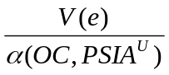), which represents agency costs as a proportion of the monetary return received by the shareholders. A higher relative agency cost for the shareholders implies a higher probability of them abandoning the task of supervising the management since the monetary reward cannot sufficiently compensate for the opportunity cost incurred. A more comprehensive understanding about agency costs can be found in Macho-Ines and Peres-Castrillo (1997) and in Holmstrom (1979).
Obaidullah (1999) also mentions the importance of maintaining a balance between PLS-based and non-PLS-based products on the assets and liabilities sides of an Islamic bank.
To keep it simple, we are making no distinction between equity capital and PLS-based deposits, and between general debt and other fixed-claim deposits, i.e., EC_{t} is assumed to include PSLA^{U}, and DBC_{t} is assumed to include SA and all other fixed claim liabilities.
The equation shows the possibility that the future value of a PLS-based asset might be zero (totally lost).
The equation shows that the expected return to the shareholders is proportionate to the sharing coefficient (β), and that if the bank experiences losses, the financial losses should be less than its loss absorbing capability.
Referring to the Basel Committee’s principles about credit mitigation, the collateral is mandatory to back-up the repayment if the loans are defaulted on. An asset which is not sufficiently backed-up by sound collateral, should be backed-up by equity capital. In the case above, the expected value of the PLS-based assets and the monetary surplus of the hybrid-based assets should be considered as zero ( PLS_{t+1} = 0 and ΔHBY_{t+1} = 0).
Insolvency in an Islamic bank happens when TA < DBC.
This analysis, as a matter of fact, is a modification of the analysis by Milne and Whalley (2001) and aims at analyzing the shareholder value of Islamic banks under the threat of liquidation if the banks become insolvent. The reason for the liquidation process is because the banking regulator wants to minimize the systemic costs. In order to strengthen systemic stability, some countries that operate Islamic banks establish a safety net scheme to enhance the repayment capacity of the Islamic banking system for the risk-averse depositors. The implementation of a safety net scheme may, however, create moral hazard since there is a possibility of transferring bankruptcy cost from the bank to the government.
PSLA^{U} depositors engage in fixed term contracts; hence, they have less flexibility to withdraw their funds if the banks do not perform well financially.
Mathematically, this is expressed in Pareto optimality. Baldwin (2000) develops a basic framework for financial participation in a profit-sharing contract.
The optimal minimum financial participation, as a matter of fact, should be determined empirically.
The differential equation adopts the Bellman equation for non-finite time horizon problem solving where there is no final value function from which we can work backwards. This problem solving equation applied for analyzing the moral hazard in the banking industry is also analyzed in Milne and Whalley (2001), and in Milne and Robertson (1996).
There are important departures from the random walk that the Dickey-Fuller unit root test cannot detect. The variance ratio test is more appropriate than the Dickey-Fuller test when the attribute of interest is uncorrelatedness of increments.
The views expressed in the paper are the author’s own and are not attributable in any way to the Government of Pakistan or any administrative unit, agency or office thereof.
The following comments from the author, submitted in spring 2003, are an update on the latest situation in Islamic finance in Pakistan.
Atta, Hajara. “Ethical Rewards.” M.Sc. Dissertation. University of Durham, Department of Economics and Finance. September 29, 2000.
Dow Jones Islamic Market Index and Dow Jones Global Index are trademarks of Dow Jones and Company, Inc.
Russell 1000, Russell 2000 and Russell 3000 are trademarks of Frank Russell Company.
Here and subsequently, in performing these back tests, we were careful to avoid survivorship bias and look-ahead bias.
The stocks remaining after applying shari^{c}a constraints were weighted by market capitalization to form the IILCS and the IISCS. The Russell Indexes are weighted by their available market capitalization.
The Sharpe Ratio is a measure of return adjusted for risk. It is calculated as (average return-1-year T-bill rate)/standard deviation of return.
Muḥammad b. Makram Ibn Manẓur, Lisan li-Lisan Tahdhib Lisan al-^{c}Arab (Dar al-Kutub al-^{c}Ilmiyya: Bayrut); Sayf al-Din al-Amidi, al-Iḥkam fi Uṣul al-Aḥkam, (Dar al-Kutub al-^{c}Ilmiyya: Bayrut) n.d., 1:7-8
al-Iḥkam fi Uṣul al-Aḥkam, 7-8 and 84-109.
Wahba al-Zuḥayli, al-Fiqh al-Islami wa-Adillatuh (Dar al-Fikr: Dimashq) 1409/1989, 4:78-284.
^{c}Abd al-Raḥman al-Jaziri, al-Fiqh ^{c}ala al-Madhahib al-Arba^{c}a (Dar al-Manar: al-Qahira) 1420/1999, 2:131-141.
al-Fiqh al-Islami, 4:668; al-Fiqh ^{c}ala al-Madhahib al-Arba^{c}a, 2:202.
al-Fiqh al-Islami, 4:668-702; al-Fiqh ^{c}ala al-Madhahib al-Arba^{c}a, 2:202-221.
Nizam Yaquby [Nizam al-Ya^{c}qubi], “Participation and Trading in Equities of Companies Which Main Business is Primarily Lawful but Fraught with Some Prohibited Transactions,” Fourth Harvard Islamic Finance Forum, Cambridge, Massachusetts (October 1, 2000) 21.
al-Fiqh al-Islami, 4:682.
This article will not examine collateral security aspects of the transactions that are discussed, nor will it consider the collateral security aspects of the structure in general terms. The structure provides for mortgages, deeds of trust, security interests and other forms of collateral security, and all such devices were used in the transactions that are discussed in this article. For a general discussion of rahn and collateral security concepts in shari^{c}a-compliant transactions, see Michael J.T. McMillen, The Proceedings of the Third Harvard University Forum on Islamic Finance: Local Challenges, Global Opportunities (2000): 111-31 (“Third Harvard Islamic Forum”), and Michael J.T. McMillen, "Islamic Shari^{c}a-Compliant Project Finance: Collateral Security and Project Finance Structural Case Studies," Fordham International Law Journal 48 (June 2001) (this structure was also discussed in that article). A general description of the financing of the rahn-adl structure in the Saudi Chevron petrochemical project financing appeared in Michael J.T. McMillen, "Special Report, Saudi Arabia, Briefing: Project Finance, Reconciling New Funding with the Shari^{c}a" Middle East Economic Digest 38 (1999): 36-39. A general description of the financing of the Maconda Park Project istişna^{c}-ijara transaction, one of the two transactions discussed in this article, appeared in Michael J.T. McMillen, "Special Report U.S., Briefing: Islamic Finance: Breaking the Mould," Middle East Economic Digest 38 (2000): 28-29.
Riba is traditionally translated as usury. However, Islamic jurists have a more expansive concept which addresses not only prevention of the exploitation of those in a weak bargaining position, but also “the illegality of all forms of gain or profit which were unearned in the sense that they resulted from speculative or risky transactions and could not be precisely calculated in advance by the contracting parties.” Noel J. Coulson, Commercial Law in the Gulf States: The Islamic Legal Tradition, (1984) 11 (“Coulson, Gulf States Commercial Law”); Frank E. Vogel & Samuel L. Hayes, III, Islamic Law and Finance: Religion, Risk and Return, (1998) 71-95 (“Vogel and Hayes); Nabil A. Saleh, Unlawful Gain and Legitimate Profit in Islamic Law, 2nd ed., (1992), 11-43 (“Saleh”); Nayla Comair-Obeid, The Law of Business Contracts in the Arab Middle East (1996), 43-57; Mahmoud A. El-Gamal, "An Economic Explication of the Prohibitions of Riba in Classical Islamic Jurisprudence," in Third Harvard Islamic Forum, 29-40. See more generally: J.T. Noonan, Scholastic Analysis of Usury (1957), which provides an interesting perspective on the Islamic concept of riba and a good history of usury in medieval Europe, including canon law positions at different periods). See also Don Babai, "Islamic Project Finance: Problems and Promises," in Proceedings of the Second Harvard University Forum on Islamic Finance: Islamic Finance into the 21st Century (1999) (the “Second Harvard Islamic Forum”), which notes other limitations.
Substantial tax structuring and property ownership structuring, as well as structuring to address other laws applicable to foreign persons, was undertaken in developing and implementing the istişna^{c}-ijara structure. None of those topics is addressed in this article.
At the time of the writing of this article, the Maconda Park Project is being replicated in a transaction in the San Francisco Bay area of California.
Insightful and creative contributions to the implementation and refinement of the istişna^{c}-ijara structure have been made by Andrew M. Metcalf, Esq. and Jawad I. Ali, Esq., both Associates at King & Spalding who spent many long hours on this project. These transactions, and similar creative Islamic financing, could not have been achieved without the entrepreneurial vision, patience and persistence of the people at each of the institutions involved, most notably those at Key Global Capital, Inc., KeyBank, National Association, Gulf Investment House, Fairfield Residential Properties, Inc., The Dolben Company, Inc., ABC International Bank p.l.c., Abu Dhabi Islamic Bank and their respective law firms. Particular acclaim in this regard goes to James M. Godec, Esq. of Key Global Capital, Inc., Bader A. Al-Ali of Gulf Investment House, Duncan R. Smith and Robbie Morrison of ABC International Bank plc, the shari^{c}a supervisory boards of Gulf Investment House, ABC Islamic Bank (and Arab Banking Corporation) and Abu Dhabi Islamic Bank, W. Donald Knight, Jr., Esq. and Isam Salah, Esq., my Partners at King & Spalding, W. James Conrad and Glenn D. Jones of Fairfield Residential Properties, Inc., Dana G. Pope and Andrew K. Dolben of The Dolben Company, Inc., David M. Tatum, Esq. of Geary, Porter & Donovan, and Andrew J. Ley, Esq. of Jager, Smith & Stetler.
The structure was designed to implement financing of, among other things, other real estate projects (including commercial and industrial construction and project financing), vessels, manufacturing equipment of all types, and a broad range of other assets.
The transaction could have been structured as a pure istişna^{c}, in which the bank enters into a construction contract (istişna^{c}) with the construction contractor and the bank client enters into an agreement with the bank to make payments for the constructed asset on an installment basis. Alternatively, it could have been constructed as an istişna^{c}-parallel istişna^{c}, in which (a) the bank client entered into a construction contract (istişna^{c}) with the bank pursuant to which the bank will construct, or cause construction of, the asset and (b) the bank entered into a construction contract (parallel istişna^{c}) with the construction contractor. The istişna^{c}-ijara structure was used as an alternative to the foregoing for numerous reasons, including those pertaining to United States bankruptcy considerations, the status of leases under state laws in the United States, and flexibility of payment alternatives. A portion of the istişna^{c}-ijara structure does include an istişna^{c}-parallel istişna^{c} arrangement, i.e., that portion pertaining to the Construction (Istişna^{c}) Agreement and the Construction Contract. Kuwait Finance House implemented a financing lease (ijara) structure as part of combined conventional-Islamic financing of the Equate Petrochemical Company project in Kuwait in 1997. Mohammad S. Al-Omar, "Islamic Project Finance: A Case Study of the Equate Petrochemical Company," Third Harvard Islamic Forum 259-64 describes financing for Equate Petrochemical Company project in Kuwait. A range of legal and tax issues pertaining to cross-border Islamic transactions, particularly those implemented in the United States, are discussed in Isam Salah & W. Donald Knight, Jr., "Practical Legal and Tax Issues in Islamic Finance and Investment in the United States," in Second Harvard Islamic Forum 155-58. Tax aspects of a cross-border lease (ijara) structure with structural aspects in common with the istişna^{c}-ijara discussed in this paper are discussed in Robert W. Toan, "Cross-Border Ijara: A Case Study in the U.S. Taxation of Islamic Finance," in Third Harvard Islamic Forum 191-197.
This article focuses on, and refers to, construction of assets, although the principles applicable to manufacturing of assets are identical.
See Majalat al-Aħkam Al-Adliya (as hereinafter defined), articles 338-92; Abdul-Rahman Abdullah bin Aqueel, "Shari^{c}a Precautionary Procedures in Murabaħa and Istişna^{c}: A Practical Perspective" in Second Harvard Islamic Forum 127-30 (“bin Aqueel”). As with most Islamic structures, development of the istişna^{c}-ijara structure was based upon both oral discussions and written materials. Shari^{c}a advisors and shari^{c}a supervisory boards of Islamic institutions provide invaluable knowledge, advice and assistance in elucidating shari^{c}a principles and effecting the application of those principles in Islamic financial products. Of the written materials, many are available only in the Arabic language. The most widely available summary of shari^{c}a precepts in the English language is the Majalat Al-Aħkam Al-Adliya, a summary of certain principles of the shari^{c}a as applied by the Hanafi school of Islamic jurisprudence in the Ottoman Empire and countries that were formerly part thereof; it was officially adopted in portions of the Ottoman Empire. Throughout this article, footnote references are made to the translation of the Majalat Al-Aħkam Al-Adliya by Judge C. A. Hooper, The Civil Law of Palestine and Trans-Jordan, vol. I & II (1933), reprinted in Arab Law Quarterly (Aug. 1986): 4.
The bank client would be the mustaşni^{c} in the agreement between such bank client and the financing bank if a parallel istişna^{c} structure were used, and the bank would be the sani^{c}.
Majalat al-Aħkam Al-Adliya, articles 404-611.
Majalat al-Aħkam Al-Adliya, articles 466-79.
Majalat al-Aħkam Al-Adliya, articles 450, 454, 464, 484-96.
Majalat Al-Aħkam Al-Adliya, articles 443, 470-472, 477, 478. As noted in the text of this article, this is a difficult structural and documentary issue in any project financing involving construction of an asset and is the subject of considerable debate among shari^{c}a scholars.
There is substantial discussion of variable rate rental arrangements in shari^{c}a-compliant leases of equipment and real property. Many such leases make reference to the London Interbank Offered Rate (“LIBOR”) as a referential base from which to compute periodic rentals. Given the absence of reference rates based on Islamic financial instruments, most shari^{c}a scholars allow the use of LIBOR as a reference rate. However, most shari^{c}a scholars object to the direct determination of rental rates by reference solely to variable or floating rates in the body of an on-going ijara. See, e.g., M.A. Elgari, "Some Recurring Shari^{c}a Violations in Islamic Investment Agreements Used by International Banking Institutions," in Second Harvard Islamic Forum, 153 (“M. A. Elgari”). Other methods have been used to structure an ijara that have the practical effect of allowing the implementation of a variable rate structure (one such structure being that used in the Maconda Park Project and the Truman Park Project). The mechanics of that structure are not discussed in this article.
Majalat Al-Aħkam Al-Adliya, articles 513-21 (pertaining to the concept of an option for defect). These provisions, and the shari^{c}a precepts implementing these principles, are a major factor in structuring financing leases, particularly in the United States and Europe where financing parties rely heavily on triple-net leasing concepts. This article refers to “structural maintenance” and similar concepts. These references are a shorthand, and one often used by shari^{c}a boards as well, to those elements of structure, maintenance, and integrity of the project that pertain directly to the benefits sought to be obtained through leasing of the leased assets, and thus may include items beyond pure structural maintenance. Those items will be determined on a case-by-case factual analysis of the leased assets and the purposes of the ijara.
Consider, for example, the Resource Conservation and Recovery Act of 1976 (42 U.S.C. Section 6901 et seq.), as amended, and the regulations promulgated thereunder (“RCRA”), and the Comprehensive Environmental Response, Compensation and Liability Act of 1980 (42 U.S.C. Section 9601 et seq.), as amended, and regulations promulgated thereunder (“CERCLA”).
KeyBank, N.A., provided financing for both the Maconda Park Project and the Truman Park Project. The financing was provided through affiliates of KeyBank, N.A. that acted as the Owner in the two transactions. The structure is presently being used, in various modified forms, for other transactions and a different bank is providing the financing in each of those transactions.
FF Development, L.P. (“FF Development”), an affiliate of Fairfield Residential Properties, Inc. (“Fairfield Residential”), was the general contractor for the Maconda Park Project. Bovis Lend Lease, Inc. was the general contractor for the Truman Park Project.
The customary practice is that each construction contractor (i.e., each General Contractor in the istişna^{c}-ijara transaction) dictates the form of construction contract that it uses. Many construction contractors use a widely recognized standard form (such as those of the American Institute of Architects, which was used, in modified form, by Bovis Lend Lease, Inc. as the General Contractor in the Truman Park transaction). Others use their own forms, which are precisely tailored to that individual construction contractor, such as in the Maconda park transaction.
The Construction Arranger format was used for the Truman Park Project, but not for the Maconda Park Project. In the Maconda Park Project, Fairfield Development executed the Construction (Istişna^{c}) Agreement, which had the customary FF Development Construction Contract attached to it. Various affiliates of Fairfield Residential (including FF Development) were involved in the Maconda Park Project, all of which used the services of a single law firm. Thus, no extra transactional costs were incurred by involving a separate counsel, and other advisers, for the General Contractor. In most transactions, such as the Truman Park Project, an unaffiliated General Contractor is involved. The Construction Arranger format is then appropriate in order to eliminate consideration of the Islamic structure by the General Contractor and its legal counsel and other advisers.
The ijara contains a sublease of the land back to the Project Company to allow the Project Company to possess the land as lessee and operate the project.
The documentation for each of the Maconda Park Project and the Truman Park Project is for a construction financing. As such, the Rental Term is likely to be in the range of one to four years, with a permanent long-term financing take-out contemplated during, or at the end of, such period. The structure could be extended to cover a long-term financing of the projects. In other transactions, a long-term lease (ijara) has been used.
Significant construction or expenditure may be completed or made at the time of entering into, or very shortly after execution of, the Lease (Ijara). This is likely in most projects because approximately 20-25% of the total costs already have been incurred prior to the execution of the Lease (Ijara). The 20-25% represents the equivalent of the equity investment in the project that must have been spent on approved expenditures before the Owner thereof will make payment advances under the Construction (Istişna^{c}) Agreement. As a result, the site will have been acquired, much of the site preparation work may be completed, and the related site may already contain sewers, roads, water, and other infrastructural improvements. Some shari^{c}a boards have indicated that this degree of expenditure upon a project is sufficient to cause the Basic Rent provisions to become effective because the value of the related site will be substantially, and sufficiently, increased by this time. Further, and as noted in the Lease (Ijara), construction of certain blocks and segments of the improvements for the project will be completed before completion of other blocks or segments. Certain blocks and segments will have considerable lease value, and units will actually be rentable (and rented), prior to completion of other blocks and segments. Thus, significant rental income will already be generated prior to completion of the entire project. This, in turn, allows full effectuation of all provisions of the Lease (Ijara) at a relatively early time. Although the determination of sufficient economic value, sufficiency and benefit to permit the intended use are significant and vexing shari^{c}a issues, they are not difficult issues in a practical sense in projects such as the Maconda Park Project and the Truman Park Project. This is because the transaction is a construction financing in which no Basic Rent is payable during the construction period, i.e., for approximately two or two and one-half years from commencement of the financing. Construction is complete for the entire project by the end of that period and the project is fully rented by the end of that period. Although no Basic Rent is payable during that period, most construction financing include a feature that capitalizes interest (in a conventional financing) or profit (in an Islamic financing) during the construction period. The capitalization method used in the Maconda Park Project and the Truman Park Project, and in similar projects, is particularly complex and has received the approval of various shari^{c}a boards. That capitalization method is not discussed in this article.
The author has worked on transactions in which multiple leases were used, one for each phase of the project. This approach permits different leases, and financing arrangements, for different aspects of construction, and allows each lease to be tailored to a different intended use. Given that the shari^{c}a precept focuses on the intended use, effectuation of the leases under shari^{c}a precepts can be obtained at an earlier point in the overall financing transaction, and the various leases can be closely tailored to construction milestone completion and funding. The author is presently working on an istişna^{c}-ijara transaction that poignantly raises the effect of factual variation on the shari^{c}a determination of full effectuation of the lease. The transaction involves the acquisition of a large farm. An Islamically acceptable joint venture has been formed to subdivide the farmland, obtain certain permits for construction and related activities, and construct infrastructure (roads, sewers, lighting, and the like). Each parcel will be sold off to another residential or commercial developer, or a commercial enterprise, which will construct the housing or commercial facilities for that specific parcel. The entire purpose of the joint venture is so limited. Clearly, the intended construction activities are limited, and substantial economic value and sufficiency, especially when considered from an “intention” perspective, is obtained at a very early stage in the business cycle. Another factor affecting substantial economic value, sufficiency and benefit issues, particularly in the United States of America, is the fact that obtaining a permit or zoning approval, without more, will frequently substantially enhance the value and sufficiency of the land (without regard to any physical construction).
As noted in the text of this article, a Managing Contractor, among other things, supervises construction activities, inspects construction of the project on an on-going basis, accepts the project, and provides for maintenance (including major and structural maintenance), pursuant to the Managing Contractor Agreement.
Certain modifications to the triple net lease concept that are necessary for compliance with shari^{c}a precepts are discussed below.
See M.A. Elgari, at 151-54.
Ibid.
See, for example, Dow Jones Islamic Market Indexes, at <http://indexes.dowjones.com/djimi/imiinvest.html>; Islamic Business & Finance Network (“IBFNET”), at <http://islamic-finance.net/islamic-equity/equity1.html>; Abdul Hamid, "Investing in Equities: Some Issues from the Islamic Perspective," in Third Harvard Islamic Forum, 91-101.
The form of lease (ijara) that served as the structural basis for the Lease (Ijara) has been used in numerous Islamic financings and the adjustment mechanism has been approved by several shari^{c}a boards. Analytically, the Lease (Ijara) can be thought of as a lease for a specified period (for example, one month). The Basic Rent payable under the Lease (Ijara) is determined by dividing the absolute amount of the Total Construction Cost paid to the first day of such month by the overall payment period, and then adding the applicable Lessor’s Profit. Analytically, the Lease (Ijara) will then terminate on the last day of such month unless the parties agree to extend for another period (say, another month). If the Lease (Ijara) is so extended by virtue of a new and otherwise identical lease, the Basic Rent is recalculated to increase by the amount of Total Construction Cost advanced to the first day of such second month, and, again the weighted reference rate analysis is applied to determine the applicable Lessor’s Profit for the new lease. This process is repeated with respect to each subsequent rental period. Payment of some or all of the Rent is deferred during the construction period so long as there is a continuous and contiguous series of leases. If the Lease (Ijara) is not renewed at the end of any month or other rental period, the Lease (Ijara) terminates and the total amount of Rent accrued to such date becomes immediately due and payable and can no longer be deferred. Pursuant to the Put Option, the Owner is entitled to cause the Project Company to immediately purchase the project in its then-existing state and condition for a specified amount. In practice, the Lease (Ijara) is written such that it automatically renews each period (for example, each month) unless there is a cancellation. These, and other structural elements, are designed to minimize the administrative and financial burden on the parties (especially the Project Company as the Lessee) and streamline the renewal and recalculation process and to avoid various complications of various United States laws, including bankruptcy laws, mortgage recordation laws, and recordation and taxation requirements in different jurisdictions.
See Majalat Al-Aħkam Al-Adliya, articles 101-403 (addressing concepts of sale); Ray 38-59; Vogel & Hayes 117-20 and 140-43; bin Aqueel, in Second Harvard Islamic Forum 127-30; Yusuf Talal DeLorenzo, "Murabaħa, Sales of Trust, and Money-value of Time," in Second Harvard Islamic Forum, 151-54 (discussing nature of murabaħa transactions and, as a general references); and Yusuf Talal DeLorenzo, ed. & trans., A Compendium of Legal Opinions on the Operations of Islamic Banks: Murabaħa, Muđaraba, and Musharaka (1997), 219-61 (“DeLorenzo Legal Opinions”) (containing a good collection of fatawa regarding various sales-related concepts in different structures and transactions).
See Majalat Al-Aħkam Al-Adliya, articles 320-35 (pertaining to the option to inspect, which provides a purchaser certain rights to inspect assets to be purchased and to reject such assets in certain circumstances) and articles 336-55 (addressing related option for defect). These doctrines also have significant application to construction (istişna^{c}) and lease (ijara) arrangements. Other types of options that are applicable in similar transactions are the contractual options (articles 300-09), options for misdescription (articles 310-12), options as to payment (articles 313-15), and options as to selection (articles 316-18).
The mortgage (rahn), security agreement, and other collateral security documentation, including guarantees of payment, completion of construction, and environmental matters (collectively, “Security Documents”) are not discussed in this article, nor are the various consents and similar documents between and among the parties to the transaction that allow for assignment of documents in connection with the Security Documents and which also make provision for the exercise of remedies in various default scenarios and provide for damages in such scenarios.
Such a standard construction contract might be the American Institute of Architects Form A111, Standard Form of Agreement Between Owner and Contractor, and Standard General Conditions and Special Conditions Relating Thereto, as was used in the Truman Park transaction. In the Maconda Park transaction, the Construction Terms were the General Contractor’s own customary form of construction contract and conditions.
The obligations of the Lessee under the Lease (Ijara) are evidenced by a Basic Rent Note.
Many shari^{c}a advisors have argued that a well-developed shari^{c}a-compliant documentary structure covers every risk that is addressed in the documentation for a conventional loan financing. In the author’s personal experience, Nizam Yaquby and Mohamed A. Elgari have been the most adamant. It is the author’s conclusion that they are correct and that the spreadsheet technique demonstrates that quite elegantly.
See generally Noel J. Coulson, A History of Islamic Law (1964); Joseph Schacht, An Introduction to Islamic Law (1964); Vogel & Hayes; Nicholas Dylan Ray, Arab Islamic Banking and the Renewal of Islamic Law (1995) (“Ray”); Saleh; Coulson, Gulf States Commercial Law; see also Second Harvard Islamic Forum and Third Harvard Islamic Forum (containing articles covering current issues in Islamic finance). While, as a precise matter, all discussion of Islamic jurisprudence is one of fiqh, this article, in keeping with convention, refers to precepts and principles of shari^{c}a without further reference to fiqh.
See Nizam Yaquby, “Islamic Finance in View of the Shari^{c}a,” in Second Harvard Islamic Forum, 159-61 (summarizing these and other responsibilities of modern shari^{c}a boards).
The four major schools of Islamic jurisprudence are: (1) the Hanafi school, which is predominant in the countries of the former Ottoman Empire, and emanates from the disciples of Abu Hanifa (d. 767 CE) in the Iraqi center of Kufa; (2) the Hanbali school, which is predominant in Saudi Arabia and a few other jurisdictions and was formed by Ahmad b. Hanbal (d. 855 CE); (3) the Maliki school, which emanated from the Arabian center in Medina through the followers of Malik b. Anas (d. 796 CE); and (4) the Shafi^{c}i school formed by the followers of Shafi’i (d. 820 CE). The four major schools differ in many respects in their interpretation of certain shari^{c}a precepts. Most scholars from medieval times until modern times aligned themselves with one of the four major schools of Islamic jurisprudence. However, in modern times many scholars do not believe it necessary to belong to any single school of Islamic jurisprudence. See Vogel & Hayes, 34-41 (describing methods of elaboration of law).
See, e.g., Dow Jones Islamic Market Indexes, <http://indexes.dowjones.com/djimi/imiinvest.html>; IBFNET, <http://islamic-finance.net/islamic-equity/equity1.html>; Abdul Hamid, 91-101.
Qur’an 13:49.
As recent fatawa from Al-Azhar University make clear.
“The Perfect Storm: Why Successful Lease Financing Companies Have Exited the Marketplace,” The November 2001 report of the Equipment Leasing and Finance Foundation, prepared by the Alta Group.
In fact, it has been suggested that Islamic investors are even more risk averse than conventional investors. Approximately 80% of all the assets of Islamic banking institutions are held in secure, short-term murabaħa transactions.
The authors wish to express their gratitude to Mohamed Elgari, Nizam Yaquby, and Yusuf DeLorenzo, the shari^{c}a scholars who have guided them in regard to the concepts discussed herein. This article has not been reviewed by these scholars and any errors are solely the responsibility of the authors.
The authors wish to acknowledge their debt to Samuel Hayes and Frank Vogel of the Harvard Islamic Finance Program, whose provocative and thoughtful book, Islamic Law and Finance: Risk, Religion and Return (Kluwer 1998) they consulted and relied upon extensively in the article.
Robert I. Mehr and Bob A. Hedges, Risk Management in the Business Enterprise, Homewood, Ill.: Richard D. Irwin, 1963.
* The authors wish to thank Badariah Mohd Zahir and Khairul Anuar Adnan for their administrative assistance, and to acknowledge the grant from Universiti Utara Malaysia.
VF Garcia et al.
See Reports of Working Groups on the International Financial Architecture, available on the Web site of the Bank for International Settlements: http://www.bis.org/publ/other.html/FinArch
Ibid. p. 40.
The early modern writings are associated with the names of the founders of the contemporary Islamic movement: Maulana Maududi in India and Pakistan and Hassan al-Banna in Egypt, followed by Sayyid Qutb’s famous book, Social Justice in Islam. Probably the first systemic work on the issue of interest by an economist was Anwar Qureshi 1948, followed by Muhammad Uzair 1955, and Muhammad Baqer Al Sadr 1960.
The first two Islamic banks and the IDB are all development-oriented institutions with little interest in commercial banking. The Dubai Islamic Bank was established and managed by businessmen in a country whose banking laws were still in their infancy. This bank was more involved in merchandise trading than other banking activities. Thus full-fledged commercial Islamic banking came about only with the birth of the Islamic banks in Egypt, Jordan and Sudan in the late 1970s.
As at the writing of this paper IDB still had no shari^{c}a board or committee. Dubai Islamic Bank got a shari^{c}a advisory board only after its restructuring in 1999.
It must be pointed out that both IDB and Dubai Islamic Bank have occasionally consulted shari^{c}a scholars when they needed advice.
It should be noted that 20th century Islamic movements in almost all Muslim countries other than Turkey and Sudan have generally been on unfriendly terms with the ^{c}ulama’. Since the time of Hasan al-Banna in Egypt and Maududi in South Asia, the real raison d’être of the Islamic movement has been conceived in terms of the failure of the ^{c}ulama’ in discharging their responsibility to awaken the umma and educate it about the importance of religion in contemporary social and political life. At the same time Islamic movements have always had fraught relations with governments. Al-Banna declared in 1938 that the true demonstration of the righteousness of the Muslim Brotherhood was expressed in the visible hostility of stooge governments and a corrupt ^{c}ulama’; and Maududi was more than once accused of apostasy by many traditional Pakistani ^{c}ulama’.
Some Islamic banks also charge their shari^{c}a board with the responsibility for arbitration in case of disputes with customers. This function is also a part of the public relations role of the ^{c}ulama’, as it is intended to assure the public that the bank abides by shari^{c}a rules.
Some writers consider Islamic banks as more than finance intermediary institutions. This is not true. For instance, in a 1997 paper, Timor Kuran said, “Islamic banking defies the separation between economics and religion. It invokes religious authority in a domain that modern civilization has secularized.” A close look at the difference between shari^{c}a-as-law and religion indicates that Islamic banks are not religious organizations. They are civic institutions that elect to abide by the rules of shari^{c}a. Their shari^{c}a boards have advisory capacity with no executive power, they act in a manner similar to legal advisors. the only executive authority exercised in Islamic banks is that of their boards of directors under the control and supervision of their respective central banks or monetary authorities.
Most Islamic banks create an investment-risk reserve fund or provision to stabilize the distributed returns to investment-deposit holders. With the help of such funds, Islamic banks were able to practically stabilize the return on deposits from year to year. Furthermore, investment-risk funds were utilized to support distributed profits in low-return times in order to maintain a competitive status vis-à-vis interest-giving banks. This reserve fund is normally financed from the share of profit distributable to investment deposits.
There are differing views by some ^{c}ulama’ that defend the owners of current accounts. For instance, Hassan Abdulla al-Amin’s analysis that these accounts deserve a return was rejected by the ^{c}ulama’. Al-Amin argues that demand deposits cannot be considered loans from the shari^{c}a point of view, because they lack the intention of lending, and the contractual relation calls them deposits. Accordingly, demand deposits must be considered deposits in fiqhi terms, i. e. wadi^{c}a and the rulings of wadi^{c}a must apply to them. He also states that these deposits are given for safeguard and convenience purposes and the bank uses them in its investment activities in violation of the fiqhi rules of wadi^{c}a. This violation has two effects: it imposes a guarantee of principal on the user, and it gives the owner all the return that resulted from the utilization of the wadi^{c}a. (al-Amin 1980).
Kahf 1980.
Islamic banks usually impose restrictive measures on investment deposits. Faisal Islamic Bank of Egypt is the only Islamic bank that allows withdrawal from investment deposits on a 24 hour notice. As a result, its balance sheet shows low balances on its current accounts and high balances on investment accounts. This is in contrast with all other Islamic banks.
Mirakhor 1997.
This point shall be touched upon later when I discuss the future of Islamic banking and finance.
The early writings on Islamic banking envisioned the Islamic banks would provide funds on the basis of muđaraba. This turned out to be demanding on the Islamic banks’ personnel, as it requires knowledge in project evaluation, market forecasting, price extrapolation techniques etc., with a horizontal spread over all commodities traded in the market; in addition to a different type of follow-up with the beneficiaries of finance. It is interesting to note that even the theoretical writings had never made any reference to murabaħa until Sami Hamoud’s dissertation was published in 1976. Ijara and especially ijara wa iqtina’ only entered the theory of Islamic banking in the 1990s. (Kahf 2000).
Notably, murabaħa and ijara can also be used as vehicles in debts rescheduling. However, shari^{c}a boards restrict their use in rescheduling to the substitution of interest-based loans for Islamic financing.
It has been the practice of Islamic banks to finance less than 100% of a transaction and to leave a certain percentage to be financed by the customer under what they call “the margin of serious commitment.”
Qur’an 2:280.
The moral commitment of Islamic banks is intrinsic because the shari^{c}a rulings are always morally loaded. On the other hand, during the struggle against apartheid, there were calls to boycott the oppressors, which culminated in a movement to include moral criteria in investment outside Islamic banking. While all Islamic banks are, by definition, morally committed, few other bankers apply moral standards in investment screening.
This raises the issue of financing terrorism. The history of Islamic banks and of main shareholders and management staff indicates that they cannot accommodate terrorists or terrorist financing They are committed, controlled and supervised by local monetary authorities. Unfortunately, no evidence connecting Islamic banks to financing terrorism has been provided, and the actions against some has no legal or moral grounds. Unfortunately, after the attacks of 9/11, an atmosphere of distrust has impacted Islam, the Muslim world, and American Muslims severely.
Al Murtan 1999.
While the image of Islamic banking received a boost from the ^{c}ulama’, the so-called “Islamic investment companies” found it unnecessary to hire shari^{c}a advisers. These companies draw their clientele from two categories: people who can be reached directly and indirectly through word of mouth and personal contacts, and those who have are willing to take high risks for a quick windfall profit. The earliest of such companies emerged in Saudi Arabia in the mid-70s and wiped out the savings of many people, while its owner/founder landed in a Mecca prison. The same experience was repeated in Egypt, and on a smaller scale in Syria, in the late 1980s. Several “Islamic investment companies” were established in Egypt, taking advantages of loopholes in the law. They collected huge savings from the public, and their main practice was to distribute a high rate of return, actually taken from new deposits. They mainly counted on the pyramidal cumulative effect of new deposits, with very little actual investment. Though Islamic banks and ^{c}ulama’ and most Islamic economists and financiers took strong stands against these companies, a few outspoken Egyptian Islamic activists allied with them, strongly defended them and attacked what they called “the government conspiracy against the Islamic investment companies.” The support of Islamic activists did not compensate for the lack of support from the ^{c}ulama’ did not lend these “Islamic” investment companies public acceptance.
The bank management flopped in 1998. The bank’s report at the end of the year showed a loss of over 23% of the principal to both muđaraba depositors and shareholders. The shari^{c}a board reported that “the management did not violate the shari^{c}a rules,” and went so far as to state that the board of directors and the management did their best with sound banking and investment decisions, and that the loss was a result of the South-East Asian crisis, as the management claimed. In 2000, a letter from the management revealed the truth, indirectly indicating that in a breach of established principles of sound banking and common standards of financial wisdom, the bank management actually took high exposures, as it invested more than 60% of the bank’s assets in a single project.
It is worth noting that historically the ^{c}ulama’ have played leading advisory roles, and defended the public from rulers’ atrocities and outside aggression. Ibn Hanbal, Nawawi, Ibn ^{c}Abd al-Salam, and Ibn Taymiyya are only some of the most prominent examples. In the past the awqaf was the main source of finance for Islamic and secular education. From the days of Muhammad Ali in Egypt the control of awqaf was transferred to the government. The Awqaf Act of 1856 in the Ottoman Empire extended the government authority to awqaf and made the ^{c}ulama’ government employees, which made them lose their independent source of finance, and thus their leadership status. Gradually, they took a position on the peripheries of the political stage. Although the European invasion of much of the Muslim world caused revolutionary reactions and resistance movements often lead by ^{c}ulama’, most remained invisible. The 20th century political Islamic movement was partly a reaction to this dormancy, but took a turn in the 1940s and 1950s when it presented itself as a substitute for existing regimes instead of the ^{c}ulama’. This is in contrast with the ^{c}ulama’ of the medieval Islamic period, who did not pose threats to their rulers.
Both stories come from the Sudan’s Bank al Tadamun and Central Bank.
Iqbal, 2000.
Directories of Islamic Banks, 1994-1996. Also, Al-Omar 1997.
The remaining 46 are distributed as follows: 20 medical, 11 administrative, 14 miscellaneous, and one on a query from the American Muslim community consisting of about 30 questions, many which are financial.
Babikr 1997.
Reports for the 1998 and 1999 fiscal years, of the three banks named in the text.
Two more Islamic banks were established in 1988-89: The Islamic Bank of Sudan-North and the Bank of Workers, but neither was very active before the coup. It should be noted, however, that some Islamic banks restrict a considerable proportion of their financing to a closed circle of main shareholders and their partners and associates. This is especially noticeable in one Sudanese and one Saudi Arabian bank.
Most ^{c}ulama’ come from poor backgrounds. This is because of the structure of the educational system in Muslim countries. With the introduction of the Western educational system and its emphasis on the sciences, the financial resources of the traditional Islamic educational centers and job opportunities for their graduates became very thin. Since the beginning of the twentieth century, Islamic education became the monopoly of poor children whose parents cannot afford to send them to public or private schools, whereas most Islamic schools provide meager boarding facilities subsidized by charities and the remnants of awqaf.
Most Islamic banks take charge of distributing the zakat due on shareholders’ equity, and some of them obtain the consent of their depositors to deduct and distribute their zakat. This allowed some of the Islamic banks to create sizable zakat distribution departments that keep relations with the needy, and with other local charities. This is evident in the Social Naser Bank and the Faisal Islamic Bank of Egypt and Kuwait Finance House.
Although there are no statistical data to substantiate this claim, a close look at the lists of CEOs of Dar-al-Mal’s central office and affiliated banks and Al-Baraka Group’s banks especially in Tunisia, Algeria, Mauritania, and Bangladesh support it.
Islamic banks follow different trends in some areas. The peculiarities of the economic and political scenes in Sudan, Turkey, Pakistan and Iran affect the alliance, especially with regards to interaction with the Islamic movement. Analysis of these special cases is outside the limits of this paper.
Directory of Islamic Banks and Financial Institutions 1996. The 1996 report was the last one published by the IAIB before it closed. It should be noted that 92 of the reported 166 Islamic banks had a capital of no more than $10 million, and only seventeen had a capital of $100 million or more. Of the latter, nine are state-owned Iranian banks. A similar trend appears for assets. Although total assets average at $826 million, only twenty-three banks have assets of more than one billion dollars. Of these ten are Iranian, which inflates numbers because of the use of official rate of exchange in converting from rials to dollars. There are 85 banks with assets under $100 million.
For instance, some shari^{c}a boards ask the management to submit each individual contract to scrutiny, while others restrict themselves to studying standardized contracts.
The closing of Al-Barakah Bank in London was partly due to its inability to form a relationship between the bank management and the shari^{c}a board which satisfies the Bank of England.
See n. 25 above.
Bahrain, where three full-service and several off-shore Islamic banks compete in a small economic environment, may be an exception. Some other Muslim countries are also creating a competitive environment. Bangladesh and Bahrain have five banks each, and Malaysia, Qatar, Saudi Arabia and Indonesia have two each.
The establishment of a second Islamic bank in Jordan was not appreciated by an existing bank, which tried to draw its customers away by questioning the Islamic legitimacy of the new bank, on the grounds that it was established by traditional bankers’ capital. Similar fears were raised about the Islamic branches of the National Commercial Bank in Saudi Arabia, as Sa^{c}id Martan wrote.
Prior to 1998, shareholder’s rate of return in the Bahrain Faisal Islamic Bank was above 16% for several consecutive years, while investment deposits’ return was only 4-5%.
For example, Citicorp of New York established an Islamic Citibank in Bahrain (1995); the National Commercial Bank of Saudi Arabia established more than 46 Islamic branches between 1992 and 1998; and the recently established full-service Islamic bank by the Arab Bank of Jordan (1998), The Arab Investment Banking Corp in Bahrain (2000); in addition to Islamic banking services offered by many traditional banks from New York to London to Geneva to Cairo to Kuala Lumpur.
This is an important reason for the argument in the Kuwaiti Parliament between supporters of the Kuwait Finance House and the central bank; the latter wants (rightly) to restrict the Kuwait Finance House to the role of financial intermediary, while the former holds to the authorities granted in the Princely Decree of its establishment.
Bahrain Monetary Authority has recently published standardized criteria for supervising Islamic banking. These criteria were developed in cooperation with the Accounting and Auditing Organization of Islamic Financial Institution.
Luca Errico and Mitra Farahbaksh suggested applying the CAMEL of the Basel Committee on Banking supervision with higher than 8% capital adequacy, which is the Basel Committee minimum level for OECD countries (Errico and Farahbaksh 1998). This suggestion may be rejected on the ground that unlike the theoretical model used by Errico and Farahbaksh, Islamic banks’ assets consist mainly of debts, while most of their liabilities are investment deposits, i. e., venture capital not liability. This makes their capital needs smaller than those of conventional banks. This line of argument borrows support from the practice of the Gambia’s central bank in excluding investment deposits of the Arab Gambian Islamic Bank from liquidity requirements because they are not bank liabilities.(Information from the Chairman of the Board of Directors of the AGIB).
It would be an interesting subject of research to study the effect of the Islamization of the banking sector in Pakistan, Iran and Sudan on the size of rescheduling, discounting and wholesale financing in those countries, and on the financing facilities for on tobacco and other “unethical” production and exchange.
Securities and Exchange Commission Division of Market Regulation. Special Study: Electronic Communication Networks and After-Hours Trading. Washington DC: June, 2000. p. 6.
Securities and Exchange Commission. Exchange Act Release No. 40760. Washington DC: December 8, 1998. p. 4.
Securities and Exchange Commission. Exchange Act Release No. 37619A. Washington DC: September 6, 1996.
Exchange Act Release 40760 p. 5.
CFR 17 240.3b-16 (a) (1)-(2).
CFR 17 240.3a1-1 (a) (2).
CFR 17 242.300 (a).
Exchange Act Release 40760 p. 53.
Ibid. p. 126.
Exchange Act Release 37619A. p. 8.
Ibid. pp. 12-13.
CFR 17 240.11Ac1-4.
CFR 17 240.11Ac1-1.
Exchange Act Release 37619A. pp. 88-90.
CFR 17 240.11Ac1-1(c)(5).
CFR 17 204.11Ac1-1(c)(5)(ii).
Exchange Act Release 37619A. pp. 35-36.
Ibid. p. 62.
Ibid. pp. 100-101. See also CFR 17 240.11Ac1-1(c)(5)(ii)(A)(1)-(2).
New York Stock Exchange. NYSE Constitution and Rules. Rule 123B(a).
Ibid. Rule 123B(b)(1).
Ibid. Rule 104.
National Association of Securities Dealers. NASD Manual. Rule 4613.
Ip, Greg. “Floor Show: If Big Board Specialists are an Anachronism, They’re a Profitable One.” Wall Street Journal CCXXXVII.49. March 12, 2001. p 1.
New York Stock Exchange Special Committee on Market Structure. Governance and Ownership, Market Structure Report. New York Stock Exchange. March 2000.
EDS Global Financial Industry Group. Electronic Communications Networks and Global Financial Markets. April 2000. p 17.
Smith, J., J.P. Selway III, and D.T. McCormick. The NASDAQ Stock Market: Historical Background and Current Operation. NASD Working Paper 98-01. NASD Department of Economic Research. August 1998. p. 48.
Ibid. p. 18.
EDS Global Financial Industry Group. p. 34.
Mohd Ma’sum Billah. Principles and Practices of Takaful and Insurance Compared. International Islamic University. Malaysia: 2001. p.4-6.
In a later section of this paper the authors outline the contrasting elements of these two models for takaful management.
Islamic scholars have issued opinions that on an exception basis takaful operators may cede premiums to conventional reinsurers that do not adher to shari^{c}a guidelines in either operations or investments. The moral imperative exists, however, for Muslims to redress the shortcomings in all aspects of primary risk-protection and reinsurance in order to realize the full material and spiritual benefits of the takaful system
‡ Operates under Takaful/cooperative principles while evolving into a full entity in accordance with Takaful model.
Khidr Capital Corporation, June 2000.
Sigma 9/2000 and American RE reports.
Bahrain, Brunei, Egypt, Indonesia, Jordan, Kuwait, Morocco, Pakistan, Qatar, Singapore, Tunisia, Turkey, Saudi Arabia and UAE.
Some exceptions to this rule exist among takaful operators.
Takaful Nasional (Malaysia) currently sells through independent agents, and charges their commissions to the Participants’ Takaful Fund.
Internet Web site of Takaful Malaysia, June 2001.
Nizam Yaquby, “Possibilities of Global Uniformity amongst Takaful Operators in Light of the Shari^{c}a Norms.” Malaysia International Summit on Takaful. Kuala Lumpur: June 2001, p.2-3.
Nizam Yaquby. “Role of Shari^{c}a Board in Islamic Insurance.” International Conference on Takaful. Kuala Lumpur: June 1999. p. 3.
Sigma Report 9/2000, Swiss Re.
Ajmal Bhatty. “Opportunities and Prospects of Investment Links amongst Takaful Operators in the International Feasible Market” International Takaful Summit. Kuala Lumpur: June 2001. p. 4-5.
See Figure 6 for details.
“Preliminary Findings on Ongoing Survey Conducted on IBF Net Online Discussion Forum.” Malaysia International Summit on Takaful. Kuala Lumpur: June 2001. p. 2.
Estimates by Failaka Islamic Funds Quarterly, www.failaka.com.
Online Survey on Investor Perceptions of Islamic Financial Products, conducted on visitors to www.islamic-finance.net, the Web site of the Islamic Business and Finance Network.
Screening criteria in use at Dow Jones Islamic Market Index, www.djim.com.
Andrew Clout, Franchising at The International Investor, Paper Presented at IBFF Forum on Islamic Finance held in Bahrain, 1999.

